Day 1 - 112329867 - Jaswanth Vadlamudi

What is SDLC ?

SDLC is software development life cycle is a process that use to develop and test software, in SDLC we have set of processes to follow like,

Planning, analysis, design, Development, testing and maintenance.

Why is SDLC ?

By following SDLC it makes sure requirements are clear before coding and helps tracking code changes and versions properly, and it ensures testing and maintenance.

We can technically create software without SDLC and it is not recommended for small projects.

Stages of SDLC ?

1.Planning : This is the first stage, collecting the information about the project from the client requirements and creating the roadmap.

2. Analysis : In this stage we gather the necessary requirements for the software and plan a technical approach.

3. Design:  In this stage we design  the software, how it is going to look/work.

4. Development : In this stage we write actual code for the software.

5 .Testing : Here we test the Software that we made, find any bugs and fix them.

6 .Deployment: Release the software to users.

7.Maintenance : Keep tracking software functionality updated as needed.

SDLC models:

**Waterfall model:**

Water fall model follows step by step sequence, each phase should be 100 % completed before moving into the next steps. It is best for projects when requirements are clear.

We use waterfall model small and simple projects with clear requirements, project not change their scope.

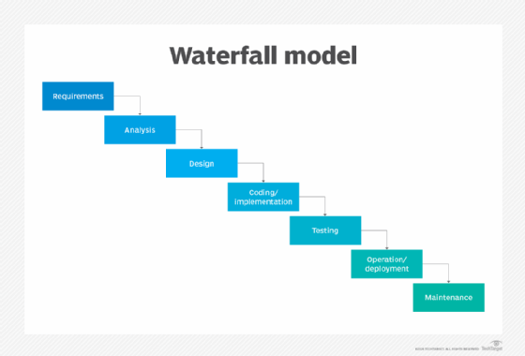

Used in Banking, Government, manufacturing

Advantages:

* Simple and easy to understand
* Clear deadlines

Disadvantages:

* No flexibility for changes
* Not good for large projects

**Agile Model:**

Agile model breaks work into small parts and called sprints, changes are welcome even late in development.

It is flexible to use in projects with changing environments.

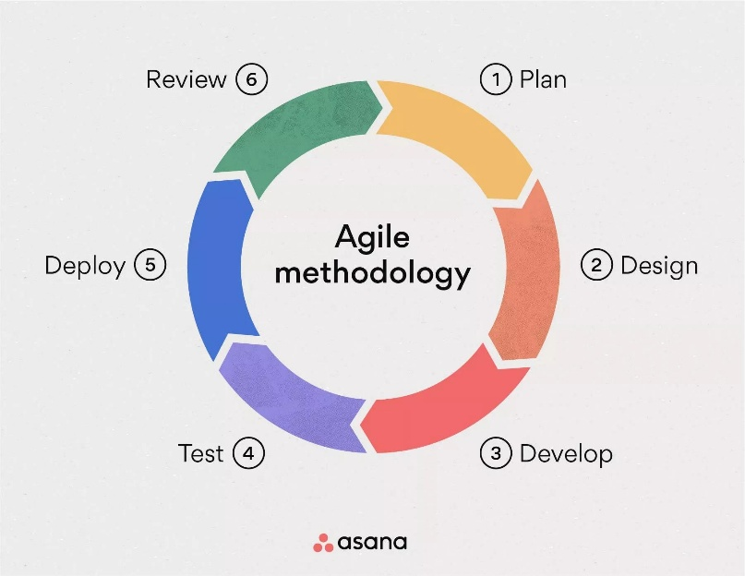

Used in Social media, Small projects

Advantages:

* Flexible to changes
* Early bug detection
* Continues improvements

Disadvantages:

* Unclear ETA
* Hard to manage

**V-Model:**

The verification and validation model or V model and it is test driven model like for every step-in development matching pair with testing.

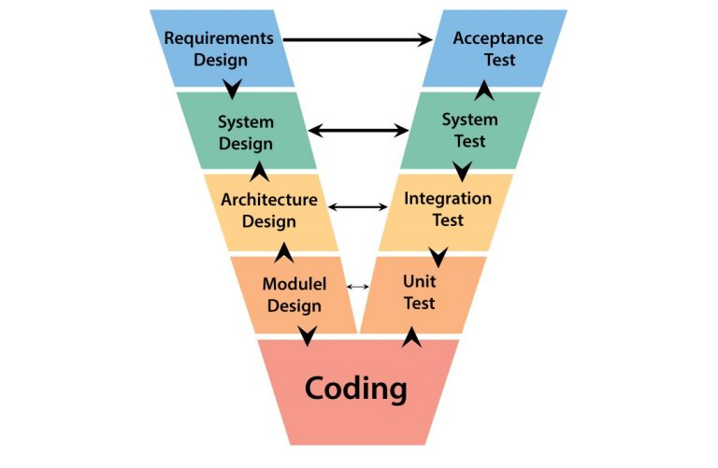

Used in Health care

Advantages:

* Early test planning
* Structured approach

Disadvantages:

* Expensive
* Time consuming

**Spiral Model:**

This model is repeatedly going to every cycle, and check risks before each cycle starts. 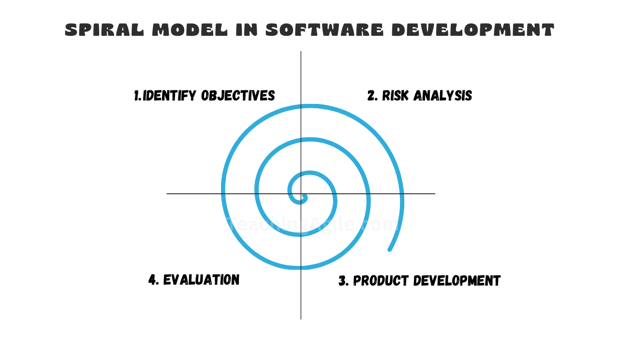

Used in financial risk heavy projects

Advantages:

* High risk management
* Good for large projects

Disadvantages:

* Not flexible like waterfall model
* Complex to manage

**Iterative model :**

This is used to build software in repeated cycles starting with the simple version and adding more features to it until the final model.

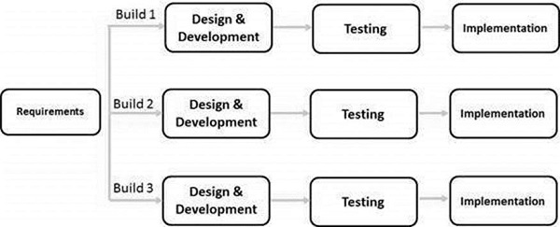

Used in operating systems

Advantages:

* Early working product
* Lower risks

Disadvantages:

* More management needed
* Expensive

**Prototype Model:**

Prototype model is to use build for a working sample

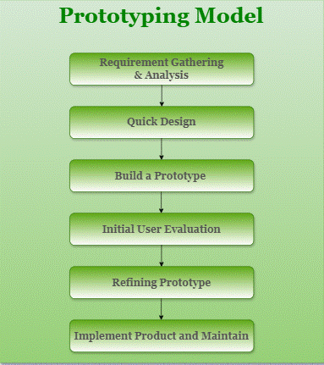

Used in Mobile apps UI design projects

Advantages:

* Clear user feedback
* Reduced rick failure

Disadvantages:

* Expensive
* Time consuming
* Confusing to the clients

What is Scrum?

Scrum is a way to break big work into small parts that completed in short time period.

It is a cycle of planning, doing, checking and improving.

Core roles:

* Product owner: manages what to build
* Scrum master: facilitate processes
* Dev Team: Builds the product

What is sprint?

Time boxed period where team works to complete a specific set of goals.

No changes to sprint goal once started.

Think It as a mini-project, the team should have something new to show that actually works.

What we should do, what shouldn’t do while working in sprint?

**Do’s**

* Tell team quickly if you’re stuck or having problems
* Join daily team meetings and share progress
* Focus only tasks that you promised to do in this sprint

**Should not**

* do not take more work than you can finish in the sprint
* don’t change or add new tasks once sprint has started
* don’t work on things that aren’t part of the sprint plan

Definition of backlogs and stories?

Backlog:

* It is a to – do list for whole project
* Items at the top are most important and need to be done first
* Team picks items form this list when planning their sprint work.

Stories:

* Simple description of features that user want

what are scrum artifacts?

product backlogs: it is a to-do list for everything that need to be built in the project, ordered by importance.

Sprint Backlogs: The small to-do list of items the team picks from the big list to work on during the current sprint.

Increment: The actual working piece of the product that’s completed at the end each sprint, ready to be used

Scrum Board: it is a visual display with the columns showing “To Do”, and “Done”

Team members move their tasks cards across these columns as they work, so everyone can easily see what being worked on and what’s being worked on that’s finished.

Burndown Charts: Is a simple graph that shows how much work is left in the sprint

Ports and Protocols?

Port is like a door on your computer where different types of information go in and out.

Protocol is a set of rules that tell information how to travel through these doors

What are the network types?

LAN : Local area network

WAN : wide area network

PAN : personal area network

VPN : virtual private networks

What do you know about DNS? Domain Name Service?

DNS is like translator to the internet, when you type a website name, DNS converts into numbers like 142.250.190.78

Computers need these numbers to find websites, but humans are better at remembering names.

Without DNS we would have to remember number address for every website.

What are the types of servers ?

Web server: stores and deliveries website files

File server: stores and shares files across a network

Main Server: Handle sending, receiving and storing mails

DNS Server: Converts website names into IP

Application Server: Runs specific software application

FTP Server: File transfer server

What is the different type of network topologies?

BUS: All devices connected to one main cable, if main cable breaks whole network stops.

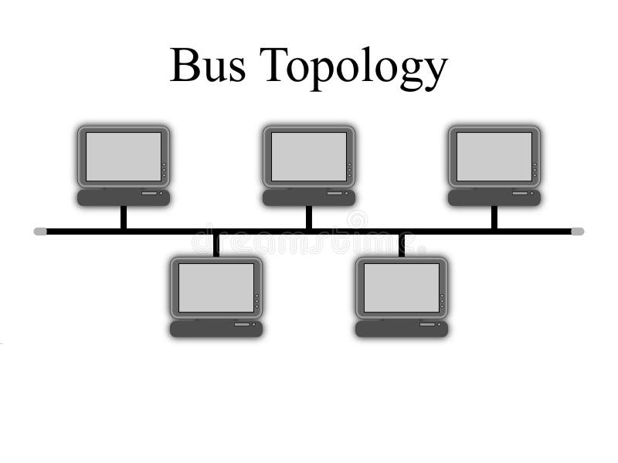

Star: All devices connected to one central point, if one cable breaks only that devices is affected.

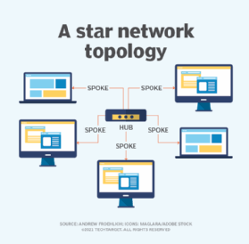

Ring: Devices connected in a circle, data travels in on direction, like passing message around a circle.

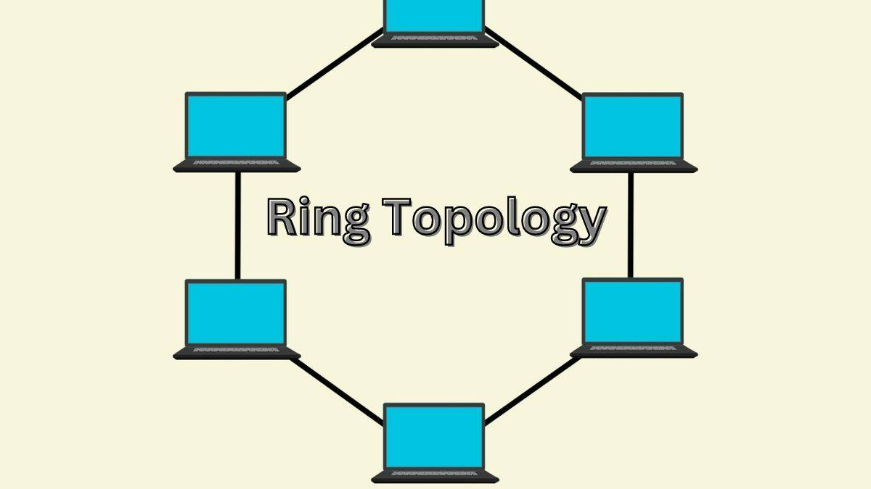

Mesh: Every device connects to every other device, like a spider web, very reliable as data can take many paths

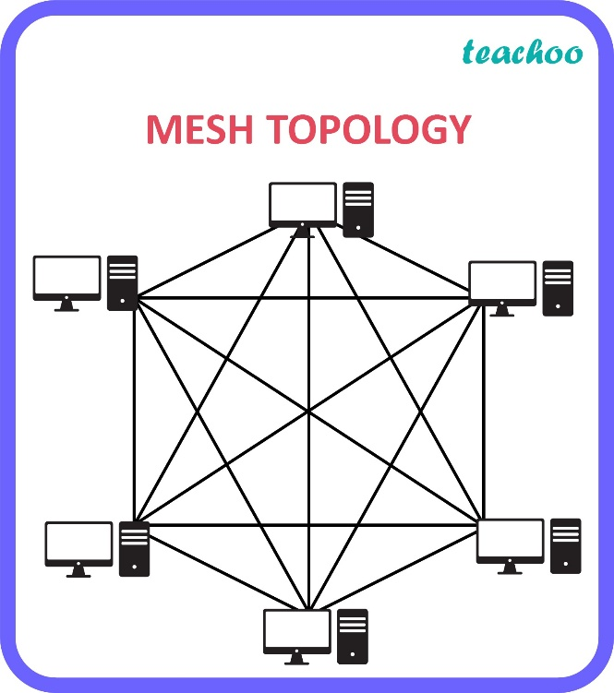

Tree: Branches out from main point like a tree, with smaller branches

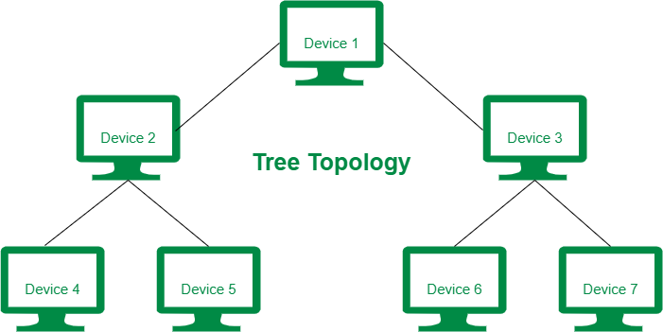

Hybrid: Mix of different types, like combining ring or tree, used when one type isn’t enough for all needs

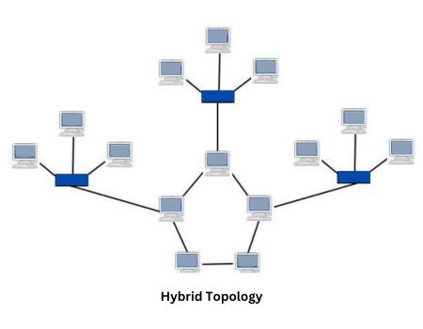

What is OSI Model?

* Application Layer: what user actually see and use, Ex: Email, browser.
* Presentation Layer: Translate data into usable format, handles data encryption and compression.
* Session Layer: controls conversations between computers, starts and stop connections.

* Transport Layer: Makes sure data arrives completely and in order handles errors and resends lost data
* Network Layer: Finds best path for data to travel, handles addressing (like IP)
* Data Link Layer: Moves data between network devices, checks for errors in transmission
* Physical Layer: The actual wires and hardware, sends raw data as electrical signals