Task – 5

Plz check the working directory (Hint : pwd)

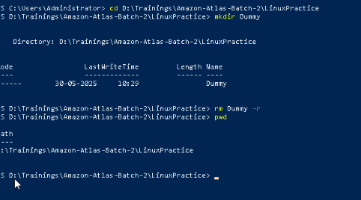

Task -6

How do you check all the files and directories in the directory you are in?

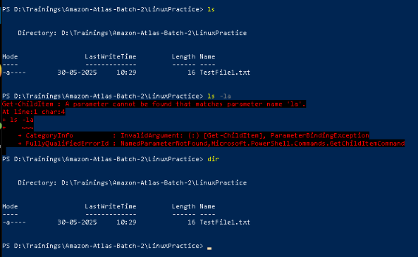

Task 7

Create five files named TestFile2.txt.. TestFile3.txt… and so on till TestFile6.txt

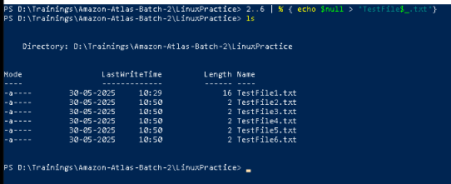

Task – 8

Copy all files from Dir 1 ti Dir 2

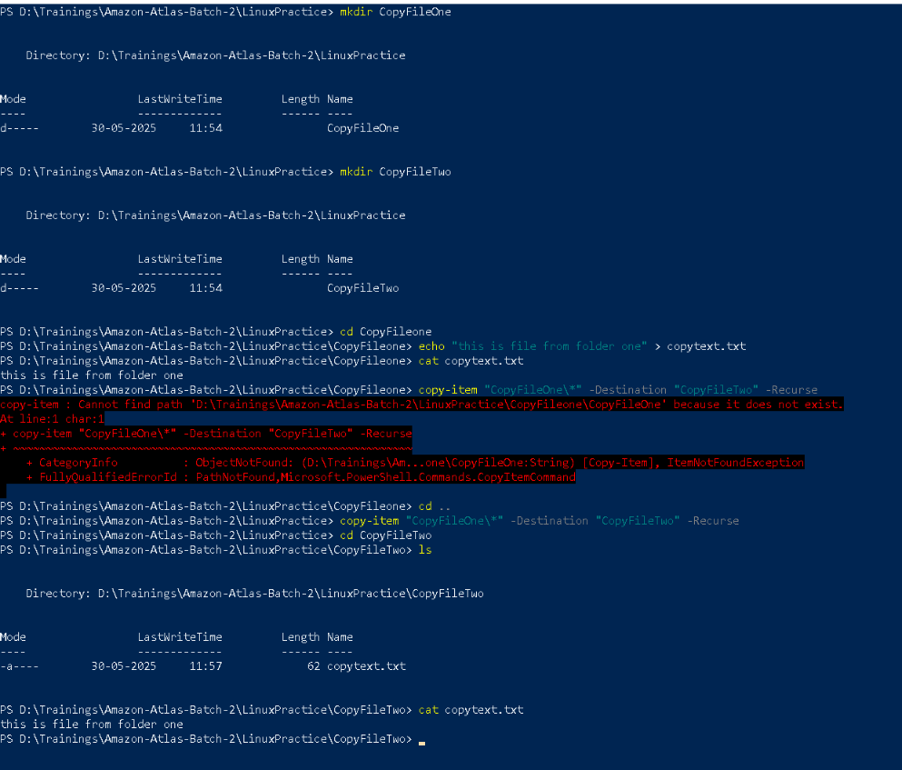

Task – 9

Move all files from Dir 2 to Dir 3 (finally ur Dir 2 should be empty)

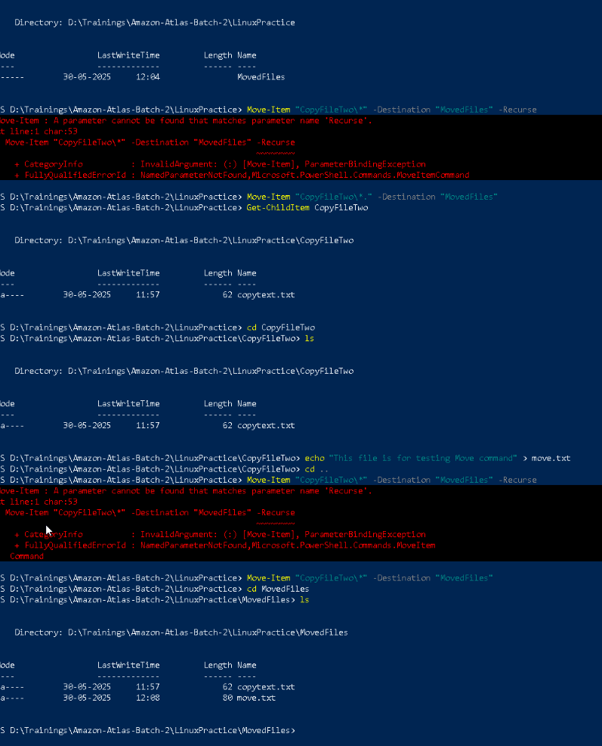

Task – 10

Can you plz show me the diff between **rm** and **rmdir** commands with screen shots ?

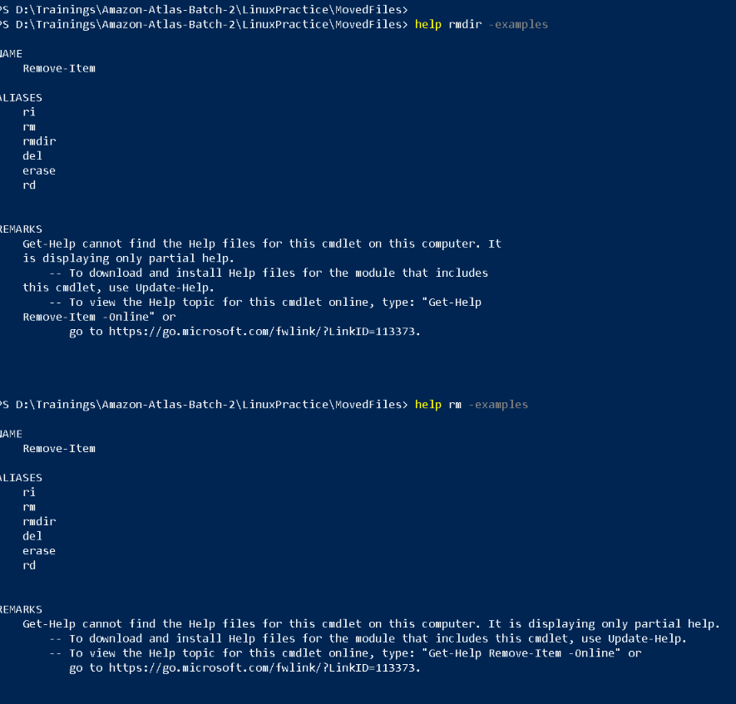

Task – 11

Now use specifically use cat command to create a file

And add the dummy text of 2 to 3 paragraphs from the above link Lorem Ipsum.

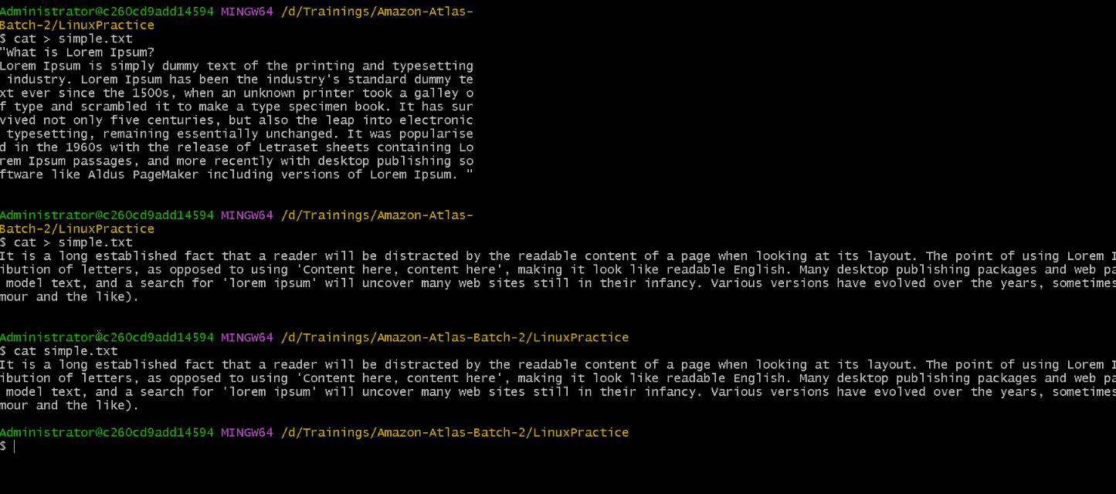

Task-12

How to get only the top part of your file..

Hint: use head

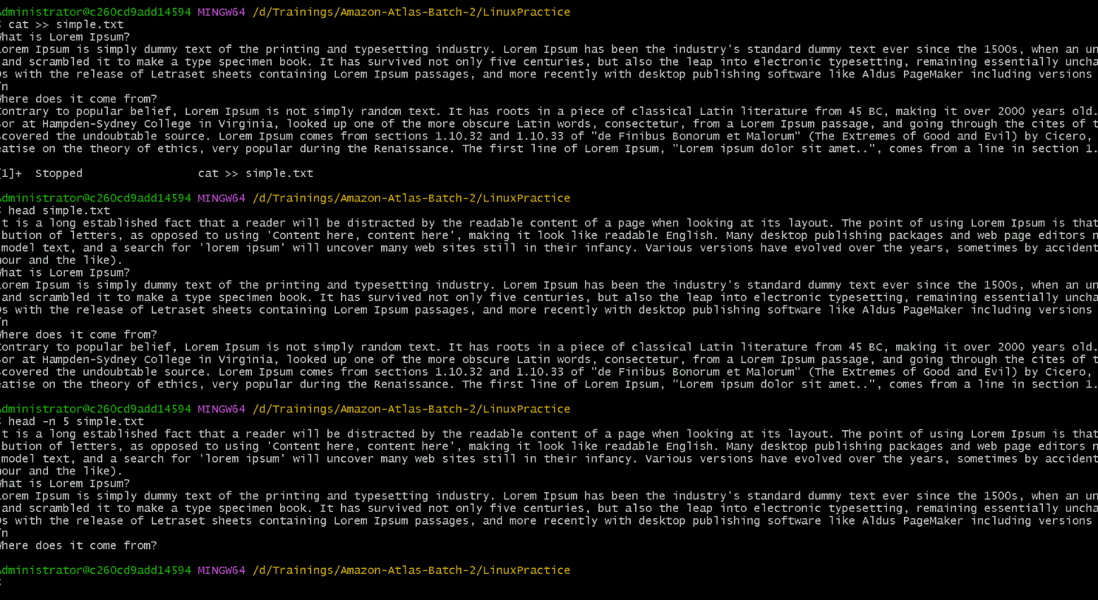

Task 13

How to get only the last part of your file

Hint: use tail

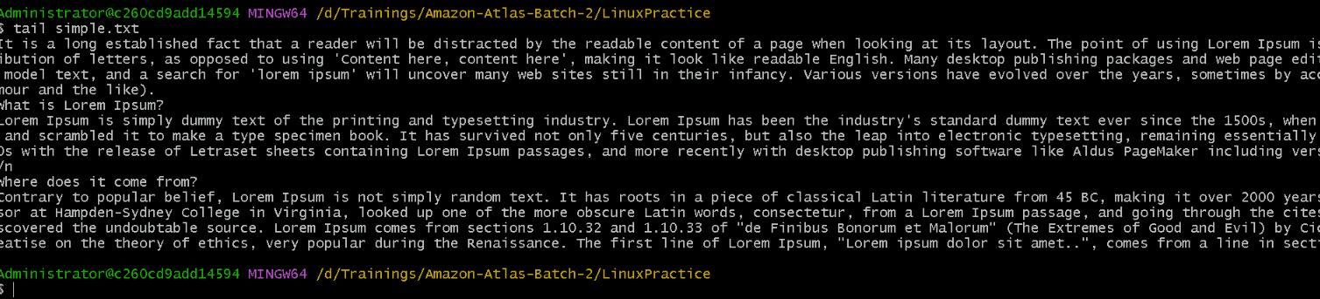

Task 14

Plz add dummy text of 5 to 6 pages in to the same file

And

Now show the file in page by page

Hint : use less command

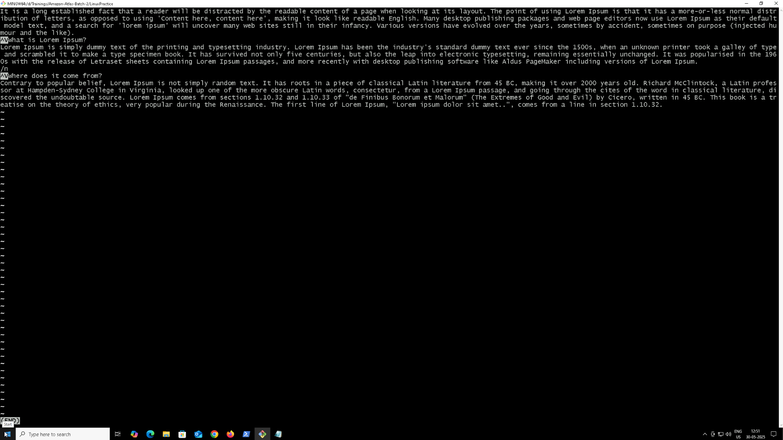

Task -15

Use more command on the above file and find out the diff between less command and more command.

More command not working

Task -16

Can you use echo command with -e and see the diff.. Also take a ss and paste .

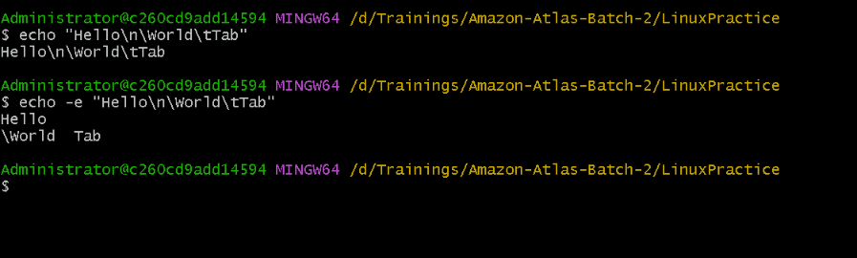

Task 17

What is diff between ls and ls -l command .. ss plz

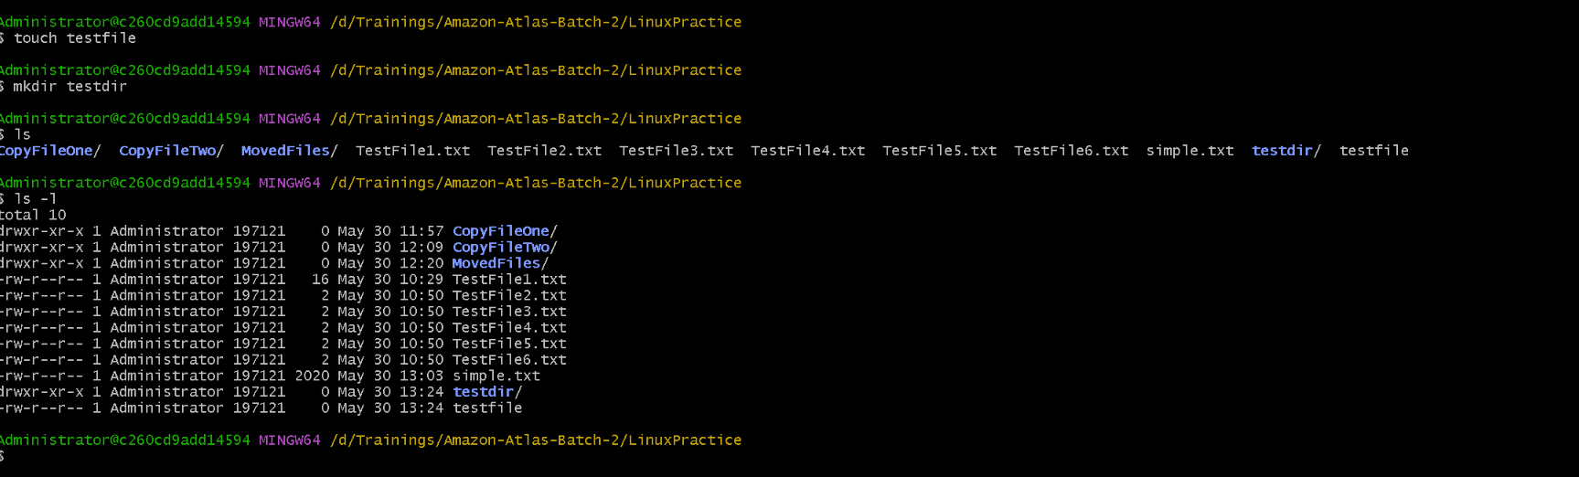

Task 18

Create  a file using **touch** command , **cat** command and **echo** command and take ss (screen shot)..

Also write the difference between touch , cat and echo commands.

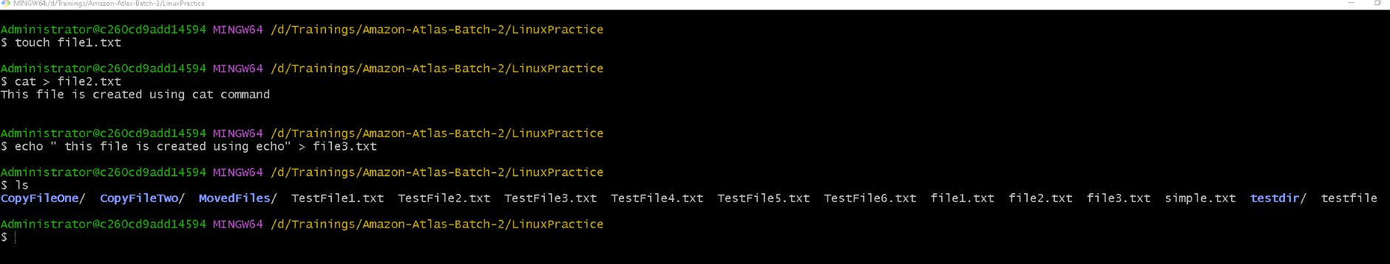

- Touch: For empty files or timestamp updates

- Cat: For interactive, multi-line content

- Echo: For quick, single-line or scripted content creation

Task – 19

Can you guys try to display the calendar by using a command..

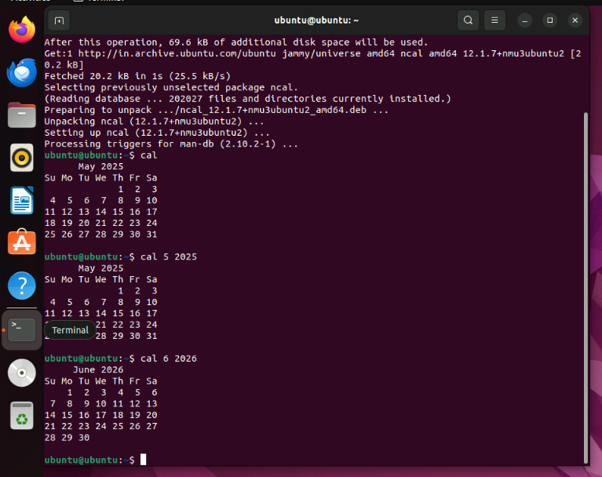

Task 20

Can you go back to 1 directory .. at a time  whats the command

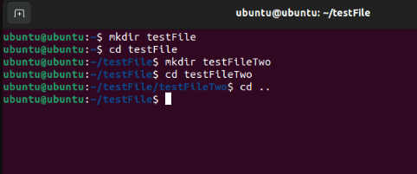

Task 21

How to know whose user u are working on ?

Hint: use whoami command

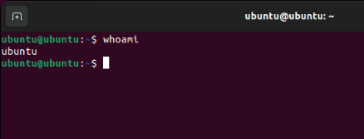

Task 22

Try to find out who is peeping into your system..

Hint: Use users, who and w commands with ss

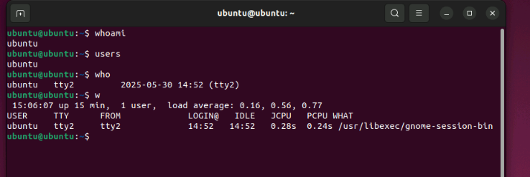

Task 23

Can you guys try to check how much disk space is consumed..

Hint : use df -h

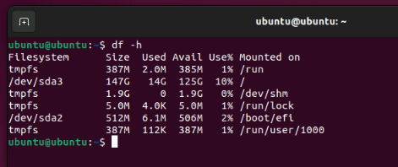

Task 24:

In the **ls -l** listing example, every file line begins with a **d**, **-**, or **l**. These characters indicate the type of the file that's listed.

Can you plz try using the below commands

|  |  |
| --- | --- |
| **Prefix** | **Description** |
| **-** | **Regular file**, such as an ASCII text file, binary executable, or hard link. |
| **b** | **Block special file**. Block input/output device file such as a physical hard drive. |
| **c** | **Character special file**. Raw input/output device file such as a physical hard drive. |
| **d** | **Directory** which contains a listing of other files and directories. |
| **l** | **Symbolic link file**. Links on any regular file. |
| **p** | **Named pipe**. A mechanism for interprocess communications. |
| **s** | **Socket** which is used for interprocess communication. |

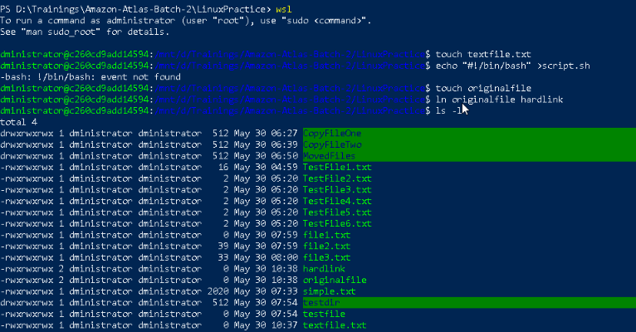

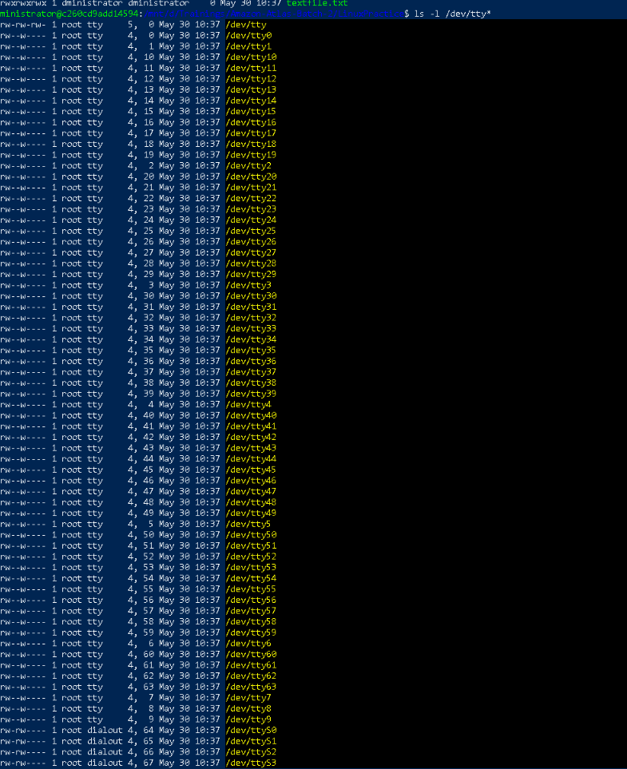

Task 25:

Find the list pf all files ending with .txt

Hint : use * in ls

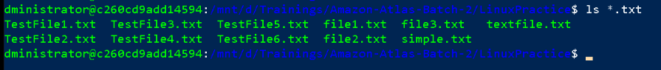

2 min

Task 26:

In Linux all the hidden files starts with . (period)

How to check all the hidden files in Linux..

Hint : use  ls -a

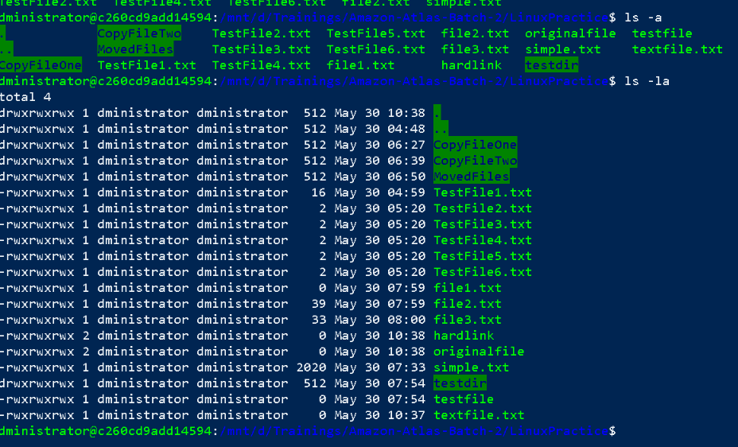

Task 27:

What is the difference between . and .. in linux

Line 1 line for each

. reference to the current directory.

.. reference to the parent directory

Task 28:

Can you create a file using vi editor and show the details in ss

Hint:

 Esc is for come out of the edit mode

Press two keys Shift &plus; ZZ together to come out of the file completely

* I - to insert

To move inside the file

* **l** key to move to the right side.
* **h** key to move to the left side.
* **k** key to move upside in the file.
* **j** key to move downside in the file.

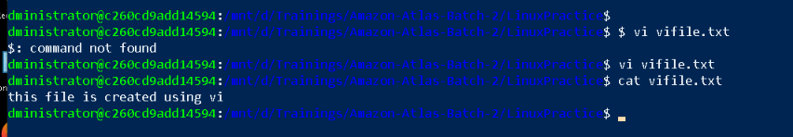

Task 29:

How to find the no of words in the file

Hint: use wc

Here is the detail of all the four columns of wc command  −

* **First Column** − Represents the total number of lines in the file.
* **Second Column** − Represents the total number of words in the file.
* **Third Column** − Represents the total number of bytes in the file. This is the actual size of the file.
* **Fourth Column** − Represents the file name.
* 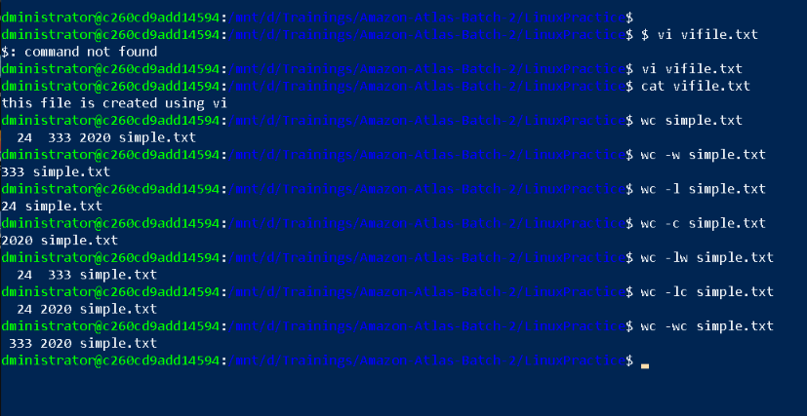

Task 30:

What is the use of cat -b myfilename.txt command?

Displays file contents with line numbers, but only numbers non blank lines

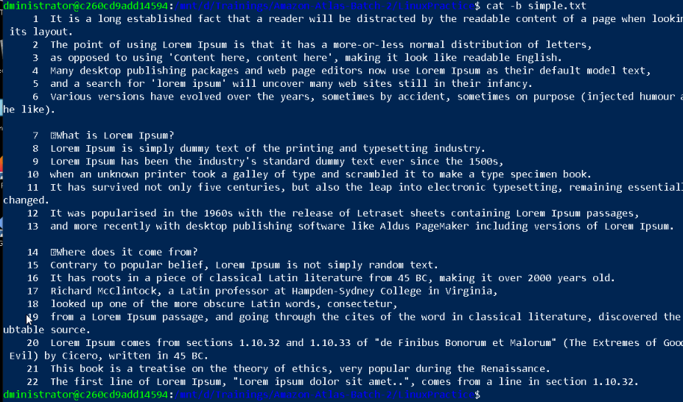

Task 31:

Can I use the wc with 2 or more files?

Wc file1 file2 file3

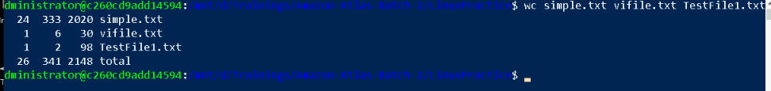

Linux directory structure: plz have a reading and try to remember..

|  |  |
| --- | --- |
| **Directory** | **Description** |
| **/bin** | important binary applications |
| **/boot** | boot configuration files, kernels, and other files needed at boot time. |
| **/dev** | System device files. |
| **/etc** | configuration files, startup scripts, etc. |
| **/home** | List of home directories for different users |
| **/lib** | system libraries, shared libraries |
| **/lost+found** | a lost+found system for files that exist under the root (/) directory |
| **/media** | automatically mounted (loaded) partitions on your hard drive and removable media such as CDs, digital cameras, etc. |
| **/mnt** | manually mounted filesystems on your hard drive |
| **/opt** | 3rd part applications to be installed |
| **/proc** | Maintains information about the state of the system, including currently running processes. |
| **/root** | root user's home directory. |
| **/sbin** | important system binaries |
| **/srv** | contain files that are served to other systems |
| **/sys** | system files |
| **/tmp** | temporary files |
| **/usr** | applications and files that are mostly available for all users to access |
| **/var** | variable files such as logs and databases |