**Task 01:**

Day-26\StrategyMethodDP_2

Output:

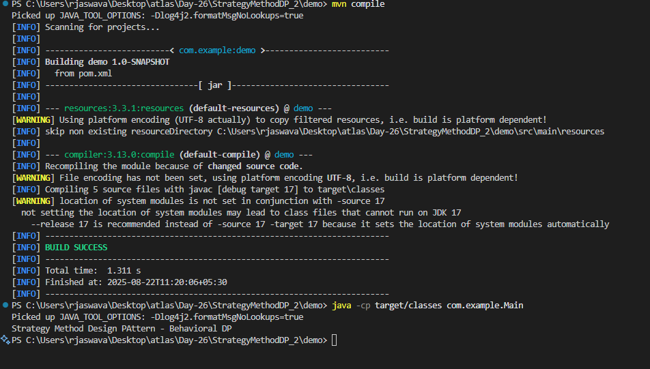

**Task 2**

Day-26\PubSubPattern_2\demo

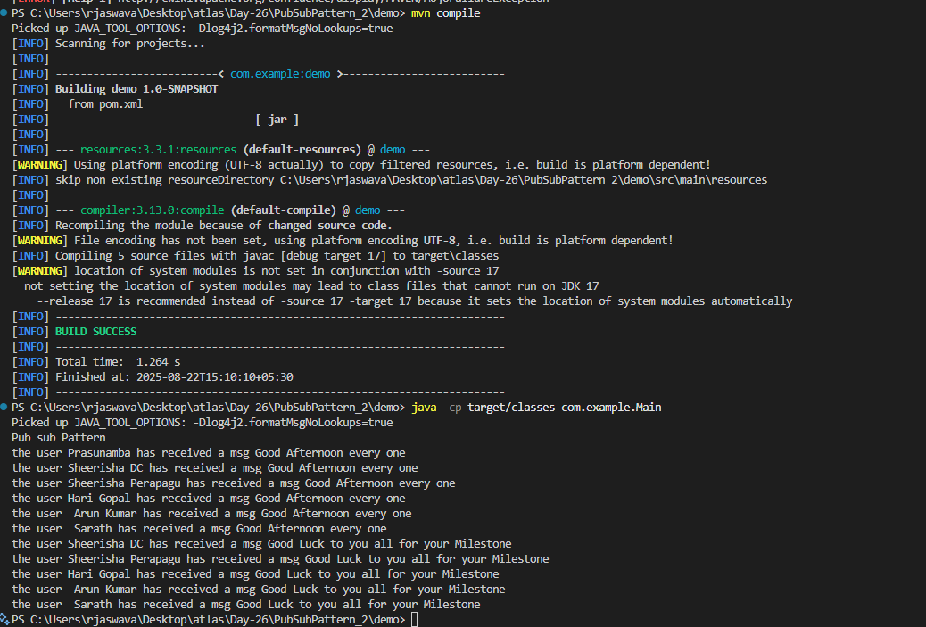

**Task 3 - Design Workflow:**

A design workflow is a structured sequence of steps and processes that designers follow to complete a project. It typically includes:

1. Research & Planning

2. Conceptualization

3. Design Creation

4. Review & Feedback

5. Revisions

6. Final Approval

7. Implementation.

**Task 4 - Persistent Objects:**

Persistent objects are things in computer programs that stay saved even when you turn off your computer. They "persist" or remain stored.

1. They stay saved

2. Don't disappear when program closes

3. Can be used again and again

4. Stored safely on your computer

Persistent objects are saved items that don't disappear - they stick around until you choose to delete them.

**Task 5:**

Which of the following components is not typically part of the Command pattern?

a) Invoker

b) Receiver

c) Abstract Factory

d) Command (interface/abstract class)

**Task 6:**

What role does the Invoker play in the Command pattern?

a) It knows how to perform the operations associated with a request.

b) It encapsulates the request as an object.

c) It asks the command to carry out the request.

d) It defines the interface for executing an operation.

**Task 7 :**  
A key benefit of using the Command pattern is its ability to support:  
a) Lazy initialization  
**b) Undo/Redo functionality**c) Singleton instance creation  
d) Compile-time polymorphism

**Task 8:**

In the Strategy pattern, what role does the "Context" play?

A. It defines the interface for the algorithms.

B. It implements a specific algorithm.

C. It maintains a reference to a Strategy object and delegates the task to it.

D. It creates the Concrete Strategy objects.

Task 9:

In which of the following mechanisms, types of all variables and expressions are fixed at compilation time.

a) Strong Typing

b) Weak Typing

c) Static Binding/ early binding

d) Dynamic Binding/ late binding

Task 10:

In which pattern does a class represent the functionality of another class, providing a simplified interface to a complex subsystem?

a) Decorator Pattern

b) Facade Pattern

c) Proxy Pattern

d) Composite Pattern

Task 11:

 Which of the following statements about Persistence is correct?

a) It is the enforcement of the class of an object, such that objects of different types may not be interchanged, or at the most they may be interchanged only in very restricted ways.

b) It is the property of an object through which its existence transcends time and/or space.

c) It is the property that distinguishes an active object from one that is not active.

d) All of the mentioned

Task 12:

 What is that concept in type theory in which a single name may denote objects of many different classes that are related by some common super class referred to ______

a) Monomorphism

b) Type Checking

c) Polymorphism

d) Generalization

Task 13:

Which of the following patterns is used to create a single instance of a class and provide a global point of access to it?

a) Factory Pattern

b) Singleton Pattern

c) Builder Pattern

d) Prototype Pattern

Task 14:

 The Adapter pattern is a type of ______ pattern.

a) Creational

b) Structural

c) Behavioral

d) Concurrency

Task 15:

Which design pattern defines a one-to-many dependency between objects so that when one object changes state, all its dependents are notified and updated automatically?

a) Strategy Pattern

b) Command Pattern

c) Observer Pattern

d) Mediator Pattern

Task 16:

The Model-View-Controller (MVC) is an example of a ______ pattern.

a) Creational

b) Structural

c) Behavioral

d) Architectural