TEMP CRED---

Task 01:

Create a table using AWS Management Console

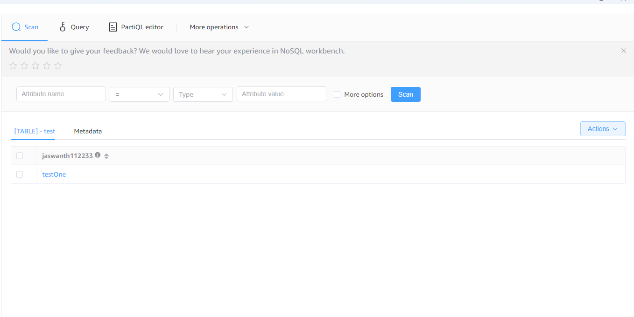

Task 02:

Use all the CRUD operations using AWS Management Console.

