Task001:

Wap to display greetings

public class task001 {

    public static void main(String[] args) {

        System.out.println("Hello! Welcome to Java Programming");

    }

}

output

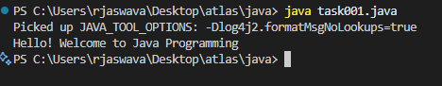

Task002:

Wap to create a add method and call the method 3 times ..

Hint in method add declare variables and display them

public class task002 {

    public static int add(int num1, int num2) {

        return num1 + num2;

    }

    public static void main(String[] args) {

        int result1 = add(5, 10);

        System.out.println(result1);

        int result2 = add(20, 30);

        System.out.println(result2);

        int result3 = add(100, 200);

        System.out.println(result3);

    }

}

Output

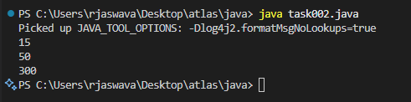

Task003

 Write a Program in Java to Add two Numbers.

Input: 2 3

Output: 5

public class task003 {

    public static void main(String[] args) {

        int num1 = 2;

        int num2 = 3;

        int sum = num1 + num2;

        System.out.println(sum);

    }

}

Output:

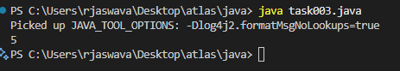

Task004

Write a Program to Swap Two Numbers

Input: a=2  b=5

Output: a=5  b=2

public class task004 {

    public static void main(String[] args) {

        int a = 2;

        int b = 5;

    int c = a;

     a = b;

     b = c;

    System.out.println(a);

    System.out.println(b);

    }

}

Output

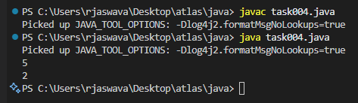

Task005

Create a code in which you have 4 methods add, subtract, multiply and divide (return type int) with a main [method to](http://method..to) call all the other methods

Out put:

Main started

Sum of 2 numbers is …..

Diff of 2 numbers is —-

Product of 2 numbers ….

Division of 2 numbers is ….

Main ended

public class task005 {

   int add(int num1, int num2) {

        return num1 + num2;

    }

    int subtract(int num1, int num2) {

        return num1 - num2;

    }

    int multiply(int num1, int num2) {

        return num1 * num2;

    }

    int divide(int num1, int num2) {

        return num1 / num2;

    }

    public static void main(String[] args) {

        int num1 = 10;

        int num2 = 20;

        int adding = (num1 + num2);

        int subtract = (num1 - num2);

        int multiply = (num1 * num2);

        int divide = (num1 / num2);

        System.out.println(adding);

        System.out.println(subtract);

        System.out.println(multiply);

        System.out.println(divide);

    }

}

Output

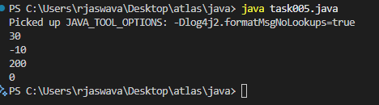

Task006

Write a program to check if a is greater or b.. Use ternary op

public class task006 {

    public static void main(String[] args) {

        int a = 10;

        int b = 7;

        System.out.println("a = " + a);

        System.out.println("b = " + b);

        String result = (a > b) ? "a is greater than b" : "b is greater than or equal to a";

        System.out.println(result);

    }

}

Output

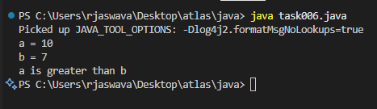

Task007

Write a program to take input from the user and display it to the user

Input:

Id : Prasunamba

Pwd: 123456789

Output:

Hi ,

Your login id is Prasunamba

And your pwd is *********

HInt :

For scanner … import java.util.scanner;

Scanner sc = new Scanner([System.in](http://system.in));

Id = sc.nexLine();

import java.util.Scanner;

public class task007 {

    public static void main(String[] args) {

        Scanner sc = new Scanner(System.in);

        System.out.print("Id : ");

        String id = sc.nextLine();

        System.out.print("Pwd: ");

        String password = sc.nextLine();

        System.out.println("Hi");

        System.out.println("Your login id is " + id);

        System.out.println("And your pwd is " + "*".repeat(password.length()));

        sc.close();

    }

}

Output

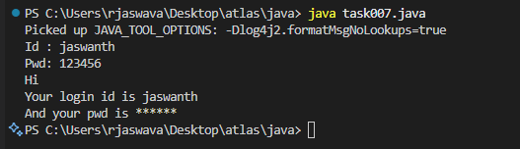

Task008

Write a program to create a class named Customer

Call the customer class in Task007 class using an object

Hint

In the main method

Class Customer{

  void accept(){

sysout(“accept customer called”);

}

Void display(){

sysout(“display customer called”);

}

}

Public class Test008{

psvm(String[] args){

Customer cobj = new Customer();

cobj.accept();

cobj.display();

}

}

class Customer {

    void accept() {

        System.out.println("accept customer called");

    }

    void display() {

        System.out.println("display customer called");

    }

}

public class task008 {

    public static void main(String[] args) {

        Customer cobj = new Customer();

        cobj.accept();

        cobj.display();

    }

}

Output

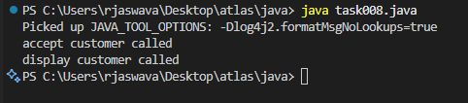

Task009:

Wap to check the greater of 2 numbers

Hint:

Use if else

If ( num1 > num2){

sout(“num1 is greater”);

}

Else {

sout(“num2 is greater”);

}

public class task009 {

    public static void main(String[] args) {

        int num1 = 20;

        int num2 = 30;

            if (num1 > num2) {

            System.out.println("num1 is greater");

        } else {

            System.out.println("num2 is greater");

        }

    }

}

Output

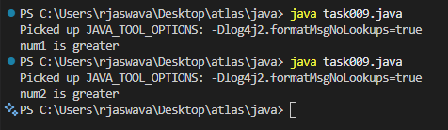

task 010

Wap to check greater of 3 numbers

Hint 👍

Use elseif

public class task010 {

    public static void main(String[] args) {

        int num1 = 30;

        int num2 = 20;

        int num3 = 10;

        if (num1 > num2 && num1 > num3) {

            System.out.println("num1 is the greater");

        }

        else if (num2 > num1 && num2 > num3) {

            System.out.println("num2 is the greater");

        }

        else if (num3 > num1 && num3 > num2) {

            System.out.println("num3 is the greater");

        }

        else {

            System.out.println("Some numbers are equal");

        }

    }

}

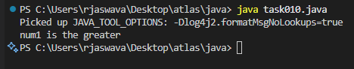

Task11:

Wap to check if  week days

1  ===> sunday

2 ===> monday

So on

8 and above ===> invalid input

Hint : use Switch case

public class task011 {

    public static void main(String[] args) {

        int day = 3;

        switch(day) {

            case 1:

                System.out.println("Sunday");

                break;

            case 2:

                System.out.println("Monday");

                break;

            case 3:

                System.out.println("Tuesday");

                break;

            case 4:

                System.out.println("Wednesday");

                break;

            case 5:

                System.out.println("Thursday");

                break;

            case 6:

                System.out.println("Friday");

                break;

            case 7:

                System.out.println("Saturday");

                break;

            default:

                System.out.println("Invalid input");

        }

    }

}

Output

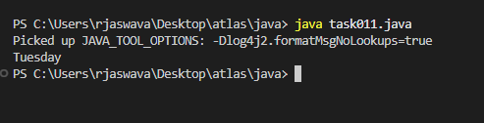

Task 012

Wap to check loginid and password validation

Hint use while loop

Scanner sc = new Scanner(System.in);

String loginid = “Prasunamba”

String pwd = “12345867”

Int Count = 0;

While (loginid == “Prasunamba” && pwd == “12345867”){

sout(“ you have logged in for  ”+ count++ +” times”);

sout(“enter ur login id and password”);

loginid = sc.NextLine();

pwd = sc.NextLine();

}

Do while also use 👍

Scanner sc = new Scanner(System.in);

String loginid = “Prasunamba”

String pwd = “12345867”

Int Count = 0;

do{

sout(“ you have logged in for  ”+ count++ +” times”);

sout(“enter ur login id and password”);

loginid = sc.NextLine();

pwd = sc.NextLine();

}While (loginid == “Prasunamba” && pwd == “12345867”);

sc.close();

While and do while loops - indefinite loops

For loop is definite…

For (initialization exp; condition exp; incre or decre exp)

import java.util.Scanner;

public class task012 {

    //while loop

    public static void whileLoopLogin(Scanner sc) {

        String loginid = "";

        String pwd = "";

        while (!loginid.equals("jaswanth") || !pwd.equals("password123")) {

            System.out.println("Enter your login id:");

            loginid = sc.nextLine();

            System.out.println("Enter your password:");

            pwd = sc.nextLine();

            if (loginid.equals("jaswanth") && pwd.equals("password123")) {

                System.out.println("While Loop - Login Successful!");

                break;

            } else {

                System.out.println("Invalid credentials! Try again.");

            }

        }

    }

    //do-while loop

    public static void doWhileLoopLogin(Scanner sc) {

        String loginid = "";

        String pwd = "";

        int count = 0;

        do {

            System.out.println("Enter your login id:");

            loginid = sc.nextLine();

            System.out.println("Enter your password:");

            pwd = sc.nextLine();

            if (loginid.equals("jaswanth") && pwd.equals("password123")) {

                System.out.println("Do-While Loop - Login Successful!");

            } else {

                System.out.println("Invalid credentials! Try again.");

            }

        } while (!loginid.equals("jaswanth") || !pwd.equals("password123"));

    }

    public static void main(String[] args) {

        Scanner sc = new Scanner(System.in);

        whileLoopLogin(sc);

        doWhileLoopLogin(sc);

        sc.close();

    }

}

Output

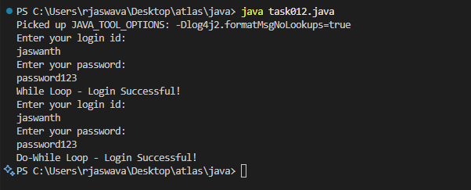

Task 13:

Wap to display numbers from 10 to 1 .. skip 7 and 5.

for(int i= 10; i >0; i–){

If ( i == 5 || i == 7){

Continue;

sout(i);

}

public class task013 {

    public static void main(String[] args) {

        for (int i = 10; i > 0; i--) {

            if (i == 5 || i == 7) {

                continue;

            }

            System.out.println(i);

        }

    }

}

Output

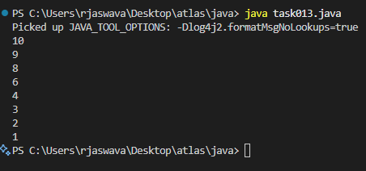

Task 014:

Arrays:

Try the below code and display the output…

Now play with it try to access arr of 5th index and see the output…and try to access arr of -1 index and see the output..

package Arrays;

public class Demo01 {

public static void main(String[] args) {

// TODO Auto-generated method stub

char[] arr = {'a','e','i','o','u'};

System.out.println(arr);

String[] names = {"Meena", "Tina", "Veena", "heena"};

System.out.println(names[0]);

names[1]= "Reena";

System.out.println(names[1]);

System.out.println(names.length);

System.out.println(names[4]);

//Exception in thread "main" java.lang.ArrayIndexOutOfBoundsException

}

}

public class task014 {

    public static void main(String[] args) {

        char[] arr = {'a','e','i','o','u'};

        System.out.println(arr);

        String[] names = {"Meena", "Tina", "Veena", "heena"};

        System.out.println(names[0]);

        names[1] = "Reena";

        System.out.println(names[1]);

        System.out.println(names.length);

        System.out.println(names[4]);

    }

}

Output

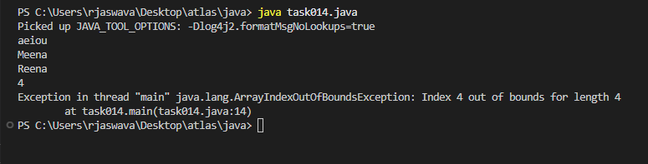

Task 015:

String – non primitive data gtype —> collection of characters or any value within “ ”

– immutable ⇒ cannot be changed

String Name = “Prasunamba is a trainer”;

Name = “Hello”;

Variables are mutable ⇒ which can be chaged

package StringHandling;

public class Demo01 {

public static void main(String[] args) {

// TODO Auto-generated method stub

String str1 = "Java Strings "; // string Literal

String str2 = new String(str1); // obj of the string - new keyword

String str3 = new String("are easy to learn ");

char ch[] = {'S', 't', 'r' ,'i', 'n', 'g'};

String str4 = new String(ch);

System.out.println(str1 + "\n" + str2 + "\n" +str3 + "\n" +str4);

}

}

public class task015 {

    public static void main(String[] args) {

        String str1 = "Java Strings "; // string Literal

        String str2 = new String(str1); // obj of the string - new keyword

        String str3 = new String("are easy to learn ");

        char ch[] = {'S', 't', 'r' ,'i', 'n', 'g'};

        String str4 = new String(ch);

        System.out.println(str1 + "\n" + str2 + "\n" +str3 + "\n" +str4);

    }

}

Output

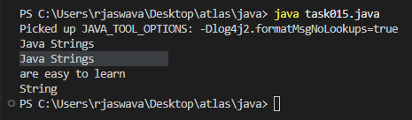

Task 016

Enums or Enumerations   – part of  collection framework

What is the output of the below code snippet

package Enumerations;

enum color{

red, blue, green, yellow

}

public class Demo01 {

public static void main(String[] args) {

color c1 = color.yellow;

System.out.println(c1);

}

}

package Enumerations;

enum Weekdays{

Sunday , Monday , Tuesday

}

public class Demo01 {

public static void main(String[] args) {

Weekdays c1 = Weekdays.Tuesday;

System.out.println(c1);

}

}

enum Color {

    RED, BLUE, GREEN, YELLOW

}

enum Weekdays {

    SUNDAY, MONDAY, TUESDAY, WEDNESDAY, THURSDAY, FRIDAY, SATURDAY

}

public class task016 {

    public static void main(String[] args) {

        for (Color color : Color.values()) {

            System.out.println(color);

        }

        for (Weekdays day : Weekdays.values()) {

            System.out.println(day);

        }

    }

}

Output

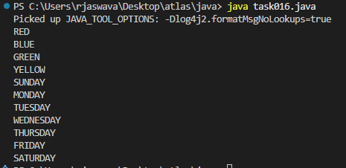

Task 017:

Getter and setter

Create a program name Person.java

public class Person {

   private String name;

   // Getter

   public String getName() {

     return name;

   }

   // Setter

   public void setName(String newName) {

     this.name = newName;

   }

}

Create another program named Task017.java

public class Task017{

  public static void main(String[] args) {

    Person myObj = new Person();

    myObj.name = "John";

    System.out.println(myObj.name);

  }

}

—----------------------------------what is the reason for the error —---------------explain

public class Person {

   private String name;

   // Getter

   public String getName() {

     return name;

   }

   // Setter

   public void setName(String newName) {

     this.name = newName;

   }

}

public class task017 {

    public static void main(String[] args) {

    Person myObj = new Person();

    myObj.setName("John");

    System.out.println(myObj.getName());

  }

}

Error:

The name filed is private, which means it cannot be accessed directly from outside the person class.

Task017.java is trying to access the private field directly instead of using the public getter and setter methods.

Output

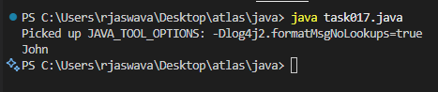

Task 018

Now create one more program named Task018.java

public class Main {

  public static void main(String[] args) {

    Person myObj = new Person();

    myObj.setName("John");

    System.out.println(myObj.getName());

  }

}

Now —--------------think what is the output of the above code—--------------

public class Person {

   private String name;

   // Getter

   public String getName() {

     return name;

   }

   // Setter

   public void setName(String newName) {

     this.name = newName;

   }

}

public class task018 {

    public static void main(String[] args) {

    Person myObj = new Person();

    myObj.setName("John");

    System.out.println(myObj.getName());

  }

}

Output

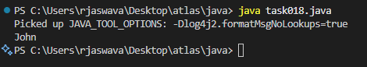

Task016_1.java

Enums    – understand the code

//Attaching Multiple values

public enum Element {

    H("Hydrogen", 1, 1.008f),

    HE("Helium", 2, 4.0026f),

    // ...

    NE("Neon", 10, 20.180f);

    private static final Map<String, Element> BY_LABEL = new HashMap<>();

    private static final Map<Integer, Element> BY_ATOMIC_NUMBER = new HashMap<>();

    private static final Map<Float, Element> BY_ATOMIC_WEIGHT = new HashMap<>();

    static {

        for (Element e : values()) {    //for each loop

            BY_LABEL.put(e.label, e);

            BY_ATOMIC_NUMBER.put(e.atomicNumber, e);

            BY_ATOMIC_WEIGHT.put(e.atomicWeight, e);

        }

    }

    public final String label;

    public final int atomicNumber;

    public final float atomicWeight;

    private Element(String label, int atomicNumber, float atomicWeight) {

        this.label = label;

        this.atomicNumber = atomicNumber;

        this.atomicWeight = atomicWeight;

    }

    public static Element valueOfLabel(String label) {

        return BY_LABEL.get(label);

    }

    public static Element valueOfAtomicNumber(int number) {

        return BY_ATOMIC_NUMBER.get(number);

    }

    public static Element valueOfAtomicWeight(float weight) {

        return BY_ATOMIC_WEIGHT.get(weight);

    }

}

Task019.java

Wap to display the content of the above enum from the class Task016_1 in this program.. (main  needs to be added)

import java.util.Map;

import java.util.HashMap;

public enum Element {

    H("Hydrogen", 1, 1.008f),

    HE("Helium", 2, 4.0026f),

    NE("Neon", 10, 20.180f);

    private static final Map<String, Element> BY_LABEL = new HashMap<>();

    private static final Map<Integer, Element> BY_ATOMIC_NUMBER = new HashMap<>();

    private static final Map<Float, Element> BY_ATOMIC_WEIGHT = new HashMap<>();

    static {

        for (Element e : values()) {

            BY_LABEL.put(e.label, e);

            BY_ATOMIC_NUMBER.put(e.atomicNumber, e);

            BY_ATOMIC_WEIGHT.put(e.atomicWeight, e);

        }

    }

    public final String label;

    public final int atomicNumber;

    public final float atomicWeight;

    private Element(String label, int atomicNumber, float atomicWeight) {

        this.label = label;

        this.atomicNumber = atomicNumber;

        this.atomicWeight = atomicWeight;

    }

    public static Element valueOfLabel(String label) {

        return BY_LABEL.get(label);

    }

    public static Element valueOfAtomicNumber(int number) {

        return BY_ATOMIC_NUMBER.get(number);

    }

    public static Element valueOfAtomicWeight(float weight) {

        return BY_ATOMIC_WEIGHT.get(weight);

    }

}

public class task019 {

    public static void main(String[] args) {

        for (Element element : Element.values()) {

            System.out.println("Element: " + element);

            System.out.println("  Label: " + element.label);

            System.out.println("  Atomic Number: " + element.atomicNumber);

            System.out.println("  Atomic Weight: " + element.atomicWeight);

            System.out.println();

        }

        Element hydrogen = Element.valueOfLabel("Hydrogen");

        System.out.println("Found: " + hydrogen + " - " + hydrogen.label);

        System.out.println("Hydrogen: " + Element.H.label);

        System.out.println("Helium: " + Element.HE.label);

        System.out.println("Neon: " + Element.NE.label);

    }

}

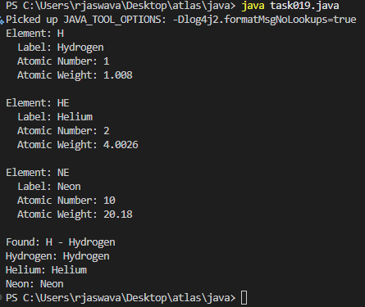

Task 020:

Create an array of your name

Hint : use

Char[] Name = {‘P’, “r’, ….}; // initializing an array

sout(Name);

Int n = Name.length; // size of your name

sout(“there are “+ n +”letters in my name”);

Use for loop to display each letter..

HInt: use ghe below code snippet…

// traversing array

        for (int i = 0; i < n; i++)

            System.out.print(Name[i] + " ");

public class task020 {

    public static void main(String[] args) {

        char[] Name = {'J', 'A', 'S', 'W', 'A', 'N', 'T', 'H'};

        System.out.println("My name array: ");

        System.out.println(Name);

        int n = Name.length;

        System.out.println("There are " + n + " letters in my name");

        System.out.println("Each letter in my name:");

        for (int i = 0; i < n; i++) {

            System.out.print(Name[i] + " ");

        }

        System.out.println();

    }

}

Output

