Task 1:

RegEX Symbols in Linux

List them down with description

Regular expression is a specialized sequence of characters that define search pattern for matching, finding, and manipulating text within the strings.

Quantifiers:

* ? Zero or one
* {n} n times
* {n,} n or more times
* {n, m} between n and m times

Character Classes:

* [] set of characters
* [^] Negated Set
* \d Digit (same as [0-9])
* \w word character
* \s space

Anchors

* ^ starts the line
* $ End of line
* \b word boundary

Groups

* () capturing group
* (?:) non-capturing group

Look:

* (?=) positive lookahead
* (?!) negative lookahead
* (?<=) positive lookbehind
* (?<!) Negative lookbehind

Other

* | alternation (or)
* \ Escape character

Task 2:

If you are aware of Linux OS. can you tell me the feature of Linux?

Open source: anyone can use, change and share it freely

Security: Just like android phone ask permission for apps, every user get their own private space built in protection against viruses

Stability: Runs for months without needing restart, doesn’t slow down over time like other systems

Modularity: Install Only what you need

Package Management: Install software easily through software center, all software comes from safe sources

Network: Easy to connect to internet and Wi-Fi

Hardware: Works an old and new computer, runs well even on basic systems

Cost: No need to buy expensive software

Task 3:

What is Kernel? can you explain about it in your words.

Kernel is the (heart and brain) of Linux operating system, it controls all hardware like keyboard mouse screen) and software (programs) communication. It manages computer resources like memory (RAM) and processing power (CPU). It handles security by deciding which program can access what resources. Without kernel computer cannot run any programs or use any hardware.

Task 4:

BASH in Linux full form and Explanation.

BASH stands for Bourne Again Shell is the basic language we use to talk to the Linux commands. It is like a translator that helps us give commands to the computer in a way it understands. When we want to create folders, copy files, or do anything on Linux, we use BASH to tell the computer what to do it.

Task 5:

Now that you know Linux is also an Operating System like Windows.

What do you think is the difference between Linux and Windows?

Windows costs money to buy, but Linux is free for everyone to use, windows is easy to use with its click and point style, while Linux need some command typing, windows comes with everything ready to use, but Linux lets you customize everything your way, windows gets viruses easily, but Linux is much safer from viruses, windows works mainly with paid software, while Linux has lots free software options.

Task 6:

What are the basic components of Linux? Describe each in detail with diagrams.

Linux has five main components that work as one system. The Hardware layer connects all physical computer parts. The kernel is the core component that manages hardware resources and runs basic system operations. The Shell is the command interface that takes user inputs and passes them to the kernel. The file System manages how data is stored and retrieved on the computer. Application are the software programs that users run for different tasks on Linux.

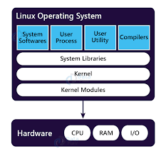

Task 7:

Is it legal to edit Kernel? when do you think we have to in case?

Yes, it is legal to edit the Linux Kernel because Linux is free and open source for every one to modify. We might need to edit the kernel when our computer hardware isn’t working properly. When we need a better performance, or we want to add new features that aren’t available. And Better to know, one small mistake can crash the whole system.

Task 8:

What is LILO? Explain

LILO Linux Loader is a boot loader program that starts up when we turn on our computer. It's like a startup manager that helps our computer choose which operating system to load, especially when we have both Linux and Windows installed. LILO stays in a special part of our computer and shows us a menu to select which system we want to use. Though many computers now use newer boot loaders like GRUB, LILO was one of the first boot loaders that made it possible to have multiple operating systems on one computer.

Task 9:

What is shell? How many shells are there and what are they? can you explain.

A shell is like a special program that helps us talk to our computer in Linux by typing commands. There are several main types of shells we commonly use:

Bourne Shell (sh) which was the first one, the Bourne Again Shell (BASH) which is the most popular and what we usually use in class, the C Shell (csh) which some programmers like, and the Korn Shell (ksh) which combines features of other shells. While there are more shells available, BASH is the one we mostly use because it's easy to understand and comes with most Linux systems.

Task 10:

What is swap space?

Swap space is an extra memory space on our computer's hard disk that Linux uses when our main memory (RAM) gets full. When we run too many programs and our RAM can't handle them all, Linux automatically moves some less-used data to this swap space to free up RAM for active programs. While swap space is slower than RAM, it helps prevent our computer from crashing when memory is low. It's like having an extra room to store things when our main room (RAM) gets too crowded.

Task 11:

What is Mount? how do you mount and unmount file system in Linux?

Mounting in Linux means connecting storage devices (like pendrives or hard disks) to our system so we can use them. To mount a device, we use the 'mount' command followed by the device name and where we want to access it. When we're done using the device, we use the 'umount' command to safely disconnect it. This is similar to how we safely remove USB drives in Windows, but in Linux, we need to use these commands. The mount command tells Linux where to find the files on these devices and how to access them.

Task 12:

What is chmod command? how to use it?

chmod even stand for "change mode, It's about changing permissions.

In Unix-like systems, every file and directory has permissions, These permissions control who can do what with the file.

There are three types of permissions:

- Read (r)

- Write (w)

- Execute (x)

And three categories of users:

- Owner (u)

- Group (g)

- Others (o)

the octal notation:

- Read = 4

- Write = 2

- Execute = 1

- 7 means full permission (4+2+1)

- 6 means read and write (4+2)

- 5 means read and execute (4+1)

- 4 means read only

chmod 755 file.txt would mean:

- Owner: 7 (rwx)

- Group: 5 (r-x)

- Others: 5 (r-x)

- chmod 755 file.txt (rwx for owner, rx for group and others)

- chmod u+x file.txt (adds execute permission for owner)

- chmod a+r file.txt (adds read permission for all

Task 13:

Can you add a new user account? Crate a new user in different ways and paste ss

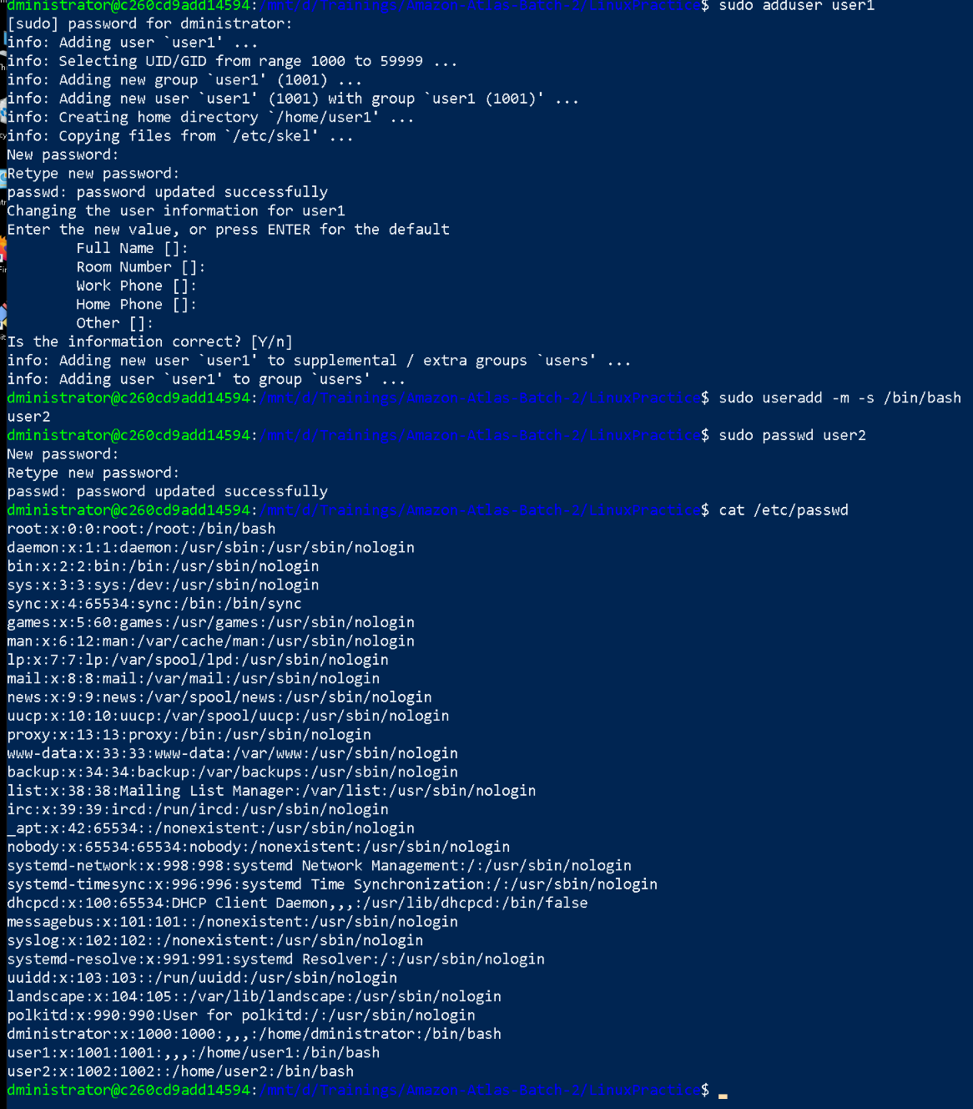

sudo useradd -m -s /bin/bash username

sudo passwd username

-m : creates home directory

-s /bin/bash: sets default shell to bash

Task 14:

Can you change the password of a user?

How do you do that? Plz share ss

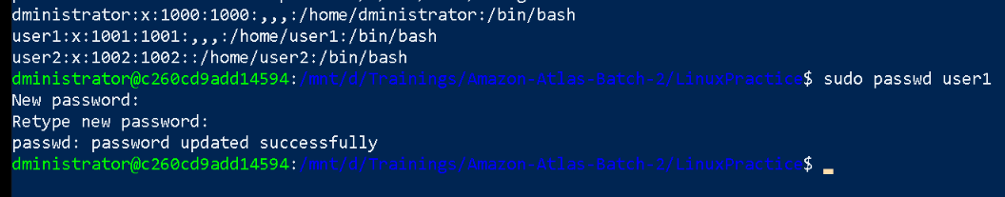

Task 15:

What is diff between Process and Thread?

Process:

A process is a program in execution that contains the program code, current activity, and a complete set of system resources. Each process has its own memory space called address space, which contains the executable code, data, heap, and stack. Processes are isolated from each other, meaning one process cannot directly access another process's memory. The operating system provides each process with its own Process Control Block (PCB) that tracks process state, program counter, CPU registers, and memory management information. Creating a new process requires allocating new memory space and resources, making it a heavier operation.

Thread:

A thread is the smallest unit of execution within a process, sharing the same memory space and resources with other threads in the same process. Multiple threads within a process share the code section, data section, and system resources, but each thread has its own stack and registers. Threads can communicate directly through shared memory, making data exchange faster than inter-process communication. Thread creation is lighter as it only requires a new stack and register set, not a complete memory space. Thread switching is faster than process switching because the memory map remains the same.

Task 16:

Doc 14 Linux Grep commands in docs to study folder .. plz work on it..

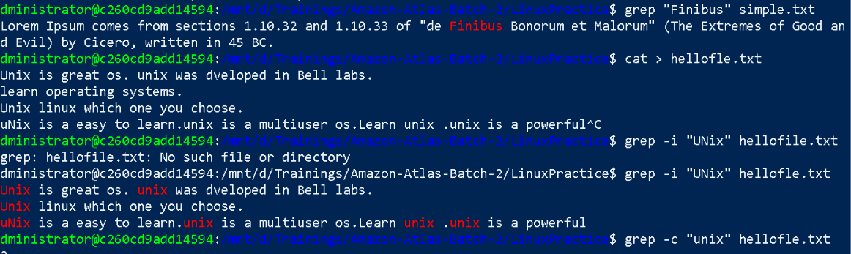

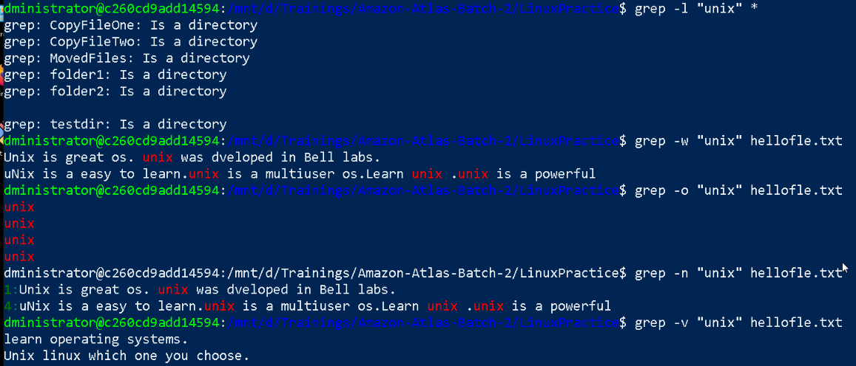





Task 17:

AWK commands in doc 15 Linux AWK commands.

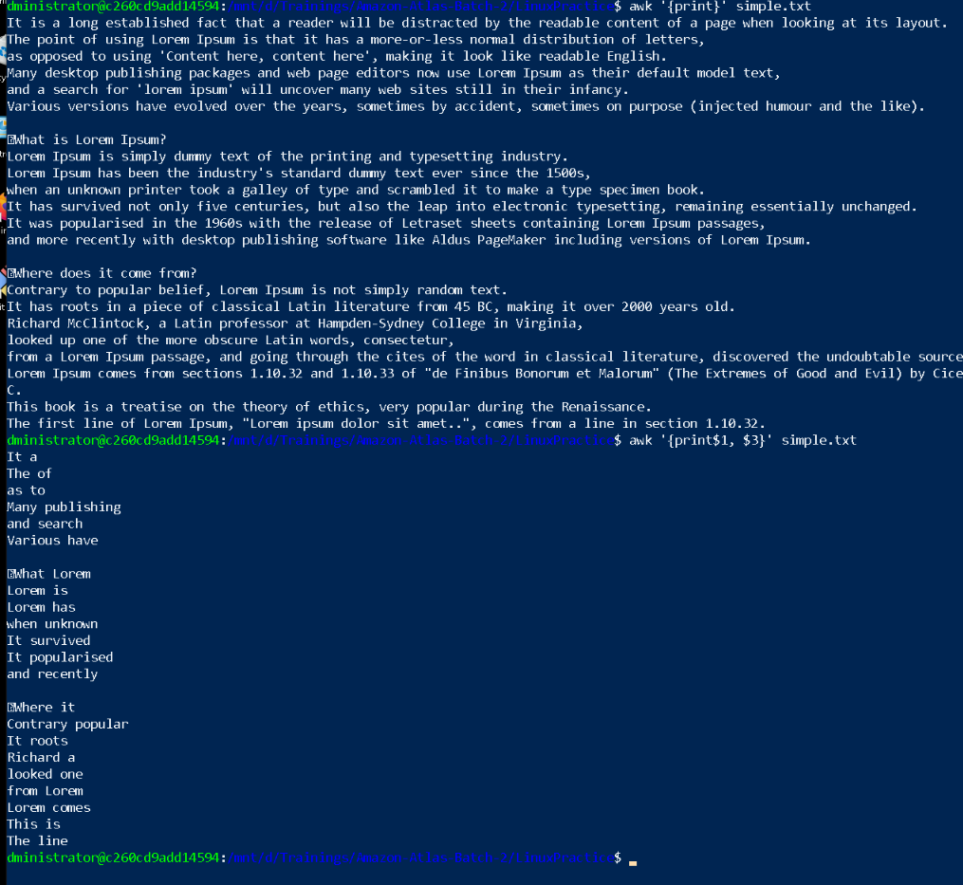

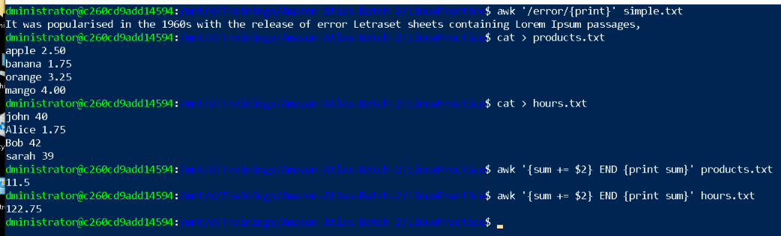

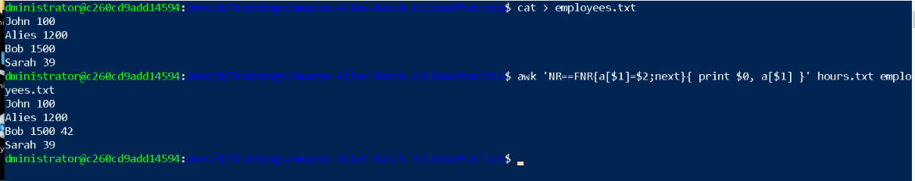

Task 18:

How to check file access permission in Linux?

Hint use:

 Ls -l



Task 19:

What are the default permissions for a new file ?

Plz find out for

Owner   → ?

Group → ?

All and others → ?



rwxrwxrwx = 777 Full permissions

r = 4

w = 2

x = 1

Total = 7

For defaultfile.txt

Owner = rwx = 7

Group = rwx = 7

Others = rwx = 7

Task 20:

What is the command to change the permisssion to read only for the owner, group and all other users

HInt: chmod 444 filename

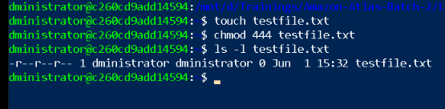

Task 21:

Can you change the file permissions to match the following:

* owner: Read and Write
* group: Read
* other: no permissions (None)

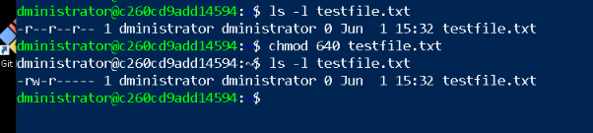

Task 22:

What was the command for changing the file permissions to -rw-r-----?

Hint : use chmod 640 filename



Task 23:

Change chmod.exercises permissions to -rwxr-x--x

Change the file permissions to match the following:

owner: Read, Write and Execute

group: Read and Execute

other: Execute

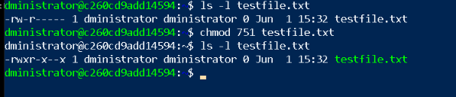

Task 24:

What was the command for changing the file permissions to -rwxr-x--x

Hint : use chmod 751 filename



Task 25:

Guys what will this command do?

chown -c master file1.txt

chown: The command to change file ownership

--c: The "changes" flag, which makes the command report only when an actual ownership change is made

master: The username of the new owner

file1.txt: The target file

changed ownership of 'file1.txt' from currentuser to master

Task 26:

Can you define what is  a process

Process is a program is execution, it’s an active entity, has its own memory space and resources, process have different states New, ready, running, waiting, and terminated.

Process types:

* Foreground
* Background

Task 27:

What is command to check foreground process and background process

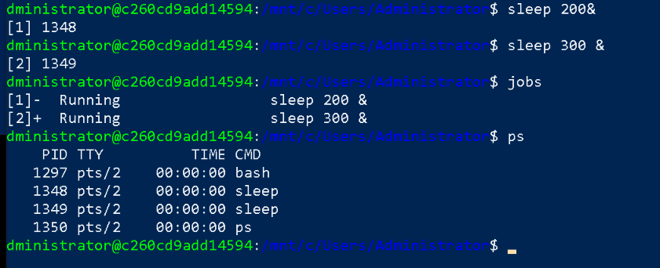

Task 28:

Can you list all the running processes?

Hint use ps



Task 29:

What will ps -f command do ? plz try n check .. ss required.

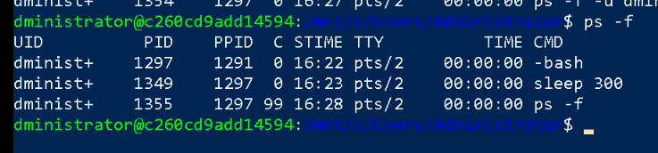

Task 30:

Can you create  a variable name with your name in it

Ex:

Name =  “prasunamba”

Id  = 10001

And check

Echo $Name

Chek the output

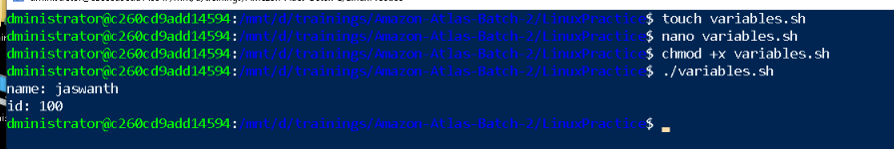

Task 31:

Can you make the above name variable read only..

Ex:

Name = “Prasunamba”

Readonly Name

Name = “Meher” —>what will this display.. Is it saying read only?? Pl check

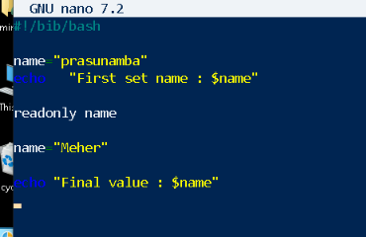

Task 32:

Now will unset or delete the variables

Use the below command and check

Unset Name

Now check for

 echo $Name   —> this should not print anything.. Plz try also specify the reason

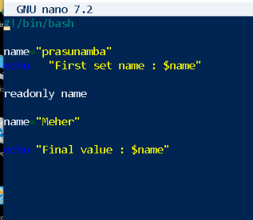

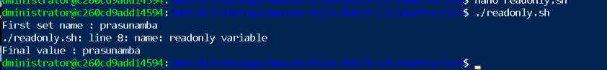

Last Task

