SIT233/SIT706 – Cloud Computing
  - Deakin University
  - Learning Summary Report

  - Jasveena - 224001588

Introduction
This report summarises what I have learnt in SIT233/SIT706 Cloud Computing. It includes a summary of the completed tasks within the Unit Portfolio and a reflection on my learning.

Assessment Summary
Please complete the tables below to show the target grade and summarise completion of individual tasks in this Portfolio

Grade | Tick the grade you are targeting ()
Pass
Credit
Distinction
High Distinction

Number of
completed tasks
Pass Tasks | 12
Credit Tasks | 4
Distinction Tasks | 2
High Distinction Tasks | 1

Declaration
I declare that this portfolio is my individual work. I have not copied from any other student’s work or from any other source except where due acknowledgment is made explicitly in the text, nor has any part of this submission been written for me by another person.

Signature: jasveena

Portfolio Overview
This portfolio includes work that demonstrates I have achieved all Unit Learning Outcomes for SIT233 Cloud Computing to a High Distinction level.
Throughout this unit, I engaged with a diverse range of cloud computing topics, from static and dynamic web development to infrastructure automation and serverless architecture. Starting from foundational concepts, I built a deep and practical understanding of cloud services offered by Amazon Web Services (AWS).
Key milestones include:
- Designing and implementing a scalable and highly available cloud environment for a café business, using services like Amazon EC2, RDS, Load Balancers, and Auto Scaling.
- Automating infrastructure using AWS CloudFormation, demonstrating professional-level deployment practices .
- Implementing a serverless architecture using AWS Lambda in Task , where I developed a production-level cloud solution following best practices in decoupled design and event-driven execution.
- Demonstrating clear understanding of IAM, VPCs, VPC peering, and SQS messaging, showcasing my ability to work with cloud networking, security, and microservices patterns.
These tasks collectively show that I have gone beyond the basics and applied advanced cloud concepts in realistic business use cases. I have reflected critically on architectural decisions and backed my work with sound reasoning and documentation.
Given the depth, quality, and scope of the tasks completed — and the real-world relevance of the designs and implementations — I strongly believe I have demonstrated achievement at a High Distinction level.

Reflection

The most important things I learnt:
How to structure cloud-native applications for scalability, resilience, and efficiency.
The use of AWS tools like CloudFormation, EC2, RDS, Lambda, and S3 in deploying full-stack cloud solutions.
How to automate infrastructure and avoid manual provisioning to achieve DevOps best practices.
The importance of cost-performance trade-offs and secure architecture in real-world systems.

I feel I learnt these topics, concepts, and/or tools really well:
Creating and managing VPCs and networking components like subnets, routing tables, NAT gateways, and VPC peering.
Serverless deployment models using AWS Lambda and API Gateway.
Automating repeatable infrastructure deployment using CloudFormation templates.
Breaking monolithic systems into microservices architectures with decoupled communication .

I found the following topics particularly challenging:
Understanding VPC peering and its role in cross-network communication .
Learning CloudFormation syntax and dependencies for complex infrastructure.
Implementing event-driven serverless logic while managing permissions and triggers.

I found the following topics particularly interesting:
Using Elastic Load Balancing and Auto Scaling to create resilient environments .
Migrating legacy databases to Amazon RDS and managing data accessibility and integrity.
Developing the final Lambda-based solution that operated without managing servers .

I still need to work on the following areas:

Advanced cost optimization strategies across AWS services.

Learning about hybrid cloud models and integration with on-prem systems.

Gaining more confidence with CloudFormation parameters, mappings, and nested stacks.

The things that helped me most were:
AWS official documentation and real-world architecture diagrams.
OnTrack task instructions and feedback sessions with the teaching team.
Hands-on guided labs and trial deployments within the AWS Console.

My progress in this unit was …:
My graph reflects consistent progress across the trimester, with high engagement and effort allocated to challenging tasks like Distinction and HD-level activities.
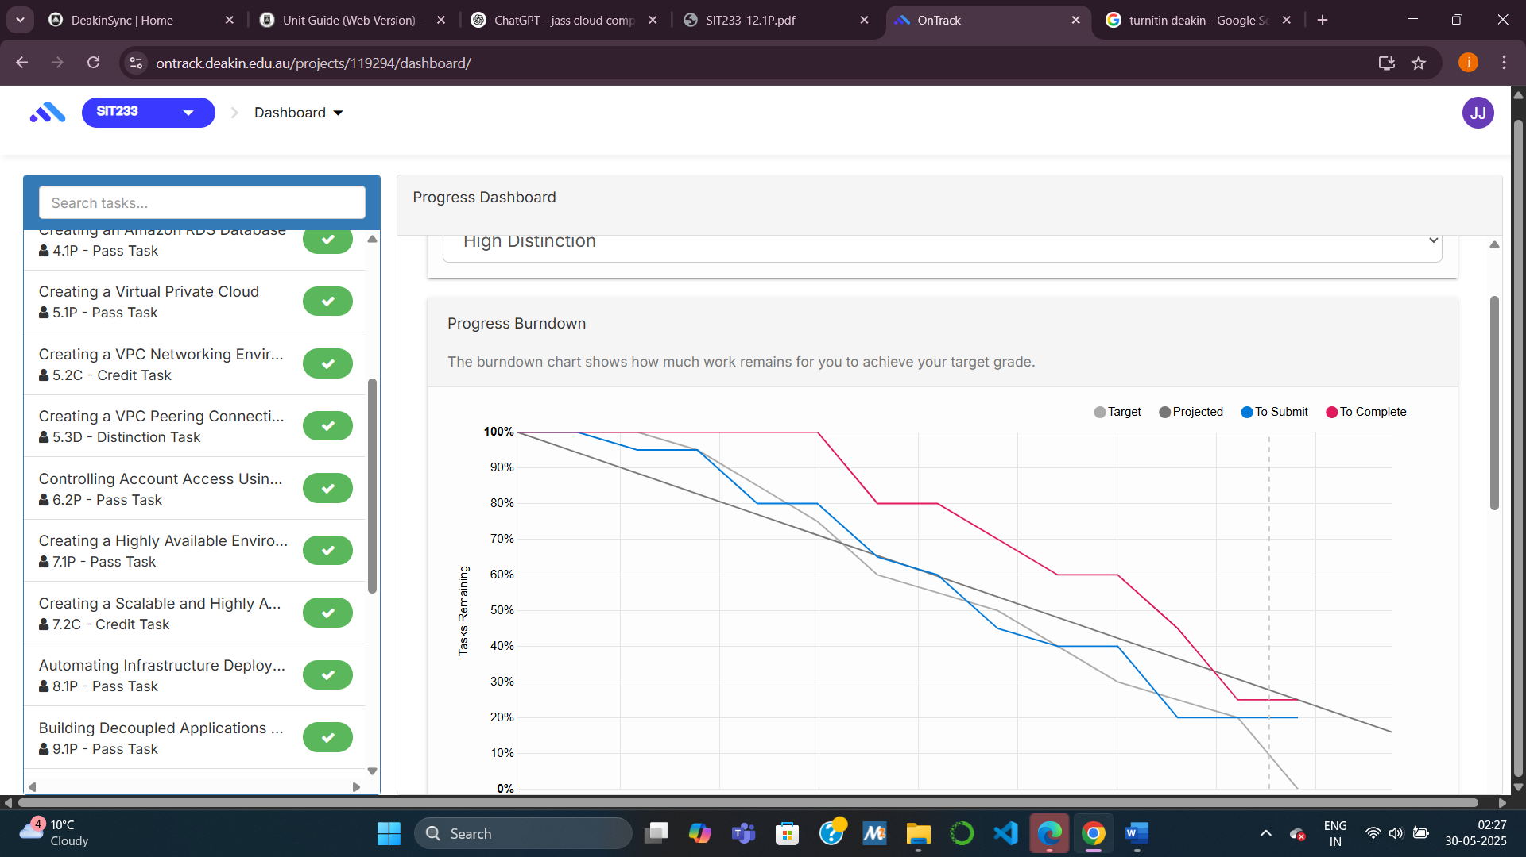

This unit will help me in the future:
The skills and experience I gained in SIT233 will help me pursue careers in Cloud Engineering, DevOps, and Solution Architecture. I can now confidently design, implement, and manage cloud-based systems, automate infrastructure, and communicate technical choices to stakeholders

If I did this unit again I would do the following things differently:
Begin complex tasks like CloudFormation earlier in the study period.
Seek earlier feedback on diagrams and design justifications.
Document all key learnings weekly to build a stronger reflective log.

Other…:
SIT233 has transformed my perspective on cloud computing. I now approach design tasks with a cost-aware, scalable, and modular mindset. The unit has strengthened both my technical capabilities and my ability to think critically about system architecture in the real world.

