SIT233/SIT706 – Cloud Computing
  - Deakin University
  - Learning Summary Report

  - STUDENT NAME (student id)

Introduction
Update header with your name and id. Then delete this box.
This report summarises what I have learnt in SIT233/SIT706 Cloud Computing. It includes a summary of the completed tasks within the Unit Portfolio and a reflection on my learning.

Assessment Summary
Please complete the tables below to show the target grade and summarise completion of individual tasks in this Portfolio

Grade | Tick the grade you are targeting ()
Pass
Credit
Distinction
High Distinction

Number of
completed tasks
Pass Tasks
Credit Tasks
Distinction Tasks
Enter the non-graded tasks you successfully completed within OnTrack. Then delete this box.
High Distinction Tasks

Declaration
I declare that this portfolio is my individual work. I have not copied from any other student’s work or from any other source except where due acknowledgment is made explicitly in the text, nor has any part of this submission been written for me by another person.

Signature:

Portfolio Overview
Start with something like “This Portfolio includes work that demonstrates that I have achieve all Unit Learning Outcomes for SIT233/SIT706 Cloud Computing to a Pass/Credit/Distinction/High Distinction level.”
Describe your learning journey – where did you start, what did you learn, where will this take you? Note significant milestones or hurdles you overcame.
Provide a justification for why you should receive the above grade. Write this for the assessment panel – tell them why you should get this grade.
- For Pass: you need to indicate how you have demonstrated all Unit Learning Outcomes to an acceptable level.
- For Credit: you need to indicate how you have demonstrated all Unit Learning Outcomes to a good level.
- For Distinction: you need to indicate how you have been able to apply all of the Unit Learning Outcomes in achieving the distinction tasks.
- For High Distinction: you need to indicate how you have been able to extend beyond the material presented in the unit.
In this section, refer to the tasks you have completed. These will be attached by OnTrack after this summary. Do not try to demonstrate the outcomes here, this is just a summary.
Think of this like a cover letter to a job application. The unit learning outcomes are the job’s selection criteria. Your tasks provide the evidence of how you have met these criteria.

Read and then delete this text… This is where you present your Portfolio overview and summary. This should be no more than one page.
Then delete this box.

Reflection
Reflect on your learning and discuss these areas. The text provided outlines what we want you to discuss in this section – this should be read and then deleted so that each reflection contains just your text.

The most important things I learnt:
[ Think about topics covered, but also other general things you may have learnt. Think about what you have learnt in this subject, and reflect on what you think were key learning points, or incidents. Did you learn what you wanted/expected to learn? ]

I feel I learnt these topics, concepts, and/or tools really well:
[What things are you really confident about now?]

I found the following topics particularly challenging:
[What was the most challenging part of the unit? Have you mastered those ideas, concepts, or skills now? What did you learn about yourself in how you dealt with these challenges?]

I found the following topics particularly interesting:
[What was the most interesting or valuable thing you learnt from this unit? This could be related to the unit concepts, or general things you learnt about yourself.]

I still need to work on the following areas:
[University is about developing lifelong learning skills. Given what you have achieved already, what is the next step for you? How will you build upon what you learnt in this unit? This could be related to the unit concepts and skills, or to personal traits you identified as needing further development.]

The things that helped me most were:
[What were the most helpful/useful resources? How did they assist you with your learning?]

My progress in this unit was …:
[ Include a screenshot of your progress graph from OnTrack, and comment on what happened from your perspective… what does the graph say about how you approached the unit? (Login to OnTrack to get your graph https://ontrack.deakin.edu.au)]
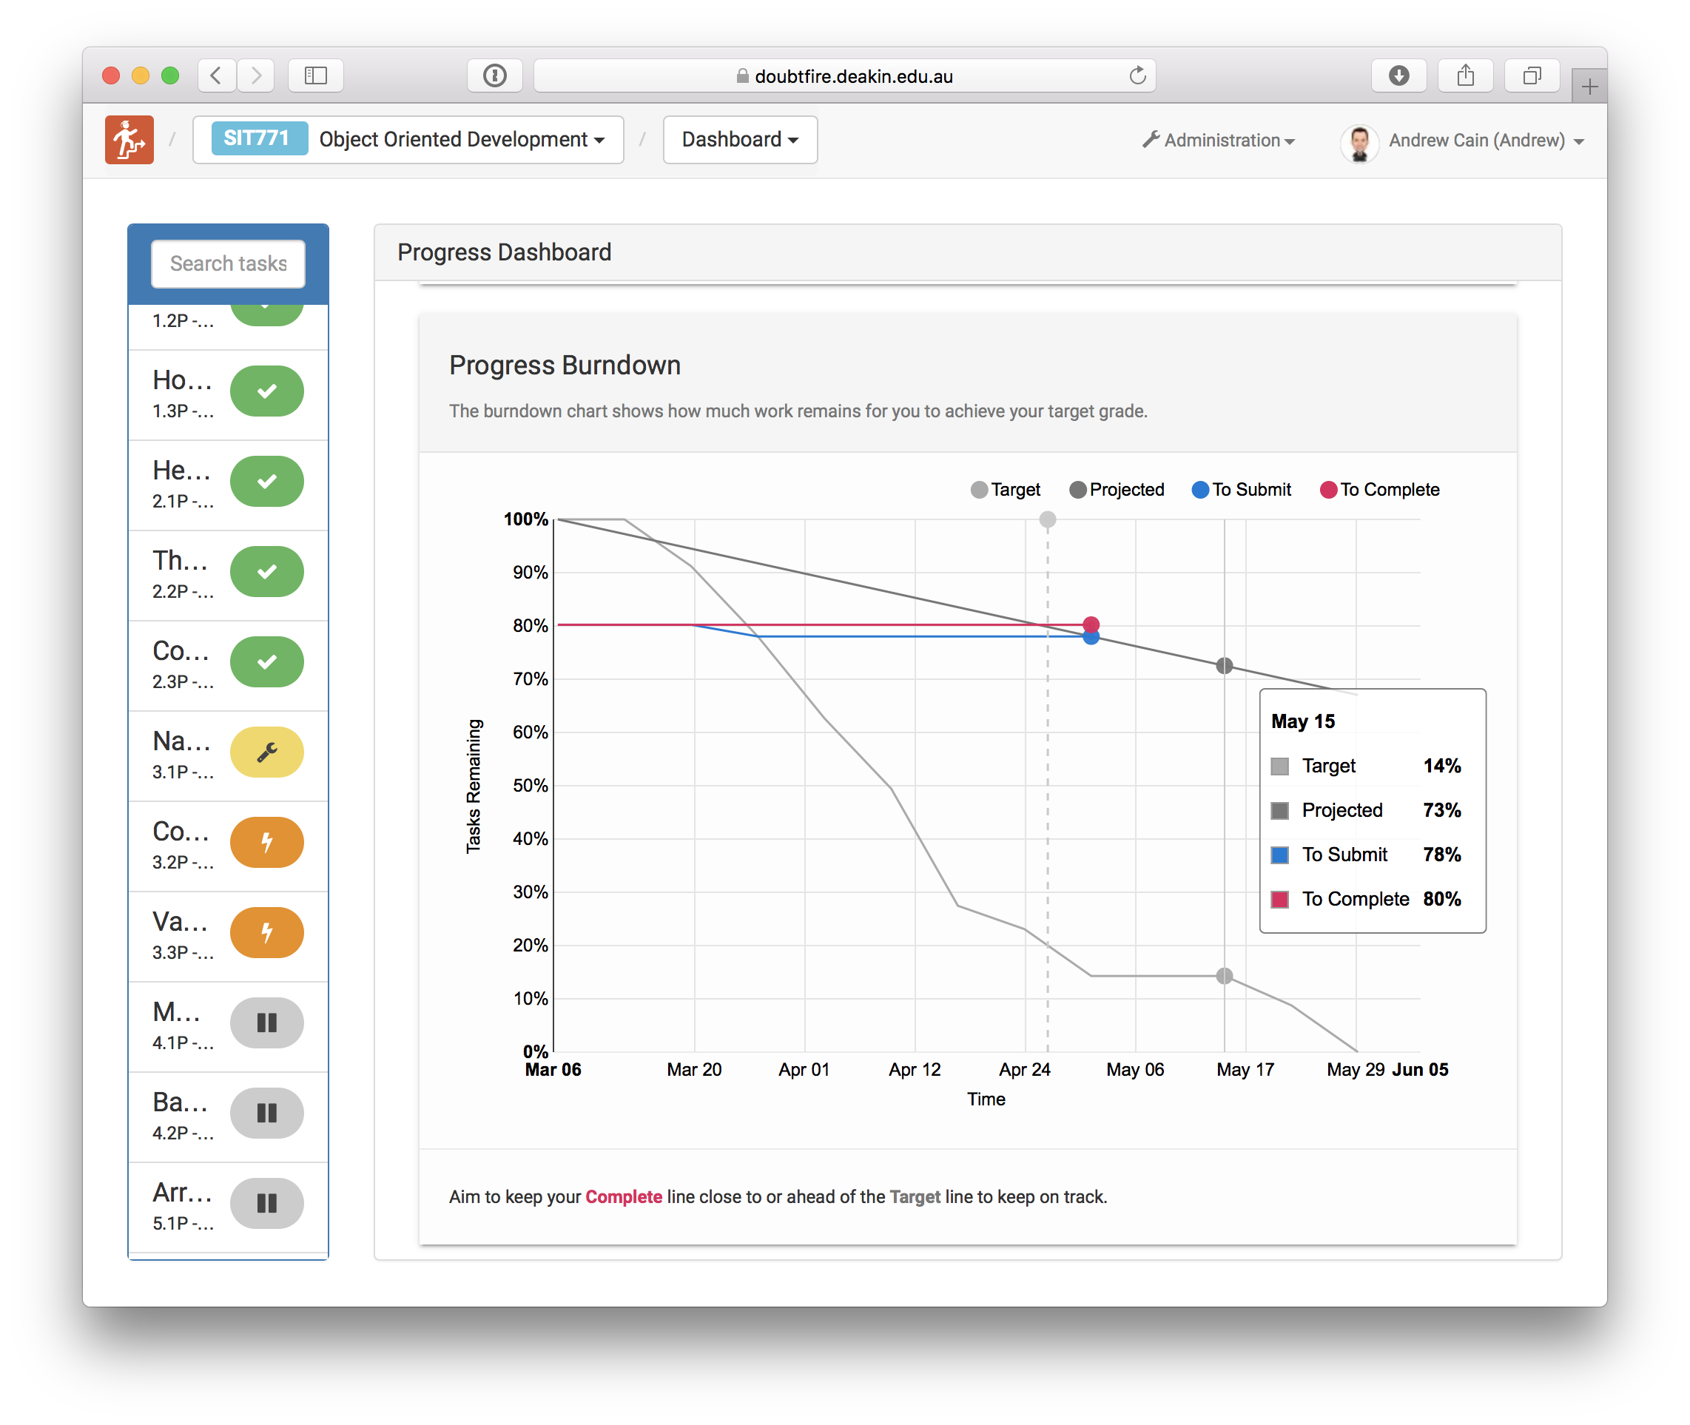

This unit will help me in the future:
[ How will the things you learnt relate to the rest of your studies, and career. What have you learnt that will be valuable for you in the future?]

If I did this unit again I would do the following things differently:
[ Looking back, what is it that you think you could have done differently to help you achieve the most you could in this unit (both in terms of the unit concepts and skills, and in terms of personal growth). How will you approach learning in the future?]

Other…:
[Adjust this heading to add any other reflections you think help you demonstrate what you got out of this unit, and how it has or will help shape you as an IT Professional.]

