Family Alerts Kit (WhatsApp)
How the code works, explained simply. Ready-made for any theme picked on the hackathon day.
Life Powered by Tech hackathon · 13–14 Nov 2026 · Folder: Desktop\Hackathon\whatsapp-alerts
In one sentence: a person tells the app what they are doing and when they will be back. If they don't check in on time, the app automatically sends their family a WhatsApp message, even if the person's phone is switched off or out of signal.
Any theme: walking home at night, an elderly parent living alone, a hike, a cyclone, a day at sea... Only the words on screen change. Pick the theme on the day in one line (section 4b).

1. The big picture
There are four parts. The app is what people see. The backend is the "brain" that does the work. Meta delivers the WhatsApp messages. MongoDB remembers everything.
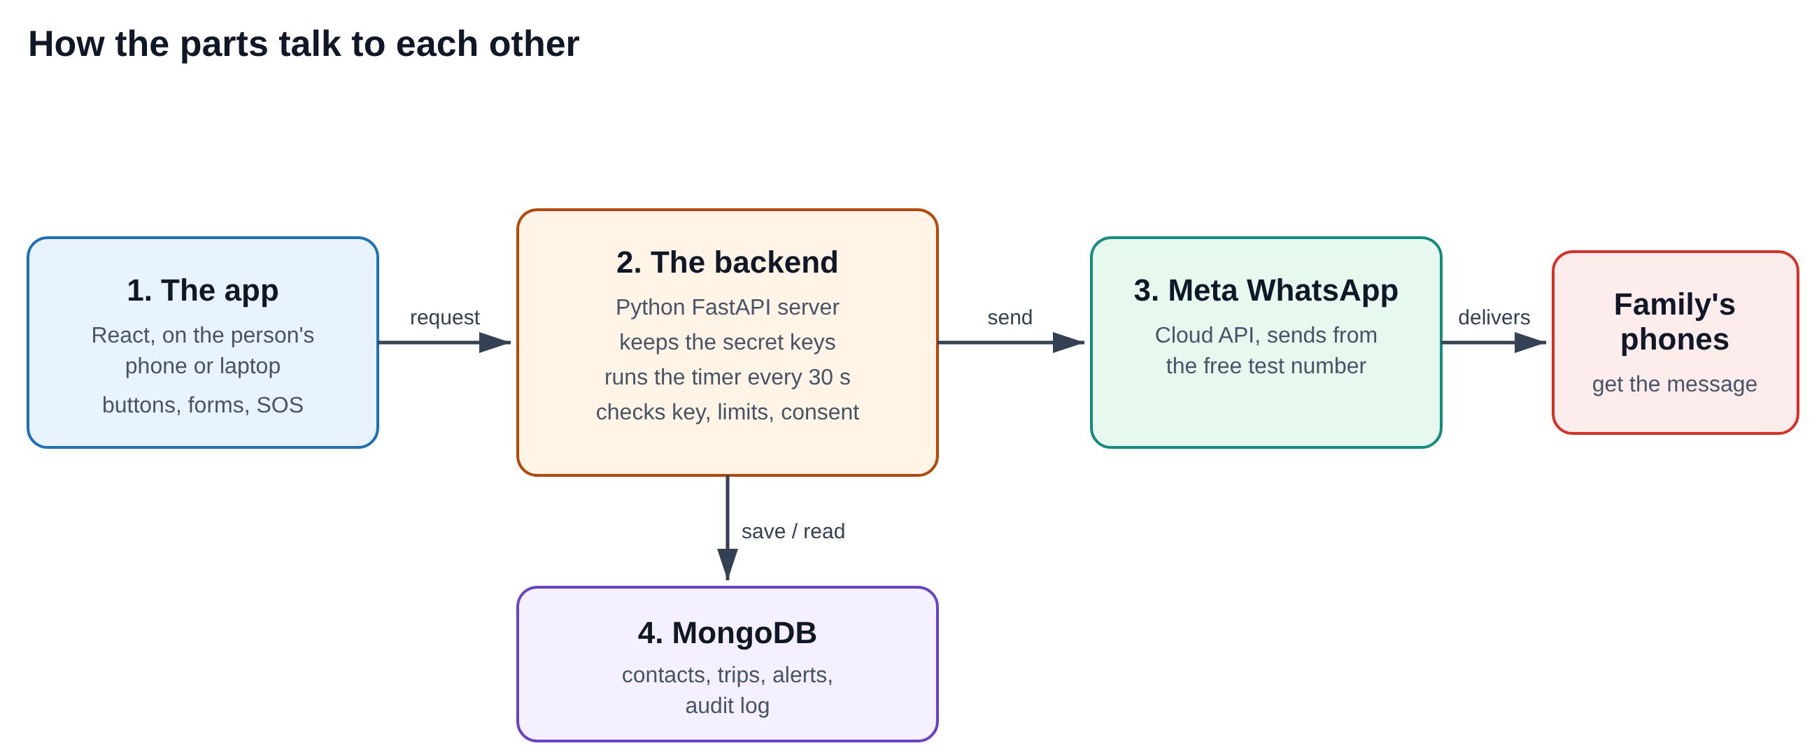
Part | What it is | Its job, in plain words
1. The app | React + TypeScript (Vite) | The screens: family contacts, trip check-in form, countdown, SOS button, alert history, "Your data".
2. The backend | Python + FastAPI | Holds the secret keys, checks every request, sends messages, and runs a timer every 30 seconds to spot anyone who is late.
3. Meta WhatsApp | WhatsApp Cloud API | Actually delivers the message to the family's WhatsApp, from Meta's free test number.
4. MongoDB | Database (Atlas) | Saves contacts, trips, the alert history and the audit log. If it's unreachable, the backend uses memory instead.
Why a backend at all? Two reasons. The Meta key must stay secret, so it can't be inside the app. And the "missed check-in" alert has to fire even when the person's phone is off, so a server has to watch the clock.

2. The life of one check-in
In the code, each check-in is called a "trip", whatever the activity is.
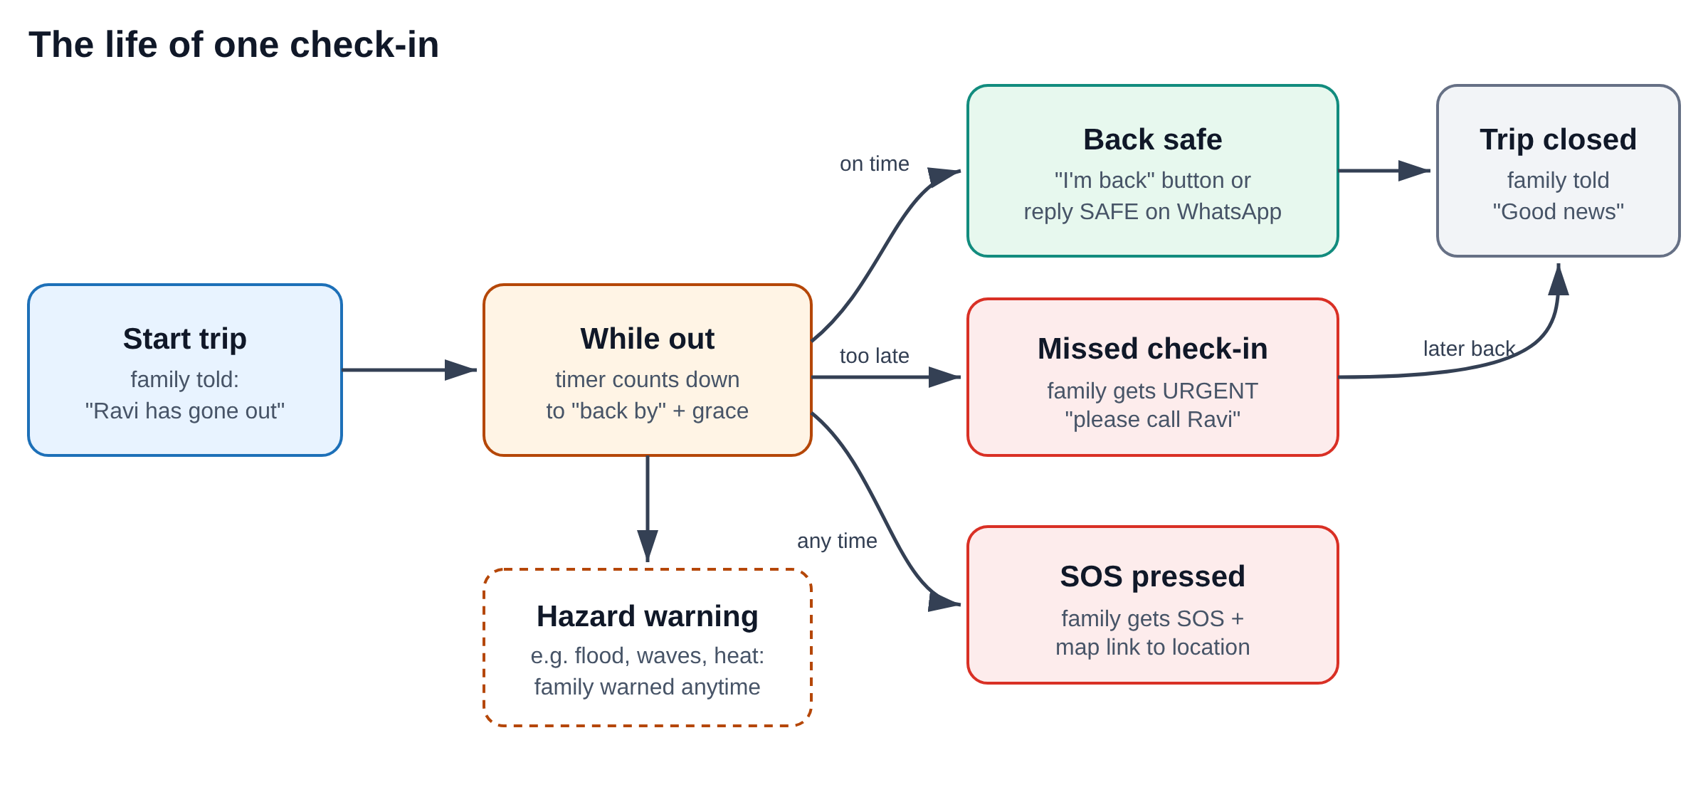
- Before leaving: the person adds family members (each must agree to receive alerts), then fills in name, where they're going, and "back by" time.
- Start: family gets "Safety alert: Ravi has started: Hike at Le Pouce. Expected back by 14:30."
- While out: the app shows a countdown. The backend checks the clock every 30 seconds.
- Back on time: the person taps "I'm safe" (or replies SAFE on WhatsApp). Family gets "Good news". Trip closed.
- Too late: when "back by" plus the grace minutes (default 30) passes, family gets URGENT: Ravi has not checked in. Please call them now. If you cannot reach them, call 999.
- Danger at any time: the SOS button sends the family a Google Maps link to the person's location.
- Hazard: another part of the app (e.g. a weather, flood or crime-data agent) can warn the family about a danger during the activity.
- Custom: any theme can send its own short message, e.g. "Missed the morning medication".

3. The 6 messages
Each family member gets the message in their own language: English or French. The wording is generic, so it fits any theme and Meta only has to approve it once.
Message | When it is sent | Example (English)
Started | Person taps "Start & tell family" | Safety alert: Ravi has started: Hike at Le Pouce. Expected back by 14:30, 14/11.
Missed check-in | Automatically, when late | URGENT: Ravi has not checked in… Please call them now. If you cannot reach them, call 999.
SOS | Person presses SOS | SOS: Ravi pressed the emergency button. Last location: (map link).
Hazard warning | Any data/AI part of the app | Safety warning for Ravi (Hike at Le Pouce): Heavy rain warning this afternoon. Please check on them.
Back safe | "I'm safe" or reply SAFE | Good news: Ravi checked in safely at 13:55. No action needed.
Custom | Any theme, its own text | Safety alert about Mamie Lise: Missed the morning medication. Sent by the Granmoun Check-in app.

4. What each file does

Backend (backend/whatsapp_alerts/)
File | What it does
config.py | Reads all settings from the .env file (keys, timings, limits).
templates.py | The wording of the 6 messages in English and French.
client.py | Talks to Meta: sends one WhatsApp message and turns Meta's error codes into plain hints.
service.py | The main logic: start trip, check in, SOS, hazard, and the 30-second timer.
store.py | Saves and loads data from MongoDB (or memory if MongoDB is down).
router.py | The web addresses the app calls, e.g. /api/alerts/trips, /sos.
security.py | App key check, rate limits, and checking that WhatsApp replies really come from Meta.
governance.py | Audit log, consent, auto-delete after 30 days, "download / delete my data".
main.py | Starts the server. In the team app, only 2 lines are needed to plug the module in.
tests/ | 15 automated tests. Run pytest -q to check nothing is broken.

Frontend (frontend/src/whatsapp-alerts/)
File | What it does
api.ts | Sends requests to the backend, with the app key attached.
useWhatsAppAlerts.ts | The "memory" of the screen: contacts, current trip, alert log; refreshes every 15 s.
context.tsx | Shares that memory with every component (wrap your page in WhatsAppAlertsProvider).
components/ | The building blocks: FamilyContacts, TripCheckIn, SosButton, AlertLog, PrivacyPanel, FallbackSheet, and WhatsAppAlertsPanel (all in one).
theme.ts | The theme switch. App name, button words and example alerts for each preset, in EN/FR. Change ACTIVE_THEME here.
messages.ts | Same message wording as the backend (for the offline backup) + all screen text in EN/FR.
fallback.ts | Builds the free WhatsApp and SMS backup links.
whatsapp-alerts.css | The look. Every class starts with wa- so it won't clash with other code.

4b. Change the theme on the day
The kit comes with 5 ready-made themes. Pick one in frontend/src/whatsapp-alerts/theme.ts, or copy one and change its words.
Preset | App name | Example use
general | Safe Check-in | Any activity (the default).
elderly | Granmoun Check-in | An elderly parent confirms they are fine each day.
walkHome | Walk Home Safe | Getting home safely at night.
cyclone | Cyclone Safe | Checking in during a cyclone or flood.
fishing | Pêcheur Buddy | A fisher at sea.
- In theme.ts, change export const ACTIVE_THEME = PRESETS.general; to the preset you want.
- In backend\.env, set ALERTS_APP_NAME= to the same app name.
- That's it. The WhatsApp templates are generic, so Meta does not need to approve anything new.

5. When things go wrong
The demo is built to survive failures. Each problem has a backup:
Problem | What happens automatically
No Meta key yet | Demo mode: messages are written to the log instead of sent. A banner says so. Nothing crashes.
WhatsApp refuses a message | The app shows a WhatsApp and SMS button per family member with the message ready. Tap and press Send.
Backend unreachable / Wi-Fi down | Same buttons appear, using contacts saved on the phone.
MongoDB unreachable | The backend keeps working using memory (data resets on restart).
Templates not approved yet | Send plain text instead. Works if the family messaged the number in the last 24 hours.
Same alert fired twice | Can't happen: a trip is "claimed" before the URGENT message, so it is only sent once.

6. Security
Protection | In simple words
Secret keys | The Meta token and database password only live in .env on the server. Never in the app, never on GitHub.
App key | Every request must carry a secret key. Strangers who find the server get "401 refused".
Rate limits | Max 10 actions per minute per user, 60 in total. Stops spam and protects the Meta quota.
Signed replies | A "SAFE" reply only counts if Meta's signature proves it really came from WhatsApp.
Input checks | Phone numbers must be 8–15 digits; max 5 contacts; text length limits; fixed message wording.
Demo button lock | "Run missed check-in check now" only works when switched on in .env.
Honest note: the app key is visible inside the web app, so it keeps strangers out but is not a personal login. A real launch would add proper user login.

7. Governance (ISO-style)
Built to follow ISO 27001 / ISO 27701 practices and Mauritius' Data Protection Act 2017. Full control map: GOVERNANCE.md. It is "built to ISO practices", not "ISO certified".
Feature | What it means for a user
Consent | You can't add a family member without ticking "This person agreed…". When and what they agreed to is saved.
Audit log | Every action is recorded. Phone numbers are hidden (2305****456), GPS is not stored. Each entry is chained to the previous one, so any edit is detected by /governance/audit/verify.
Auto-delete | Finished trips and alerts are deleted after 30 days.
Your data | "Download my data" gives a file of everything stored. "Delete all my data" erases it.
Incident plan | 5 steps in GOVERNANCE.md: revoke key, stop sending, check audit log, notify within 72 h, write it up.

8. Settings (.env file)
All settings live in backend\.env (copy from .env.example). The important ones:
Setting | What it controls
WA_ACCESS_TOKEN | Meta's secret token (use the permanent one).
WA_PHONE_NUMBER_ID | Which WhatsApp number sends (the test number's ID).
WA_USE_TEMPLATES | true once Meta approves the 6 templates; false = plain text.
WA_APP_SECRET | Lets the backend verify that WhatsApp replies are real (needed for SAFE replies).
MONGODB_URI | Database address. Empty = use memory.
ALERTS_API_KEY | The app key. Must equal VITE_ALERTS_API_KEY in frontend\.env.
ALERTS_GRACE_MINUTES | How many minutes late before family is alerted (default 30).
ALERTS_RETENTION_DAYS | Days before old trips/alerts are deleted (default 30).
ALERTS_ENABLE_DEV_ROUTES | true only while demoing the "Run check now" button.
ALERTS_EMERGENCY_NUMBER | Number in the URGENT message (default 999).
ALERTS_APP_NAME | App name used in the custom message. Set it to the theme's app name.

9. How to run it
- Backend: in backend, run py -3.11 -m venv .venv, then .venv\Scripts\activate, pip install -r requirements.txt, and uvicorn main:app --reload --port 8000.
- Frontend: in frontend, run npm install, then npm run dev.
- Open http://localhost:5173. Add yourself as family, start a trip due in 1 minute with grace 0, and press "Run missed check-in check now".
- Check http://localhost:8000/docs to see and try every backend address.

10. Plugging it into another idea
Where | What to add
Backend | Copy the whatsapp_alerts folder, then 2 lines: app = FastAPI(lifespan=alerts_lifespan) and app.include_router(alerts_router).
Frontend | Copy the whatsapp-alerts folder, then wrap the page: <WhatsAppAlertsProvider ownerId={user.id}> and add <WhatsAppAlertsPanel /> (or single pieces).
From another agent | Call hazard_warning(...) or notify_contacts(...) in Python, or alerts.hazardWarning("...") in React.

11. Words explained
Word | Meaning
API | A way for one program to ask another to do something (e.g. "send this WhatsApp").
Backend / server | The program running on a computer that does the work behind the app.
Token / key | A secret password that proves who is asking.
Template | Message wording Meta approved in advance, needed to message people any time.
Webhook | Meta calling our server when something happens (message delivered, reply received).
Rate limit | A cap on how many actions are allowed per minute.
Audit log | A diary of every action, for checking what happened later.
Hash chain | Each diary entry includes a fingerprint of the one before, so edits are detectable.

