**For Tester,**

If you get 85% to 100% you will get jobs but you don’t copy and paste of ChatGPT. If you use GPT I will not satisfy with your job.

If you get 70% to 84% as well as below the marks you will get jobs but I will think to get your job. You don’t copy and paste of ChatGPT. If you use GPT I will not satisfy with your job.

- **You answers should be 1000-1500 words approx**

- Please answer these questions as an individual in an overleaf document and submit the PDF formatted output downloaded from Overleaf.

Based on the requirements of the project and the agile testing quadrants, describe how you will be carrying out your tests and what sort of tests you will be conducting within the given timeframe.

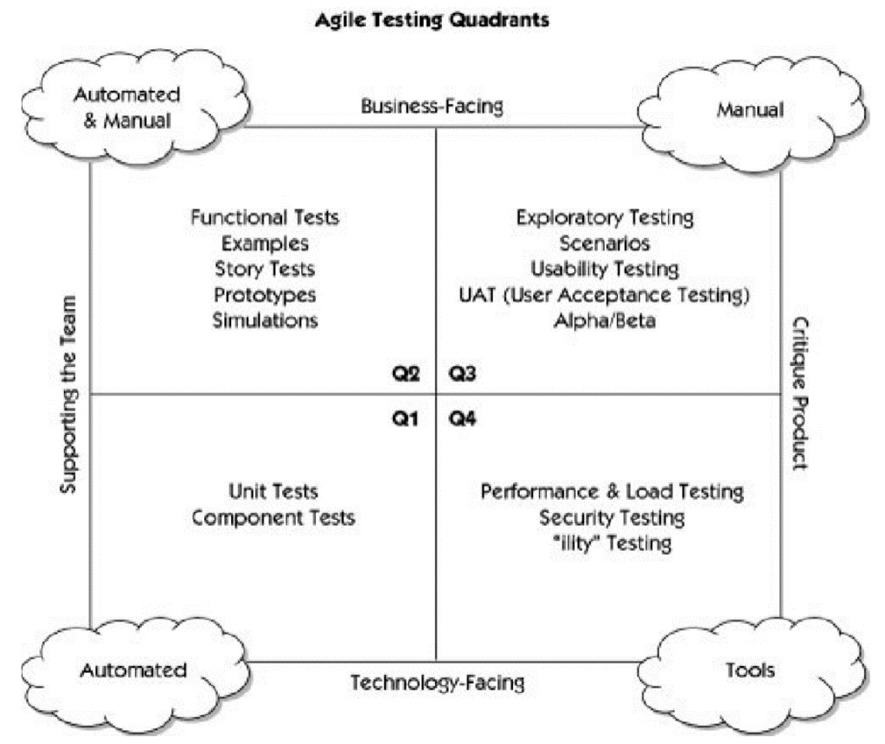

You can use the report format shown below:

**Report Format:**

1. Cover page
2. Content page
3. Background
4. Aims and Scope
5. Requirements
6. Agile testing
7. Conclusion

The marking rubric is shown below:

