

Automatic Text Summarization Using a
Transformer-Based T5 Model
A Traceable, Personalized PDF-to-Notes Learning Platform
A CAPSTONE PROJECT REPORT

Submitted in partial fulfilment of the requirements
for the Course of
DSA0308 – Natural Language Processing
to the award of the degree of
BACHELOR OF TECHNOLOGY
IN
COMPUTER SCIENCE ENGINEERING - AI
Submitted by
- Jaswanth (192472235)

Under the Supervision of
Dr. Kumaraguruban

SIMATS ENGINEERING
Saveetha Institute of Medical and Technical Sciences
Chennai–602105

SEPTEMBER 2026

BONAFIDE CERTIFICATE

This is to certify that the Capstone Project entitled “Automatic Text Summarization Using a Transformer-Based T5 Model” has been carried out by G. Jaswanth (192472235) under the supervision of Dr. Kumaragurubaran T and is submitted in partial fulfilment of the requirements for the Capstone Project at SIMATS Engineering, Saveetha Institute of Medical and Technical Sciences, Chennai.
The work presented in this report covers the analysis, design, implementation, evaluation and application integration of a transformer-based automatic text summarization system. The project further develops the summarization pipeline into a traceable academic PDF-to-notes workflow in which generated notes can be related back to their originating source locations.

COURSE COORDINATOR | COURSE FACULTY / GUIDE
Dr. Devi  Professor  Department of CSE  SIMATS Engineering | Dr. Kumaraguruban  Professor  Department of CSE  SIMATS Engineering

DECLARATION

We, G. Jaswanth (192472235), Yuvaraj R (192524058), and Pradeepkumar (192425016), of the Artificial Intelligence and Data Science programme, SIMATS Engineering, Saveetha Institute of Medical and Technical Sciences, Chennai, hereby declare that the Capstone Project Work entitled “Automatic Text Summarization Using a Transformer-Based T5 Model” is the result of our bonafide efforts.
To the best of our knowledge, the work presented herein has been developed in accordance with engineering ethics, academic integrity and the requirements of the capstone project. Sources, datasets, software libraries, computational resources and external materials used in the project have been acknowledged. Any AI-assisted tools used during development or documentation are to be disclosed in accordance with institutional requirements.
The report distinguishes between implemented functionality, planned deployment features and future enhancements. Numerical performance values are not presented unless they are supported by the team's actual experimental records.
Place: Chennai
Date: 8-9-2026
Student Signatures:
G. Jaswanth (192472235)

INDIVIDUAL CONTRIBUTION STATEMENT
(Mandatory for all team projects)
The following contribution statement records the team's current working distribution for the capstone report. G. Jaswanth has been assigned the largest share for the NLP pipeline, source mapping, evaluation, architecture and final technical documentation; Pradeepkumar and Yuvaraj R are assigned the remaining project responsibilities.
Student Name / Register No. | Specific Responsibilities | Design & Development Contribution | Testing & Analysis Contribution | Report Contribution | Approx. %
Pradeepkumar (192425016) | Dataset preparation and model-development support | Dataset organization, preprocessing and T5-family model workflow | Training/validation checks and summary-quality analysis | Methodology, implementation and results documentation | 30%
Yuvaraj R (192524058) | Application integration and interface workflow | Integration of summarization workflow with application components | Functional testing and output verification | System design, integration and documentation | 30%
G. Jaswanth (192472235) | NLP pipeline, evaluation and technical design | Preprocessing, T5 summarization, source mapping and evaluation workflow | ROUGE analysis, debugging and end-to-end verification | Architecture, engineering analysis, conclusion and final report | 40%
TOTAL |  |  |  |  | 100%

ABSTRACT
Automatic text summarization is an important Natural Language Processing task that reduces lengthy textual content into shorter representations while attempting to preserve the central information, relationships and meaning of the source. This capstone project develops an automatic abstractive summarization system using a transformer-based T5-family model and extends the core NLP pipeline into a traceable, personalized PDF-to-notes learning platform.
The system is designed for academic material such as textbooks, lecture notes and complete units, including documents that may exceed 80 pages. Instead of treating the entire document as one model input, the proposed workflow extracts text together with page, paragraph and coordinate information, cleans and organizes the content, and performs hierarchical summarization. Paragraph-level summaries are rolled up into topic summaries, page summaries and chapter-level revision notes. This strategy addresses the practical input-length limitations of transformer models while producing summaries at multiple levels of detail.
The NLP/ML layer uses PyMuPDF for PDF extraction, spaCy for sentence processing and preprocessing, Hugging Face Transformers with PyTorch for T5-family summarization, sentence-transformers for semantic retrieval, ChromaDB or FAISS for vector search, and NetworkX for knowledge-graph construction. The project uses the MLSUM/MLSAM multilingual news summarization dataset, which contains human-written article–summary pairs in French, German, Spanish, Russian and Turkish. Generated summaries are evaluated using ROUGE-1, ROUGE-2 and ROUGE-L.
A central engineering contribution is source traceability. Every processed chunk retains a source 'home address' consisting of document, page, paragraph and text-position information. Generated notes can therefore be linked back to their supporting source paragraph.
The project therefore combines NLP model development with document engineering, evaluation, application integration and responsible AI considerations. The design emphasizes that generated summaries are aids to understanding rather than substitutes for source verification, particularly in academic contexts where missing conditions, formulas or exceptions may affect correctness.
Keywords: Natural Language Processing, Automatic Text Summarization, T5, Transformer, Abstractive Summarization, MLSUM, Multilingual NLP, ROUGE, PDF Processing, Source Traceability, Personalized Learning.

TABLE OF CONTENTS
Sl. No. | Title | Page No.
i | CERTIFICATE FROM THE SUPERVISOR / BONAFIDE CERTIFICATE | i
ii | DECLARATION BY THE CANDIDATE | ii
iii | INDIVIDUAL CONTRIBUTION STATEMENT | iii
iv | ABSTRACT | iv
v | LIST OF FIGURES | v
vi | LIST OF TABLES | vi
vii | LIST OF ABBREVIATIONS / SYMBOLS | vii
1 | CHAPTER 1: Introduction and Engineering Problem | 1
1.1 | Background | 1
1.2 | Evolution of Text Summarization | 2
1.3 | Problem Context | 2
1.4 | Need for the Proposed System | 3
1.5 | Problem Statement | 3
1.6 | Aim | 4
1.7 | Objectives | 4
1.8 | Scope | 5
1.9 | Stakeholders | 5
1.10 | Expected Engineering Outcomes | 6
2 | CHAPTER 2: Literature Review and Existing Solutions | 7
2.1 | Review Method | 7
2.2 | Extractive Summarization | 7
2.3 | Abstractive Summarization | 8
2.4 | Transformer Architectures | 9
2.5 | T5 and Multilingual T5 | 10
2.6 | Long-Document Summarization | 11
2.7 | Evaluation with ROUGE | 12
2.8 | Traceable / Source-Grounded Learning Systems | 13
2.9 | Comparative Analysis | 14
2.10 | Engineering Gap | 15
3 | CHAPTER 3: Engineering Design & Trade-offs, Sustainability, Ethics, Safety, Risk & Security | 16
3.1 | System Requirements | 16
3.2 | Constraints and Applicable Standards | 17
3.3 | Design Specifications | 18
3.4 | Alternative Solutions and Evaluation | 19
3.5 | Selected Architecture | 20
3.6 | Detailed NLP Pipeline Design | 21
3.7 | Source-Mapping and Traceability Design | 23
3.8 | Data Model and Information Flow | 24
3.9 | Application and Interface Design | 25
3.10 | Trade-off Analysis | 26
3.11 | Sustainability | 27
3.12 | Ethics and Responsible AI | 28
3.13 | Safety and Reliability | 29
3.14 | Security and Privacy | 30
3.15 | Risk Register and Mitigation | 31
4 | CHAPTER 4: Implementation, Testing & Results, Project Management | 32
4.1 | Development Approach | 32
4.2 | Implementation Environment | 33
4.3 | Dataset Preparation | 34
4.4 | PDF Extraction and Preprocessing | 35
4.5 | T5 Summarization Implementation | 36
4.6 | Hierarchical Summarization Implementation | 37
4.7 | Source Grounding Implementation | 38
4.8 | Application Integration | 39
4.9 | Testing Strategy | 40
4.10 | Functional Test Cases | 41
4.11 | Evaluation Method | 42
4.12 | Results and Analysis | 43
4.13 | Comparison with Existing Approaches | 44
4.14 | Strengths and Limitations | 45
4.15 | Project Planning and Team Roles | 46
4.16 | Budget and Resource Considerations | 47
5 | CHAPTER 5: Conclusion & Reflection | 48
5.1 | Conclusion | 48
5.2 | Future Work | 49
5.3 | Professional Learning & Individual Reflection | 50
— | REFERENCES | 53
— | APPENDICES | 56

LIST OF FIGURES
Figure No. | Figure Name | Page No.
Figure 1 | Evolution of Text Summarization Techniques | 2
Figure 2 | Transformer-Based Text Summarization Architecture | 9
Figure 3 | Comparison of Extractive and Abstractive Summarization | 8
Figure 4 | T5 Transformer Encoder-Decoder Architecture | 10
Figure 5 | Hierarchical Summarization for Long Documents | 11
Figure 6 | PDF Document Processing and Text Extraction Workflow | 35
Figure 7 | Source Mapping Between Generated Summary and Original Document | 23
Figure 8 | ROUGE-Based Summary Evaluation Process | 42
Figure 9 | Selected System Architecture | 20
Figure 10 | Implementation Workflow | 32
Figure 11 | Hierarchical Summarization Implementation | 37

LIST OF TABLES
Table No. | Table Name | Page No.
Table 1 | Stakeholder / User Requirements | 16
Table 2 | Functional and Non-Functional Requirements | 17
Table 3 | Constraints and Applicable Standards | 17
Table 4 | Design Specifications | 18
Table 5 | Alternative Solutions Evaluation | 19
Table 6 | Trade-off Analysis | 26
Table 7 | Sustainability, Ethics, Safety and Security Evidence | 27
Table 8 | Risk Register | 31
Table 9 | Tools / Software / Equipment | 33
Table 10 | Test Plan and Verification | 41
Table 11 | Results / Key Outcomes | 43
Table 12 | Objective Achievement | 45
Table 13 | Project Roles | 46
Table 14 | Project Budget | 47

LIST OF ABBREVIATIONS / SYMBOLS
Abbreviation / Symbol | Description | Unit
AI | Artificial Intelligence | —
NLP | Natural Language Processing | —
T5 | Text-to-Text Transfer Transformer | —
mT5 | Multilingual Text-to-Text Transfer Transformer | —
ML | Machine Learning | —
DL | Deep Learning | —
PDF | Portable Document Format | —
API | Application Programming Interface | —
UI | User Interface | —
UX | User Experience | —
NLG | Natural Language Generation | —
ROUGE | Recall-Oriented Understudy for Gisting Evaluation | —
BLEU | Bilingual Evaluation Understudy | —
TF-IDF | Term Frequency–Inverse Document Frequency | —
NLP Pipeline | Sequence of NLP processing stages | —
CPU | Central Processing Unit | —
GPU | Graphics Processing Unit | —
RAM | Random Access Memory | GB
IDE | Integrated Development Environment | —
JSON | JavaScript Object Notation | —
CSV | Comma-Separated Values | —
DB | Database | —
LCS | Longest Common Subsequence | —
MLSUM | Multilingual Summarization Dataset | —

CHAPTER 1
INTRODUCTION AND ENGINEERING PROBLEM

1.1 Background
The growth of digital educational content has made large volumes of textual information available to students, researchers and professionals. Textbooks, lecture material, technical manuals, articles and complete course units may contain many pages of information. Reading every page is valuable when deep study is required, but it can become inefficient when a learner first needs an overview, a revision structure or a quick identification of important concepts.
Automatic text summarization attempts to solve this information overload by producing a shorter version of a source text. A good summarizer should retain the main ideas, preserve important relationships and remain readable. The project focuses specifically on abstractive summarization, in which a transformer model generates new text rather than simply selecting a set of existing sentences.
The project material defines the proposed system as an intelligent academic study platform that converts long PDFs into structured, hierarchical and traceable notes. The system is designed to retain page, paragraph and coordinate information before summarization, thereby allowing generated notes to be verified against the original source.

1.2 Evolution of Text Summarization
Traditional summarization systems generally followed extractive strategies. They assigned importance scores to sentences using word frequency, TF-IDF-like statistics, graph relationships or other features, and then selected high-scoring sentences. Such methods can be computationally efficient, but they are restricted to wording already present in the source.
Abstractive methods attempt to understand source content and generate a condensed representation. The introduction of neural sequence-to-sequence models improved the ability to rewrite information. Transformer architectures further strengthened this approach by using attention mechanisms to model relationships between tokens and by enabling highly parallelizable training.
The project positions T5 as the main summarization model because T5 frames many NLP tasks as text-to-text transformation. Its encoder-decoder structure is appropriate for taking an input article or passage and generating a target summary.

1.3 Problem Context
Generic summarization tools often provide a generated paragraph without exposing the exact source material that supports each statement. For academic study, this creates a verification problem. A summary may be fluent while still omitting a condition, exception, definition or formula. The learner must therefore switch between tools or manually search the original document.
The project addresses this problem by treating traceability as a first-class engineering requirement rather than as an optional citation feature. The system retains the original page, paragraph and coordinate information throughout extraction and preprocessing and associates that information with generated notes.

1.4 Need for the Proposed System
- Students need concise representations of lengthy academic documents for revision.
- Long PDFs may contain repeated headers, broken lines, page numbers and other extraction noise.
- Traditional extractive summarization cannot naturally rewrite and reorganize information.
- Transformer summarization provides stronger contextual generation but introduces sequence-length and computational constraints.
- Academic users need to verify AI-generated notes against the original source.
- Different learners may struggle with different parts of the same document, motivating personalization.

1.5 Problem Statement
To design and develop a transformer-based automatic text summarization platform that accepts lengthy textual or PDF-based academic material, extracts and preprocesses the source while preserving its location metadata, generates coherent abstractive summaries using a T5-family model, constructs hierarchical notes for different levels of granularity, evaluates summary quality using standard NLP metrics, and provides source-linked access to the original material for verification.

1.6 Aim
To develop an automatic abstractive text summarization system using a T5-based Transformer model and integrate it into a traceable, personalized PDF-to-notes learning platform for efficient academic document understanding.

1.7 Objectives
- Develop a robust document extraction and preprocessing pipeline.
- Prepare multilingual article–summary data for transformer-based summarization.
- Use a pretrained/fine-tuned T5-family model for abstractive summary generation.
- Construct paragraph, topic, page and chapter summaries through hierarchical processing.
- Evaluate generated summaries using ROUGE-1, ROUGE-2 and ROUGE-L.
- Preserve source page, paragraph and coordinate metadata during processing.
- Provide click-to-source and reverse-lookup traceability.
- Support an interactive workspace for reading source documents and generated notes.
- Provide a foundation for semantic search, adaptive learning analytics and retrieval-grounded assistance.

1.8 Scope
The core scope covers multilingual news summarization and the engineering of an NLP pipeline around a T5-family model. The application scope extends the pipeline to academic PDFs, including extraction, topic segmentation, hierarchical summarization and evidence mapping. The system is intended as a learning support tool rather than a replacement for textbooks, faculty instruction or human verification.
The current architecture also defines optional or planned components such as Celery/Redis background processing, MongoDB Atlas storage, sentence-transformer embeddings, ChromaDB/FAISS vector search, NetworkX knowledge graphs, a Groq-based conversational assistant and later deployment through Docker Compose and Render.

1.9 Stakeholders
Stakeholder | Interest in the System | Primary Need
Students | Use summaries and revision artifacts | Fast understanding and source verification
Faculty | Review learning support and project outcome | Reliable and explainable generated content
Researchers | Experiment with multilingual summarization | Dataset, model and evaluation pipeline
Developers | Maintain and extend the platform | Modular architecture and clear interfaces
Institution | Promote responsible educational technology | Security, ethics, usability and academic integrity

1.10 Expected Engineering Outcomes
The expected engineering outcome is an integrated system in which document processing, NLP summarization, evaluation and user interaction operate as connected modules. The most important project differentiator is not merely producing a short paragraph, but maintaining a structured relationship between source content and generated notes. This supports verification, multi-level navigation and later personalization.

CHAPTER 2
LITERATURE REVIEW AND EXISTING SOLUTIONS

2.1 Review Method
The project review considers the evolution of summarization from extractive methods to neural abstractive models and then to transformer-based architectures. It also considers multilingual datasets, long-document processing, automatic evaluation and source-grounded learning workflows. The project presentation identifies early extractive techniques, modern transformer models such as BERT, GPT and T5, the MLSUM multilingual dataset and ROUGE evaluation as important areas.
The final institutional submission can include the team's actual literature-search database, keywords and inclusion/exclusion criteria if those records were maintained separately. This report does not claim search statistics that are not present in the supplied project material.

2.2 Extractive Summarization
Extractive summarization selects sentences or phrases from the source document. A typical pipeline computes features or importance scores, ranks candidate sentences and selects a non-redundant subset. TF-IDF-based scoring emphasizes terms that are frequent in a document but less common across documents. Graph-based methods such as TextRank model sentence relationships and rank sentences by graph importance.
The primary advantage is controllability: selected sentences can be directly traced to the source. The major limitation is that the system cannot naturally paraphrase, merge information from separate sentences or rewrite a complex explanation into a concise new form.

2.3 Abstractive Summarization
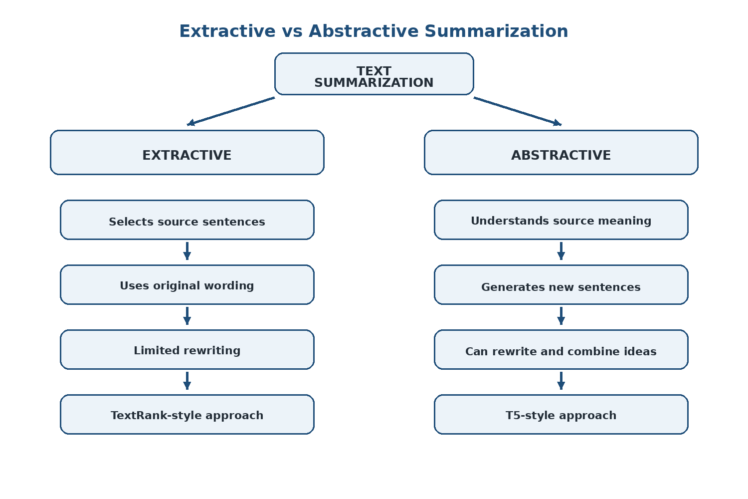
Figure 2.3: Comparison of Extractive and Abstractive Summarization
Abstractive summarization generates new language based on a representation of the source. Neural encoder-decoder architectures learn a mapping between source text and reference summaries. The approach can produce more natural and compact text, but generation also introduces risks such as omission, unsupported wording and hallucination. These risks are especially important in academic use.

2.4 Transformer Architectures
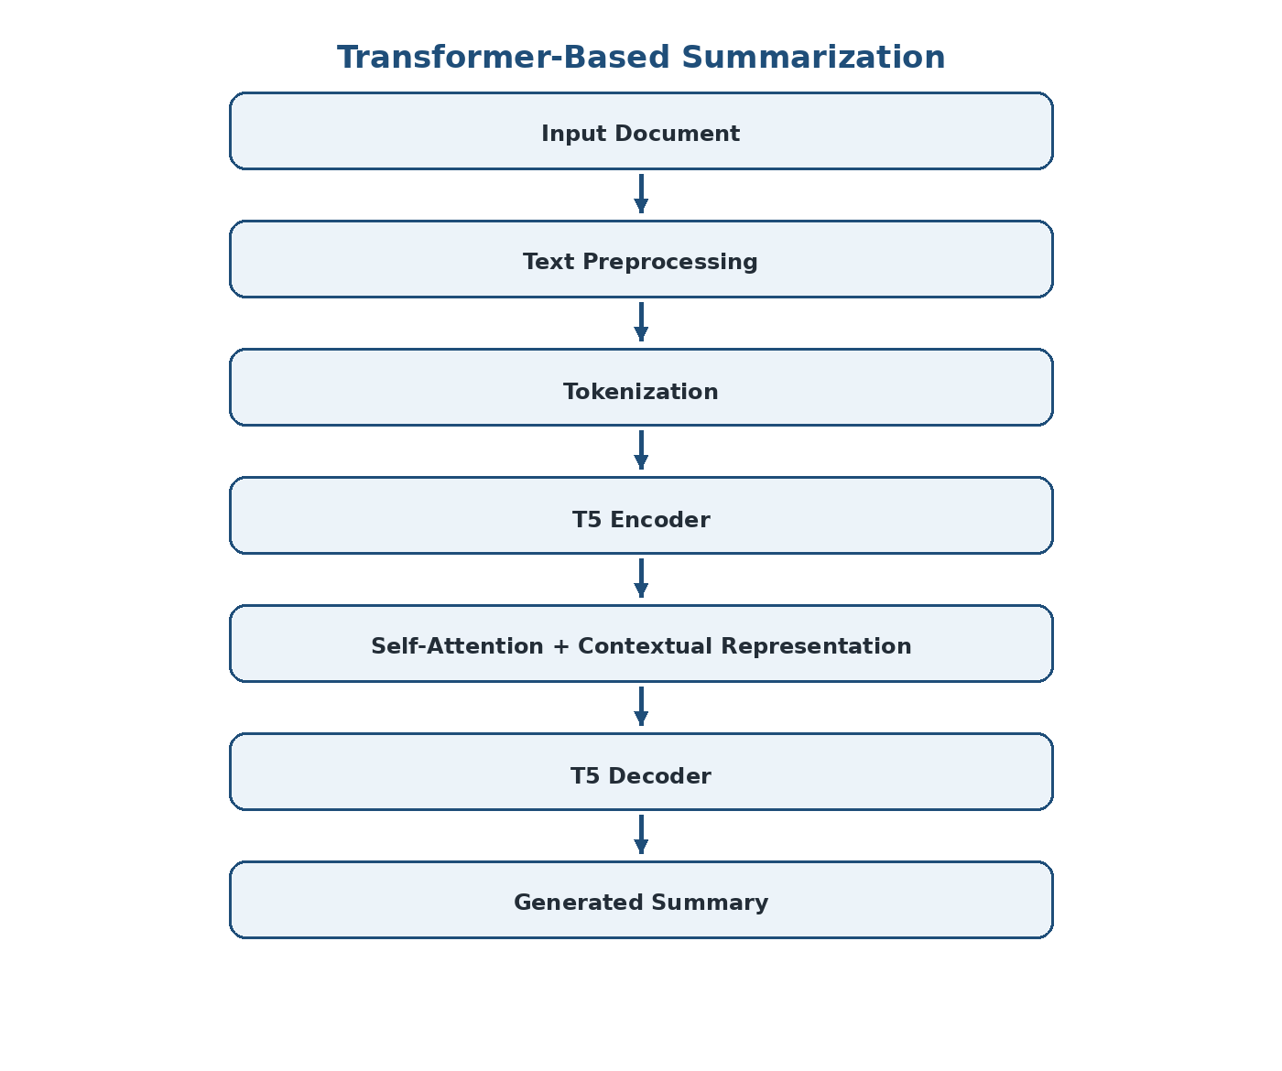
Figure 2.2: Transformer-Based Text Summarization Architecture
Transformers use attention mechanisms to model relationships among tokens. The project material distinguishes BERT, GPT and T5 by their architecture and intended role. BERT is primarily an encoder model focused on representation and understanding. GPT is decoder-oriented and designed for generation. T5 uses an encoder-decoder structure, making it naturally suitable for conditional generation tasks such as summarization.
The use of pretrained models is an engineering advantage because transfer learning reduces the amount of task-specific training required compared with building and training a large transformer from scratch. The trade-off is that inference and fine-tuning still require substantial computational resources depending on model size and workload.

2.5 T5 and Multilingual T5
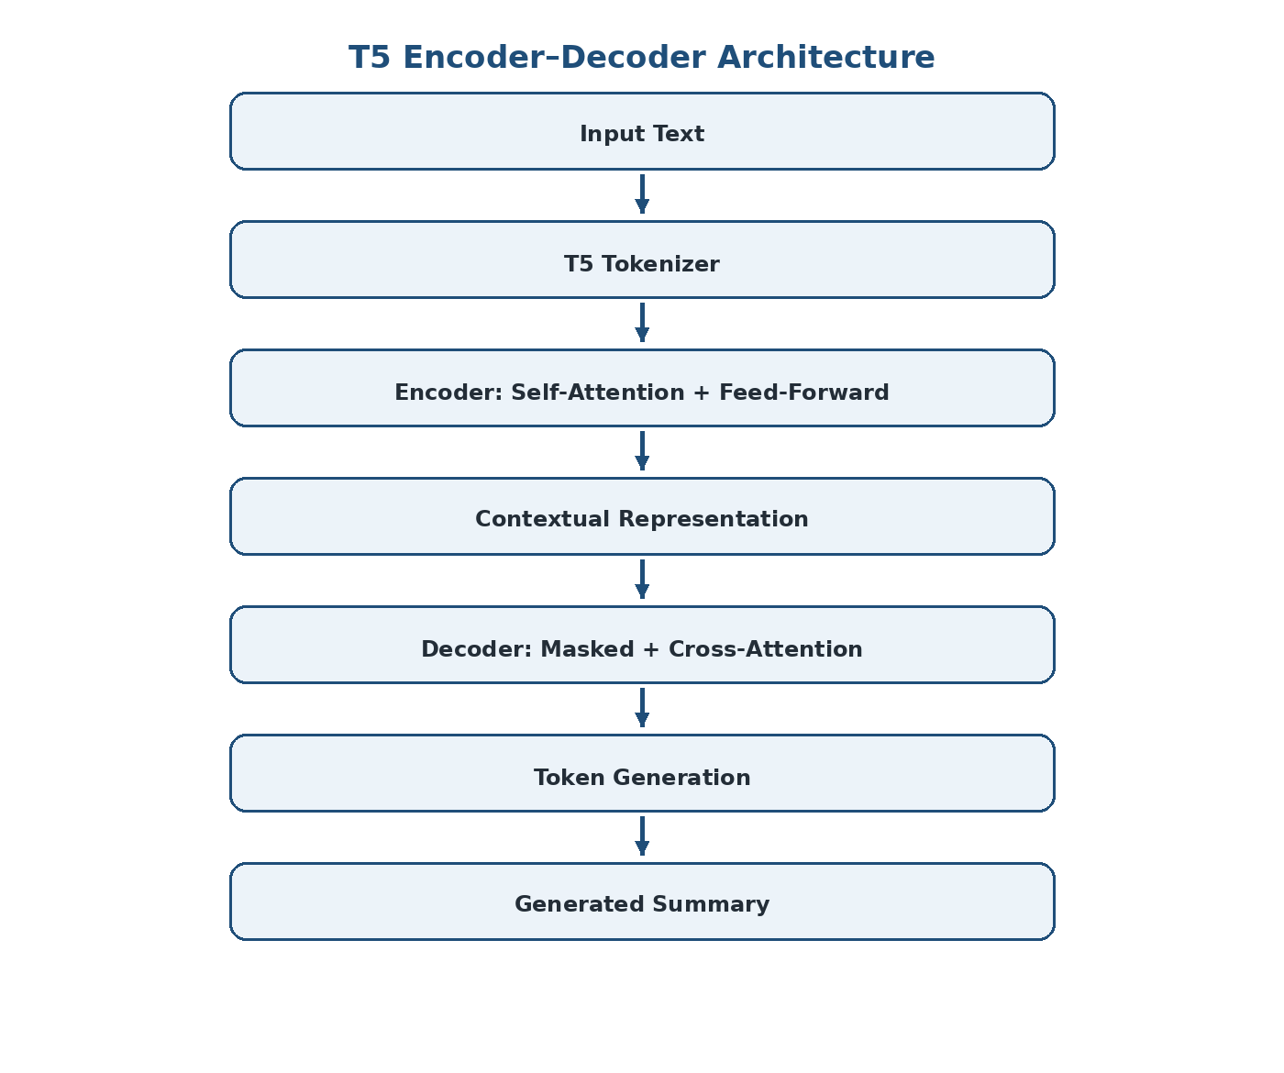
Figure 2.4: T5 Transformer Encoder–Decoder Architecture
T5 formulates NLP tasks in a text-to-text manner. For summarization, the input is converted into an instruction-style or task-specific sequence and the decoder generates the target summary. A multilingual T5-family model can extend this concept across languages using a shared multilingual representation and tokenizer.
The project uses the MLSUM/MLSAM dataset as the primary multilingual summarization dataset. The supplied project material states that it contains more than 1.5 million article–summary pairs across French, German, Spanish, Russian and Turkish and is organized into training, validation and test splits.

2.6 Long-Document Summarization
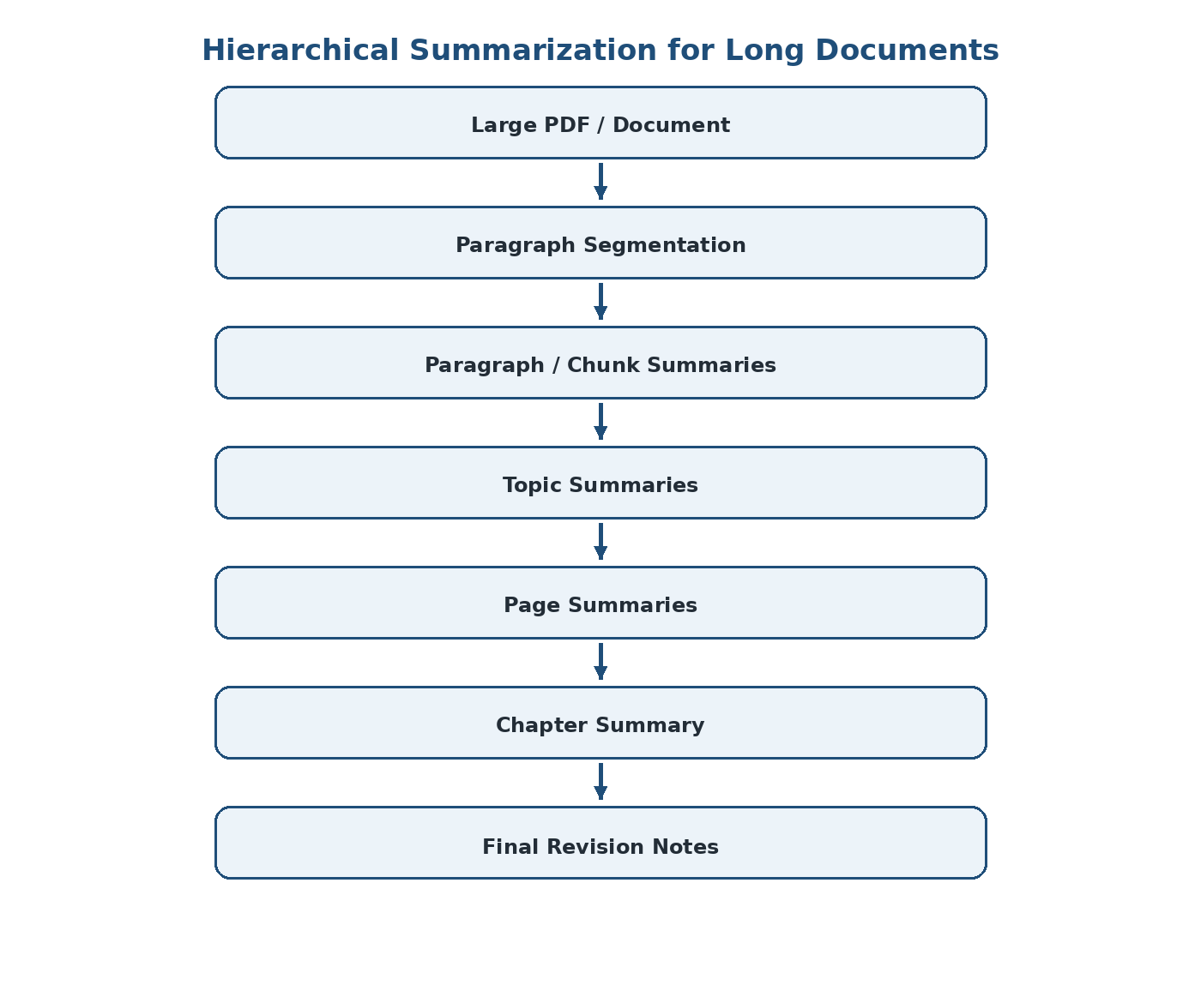
Figure 2.5: Hierarchical Summarization for Long Documents
A major engineering issue is input length. A full 80-page PDF cannot simply be placed into one model input without exceeding practical context limits. The proposed system therefore uses hierarchical summarization. It first summarizes smaller paragraphs, then combines those micro-summaries into topic notes, page notes and chapter-level notes.
This approach introduces additional model calls and possible error accumulation, but it creates a controllable hierarchy and allows the application to present different levels of detail. It also makes source mapping more manageable because each intermediate representation can retain its source relationship.

2.7 Evaluation with ROUGE
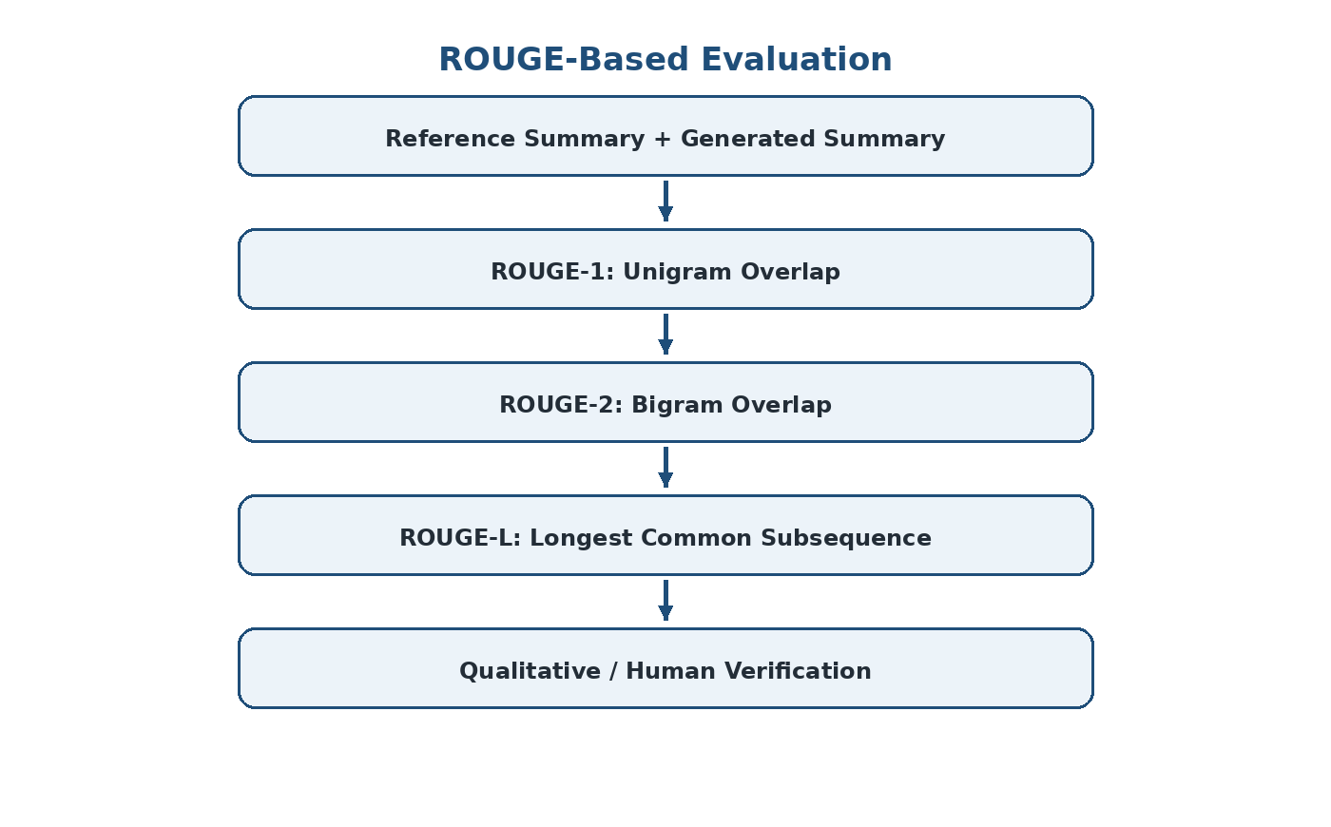
Figure 2.8: ROUGE-Based Summary Evaluation Process
ROUGE is used to compare generated summaries with human-written reference summaries. ROUGE-1 measures overlap of individual tokens or unigrams, ROUGE-2 measures bigram overlap, and ROUGE-L uses the longest common subsequence to capture a broader sequence relationship.
ROUGE is useful because it provides a repeatable numerical evaluation, but it does not completely represent factual correctness, readability or semantic equivalence. The project material explicitly notes that human evaluation remains important because different metrics can produce different conclusions and word overlap can miss meaning.

2.8 Traceable / Source-Grounded Learning Systems
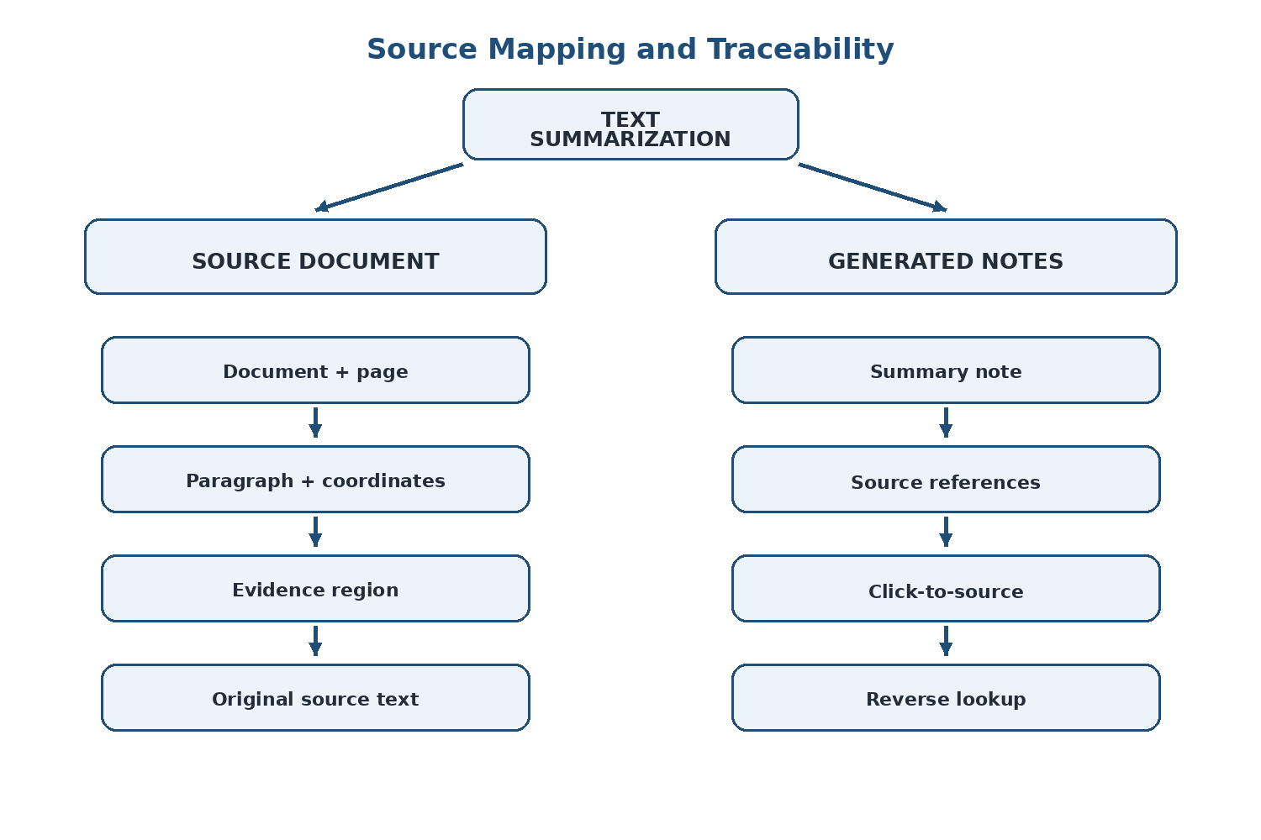
Figure 2.7: Source Mapping Between Generated Summary and Original Document
The proposed platform extends summarization into source-grounded learning. Instead of storing only generated text, it stores page numbers, paragraph identifiers and text-position coordinates. When a learner selects a note, the application can locate the corresponding source region and highlight it in the PDF viewer.
This changes the role of summarization from a final answer generator into a navigable representation of a document. It also provides a mechanism for students to verify definitions, formulas, conditions and exceptions before relying on a generated note.

2.9 Comparative Analysis
Aspect | Traditional Extractive | Generic Abstractive | Proposed T5 Platform
Output | Selected source sentences | Generated text | Generated hierarchical notes
Rewriting | No | Yes | Yes
Multilingual support | Depends on method | Model dependent | MLSUM/MLSAM + T5-family
Context modeling | Limited | Strong | Transformer-based
Long documents | Possible with ranking | Context limited | Hierarchical processing
Source traceability | Naturally available | Often weak | Explicit page/paragraph/coordinate mapping
Personalization | Usually absent | Usually limited | Planned confusion/learning analytics
Evaluation | Precision/coverage variants | ROUGE and human review | ROUGE + source verification

2.10 Engineering Gap
The engineering gap identified by the project is the separation between summary generation and trustworthy academic use. A generic summarizer can produce fluent output, but an academic learning platform needs additional structure: document segmentation, source mapping, multiple levels of summary, reusable notes and mechanisms for checking the generated information. The project therefore combines the NLP model with an evidence-oriented document representation.

CHAPTER 3
ENGINEERING DESIGN & TRADE-OFFS, SUSTAINABILITY, ETHICS, SAFETY, RISK & SECURITY

3.1 System Requirements

3.1.1 Functional Requirements
ID | Functional Requirement | Description | Priority
FR-01 | Document Input | Accept supported PDF/text learning material. | High
FR-02 | PDF Extraction | Extract text, page structure, paragraph boundaries and coordinates. | High
FR-03 | Preprocessing | Clean noise, normalize text and segment content. | High
FR-04 | Topic Segmentation | Detect headings and group related content. | High
FR-05 | T5 Summarization | Generate abstractive summaries from processed chunks. | High
FR-06 | Hierarchy | Create paragraph, topic, page and chapter summaries. | High
FR-07 | Source Mapping | Associate notes with source pages, paragraphs and coordinates. | High
FR-08 | Evaluation | Calculate ROUGE-1, ROUGE-2 and ROUGE-L. | High
FR-09 | Search | Support keyword and semantic retrieval across source and notes. | Medium
FR-10 | Study Workspace | Display PDF and notes in a linked interface. | High
FR-11 | Editing | Allow notes to be edited, annotated and pinned. | Medium
FR-12 | Learning Analytics | Collect interaction signals for confusion analysis. | Medium
FR-13 | Assistant | Provide retrieval-grounded clarification/viva support. | Medium

3.1.2 Non-Functional Requirements
Quality Attribute | Requirement | Engineering Interpretation
Performance | Reasonable processing time | Use chunking, batching and background jobs for large documents.
Usability | Simple study workflow | Keep PDF and notes visible together.
Reliability | Consistent source mapping | Never discard location metadata during preprocessing.
Maintainability | Modular implementation | Separate extraction, preprocessing, model, evaluation and UI layers.
Scalability | Support larger documents | Use hierarchical processing and asynchronous jobs.
Security | Protect uploaded content | Authentication, authorization and secure secret handling.
Explainability | Allow verification | Provide exact source links for generated notes.
Portability | Deployment flexibility | Containerization and environment-variable configuration.

3.2 Constraints and Applicable Standards
The project is a software/NLP capstone and therefore has constraints associated with model context length, available computing resources, dataset quality, inference time, data privacy and the reliability of generated text. These constraints are addressed as design requirements rather than ignored during implementation.
Reference / Principle | Relevance to Project | Application
ISO/IEC 25010 | Software quality characteristics | Consider functionality, performance, usability, reliability, security and maintainability.
IEEE 29148 principles | Requirements engineering | Document stakeholder needs, functional requirements and acceptance criteria.
Responsible AI principles | Generated-content risk | Make outputs verifiable and avoid presenting generated text as unquestionable fact.
Data minimization principle | Uploaded documents | Store only information required for the learning workflow.
Secure software practice | Authentication and secrets | Protect JWT secrets, database credentials and external API keys.

3.3 Design Specifications
Component | Selected Technology | Design Reason
Frontend | Vite + React + TypeScript | Component-based interactive interface.
Styling | TailwindCSS | Rapid construction of notebook and split-screen layouts.
PDF Viewer | react-pdf / pdf.js | Render source documents and support coordinate-based overlays.
Panel Layout | react-resizable-panels | Resizable source/notes workspace.
Graph UI | react-flow | Interactive concept and relationship visualization.
State | Zustand | Shared state such as selected note and active highlight.
Backend | FastAPI + Pydantic | Python-native API around NLP/ML components.
Background Jobs | Celery + Redis | Long-running document processing.
Database | MongoDB Atlas | Flexible nested document/note metadata.
PDF Extraction | PyMuPDF | Text plus exact bounding-box coordinates.
Preprocessing | spaCy | Sentence splitting, cleaning and pattern detection.
Summarization | T5/mT5 via Transformers + PyTorch | Abstractive encoder-decoder generation.
Embeddings | sentence-transformers | Semantic retrieval and confidence-related features.
Vector Search | ChromaDB / FAISS | Fast retrieval of relevant chunks.
Knowledge Graph | NetworkX | Concept and relationship construction.
Assistant | Groq API | Conversational clarification only; core summarization remains T5-based.

3.4 Alternative Solutions and Evaluation
Alternative | Advantages | Disadvantages | Decision
Extractive summarizer | Simple, fast, naturally source-linked | Cannot paraphrase or synthesize | Baseline only
Single-pass full-document T5 | Simple pipeline | Sequence-length limitation; high memory/input burden | Rejected
Large T5 model | Potentially stronger generation | High compute and inference cost | Not preferred for realistic deployment
T5-small/base family | Transfer learning with lower cost | May require careful tuning | Preferred
Generic PDF chatbot | Easy question-answer interaction | Does not build persistent hierarchical notes | Not sufficient as core system
Hierarchical T5 | Long-document handling + multiple granularities | More processing stages | Selected
Relational database | Strong tabular consistency | Less natural for nested note/graph structures | Not primary choice
MongoDB | Flexible nested document representation | Requires careful schema discipline | Selected

3.5 Selected Architecture
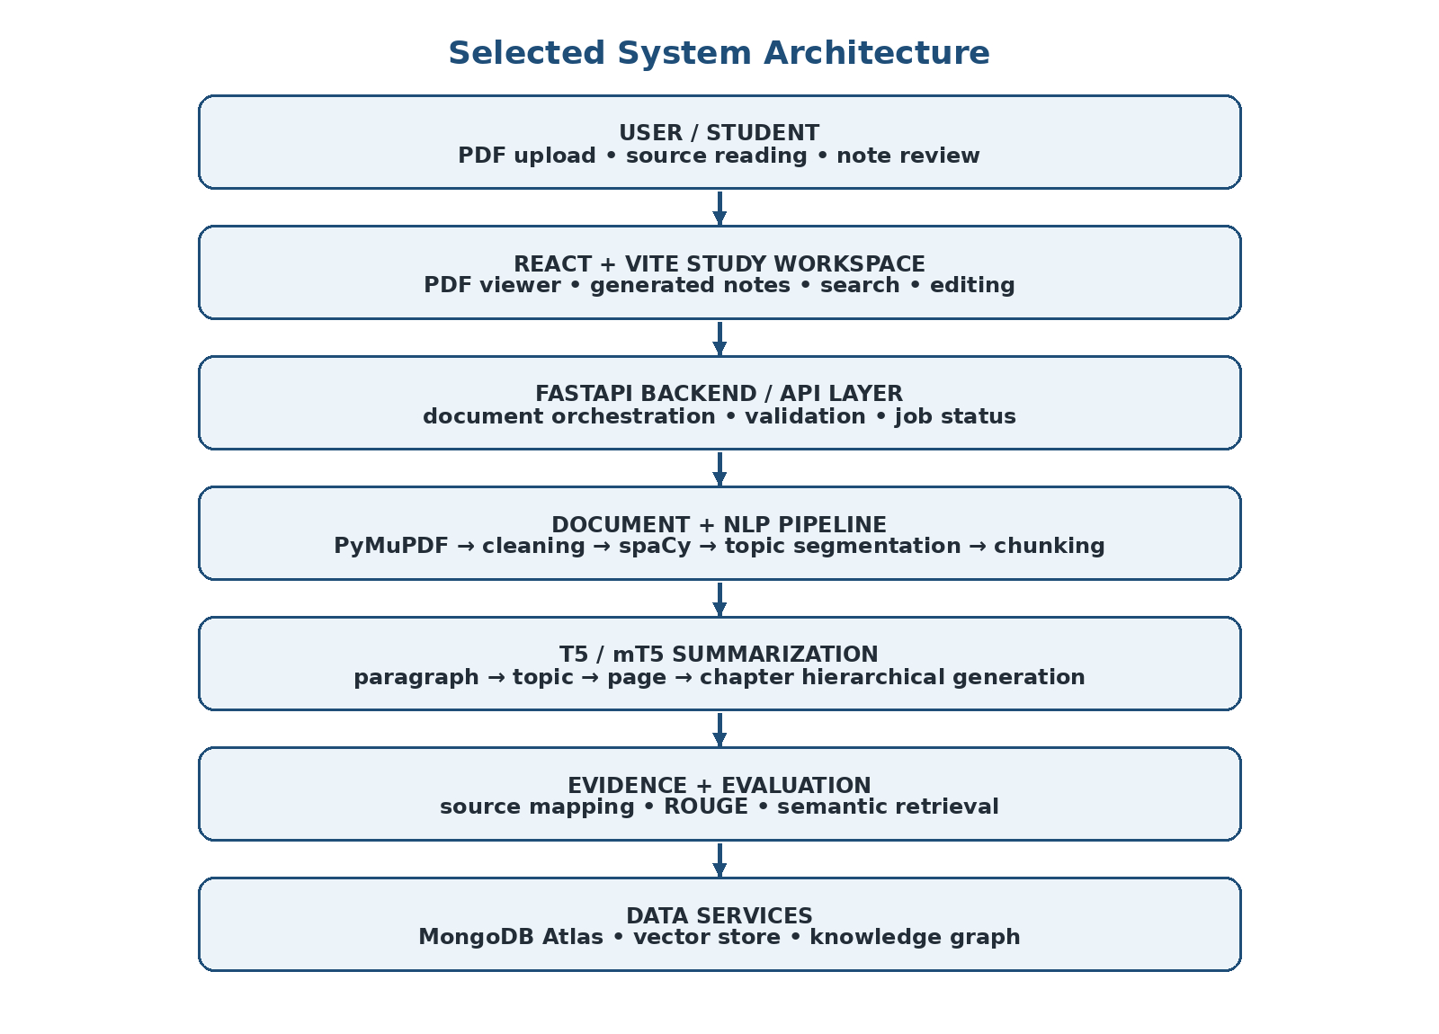
Figure 3.1: Selected System Architecture
The selected architecture is layered so that each major engineering concern can be developed and tested independently. The document layer extracts source content and coordinates. The NLP layer cleans and segments the text. The summarization layer generates abstractive content. The evidence layer preserves the relationship between generated notes and source regions. The application layer presents the results and supports interactive learning.
High-level flow:
PDF / Text Input → Extraction → Preprocessing → Topic Segmentation → Chunking → T5 Summarization → Hierarchical Roll-up → Source Mapping → Evaluation → Interactive Learning Workspace

3.5.1 Frontend Layer
The frontend is planned around React and Vite using TypeScript. The PDF is rendered using react-pdf/pdf.js. Generated notes are presented in a notebook-like interface. A resizable panel separates the source PDF from the generated notes, allowing users to change the amount of screen space given to each view.

3.5.2 Backend Layer
FastAPI provides Python-native API endpoints around document processing and model inference. Pydantic is used to validate structured information such as page numbers, paragraph identifiers and coordinates. Long-running jobs can be moved to Celery workers with Redis acting as the message broker so that a large PDF does not block a normal web request.

3.5.3 Data Layer
MongoDB Atlas is selected for flexible storage of document metadata, extracted chunks, hierarchical notes and graph-related information. The project's data structures are naturally nested: a chapter contains pages, pages contain topics and topics contain paragraphs, while a note may reference one or more source regions.

3.6 Detailed NLP Pipeline Design

3.6.1 Stage 1 – PDF Extraction
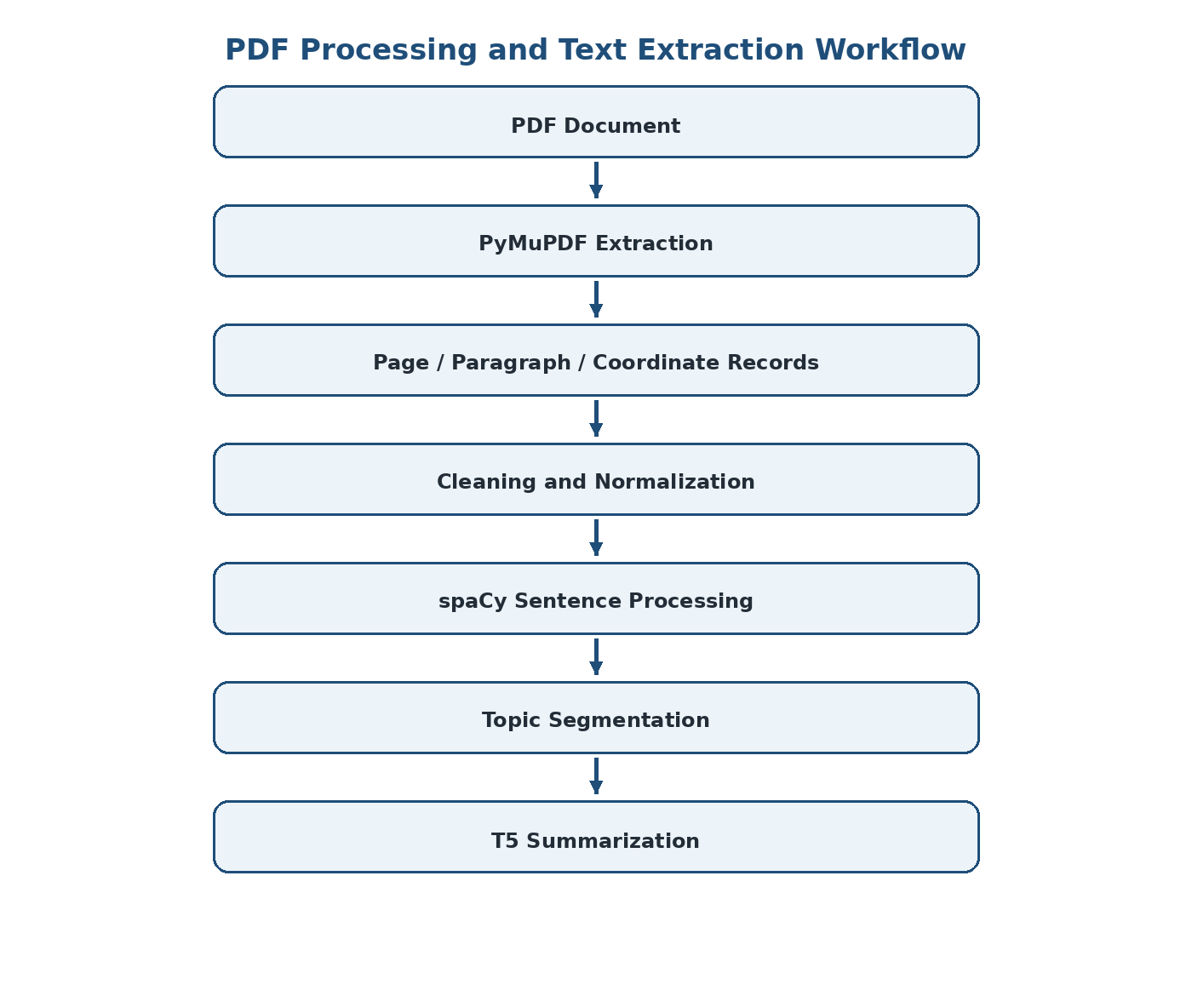
Figure 3.2: PDF Document Processing and Text Extraction Workflow
PyMuPDF reads the source PDF and extracts text along with page-level and text-span information. The critical engineering requirement is to retain bounding-box coordinates because later highlighting depends on knowing where a source span appears on the rendered page.

3.6.2 Stage 2 – Cleaning and Normalization
Extracted PDF text may contain line breaks inside sentences, repeated headers and footers, page numbers, inconsistent spaces and extraction artifacts. The preprocessing stage removes or normalizes these patterns while preserving the mapping to the original page and paragraph. The system therefore separates 'clean text for the model' from 'source metadata for evidence'.

3.6.3 Stage 3 – Sentence Processing
spaCy is used for sentence splitting and rule-based processing. Sentence boundaries are required because chunking at arbitrary character positions can split logical statements. The preprocessing stage also provides a foundation for detecting definitions, formulas, units, laws, examples and other exam-relevant patterns.

3.6.4 Stage 4 – Topic Segmentation
Headings and subheadings are used to organize related paragraphs into topics and subtopics. Topic segmentation is important because the later hierarchy should represent the document's logical structure rather than simply its raw page order.

3.6.5 Stage 5 – T5 Generation
The processed text is tokenized using the model's tokenizer and supplied to the T5-family encoder-decoder. The encoder builds contextual representations of the input, while the decoder generates the summary token by token. The project uses abstractive generation so that the output can condense and rewrite information.

3.6.6 Stage 6 – Hierarchical Roll-up
Paragraph summaries are aggregated into topic notes. Topic notes are then used to construct page-level summaries, and page-level information is rolled into chapter-level revision notes. This bottom-up process is deliberately chosen because it respects the practical limitations of transformer input size and creates multiple useful study views.

3.7 Source-Mapping and Traceability Design
Traceability is the main differentiating design decision. Every chunk entering the NLP pipeline carries metadata that identifies its document, page, paragraph and text coordinates. The generated note stores references to those source records. The application can therefore translate a selected note into one or more highlight regions in the original PDF.
Metadata Field | Purpose | Example Meaning
document_id | Identifies source document | Uploaded textbook/unit
page_number | Identifies source page | Page 27
paragraph_id | Identifies source paragraph | Paragraph 27-04
bbox | Identifies visual position | x0, y0, x1, y1
topic_id | Connects paragraph to topic | Topic 5
note_id | Identifies generated note | Note 5.3
source_refs | Maps note to evidence | List of paragraph IDs
summary_level | Identifies hierarchy | paragraph/topic/page/chapter
When a user clicks a generated note, the frontend uses the stored source reference to locate the page and draw a highlight overlay over the stored coordinates. Reverse lookup follows the opposite direction: a selected paragraph can identify the notes that summarize it.

3.8 Data Model and Information Flow
The information flow is intentionally designed so that source information is never detached from processed content. Raw extraction produces source records. Preprocessing produces cleaned chunks while retaining source references. Summarization produces generated text with source references. Hierarchical aggregation combines notes while retaining links to the underlying evidence.
Object | Important Fields | Relationship
Document | id, title, page_count, metadata | Contains pages/chunks
Source Chunk | page, paragraph, text, bbox, topic_id | Evidence unit
Summary Note | id, text, level, source_refs | Summarizes one or more chunks
Topic | id, heading, parent, note_refs | Groups related chunks/notes
Graph Node | id, label, type, evidence_refs | Represents concept
Graph Edge | source, target, relation, evidence_refs | Represents relationship
Learning Signal | student, source_id, event, timestamp | Feeds personalization

3.9 Application and Interface Design
The proposed interface uses a split-screen layout. The left side displays the original PDF and evidence highlights. The right side displays generated notes organized by topic. A draggable divider allows the user to prioritize either source reading or note review.
- Click-to-source: selecting a note highlights its supporting PDF paragraph.
- Reverse lookup: selecting a source paragraph reveals its related note.
- Multi-granularity views: paragraph, topic, page and chapter.
- Editable notes: learners can modify generated text and add annotations.
- Personal notebook: pinned content can be collected for revision.
- Universal search: search source content and generated notes.
- Style switching: concise revision points, detailed notes or simplified explanations.
- Export: notes can be prepared for offline PDF or Markdown use.

3.10 Trade-off Analysis
Design Decision | Benefit | Cost / Risk | Reason for Selection
T5 over extractive baseline | Abstractive, coherent rewriting | Higher compute and generation risk | Core project requirement
Hierarchical summarization | Supports long documents and multiple levels | More inference stages | Avoids single-input length problem
Source coordinates | Pixel-level evidence highlighting | More metadata and storage | Critical for trust
MongoDB | Flexible nested structures | Schema discipline required | Fits notes/graphs
FastAPI | Python-native ML integration | Requires async job strategy | Reduces language boundary
Celery + Redis | Non-blocking long jobs | Operational complexity | Needed for larger documents
Separate embedding model | Better semantic retrieval | Additional model/storage | T5 is not primarily an embedding model
Groq assistant boundary | Interactive conversation | External dependency | Keeps core NLP contribution independent

3.11 Sustainability
Sustainability is addressed primarily through computational efficiency and software lifecycle design. Transformer training and inference can consume substantial compute. The use of pretrained models avoids the need to train a large model from scratch. The architecture also allows smaller T5-family checkpoints to be used for practical development and deployment.
- Use pretrained models and transfer learning.
- Use batching and chunk-level processing where appropriate.
- Use smaller model variants when their quality is adequate.
- Introduce background processing only when necessary for long jobs.
- Consider quantization, pruning or distillation in future optimization.
- Keep deployment configuration reproducible through Docker and environment variables.

3.12 Ethics and Responsible AI
The central ethical issue is that generated text may appear authoritative even when it is incomplete or incorrect. The project therefore treats verification as a system feature. Source links should be visible when a generated note is used for academic study.
- Do not present generated summaries as guaranteed factual truth.
- Preserve source evidence so learners can verify important claims.
- Clearly separate the core T5 summarizer from the optional conversational assistant.
- Do not use student interaction data beyond what is necessary for personalization.
- Protect uploaded academic documents and avoid unnecessary exposure of private information.
- Retain human review as part of high-stakes academic interpretation.

3.13 Safety and Reliability
For a software-only educational system, safety is primarily concerned with information reliability, predictable operation and avoidance of misleading output. A fluent summary that drops a critical condition can be more dangerous academically than a visibly poor summary. The system should therefore encourage users to inspect source evidence, especially for formulas, rules, exceptions and definitions.

3.14 Security and Privacy
Security Area | Threat | Mitigation
Authentication | Unauthorized account access | JWT-based authentication
Authorization | Access to another user's documents | User/document ownership checks
Secrets | API/database key exposure | Environment variables and secure deployment secrets
Database | Unauthorized data access | Protected MongoDB configuration and least privilege
Uploaded PDFs | Sensitive content leakage | Controlled storage and access
API | Malicious or invalid requests | Pydantic validation and input checks
External AI | Unintended source-data disclosure | Retrieve only necessary context and maintain project boundary

3.15 Risk Register and Mitigation
Risk | Likelihood | Impact | Mitigation | Residual Risk
Model input exceeds context limit | High | High | Chunking and hierarchical summarization | Medium
Important information omitted | Medium | High | Source mapping + evaluation + human verification | Medium
Hallucinated statement | Medium | High | Evidence links and retrieval-grounded assistance | Medium
Poor language-specific performance | Medium | Medium | Language-wise testing and dataset analysis | Medium
Slow inference | Medium | Medium | Smaller models, batching and async jobs | Low/Medium
PDF extraction error | Medium | High | Extraction validation and source-preserving preprocessing | Medium
Unauthorized document access | Low | High | JWT, authorization and protected storage | Low/Medium
External API unavailable | Medium | Low/Medium | Keep core summarizer independent of assistant layer | Low
Evaluation metric misleading | Medium | Medium | Use ROUGE with qualitative/human | Medium

CHAPTER 4
IMPLEMENTATION, TESTING & RESULTS, PROJECT MANAGEMENT

4.1 Development Approach
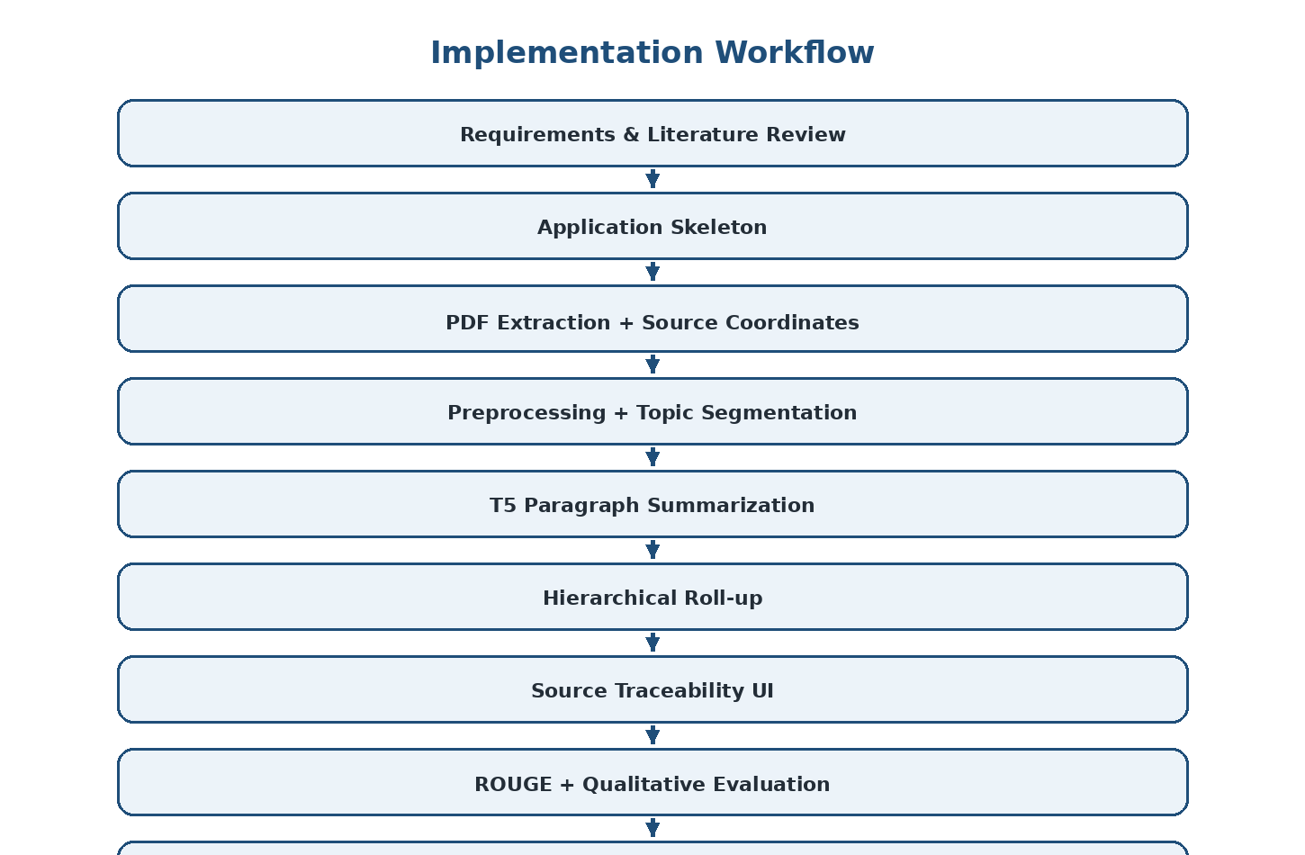
Figure 4.1: End-to-End Implementation Workflow
The project follows an incremental development strategy. The application skeleton and document pipeline are established before adding advanced AI features. The recommended implementation sequence begins with the frontend, backend, database connection and authentication, followed by PDF extraction and source highlighting. Preprocessing and topic segmentation are then validated before T5 summarization is introduced.
- Set up Vite + React frontend, FastAPI backend and MongoDB Atlas connection.
- Implement basic authentication and document upload.
- Build PDF extraction using PyMuPDF and store source coordinates.
- Verify coordinate-based highlighting before adding machine learning.
- Implement spaCy-based preprocessing and topic segmentation.
- Implement paragraph-level T5 summarization.
- Store generated summaries together with source references.
- Build topic → page → chapter hierarchical roll-up.
- Connect notes to PDF highlights and reverse lookup.
- Add key-information extraction and exam-essentials notebook.
- Add semantic search and retrieval-grounded assistant.
- Add confusion analytics, knowledge graph and viva simulator.
- Introduce Celery/Redis for large background jobs.
- Containerize and deploy only after the local workflow is stable.

4.2 Implementation Environment
Layer | Technology / Tool | Role
Programming | Python | NLP and backend implementation
Deep Learning | PyTorch | Model computation
Transformer | Hugging Face Transformers | T5/mT5 model and tokenizer
Data | Pandas, NumPy | Dataset processing
PDF | PyMuPDF | Text and coordinate extraction
NLP | spaCy | Sentence processing and pattern detection
Evaluation | ROUGE | Summary quality measurement
Frontend | React + Vite + TypeScript | User interface
Backend | FastAPI + Pydantic | API and orchestration
Async | Celery + Redis | Background processing
Database | MongoDB Atlas | Metadata and notes
Semantic Retrieval | sentence-transformers + ChromaDB/FAISS | Retrieval
Graph | NetworkX + react-flow | Knowledge graph
Assistant | Groq API | Grounded conversation

4.3 Dataset Preparation
The project uses the MLSUM/MLSAM multilingual summarization dataset. The supplied project material describes it as a large dataset of multilingual news article–summary pairs, with more than 1.5 million pairs across French, German, Spanish, Russian and Turkish. Human-written summaries provide reference targets for supervised abstractive summarization.
The dataset preparation process consists of loading records, checking required article and summary fields, removing invalid or empty records, normalizing text where appropriate, tokenizing inputs and targets, and maintaining train/validation/test separation. Because multilingual text may contain different scripts and word structures, subword tokenization is important.
Preparation Step | Purpose | Expected Output
Record validation | Remove malformed examples | Valid article-summary pairs
Text cleaning | Reduce irrelevant noise | Normalized source/target
Language handling | Preserve multilingual content | Language-aware records
Tokenization | Convert text to model tokens | Input/target token IDs
Length filtering | Respect model limits | Usable training/evaluation examples
Dataset split | Avoid leakage between stages | Train/validation/test sets

4.4 PDF Extraction and Preprocessing
For the application workflow, PyMuPDF extracts readable text and coordinates from uploaded PDFs. The extraction process must preserve enough structure to distinguish headings, paragraphs and pages. The system keeps source metadata even when the visible text is cleaned for NLP processing.
The preprocessing stage handles common PDF extraction artifacts such as broken lines, repeated headers, page numbers and inconsistent whitespace. spaCy provides sentence splitting, while rule-based patterns can support identification of definitions, formulas, units and other exam-oriented information.

4.5 T5 Summarization Implementation
The T5-family model is loaded through Hugging Face Transformers. A tokenizer converts source text into model-compatible token sequences. The encoder processes the input and builds contextual representations. The decoder then generates the summary sequentially.
The implementation can use a pretrained checkpoint for initial development and a fine-tuned checkpoint for the project's supervised summarization task. Model size is a practical engineering decision: larger models may provide stronger capacity but increase inference time and resource requirements. The project architecture therefore favors realistic model sizes for development and deployment.

4.5.1 Generation Process
- Receive a cleaned text chunk.
- Apply the T5 tokenizer.
- Create model input tensors and attention masks.
- Pass the input through the encoder-decoder model.
- Generate output tokens using configured decoding parameters.
- Decode tokens back into readable text.
- Store the generated summary with source metadata.

4.6 Hierarchical Summarization Implementation
The hierarchical summarizer is the core long-document strategy. A large document is first divided into logical paragraphs or manageable chunks. Each chunk receives a micro-summary. Micro-summaries belonging to a topic are then combined and summarized again. The same process is repeated for page and chapter levels.
Level | Input | Output | Purpose
Paragraph | Original paragraph | Micro-summary | Fine-grained compression
Topic | Paragraph summaries | Topic note | Concept-level organization
Page | Topic notes / page content | Page note | Page-level revision
Chapter | Page notes | Chapter summary | High-level revision
The hierarchy provides an important usability benefit: a student can begin with a chapter-level overview and progressively inspect a topic or paragraph when more detail is required. The same hierarchy also provides natural units for source mapping.

4.7 Source Grounding Implementation
Each summary record contains a source reference list. For paragraph-level summaries, this may point directly to one source paragraph. Higher-level summaries can point to multiple lower-level notes and therefore indirectly to multiple source regions. The source-mapping engine resolves these relationships to page and coordinate information for visual highlighting.
This design supports two directions of navigation. Forward navigation begins with a note and opens its supporting source. Reverse navigation begins with a source paragraph and opens the generated note associated with it.

4.8 Application Integration
The React interface receives document and note metadata through the FastAPI backend. The PDF viewer renders the source document. When a note becomes active, the frontend requests or uses the stored page and coordinate information to render a highlight overlay. The notes panel displays the corresponding generated text.
For large documents, the backend can delegate processing to Celery workers. Redis acts as the message broker. The user interface can then show stages such as extraction, segmentation and summarization instead of appearing unresponsive during a long-running job.

4.9 Testing Strategy
Testing is organized at unit, integration and end-to-end levels. Unit testing verifies individual functions such as cleaning, sentence segmentation and metadata handling. Integration testing verifies that extracted source records can be passed through preprocessing and summarization while retaining source references. End-to-end testing verifies the full workflow from upload to displayed notes and evidence highlighting.

4.10 Functional Test Cases
TC ID | Test Scenario | Input | Expected Result | Status
TC-01 | Upload valid PDF | Readable PDF | Document accepted and extracted | To be recorded
TC-02 | Extract page text | PDF page | Text associated with correct page | To be recorded
TC-03 | Preserve coordinates | Text span | Bounding box stored | To be recorded
TC-04 | Clean extraction noise | PDF with headers/line breaks | Normalized text | To be recorded
TC-05 | Segment topic | Headings + paragraphs | Logical topic groups | To be recorded
TC-06 | Generate paragraph summary | Clean paragraph | Abstractive summary returned | To be recorded
TC-07 | Generate hierarchy | Paragraph summaries | Topic/page/chapter notes | To be recorded
TC-08 | Click-to-source | Generated note | Correct source highlighted | To be recorded
TC-09 | Reverse lookup | Source paragraph | Related note displayed | To be recorded
TC-10 | ROUGE evaluation | Generated + reference summary | ROUGE-1/2/L values | To be recorded
TC-11 | Semantic search | Keyword/concept query | Relevant source chunks | To be recorded
TC-12 | Invalid input handling | Unsupported/empty file | Validation error | To be recorded
TC-13 | Long document | Large PDF | Background processing without UI blocking | To be recorded
TC-14 | Authentication | Valid/invalid credentials | Authorized access only | To be recorded

4.11 Evaluation Method
The principal automatic evaluation method is ROUGE. Generated summaries are compared against human-written reference summaries. ROUGE-1 provides unigram overlap, ROUGE-2 provides bigram overlap and ROUGE-L measures longest-common-subsequence similarity.
The project deliberately avoids treating ROUGE as a complete measure of quality. A generated summary may have low word overlap while preserving meaning through paraphrasing, or it may have high overlap while still missing an important condition. Therefore, qualitative review and source verification should accompany metric-based evaluation.

4.12 Results and Analysis
The supplied project material confirms the use of T5-based abstractive summarization, MLSUM/MLSAM multilingual data and ROUGE-1/2/L evaluation. It also defines the source-traceability and hierarchical-note architecture. However, the supplied material does not provide a verified final numerical ROUGE table, latency benchmark or completed test-count record. Accordingly, this report does not fabricate those values.
Measure | Evidence Available from Project Material | Final Submission Action
Summary generation | T5-family abstractive generation is part of the system design | Attach representative generated outputs
ROUGE-1 | Defined as an evaluation metric | Insert actual measured score
ROUGE-2 | Defined as an evaluation metric | Insert actual measured score
ROUGE-L | Defined as an evaluation metric | Insert actual measured score
Long-document handling | Hierarchical paragraph → topic → page → chapter design | Attach end-to-end demonstration
Source traceability | Page/paragraph/coordinate mapping design | Attach click-to-source screenshot
Processing time | No verified benchmark supplied | Measure on final hardware/software setup
Test pass rate | Test scenarios defined | Insert actual executed test results

4.13 Comparison with Existing Approaches
Aspect | Traditional / Generic Method | Proposed System
Summarization | Extractive or free-form generated text | T5 abstractive summarization
Long documents | May truncate or require manual splitting | Hierarchical processing
Source evidence | Often limited | Explicit source mapping
Study structure | Single summary | Paragraph/topic/page/chapter
Personalization | Usually absent | Confusion and interaction analytics planned
Retrieval | Question-focused | Persistent document representation + semantic retrieval
Learning artifacts | Usually not available | Notebook, exam essentials, graph and transition cards
Assistant | General chatbot | Retrieval-grounded assistant over source content

4.14 Strengths and Limitations

Strengths
- Transformer-based abstractive generation.
- Multilingual dataset and model orientation.
- Hierarchical summarization for long documents.
- Exact source-location metadata for verification.
- Interactive PDF and notes workspace.
- Reusable study artifacts beyond one chat session.
- Clear separation between core T5 NLP contribution and optional conversational AI.

Limitations
- Long-document processing can be computationally expensive.
- Hierarchical summarization may introduce information loss across stages.
- ROUGE focuses heavily on textual overlap and cannot fully judge factuality.
- PDF extraction quality depends on the structure and encoding of the input document.
- Language-wise performance may vary across the five dataset languages.
- Personalization features depend on sufficient user interaction data.
- External assistant functionality introduces a dependency when enabled.

4.15 Project Planning and Team Roles
Phase | Major Work | Expected Deliverable
Phase 1 | Requirements and literature review | Problem definition and design basis
Phase 2 | Application skeleton | Frontend/backend/database connectivity
Phase 3 | PDF extraction | Source text and coordinate records
Phase 4 | Preprocessing | Clean chunks and topic segmentation
Phase 5 | T5 summarization | Paragraph-level generated summaries
Phase 6 | Hierarchy | Topic/page/chapter notes
Phase 7 | Traceability UI | Click-to-source and reverse lookup
Phase 8 | Evaluation | ROUGE and qualitative analysis
Phase 9 | Advanced features | Search, graph, heatmap, assistant, viva
Phase 10 | Testing and documentation | Final report and demonstration
The team contribution statement records individual responsibility areas. For final assessment, the contribution percentages and evidence should be aligned with actual Git history, code ownership, testing records and report sections.

4.16 Budget and Resource Considerations
The project is primarily software-based and relies on open-source development libraries and pretrained models. Major cost drivers are computational resources, cloud deployment and any external API usage. During development, local execution reduces recurring infrastructure cost. The planned deployment architecture uses Docker Compose and Render later, while MongoDB Atlas provides cloud-hosted database infrastructure.
Resource | Nature | Cost Consideration
Python / open-source libraries | Software | No software license cost
Hugging Face Transformers / PyTorch | Software | Open-source; compute is the main cost
MLSUM/MLSAM dataset | Dataset | Used as project dataset; access conditions should be checked
Local development machine | Hardware | Existing system
MongoDB Atlas | Cloud service | Free/paid tier depending on usage
Groq API | External service | Usage-dependent if enabled
Render / hosting | Cloud deployment | Usage-dependent if deployed
Storage / bandwidth | Infrastructure | Depends on document volume

CHAPTER 5
CONCLUSION & REFLECTION

5.1 Conclusion
This capstone project presents an automatic text summarization system based on a T5-family Transformer and extends it into a traceable academic PDF-to-notes platform. The project addresses a practical problem: students often need concise representations of lengthy documents, but generic summaries may be difficult to verify and may not preserve the document's logical structure.
The selected approach uses abstractive generation so that the model can rewrite and condense source information. The MLSUM/MLSAM multilingual dataset provides article–summary pairs for supervised summarization, while ROUGE-1, ROUGE-2 and ROUGE-L provide standard automatic evaluation measures. The system architecture also incorporates PyMuPDF, spaCy, sentence-transformers, vector search and NetworkX to support the wider learning workflow.
The most important engineering decision is the preservation of source metadata. Page numbers, paragraph identifiers and text coordinates are retained from extraction through preprocessing and summarization. This makes it possible for a generated note to act as an entry point back into the original PDF. The design therefore treats trust and verification as part of the product architecture rather than as an afterthought.
The hierarchical paragraph → topic → page → chapter strategy addresses the practical difficulty of summarizing very long documents within transformer context limits. At the same time, it gives students several levels of revision detail. The final system is consequently not just a summarization model, but an integrated document-understanding and learning workflow.

5.2 Future Work
- Extend support to additional low-resource and regional languages.
- Evaluate language-specific performance rather than relying only on aggregate metrics.
- Adapt the summarization model to academic, medical, legal and technical domains.
- Investigate long-context transformer models alongside the hierarchical approach.
- Introduce factuality and consistency checks for generated summaries.
- Use human-in-the-loop evaluation with students and subject experts.
- Optimize inference through quantization, pruning, distillation or smaller task-specific models.
- Improve semantic confidence scoring and evidence ranking.
- Develop richer adaptive learning models from reading, rereading, quiz and doubt signals.
- Deploy the system as a scalable web/mobile application.
- Improve offline export and personal revision-notebook capabilities.
- Measure latency, memory use, throughput and cost under realistic document workloads.

5.3 Professional Learning & Individual Reflection

G. Jaswanth (192472235)
The most difficult engineering problem I encountered was designing a long-document summarization workflow without losing the relationship between generated content and its source. I addressed this by using hierarchical paragraph-to-topic/page/chapter processing while preserving page, paragraph and coordinate metadata throughout the NLP pipeline. A key engineering decision I personally made was to treat source traceability as a core system requirement because academic users need evidence before trusting generated notes. I independently strengthened my knowledge of T5 encoder-decoder models, tokenization, ROUGE evaluation, PDF coordinate extraction and source-grounded NLP. If I repeated the project, I would add stronger factuality evaluation and benchmark the system systematically across document lengths and languages.

Pradeepkumar (192425016)
The most difficult engineering problem I encountered was preparing multilingual article-summary data in a consistent format suitable for transformer-based learning. I addressed it through structured validation, preprocessing, tokenization and separation of training, validation and test data. A key engineering decision I supported was using a pretrained T5-family model so that transfer learning could be used instead of training a transformer from scratch. I independently acquired deeper knowledge of multilingual summarization datasets, Hugging Face model pipelines and automatic evaluation. If I repeated the project, I would perform more systematic language-wise experiments and hyperparameter comparisons.

Yuvaraj R (192524058)
The most difficult engineering problem I encountered was integrating the NLP processing pipeline with an interactive application without making the user interface dependent on model internals. I addressed this by separating the frontend, backend, document-processing and summarization responsibilities into modular components. A key engineering decision I supported was using FastAPI as the backend boundary because the NLP pipeline is Python-native and can therefore be integrated without an additional language bridge. I independently developed knowledge of API integration, interactive document workflows and asynchronous processing requirements. If I repeated the project, I would place greater emphasis on deployment testing, response-time monitoring and usability evaluation.

REFERENCES

- Raffel, C., et al. (2020). Exploring the Limits of Transfer Learning with a Unified Text-to-Text Transformer. Journal of Machine Learning Research, 21(140), 1–67.
- Lin, C.-Y. (2004). ROUGE: A Package for Automatic Evaluation of Summaries. In Text Summarization Branches Out.
- Wang, J., Meng, F., Zheng, D., Liang, Y., Li, Z., Qu, J., & Zhou, J. (2023). Towards Unifying Multi-Lingual and Cross-Lingual Summarization with Many-to-Many Models. arXiv preprint.
- Daraghmi, E., Atwe, L., & Jaber, A. (2025). A Comparative Study of PEGASUS, BART, and T5 for Text Summarization Across Diverse Datasets. Future Internet, 17(9).
- Krishna, R., Somasundaram, K. M., Arulmozhivarman, P., et al. (2025). Deep learning for text summarization using NLP for automated news digest. Scientific Reports, 15, 36343.
- MLSUM / MLSAM multilingual summarization dataset documentation and dataset record used by the project.
- Hugging Face Transformers documentation for T5-family transformer model and tokenizer implementation.
- PyTorch documentation for deep-learning model implementation and tensor computation.
- spaCy documentation for sentence processing and NLP pipeline components.
- PyMuPDF documentation for PDF text extraction and text-span coordinates.

APPENDICES

Appendix A – System Architecture
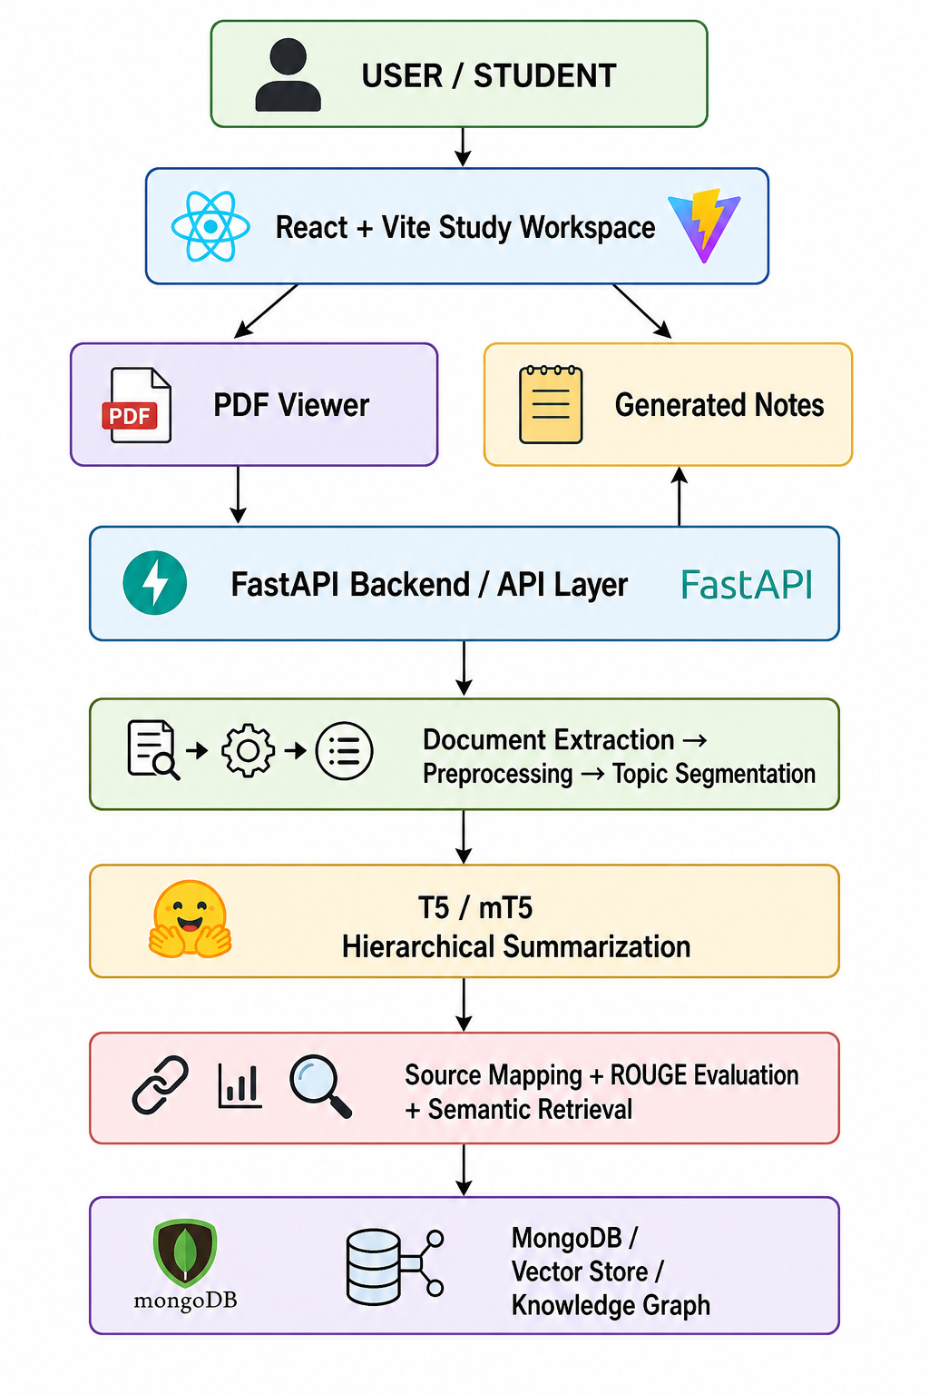
The architecture follows the project design described in the supplied project overview. The source PDF and generated notes remain connected through page, paragraph and coordinate metadata. The optional conversational assistant is kept outside the core summarization contribution and uses retrieved PDF content as context.

Appendix B – Detailed NLP Pipeline
Stage | Input | Processing | Output | Evidence
Extraction | PDF | Read pages and text spans | Text + coordinates | Page/paragraph
Cleaning | Raw extracted text | Remove noise and normalize | Clean text | Source reference retained
Segmentation | Clean text | Sentence/topic grouping | Logical chunks | Topic IDs
Tokenization | Chunk | SentencePiece/model tokenizer | Token IDs | Chunk ID
Generation | Token IDs | T5 encoder-decoder | Summary text | Source refs
Hierarchy | Lower-level summaries | Aggregate and summarize | Topic/page/chapter notes | Inherited refs
Evaluation | Generated + reference | ROUGE | Scores | Test record
Presentation | Notes + evidence | Render UI and highlights | Interactive workspace | Coordinate overlay

Appendix C – Sample Data Structure
Illustrative structure for a source chunk:
{ document_id, page_number, paragraph_id, text, bbox, topic_id }
Illustrative structure for a generated note:
{ note_id, level, text, source_refs, topic_id, parent_note_id }
Illustrative structure for a learning event:
{ student_id, source_id, event_type, timestamp, metadata }

Appendix D – Evaluation Record Template
Test / Metric | Dataset / Input | Configuration | Observed Value | Remarks
ROUGE-1 | Test set | Final model configuration | ________________ | Insert actual result
ROUGE-2 | Test set | Final model configuration | ________________ | Insert actual result
ROUGE-L | Test set | Final model configuration | ________________ | Insert actual result
Average inference time | Representative document | Final environment | ________________ | Insert measured result
Peak memory | Representative document | Final environment | ________________ | Insert measured result
End-to-end pass rate | Functional tests | Final build | ________________ | Insert actual count

Appendix E – Screenshots / Demonstration Evidence
- Project home / document upload screen.
- PDF viewer with extracted content.
- Generated paragraph summary.
- Topic/page/chapter summary hierarchy.
- Click-to-source highlight.
- Reverse lookup from PDF to note.
- ROUGE evaluation output.
- Semantic search result.
- Exam Essentials notebook.
- Knowledge graph with evidence.
- Confusion heatmap.
- Viva simulator.
- Final integrated application workflow.

Appendix F – Individual Contribution Evidence
Student | Suggested Evidence
G. Jaswanth | NLP pipeline, source mapping, evaluation, architecture/design work, related commits and report sections.
Yuvaraj R | Application integration, UI/API work, testing records, related commits and report sections.
Pradeep Kumar | Dataset preparation, model configuration, training/evaluation records, related commits and report sections.

Appendix G – Capstone Outcome Mapping
Engineering / Professional Area | Report Evidence
Problem identification | Chapter 1
Literature and existing solutions | Chapter 2
Requirements engineering | Chapter 3.1
Design under constraints | Chapter 3.2–3.10
Sustainability | Chapter 3.11
Ethics and responsible AI | Chapter 3.12
Safety and reliability | Chapter 3.13
Security and privacy | Chapter 3.14
Risk assessment | Chapter 3.15
Implementation | Chapter 4.1–4.8
Testing and analysis | Chapter 4.9–4.14
Project management | Chapter 4.15–4.16
Conclusion and future work | Chapter 5.1–5.2
Independent learning | Chapter 5.3
Team contribution | Contribution Statement + Appendix F
Technical communication | Complete report + presentation

