Automatic Text Summarization Using Transformer-Based T5 Model
A CAPSTONE PROJECT REPORT

Submitted in the partial fulfilment for the Course of
DSA0308 – Natural Language Processing
to the award of the degree of
BACHELOR OF TECHNOLOGY
IN
Artificial Intelligence,
AI & ML,
AI & DS
Submitted by
- Jaswanth - 192472235

Under the Supervision of
Dr. T. Kumaragurubaran


SIMATS ENGINEERING
Saveetha Institute of Medical and Technical Sciences
Chennai-602105
March 2026

SIMATS ENGINEERING


Saveetha Institute of Medical and Technical Sciences
Chennai-602105

DECLARATION
We G. Jaswanth (192472235), Pradeepkumar (192425016), Yuvaraj R (192524058)
of the CSE - ARTIFICIAL INTELLIGENCE department, ARTIFICIAL INTELLIGENCE & MACHINE LEARNING department, ARTIFICIAL INTELLIGENCE & DATA SCIENCE department Saveetha Institute of Medical and Technical Sciences, Saveetha University, Chennai, hereby declare that the Capstone Project Work entitled ‘DSA0308 - Natural Language Processing’ is the result of our own Bonafide efforts. To the best of our knowledge, the work presented herein is original, accurate, and has been carried out in accordance with principles of engineering ethics.

Place: Chennai
Date: 8-9-2026

Signature of the Students with Names
G.Jaswanth



SIMATS ENGINEERING
Saveetha Institute of Medical and Technical Sciences
Chennai-602105

BONAFIDE CERTIFICATE
This is to certify that the Capstone Project entitled “Automatic Text Summarization Using Transformer-Based T5 Model” has been carried out by G. Jaswanth (192472235), Pradeepkumar (192425016), Yuvaraj R (192524058) under the supervision of Dr. T. Kumaraguruban is submitted in partial fulfilment of the requirements for the current semester of the B.E COMPUTER SCIENCE ENGINEERING - ARTIFICIAL INTELLIGENCE program at Saveetha Institute of Medical and Technical Sciences, Chennai.

SIGNATURE SIGNATURE
Dr Sashi Rekha Dr. T. Kumaraguruban
Program Director Project Guide
Department of CSE Department of CSE
Saveetha School of Engineering Saveetha School of Engineering
SIMATS SIMATS

INTERNAL EXAMINER EXTERNAL EXAMINER




ACKNOWLEDGEMENT

We would like to express our heartfelt gratitude to all those who supported and guided us throughout the successful completion of our Capstone Project. We are deeply thankful to our respected Founder and Chancellor, Dr. N.M. Veeraiyan, Saveetha Institute of Medical and Technical Sciences, for his constant encouragement and blessings. We also express our sincere thanks to our Pro-Chancellor, Dr. Deepak Nallaswamy Veeraiyan, and our Vice-Chancellor, Dr. S. Suresh Kumar, for their visionary leadership and moral support during the course of this project.

We are truly grateful to our Director, Dr Sashi Rekha, SIMATS Engineering, for providing us with the necessary resources and a motivating academic environment. Our special thanks to our Principal, Dr. B. Ramesh for granting us access to the institute’s facilities and encouraging us throughout the process. We sincerely thank our Head of the Department, Dr Sashi Rekha for his continuous support, valuable guidance, and constant motivation.

We are especially indebted to our guide, of Dr. T. Kumaraguruban for his creative suggestions, consistent feedback, and unwavering support during each stage of the project. We also express our gratitude to the Project Coordinators, Review Panel Members (Internal and External), and the entire faculty team for their constructive feedback and valuable inputs that helped improve the quality of our work. Finally, we thank all faculty members, lab technicians, our parents, and friends for their continuous encouragement and support.

Signature With Student Name

ABSTRACT
The “Automatic Text Summarization Using a Transformer-Based T5 Model” is an intelligent NLP system designed to automatically convert large text documents into concise, meaningful, and context-aware summaries. With the rapid growth of digital content, reading and manually summarizing lengthy documents can be time-consuming and inefficient. Traditional extractive summarization methods mainly select existing sentences and may fail to preserve the meaning, coherence, and context of complex documents. This project addresses these limitations by using a transformer-based T5 (Text-to-Text Transfer Transformer) model for abstractive text summarization.
The system is structured into three key modules. The first module, Data Collection, Preparation & Text Preprocessing, focuses on collecting text datasets from reliable sources and preparing them for model training and evaluation. The data is cleaned by removing noise and unnecessary symbols, followed by tokenization, normalization, and formatting. The prepared dataset is divided into training, validation, and testing sets to support effective model development.
The second module, Transformer-Based T5 Model Development & Summarization, loads a pretrained T5 model and fine-tunes it using the prepared dataset. Hyperparameters such as learning rate, batch size, and epochs are configured during training. The encoder-decoder architecture and attention mechanism enable the model to understand contextual relationships and generate fluent abstractive summaries.
The third module, Performance Evaluation, Web Integration & Visualization, generates summaries using the trained model and compares them with reference summaries. The model is evaluated using ROUGE-1, ROUGE-2, and ROUGE-L metrics to analyze summary quality and identify areas for improvement. The results can be presented through an interactive application, making the system practical and accessible for users.
Overall, the proposed system provides an efficient approach for transforming lengthy text into accurate, concise, coherent, and context-aware summaries using a transformer-based T5 model. It reduces the effort required to understand large documents while demonstrating the effectiveness of modern transformer-based NLP techniques for automatic text summarization.
Additionally, the system can be used to support users in quickly understanding information from lengthy documents by presenting the most important content in a simplified form. The use of a pretrained transformer model reduces the need to build a language model from scratch, while evaluation through standard summarization metrics provides a measurable way to assess the effectiveness of the generated summaries. This makes the proposed system suitable for practical applications where fast, reliable, and readable text summarization is required.
TABLE OF CONTENTS
S.NO | CHAPTER | TOPICS | PAGE NO
1 |  | Abstract | 5
2 | Chapter 1 | 1.1 Background Information | 7-9
 |  | 1.2 Project Objectives
 |  | 1.3 Significance
 |  | 1.4 Scope
 |  | 1.5 Literature Review
3 | Chapter 2 | 2.1 Description of the Problem | 10-12
 |  | 2.2 Evidence of the Problem
 |  | 2.3 Stakeholders
 |  | 2.4 Supporting Data/Research
4 | Chapter 3 | 3.1Development and Design | 13-19
 |  | 3.2 Tools and Technologies
 |  | 3.3 Solution Overview
 |  | 3.4 Engineering Standards
 |  | 3.5 Solution Justification
5 | Chapter 4 | 4.1 Evaluation of Results | 20-25
 |  | 4.2 Challenges Encountered
 |  | 4.3 Possible Improvements
 |  | 4.4 Recommendations
6 | Chapter 5 | 5.1 Key Learning Outcomes | 26-28
 |  | 5.2 Challenges Encountered
 |  | 5.3 Application of Engineering
 |  | 5.4 Insights into the Industry
 |  | 5.5 Conclusion of development
7 | Chapter 6 | Conclusion | 29-31
8 |  | References | 32
9 |  | Appendices | 33-34
CHAPTER 1
INTRODUCTION
Automatic text summarization has become an important application of Natural Language Processing (NLP) in modern intelligent systems such as document analysis, education, news processing, research, and information retrieval. The rapid growth of digital information has resulted in large volumes of textual content that are difficult and time-consuming to read manually. Traditional summarization methods, particularly extractive approaches, select important sentences directly from the source document but may fail to preserve overall context, coherence, and meaning. On the other hand, transformer-based approaches provide a more effective way to understand contextual relationships and generate meaningful summaries.
The T5 (Text-to-Text Transfer Transformer) model provides a unified text-to-text framework that can be fine-tuned for various NLP tasks, including abstractive text summarization. Unlike extractive methods, abstractive summarization allows the model to generate new sentences that represent the important information in the original document. The encoder-decoder architecture and attention mechanism of T5 enable the model to understand the input text and generate concise and coherent summaries.
1.2 Project Objectives
The primary objective of this project is to develop an intelligent system for automatic text summarization using a transformer-based T5 model.
The specific objectives are:
- To collect and preprocess textual data suitable for training and evaluating a summarization model.
- To clean, normalize, tokenize, and format text data for T5 model processing.
- To utilize a pretrained T5 transformer model for abstractive text summarization.
- To fine-tune the pretrained model using article-summary pairs.
- To generate concise, coherent, and context-aware summaries from lengthy text documents.
- To evaluate the quality of generated summaries using standard metrics such as ROUGE-1, ROUGE-2, and ROUGE-L.
- To analyze the performance of the summarization model and identify areas for improvement.
- To provide the summarization functionality through an accessible application interface.
1.3 Significance of the Project
The proposed automatic text summarization system offers several important benefits:
- Reduces the time and effort required to read lengthy documents.
- Provides concise summaries while retaining important information.
- Improves accessibility to large amounts of textual information.
- Uses contextual understanding to produce more coherent summaries.
- Demonstrates the practical application of transformer-based NLP techniques.
- Supports automated analysis of large text documents.
- Provides a foundation for practical applications in education, research, news, and document processing.
1.4 Scope of the Project
The scope of this project includes:
- Collecting and preparing text datasets for summarization.
- Performing text cleaning, normalization, and tokenization.
- Using a pretrained T5/mT5 transformer model for abstractive summarization.
- Fine-tuning the model using prepared training data.
- Generating summaries for unseen text documents.
- Evaluating generated summaries using ROUGE metrics.
- Integrating the trained summarization model into an application for displaying results.
1.5 Literature Review
Research in the field of Natural Language Processing has demonstrated the evolution of text summarization from traditional extractive methods to modern transformer-based abstractive approaches. Early summarization techniques primarily focused on identifying and extracting important sentences using statistical and linguistic features. Although these methods can identify significant information, they may produce summaries with limited coherence because the selected sentences are directly taken from different parts of the source document.
Recent research has introduced transformer-based models such as BERT, GPT, and T5, which use attention mechanisms to capture contextual and semantic relationships within text. T5 uses an encoder-decoder architecture, making it particularly suitable for text generation tasks such as summarization.
Despite these advancements, generating concise and coherent summaries from lengthy documents while minimizing information loss remains a challenge. The proposed project focuses on using a transformer-based T5 model to address these limitations and produce accurate, fluent, and context-aware summaries. Model performance is evaluated using standard summarization metrics to determine the effectiveness of the developed system.

CHAPTER 2
PROBLEM IDENTIFICATION AND ANALYSIS
2.1 Description of the Problem
The rapid growth of digital information has resulted in large volumes of textual content being generated through news articles, research documents, educational materials, reports, and online sources. The primary challenge is to efficiently read, understand, and summarize this large amount of information. Manually analyzing lengthy documents is time-consuming and makes it difficult for users to quickly identify the most important information.
Traditional text summarization approaches, particularly extractive methods, select important sentences or phrases directly from the original document. Although these methods can identify relevant content, they may produce summaries that lack proper coherence and context because the selected sentences may not form a naturally flowing summary. They also have limited ability to paraphrase information or generate new sentences.
Transformer-based models provide a more effective approach by using attention mechanisms to understand contextual and semantic relationships within text. The T5 (Text-to-Text Transfer Transformer) model can be fine-tuned for abstractive summarization and generate concise summaries based on the meaning of the input document.

2.2 Evidence of the Problem
Research and observations in Natural Language Processing highlight several limitations of traditional text summarization methods:
- Extractive methods mainly select existing sentences instead of generating new summaries.
- Selected sentences may lack coherence and contextual flow.
- Important information may be lost when only individual sentences are extracted.
- Traditional approaches have limited ability to paraphrase and condense information.
- Long documents remain challenging to summarize while preserving important information.
- Generating concise summaries without significant information loss remains an important NLP challenge.
These limitations create a need for an automated summarization system that can understand the context of lengthy documents and generate meaningful summaries rather than simply extracting sentences.
2.3 Stakeholders
Students and Learners
They can use concise summaries to understand lengthy educational materials and revise important concepts more efficiently.
Researchers
Researchers can reduce the time required to review large amounts of textual information and identify important content.
Content Readers
Users can quickly understand the main ideas of lengthy articles, reports, and documents without reading the complete text.
Educational Institutions
Educational applications can use automated summarization to support learning materials, study resources, and information processing.
NLP Developers and Researchers
They can use the system to study transformer-based abstractive summarization and evaluate the effectiveness of T5 models.
2.4 Supporting Data and Research
Research in Natural Language Processing shows a transition from traditional extractive summarization to modern transformer-based abstractive summarization. Important developments include:
- Extractive methods focus on selecting important sentences from documents.
- Transformer models such as BERT, GPT, and T5 use attention mechanisms to capture contextual and semantic relationships.
- T5 uses an encoder-decoder architecture, making it suitable for text generation tasks such as summarization.
- Pretrained transformer models can be fine-tuned for specific summarization tasks using transfer learning.
- Standard evaluation metrics such as ROUGE-1, ROUGE-2, and ROUGE-L can be used to evaluate generated summaries.
The project therefore focuses on using a pretrained T5 model and fine-tuning it with prepared text-summary data to generate concise and context-aware summaries.
2.5 Problem Summary
Traditional summarization approaches lack sufficient contextual understanding, coherence, and abstractive generation capability, making it difficult to efficiently summarize lengthy and complex documents while preserving important information.
To address these limitations, this project proposes an Automatic Text Summarization System Using a Transformer-Based T5 Model. The system performs text preprocessing, fine-tunes a pretrained T5 model, generates abstractive summaries, and evaluates their quality using standard evaluation metrics. The proposed approach reduces the time required to understand lengthy documents and provides concise, meaningful, and context-aware summaries.

CHAPTER 3
SOLUTION DESIGN AND IMPLEMENTATION
3.1 Development and Design Process
The development of the Automatic Text Summarization Using a Transformer-Based T5 Model follows a structured and modular design methodology to ensure effective text processing, model development, summary generation, and performance evaluation. The primary goal is to design an intelligent NLP system capable of converting lengthy text documents into concise, meaningful, coherent, and context-aware summaries.
The development process begins with:
- Collecting suitable text datasets containing articles and human-written summaries.
- Cleaning and preprocessing the collected text data.
- Tokenizing and formatting the data for T5 model processing.
- Loading a pretrained T5/mT5 Transformer model.
- Fine-tuning the model using the prepared dataset.
- Generating abstractive summaries from input documents.
- Evaluating the generated summaries using ROUGE-1, ROUGE-2, and ROUGE-L metrics.
The system is designed with three main modules:
1. Data Collection, Preparation & Text Preprocessing Module
2. Transformer-Based T5 Model Development & Summarization Module
3. Performance Evaluation, Web Integration & Visualization Module

1. Data Collection, Preparation & Text Preprocessing Module
This module is responsible for collecting and preparing textual data for summarization. The preprocessing stage ensures that the input data is clean, consistent, and suitable for training the T5 model.
The major activities include:
- Collecting text documents and corresponding human-written summaries.
- Removing unnecessary noise, special characters, and unwanted symbols.
- Performing text cleaning and normalization.
- Tokenizing the input text using appropriate tokenizer utilities.
- Formatting the article-summary pairs for T5 training.
- Dividing the dataset into training, validation, and testing sets.
The output of this module is a structured and preprocessed dataset suitable for transformer-based model training and evaluation.

2. Transformer-Based T5 Model Development & Summarization Module
This is the core module of the proposed system. It uses a pretrained T5 Transformer model to perform abstractive text summarization.
The major activities include:
- Loading a pretrained T5/mT5 model.
- Preparing input-output pairs in the required text-to-text format.
- Fine-tuning the pretrained model using the prepared dataset.
- Configuring hyperparameters such as:
  - Learning rate
  - Batch size
  - Number of epochs
- Training and validating the model.
- Using the trained model to generate summaries.
- Saving the fine-tuned model for later summary generation.
The T5 encoder processes the input text and captures contextual information using attention mechanisms. The decoder then generates the summary token by token based on the encoded representation and previously generated content.
The output of this module is a concise and meaningful abstractive summary.

3. Performance Evaluation, Web Integration & Visualization Module
This module evaluates the quality of generated summaries and provides an interface for users to interact with the summarization system.
The major activities include:
- Generating summaries using the fine-tuned T5 model.
- Comparing generated summaries with reference summaries.
- Evaluating the model using:
  - ROUGE-1
  - ROUGE-2
  - ROUGE-L
- Analyzing the obtained evaluation results.
- Identifying strengths, weaknesses, and possible improvements.
- Integrating the trained model into a user-friendly application.
- Accepting user text or document input.
- Displaying the generated summary and evaluation results.
ROUGE provides an objective measurement of summarization quality; however, it primarily measures word overlap, so human evaluation may still be required for a complete assessment of summary quality.
3.2 Tools and Technologies Used
The system uses Python along with deep learning and NLP frameworks for model development, data processing, and evaluation.

Programming Language
- Python – Used for implementing the complete summarization pipeline.

Libraries and Frameworks
- PyTorch – Used for deep learning computations and model training.
- Hugging Face Transformers – Used to load and fine-tune pretrained T5/mT5 models.
- Tokenizer Utilities – Used to convert text into model-readable tokens.
- Pandas – Used for dataset loading, manipulation, and preprocessing.
- NumPy – Used for numerical operations and data processing.
- ROUGE – Used to evaluate the quality of generated summaries.
The Python-based implementation provides a modular foundation that can be extended with additional models, datasets, and evaluation techniques.
3.3 Solution Overview
The proposed system integrates text preprocessing, transformer-based abstractive summarization, and performance evaluation within a unified framework.
The system follows a layered structure:

1. Data Layer
Defines:
- Collection of article and summary datasets.
- Storage of training, validation, and testing data.
- Organization of input documents and reference summaries.

2. Processing Layer
Implements:
- Text cleaning.
- Normalization.
- Tokenization.
- Text formatting.
- Dataset preparation.

3. Transformer Model Layer
Implements:
- Pretrained T5/mT5 model.
- Encoder-decoder architecture.
- Self-attention and cross-attention mechanisms.
- Fine-tuning using article-summary pairs.

4. Summary Generation Layer
Performs:
- Input text processing.
- Abstractive summary generation.
- Generation of concise and coherent summaries.

5. Evaluation & Application Layer
Measures and displays:
- ROUGE-1 score.
- ROUGE-2 score.
- ROUGE-L score.
- Generated summaries.
- Comparison with reference summaries.
- Results through the application interface.
3.4 Engineering Standards Applied
The system follows software engineering and machine learning practices to improve reliability, maintainability, and reproducibility.

Machine Learning Standards
- Proper dataset preprocessing.
- Appropriate tokenization and normalization.
- Training, validation, and testing separation.
- Transfer learning using a pretrained T5 model.
- Hyperparameter configuration.
- Model validation and performance evaluation.
- Evaluation using standard ROUGE metrics.

Software Engineering Practices
- Modular system architecture.
- Separation of preprocessing, model development, and evaluation.
- Reusable Python components.
- Clear documentation.
- Structured data processing.
- Scalable design for future improvements.

Testing Procedures
- Testing preprocessing operations.
- Validating input and output formatting.
- Testing summary generation using sample documents.
- Evaluating the model on unseen test data.
- Comparing generated summaries against reference summaries.
3.5 Solution Justification
The proposed approach is justified because transformer-based models provide strong contextual understanding and are well suited for abstractive text generation. T5 uses an encoder-decoder architecture that combines understanding of the input document with generation of the final summary.
Compared with traditional extractive summarization approaches, the proposed T5-based approach:
- Generates new sentences rather than simply selecting existing sentences.
- Provides better contextual understanding.
- Produces more natural and coherent summaries.
- Can be adapted to summarization through transfer learning.
- Reduces the effort required to manually summarize lengthy documents.
- Provides measurable performance through standard evaluation metrics.
The modular architecture also allows future improvements such as better preprocessing techniques, alternative transformer models, improved evaluation methods, and enhanced application features without redesigning the entire system.
This design ensures:
- Scalability
- Modularity
- Contextual understanding
- Efficient summarization
- Measurable performance
- Practical applicability

CHAPTER 4
RESULTS AND RECOMMENDATIONS
4.1 Evaluation of Results
The Automatic Text Summarization Using a Transformer-Based T5 Model was designed to process lengthy text and generate concise, meaningful, and context-aware summaries. The system was evaluated through its three major modules: Data Collection, Preparation & Text Preprocessing; Transformer-Based T5 Model Development & Summarization; and Performance Evaluation, Web Integration & Visualization. Each module was analyzed to determine the effectiveness, quality, and practical usability of the proposed system.

Observations from Data Collection & Preprocessing
- Text cleaning improved the consistency and quality of the input data.
- Tokenization converted the text into a format suitable for T5 processing.
- Normalization reduced inconsistencies in the textual data.
- Dividing the dataset into training, validation, and testing sets supported systematic model development and evaluation.
- Proper preprocessing reduced unwanted noise while preparing the data for summarization.

Observations from T5 Model Development & Summarization
- The pretrained T5 model provided a suitable foundation for abstractive summarization.
- Fine-tuning allowed the model to adapt to the summarization task.
- The encoder-decoder architecture helped capture contextual relationships in the input text.
- The model generated new sentences rather than simply extracting sentences from the source.
- Attention mechanisms helped the model focus on relevant information while generating the summary.

Observations from Performance Evaluation
- Generated summaries were compared with reference summaries.
- ROUGE-1, ROUGE-2, and ROUGE-L were used to evaluate summarization performance.
- ROUGE scores provided an objective measurement of the similarity between generated and reference summaries.
- Evaluation results can be used to identify strengths and weaknesses of the summarization model.
- Performance analysis provides a basis for further model optimization.
4.2 Challenges Encountered
The system involves several challenges during data preparation, model development, and evaluation.

1. Data Quality Issues
Inconsistent, noisy, or poorly formatted text can affect the quality of preprocessing and subsequently influence the quality of generated summaries.

2. Computational Requirements
Fine-tuning transformer-based T5 models requires considerable computational resources, particularly GPU/TPU resources.

3. Long Document Processing
Large documents contain substantial amounts of information, making it challenging to generate concise summaries while preserving important context and minimizing information loss.

4. Evaluation Limitations
ROUGE metrics primarily focus on word overlap and may not completely represent the semantic quality, fluency, or factual correctness of a generated summary. Therefore, human evaluation may still be required.
  - Possible Improvements
Several improvements can be considered to enhance the proposed system:

1. Improved Data Preprocessing
More advanced preprocessing techniques can be introduced while avoiding excessive cleaning that could remove useful contextual information.

2. Model Optimization
The T5 model can be optimized through better hyperparameter selection, efficient fine-tuning methods, and appropriate model configurations.

3. Long-Document Summarization
Hierarchical or chunk-based summarization strategies can be explored to handle lengthy documents more effectively.

4. Enhanced Evaluation
Additional semantic and human-based evaluation methods can be combined with ROUGE to provide a more comprehensive assessment of summary quality.
4.4 Recommendations
The system can be enhanced through:
- Implementing advanced T5 variants and transformer-based architectures.
- Improving preprocessing techniques for different document types and domains.
- Developing better approaches for handling very long documents.
- Combining ROUGE with semantic evaluation and human assessment.
- Optimizing the model to reduce computational and inference time.
- Integrating the summarization model into a user-friendly web application.
- Supporting additional languages and multilingual summarization where suitable.

Based on the System Analysis
- Transformer-based abstractive summarization provides a more flexible approach than traditional sentence-extraction methods.
- T5's encoder-decoder architecture is well suited for text generation and summarization.
- Proper preprocessing is important for producing consistent model inputs.
- Fine-tuning a pretrained model reduces the need to train a summarization model from scratch.
- ROUGE metrics provide useful quantitative measurements, but should not be treated as the only indicator of summary quality.
- The modular design allows future improvements to be introduced without redesigning the complete system.
Overall, the proposed Automatic Text Summarization Using a Transformer-Based T5 Model provides an effective framework for converting lengthy text into concise and meaningful summaries while reducing the time and effort required for manual summarization.
Website preview :

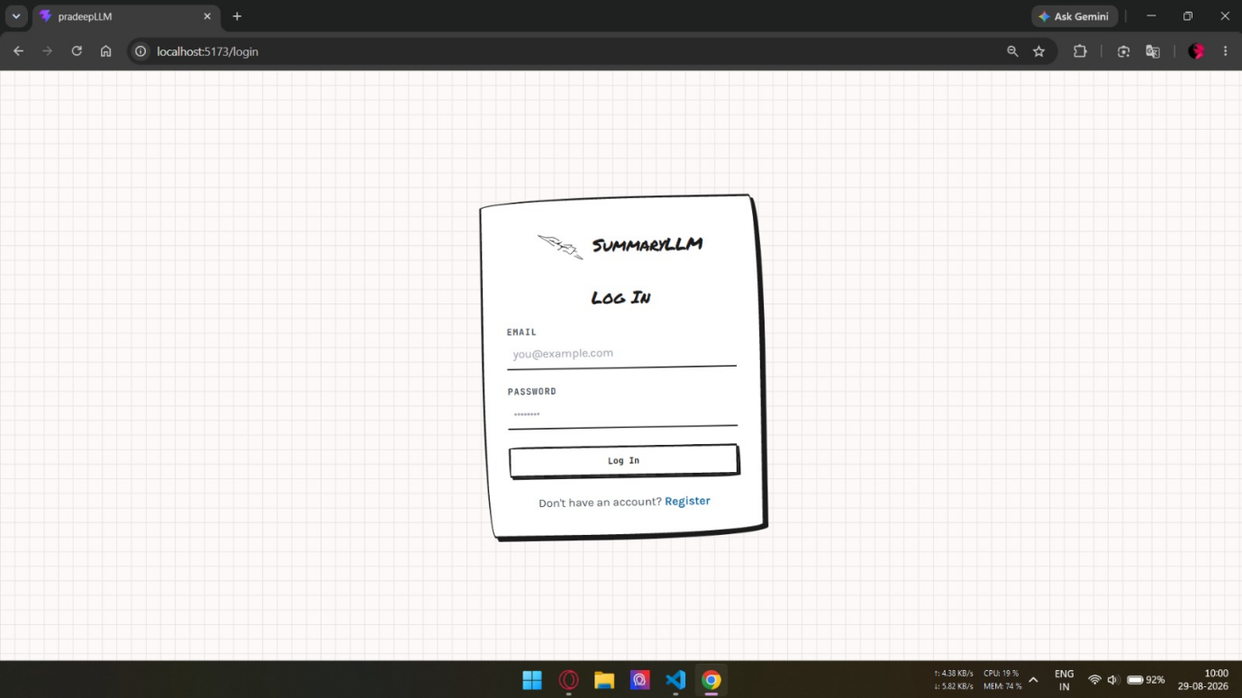
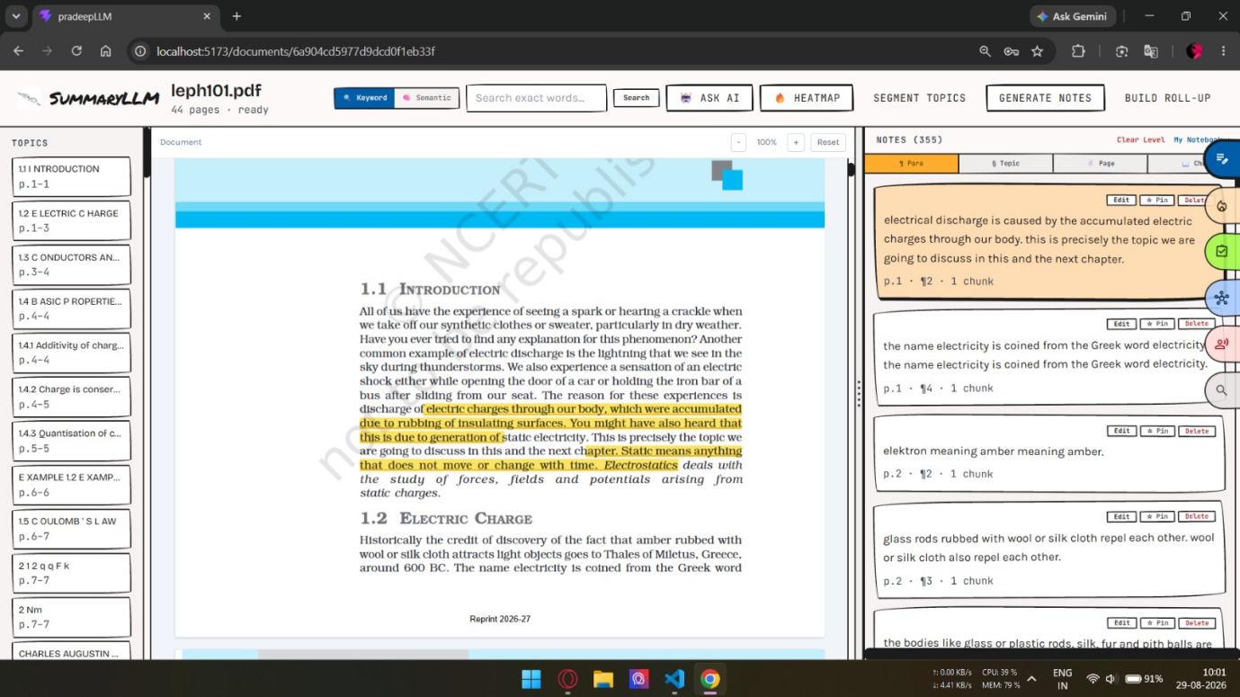

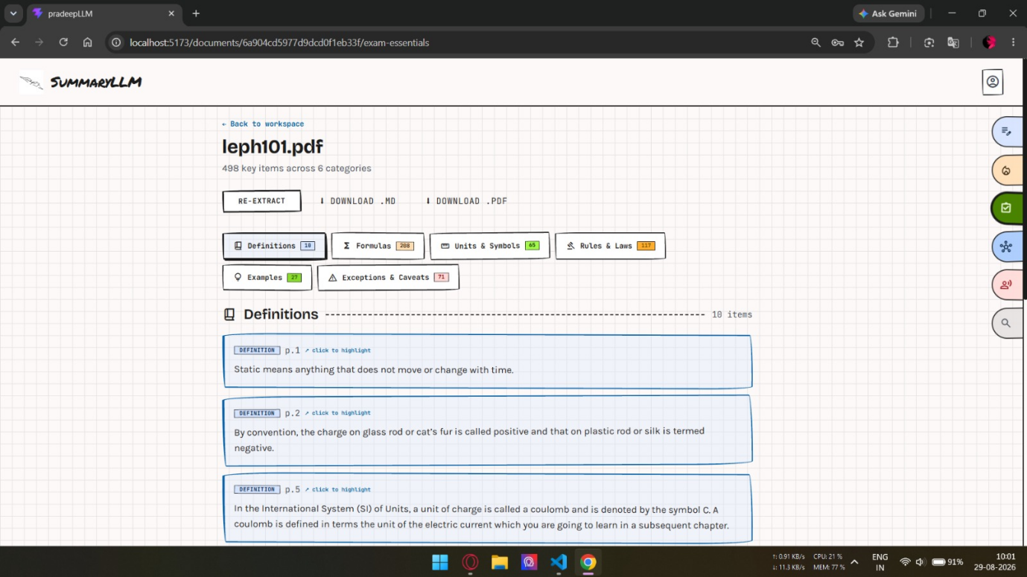
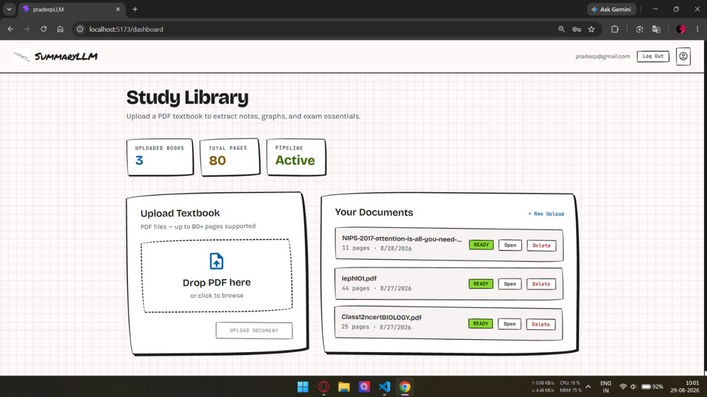
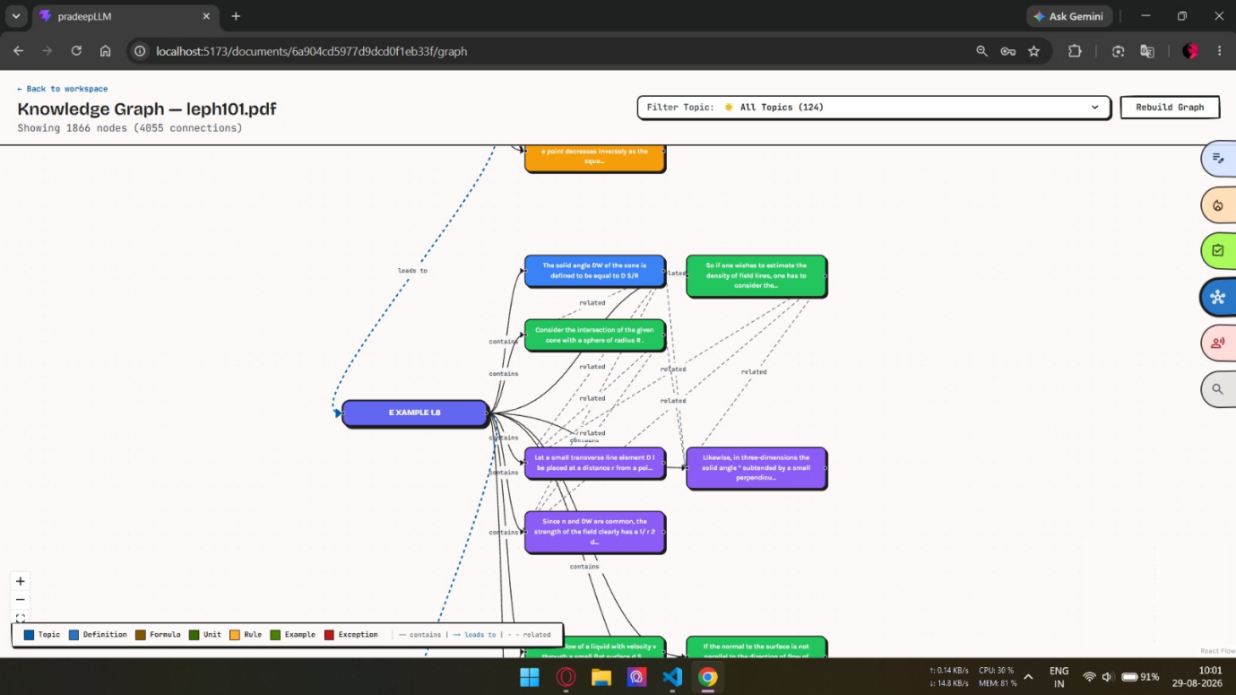

CHAPTER 5
REFLECTION ON LEARNING AND PERSONAL DEVELOPMENT
5.1 Key Learning Outcomes
The Automatic Text Summarization Using a Transformer-Based T5 Model was designed and evaluated using prepared text datasets. The project demonstrated how the integration of text preprocessing, transformer-based modelling, abstractive summarization, and performance evaluation can provide an effective solution for reducing lengthy text into concise and meaningful summaries.
The data preparation stage provided practical understanding of cleaning, normalization, tokenization, and dataset organization. The model development stage demonstrated the use of a pretrained T5 Transformer and fine-tuning for the summarization task. The encoder-decoder architecture and attention mechanism helped the model capture contextual relationships and generate summaries.
The evaluation stage provided experience in comparing generated summaries with reference summaries using ROUGE-1, ROUGE-2, and ROUGE-L metrics.
The system effectively integrated all modules, resulting in:
- Automated generation of concise summaries.
- Improved handling of lengthy textual content.
- Context-aware abstractive summarization.
- Systematic evaluation of summary quality.
- Reduced time and effort required for manual summarization.
- Practical understanding of transformer-based NLP systems.
5.2 Challenges Encountered and Overcome
This project highlighted the importance of combining quality preprocessing, transformer-based modelling, and systematic evaluation for effective text summarization.
Key challenges encountered include:
- Handling noisy and inconsistent textual data.
- Preparing large text documents for model processing.
- Managing tokenization and input formatting.
- Fine-tuning the pretrained T5 model efficiently.
- Handling computational requirements during model training.
- Generating concise summaries while retaining important information.
- Evaluating summary quality using automated metrics.
These challenges were addressed through appropriate preprocessing, structured dataset preparation, pretrained model fine-tuning, and evaluation using standard summarization metrics.
5.3 Application of Engineering Standards
The project followed appropriate machine learning and software engineering practices throughout development.
The system applied:
- Modular architecture for separate processing stages.
- Proper text preprocessing and tokenization.
- Training, validation, and testing procedures.
- Transfer learning using a pretrained T5 model.
- Hyperparameter configuration during fine-tuning.
- Standardized performance evaluation using ROUGE metrics.
- Structured and reusable implementation.
These practices improve the reliability, maintainability, scalability, and reproducibility of the developed system.
5.4 Insights into the Industry
Automatic text summarization has practical applications in areas where users need to process large amounts of textual information quickly.
The system can be enhanced through:
- Implementing more advanced T5 variants and transformer models.
- Improving long-document summarization techniques.
- Supporting additional languages and domains.
- Integrating semantic and human-based evaluation methods.
- Optimizing inference time and computational requirements.
- Deploying the system as a web or cloud-based application.
- Providing interactive document summarization and analysis features.
These improvements align with current developments in Natural Language Processing, transformer-based AI, automated document analysis, and intelligent information systems.
5.5 Conclusion of Development
The development of the Automatic Text Summarization Using a Transformer-Based T5 Model provided valuable practical knowledge in Natural Language Processing, text preprocessing, transformer architectures, abstractive summarization, model fine-tuning, and performance evaluation.
By successfully integrating data preparation, T5-based model development, summary generation, and evaluation, the project demonstrates that transformer-based approaches can provide an effective solution for automatically converting lengthy text into concise and meaningful summaries.
Through this project, practical experience was gained in handling textual datasets, preparing model inputs, fine-tuning pretrained transformer models, generating summaries, and evaluating model performance. It also strengthened important technical skills such as problem-solving, analytical thinking, model development, and system design.
The modular architecture provides a strong foundation for future enhancements such as long-document summarization, multilingual support, advanced evaluation techniques, model optimization, and web-based deployment. This highlights the potential of the proposed system as a practical solution for efficient and automated understanding of large text documents.

CHAPTER 6
CONCLUSION
6.1 Summary of Findings
The Automatic Text Summarization Using a Transformer-Based T5 Model was developed to address the challenges associated with processing and understanding large volumes of textual information efficiently. The project successfully achieved its primary objective of designing an intelligent system capable of transforming lengthy text documents into concise, meaningful, coherent, and context-aware summaries.
The implementation demonstrated that integrating text preprocessing, transformer-based modelling, abstractive summarization, and performance evaluation provides an effective approach to automatic text summarization. The preprocessing stage improved the quality and consistency of the input data, while the pretrained T5 model used its encoder-decoder architecture and attention mechanisms to understand contextual relationships and generate summaries.
Testing and evaluation involved comparing generated summaries with reference summaries using ROUGE-1, ROUGE-2, and ROUGE-L metrics. The evaluation process provided measurable information about the quality of the generated summaries and helped identify areas for further improvement.
6.2 Project Significance and Contributions
The significance of this project lies in its practical application of Natural Language Processing and Transformer-based deep learning techniques to address the problem of lengthy textual content. By automating summarization, the system reduces the time and effort required to manually read and summarize large documents.
From an academic perspective, the project demonstrates how a pretrained T5 Transformer can be fine-tuned for an abstractive NLP task. It highlights the importance of text preprocessing, tokenization, model fine-tuning, summary generation, and systematic performance evaluation in developing an intelligent NLP application.
In practical terms, the system can help users quickly understand the important information contained in lengthy documents. It can be applied to areas such as education, research, news processing, document analysis, and information management, where efficient understanding of large amounts of text is required.
6.3 Limitations and Future Enhancements
While the system addresses the primary objectives, certain limitations were identified:
- The quality of generated summaries depends on the quality and completeness of the training data.
- Fine-tuning transformer-based T5 models requires significant computational resources.
- Processing very long documents can increase computational and processing time.
- ROUGE metrics mainly measure word overlap and may not fully capture semantic meaning, fluency, or factual correctness.
- Human evaluation may still be required for comprehensive assessment of summary quality.

Future Enhancements
- Implementing advanced T5 variants and other transformer architectures.
- Improving summarization techniques for very long documents.
- Supporting additional languages and multilingual summarization.
- Combining ROUGE with semantic and human-based evaluation methods.
- Optimizing model inference to reduce processing time and computational requirements.
- Developing an advanced web-based or cloud-based summarization application.
- Adding interactive document analysis and source-traceability features.
6.4 Final Reflection
The development of the Automatic Text Summarization Using a Transformer-Based T5 Model has been a valuable academic and practical experience. The project provided an opportunity to apply theoretical concepts from Natural Language Processing, text preprocessing, transformer architectures, abstractive summarization, and machine learning to a practical problem.
Throughout the project, a systematic approach was followed—from data collection and preprocessing to model development, summary generation, evaluation, and application integration. This structured process strengthened the understanding of NLP pipelines and transformer-based model development.
Working on this project enhanced problem-solving abilities, analytical thinking, and technical skills. It provided practical experience in handling textual datasets, preparing data for transformer models, fine-tuning pretrained models, generating summaries, and interpreting evaluation results.
Overall, the system demonstrates the potential of transformer-based NLP for efficiently converting lengthy documents into concise and meaningful summaries. The modular design provides a strong foundation for future improvements, including better long-document handling, multilingual support, advanced evaluation, model optimization, and real-world deployment.

REFERENCES
- Raffel, C., Shazeer, N., Roberts, A., Lee, K., Narang, S., Matena, M., Zhou, Y., Li, W., & Liu, P. J. (2020). Exploring the limits of transfer learning with a unified text-to-text transformer. Journal of Machine Learning Research, 21(140), 1–67.
- Xue, L., Constant, N., Roberts, A., Kale, M. S., Al-Rfou, R., Siddhant, A., Barua, A., & Raffel, C. (2021). mT5: A massively multilingual pre-trained text-to-text transformer. Proceedings of the 2021 Conference of the North American Chapter of the Association for Computational Linguistics: Human Language Technologies, 483–498.
- Vaswani, A., Shazeer, N., Parmar, N., Uszkoreit, J., Jones, L., Gomez, A. N., Kaiser, Ł., & Polosukhin, I. (2017). Attention is all you need. Advances in Neural Information Processing Systems, 30.
- Lin, C.-Y. (2004). ROUGE: A package for automatic evaluation of summaries. In Text Summarization Branches Out, 74–81. Association for Computational Linguistics.
- Mihalcea, R., & Tarau, P. (2004). TextRank: Bringing order into text. Proceedings of the 2004 Conference on Empirical Methods in Natural Language Processing, 404–411. Association for Computational Linguistics.
- Devlin, J., Chang, M.-W., Lee, K., & Toutanova, K. (2019). BERT: Pre-training of deep bidirectional transformers for language understanding. Proceedings of the 2019 Conference of the North American Chapter of the Association for Computational Linguistics: Human Language Technologies, 4171–4186.
- Paszke, A., Gross, S., Massa, F., Lerer, A., Bradbury, J., Chanan, G., Killeen, Z., Lin, Z., Gimelshein, N., Antiga, L., Desmaison, A., Kopf, A., Yang, E., DeVito, Z., Raison, M., Tejani, A., Chilamkurthy, S., Steiner, B., Fang, L., Bai, J., & Chintala, S. (2019). PyTorch: An imperative style, high-performance deep learning library. Advances in Neural Information Processing Systems, 32.
- Scialom, T., Dray, P.-A., Lamprier, S., Piwowarski, B., & Staiano, J. (2020). MLSUM: The multilingual summarization dataset. Proceedings of the 2020 Conference on Empirical Methods in Natural Language Processing (EMNLP), 8051–8067.
- Lewis, M., Liu, Y., Goyal, N., Ghazvininejad, M., Mohamed, A., Levy, O., Stoyanov, V., & Zettlemoyer, L. (2020). BART: Denoising sequence-to-sequence pre-training for natural language generation, translation, and comprehension. Proceedings of the 58th Annual Meeting of the Association for Computational Linguistics, 7871–7880.
- See, A., Liu, P. J., & Manning, C. D. (2017). Get to the point: Summarization with pointer-generator networks. Proceedings of the 55th Annual Meeting of the Association for Computational Linguistics, 1073–1083.

APPENDICES

