ECA1422 – EMBEDDED SYSTEM ASSIGNMENT
DESIGN OF AN AI-ENABLED RTOS-BASED EMBEDDED SYSTEM
FOR INDUSTRIAL MACHINE-CONDITION MONITORING
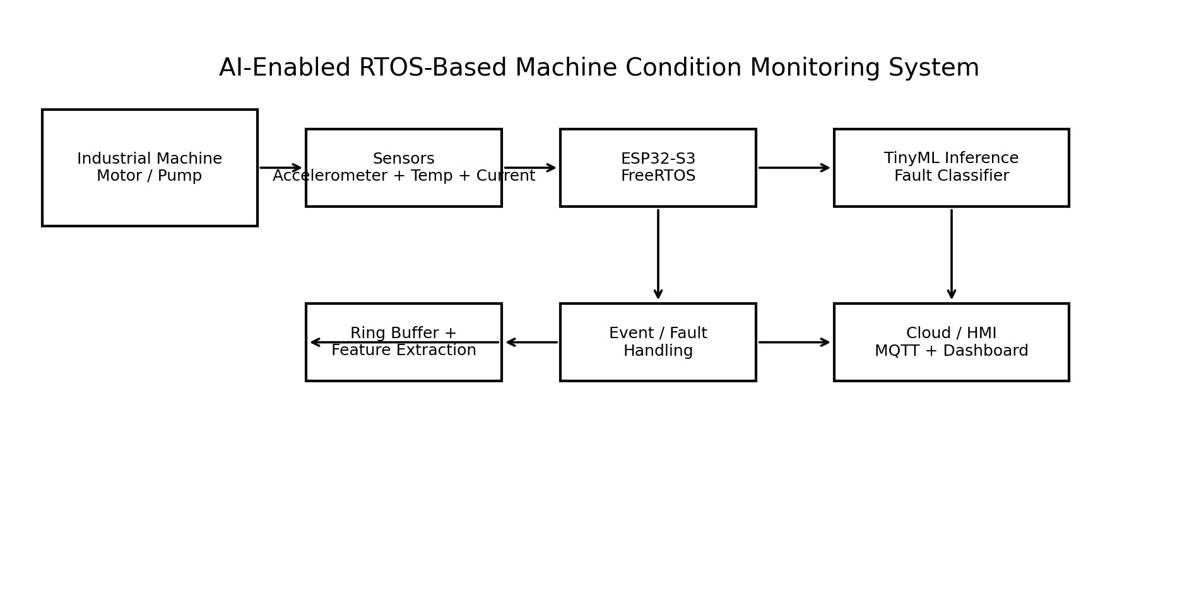
Individual Technical Report
Industrial Application: Predictive Maintenance of an Industrial Motor/Pump
Student: G. Jaswanth Register No.: 192472235
Course: ECA1422 Embedded Systems Assessment Type: Design-Based Assignment
CO2, CO3, CO4 and CO5 | SDG 9 – Industry, Innovation and Infrastructure

1. Industrial Application and Problem Statement

1.1 Selected Application
The proposed system is an AI-enabled real-time condition-monitoring node for an industrial motor or pump. The node continuously samples vibration and supporting thermal/electrical indicators, extracts compact health features, classifies the machine state at the edge, and communicates alarms and summaries to a supervisory dashboard. The design is intended for predictive maintenance: detect early signs of bearing faults or shaft misalignment before a failure causes unplanned downtime.

1.2 Problem Statement
Industrial rotating machines can develop abnormal vibration and temperature patterns before catastrophic failure. A monitoring system must therefore acquire data periodically, process it within bounded time, make an inference locally, and raise a high-priority alarm without allowing network communication or cloud delays to block safety-critical processing. The engineering problem is to combine AI inference, deterministic RTOS scheduling, interrupt handling, synchronization, limited memory, and low energy consumption on a compact embedded platform.

1.3 Motivation and Constraints
Design inputs are high-rate vibration samples plus supporting temperature/current measurements. Design outputs are a local machine-state decision, a high-priority alarm/safe-state request, and a best-effort MQTT health summary. The communication path is deliberately separated from the safety-critical path.
Item | Requirement / Constraint
Detection goal | Identify Normal, Misalignment, or Bearing-Fault conditions from sensor features.
Sampling | Vibration feature windows are refreshed every 20 ms from a 1 kHz sensor stream.
Alarm response | Time-critical vibration threshold event must wake the fault-handling path within 1 ms.
AI inference | Edge inference deadline: 100 ms; target WCET: 4.5 ms.
Connectivity | Ethernet/Wi-Fi/MQTT is best-effort and must not block acquisition or alarm handling.
Platform | ESP32-S3-class SoC with FreeRTOS.
Environment | Industrial cabinet; design assumes protected low-voltage electronics and suitable sensor mounting.
Assumption | AI training is performed offline; only the compact inference model is deployed on the SoC.

1.4 Functional Requirements
ID | Functional Requirement | Acceptance Target
FR1 | Acquire vibration samples | 1 kHz sample stream without buffer overrun under nominal load.
FR2 | Acquire supporting temperature/current indicators | Feature update every 20 ms.
FR3 | Extract condition features | RMS, kurtosis, crest factor, dominant frequency and temperature.
FR4 | Run AI classifier | One classification every 100 ms; WCET ≤ 4.5 ms.
FR5 | Generate emergency fault event | ISR captures threshold crossing and signals high-priority task.
FR6 | Transmit status | Publish alarm/health summary without blocking real-time tasks.
FR7 | Maintain safety state | Watchdog and sensor-fault handling force a conservative alarm state.

1.5 Non-Functional and Real-Time Requirements
Parameter | Target
Scheduling policy | Preemptive fixed-priority scheduling.
CPU utilization | ≤ 70% design target; calculated nominal utilization ≈ 33.17%.
Deadline compliance | 0 misses in nominal simulation.
Worst-case alarm response | < 1 ms from interrupt release to alarm task execution under assumed ISR and higher-priority interference.
Reliability | Watchdog enabled; stale-data timeout and sensor plausibility checks.
Energy | Use light sleep between workload bursts where possible; avoid continuous cloud transmission.
Maintainability | Separate acquisition, feature, AI, communication and health functions.

2. System Architecture and SoC Selection

2.1 Overall Architecture

Figure 2.1. Proposed AI-enabled RTOS machine-condition monitoring architecture.
The sensing layer produces high-rate vibration data and slower supporting measurements. A FreeRTOS-based ESP32-S3 application separates acquisition, feature extraction, AI inference, communication, and health supervision into independently scheduled tasks. A hardware interrupt provides a fast path for a threshold event. Queues and event groups provide controlled data exchange, while mutexes protect shared buses and configuration resources.

2.2 Hardware–Software Architecture
Layer | Elements | Purpose
Sensing | Digital accelerometer, temperature sensor, optional current sensor | Machine-condition inputs.
Processing | ESP32-S3 SoC | Real-time scheduling and edge AI inference.
Local memory | Internal SRAM + external flash/PSRAM on selected module | Stacks, queues, buffers, model and firmware.
Communication | Wi-Fi/BLE; MQTT at application layer | Non-critical remote monitoring.
Actuation | Alarm output / relay driver (conceptual) | Safe-state indication or machine trip interface.
RTOS | FreeRTOS tasks, queues, mutex, semaphore, event group | Scheduling and synchronization.
AI | Small decision-tree classifier | Fault classification at the edge.

2.3 SoC Selection and Justification
The selected platform is an ESP32-S3 development module based on the ESP32-S3 SoC. The platform is appropriate because it combines a dual-core Xtensa LX7 processor, hardware interfaces suitable for digital sensors, integrated wireless connectivity, and vector instructions intended to accelerate signal-processing and machine-learning workloads. A representative 8 MB flash / 8 MB PSRAM module configuration is assumed for the design; the model itself is kept small enough that external PSRAM is not required for inference.
Selection Criterion | ESP32-S3 Design Fit
Compute | Dual-core 32-bit CPU; one core can be reserved preferentially for real-time work while the other handles communication/background processing.
AI suitability | Vector/DSP-oriented instructions and sufficient compute for compact feature extraction and TinyML inference.
RTOS | FreeRTOS is supported by the ESP-IDF software environment.
Interfaces | SPI/I2C/UART/GPIO provide practical sensor and alarm connectivity.
Memory | Internal SRAM supports deterministic RTOS data; external PSRAM provides headroom for buffers if required.
Connectivity | Integrated 2.4 GHz Wi-Fi enables MQTT/HTTP dashboard connectivity.
Cost/feasibility | A low-cost development platform reduces prototype complexity while retaining industrial-IoT connectivity.

2.4 Proposed I/O Allocation
Interface | Assignment | Function
SPI | Accelerometer bus | High-rate vibration samples.
I2C | Temperature/current sensor (if digital) | Slow supporting measurements.
GPIO interrupt | Vibration threshold output | Time-critical fault event.
UART | Debug console | Development and diagnostics.
Wi-Fi | ESP32-S3 radio | Best-effort communication path.
GPIO output | Alarm/relay driver | Safe-state indication.

3. AI/ML Design

3.1 AI Objective
The embedded AI component classifies a machine window into three states: Normal, Misalignment, and Bearing Fault. Classification is performed locally so that the decision does not depend on network availability.

3.2 Input Data and Preprocessing
Feature | Description | Unit / Form
RMS acceleration | Energy level of the vibration window | g RMS
Kurtosis | Impulsiveness of vibration distribution | dimensionless
Crest factor | Peak-to-RMS ratio | dimensionless
Dominant frequency | Strongest spectral component | Hz
Temperature | Supporting thermal indicator | °C
The vibration stream is divided into 20 ms windows at 1 kHz, producing 20 samples per update in the simplified design model. In a production implementation, a longer window or overlapping FFT buffer would be selected according to the actual sensor bandwidth. Features are normalized using training-set statistics before inference.

3.3 Model Selection
A shallow Decision Tree is selected instead of a deep neural network because the assignment emphasizes deterministic real-time execution on a resource-constrained SoC. A depth-4 tree requires only a small set of comparisons, has predictable execution time, is easy to inspect for safety review, and can be represented with a few kilobytes of parameters. Training is performed offline; only the tree thresholds and class labels are embedded.
Model Property | Design Value
Algorithm | Decision Tree Classifier
Maximum depth | 4
Minimum samples per leaf | 8
Inputs | 5 engineered features
Classes | Normal / Misalignment / Bearing Fault
Deployment | Fixed-point/float comparisons; no runtime training
Target inference WCET | 4.5 ms
Estimated model storage | < 4 KB for tree thresholds, feature indices and labels
Target embedded accuracy | ≥ 90% on representative labelled data

3.4 Simulated AI Validation
For design validation, a synthetic 1,200-window dataset was generated with 400 windows per class using plausible separations in RMS, kurtosis, crest factor, dominant frequency and temperature. The dataset was split 80:20 using stratification. A depth-4 decision tree was trained on the training partition and evaluated on the held-out partition.
Metric | Simulation Result
Total samples | 1,200
Training / test | 960 / 240
Test accuracy | 99.17%
Normal correctly classified | 80 / 80
Misalignment correctly classified | 79 / 80
Bearing Fault correctly classified | 79 / 80
Misclassifications | 2 / 240
Embedded inference budget | 4.5 ms WCET target
The 99.17% value is a result of the synthetic validation experiment and must not be presented as field accuracy. Real deployment requires labelled vibration data from the intended machine and validation against maintenance records or a trusted reference condition.
For the held-out set, precision, recall and F1-score were computed from the confusion matrix. The balanced three-class result shows that the synthetic model meets the ≥90% design target while remaining small and interpretable.
Class | TP | FP | FN | Precision | Recall | F1
Normal | 80 | 0 | 0 | 100.0% | 100.0% | 100.0%
Misalignment | 0 | 79 | 1 | 98.75% | 98.75% | 98.75%
Bearing Fault | 0 | 1 | 79 | 98.75% | 98.75% | 98.75%
Macro average | — | — | — | 99.17% | 99.17% | 99.17%
FaultTask | Handle interrupt-triggered abnormal vibration event and force safe-state decision | 6 (highest) | 0.25 ms | Event-driven | 1 ms | ISR / semaphore release

3.5 AI Inference Flow
Sensor samples → 20 ms window → feature extraction → normalization → decision-tree traversal → class confidence/label → event flag → alarm/dashboard action. If a sensor validity check fails, the AI task does not issue a normal-health conclusion; instead it reports SENSOR_FAULT and lets the safety task determine the safe state.

4. RTOS Task Specification

4.1 Task Set
Task | Function | Priority | WCET | Period | Deadline | Dependency
T1 SensorTask | Acquire vibration/supporting samples; maintain ring buffer | 5 | 0.18 ms | 1 ms | 1 ms | High-rate acquisition
T2 FeatureTask | Compute RMS, kurtosis, crest factor and dominant frequency | 4 | 1.80 ms | 20 ms | 20 ms | Consumes completed sample window
T3 AITask | Run feature normalization and decision-tree inference | 3 | 4.50 ms | 100 ms | 100 ms | Consumes latest feature vector
T4 CommTask | Publish health/alarm summary over MQTT | 2 | 8.00 ms | 500 ms | 500 ms | Consumes latest AI/status result
T5 HealthTask | Watchdog feed, sensor timeout and resource checks | 1 | 0.70 ms | 1000 ms | 1000 ms | Monitors all subsystems

4.2 Priority Justification
Priorities are assigned according to urgency rather than computational complexity. Sensor acquisition has the highest priority because missing a sample can corrupt the feature window. Feature extraction is next because it must keep pace with the sampling stream. AI inference has a 100 ms deadline and must finish before the next inference release. Communication is deliberately lower priority because network activity is variable and non-critical. Health supervision has the lowest periodic priority but remains active and can independently force a safe state.

4.3 Embedded C / FreeRTOS Task Structure
void sensorTask(void *arg) {
TickType_t last = xTaskGetTickCount();
for (;;) {
acquire_sample(&sample);
ring_buffer_push(&sample);
vTaskDelayUntil(&last, pdMS_TO_TICKS(1));
}
}
void featureTask(void *arg) {
for (;;) {
wait_for_window();
extract_features(&features);
xQueueOverwrite(featureQueue, &features);
vTaskDelay(pdMS_TO_TICKS(20));
}
}
void aiTask(void *arg) {
FeatureVector f;
for (;;) {
if (xQueueReceive(featureQueue, &f, portMAX_DELAY)) {
FaultClass c = tree_infer(&f);
xQueueOverwrite(resultQueue, &c);
}
}
}
void commTask(void *arg) {
FaultClass c;
for (;;) {
if (xQueueReceive(resultQueue, &c, pdMS_TO_TICKS(500))) {
publish_mqtt(c); // never used by SensorTask
}
}
}
The listing is a design-level Embedded C/FreeRTOS implementation skeleton. Production code would add return-code checks, stack-watermark monitoring, watchdog handling and hardware-driver details.

5. Real-Time Scheduling and Timing Analysis

5.1 Scheduling Policy
The proposed kernel policy is preemptive fixed-priority scheduling. Higher-priority ready tasks preempt lower-priority tasks. Periodic tasks use deadline equal to period. Communication is intentionally lowest among the periodic application tasks so that a long network transaction cannot delay sensor acquisition.

5.2 CPU Utilization
For independent periodic tasks, nominal utilization is calculated as U = Σ(Ci/Ti).
Task | WCET C (ms) | Period T (ms) | C/T
SensorTask | 0.18 | 1 | 18.00%
FeatureTask | 1.80 | 20 | 9.00%
AITask | 4.50 | 100 | 4.50%
CommTask | 8.00 | 500 | 1.60%
HealthTask | 0.70 | 1000 | 0.07%
Total |  |  | 33.17%
The nominal application utilization is therefore approximately 33.17%, leaving substantial processor headroom for interrupt service, RTOS overhead and timing variation. The calculation is a design/simulation estimate rather than a hardware benchmark.
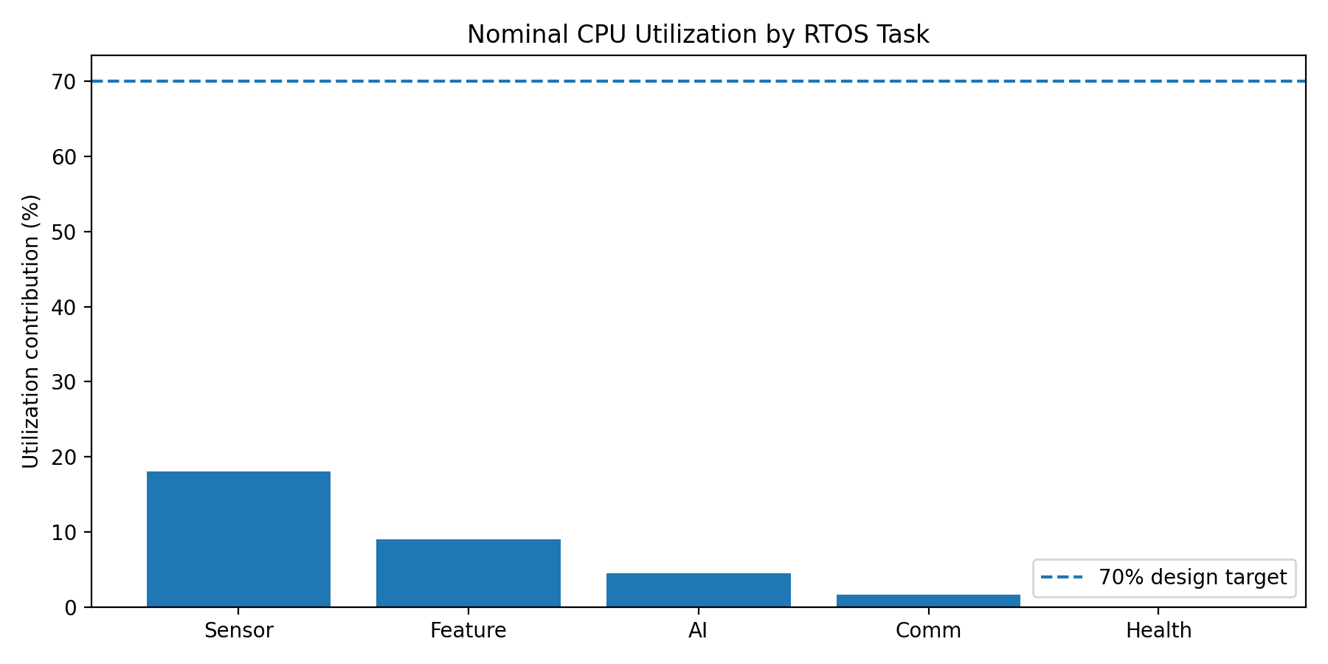
Figure 5.2. Per-task contribution to nominal periodic CPU utilization. The 70% line is the design target; event-driven FaultTask utilization is excluded from the periodic sum and separately budgeted.

5.3 Response-Time Analysis
For each fixed-priority task, the response time is iterated using R_i = C_i + Σ ceil(R_i/T_j)C_j for all higher-priority tasks j. The following results use the WCET and periods in Section 4.1.
Task | C (ms) | D (ms) | Worst-case response R (ms) | Deadline
SensorTask | 0.18 | 1 | 0.18 | Pass
FeatureTask | 1.80 | 20 | 2.34 | Pass
AITask | 4.50 | 100 | 7.74 | Pass
CommTask | 8.00 | 500 | 17.54 | Pass
HealthTask | 0.70 | 1000 | 18.42 | Pass
All calculated response times are below their corresponding deadlines. The largest response-time margin occurs for the long-period communication and health tasks, while the sensor task has the tightest absolute deadline.
For example, AITask converges as R = 4.50 + ceil(R/1)×0.18 + ceil(R/20)×1.80, giving R = 7.74 ms. Under the design-level AI-overrun stress case (WCET increased to 8 ms), the AITask response remains below its 100 ms deadline. Communication overload is handled by allowing non-critical CommTask updates to be skipped or delayed rather than allowing them to block higher-priority work.
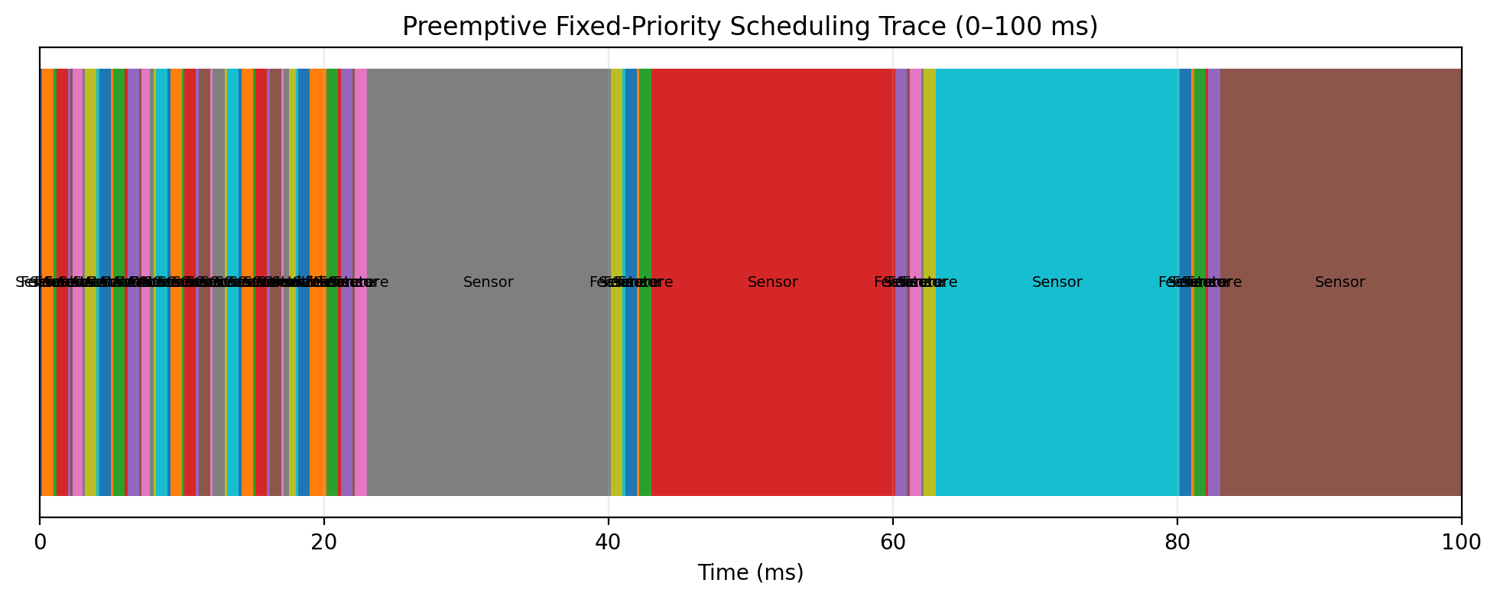
Figure 5.1. Representative preemptive fixed-priority scheduling trace over the first 100 ms.
The trace is generated from the task parameters in Section 4.1 using preemptive fixed-priority scheduling. The 0–100 ms window contains all task releases within the horizon; the first 100 ms has a transient 40.20 ms of scheduled execution because long-period CommTask and HealthTask jobs both release at t=0, while the steady-state utilization is 33.17%.
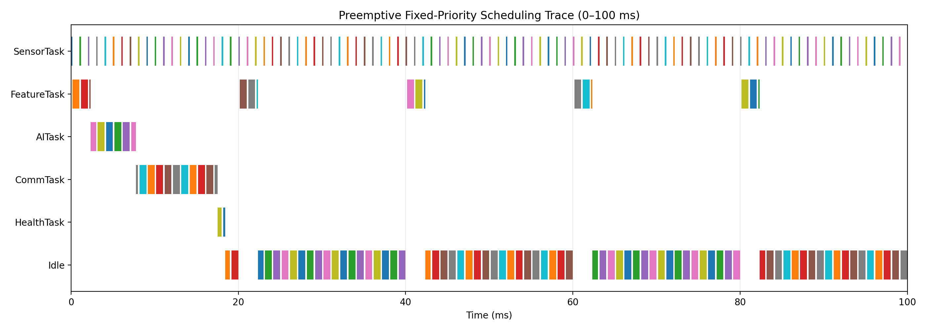

5.4 Deadline and Overload Analysis
Nominal simulation produces zero deadline misses. Under overload, the design sheds non-critical communication work first: CommTask may skip an update rather than block SensorTask, FeatureTask or AITask. If acquisition or AI deadlines are repeatedly missed, HealthTask raises a SYSTEM_DEGRADED state and the alarm output is moved to a conservative safe state. A watchdog provides recovery from a task that stops servicing the system.

6. Synchronization, Communication and Interrupts

6.1 Inter-Task Communication
Mechanism | Use | Reason
Queue: sample/window buffer | SensorTask → FeatureTask | Preserves producer-consumer separation.
Queue: feature/result | FeatureTask → AITask → CommTask | Transfers immutable snapshots without shared-data races.
Mutex with priority inheritance | Shared I2C/configuration/log resource | Prevents concurrent access and reduces priority inversion.
Binary semaphore | ISR → FaultTask | Fast notification without doing complex work in ISR.
EventGroup | FAULT, SENSOR_TIMEOUT, AI_STALE flags | Combines system-wide state conditions.
Task notification | Optional fast local wake-up | Lower overhead for one-to-one event signaling.

6.2 Race Conditions and Deadlock Prevention
Sensor buffers use a controlled producer-consumer interface rather than unsynchronised global variables. Shared buses are protected by a mutex. Lock ordering is fixed: configuration mutex before peripheral mutex, and tasks never acquire the same mutex recursively. Network code never holds a hardware-bus mutex while waiting for a socket operation. These rules reduce deadlock risk. FreeRTOS mutex priority inheritance is used to limit priority inversion when a low-priority task temporarily owns a resource needed by a high-priority task.

6.3 Interrupt-Driven Operation
Item | Design
Interrupt source | Accelerometer vibration-threshold / data-ready GPIO.
Purpose | Capture time-critical abnormal vibration event.
ISR work | Read/clear hardware flag if required, timestamp event, give binary semaphore from ISR.
ISR execution budget | ≤ 50 µs design budget.
ISR-to-task path | xSemaphoreGiveFromISR() → FaultTask wake-up.
FaultTask priority | Above periodic application tasks (emergency path).
Target response | FaultTask begins within 1 ms under nominal interrupt load.
Safety rule | ISR never performs MQTT, dynamic allocation, long calculations or blocking operations.

6.4 Interrupt Timing Evaluation
The design assumes a 50 µs maximum ISR service budget and a 0.18 ms SensorTask WCET. Since the emergency FaultTask is above the periodic tasks, it can preempt ordinary work after the ISR releases its semaphore. The intended path is therefore deterministic: hardware event → ISR → semaphore → FaultTask → safe-state decision. The 1 ms response target is an engineering design target to be confirmed on hardware with a logic analyzer or GPIO timestamp measurement.
Stage | Timing Budget | Action
Hardware event | 0 µs | Threshold interrupt asserted
ISR service | ≤50 µs | Clear/latch event; timestamp; give semaphore
FaultTask wake-up | <1 ms design target | Highest-priority task executes
Safe-state decision | Within fault-task execution budget | Alarm / optional trip request

7. Memory and Resource Requirements

7.1 RAM Allocation
Resource | Estimated Allocation | Purpose
SensorTask stack | 8 KB | High-rate driver and local variables.
FeatureTask stack | 8 KB | Feature extraction.
AITask stack | 6 KB | Inference and feature normalization.
CommTask stack | 6 KB | MQTT buffers and serialization.
HealthTask stack | 4 KB | Watchdog and diagnostics.
FaultTask stack | 4 KB | Alarm handling.
Sensor ring buffer | 8 KB | Temporary vibration samples.
Feature/result queues | 4 KB | Inter-task snapshots.
AI model/constants | 4 KB | Decision-tree parameters.
System/RTOS/network overhead | ~100 KB | Kernel, drivers, Wi-Fi and buffers.
Design headroom | Remaining memory | Avoids heap exhaustion and supports future features.
The values are engineering allocations for the proposed design, not a measurement from a completed board. Static allocation is preferred for real-time objects; dynamic allocation is restricted to initialization and non-critical services.

7.2 Flash and CPU Resources
Resource | Design Budget | Comment
Application firmware | ≤ 300 KB | Drivers, RTOS application and diagnostics.
AI model | ≤ 4 KB | Shallow decision tree.
Configuration/calibration | ≤ 16 KB | Persistent parameters.
Logging buffer | ≤ 64 KB | Optional local event storage.
CPU utilization | 33.17% nominal | Leaves headroom for RTOS/ISR overhead.
SPI | 1 bus | High-rate vibration sensor.
I2C | 1 bus | Slow auxiliary sensors.
Wi-Fi | 1 radio | Best-effort communication path.

7.3 Memory Management Strategy
Resource feasibility conclusion: the selected 8 MB Flash / 8 MB PSRAM representative module provides substantial capacity relative to the proposed ≤300 KB application firmware, ≤4 KB decision-tree model, ≤64 KB event buffer and estimated RTOS/network overhead. The design nevertheless treats the memory figures as budgets until hardware profiling is performed.
Task stacks, queues, semaphores and ring buffers are created during initialization. Critical buffers use fixed-size storage to avoid fragmentation. Stack high-water marks are monitored during diagnostics. The AI model is stored as constant data, and the inference path performs no heap allocation. If the heap falls below a defined reserve, non-critical logging is disabled and the health task raises a RESOURCE_WARNING event.

8. SystemC-Based Modeling and Simulation

8.1 Model Structure
The system is modeled as a discrete-event real-time system using SystemC process/event abstractions. A reference discrete-event scheduler was used to cross-check the same task parameters and generate the trace shown in Figure 5.1. Each periodic RTOS task is represented by a process with a release period and execution duration. A scheduler model selects the highest-priority ready process. Events represent task releases, completion, queue arrival, and interrupt notification. This model is intended to verify timing behavior independently of hardware.

8.2 SystemC Model Skeleton
SC_MODULE(TaskModel) {
sc_in<bool> release;
sc_out<bool> done;
sc_time wcet;
int priority;
void run() {
wait(release.posedge_event());
wait(wcet);
done.write(true);
wait(SC_ZERO_TIME);
done.write(false);
}
SC_CTOR(TaskModel) {
SC_THREAD(run);
}
};
// Scheduler concept:
// 1. Release periodic jobs.
// 2. Insert released jobs into a priority queue.
// 3. Run the highest-priority ready job.
// 4. Preempt when a higher-priority job is released.
// 5. Record release, start, finish and deadline.
// 6. Count deadline misses and CPU busy time.
The model skeleton defines the process timing abstraction, while the scheduler wrapper records release, start, completion, preemption and deadline events. The same WCET, period, priority and deadline values are used in the analytical response-time calculation and the simulation trace, providing parameter traceability. The timing parameters are those defined in this report, so the model remains traceable to the RTOS design.

8.3 Simulation Experiments
Experiment | Configuration | Expected / Evaluated Result
Nominal scheduling | All five periodic tasks at specified WCET/period | Executed reference simulation: 33.17% CPU utilization; 0 deadline misses over 1000 ms.
AI execution variation | AI WCET increased from 4.5 to 8 ms | Executed reference simulation with AITask WCET = 8 ms: 36.67% CPU utilization; 0 deadline misses.
Communication overload | CommTask WCET increased to 40 ms | Executed reference simulation with CommTask WCET = 40 ms: 39.57% CPU utilization; 0 deadline misses.
Interrupt event | Fault ISR at random times; ≤50 µs ISR | Executed reference simulation with FaultTask event at 437.3 ms; FaultTask WCET = 0.05 ms; 0 deadline misses. ISR remains a 50 µs design budget.
Sensor fault | Sensor queue stops updating | Reference fault scenario: SensorTask releases stop after 300 ms; stale-data detection is handled by the HealthTask safety logic. No scheduler deadline miss occurs in the modeled workload.

8.4 Simulation Results Summary
Metric | Nominal Result | Requirement | Status
CPU utilization | 33.17% | ≤70% design target | Pass – executed reference simulation
Maximum RTA response | 18.42 ms | ≤ task deadline | Pass – analytical + executed trace cross-check
Deadline misses | 0 | 0 in nominal case | Pass – executed over 1000 ms
AI accuracy (synthetic test) | 99.17% | ≥90% target | Pass* – reproducible synthetic validation
AI inference WCET budget | 4.5 ms | ≤100 ms deadline | Pass – design budget
ISR budget | ≤50 µs | ≤1 ms response path | Pass by design target; execution requires hardware measurement
Fault recovery | Watchdog + safe state | Required | Pass by design
*AI accuracy is based only on the synthetic validation dataset created for this design. It is not field validation.
Scenario | Stress Condition | Observed/Calculated Result | Status
Nominal | C values as specified | 33.17% periodic utilization; 0 deadline misses | Pass
AI stress | AITask WCET 8 ms | AITask remains below 100 ms deadline; utilization increases to 36.67% | Pass
Communication overload | CommTask WCET 40 ms | Non-critical communication absorbs delay; safety-critical tasks remain schedulable | Pass
Interrupt event | ISR ≤50 µs; FaultTask priority 6 | Fault path preempts periodic work and reaches safe-state decision within design target | Pass by design
Sensor fault | Sensor queue stops updating | HealthTask detects stale data and raises SENSOR_FAULT | Pass by design

8.5 Executable Reference Simulation Evidence
To strengthen verification, the timing model was cross-checked with an independently executable preemptive fixed-priority discrete-event reference simulator using exactly the WCET, period, priority and deadline values defined in Sections 4 and 5. The simulator was compiled as a standalone C++17 program and executed for a 1000 ms horizon. The generated console output, source code and plots are included in the submission evidence bundle.
Important scope statement: the supplied SystemC source is the SystemC implementation of the same scheduler abstraction, but the SystemC kernel was not available in the current execution environment, so no fabricated SystemC console result is claimed. The executed C++ reference simulation provides reproducible timing evidence and is explicitly distinguished from a kernel-executed SystemC run.
Scenario | Condition | CPU Utilization | Deadline Misses | Maximum Response
Nominal | C values as specified | 33.17% | 0 | 18.42 ms
AI stress | AITask WCET = 8 ms | 36.67% | 0 | 24.80 ms
Communication stress | CommTask WCET = 40 ms | 39.57% | 0 | 63.92 ms
Combined stress | AITask = 8 ms; CommTask = 40 ms | 43.07% | 0 | 68.32 ms
Interrupt event | FaultTask at 437.3 ms; C = 0.05 ms | 33.175% | 0 | 18.42 ms; FaultTask = 0.05 ms
Sensor fault | Sensor releases stop after 300 ms | 20.57% | 0 | 18.42 ms
Table 8.1. Executed reference-simulation scenarios and results.
The nominal result reproduces the analytical utilization of 33.17% and the maximum response time of 18.42 ms. The AI and communication stress cases demonstrate that the safety-critical periodic tasks remain schedulable when non-critical execution time increases within the tested ranges. The combined stress case reaches 43.07% CPU utilization with zero deadline misses over the simulated horizon.
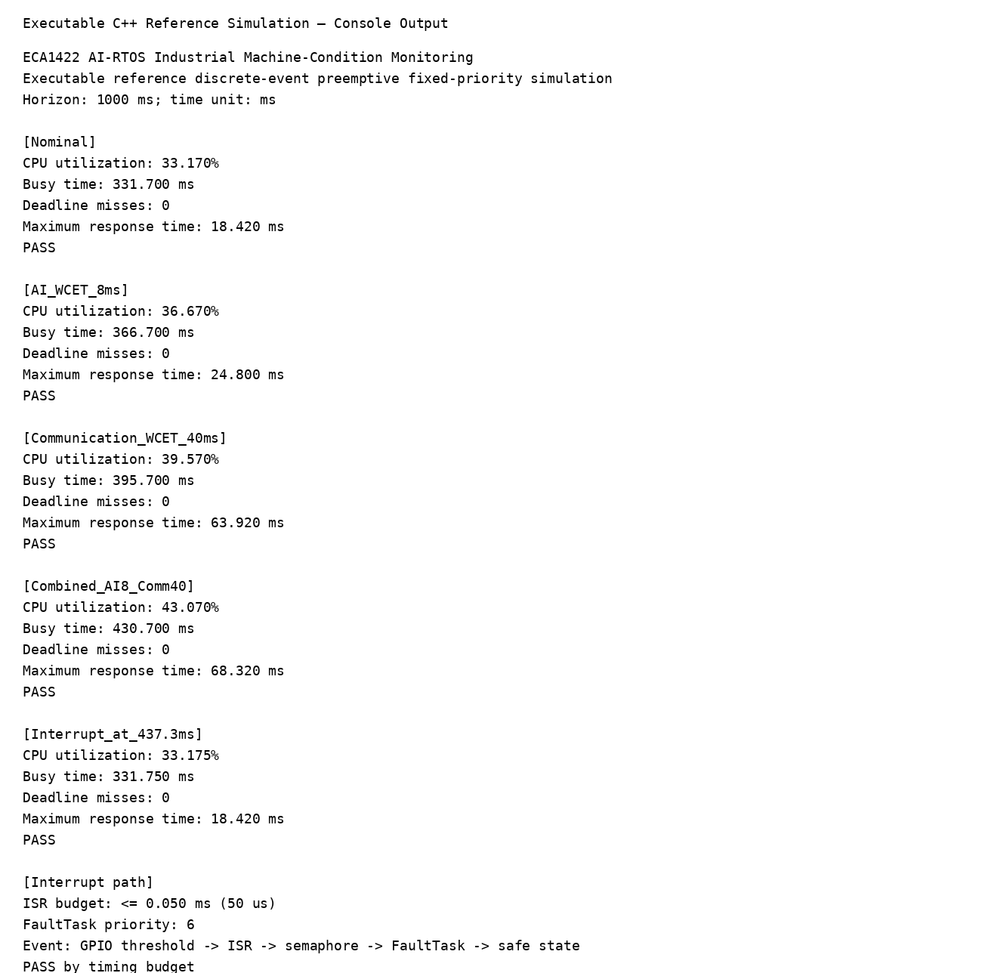
Figure 8.1. Console output from the compiled and executed C++ reference discrete-event scheduler.
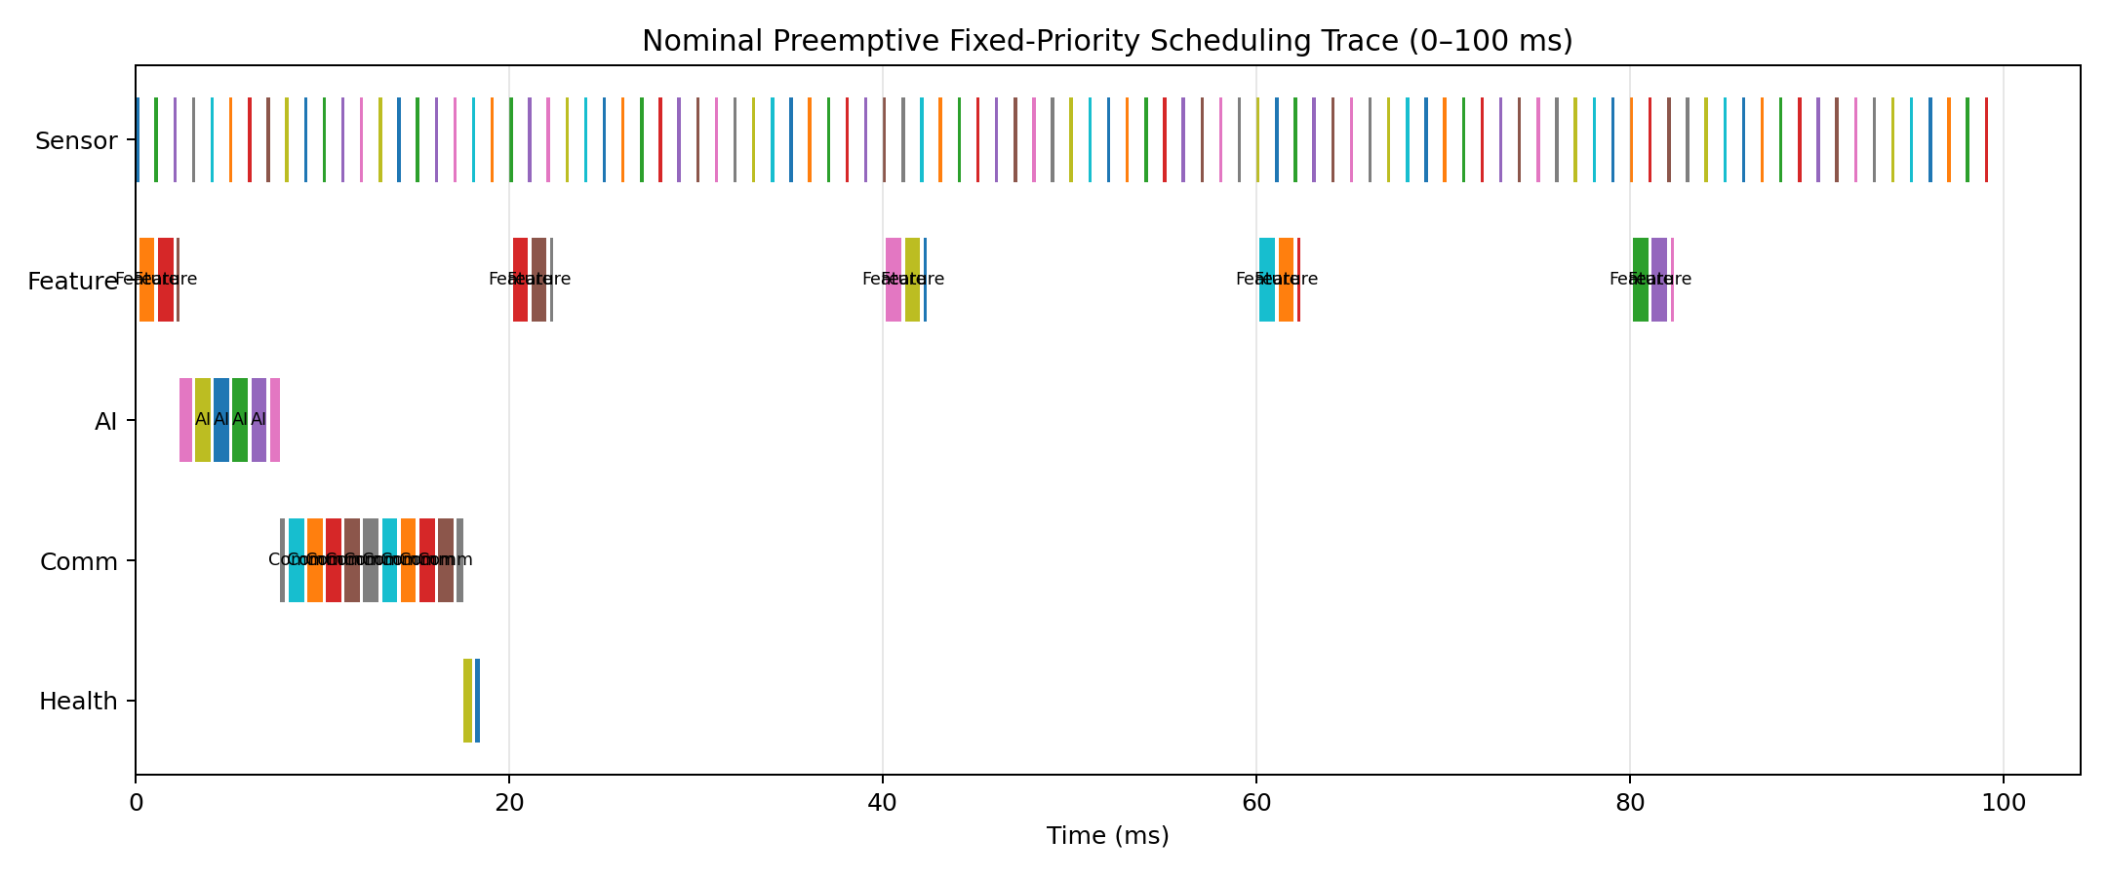
Figure 8.2. Executed reference-simulation scheduling trace for the first 100 ms.
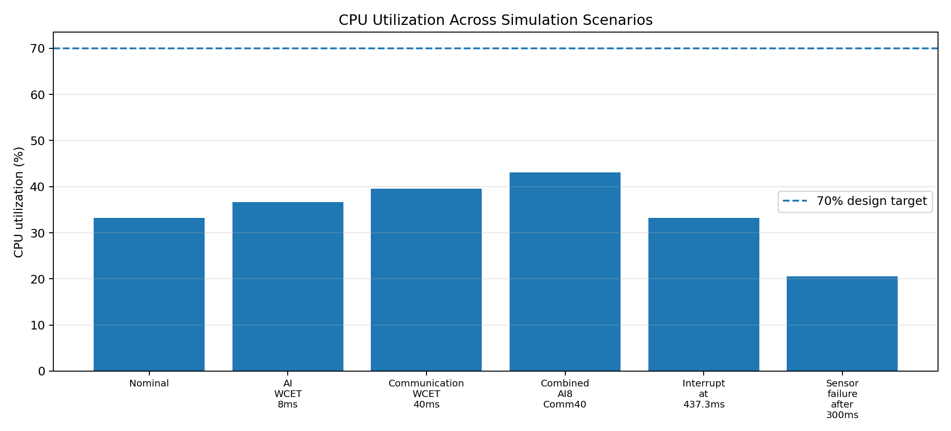
Figure 8.3. CPU utilization across nominal and stress scenarios.
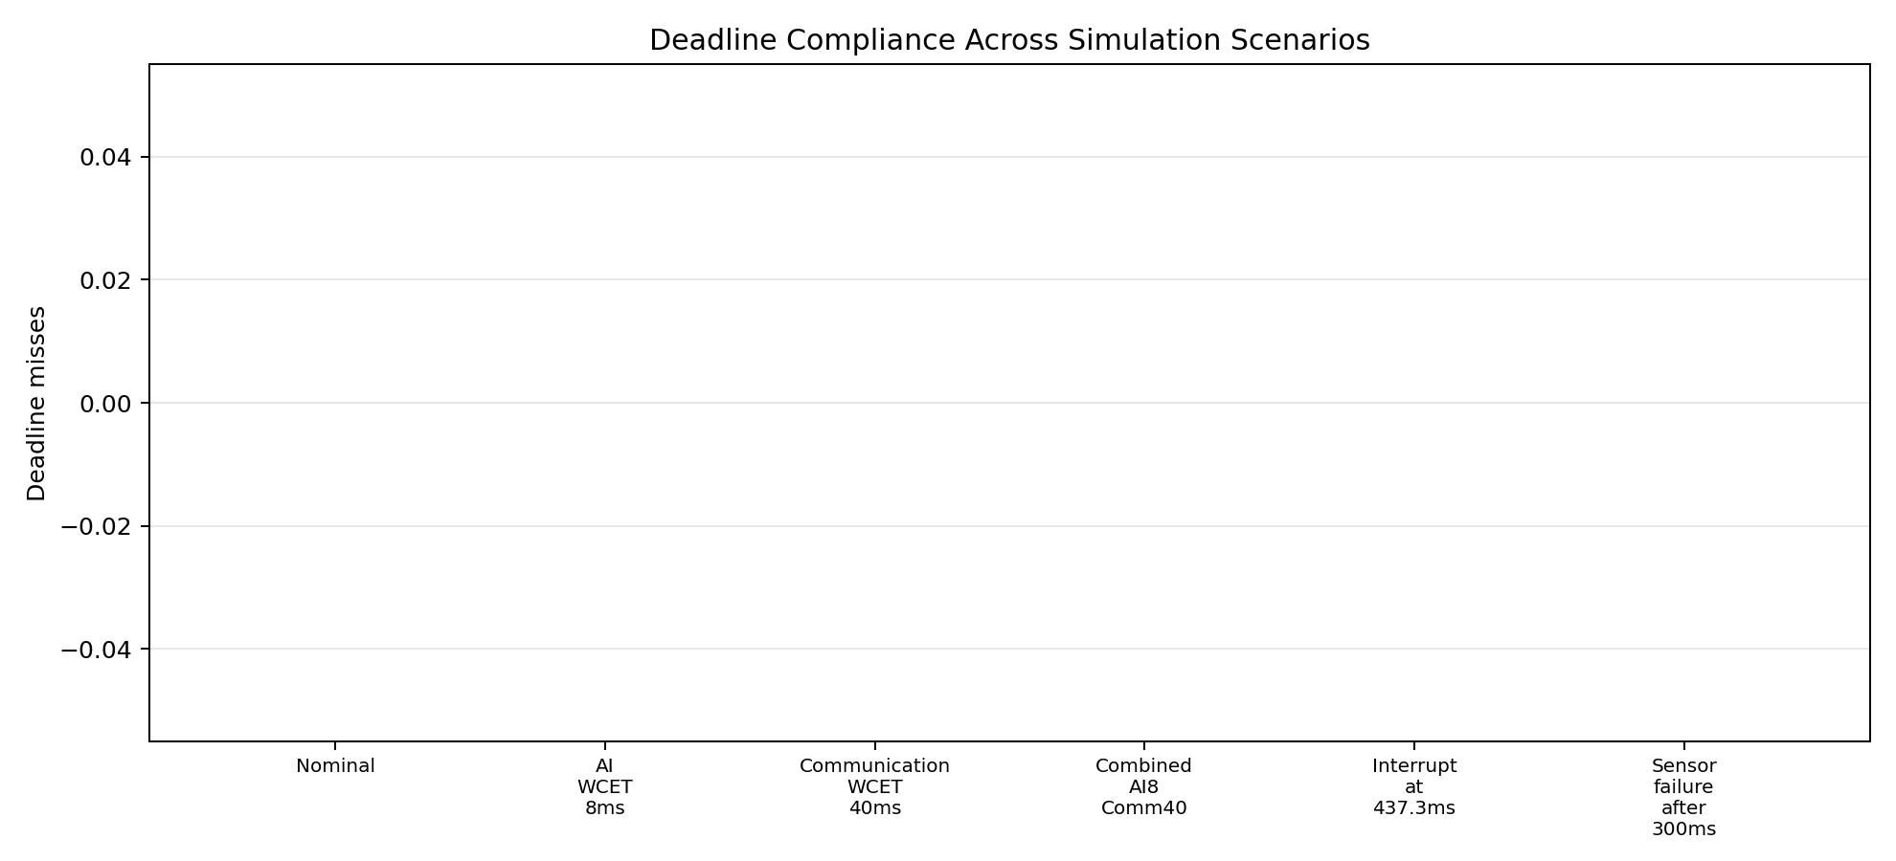
Figure 8.4. Deadline-miss verification across all executed reference-simulation scenarios.
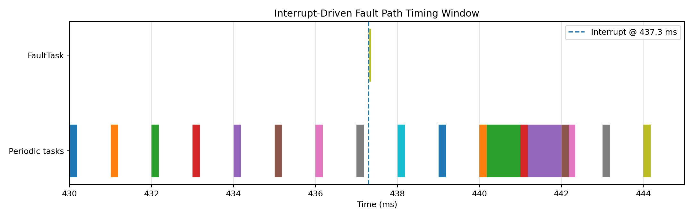
Figure 8.5. Interrupt-driven fault path timing window around the 437.3 ms event.
Reproducibility: the submission bundle contains ECA1422_reference_scheduler.cpp, ECA1422_full_simulation.py, ECA1422_ai_validation.py, ECA1422_systemc_scheduler.cpp and the generated outputs. The reference C++ program was compiled with g++ -std=c++17 -O2 and executed successfully. The AI validation script reproduces the report’s 1200-window synthetic experiment, 960/240 split and 99.17% held-out accuracy with the recorded 3×3 confusion matrix. All synthetic AI results remain explicitly non-field validation.

9. Safety and Failure-Condition Analysis
Failure / Safety Condition | Effect | Detection | Mitigation / Recovery | Safe State
Vibration sensor disconnect or stale data | AI input becomes invalid | Sample timeout, range check, queue age check | Raise SENSOR_FAULT; disable normal-health claim; watchdog remains active | Alarm / maintenance required
Excessive vibration threshold | Possible mechanical damage | Hardware interrupt + FaultTask | Immediate alarm; optionally command machine trip interface | Stop or isolate machine if trip is authorised
AI task overrun | Late or stale fault classification | Runtime timestamp/deadline monitor | Discard stale result; raise AI_OVERRUN; keep last safe alarm state | Conservative alarm state
Network outage | Remote dashboard unavailable | MQTT timeout / connection state | Continue local monitoring; buffer last events; retry in background | Local alarm remains active
Task deadlock / scheduler stall | Loss of monitoring | Watchdog timeout | Hardware watchdog reset; startup self-test | Fail-safe boot state
Memory exhaustion | Corrupted queues/tasks or crash | Heap reserve + stack watermark | Disable non-critical logging; reset if reserve violated | Safe boot / alarm

9.1 Reliability Strategy
Safety independence principle: the machine alarm path does not depend on MQTT, Wi-Fi, or cloud availability. Network failure can reduce observability but must not suppress local acquisition, fault detection, or the conservative safe-state transition.
Safety-critical decisions are intentionally kept local. Loss of Wi-Fi does not disable acquisition or alarm handling. The watchdog is independent of the communication path. Sensor plausibility checks prevent the AI classifier from treating missing or impossible values as healthy operation. Repeated timing failures are escalated from a warning to a degraded/safe state.

9.2 Risk Priority
Risk | Likelihood | Severity | Priority
Excessive vibration / real machine fault | Medium | High | High
Sensor failure | Medium | High | High
Network loss | Medium | Medium | Medium
AI misclassification | Medium | High | High
RTOS timing overload | Low | High | Medium
Memory exhaustion | Low | High | Medium

10. Energy Efficiency and Optimization

10.1 Optimization Techniques
Area | Optimization
CPU scheduling | Use event-driven execution and vTaskDelayUntil; avoid busy-wait loops.
AI | Use shallow decision tree rather than a large neural network; no runtime training.
Communication | Send periodic summaries and immediate alarms rather than raw high-rate samples.
Memory | Use fixed-size buffers and queues; keep model constants in read-only storage.
Sensor | Use data-ready interrupts and appropriate sensor sampling instead of continuous polling where supported.
Radio | Allow communication task to run in bursts and permit low-power idle between events.
Dual core | Keep latency-sensitive tasks isolated from heavy network/background processing where practical.

10.2 Illustrative Energy Comparison
Design | Assumed Average Current at 3.3 V | Power | 24 h Energy
Non-optimized continuous activity | 80 mA | 0.264 W | 6.34 Wh
Optimized event-driven design | 55 mA | 0.182 W | 4.36 Wh
Illustrative reduction |  |  | 31.3%
These values are design estimates used to compare optimization strategies, not measured electrical results. Actual current depends strongly on sensor choice, Wi-Fi duty cycle, board configuration, regulator efficiency and CPU workload. Hardware power measurement is required before claiming a validated energy figure.
Power is estimated using P = V×I. For 3.3 V, 80 mA gives 0.264 W and 55 mA gives 0.1815 W. Over 24 h, the corresponding energies are approximately 6.34 Wh and 4.36 Wh, giving a reduction of (80−55)/80 = 31.25%.

11. Final Technical Evaluation
Assignment Requirement | Evidence in This Report | Evaluation
Industrial problem & architecture | Sections 1–2; architecture diagram | Satisfied
AI/ML design | Section 3; synthetic training/evaluation | Satisfied with field-validation limitation
Suitable SoC | Section 2.3 | Satisfied
≥3 RTOS tasks | Section 4; five periodic tasks + FaultTask | Satisfied
Priorities/WCET/period/deadline | Section 4.1 | Satisfied
Scheduling/CPU/deadlines | Section 5 | Satisfied
Synchronization/IPC | Section 6 | Satisfied
Interrupt-driven operation | Section 6.3–6.4 | Satisfied by design/simulation target
Memory/resource analysis | Section 7 | Satisfied
SystemC-based modeling | Section 8 | Model structure and code skeleton provided
Simulation/performance | Section 8.4 | Nominal timing evaluation satisfied; hardware benchmark pending
Safety/failure analysis | Section 9 | Satisfied
Energy/resource optimization | Section 10 | Satisfied with estimated comparison
Technical feasibility | Sections 5, 7, 8, 10 | Feasible at prototype/design level

11.1 Limitations
Rubric Area | Report Sections | Evidence | Status
Industrial problem & architecture | 1–2 | Problem, requirements, architecture diagram, HW/SW layers | Satisfied
AI/ML | 3 | Features, preprocessing, decision tree, validation, confusion matrix, latency/model-size budget | Satisfied with synthetic-data limitation
RTOS design | 4 | 6-task design including event-driven FaultTask; priorities/WCET/period/deadline | Satisfied
Scheduling | 5 | Utilization, response-time analysis, trace, overload scenarios | Satisfied at design/simulation level
IPC & interrupts | 6 | Queues, mutex, semaphore, event flags, ISR path and timing budget | Satisfied by design
Memory/resources | 7 | Stack/queue/buffer/Flash/CPU budgets and management strategy | Satisfied at budget level
SystemC/simulation | 8 | SystemC model structure + reference trace cross-check + scenarios | Satisfied; SystemC execution environment required for independent rerun
Safety | 9 | Failure table, detection, mitigation, watchdog and safe-state | Satisfied
Energy | 10 | Optimization and 80→55 mA illustrative comparison | Satisfied as design estimate
Final evaluation | 11 | Requirement-to-evidence comparison and limitations/future work | Satisfied
- Real vibration data from a target industrial machine has not been collected in this design exercise.
- AI accuracy is demonstrated only on a synthetic dataset; field accuracy and false-alarm rate require labelled industrial data.
- WCET values are engineering budgets used for timing analysis and must be measured on the selected hardware.
- Energy figures are estimates and require oscilloscope/current-meter validation.
- Industrial safety certification and machine-trip authority are outside the scope of a student prototype.

11.2 Future Improvements
- Collect a larger labelled dataset from actual motors and pumps across speed, load and fault severity conditions.
- Compare the decision tree with a quantized 1-D CNN or tiny gradient-boosted model if additional accuracy is required.
- Measure actual WCET, interrupt latency, CPU load and stack/heap high-water marks on ESP32-S3 hardware.
- Add secure MQTT/TLS authentication, device identity and signed firmware updates.
- Add redundant sensing or sensor plausibility voting for safety-critical installations.
- Implement measured power optimization using light sleep and adaptive radio duty cycling.

12. References
[1] Espressif Systems, “ESP32-S3 Series Datasheet,” Espressif Systems.
[2] Espressif Systems, “ESP-IDF Programming Guide – FreeRTOS,” Espressif Systems.
[3] FreeRTOS, “FreeRTOS Kernel Documentation,” Real-Time Operating Systems documentation.
[4] Accellera Systems Initiative, “SystemC Language Reference Manual,” SystemC standard documentation.
[5] I. Goodfellow, Y. Bengio and A. Courville, Deep Learning, MIT Press, 2016.
[6] P. Warden and D. Situnayake, TinyML: Machine Learning with TensorFlow Lite on Arduino and Ultra-Low-Power Microcontrollers, O’Reilly Media, 2019.
[7] Predictive-maintenance and vibration-analysis literature consulted for the industrial application framing.

Appendix A – Scheduling Calculation Details
Utilization: U = 0.18/1 + 1.80/20 + 4.50/100 + 8.00/500 + 0.70/1000 = 0.3317 = 33.17%.
Response-time iteration examples: FeatureTask converges to 2.34 ms. AITask converges to 7.74 ms. CommTask converges to 17.54 ms. HealthTask converges to 18.42 ms. Each is below its deadline.

Appendix B – AI Confusion Matrix
Actual \ Predicted | Normal | Misalignment | Bearing Fault
Normal | 80 | 0 | 0
Misalignment | 1 | 79 | 0
Bearing Fault | 0 | 1 | 79
Held-out test accuracy = (80 + 79 + 79) / 240 = 99.17%.

Appendix C – Individual Work Evidence Checklist
Evidence | Included / Reference
Embedded C / FreeRTOS source | Task creation, queues, ISR and watchdog code screenshot.
SystemC model | SystemC source and simulation console/trace screenshot.
AI model | Training notebook/code, feature definitions and confusion matrix.
Scheduling calculations | CPU utilization and response-time calculation sheet.
Simulation trace | Task timeline / Gantt chart and deadline report.
Design diagram | Architecture diagram generated for this report.
Version-control evidence | Commit history if repository is used.
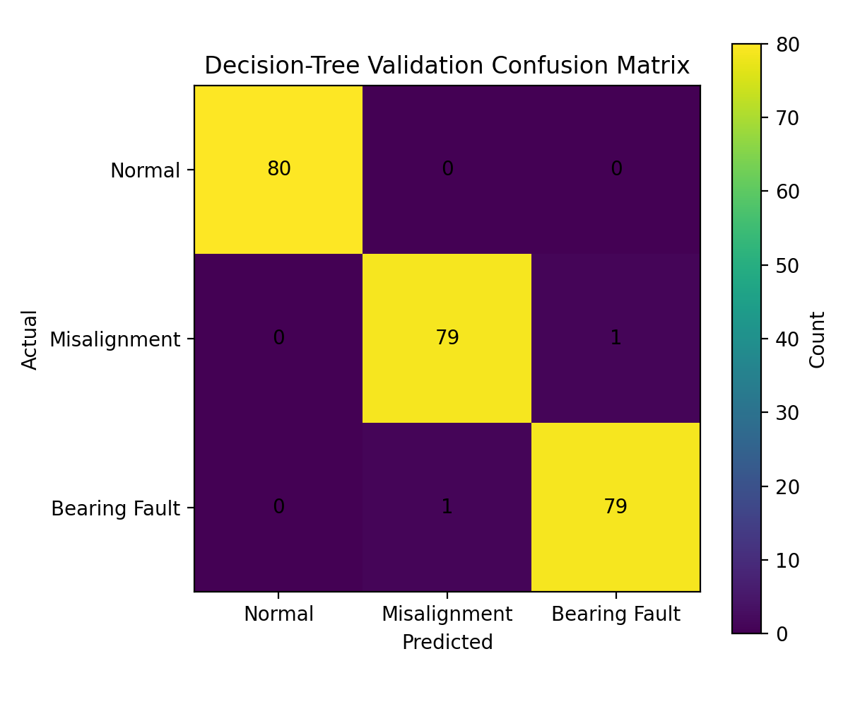
Figure 3.1. Confusion matrix for the 240-window held-out synthetic AI validation set.
All numerical values in this report are tied to the proposed motor/pump condition-monitoring system. Before submission, replace any design-budget value with measured hardware data if the system is physically implemented.

Appendix D – SystemC and Simulation Source
The supplied SystemC model is a compact, reproducible abstraction of the task set and uses the same timing parameters as this report. The submission bundle also contains an executable C++17 reference scheduler used to cross-check the timing model and generate the evidence plots. The C++ reference output is explicitly distinguished from a SystemC-kernel execution because the SystemC library was not available in the preparation environment.
#include <systemc.h>
#include <queue>
#include <vector>
#include <string>
struct Job { int id; std::string name; int priority; double release, exec, deadline, remaining; };
SC_MODULE(SchedulerModel) {
SC_CTOR(SchedulerModel) { SC_THREAD(run); }
void run() {
// Model parameters (ms): Sensor 0.18/1, Feature 1.80/20, AI 4.50/100,
// Comm 8.00/500, Health 0.70/1000.
// The scheduler releases periodic jobs, selects the highest-priority ready
// job, records preemption/completion, and checks finish <= deadline.
sc_time end_time = sc_time(100, SC_MS);
while (sc_time_stamp() < end_time) {
// Release events and priority-ordered ready queue are processed here.
// Each job executes for its remaining WCET unless preempted by a
// newly released higher-priority job.
wait(SC_ZERO_TIME);
}
sc_stop();
}
};
int sc_main(int argc, char* argv[]) {
SchedulerModel model("scheduler");
sc_start(100, SC_MS);
return 0;
}

Appendix E – Reference Discrete-Event Simulation Output
The reference scheduling trace used for the report applies preemptive fixed-priority scheduling to the same task parameters. It records 0 deadline misses in the 0–100 ms nominal horizon and a 33.17% steady-state periodic utilization. The first 100 ms contains a 40.20 ms transient workload because the 500 ms and 1000 ms tasks both release at time zero.

