TECHNICAL SUBMISSION

Advanced IoT-Based Particulate Matter and Air Quality Monitoring System Using ESP32 with Real-Time Analytics
Final reproducibility, implementation, data, verification and evidence package
ECA1422 - EMBEDDED SYSTEMS

Submitted by
G. Jaswanth (192472235)

1. Submission Scope
This document accompanies the reproducible technical submission package. It is built from the implemented ESP32 firmware, Flutter application source, Firebase export and supplied prototype/application evidence. The numerical results in this document are recalculated from the exact Firebase export included in the package.

2. Implemented System
The implemented system is an end-to-end embedded IoT monitoring pipeline: DHT11 acquisition → ESP32 processing → SSD1306 OLED → Wi-Fi/HTTPS → Firebase Realtime Database → Flutter mobile dashboard and historical analytics.
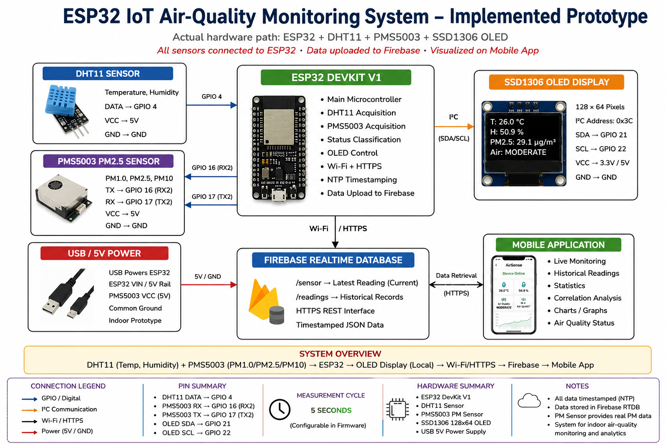
Figure 1. Final implemented system schematic.

3. Hardware and Pin Configuration
Component | Interface / Pin | Implementation
ESP32 DevKit V1 | Main controller | Sensor acquisition, processing, Wi-Fi/HTTPS
DHT11 | DATA → GPIO 4 | Real temperature and humidity acquisition
SSD1306 128×64 OLED | SDA → GPIO 21; SCL → GPIO 22; address 0x3C | Local display over I²C
Power | USB / 5V input | Prototype power source
Measured supply current was not provided, so no current-consumption value is claimed.

4. Software and Dependencies
ESP32 firmware is implemented in Arduino/C++ using the ESP32 Wi-Fi stack, secure client/HTTP libraries, I²C, Adafruit SSD1306/GFX, DHT and NTP/time functions. The mobile application is Flutter/Dart and uses firebase_core and firebase_database.
The complete source is under source_code/. Machine-specific generated folders such as .dart_tool, build, Gradle caches and local.properties are intentionally excluded from the reproducibility package.

5. Data Architecture and Operation
Each measurement cycle reads temperature and humidity, updates the PM2.5 simulation, derives a qualitative status, updates the OLED, then sends a JSON object to Firebase. The latest reading is written to /sensor; a new historical record is appended under /readings.
The mobile application subscribes to /sensor for live values and retrieves /readings for historical analysis. Its history implementation calculates minimum, average, maximum and population standard deviation and generates Pearson correlation plots.

6. Raw Dataset and Data Quality
The supplied Firebase export contains 510 historical records. 424 records contain valid explicit timestamps, 84 have no timestamp field, and 2 are explicitly marked TIME_NOT_SYNCED.
Data-quality item | Value
Total /readings records | 510
Valid explicit timestamps | 424
Missing timestamp field | 84
TIME_NOT_SYNCED | 2
Latest /sensor timestamp | 2026-09-03 16:25:54

7. Processed Numerical Results
Metric | Min | Mean | Max | Population SD | Unit
PM2.5 | 11.7 | 24.595 | 35.1 | 6.385 | µg/m³
Temperature | 23.9 | 25.588 | 30.8 | 1.320 | °C
Humidity | 43.5 | 49.678 | 81.7 | 7.340 | %
These statistics use all 510 historical records because all 510 contain the three numerical fields. They supersede older app screenshots that displayed a smaller historical subset.

8. Correlation Analysis
Variable pair | Pearson r | Interpretation
PM2.5 vs Temperature | -0.134 | Very weak negative relationship
PM2.5 vs Humidity | -0.092 | Very weak negative relationship
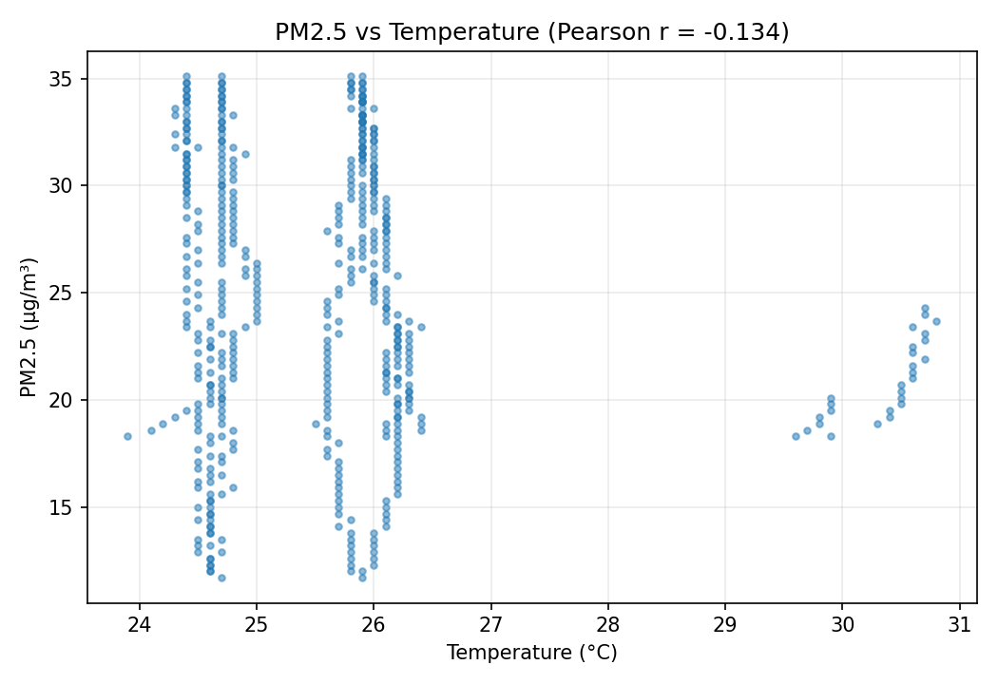
Figure 2. PM2.5 vs temperature
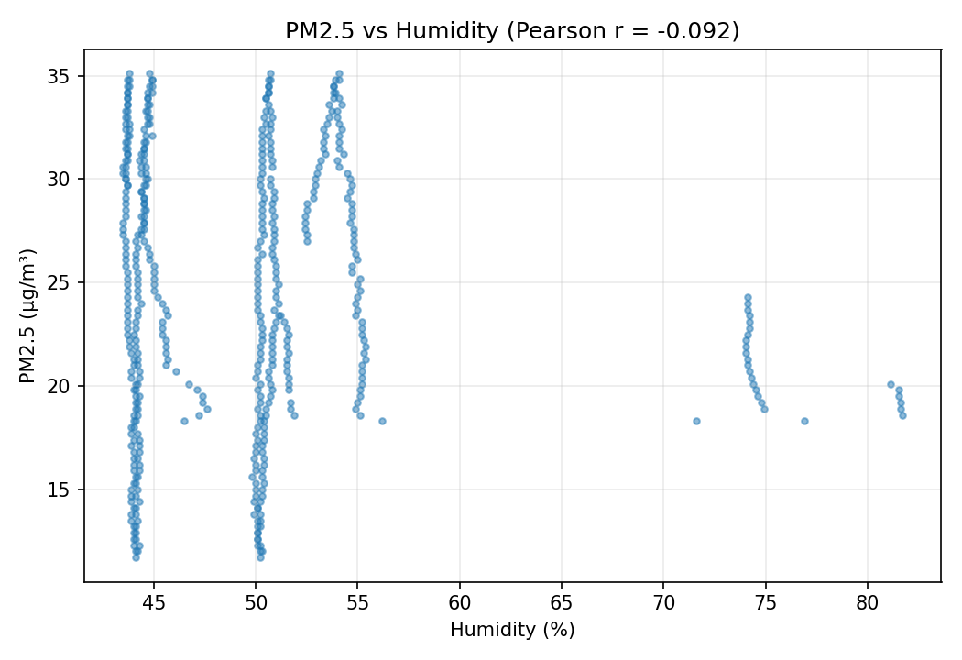
Figure 3. PM2.5 vs humidity

9. Status Distribution
Status | Count | Percentage
GOOD | 2 | 0.39%
MODERATE | 508 | 99.61%
UNHEALTHY | 0 | 0.00%
POOR | 0 | 0.00%
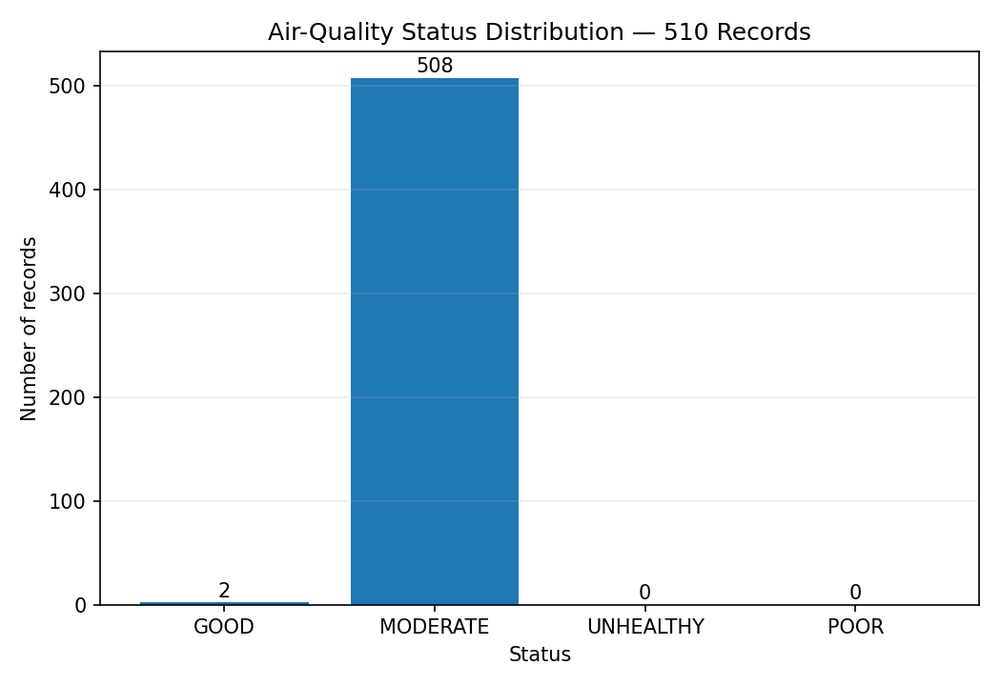
Figure 4. Status distribution calculated directly from the 510-record Firebase export.

10. Verification and Validation
T01 — DHT11 acquisition: PASS – functional evidence; formal accuracy not validated
T02 — OLED display: PASS – functional
T03 — PM2.5 simulation: DEVIATION – observed 11.7–35.1 µg/m³; ±0.3 step crosses bounds by one step
T04 — Latest Firebase upload: PASS
T05 — Historical Firebase logging: PASS – export evidence
T06 — Timestamp generation: PASS with limitation – 424 valid timestamps; 84 missing and 2 unsynced
T07 — Mobile data retrieval: PASS – functional evidence
T08 — Statistical analysis: PASS – 510 records
T09 — Correlation analysis: PASS – r=-0.134 (temperature), r=-0.092 (humidity)
T10 — Wi-Fi reconnection: PENDING
T11 — Long-duration uptime: PENDING
T12 — Sensor accuracy: PENDING
T13 — Security hardening: PENDING – development configuration uses placeholder credentials and `setInsecure()`
Formal Wi-Fi reconnection, long-duration uptime, calibrated sensor accuracy and production security-hardening tests are marked pending because controlled evidence was not supplied. This avoids unsupported performance claims.

11. Engineering Deviations and Corrective Actions
The PM2.5 simulation was documented with intended bounds of 12.0–35.0 µg/m³ and a ±0.3 step. The current implementation updates the value before reversing direction, producing observed boundary values of 11.7 and 35.1 µg/m³. This is a one-step boundary-crossing deviation, not a hidden result.
Recommended corrective action: clamp the generated value after the update (or reverse direction before crossing the bound), then re-run the dataset and verification test. The current raw dataset is retained unchanged because it represents the actual submitted run.
The firmware also uses TLS certificate bypass (`setInsecure()`) for development. Production deployment should use certificate validation and hardened Firebase rules.

12. Evidence
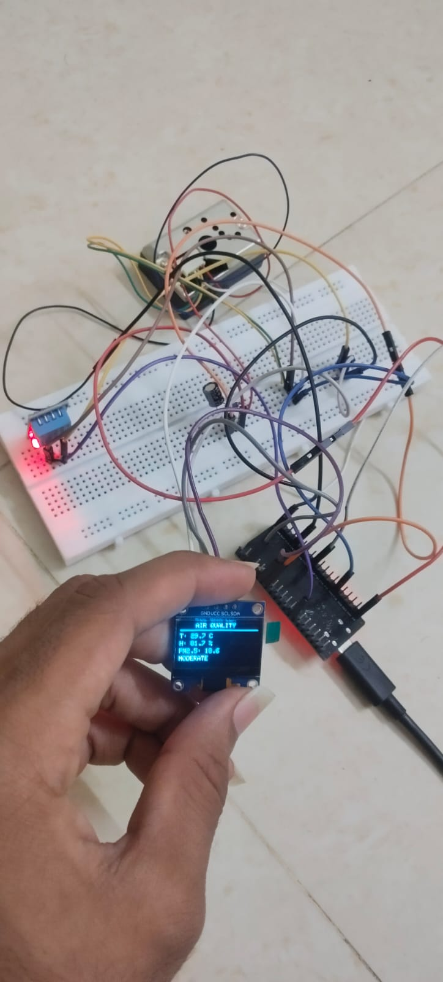
Figure 5. Prototype hardware evidence showing ESP32, breadboard wiring and OLED, PMS Sensor.
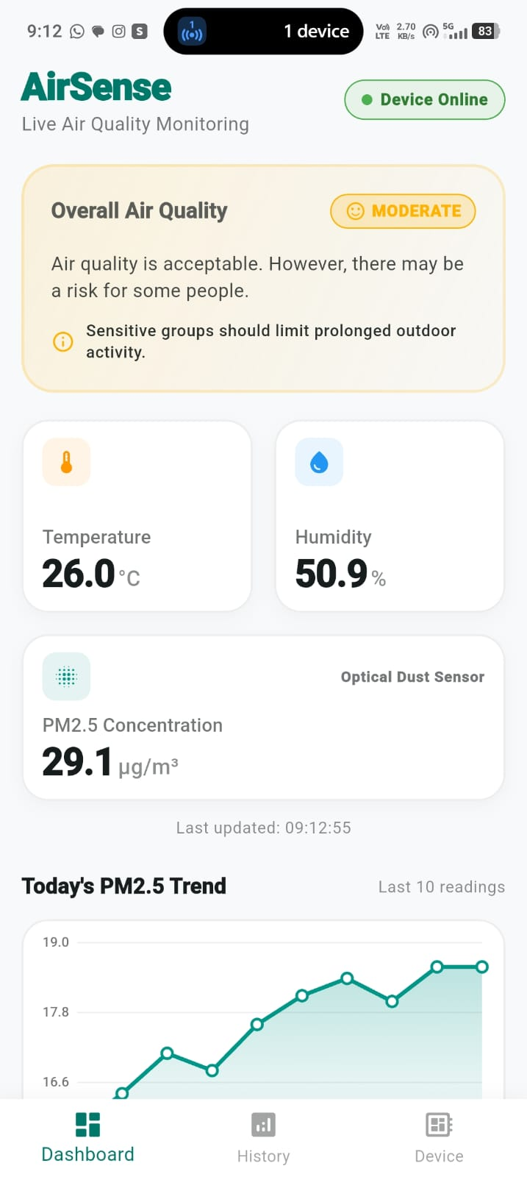
Figure 6. Mobile dashboard evidence showing live monitoring.
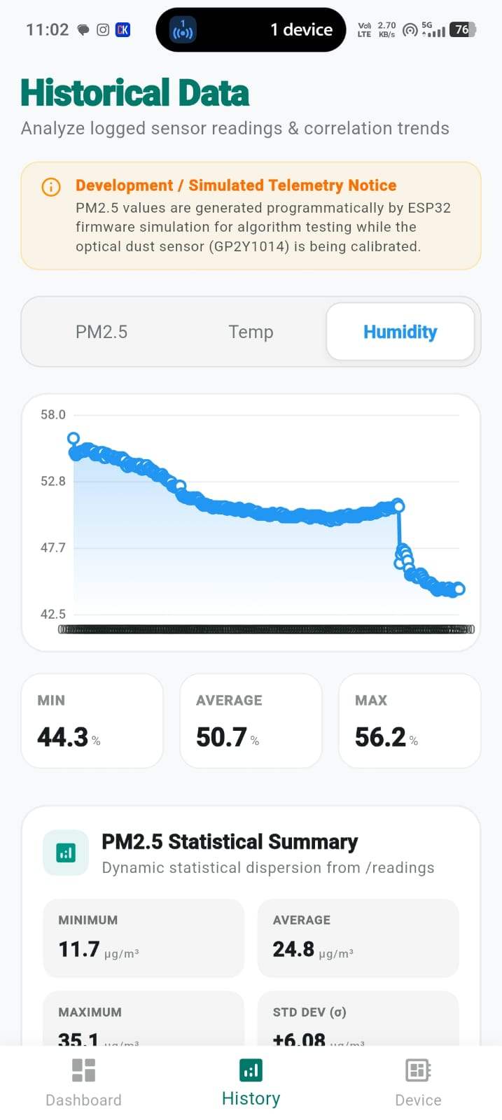
Figure 8. Mobile historical humidity analytics evidence.

13. Reproducibility Package Contents
The final ZIP contains source code, circuit diagram, raw Firebase export, processed CSV/XLSX data, generated charts, verification tables, README, implementation notes and available evidence.
GitHub repository confirmed by the team: https://github.com/jaswanth-077/ECA1422---Embedded-Systems
Demo video:

