Smart QR-Based Attendance Management System
A Project Based Learning Report Submitted in partial fulfilment of the requirements for the award of the degree

of

Bachelor of Technology
in The Department of CSE
FULL STACK APPLICATION DEVELOPMENT / 24SDCS02A

Submitted by
2410030339: BADDAM KARTHIK REDDY
2410030337: KASARLA MANI VARDHAN REDDY
2410030140: CHELLAMLLA JASWANTH REDDY
2410030146: SHAIK MUZAMMIL AHMED

Under the guidance of
Dr. Madhukar Rao Sir



Department of Computer Science and Engineering
Koneru Lakshmaiah Education Foundation, Aziz Nagar
Aziz Nagar – 500075
FEB - 2025.

Introduction
(Minimum 200 words)

- The traditional method of taking attendance in educational institutions has long been a time-consuming process that often leads to inefficiencies and inaccuracies. Teachers spend valuable class time calling out names, and students sometimes exploit the system through proxy attendance. In today's digital age, there's a pressing need for a more efficient, secure, and automated solution to this everyday problem.

- Our project, the Smart QR-Based Attendance Management System, addresses these challenges by leveraging modern web technologies to create a comprehensive attendance tracking solution. The system utilizes dynamically generated QR codes that refresh every 20 seconds, making it virtually impossible for students to share codes or mark proxy attendance. Combined with multiple layers of validation including device registration, GPS location verification, and IP subnet checking, the system ensures that attendance can only be marked by students who are physically present in the classroom.

- Built using Java Spring Boot for the backend and React.js for the frontend, this full-stack application demonstrates the practical implementation of modern software development principles. The project incorporates industry-standard security practices such as JWT authentication, device fingerprinting, and geolocation validation. What sets our system apart is its realistic approach to GPS validation—instead of rigidly rejecting students based on GPS accuracy issues common in buildings, we've implemented a confidence-based system that allows attendance within a 100-meter radius while flagging entries between 30-100 meters for teacher review.

- The motivation behind this project stems from observing the daily struggles faced by both teachers and students in the attendance process. We wanted to create a solution that not only saves time but also provides administrators with detailed analytics and reporting capabilities. The system maintains a complete audit trail of all attendance records, including timestamps, device information, and location data, which can be invaluable for administrative purposes.

- Throughout this project, we've focused on creating a production-ready system that can be actually deployed in a college environment. This means addressing real-world challenges like HTTPS requirements for geolocation APIs, handling mobile data connectivity issues, and creating an intuitive user interface that works seamlessly on both desktop and mobile devices. The project also emphasizes proper software engineering practices including comprehensive validation, error handling, and user feedback mechanisms that make the system robust and user-friendly.

Literature Review/ Application Survey
(Minimum 800 words)

The evolution of attendance management systems has witnessed a significant transformation from manual paper-based methods to sophisticated automated solutions. This literature review examines various technological approaches, their strengths and limitations, and how they inform our project design.

1. Evolution of Attendance Systems
Traditional attendance systems, while simple to implement, suffer from numerous drawbacks. The shift toward automated systems has been driven by the need to address these fundamental limitations:
- Time-consuming manual roll calls that reduce effective teaching time
- High susceptibility to proxy attendance and manipulation
- Manual data entry errors leading to incorrect records
- Difficulty in generating comprehensive reports and analytics
- Lack of audit trails and historical tracking

2. Comparative Analysis of Attendance Technologies
Various technological solutions have been proposed and implemented over the years. Table 1 provides a comprehensive comparison of these approaches:

Table 1: Comparison of Attendance Management Technologies
Technology | Security | Cost | Scalability | User Friendly | Proxy Prevention
RFID | Medium | High | Medium | Medium | Low
Biometric | Very High | Very High | Low | Low | Very High
BLE Beacon | Low | Medium | Medium | High | Low
Static QR | Very Low | Low | High | Very High | Very Low
Our System (Multi-Layer QR) | High | Low | High | High | High
As evident from the comparison, our multi-layered approach combines the cost-effectiveness of QR codes with robust security mechanisms, making it superior to single-technology solutions.

3. Hardware-Based Solutions: RFID and Biometric Systems
RFID (Radio Frequency Identification) systems were among the first technological interventions in automated attendance. While they successfully automated the marking process, several practical challenges emerged:
- Students frequently forget or lose RFID cards
- High infrastructure cost for card readers in every classroom
- Vulnerability to proxy attendance through card sharing
- Difficult scalability in large institutions

Biometric systems using fingerprint, iris, or facial recognition offer stronger security by verifying unique biological characteristics. However, they introduce their own set of challenges including privacy concerns, high hardware costs, hygiene issues particularly post-pandemic, and accuracy problems due to environmental factors. The substantial investment required makes biometric systems impractical for budget-constrained institutions.

4. QR Code Technology and Time-Rotation Mechanism
The evolution of QR-based attendance systems represents a paradigm shift from hardware-dependent to software-driven solutions. Basic QR systems using static codes proved vulnerable to screenshot sharing, leading to the development of time-rotating mechanisms.
Key advantages of dynamic QR codes:
- Cost-effective implementation requiring no specialized hardware
- Time-based expiry (typically 20-60 seconds) prevents code sharing
- Server-side validation ensures real-time verification
- Easy integration with existing campus infrastructure
- No dependency on student-owned hardware except smartphones
However, QR codes alone remain insufficient. Students could potentially position themselves near classrooms or share codes via video calls. This limitation necessitates additional validation layers.

5. Multi-Layer Validation Architecture
Modern attendance systems require a comprehensive validation pipeline that combines multiple security mechanisms. Our system implements a seven-layer validation architecture as illustrated in Figure 1:
Figure 1: Multi-Layer Validation Pipeline
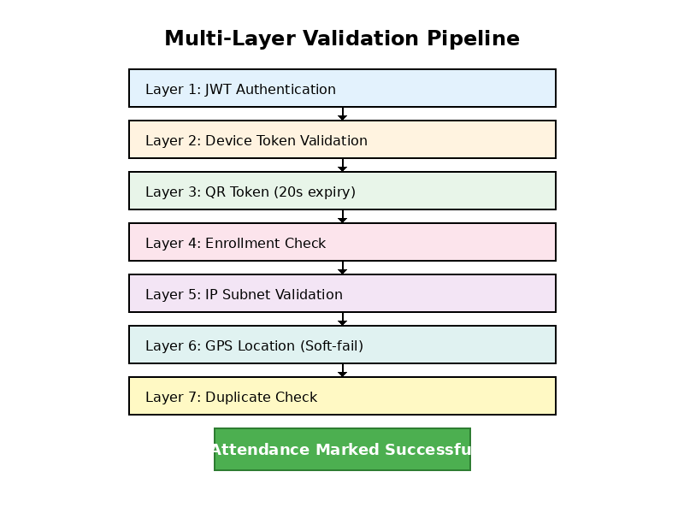
Each validation layer serves a specific security purpose. JWT authentication establishes user identity, while device token validation prevents emulator-based attacks. The QR token's 20-second expiry window creates a narrow attack surface, making real-time code sharing impractical. Enrollment verification ensures students can only mark attendance for their registered courses.

6. Location and Network-Based Validation
IP Subnet Validation:
IP validation ensures students are connected to the campus network rather than using mobile data from outside. This creates a physical boundary that students must cross to mark attendance. The system validates the client IP against predefined college subnet ranges, effectively preventing remote attendance marking.

GPS-Based Geolocation with Soft-Fail:
Traditional GPS validation systems often fail due to indoor accuracy limitations. Our research revealed that GPS accuracy varies significantly: 5-10 meters in open areas versus 30-100 meters inside buildings. Rather than implementing hard limits that would reject legitimate attendance, we've developed a confidence-based system:
Distance Range | Confidence Level | System Action
0 - 30 meters | HIGH | Accept automatically (green indicator)
30 - 100 meters | LOW | Accept with yellow flag for teacher review
> 100 meters | INVALID | Reject with distance-based error message

This graduated approach acknowledges GPS limitations while maintaining security. Teachers receive passive visual indicators (color coding) rather than intrusive notifications, allowing efficient review of potentially anomalous entries after class.

7. Technical Implementation Considerations
Modern web development frameworks and security standards impose specific requirements on attendance systems. JWT (JSON Web Tokens) have emerged as the industry standard for stateless authentication in web applications. Our implementation uses JWT for maintaining secure user sessions without server-side session storage, reducing server load and improving scalability.
Critical implementation challenges addressed:
- HTTPS Requirement: Browser geolocation APIs only function in secure contexts (HTTPS or localhost). Development environments require Ngrok tunneling or self-signed certificates for mobile testing.
- Device Fingerprinting: Combining user agent strings, screen resolution, and browser characteristics creates unique device identifiers while respecting privacy.
- Mobile-First Design: Responsive UI ensuring seamless experience across devices, with particular attention to smartphone interfaces.
- Progressive Web App Features: Offline capabilities and app-like experience without separate native app development.
Database design emphasizes both normalization for data integrity and strategic denormalization for query performance. Proper indexing on frequently accessed fields (student ID, session ID, timestamps) maintains system responsiveness as data volume grows. The audit trail functionality requires comprehensive logging of all transactions, including failed attempts with detailed error information.

8. Gap Analysis and Project Contribution
Our comprehensive review of existing attendance management solutions reveals a significant gap between highly secure but expensive systems (biometric, RFID) and user-friendly but insecure solutions (static QR codes). Commercial platforms like Moodle's attendance module and Google Classroom offer basic functionality but lack the sophisticated security mechanisms required for preventing proxy attendance in dedicated

References

- Patel, U. A., & Priya, S. (2014). Development of a student attendance management system using RFID and face recognition.
- Chintalapati, S., & Raghunadh, M. V. (2013). Automated attendance management system based on face recognition algorithms. IEEE International Conference on Computational Intelligence and Computing Research.
- Bhalla, V., Singla, T., Gahlot, A., & Gupta, V. (2013). Bluetooth based attendance management system. International Journal of Innovations in Engineering and Technology (IJIET).
- Kadry, S., & Smaili, K. (2010). A design and implementation of a wireless iris recognition attendance management system. Information Technology and Control, 39(3).
- Kumar, A., & Kaur, A. (2020). QR code based smart attendance system. International Journal of Computer Applications, 175(15).
- Spring Framework Documentation. (2024). Spring Boot Reference Guide. https://spring.io/projects/spring-boot
- React Documentation. (2024). React - A JavaScript library for building user interfaces. https://react.dev/
- Auth0. (2024). JSON Web Token (JWT) - Introduction and Best Practices. https://jwt.io/introduction
- Mozilla Developer Network. (2024). Geolocation API. https://developer.mozilla.org/en-US/docs/Web/API/Geolocation_API
- Google Developers. (2024). Google Places API Documentation. https://developers.google.com/maps/documentation/places/web-service

