FA-QEM Low-Poly Studio
Automatic (best face count) and Clean hard-surface (Tripo-like) modes
Pseudocode, parameters and measured results per SKU at Low / Medium / High / Ultra detail
Codebase: Triangle_optimization (faqem/pipeline.py, faqem/core.py, faqem/fillets.py, faqem/planar.py, faqem/retri.py, faqem/metrics.py)
Author: Jaswanth Andhavarapu
Date: 28 September 2026
Results: measured fresh for this document on 7 SKUs × 2 modes × 4 detail levels (56 runs) with the current code.

Contents

If the contents list is empty, right-click it in Word and choose Update Field.

1. Overview
Both modes remove the need to guess a face count. Instead of "keep 5% of the faces", you state how far the low-poly surface may move away from the dense original, and the tool searches for the smallest mesh that stays within that limit. All distances are fractions of the model's bounding-box diagonal ("% of size"), so the same setting behaves the same on a 10 cm product and a 3 m sofa.
Target mode | What you set | What the tool guarantees | Best for
Automatic (best face count) | Detail level Low / Medium / High / Ultra (or an exact max deviation %) | Worst-case (Hausdorff) deviation of the whole mesh ≤ the level | Any asset: organic, scanned, AI-generated, mixed
Clean hard-surface (Tripo-like) | Clean-up tolerance (0.2–2 %, default 0.5 %) + detail level for curved parts | Flat panels ≤ clean-up tolerance, curved parts ≤ detail level (measured separately) | Furniture, architecture, products: flat panels, crisp edges, knobs/handles/legs

1.1 Detail levels
Level | Allowed worst-case deviation | On a 2 m object | Typical use
Low | 0.5 % of size | ≈ 10 mm | Background / far LOD, mobile AR, thumbnails
Medium | 0.2 % of size | ≈ 4 mm | Standard web viewers, product configurators
High (default) | 0.1 % of size | ≈ 2 mm | Hero asset, close-up product view
Ultra | 0.05 % of size | ≈ 1 mm | Near-lossless archive, measurement-sensitive work

Key idea
Automatic mode never asks "how many faces?" — the face count is an output. Flat areas collapse to the minimum number of triangles (a rectangle → 2), and curved areas keep only as many triangles as the chosen deviation requires.
Clean hard-surface mode adds one more step before simplifying: small rounded edges, bevels and shallow relief are flattened into crisp flat panels, so furniture reads like a hand-modelled (Tripo-style) asset.

2. Shared building blocks
Both modes call the same FA-QEM core. Only the options passed to it differ. The pseudocode below follows the actual implementation; the file and function names are given so each block can be traced back to the code.

2.1 Constants and preparation
Source: faqem/pipeline.py: DETAIL_LEVELS, faqem/prep.py: prepare_mesh
DETAIL_LEVELS = { Low: 0.005, Medium: 0.002, High: 0.001, Ultra: 0.0005 } # × bbox diagonal

function PREPARE(file):
P, F, materials ← LOAD(file) # GLB / GLTF / OBJ / STL / PLY / OFF (Draco OK)
WELD duplicate vertices
REMOVE degenerate and duplicate faces
SPLIT non-manifold edges into manifold sheets # touching AI-mesh layers become open rims
ORIENT faces consistently
NORMALISE P so the bounding-box diagonal = 1 # every tolerance below is relative to size
BVH ← BUILD_BVH(P, F) # closest-point queries on the dense mesh
return P, F, BVH

2.2 Flat-region detection
Source: faqem/planar.py: segment_planar
function SEGMENT_PLANAR(P, F, angle = 1.5°, dist_tol):
labels[f] ← -1 for every face # -1 = curved
for seed in faces sorted by area, largest first:
if labels[seed] ≠ -1: continue
region ← { seed }; plane ← plane of seed
BFS over manifold, non-feature edges:
face t joins region if
angle(normal(t), plane.normal) ≤ angle # region normal, not neighbour's
and every vertex of t is within dist_tol of plane
update plane incrementally (area-weighted normal + centroid)
if area(region) < 0.1 % of total area or |region| < 3: keep faces curved
REFIT each region plane
return labels, planes

2.3 FA-QEM core with an error cap
Source: faqem/core.py: simplify, _can_collapse, _legal, _outline_dev2
Automatic and Clean modes run the core with no face target. Collapses continue until every remaining collapse would break the error cap; the cap is what the outer search tunes.
function FAQEM_SIMPLIFY(P, F, o):
if o.auto:
target_faces ← 1 # no face target: only the error cap stops us
topology_penalty ← ∞ # never change topology: small parts can't vanish
regions ← SEGMENT_PLANAR(P, F, 1.5°, o.planar_tolerance) if o.planar
if o.clean:
P, regions ← FLATTEN_SMALL_CURVATURE(P, F, regions,
dist_tol = o.planar_tolerance,
tol_big = 0.6 · o.clean_tolerance,
move_tol = 1.5 · tol_big) # section 4.2
Q ← Q_base + w_boundary·Q_boundary + w_normal·Q_normal + region-plane quadrics
F ← MINIMAL_RETRIANGULATE(flat regions) # interior panel vertices disappear up-front
heap ← { (cost, v*) ← EVAL_EDGE(a, b, Q) for every edge (a, b) }
while heap not empty and faces > target_faces:
(a, b, v*) ← heap.pop_min()
if stale(a, b): continue
if not CAN_COLLAPSE(a, b, v*, o): continue
move a to v*; remove b; parent[b] ← a # lineage used later for texture transfer
Q[a] ← Q[a] + Q[b]; re-evaluate edges around a
MINIMAL_RETRIANGULATE(flat regions) # constrained Delaunay: n + 2h − 2 triangles
SNAP panel vertices exactly onto their plane
return P', F', vertex_map, face_region

function CAN_COLLAPSE(a, b, v*, o):
cap ← o.max_error²
if o.clean and a, b both lie on flat panels: cap ← o.panel_error²
e ← (Qgeo[a] + Qgeo[b])(v*) / (Area[a] + Area[b]) # mean sq. distance to original planes
if e > cap: reject # "error limit"
if BOUNDARY_DEVIATION²(a, b, v*) > cap: reject # open rims may not slide or shrink
if any neighbouring face would flip: retry v* ∈ {v_a, v_b, midpoint}, else reject
if not LEGAL(b → a): reject # regions touching b must all touch a
# (clean: panels < 5° apart count as the same panel)
if outline of a flat region would bend > outline tolerance: reject
if collapse changes topology and o.auto: reject
accept

2.4 Measuring the result
Source: faqem/metrics.py: compare_meshes, split_deviation
function HAUSDORFF(dense, low):
A ← 50 000 area-weighted samples on dense (+ a subset of its vertices)
B ← 50 000 samples on low
return max( max_a dist(a, low), max_b dist(b, dense) ) # symmetric, via BVH closest point

function SPLIT_DEVIATION(dense, labels_dense, low, labels_low):
sample 60 000 points on each side, remembering the face each came from
panel side ← face is on a flat panel, or touches a panel vertex (panel border)
panel ← worst distance over samples from panel-side faces (both directions)
curved ← worst distance over all other samples (both directions)
return panel, curved, overall Hausdorff

3. Automatic mode (best face count)
Source: faqem/pipeline.py: simplify_auto. UI: target "Automatic (best face count)". CLI: cli.py model.glb --auto High or --auto-deviation 0.1

3.1 Idea
- Flat areas are merged to minimal triangles.
- Curved and detailed areas are simplified only while every collapse stays within an error cap. Open rims may not move beyond the cap either, and separate parts may not vanish.
- The per-collapse cap is a local, mean-squared measure; the guarantee the user asked for is a global worst case. So the result is measured with a real Hausdorff distance, and the cap is searched: expand while there is slack, bisect on a log scale once the limit is bracketed. The smallest result within the limit wins.
- If flattening alone already breaks a very tight limit, the search is repeated without flat-area merging.

3.2 Pseudocode
function SIMPLIFY_AUTO(mesh, tolerance, max_passes = 6):
o ← user options + { auto: true, planar: true, planar_only: false }
o.planar_tolerance ← min(0.002, 0.4 · tolerance) # flattening stays inside the guarantee
cap ← 0.5 · tolerance # first guess of the per-collapse cap
hi_ok ← none; lo_bad ← none # largest passing / smallest failing cap
best_ok ← none; best_any ← none; passes ← []

for k in 1 .. max_passes:
o.max_error ← cap
res ← FAQEM_SIMPLIFY(mesh.P, mesh.F, o)
H ← HAUSDORFF(mesh, res)
ok ← H ≤ tolerance
passes.append(cap, res.faces, H, ok)
if ok and (best_ok is none or res.faces < best_ok.faces): best_ok ← res
if best_any is none or H < best_any.H: best_any ← res
if ok: hi_ok ← max(hi_ok, cap) else: lo_bad ← min(lo_bad, cap)

# --- stop rules
if ok and H > 0.9 · tolerance: break # the allowance is used: done
if not ok and previous pass also failed
and res.faces > previous.faces and H ≥ 0.98 · previous.H:
break # error floor: more faces don't help

# --- next cap
if hi_ok and lo_bad:
if lo_bad / hi_ok < 1.3: break # bracket tight enough
cap ← sqrt(hi_ok · lo_bad) # bisect on a log scale
elif ok:
cap ← 4 · cap # lots of slack: expand fast
else:
cap ← cap · max(0.1, 0.7 · tolerance / H) # shrink in proportion to the overshoot

if best_ok is none and o.planar: # flat-area merge itself is too lossy
res2 ← SIMPLIFY_AUTO(mesh, tolerance, planar = false, max_passes = 4)
if res2.within: best_ok ← res2
elif res2.H < best_any.H: best_any ← res2

result ← best_ok if best_ok else best_any
result.within ← (best_ok is not none)
return result # face count = output, not input

3.3 App / CLI wiring
function ON_SIMPLIFY(mode = "Automatic", detail, exact_dev):
tol ← exact_dev / 100 if exact_dev > 0 else DETAIL_LEVELS[detail]
res ← SIMPLIFY_AUTO(mesh, tol)
BAKE colour + normal map by successive mapping (vertex_map lineage)
EXPORT textured GLB, geometry GLB/OBJ, wireframe GLB
REPORT faces, measured worst deviation, "within the limit" flag, every search pass

4. Clean hard-surface mode (Tripo-like)
Source: faqem/pipeline.py: simplify_clean, faqem/fillets.py: flatten_small_curvature. UI: target "Clean hard-surface (Tripo-like)". CLI: cli.py model.glb --clean 0.5 --detail High

4.1 Idea
- Two budgets. The clean-up tolerance (0.2–2 %, default 0.5 %) governs flat panels, small rounded edges and shallow relief. The detail level governs curved parts (knobs, legs, cushions).
- Rounded edge → crisp edge. A fillet of radius r between two panels deviates from the sharp corner by only ≈ 0.29 r, so when that fits the tolerance it is flattened and the panels meet at a straight crease. Their outlines become straight and the minimal re-triangulation needs only the true corners (a drawer front → 2 triangles).
- Shallow bumps are flattened, compact parts stay. Carving and noise on a panel are absorbed; knobs/buttons taller than 10 % of their width always stay curved.
- Soft borders. Borders between panels less than 5° apart are not creases, so vertices may merge across them.
- Measured separately. Panel areas are checked against the clean-up tolerance, curved areas against the detail level; the smallest result that meets both wins.

4.2 Pseudocode — flattening rounded edges and relief
function FLATTEN_SMALL_CURVATURE(P, F, regions, dist_tol, tol_big, move_tol):
# 1. strips of a finely tessellated fillet that were detected as tiny "flat" regions
for region r, smallest first:
if every vertex of r is within tol_big of a neighbour region at least 2× larger:
labels[faces of r] ← -1 # give it back to "curved"

# 2. all regions grow at once (multi-source BFS) into neighbouring curved faces
for curved face t reached from region r:
if all 3 vertices of t are within dist_tol of plane(r): labels[t] ← r

# 3. decide per connected curved piece
for each connected curved component C touching regions R:
d ← max over vertices of C of ( min distance to the planes of R )
if d > tol_big: keep C curved # too tall: cushion, leg, handle
is_edge ← |R| ≥ 2 and two planes of R differ by > 20° # a rounded edge / bevel
if not is_edge and d > 0.1 · width(C): keep C curved # compact part: knob, button
else: assign each face of C to its nearest adjacent plane

# 4. merge over-segmented, slightly warped panels
for adjacent regions (a, b) with planes < 5° apart, most parallel first:
if one plane fits a ∪ b within tol_big: merge a and b, refit plane

# 5. sharpen
for every vertex v on panels:
planes_v ← planes of v's regions, dropping near-parallel duplicates (< 10°)
x ← least-squares point of planes_v # plane → line → corner
if |x − P[v]| ≤ move_tol: P'[v] ← x
repeat up to 4×: revert vertices of any face whose normal flipped

# 6. clean-up on the sharpened mesh
EXPAND regions again (step 2)
attach zero-area slivers along the new crease to a neighbouring region
return P', regions'

4.3 Pseudocode — two-budget search
function SIMPLIFY_CLEAN(mesh, clean_tol = 0.005, detail_tol = DETAIL_LEVELS[level], max_passes = 6):
o ← user options + { auto: true, clean: true, planar: true, planar_only: false }
o.clean_tolerance ← clean_tol
o.panel_error ← 0.5 · clean_tol # cap for collapses between panel vertices
o.planar_tolerance ← min(0.002, 0.4 · detail_tol) # region detection stays at detail level
cap ← 0.5 · detail_tol # cap for curved-part collapses
hi_ok ← none; lo_bad ← none; best_ok ← none; best_any ← none

for k in 1 .. max_passes:
o.max_error ← cap
res ← FAQEM_SIMPLIFY(mesh.P, mesh.F, o) # includes FLATTEN_SMALL_CURVATURE
panel, curved ← SPLIT_DEVIATION(mesh, res)
panel_ok ← panel ≤ clean_tol
ok ← panel_ok and curved ≤ detail_tol
if ok and (best_ok is none or res.faces < best_ok.faces): best_ok ← res
score ← max(curved / detail_tol, panel / clean_tol)
if best_any is none or score < best_any.score: best_any ← res

if not panel_ok:
o.panel_error ← 0.5 · o.panel_error # clean panels up more gently
continue # retry, cap unchanged

if curved ≤ detail_tol: hi_ok ← max(hi_ok, cap) else: lo_bad ← min(lo_bad, cap)
if ok and curved > 0.9 · detail_tol: break
if hi_ok and lo_bad:
if lo_bad / hi_ok < 1.3: break
cap ← sqrt(hi_ok · lo_bad)
elif curved ≤ detail_tol:
cap ← 4 · cap
else:
cap ← cap · max(0.1, 0.7 · detail_tol / curved)

result ← best_ok if best_ok else best_any
result.panel_deviation, result.curved_deviation ← its panel, curved
return result

4.4 How it differs from Automatic mode
Aspect | Automatic | Clean hard-surface
Pre-processing | Flat-region detection only | Detection + fillet/relief flattening + edge sharpening
Error budgets | One: worst-case deviation ≤ level | Two: panels ≤ clean-up tol., curved parts ≤ level
Collapse cap | max_error everywhere | panel_error between panel vertices, max_error elsewhere
Near-parallel panels | Separate regions, border kept | Soft border (< 5°): vertices may merge across
Search driver | Overall Hausdorff | Curved-part deviation; panel overshoot halves panel_error
No-flattening fallback | Yes (retry without planar) | No (flattening is the point of the mode)
Look | Accurate, adaptive triangles | Crisp edges, 2-triangle panels, Tripo-style

5. Results by SKU
Every SKU below was run through both modes at all four detail levels with the current code (Clean mode uses the default 0.5 % clean-up tolerance). Deviation is the measured worst-case (Hausdorff) distance as a percentage of the bounding-box diagonal. Times are wall-clock for the simplification search on an 8-core Mac, with several runs sharing the machine, so they are pessimistic. Texture baking (typically 2–7 s) is not included.

5.1 Summary: face count chosen per level
Automatic
SKU | Input faces | Low | Medium | High | Ultra
Wooden rack / dresser | 854,828 | 502 | 1,910 | 5,032 | 8,406
L-shaped sofa | 860,218 | 3,150 | 14,602 | 23,339 | 25,179
STL scan | 11,420 | 2,706 | 7,152 | 7,826 | 8,970
Cartoon koala | 1,790,758 | 4,960 | 12,970 | 25,802 | 49,030
Hunyuan3D doll | 627,666 | 2,984 | 6,368 | 11,802 | 25,006
Boots | 129,094 | 3,909 | 12,967 | 19,728 | 42,760
Versa statue scan | 93,126 | 8,102 | 72,913 | 76,465 | 83,524

Clean hard-surface (clean-up tolerance 0.5 %)
SKU | Input faces | Low | Medium | High | Ultra
Wooden rack / dresser | 854,828 | 666 | 820 | 3,080 | 5,856
L-shaped sofa | 860,218 | 1,626 * | 11,316 * | 6,329 | 215,510 *
STL scan | 11,420 | 1,902 | 3,634 | 5,798 | 8,670
Cartoon koala | 1,790,758 | 10,512 * | 13,088 | 29,686 | 94,830
Hunyuan3D doll | 627,666 | 3,524 * | 5,374 | 12,298 | 28,504
Boots | 129,094 | 4,525 | 50,227 | 38,649 | 63,843
Versa statue scan | 93,126 | 8,917 | 26,902 | 67,784 | 78,899
* = no result met the limit within the pass budget; the closest one found is shown (see the per-SKU table).

5.2 Key observations
- Automatic mode always met its limit. 28 of 28 runs finished within the allowed deviation, and the face count rises steadily from Low to Ultra on every SKU.
- Clean mode wins on hard-surface SKUs. On the wooden rack, Clean needs 820 faces at Medium where Automatic needs 1,910, and 3,080 vs 5,032 at High, with flat 2-triangle panels and crisp edges.
- Clean mode is the wrong tool for soft furniture. On the sofa, the cushions are neither flat panels nor compact parts, so flattening them overshoots the 0.5 % panel budget: 3 of 4 levels miss a limit. Use Automatic for upholstered SKUs.
- Clean-mode face counts are not always monotonic. The search keeps the smallest result within both limits after at most 6 passes, and halving the panel cap can move it a lot (boots: Medium 50,227 vs High 38,649; sofa: Medium 11,316 vs High 6,329). If a level looks off, try the neighbouring level or a slightly larger clean-up tolerance.
- On Clean, the overall deviation can exceed the level. By design, panel areas are bounded by the clean-up tolerance (0.5 %), not by the level; only curved parts follow the level. That is why the Versa scan gets 26,902 faces at Clean Medium vs 72,913 with Automatic Medium: its nearly flat, noisy areas are allowed to move up to 0.5 %.
- Noisy scans need many faces at a strict worst case. The Versa statue keeps 76,465 of 93,126 faces at Automatic High. For such SKUs, Low (8,102 faces) or an exact deviation between 0.2 % and 0.5 % is a better trade.
- Clean runs above a limit: L-shaped sofa Low, L-shaped sofa Medium, L-shaped sofa Ultra, Cartoon koala Low, Hunyuan3D doll Low.

5.3 Wooden rack / dresser
Input: 854,828 faces · 427,416 vertices · 1 component(s). Hard-surface furniture with large flat panels and carved relief. This is the target case for Clean mode.
Mode | Level (limit) | Faces | Kept | Fewer | Worst deviation | Within | Time / passes
Automatic | Low (0.5%) | 502 | 0.059% | 1,703× | 0.495% | Yes | 7.7 s / 1
Automatic | Medium (0.2%) | 1,910 | 0.22% | 448× | 0.180% | Yes | 23.6 s / 3
Automatic | High (0.1%) | 5,032 | 0.59% | 170× | 0.082% | Yes | 36.9 s / 5
Automatic | Ultra (0.05%) | 8,406 | 0.98% | 102× | 0.046% | Yes | 15.2 s / 2
Clean | Low (0.5%) | 666 | 0.078% | 1,284× | 0.498% / 0.399% | Yes | 64.6 s / 6
Clean | Medium (0.2%) | 820 | 0.096% | 1,042× | 0.482% / 0.171% | Yes | 31.3 s / 3
Clean | High (0.1%) | 3,080 | 0.36% | 278× | 0.177% / 0.093% | Yes | 30.2 s / 3
Clean | Ultra (0.05%) | 5,856 | 0.69% | 146× | 0.073% / 0.025% | Yes | 52.5 s / 5
Clean-mode deviation is shown as panels / curved parts; the panel limit is 0.5 %, the curved limit is the level.
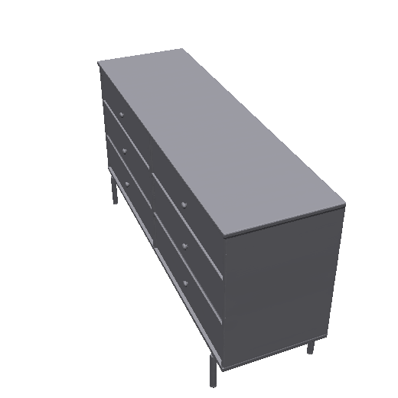  Original · 854,828 | 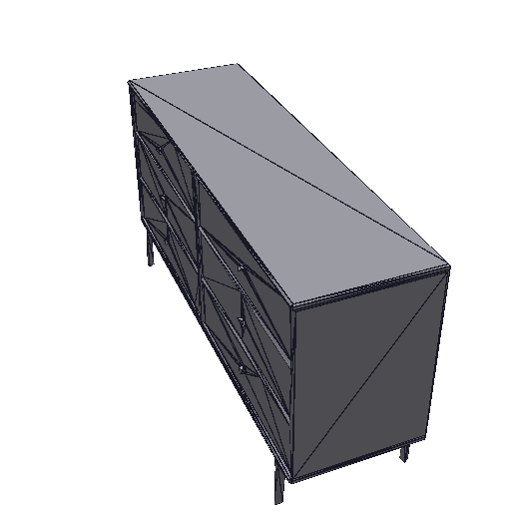  Auto Low · 502 | 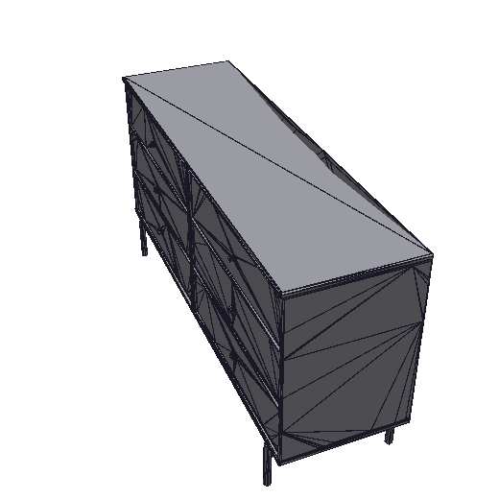  Auto Medium · 1,910 | 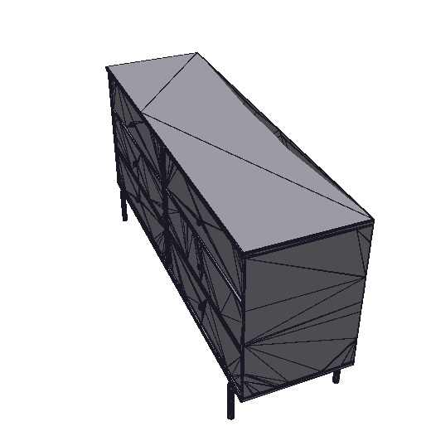  Auto High · 5,032 | 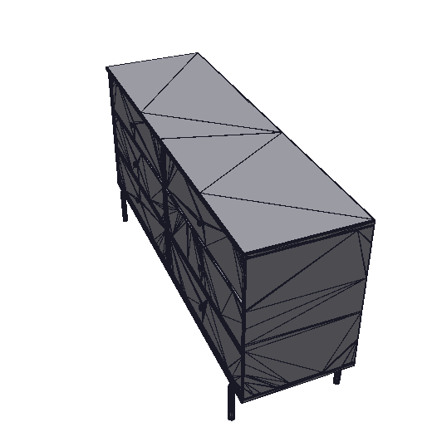  Auto Ultra · 8,406
Clean hard-surface → | 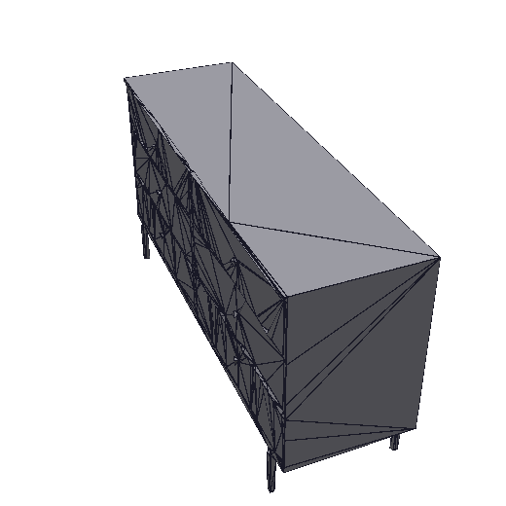  Clean Low · 666 | 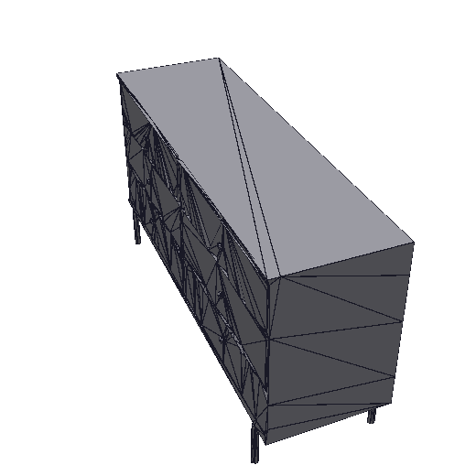  Clean Medium · 820 | 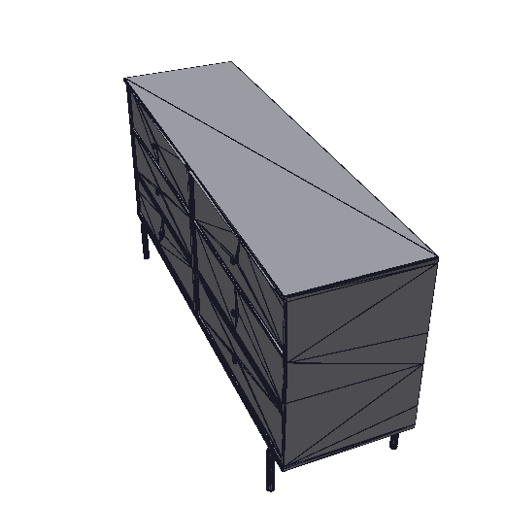  Clean High · 3,080 | 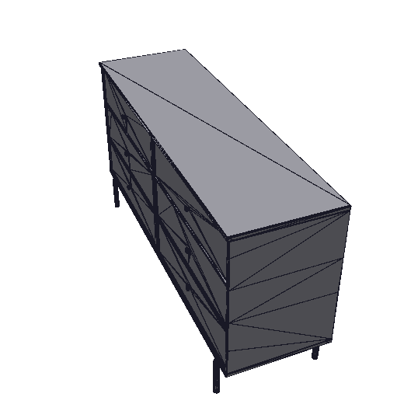  Clean Ultra · 5,856

5.4 L-shaped sofa
Input: 860,218 faces · 430,190 vertices · 2 component(s). Upholstered furniture: flat-ish frame with soft, curved cushions and fabric noise.
Mode | Level (limit) | Faces | Kept | Fewer | Worst deviation | Within | Time / passes
Automatic | Low (0.5%) | 3,150 | 0.37% | 273× | 0.456% | Yes | 23.6 s / 2
Automatic | Medium (0.2%) | 14,602 | 1.7% | 59× | 0.189% | Yes | 31.8 s / 3
Automatic | High (0.1%) | 23,339 | 2.7% | 37× | 0.084% | Yes | 40.3 s / 4
Automatic | Ultra (0.05%) | 25,179 | 2.9% | 34× | 0.043% | Yes | 69.3 s / 7
Clean | Low (0.5%) | 1,626 | 0.19% | 529× | 1.511% / 0.889% | No | 92.0 s / 6
Clean | Medium (0.2%) | 11,316 | 1.3% | 76× | 0.796% / 0.238% | No | 89.4 s / 6
Clean | High (0.1%) | 6,329 | 0.74% | 136× | 0.286% / 0.099% | Yes | 50.5 s / 4
Clean | Ultra (0.05%) | 215,510 | 25% | 4× | 0.251% / 0.083% | No | 81.3 s / 6
Clean-mode deviation is shown as panels / curved parts; the panel limit is 0.5 %, the curved limit is the level.
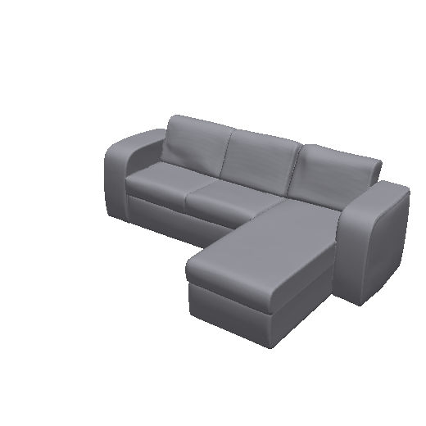  Original · 860,218 | 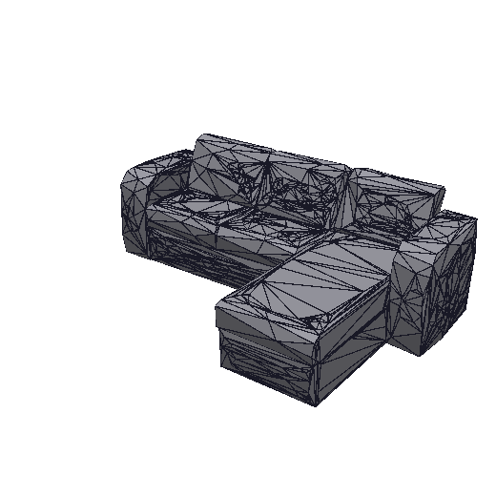  Auto Low · 3,150 | 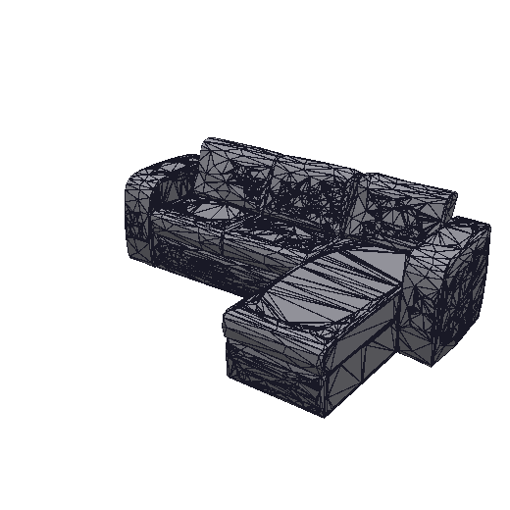  Auto Medium · 14,602 | 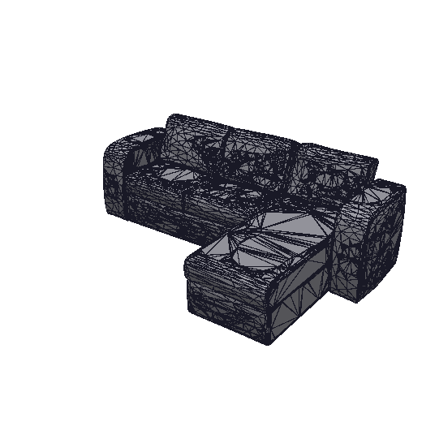  Auto High · 23,339 | 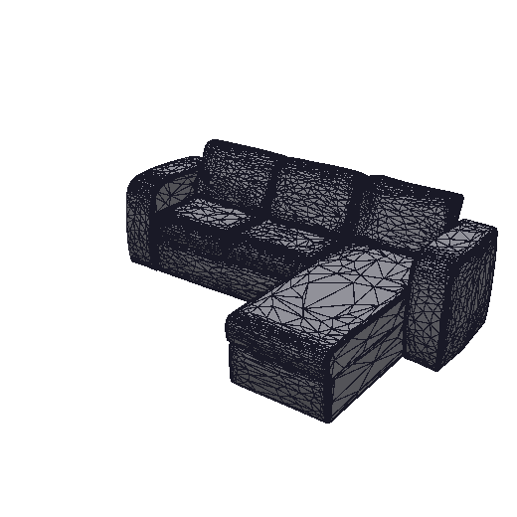  Auto Ultra · 25,179
Clean hard-surface → | 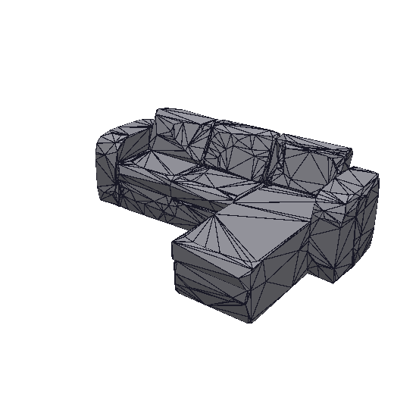  Clean Low · 1,626 | 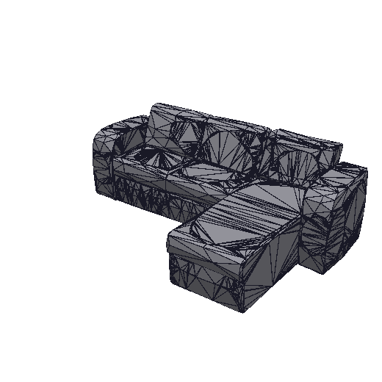  Clean Medium · 11,316 | 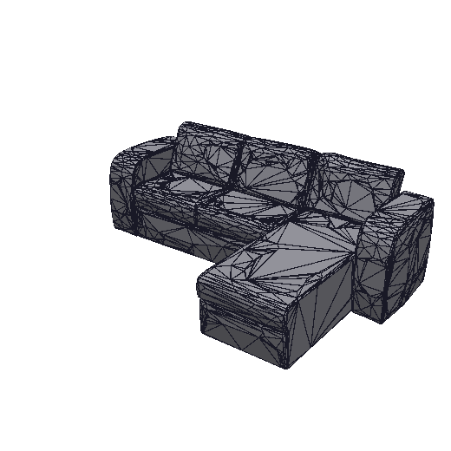  Clean High · 6,329 | 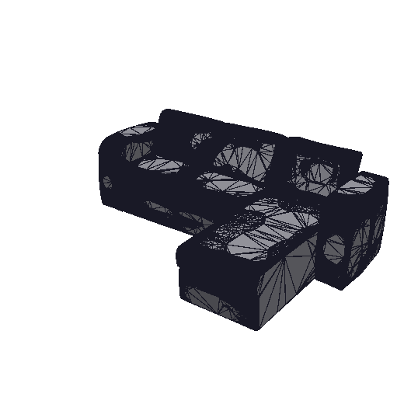  Clean Ultra · 215,510

5.5 STL scan
Input: 11,420 faces · 5,712 vertices · 1 component(s). A small scanned part delivered as STL (no texture).
Mode | Level (limit) | Faces | Kept | Fewer | Worst deviation | Within | Time / passes
Automatic | Low (0.5%) | 2,706 | 24% | 4× | 0.393% | Yes | 0.9 s / 4
Automatic | Medium (0.2%) | 7,152 | 63% | 2× | 0.103% | Yes | 1.0 s / 5
Automatic | High (0.1%) | 7,826 | 69% | 1× | 0.082% | Yes | 1.0 s / 5
Automatic | Ultra (0.05%) | 8,970 | 79% | 1× | 0.033% | Yes | 1.1 s / 6
Clean | Low (0.5%) | 1,902 | 17% | 6× | 0.424% / 0.194% | Yes | 1.1 s / 5
Clean | Medium (0.2%) | 3,634 | 32% | 3× | 0.235% / 0.193% | Yes | 0.4 s / 2
Clean | High (0.1%) | 5,798 | 51% | 2× | 0.266% / 0.086% | Yes | 1.1 s / 5
Clean | Ultra (0.05%) | 8,670 | 76% | 1× | 0.279% / 0.046% | Yes | 0.4 s / 2
Clean-mode deviation is shown as panels / curved parts; the panel limit is 0.5 %, the curved limit is the level.
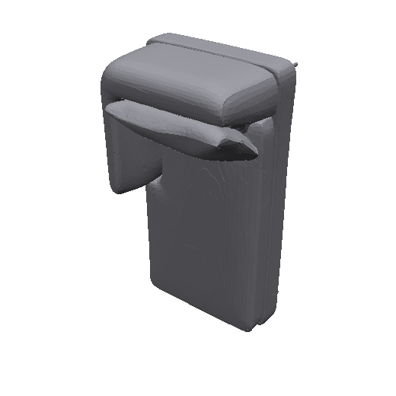  Original · 11,420 | 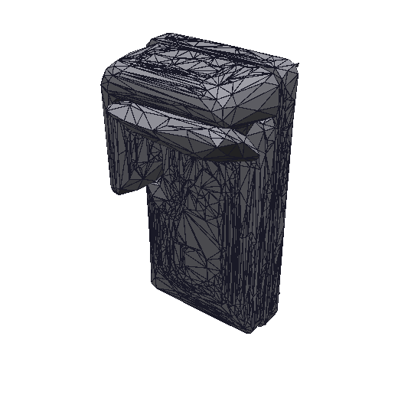  Auto Low · 2,706 | 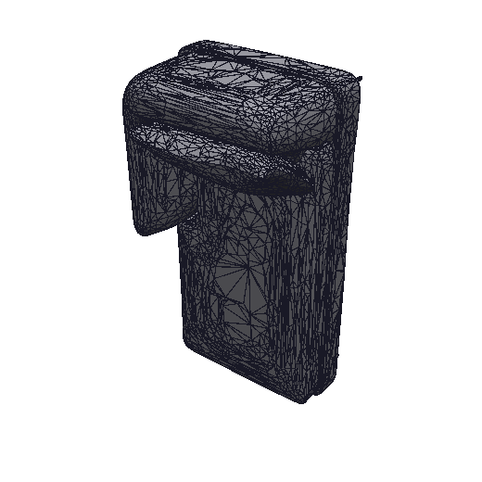  Auto Medium · 7,152 | 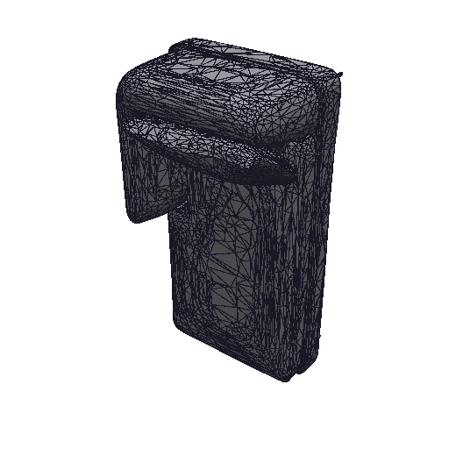  Auto High · 7,826 | 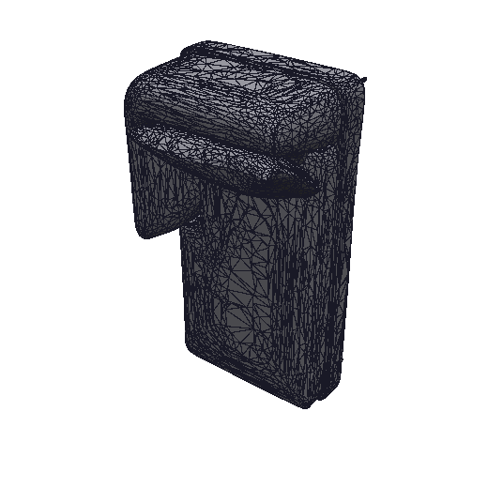  Auto Ultra · 8,970
Clean hard-surface → | 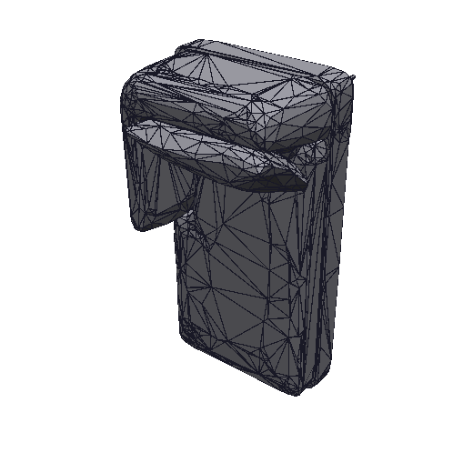  Clean Low · 1,902 | 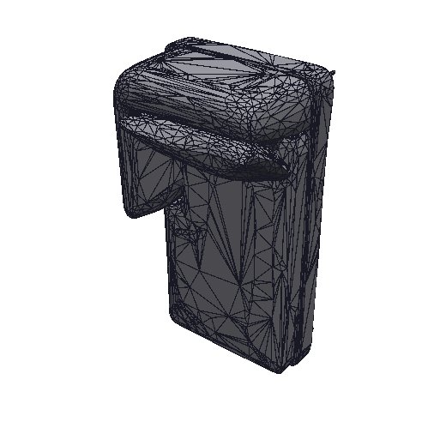  Clean Medium · 3,634 | 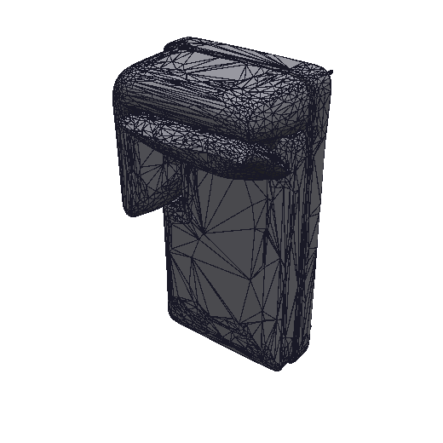  Clean High · 5,798 | 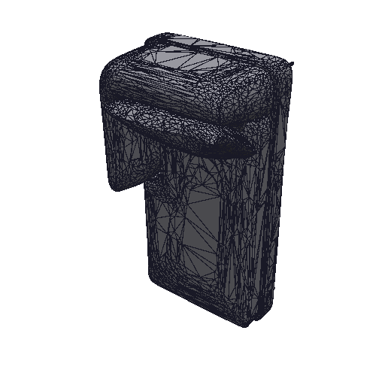  Clean Ultra · 8,670

5.6 Cartoon koala
Input: 1,790,758 faces · 895,391 vertices · 8 component(s). AI-generated cartoon character (1.79 M faces). Organic; few flat areas.
Mode | Level (limit) | Faces | Kept | Fewer | Worst deviation | Within | Time / passes
Automatic | Low (0.5%) | 4,960 | 0.28% | 361× | 0.321% | Yes | 121.4 s / 4
Automatic | Medium (0.2%) | 12,970 | 0.72% | 138× | 0.176% | Yes | 116.6 s / 4
Automatic | High (0.1%) | 25,802 | 1.4% | 69× | 0.078% | Yes | 121.4 s / 4
Automatic | Ultra (0.05%) | 49,030 | 2.7% | 37× | 0.048% | Yes | 130.1 s / 4
Clean | Low (0.5%) | 10,512 | 0.59% | 170× | 0.571% / 0.918% | No | 181.2 s / 6
Clean | Medium (0.2%) | 13,088 | 0.73% | 137× | 0.221% / 0.163% | Yes | 112.6 s / 4
Clean | High (0.1%) | 29,686 | 1.7% | 60× | 0.203% / 0.095% | Yes | 112.1 s / 4
Clean | Ultra (0.05%) | 94,830 | 5.3% | 19× | 0.159% / 0.041% | Yes | 138.2 s / 5
Clean-mode deviation is shown as panels / curved parts; the panel limit is 0.5 %, the curved limit is the level.
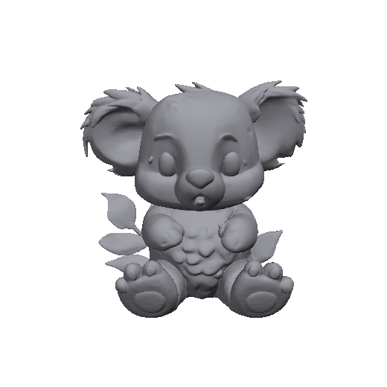  Original · 1,790,758 | 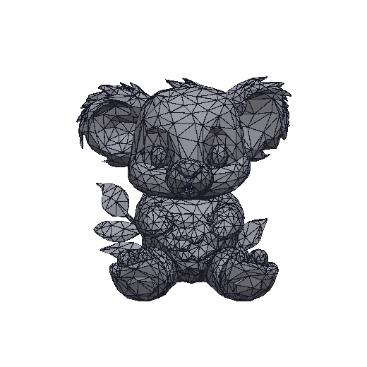  Auto Low · 4,960 | 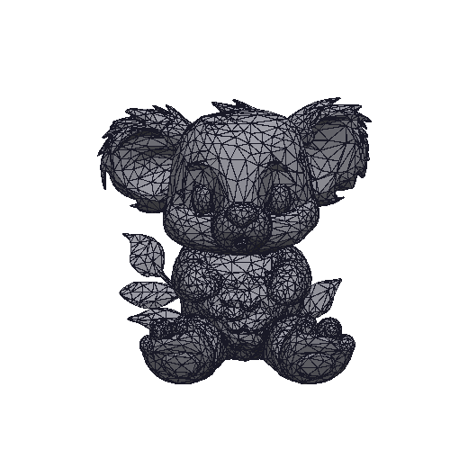  Auto Medium · 12,970 | 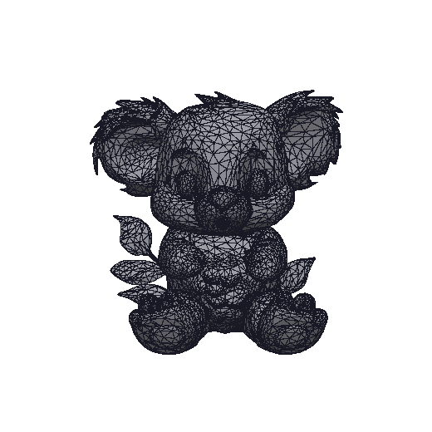  Auto High · 25,802 | 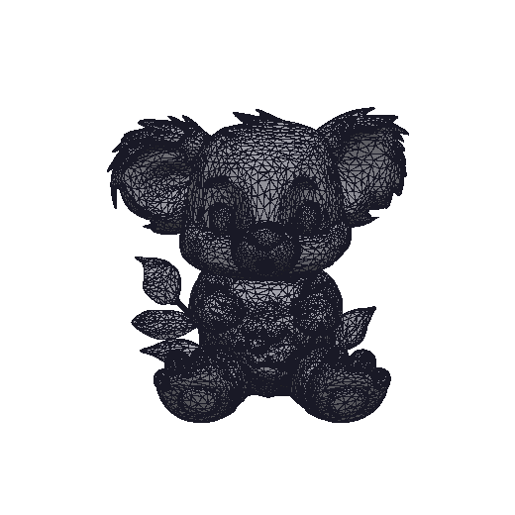  Auto Ultra · 49,030
Clean hard-surface → | 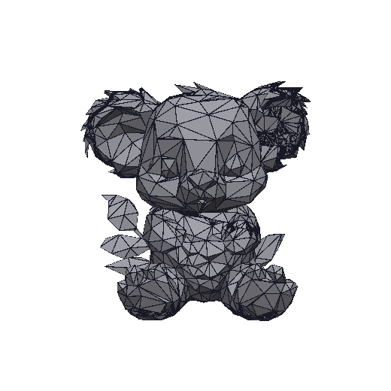  Clean Low · 10,512 | 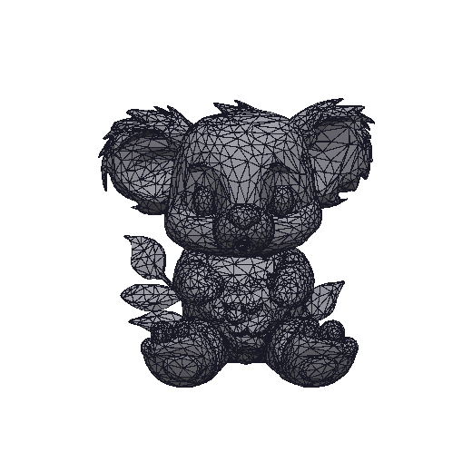  Clean Medium · 13,088 | 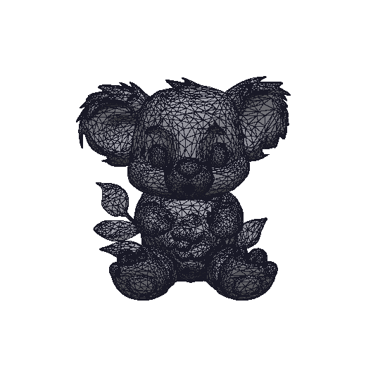  Clean High · 29,686 | 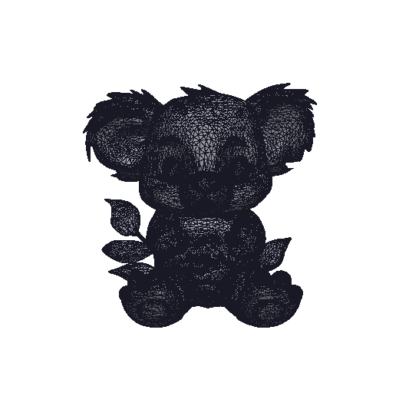  Clean Ultra · 94,830

5.7 Hunyuan3D doll
Input: 627,666 faces · 313,835 vertices · 3 component(s). Hunyuan3D-generated figure with non-manifold layers, hair and hands.
Mode | Level (limit) | Faces | Kept | Fewer | Worst deviation | Within | Time / passes
Automatic | Low (0.5%) | 2,984 | 0.48% | 210× | 0.450% | Yes | 18.9 s / 2
Automatic | Medium (0.2%) | 6,368 | 1.0% | 99× | 0.148% | Yes | 46.3 s / 5
Automatic | High (0.1%) | 11,802 | 1.9% | 53× | 0.086% | Yes | 36.8 s / 4
Automatic | Ultra (0.05%) | 25,006 | 4.0% | 25× | 0.049% | Yes | 27.6 s / 3
Clean | Low (0.5%) | 3,524 | 0.56% | 178× | 0.253% / 0.532% | No | 66.2 s / 6
Clean | Medium (0.2%) | 5,374 | 0.86% | 117× | 0.155% / 0.144% | Yes | 42.0 s / 4
Clean | High (0.1%) | 12,298 | 2.0% | 51× | 0.091% / 0.078% | Yes | 38.6 s / 4
Clean | Ultra (0.05%) | 28,504 | 4.5% | 22× | 0.070% / 0.038% | Yes | 35.8 s / 4
Clean-mode deviation is shown as panels / curved parts; the panel limit is 0.5 %, the curved limit is the level.
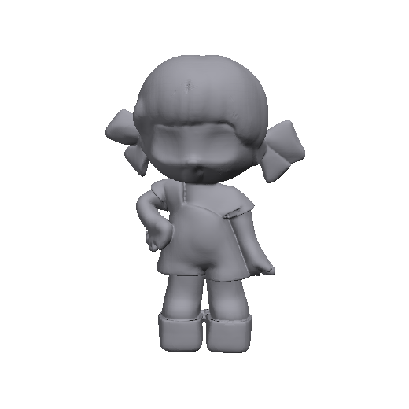  Original · 627,666 | 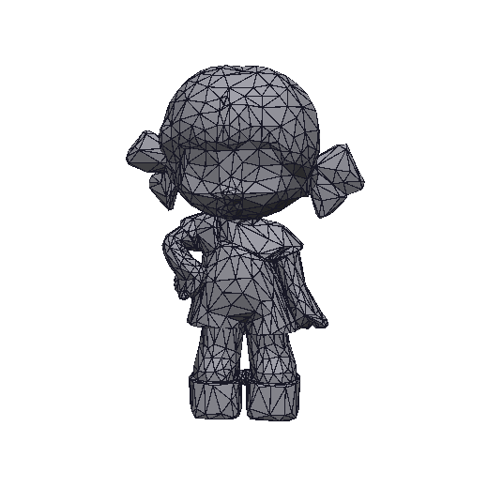  Auto Low · 2,984 | 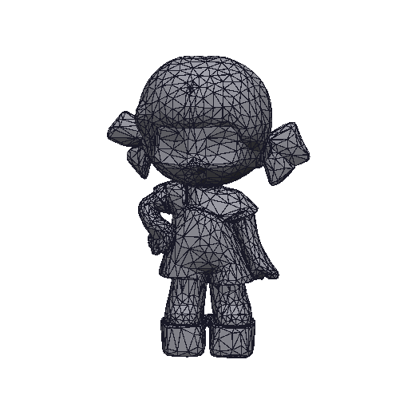  Auto Medium · 6,368 | 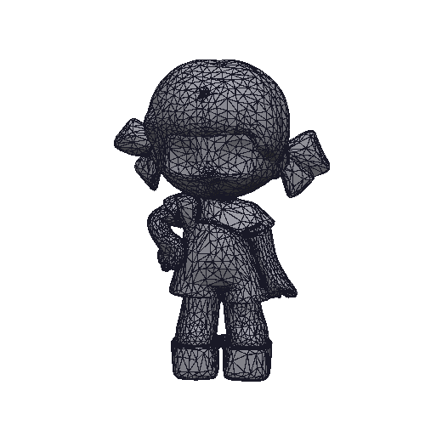  Auto High · 11,802 | 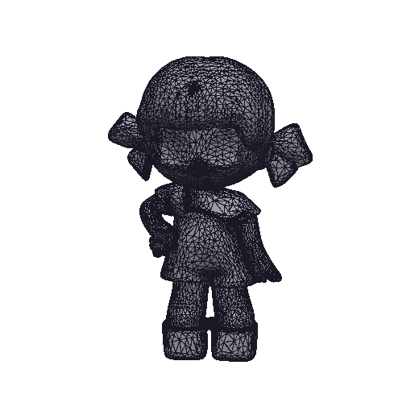  Auto Ultra · 25,006
Clean hard-surface → | 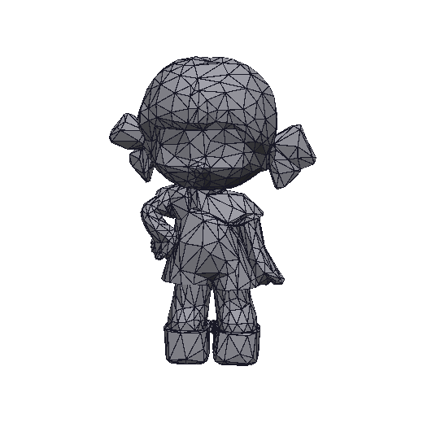  Clean Low · 3,524 | 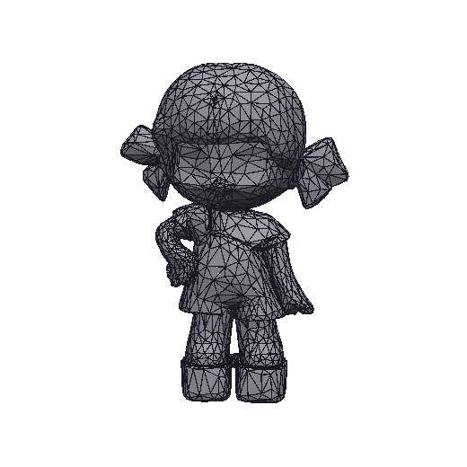  Clean Medium · 5,374 | 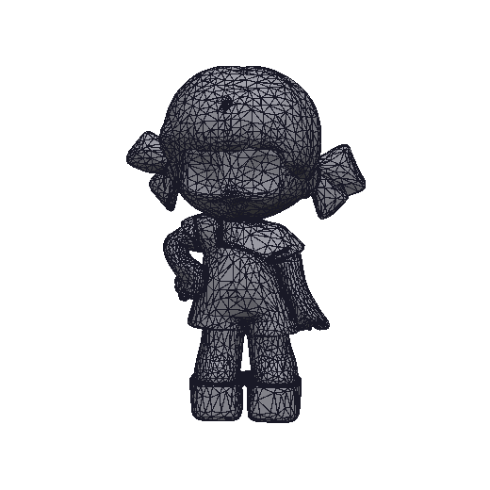  Clean High · 12,298 | 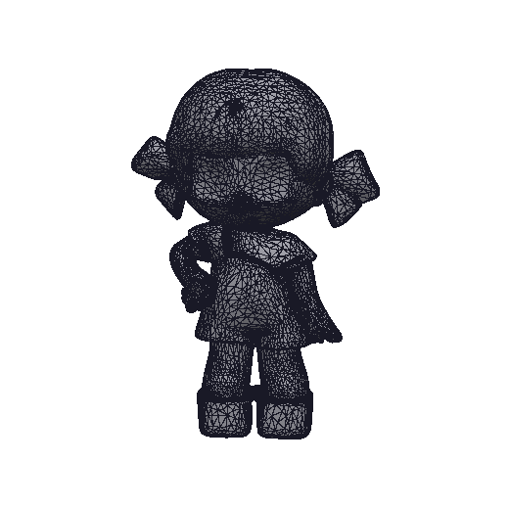  Clean Ultra · 28,504

5.8 Boots
Input: 129,094 faces · 65,486 vertices · 48 component(s). Textured organic product with folds and stitching.
Mode | Level (limit) | Faces | Kept | Fewer | Worst deviation | Within | Time / passes
Automatic | Low (0.5%) | 3,909 | 3.0% | 33× | 0.475% | Yes | 6.2 s / 3
Automatic | Medium (0.2%) | 12,967 | 10% | 10× | 0.159% | Yes | 6.9 s / 4
Automatic | High (0.1%) | 19,728 | 15% | 7× | 0.090% | Yes | 5.0 s / 3
Automatic | Ultra (0.05%) | 42,760 | 33% | 3× | 0.046% | Yes | 6.8 s / 4
Clean | Low (0.5%) | 4,525 | 3.5% | 29× | 0.337% / 0.396% | Yes | 7.2 s / 4
Clean | Medium (0.2%) | 50,227 | 39% | 3× | 0.278% / 0.115% | Yes | 11.2 s / 6
Clean | High (0.1%) | 38,649 | 30% | 3× | 0.245% / 0.099% | Yes | 7.9 s / 4
Clean | Ultra (0.05%) | 63,843 | 49% | 2× | 0.214% / 0.047% | Yes | 3.8 s / 2
Clean-mode deviation is shown as panels / curved parts; the panel limit is 0.5 %, the curved limit is the level.
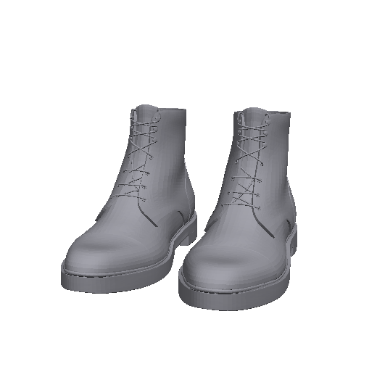  Original · 129,094 | 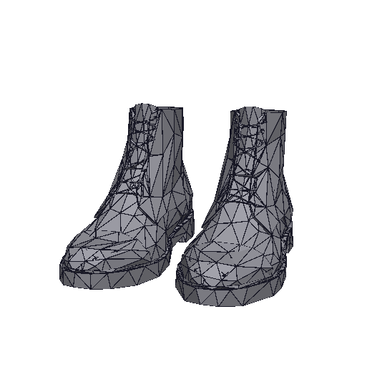  Auto Low · 3,909 | 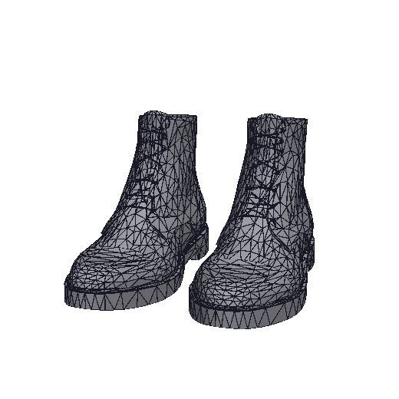  Auto Medium · 12,967 | 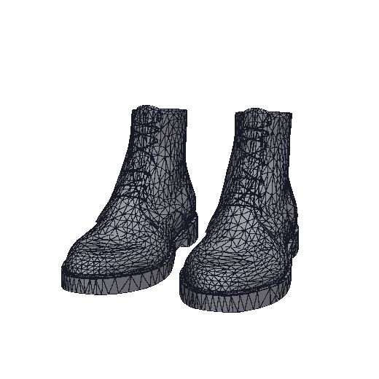  Auto High · 19,728 | 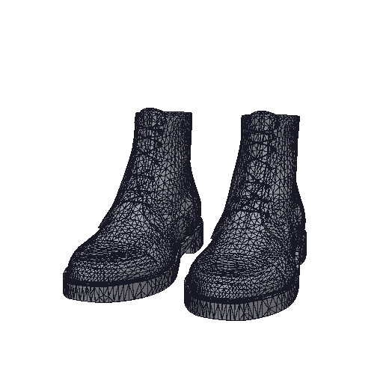  Auto Ultra · 42,760
Clean hard-surface → | 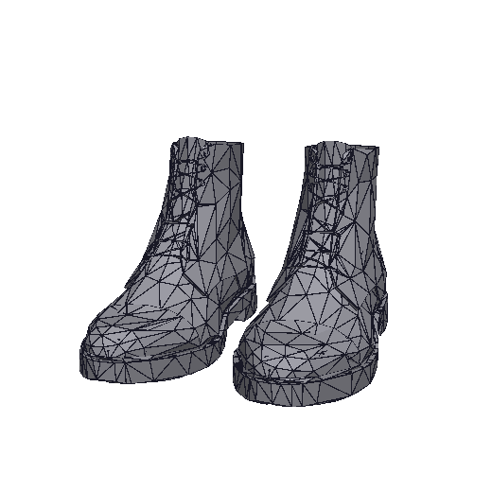  Clean Low · 4,525 | 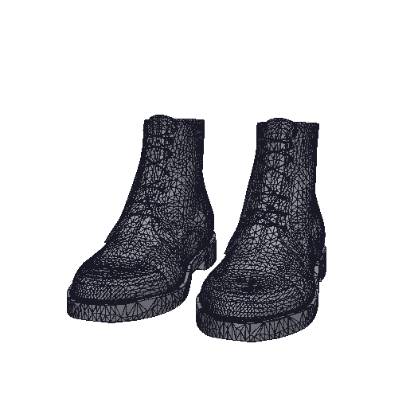  Clean Medium · 50,227 | 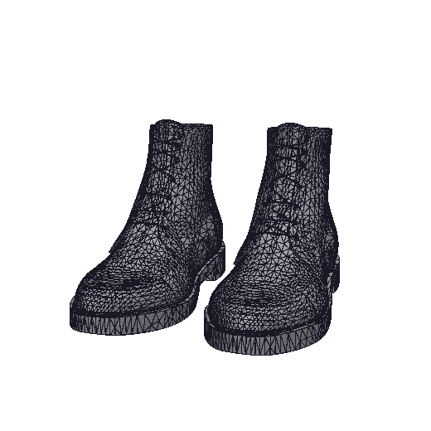  Clean High · 38,649 | 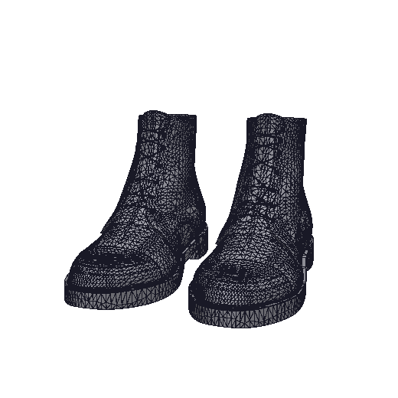  Clean Ultra · 63,843

5.9 Versa statue scan
Input: 93,126 faces · 46,635 vertices · 55 component(s). Scanned statue with thin, noisy carvings. Hardest case for a worst-case guarantee.
Mode | Level (limit) | Faces | Kept | Fewer | Worst deviation | Within | Time / passes
Automatic | Low (0.5%) | 8,102 | 8.7% | 11× | 0.456% | Yes | 3.3 s / 3
Automatic | Medium (0.2%) | 72,913 | 78% | 1× | 0.082% | Yes | 4.9 s / 5
Automatic | High (0.1%) | 76,465 | 82% | 1× | 0.082% | Yes | 4.9 s / 5
Automatic | Ultra (0.05%) | 83,524 | 90% | 1× | 0.036% | Yes | 4.6 s / 5
Clean | Low (0.5%) | 8,917 | 9.6% | 10× | 0.467% / 0.385% | Yes | 5.9 s / 5
Clean | Medium (0.2%) | 26,902 | 29% | 3× | 0.185% / 0.186% | Yes | 2.2 s / 2
Clean | High (0.1%) | 67,784 | 73% | 1× | 0.145% / 0.057% | Yes | 4.6 s / 4
Clean | Ultra (0.05%) | 78,899 | 85% | 1× | 0.154% / 0.050% | Yes | 3.4 s / 3
Clean-mode deviation is shown as panels / curved parts; the panel limit is 0.5 %, the curved limit is the level.
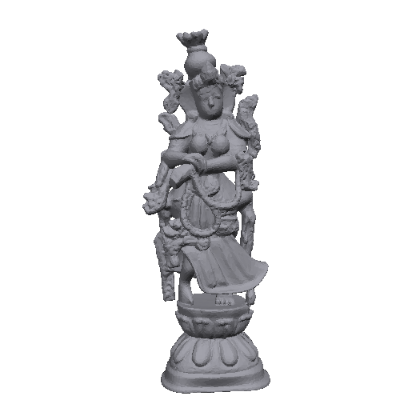  Original · 93,126 | 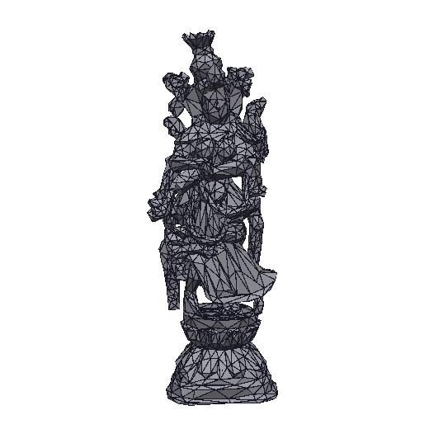  Auto Low · 8,102 | 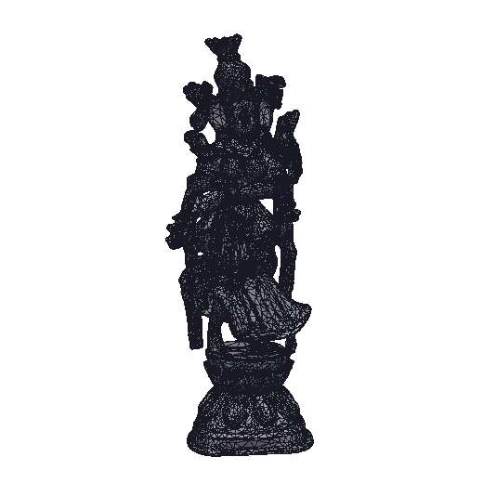  Auto Medium · 72,913 | 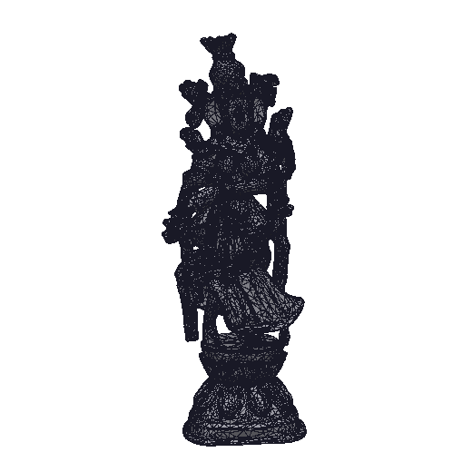  Auto High · 76,465 | 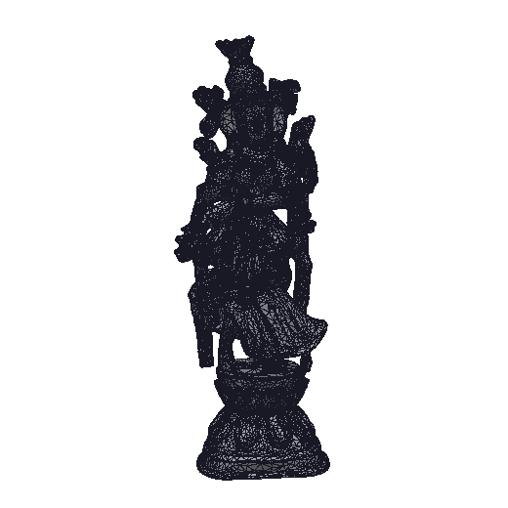  Auto Ultra · 83,524
Clean hard-surface → | 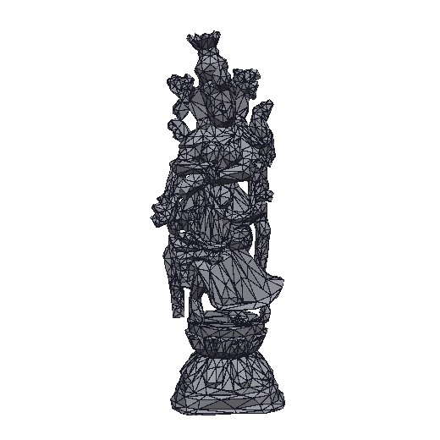  Clean Low · 8,917 | 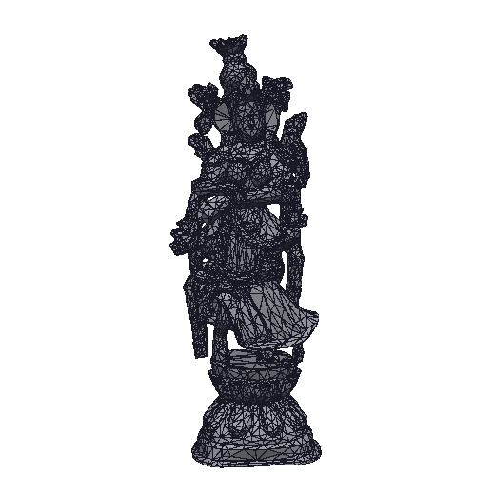  Clean Medium · 26,902 | 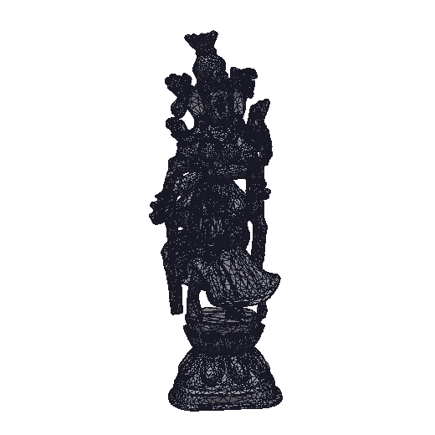  Clean High · 67,784 | 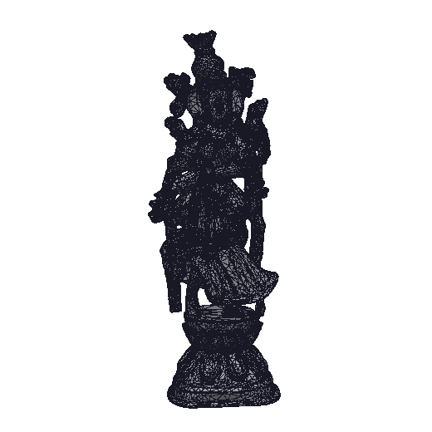  Clean Ultra · 78,899

6. Comparison with the Tripo re-model
Reference numbers for the wooden rack from the project README (curved parts at High). Tripo rebuilds the object from separate parts, so each drawer front can be exactly 2 triangles; here the knobs stay attached to their drawer fronts, which costs a few extra triangles per front — but the surface stays within a fraction of a percent of the original instead of 12 %.
Wooden rack (854,828 faces) | Faces | Deviation from dense rack | Top / side panels
Tripo re-model (reference) | 9,499 | 12.1 % | 2 / 2 triangles
Clean 0.5 % | 3,080 | 0.18 % | 2 / 7–9 triangles
Clean 1.0 % | 3,034 | 0.13 % | 2 / 6–7 triangles

7. Which mode and level to use
SKU type | Recommended | Why
Hard-surface furniture (racks, dressers, tables, cabinets) | Clean hard-surface, 0.5 %, High | Panels become 2 triangles, edges crisp, knobs and legs keep detail
Upholstered furniture (sofas, chairs) | Automatic, Medium or High | Cushions are curved; cleaning helps only the frame
Organic / characters / AI-generated figures | Automatic, Medium | No flat panels to clean; Medium balances size and look
Scans with fine carving | Automatic, Low or Medium (or exact deviation 0.3 %) | A strict worst-case limit keeps most of the noisy triangles at High/Ultra
Mobile / AR / far LOD | Automatic or Clean, Low | Smallest file; normal map restores surface detail
Hero / close-up asset | Automatic or Clean, High or Ultra | Deviation ≤ 1–2 mm on a 2 m object

7.1 Commands
# web app
.venv/bin/python app.py # http://127.0.0.1:7860

# Automatic
.venv/bin/python cli.py model.glb --auto Low|Medium|High|Ultra -o out/
.venv/bin/python cli.py model.glb --auto-deviation 0.3 -o out/ # exact limit, % of size

# Clean hard-surface
.venv/bin/python cli.py model.glb --clean 0.5 --detail High -o out/ # 0.2 .. 2.0 %

