

Pre-Requisites For DORA Metrics
Contents
1.1 Catalog Data – Pre-requisites 2
1.2 Tool Workflow – Pre-requisites 3
1.3 Tool Service A/C – Pre-requisites 4
1.4 Business Rule for SNOW Tags 5

This document has details of all the configurations that need to be done at the tool end and the service accounts for each tool.
Below are tool wise pre-requisites for the catalog data filter requirements for computing the DORA metrics. The Flowsource Data agents pick the filters for each tool from the catalog_data table, and collects only the required data - for eg. AppID, Jira Projectwise (JIRA), etc
Below is the list of filters required by Data-Engine system. These can be specified either in:
- annotations{} object in catalog data
- (Or) in the Specified Tool (as tags,etc)

Catalog Data – Pre-requisites
The following annotations should be added to the catalog-info.yaml for an application so that the DORA metrics can be computed
Tool | Field | Sample Value | Description
JIRA | flowsource/jira-project-key | UPSHIFT | JIRA project name of the app
 | flowsource/dora-jira-final-status | MOVED TO  PROD/ ACCEPTED etc. | the value for final status field  (definition of done /moved to prod).  Could vary from project to project
JENKINS | flowsource/jenkins-prod-deployment-job-full-project-name: | petclinic A8 | Jenkins – value of Full project name  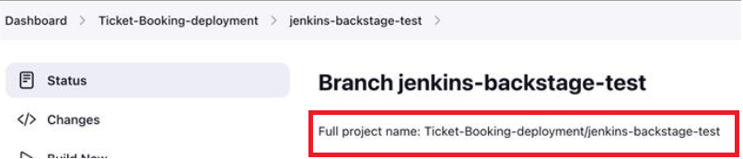
AWS -  Resilience Hub | flowsource/aws-resiliencehub-appname | TheaterBooking | Project name / app name in resilience hub
Checkmarx | cognizant/checkmarx-project-id | SeatAvailability | Checkmarx project id for specified app
Github Actions | flowsource/github-repo-owner  flowsource/github-repo-name  flowsource/githubactions-prod-deployment-workflow | "flowsource/  githubactions-  prod-deployment-workflow", "Basic workflow demo, TicketBooking-Pipeline” | GitHub Repo owner name and workflows  The workflows can be multiple comma separated values
Azure Devops | flowsource/azure-devops-project-key |  | Azure Devops project name of the app
SonarQube | flowsource/sonarqube-project-key |  | Sonarqube project key
Appdynamics | flowsource/appdynamics-application-name |  | Appdynamics application name
AWSCodePipeline | flowsource/aws-region, flowsource/awscodepipeline-prod-deployment-pipeline | Region - ap-southeast-1  Pipeline - next-shell-sonarcheck-pipeline | Provide the AWS region name  Prod deployment pipeline name
GCPCloudBuild | flowsource/gcpcodebuild-prod-deployment-pipeline  flowsource/gcp-region | Region - ap-southeast-1 | Provide the GCP Region name  Prod deployment pipeline name – provide the pipeline name
Bitbucket | flowsource/bitbucket-repo-owner  flowsource/bitbucket-repo-name  flowsource/bitbucket-prod-deployment-pipeline | repo-owner - FlowsourcePlatform  repo-name - TicketBooking  bitbucket-prod-deployment-pipeline - deployment-to-prod | Provide the Bitbucket repo name and repo owner name  Provide the pipeline name
Azure Pipeline | flowsource/azure-project-name  flowsource/azurepipeline-prod-deployment-pipeline | Project name- TicketBooking  Pipeline name - CustomerCredit | Provide the project name and pipeline name
Blackduck | flowsource/blackduck-project-name | Project name - TicketBooking | Provide the blackduck project name
Veracode | flowsource/veracode-app-name | App name - verademo | Provide the veracode app name

Tool Workflow – Pre-requisites
The below table shares details of the processes to be used at the tool end by the end users.
Tool | Field | Sample Value | Description
GIT | CommitMessage | “#ONEDEVOPS-2273 addressed PR comments for logger message and method name” | - GIT Commit message should contain JIRA story key prefixed with “#”.  - The JIRA tool to be integrated with GIT tool to get commits per story  Link for reference:  https://support.atlassian.com/jira-software-cloud/docs/reference-issues-in-your-development-work/
DataDog | Monitor Tags | “appId:<APP_ID>”  "environment:prod"  "resourceMonitor:true" | - The monitor created in Datadog tool ,must have the 3 mentioned tags
SNOW | SNOW Incident - Tags | "appid:<APP_ID>"  "deploymentId:<BUILD_NUMBER>" | SNOW Ticket created should have below tags:  1. appid - its value should be added as a tag in the SNOW ticket  2. deploymentId – is the build number of Jenkins deployment - which is causing an issue in the release  3. SNOW Incident priority should be “critical” or “high”
DYNATRACE | Entity Tags | “appId:<APP_ID>”  "environment:prod"  "severity:availability"  “status:closed” | The Tags should be defined in the Dynatrace Monitoring entity, Eg. process groups,etc  Note: The tags entered in Monitoring entity (eg.Process Group) should also reflect in individual problems in the Problem page
GITHUB-ACTIONS | Access credentials | GithubActions Token  GithubActions ClientID  GithubActions PrivateKey | By default use the ClientID and Private Key  In case those credentials are not available use Github Token
BLACKDUCK | Access credentials | Blackduck Token | Generate the token in the blackduck UI
VERACODE | Access credentials | Veracode ID  Veracode Key | Login to veracode account  From the user account dropdown menu  select API Credentials and click on Generate API Credentials

Tool Service A/C – Pre-requisites
This is service account created for each tool which the data agent will use to connect to the tool and perform data collection.
(Note: For Each tool, the permissions are needed for project(s) mentioned in
“Catalog Data Annotation” Column)
Agents | Service A/c Access Permissions | Catalog Data Annotation
JIRA | - Jira service account with read-only-users-role for all JIRA projects present in catalog data annotation (one Jira Project per appid) | flowsource/jira-project-key
DATADOG | - Datadog Org level Read Only Access ,for all datadog Monitors in Flowsource apps.  (Client Token Read + Monitors Read permission, one monitor per appid) | None.  appId should be tagged at tool end
JENKINS | - Read Only Access for Production Deployment Jobs present in catalog data annotation, for all apps (one job per appid) | flowsource/jenkins-prod-deployment-job-full-project-name
CHECKMARX | - Read Only Access for Checkmarx projects – from the catalog data table, for all apps(one Chkmx Project per appid) | cognizant/checkmarx-project-id
RESILIENCEHUB | - Read Only Access for RH appName in the catalog data (one appname per appid) | flowsource/aws-resiliencehub-appname
SNOW | - Read only Access - REST API , ALL Incidents & Tags  Access:REST_API_EXPLORER  For SNOW agent one more pre-requisite is there to configure the tags, which is explained in detail below | None. appId / deploymentId shld be Tagged at every deployment failure Incident
DYNATRACE | - Read Only access to Problem | None.  appId should be tagged at tool end
AZURE DEVOPS | - Azure devops account with access to all projects present in catalog data annotation | flowsource/azure-devops-project-key
GITHUB ACTIONS | - Access to Github Org and repository | flowsource/github-repo-owner  flowsource/github-repo-name  flowsource/github-workflows
AWS CODEPIPELINE | - Read Only access to pipeline name mentioned in the  Catalog data. | flowsource/aws-region  flowsource/awscodepipeline-prod-deployment-pipeline
GCP CLOUDBUILD | - Below access required in case of a service account  - roles/cloudbuild.builds.builder  roles/cloudbuild.builds.viewer  The service account should have the permission to access the pipelines | flowsource/gcpcodebuild-prod-deployment-pipeline  flowsource/gcp-region
AZURE PIPELINE | - Read Only access to Project and pipeline name mentioned in the  Catalog data. | flowsource/azure-project-name  flowsource/azurepipeline-prod-deployment-pipeline
BITBUCKET | - Read Only Access to project and repositories mentioned in the Catalog data | flowsource/bitbucket-repo-owner  flowsource/bitbucket-repo-name  flowsource/bitbucket-prod-deployment-pipeline
BLACKDUCK | - Read Only Access to the project | flowsource/blackduck-project-name
VERACODE | - Read Only Access to the application | flowsource/veracode-app-name

Business Rule for SNOW Tags

A Service account should be created in the SNOW instance and that account should have admin level access.
This service account credentials should be added to the secret manager for the SNOW agent, since this account will have the access to all the incidents which are created by other user account(non-admin).
The tags created by other user accounts can be automatically assigned to the Service account, by creating a business rule in the client service-now instance. The steps to create this Business rule are as mentioned below.
Step:1 When the user created an incident and adds a new tag in that incident, then to automatically assign that tag to the service account, the following steps should be followed-
- Create Business rules:
Application navigator business rules
- 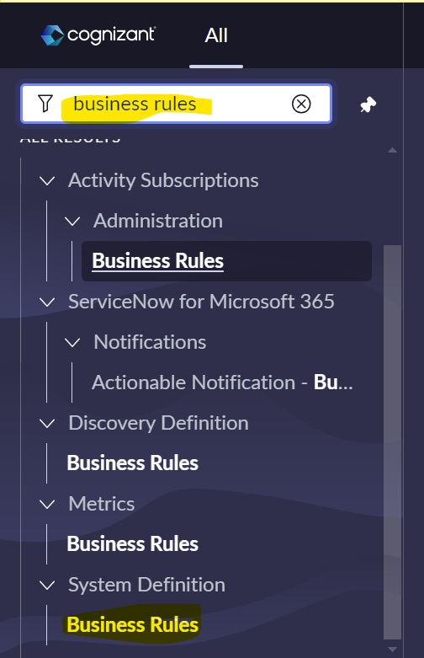

Click new and create the business rule like the below provided screenshot
- Provide name for Business rule
- Select the “Tag” table
- Select the tab “When to run” and click the checkbox for “Insert” and “Update”
- Select “after” in the When dropdown.
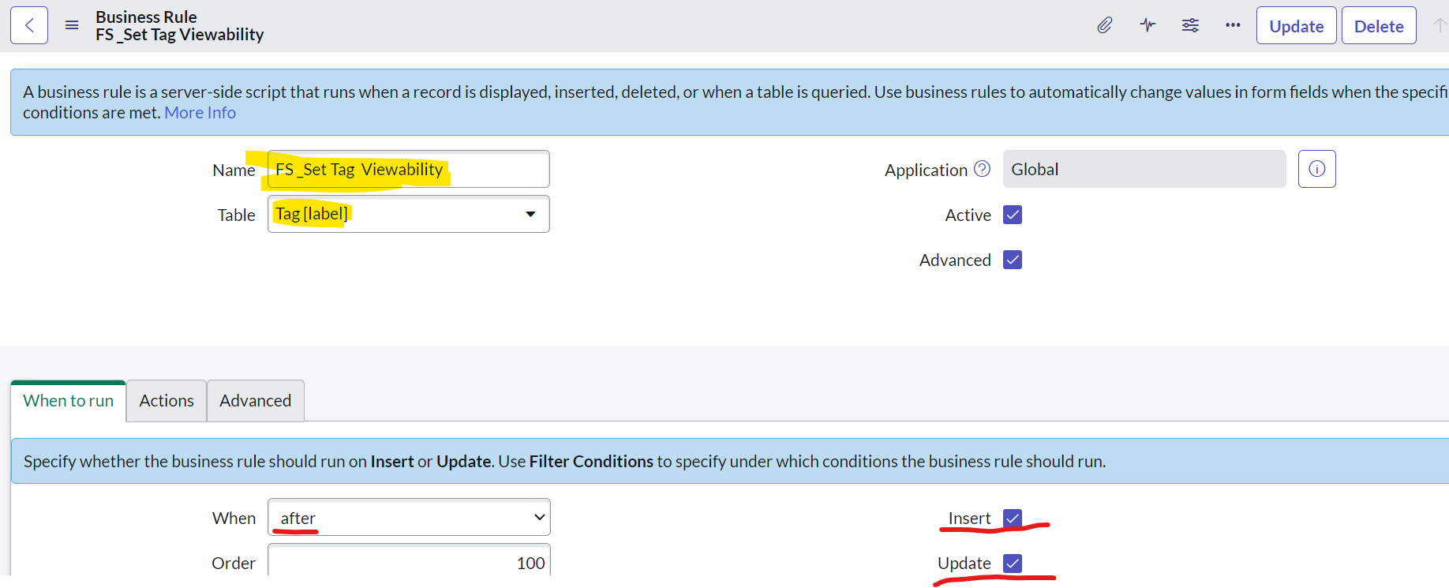
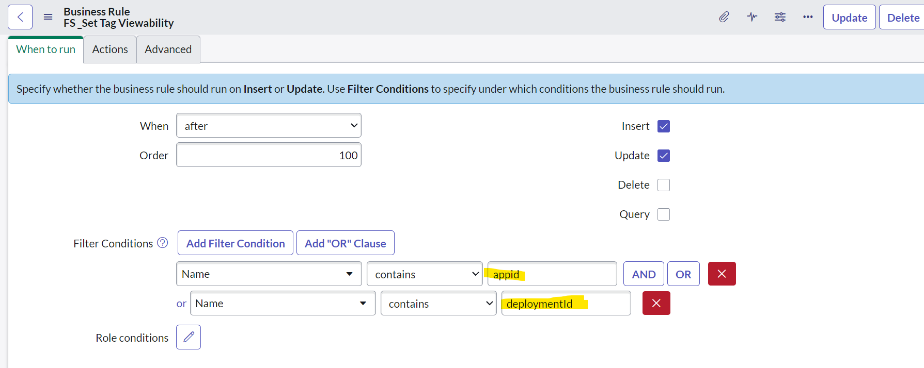
- Move to the “Actions” tab.
- In the “Set Field Values” dropdown, select the property “Viewable by”
- In the mapped to dropdown select “Groups and Users” which will reflect another condition as shown in screenshot below.
- From the dropdown select Users and in the mapped to textbox, provide the name of the service account
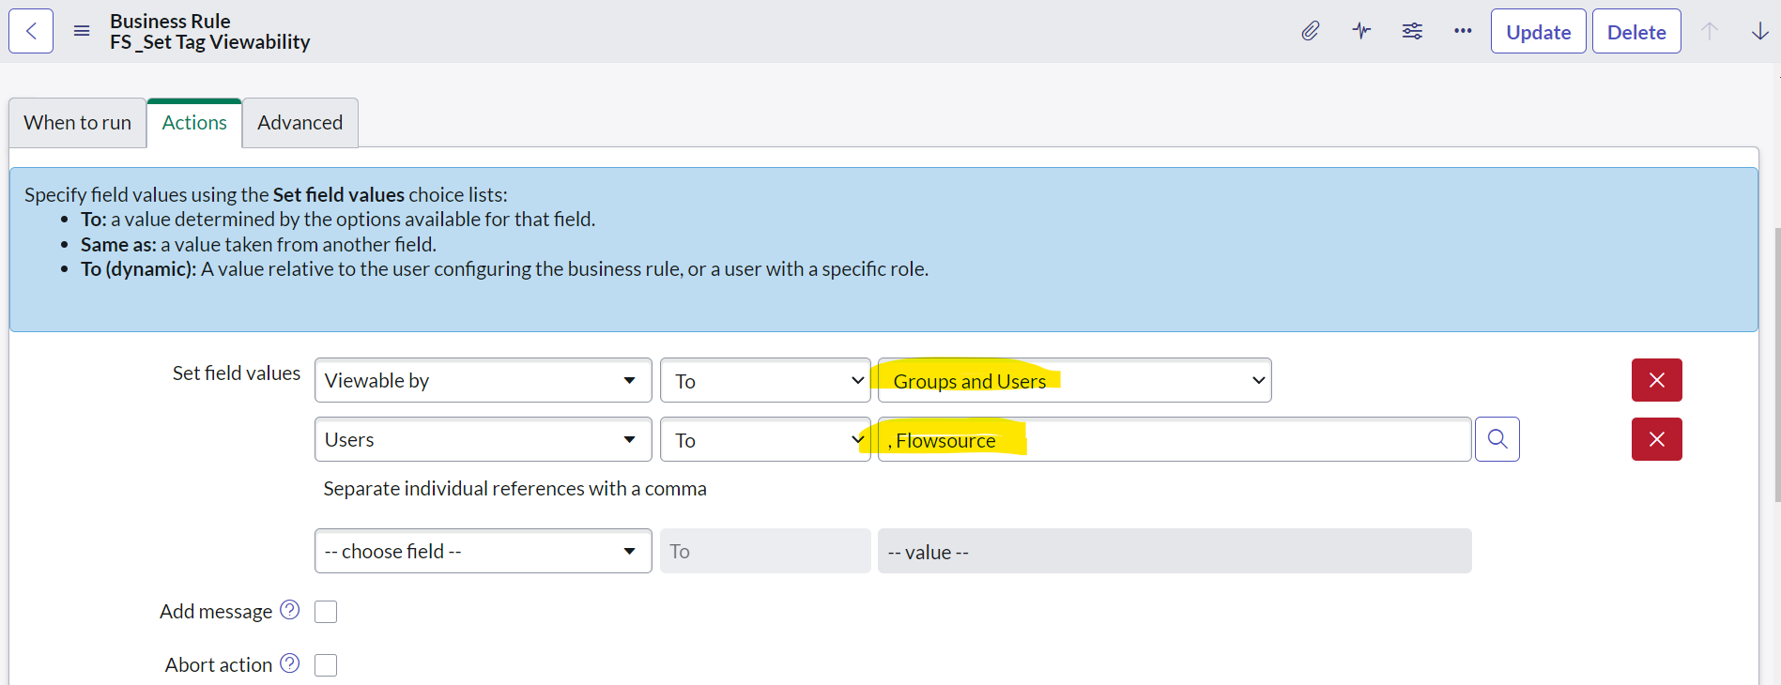

Thus when the user creates a new tag in an incident with the specified keyword(appid, deploymentId) this business rule will run automatically and assign the tags viewable by property to the service account.
Only owner and the specified service account can see the tag record.

Optional: In case the user wants to to add an existing tag to an incident, then the “viewable by” property for that tag should be set to the service account by following the below step

If the user wants to select the existing tag record and assign to a particular user or groups, then as an admin please do the following
- open the tags table from the tables list
- select that tag record which you want to assign to Service Account
- fill the fields like the below screenshot, so that it gets assigned to that specific user and groups automatically.
