

Flowsource - Data Engine Azure Deployment
Contents
1. Overview 3
1.1 Data Agent (Function App) 3
1.2 Database 3
1.3 Storage Accounts 3
1.4 Azure Data Engine 4
1.5 Exception/Error Scenarios 4
2. Terraform Deployment 6
2.1 Pre-Requisites 6
2.1.1 Storage Account- Private Endpoints 6
2.1.2 Managed Identities 7
2.1.3 Key Vault 8
2.2 Script Execution 9
2.2.1 Cosmos DB Creation (/fs-data-pipeline/cosmosdb) 9
2.2.2 Azure Function Creation (fs-data-pipeline\az_function_app) 10
2.3 Deployment Sanity Check 11

Overview
The flowsource Data Engine architecture involves the following resource of Azure –
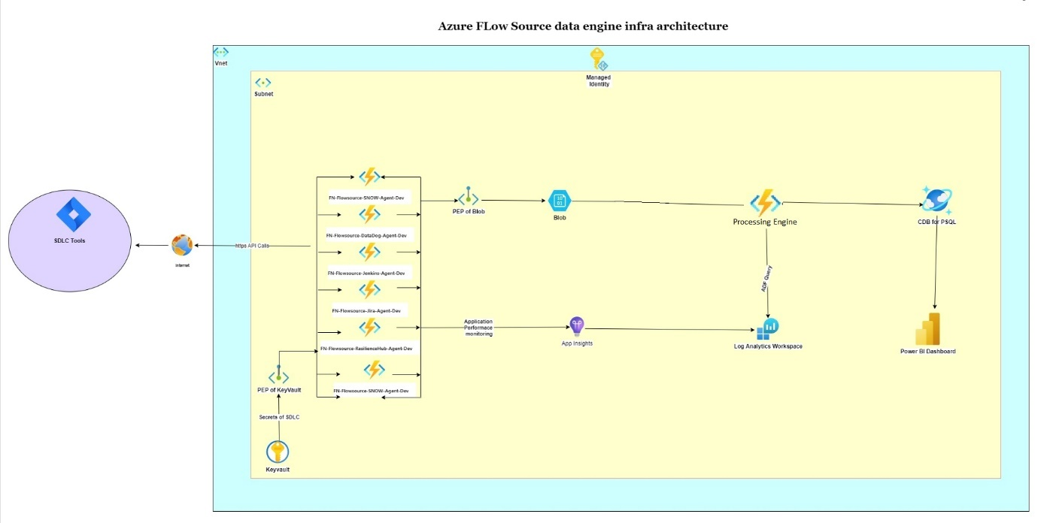

Data Agent (Function App)
The agent functions are created for deployment of each agent. The
purpose of the agent function apps is to collect tool data from various tools such as Jira, GitHub, Jenkins using RESTful API calls from these given tools and publish the data into Blob Storage.

Database
The below database used in the Data Engine –
- Azure Cosmos DB for PostgreSQL Cluster– The PostgreSQL DB has tables to store the data collected by each agent. The tables need to be created after the DB is created using the Terraform script.
The list of tables which needs to be created are mentioned below in the Terraform Deployment section. The queries to create the tables are provided in the Script folder attached with the deployment package.

Storage Accounts
The data engine uses Azure Storage Account to store the tool data which are collected by agent. After the agents are deployed below folder gets created in the Storage for each agent.
- JIRA - alm-jira
- DATADOG - appmonitoring-datadog
- JENKINS = ci-jenkins
- CHECKMARX - codequality-checkmarx
- SERVICE NOW - itsm-snow
- AWS RESILIENCE HUB - appmonitoring-awsresiliencehub
- DYNATRACE - appmonitoring-dynatrace
- AZURE DEVOPS – alm-azuredevops
- GITHUB ACTIONS – ci-githubactions
- APPDYNAMICS - appmonitoring-appdynamics
- SONARQUBE - codequality-sonarqube
- GCP CLOUDBUILD – ci-gcpcloudbuild
- AWS CODE PIPELINE – ci-awscodepipeline
- AZURE PIPELINE- ci-azurepipeline
- BITBUCKET – ci-bitbucket
- BLACKDUCK – sca-blackduck
- VERACODE - codequality-veracode

Azure Data Engine
The azure data engine function app is used to read the files published in the S3 bucket by the agents and then inserting the data into the PostgreSQL DB. The below
- FS-Data-Engine
Trigger: Engine function app will be triggered when a JSON file extension dropped in bucket
Below table contains details of the data folder and the corresponding tables.
Blob Folder | Database Table
catalog-info | catalog_data
itsm-snow | itsm_inicdent_data
alm-jira | alm_changes_data
ci-jenkins | ci_prod_deployment_data
appmonitoring-datadog | apm_event_data
codequality-checkmarx | codequality_metrics_data
appmonitoring-resiliencehub | apm_resilience_data
appmonitoring-dynatrace | apm_event_data
alm-azuredevops | alm_changes_data
ci-githubactions | ci_prod_deployment_data
appmonitoring-appdynamics | apm_event_data
codequality-sonarqube | codequality_metrics_data
ci-awscodepipeline | ci_prod_deployment_data
ci-gcpcloudbuild | ci_prod_deployment_data
ci-azurepipeline | ci_prod_deployment_data
ci-bitbucket | ci_prod_deployment_data
sca-blackduck | sca_metrics_data
codequality-veracode | codequality_metrics_data

Exception/Error Scenarios
Below are the possible exception scenarios that can occur and the reason why they have occurred-

Error Code | Error | Action Item
CODING ERRORS
1001 | FLOWSOURCE_BASEENGINE_ERROR: MAIN_TABLE_NAME should not be empty | MAIN_TABLE_NAME variable in the agent specific engine code might be empty or not present in the code
1004 | FLOWSOURCE_BASEENGINE_ERROR: INSERT_TO_MAIN_TABLE_FROM_TEMP_TABLE should not be empty | INSERT_TO_MAIN_TABLE_FROM_TEMP_TABLE variable in the agent specific engine code might be empty or not present in the code
1005 | FLOWSOURCE_BASEENGINE_ERROR: CREATE_STAGING_TABLE_TEMP should not be empty | CREATE_STAGING_TABLE_TEMP variable in the agent specific engine code might be empty or not present in the code
1101 | FLOWSOURCE_ENGINE_QUERY_ERROR: Failed to process processQuery | Query might be incorrect  Error in processQuery method
1102 | FLOWSOURCE_ENGINE_QUERY_ERROR: Command not found | Command might be incorrect or not present in the code
1201 | FLOWSOURCE_CLASSLOADER_ERROR: module not found | The name of the class might be misspelled or wrong
DATABASE ERRORS
2002 | FLOWSOURCE_POSTGRES_ERROR: Integrity constraint violation error occurred in PostgreSQL | Not null constraint violation  Datatype mismatch  Primary key or unique constraint violation  Check the data passed
COMMON ERRORS
3001 | FLOWSOURCE_FILE_ERROR: FileNotFoundError | Config.json might not be present
3101 | FLOWSOURCE_AZURE_ERROR: Azure ResourceNotFoundError occurred | The bucket, function, dataset, table name or project might not be present
3002 | FLOWSOURCE_KEY_ERROR:Environment variable not found | Environment variable or variable in config.json  Secret manager key might not be present
AGENT ERRORS
4001 | FLOWSOURCE_ERROR: No Problems for appids | No respone from the api call
4002 | FLOWSOURCE_BASEAGENT_ERROR: fetch_catalog_data: No records found in catalog table | fetch_catalog_data is empty, or the agent specific constraints specified in the query like project-key might not be present
4003 | FLOWSOURCE_ERROR: Failed to Get Access Token | No Access Token received in checkmarx and githubactions
REST FACADE ERRORS
5001 | FLOWSOURCE_RESTFACADE_ERROR: Bad request error | The project is not present in the agent  Invalid parameters  For Jira, the project key might be invalid, or the credentials might be incorrect
5002 | FLOWSOURCE_RESTFACADE_ERROR: Unauthorized error | Invalid credentials in secrets manager
5003 | FLOWSOURCE_RESTFACADE_ERROR: Forbidden error | Insufficient permission to access the resource
5004 | FLOWSOURCE_RESTFACADE_ERROR: Requested webpage not found in server | End point might not be present. Check the url

Terraform Deployment

Pre-Requisites
Following are pre-requisites required before executing the scripts:
- Create the following resources
  - Resource group
  - VNET
  - 2 Subnets -
    - One for azure function[web-delegation]
    - One for database
- App Service plan
  - There are different hosting plans available to run Azure function apps. The 3 main plans are Consumption plan, Premium Plan and Dedicated Plan.
  - Please select any plan as suitable. In our development environment we are using app service plan B3 (4vCPU and 7 GB RAM)
  - Refer to this link https://go.microsoft.com/fwlink/?linkid=2257439 for more information.
- Create log analytics workspace
- Create Application insight using the log analytics created.
- Storage account (ref 2.1.1)
- Key Vault (ref 2.1.3 )
- Create Managed Identity – Assign roles for User Assigned Managed Identity for below resources
- Database
- Storage
- Keyvault
- Azure function
(ref 2.1.2)
- Dedicated Azure VM which needs to be hosted on the same VNET
  - Install any Database client application in the VM. In our scenario we are using DBeaver client.

Storage Account- Private Endpoints
- Go to Storage Account Resource and create the following –

Container
  - Inside this storage account menu select data storage -> container -> “strg-flowsource-data-agents”
  - inside that container a folder for each agent gets created

Private Endpoint
  - In the menu select Security+networking -> Networking
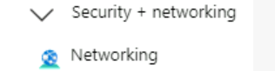
  - Under Private endpoint connections create a new private endpoint

Managed Identities
- Create a new managed identity and assign the subscription and Resource Group details.
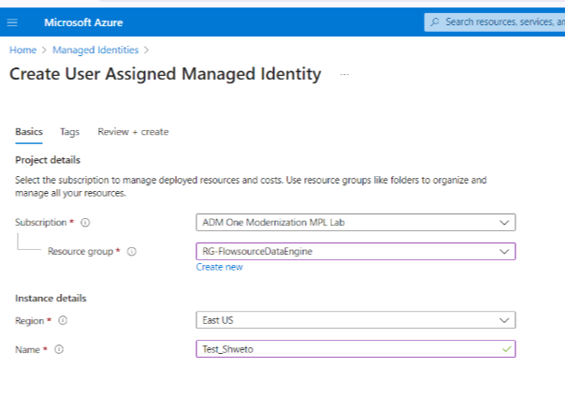
- Once its created, please go to the required resources (Example: DF, Storage, FN APP) and assign the permissions to managed identity under Access control (IAM)

- The roles assigned to the users for using the Azure resources are as listed in the table below –
User Type | Resource | Role | Scope | Activities Involved
Client Admin | Storage Account | Storage Account Contributor | Resource Level | Create the container  Create the Private End Point
Service Principle | Azure Function App | Contributor | Resource Group | Create and Deploy Azure functions

User Type | Resource | Role | Scope | Activities Involved
Managed Identity | Storage Account | Storage Blob Data Contributor | Resource Level | Uploading Data to Storage by Agents
Managed Identity | Storage Account | Storage Blob Data Reader | Resource Level
Managed Identity | Azure Cosmos DB for PostgreSQL Cluster | Admin Role at cluster level | Resource Level | Insertion of agent data into the tables
Managed Identity | Key Vault | Permissions – Get and List from Key, Secret and Certificate | Resource Level | Accessing the secrets from the Key Vault

Key Vault
The Key Vault service of Azure is used to store items such as DB connection credentials, secret id and access key.
To store data in Azure Key Vault, please follow below steps –
- Go to Key Vault from Azure list of services
- Create a new Keyvault
- Assign it to the same resource group as Function-App
- Provide name -> region -> Review+Create
- The keyvault should get listed, click on the newly created keyvault.
- Go to the Menu Option on the top left.
- Navigate to Event > Objects > Secrets
- Click on Generate/Import
- Add the Secret Name and Secret Value and click on Create.
- The Newly added Secret will be added to the list of Secrets.

Below is the list of Secrets that need to be created –

FIELD | DESCRIPTION | VALUE
JENKINS-ID | Provide the Jenkins User id | Eg – Jenkins-Service
JENKINS-PS | Provide the Jenkins Password | *********
JIRA-ID | Provide the Jira User id | Eg- Email id of Jira account
JIRA-PS | Provide the Jira Password | **********
DATADOG-API-KEY | Provide the Datadog API Key | Eg- alphanumeric key
DATADOG-APP-KEY | Provide the Datadog APP Key | Eg- alphanumeric key
SNOW-ID | Provide the SNOW User id | Eg- Email id of SNOW Account
SNOW-PS | Provide the SNOW Password | **********
RESILIENCEHUB-ID | Provide the AWS access key ID
RESILIENCEHUB-PS | Provide the AWS secret access key
CLIENT-ID | Provide the checkmarx client ID
CLIENT-TOKEN | Provie the checkmarx client Token
DB-HOST | Provide the DB host name | Host name to be selected after execution of CosmosDB Terraform Script
DB-PS | Provide the DB username
DB-UN | Provide the DB password
STORAGE-ACCOUNT-URL | Open the Storage account, click on JSON view, scroll to the bottom of the json, from the primary Endpoints property enter the value of Blob URL
DYNATRACE-API-TOKEN | Provide the Dynatrace API token
AZUREDEVOPS-ID | Provide the azure devops id
AZUREDEVOPS-PS | Provide the azure devops password
GITHUBACTIONS-TOKEN | Provide the token for GIthub actions
SONARQUBE-AUTH-TOKEN | Provide the token for SonarQube
APPDYNAMICS-CLIENTID | Provide the clientID for AppDynamics
APPDYNAMICS-PRIVATEKEY | Provide the PrivateKey for AppDynamics
AWSCODEPIPELINE-ID | Provide the aws accessKeyId for CodePipeline
AWSCODEPIPELINE-PS | Provide the AWS secret access key
GCP-CLOUDBUILD-CLIENT-ID | Provide the gcp client ID from the service account json file shared
GCP-CLOUDBUILD-CLIENT-EMAIL | Provide the gcp client email from the service account json file shared
GCP-CLOUDBUILD-PRIVATE-KEY | Provide the gcp private key for CloudBuild from the service account json file shared
GCP-CLOUDBUILD-PRIVATE-KEY-ID | Provide the gcp private key ID from the service account json file shared
GCP-CLOUDBUILD-PROJECT-ID | Provide the projectID from the service account json file shared
GCP-CLOUDBUILD-PROJECT-NUMBER | Provide the number of the account where we have the gcp-cloudbuild, where the pipelines are created
BITBUCKET-TOKEN | Provide the Bitbucket token
AZUREPIPELINE-TOKEN | Provide the Azurepipeline token
BLACKDUCK-TOKEN | Provide the Blackduck token
VERACODE-ID | Provide the Veracode Id
VERACODE-KEY | Provide the Veracode key

Script Execution
The terraform script runs in below order.

Cosmos DB Creation (/fs-data-pipeline/cosmosdb)
- Update all the attribute values provided in the file terraform.tfvars file
Example – update <CFG_RESOURCE_GROUP_NAME> with the resource group name
update <CFG_COSMOSDB_CLUSTER_NAME> with cosmos DB cluster name
- Run the terraform script cosmosdb.tf
After running the Terraform script, Cosmos DB For Azure PostgreSQL Cluster gets created
- Log in to the console and navigate to Azure Cosmos DB for PostgreSQL Cluster
- In the Overview section copy the Coordinator Name.
- In the Network settings, enable the "Allow public access from Azure services and resources within Azure to this cluster" checkbox.

- Go to Cluster Management -> Authentication -> select authentication method as PostgreSQL and Microsoft Entra ID authentication
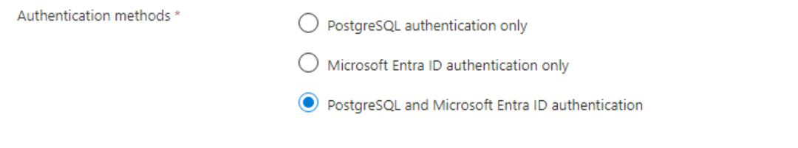
- Add the Managed Identity name.
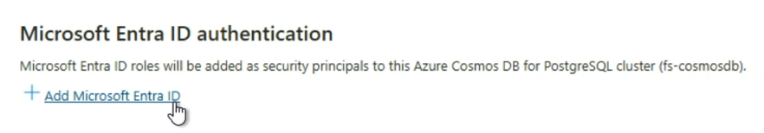
- Go to KeyVault and set the coordinator name as the value for DB-HOST key, set the username as ‘citus’ and password provided in tfvar file (for CosmosDB) as the value for DB-UN and DB-PS.
- Open the DB client which is installed and validate that DB has been created.
- Create the Schema and DB tables using the table queries which are provided in the Script folder in the deployment package.
- Create Linked service for PostgreSQL (ref 2.1.5.2)
PostgreSQL Tables List
- JENKINS / GITHUB ACTIONS/AWS CODE PIPELINE/GCP CLOUDBUILD/ AZURE PIPELINE/ BITBUCKET - ci_prod_deployment_data
- JIRA / AZURE DEVOPS - alm_changes_data
- LEADTIME - scm_leadtime_data
- DATADOG / DYNATRACE - apm_event_data
- SNOW - itsm_incident_data
- CHECKMARX / SONARQUBE / VERACODE - codequality_metrics_data
- BLACKDUCK – sca_metrics_data
- AWS RESILIENCE HUB - apm_resilience_data
- CATALOG - catalog_data
- STAGING - catalog_data_staging

Azure Function Creation (fs-data-pipeline\az_function_app)
- Update the attribute values provided in the file terraform.tfvars file.
Example – update <CFG_SERVICE_PLAN_NAME> with the service plan selected.
update < CFG_STORAGE_ACCOUNT_NAME > with Storage account name.
- Run the terraform script and validate all the 6 function apps which are listed below are created in the Azure function-
  - FS-Jira-Agent
  - FS-Jenkins-Agent
  - FS-DataDog-Agent-Dev
  - FS-SNOW-Agent
  - FS-ResilienceHub-Agent
  - FS-CheckMarx-Agent
  - FS-Dynatrace-Agent
  - FS-AzureDevops-Agent
  - FS-GithubActions-Agent
  - FS-AWSCodePipeline-Agent
  - FS-GCPCloudBuild-Agent
  - FS-AzurePipeline-Agent
  - FS-Bitbucket-Agent
  - FS-Blackduck-Agent
  - FS-Veracode-Agent
  - FS-Data-Engine
- After all the functions have been created and deployed, please validate that the below list of environment variables has been created for each of the agent function –

Data-Agent Environment Variables
(Please note the below environment variables should be configured for every agent)
KEY | VALUE
BASE_URL | Provide the base URL for the agent
DATABASE_NAME | dev
CREDENTIAL_MANAGER_ENDPOINT | Provide the keyvault URL
STORAGE_NAME | Provide the Blob Storage name to which agent will upload the files
DAYS_TO_COLLECT | Provide the number of days for which the agent should start data collection eg: 30/90/180
FN_TRIGGER_TIMER | Provide the scheduler timer of the agent eg:  0 /2*** (every 2 hours)
AZURE_CLIENT_ID | Provide the azure client ID

Data-Engine Environment Variables
KEY | VALUE
DATABASE_NAME | dev
CREDENTIAL_MANAGER_ENDPOINT | Provide the keyvault URL
STORAGE_NAME | Provide the Blob Storage name to which agent will upload the files
AZURE_CLIENT_ID | Provide the azure client ID

Deployment Sanity Check
Once the above deployment is completed, the function apps will get triggered. To perform sanity check please validate the below items –
- In the respective agent folder inside the Blob Storage container the data files along with a tracking file should get uploaded.
Example : Jenkins agent files should be present in ci-jenkins folder
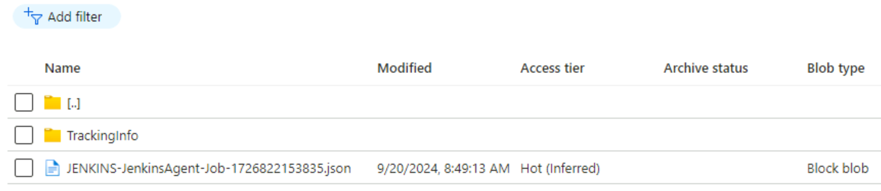

- Once the data gets published to storage, the data engine gets executed and the data gets inserted into the DB tables. Please check in the DB client if data are available in the tables of the respective agent
- Once all the above are validated, please check in the below dashboard if the panels are getting populated with the data from the table
- DORA metrics
- Flowsource Control Pane in Power BI

-------------------------------*******************------------------------------

