

Flowsource - Data Engine GCP Deployment
Contents
1. Overview 3
1.1 Data Agent (Cloud Run Function) 3
1.2 Cloud Scheduler 3
1.3 Database 3
1.4 Cloud Storage 3
1.5 Data Engine 4
1.6 Exception/Error Scenarios 4
2. Terraform Deployment 5
2.1 Pre-Requisites 5
2.1.1 Secret Manager 6
2.1.2 BigQuery DB 7
2.2 Script Execution 9
2.3 Infrastructure Validation 10
2.4 Deployment E2E Sanity Check 10

Overview
The flowsource Data Engine architecture involves the following resources of GCP –
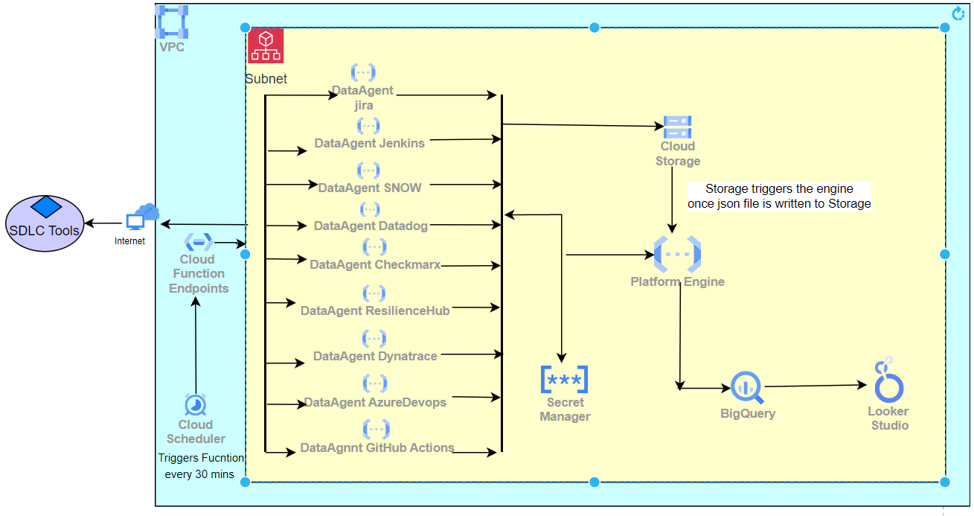

Data Agent (Cloud Run Function)
The agent functions are created for deployment of each agent. The
purpose of the agent function is to collect tool data from various tools such as Jira, GitHub, Jenkins using RESTful API calls from these given tools and publish the data into Cloud Storage.

Cloud Scheduler
The Cloud Scheduler service allows to schedule cron jobs that enables to automate the execution of the data agents. For each agent one scheduler is created which triggers the agent at the time interval which is mentioned in the frequency.

Database
The below database used in the Data Engine –
- BigQuery– The BigQuery DB has tables to store the data collected by each agent.
The DB dataset is created using terraform script (details mentioned below) and tables are created using SQL script.
The list of tables which needs to be created are mentioned below in the Terraform Deployment section. The queries to create the tables are provided in the Script folder attached with the deployment package.

Cloud Storage
The data engine uses Google Cloud Storage to store the tool data which are collected by agent. After the agents are deployed the following folder gets created in the Storage for each agent.

Agent | Storage folder Name
JIRA | alm-jira
DATADOG | appmonitoring-datadog
JENKINS | ci-jenkins
CHECKMARX | codequality-checkmarx
SERVICE NOW | itsm-snow
AWS RESILIENCE HUB | appmonitoring-awsresiliencehub
DYNATRACE | appmonitoring-dynatrace
AZURE DEVOPS | alm-azuredevops
GITHUB ACTIONS | ci-githubactions
APPDYNAMICS | appmonitoring-appdynamics
SONARQUBE | codequality-sonarqube
AWS CODE PIPELINE | ci-awscodepipeline
GCP CLOUDBUILD | ci-gcpcloudbuild
AZURE PIPELINE | ci-azurepipeline
BITBUCKET | ci-bitbucket
BLACKDUCK | sca-blackduck
VERACODE | codequality-veracode
Catalog Data | catalog-info

Data Engine
The GCP Data Engine is used to read the files stored in the Cloud Storage folder by the agents and then insert the data into the BigQuery Database Tables
Trigger: Engine will get executed when a file with JSON extension is dropped in Cloud Storage bucket

Exception/Error Scenarios
Below are the possible exception scenarios that can occur and the reason why they have occurred-

Error Code | Error | Action Item
CODING ERRORS
1001 | FLOWSOURCE_BASEENGINE_ERROR: MAIN_TABLE_NAME should not be empty | MAIN_TABLE_NAME variable in the agent specific engine code might be empty or not present in the code
1004 | FLOWSOURCE_BASEENGINE_ERROR: INSERT_TO_MAIN_TABLE_FROM_TEMP_TABLE should not be empty | INSERT_TO_MAIN_TABLE_FROM_TEMP_TABLE variable in the agent specific engine code might be empty or not present in the code
1005 | FLOWSOURCE_BASEENGINE_ERROR: CREATE_STAGING_TABLE_TEMP should not be empty | CREATE_STAGING_TABLE_TEMP variable in the agent specific engine code might be empty or not present in the code
1101 | FLOWSOURCE_ENGINE_QUERY_ERROR: Failed to process processQuery | Query might be incorrect  Error in processQuery method
1102 | FLOWSOURCE_ENGINE_QUERY_ERROR: Command not found | Command might be incorrect or not present in the code
1201 | FLOWSOURCE_CLASSLOADER_ERROR: module not found | The name of the class might be misspelled or wrong
DATABASE ERRORS
2004 | FLOWSOURCE_BIGQUERY_ERROR: Forbidden error in BigQuery  FLOWSOURCE_GCP_ERROR: GCP Forbidden error occurred | Service account doesn't have sufficient permission
COMMON ERRORS
3001 | FLOWSOURCE_FILE_ERROR: FileNotFoundError | Config.json might not be present
3101 | FLOWSOURCE_GCP_ERROR: GCP NotFound error occurred  FLOWSOURCE_BIGQUERY_ERROR: Resource not found in BigQuery | The bucket, function, dataset, table name or project might not be present
3002 | FLOWSOURCE_KEY_ERROR:Environment variable not found | Environment variable or variable in config.json  Secret manager key might not be present
AGENT ERRORS
4001 | FLOWSOURCE_ERROR: No Problems for appids | No respone from the api call
4002 | FLOWSOURCE_BASEAGENT_ERROR: fetch_catalog_data: No records found in catalog table | fetch_catalog_data is empty, or the agent specific constraints specified in the query like project-key might not be present
4003 | FLOWSOURCE_ERROR: Failed to Get Access Token | No Access Token received in checkmarx and githubactions
REST FACADE ERRORS
5001 | FLOWSOURCE_RESTFACADE_ERROR: Bad request error | The project is not present in the agent  Invalid parameters  For Jira, the project key might be invalid, or the credentials might be incorrect
5002 | FLOWSOURCE_RESTFACADE_ERROR: Unauthorized error | Invalid credentials in secrets manager
5003 | FLOWSOURCE_RESTFACADE_ERROR: Forbidden error | Insufficient permission to access the resource
5004 | FLOWSOURCE_RESTFACADE_ERROR: Requested webpage not found in server | End point might not be present. Check the url

Terraform Deployment

Pre-Requisites
Following are pre-requisites required before executing the scripts:
- Enable Eventarc api & CloudScheduler api.

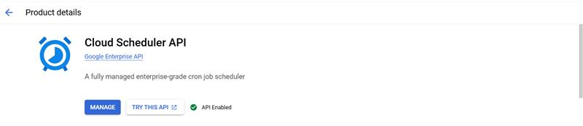

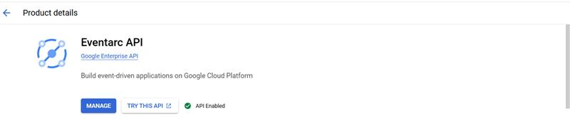

- Create the following resources
  - GCP service account
- The roles which need to be assigned to the data engine service account are as below-
  - roles/bigquery.connectionUser – allows users to use connections to
external data sources and run queries on
them.
  - roles/bigquery.user – allows users to run BigQuery jobs and
access the job information.
  - roles/cloudbuild.builds.builder – allows service account to execute build
using Cloud Build.
  - roles/cloudscheduler.jobRunner – grants permission to grant cloud scheduler
jobs.
  - roles/eventarc.eventReceiver – allows to send trigger from storage to
engine.
  - roles/bigquery.jobUser – allows users to create and manage
Big Query jobs
  - roles/iam.serviceAccountUser – allows a principle to attach a service
account to a resource.
  - roles/secretmanager.secretAccessor – to manage and access secrets within the
Secret Manager.
  - roles/storage.objectViewer – grants permission to access and read data
stored in Cloud Storage.
  - roles/artifactregistry.writer – grants permissions to service account to
read and write artifacts to repository.
  - roles/logging.logWriter – allows service account to write log entries
using the Logging API.
- The roles which need to be assigned to the default service account are as below –

- roles/iam.serviceAccountTokenCreator – allows a principle to create short-lived
credentials for a service agent.
- roles/pubsub.publisher – allows service agent to send messages
to a specified topic.
- Create a GCP storage account where the agents will publish the data that have been collected.
- Create the secrets in Secret Manager. (ref 2.1.1)

Secret Manager

The Secret Manager service of GCP is used to store items such as DB connection credentials, secret id and access key.
To store data in Secret Manager, please follow below steps –
- Search for Secret Manager in GCP.
- Click on Create New Secret
- Assign a secret name and value and Save
- The secret should get listed under the main list of Secrets.

Below is the list of Secrets that need to be created –

FIELD | DESCRIPTION | VALUE
JENKINS-ID | Provide the Jenkins User id | Eg – Jenkins-Service
JENKINS-PS | Provide the Jenkins Password | *********
JIRA-ID | Provide the Jira User id | Eg- Email id of Jira account
JIRA-PS | Provide the Jira Password | **********
DATADOG-API-KEY | Provide the Datadog API Key | Eg- alphanumeric key
DATADOG-APP-KEY | Provide the Datadog APP Key | Eg- alphanumeric key
SNOW-ID | Provide the SNOW User id | Eg- Email id of SNOW Account
SNOW-PS | Provide the SNOW Password | **********
DYNATRACE_API_TOKEN | Provide the api token for Dynatrace
RESILIENCEHUB-ID | Provide the AWS access key ID | RESILIENCEHUB-ID
RESILIENCEHUB-PS | Provide the AWS secret access key
CLIENT-ID | Provide the checkmarx client ID
CLIENT-TOKEN | Provie the checkmarx client Token
DB-PS | Provide the DB username
DB-UN | Provide the DB password
AZUREDEVOPS-ID | Provide the azure devops id
AZUREDEVOPS-PS | Provide the azure devops password
GITHUBACTIONS-TOKEN | Provide the token for GIthub actions
GITHUBACTIONS-CLIENTID | Provide the client id for Github actions
SONARQUBE-AUTH-TOKEN | Provide the token for SonarQube
APPDYNAMICS-CLIENTID | Provide the clientID for AppDynamics
APPDYNAMICS-PRIVATEKEY | Provide the PrivateKey for AppDynamics
AWSCODEPIPELINE-ID | Provide the aws accessKeyId for CodePipeline
AWSCODEPIPELINE-PS | Provide the AWS secret access key
GCP-CLOUDBUILD-CLIENT-ID | Provide the gcp client ID from the service account json file shared
GCP-CLOUDBUILD-CLIENT-EMAIL | Provide the gcp client email from the service account json file shared
GCP-CLOUDBUILD-PRIVATE-KEY | Provide the gcp private key for CloudBuild from the service account json file shared
GCP-CLOUDBUILD-PRIVATE-KEY-ID | Provide the gcp private key ID from the service account json file shared
GCP-CLOUDBUILD-PROJECT-ID | Provide the projectID from the service account json file shared
GCP-CLOUDBUILD-PROJECT-NUMBER | Provide the number of the account where we have the gcp-cloudbuild, where the pipelines are created
BITBUCKET-TOKEN | Provide the Bitbucket token
AZUREPIPELINE-TOKEN | Provide the azurepipeline token
BLACKDUCK-TOKEN | Provide the blackduck token
VERACODE-ID | Provide the Veracode Id
VERACODE-KEY | Provide the Veracode Key

Terraform Script Execution
- Update all the attribute values provided in the file terraform.tfvars file.
- The terraform tfvars file has 3 section-
  - Section 1 - project id and related details
  - Section2 - engine cloud function details along with the environment variables.
  - Section3 - agent cloud function details along with the environment variables.
  - Section4 – Add DB Dataset name, service account mail and user account mail.

- Please refer the table below for details on the variables to be updated in the tfvars file.
Variables | Values
<CFG_GCP_PROJECT_ID> | Provide the value of GCP project id
<CFG_PROJECT_NUMBER> | Provide the project number
<CFG_SERVICE_ACCOUNT_EMAIL> | Provide the service account email id
<CFG_GCP_REGION> | Provide the Google Cloud Region where resources should be created
<CFG_DATABASE_NAME> | Provide the name of the dataset that is created
<CFG_STORAGE_NAME> | Provide the storage bucket name
<CFG_CHECKMARX_BASEURL> | Provide the BaseURL for checkmarx agent
<CFG_DATADOG_BASEURL> | Provide the baseURL for Datadog agent
<CFG_DYNATRACE_BASEURL> | Provide the baseURL for Dynatrace agent
<CFG_JENKINS_BASEURL> | Provide the baseURL for Jenkins agent
<CFG_JIRA_BASEURL> | Provide the baseURL for Jira agent
<CFG_RESILIENCEHUB_REGION_NAME> | Provide the Resilience Hub Agent Region name
<CFG_SERVICENOW_BASEURL> | Provide the baseURL for Service Now agent
<CFG_AZUREDEVOPS_BASEURL> | Provide the baseURL for Azure Devops agent
<CFG_AZUREPIPELINE_BASEURL> | Provide the baseURL for Azure Pipeline agent
<CFG_BITBUCKET_BASEURL> | Provide the baseURL for Bitbucket agent
<CFG_BLACKDUCK_BASEURL> | Provide the baseURL for Blackduck agent
<CFG_VERACODE_BASEURL> | Provide the baseURL for Veracode agent
<CFG_GITHUBACTIONS_BASEURL> | Provide the baseURL for Github Actions agent
<CFG_DAYS_TO_COLLECT> | Provide the number of days for which data needs to be collected by agent (in integer format)

- Once all the variables are updated, run the terraform script using terraform apply

Infrastructure Validation

- After the Terraform script has run successfully, validate that the below items are created.
- Cloud Run function-
  - FS-Jira-Agent
  - FS-Jenkins-Agent
  - FS-DataDog-Agent
  - FS-SNOW-Agent
  - FS-ResilienceHub-Agent
  - FS-CheckMarx-Agent
  - FS-Dynatrace-Agent
  - FS-AzureDevops-Agent
  - FS-GithubActions-Agent
  - FS-AppDynamics-Agent
  - FS-SonarQube-Agent
  - FS-AWSCodePipeline-Agent
  - FS-GCPCloudBuild-Agent
  - FS-AzurePipeline-Agent
  - FS-Bitbucket-Agent
  - FS-Blackduck-Agent
  - FS-Veracode-Agenr
  - FS-Data-Engine

- Cloud Scheduler-
  - FS-Jira-Agent-Scheduler
  - FS-Jenkins-Agent-Scheduler
  - FS-DataDog-Agent-Scheduler
  - FS-SNOW-Agent-Scheduler
  - FS-ResilienceHub-Agent-Scheduler
  - FS-CheckMarx-Agent-Scheduler
  - FS-Dynatrace-Agent-Scheduler
  - FS-AzureDevops-Agent-Scheduler
  - FS-GithubActions-Agent-Scheduler
  - FS-SonarQube-Agent- Scheduler
  - FS-AppDynamics-Agent- Scheduler
  - FS-AWSCodePipeline-Agent- Scheduler
  - FS-GCPCloudBuild-Agent- Scheduler
  - FS-Bitbucket-Agent- Scheduler
  - FS-Blackduck-Agent-Scheduler
  - FS-Veracode-Agent-Scheduler
  - FS-Data-Engine- Scheduler

2.3 BigQuery DB

Open BigQuery in Google Cloud and under the project a new dataset which got created by terraform will be available. Under the dataset, create the tables using the SQL create tables queries provided in the folder path GCP/sql-scripts. The tables that has to create under the new dataset are listed below.
- JENKINS / GITHUB ACTIONS / AWS CODE PIPELINE / GCP CLOUDBUILD / AZURE PIPELINE/ BITBUCKET- ci_prod_deployment_data
- JIRA / AZURE DEVOPS - alm_changes_data
- LEADTIME - scm_leadtime_data
- DATADOG / DYNATRACE / APPDYNAMICS- apm_event_data
- SNOW - itsm_incident_data
- CHECKMARX / SONARQUBE / VERACODE - codequality_metrics_data
- BLACKDUCK – sca_metrics_data
- AWS RESILIENCEHUB - apm_resilience_data
- CATALOG - catalog_data
- STAGING - catalog_data_staging

Once all the tables get created, check the catalog-data table to verify if catalog info is available.
The flowsource catalog info will be published every one hour in the catalog-info folder in the storage account bucket which will trigger the engine cloud function, and the catalog data will be inserted into the table.

2.3.1 OPTIONAL STEP
In case you want to add another user account mail id to the BigQuery dataset, please follow below steps-
Click on the 3 dots beside the dataset and select Share -> Manage Permissions
- In the new window click on Add Principal
- In the New Principals text box type the user account email and it will show the principal in the dropdown, select that.
- In the Select a Role dropdown select BigQuery Data Owner and Save
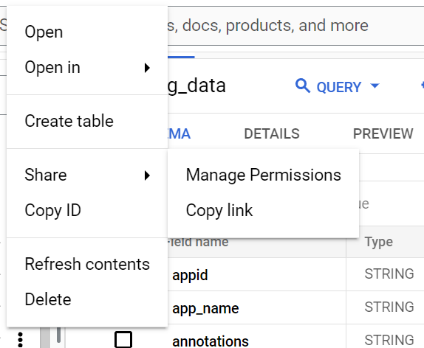
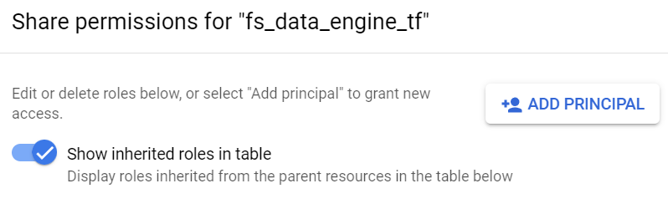
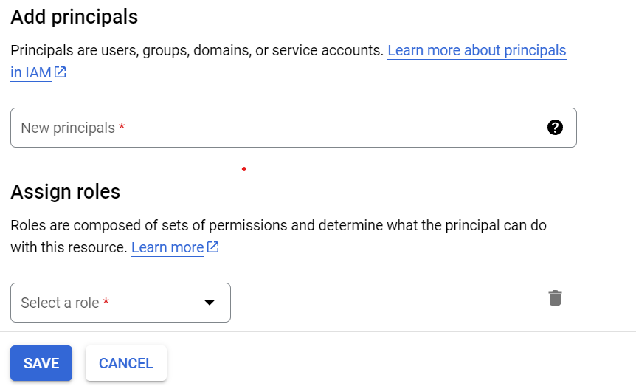

Deployment E2E Sanity Check

Once the above deployment is completed, the function apps will get triggered. To perform sanity, please validate the below items –
- In the respective agent folder inside the Cloud Storage the data files along with a tracking file should get uploaded.
Example: Jenkins agent files should be present in ci-jenkins folder
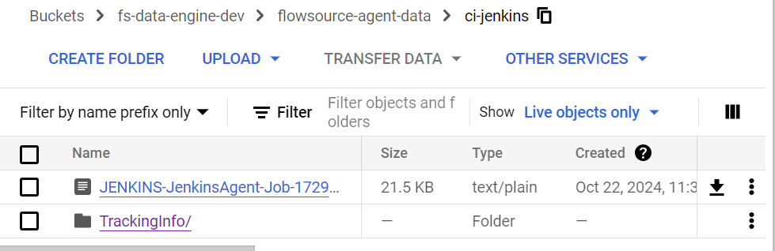

- Once the data agent file gets published in the storage, the respective data engine cloud function gets triggered.
- After the data engine has run successfully, the agent data get inserted into the DB tables. Please check in the BigQuery DB if data are available in the tables of the respective agent.
- Once all the above are validated, please check in the below dashboard if the panels are getting populated with the data from the table
- DORA metrics
- Flowsource Control Pane in Looker Studio

---------------------------------*******************------------------------------

