**VIT– AP University**

Inavolu, Beside AP Secretariat Amaravati, Andhra Pradesh – 522 237, India,

Web: www.vitap.ac.in

___________________________________________________________

Date: 28.11.2020

**School of Computer Science and Engineering**

(CSE1004: Problem Solving using JAVA)

Non-Evaluative Programs- Lab 3

1. Write a java program to calculate the sum of all odd numbers and even numbers separately within a given number using while loop.

input: read an integer

output: display two integers

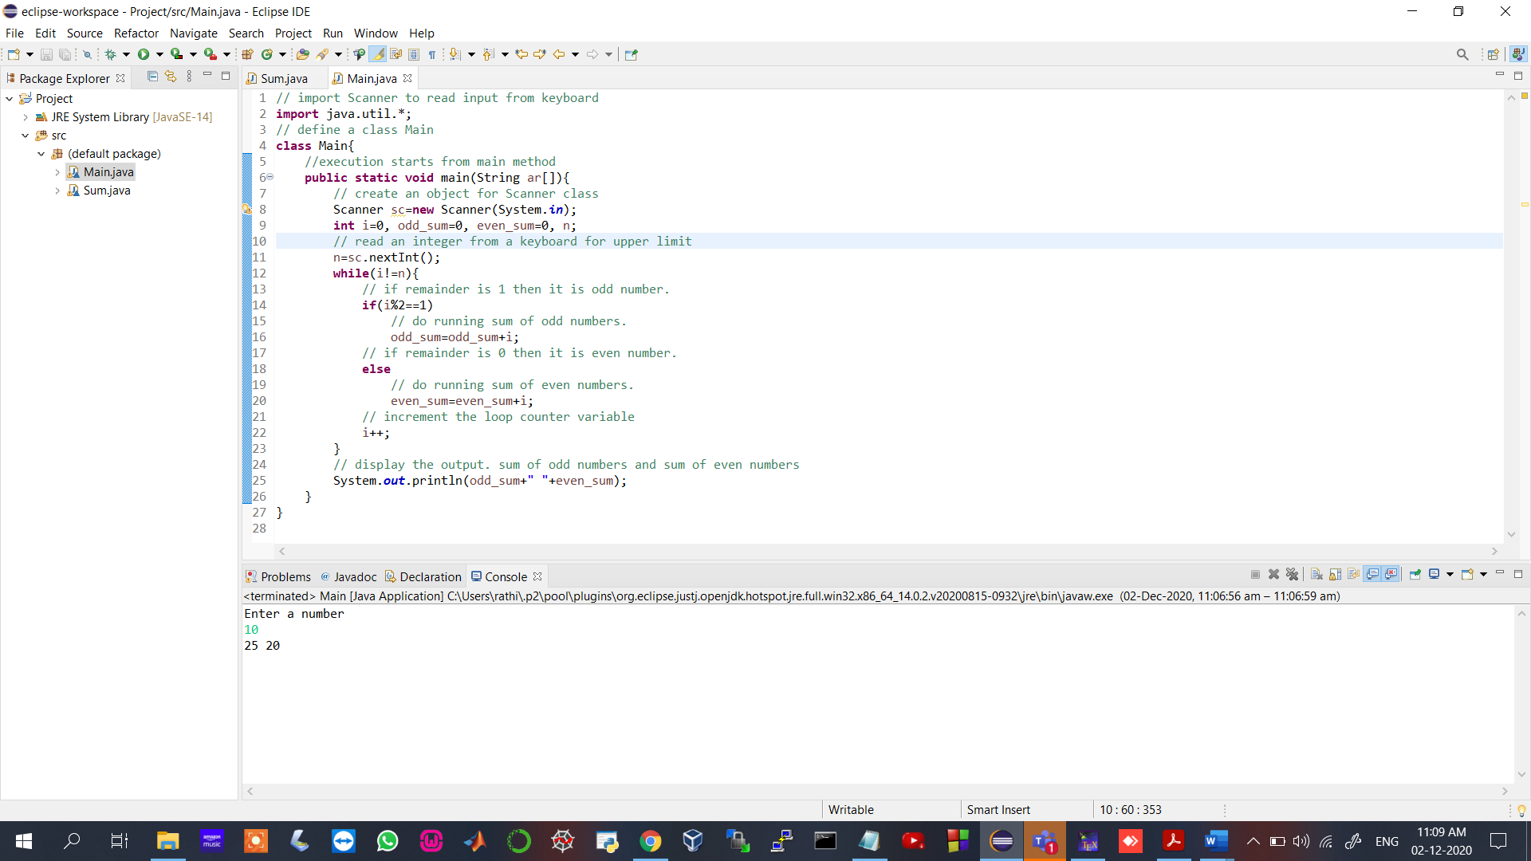

Test cases:

1. Input: 10

Expected output: 25 20

1. Input: 20

Expected output: 100 90

2. Write a java program to reverse the given number using for loop.

Input: read an integer

output: display reversed integer

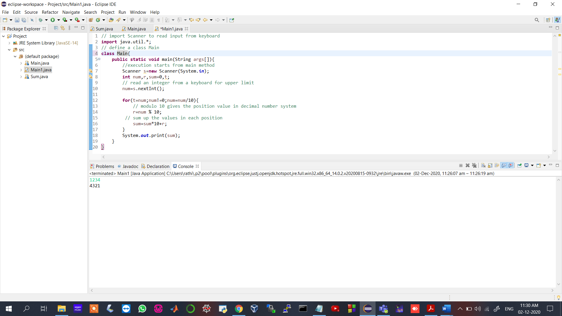

Test cases:

1. Input: 1234

Expected output: 4321

1. Input: 98762

Expected output: 26789

3. Write a java program to List out the numbers that are divisible by 7 and 13 within a given number using for loop.

Input: read an integer

output: display integers in a row separated by single space.

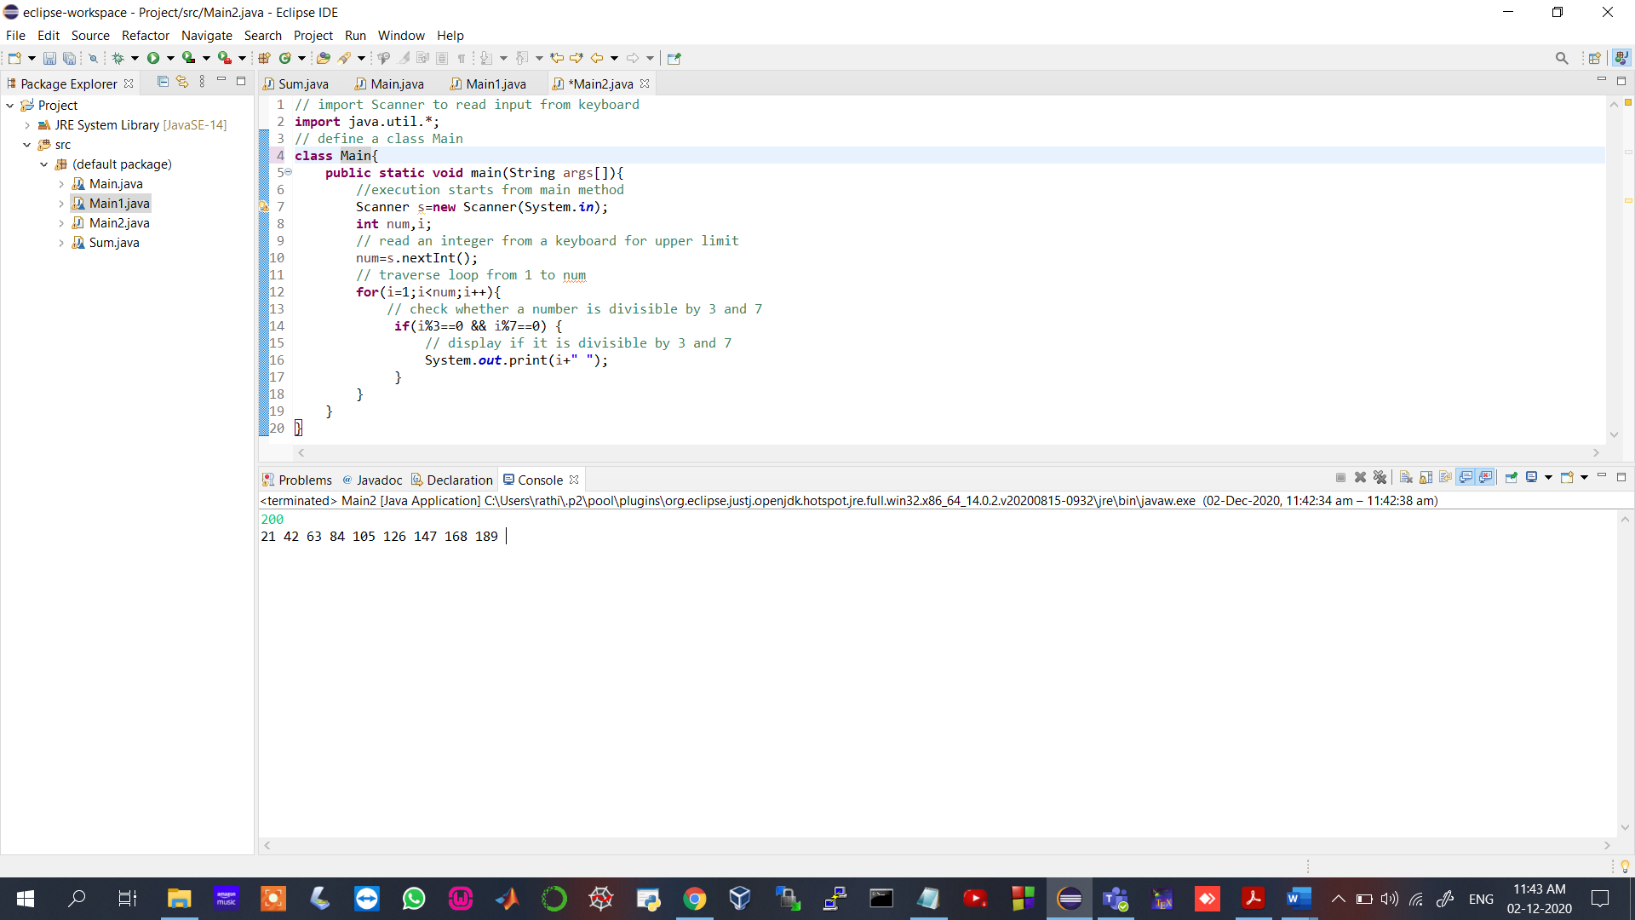

Test cases:

1. Input: 100

Expected output: 21 42 63 84

1. Input: 200

Expected output: 21 42 63 84 105 126 147 168 189

4. Write a java program to build a triangle up to given number of rows using break and continue keyword.

Input: read an integer

output: display triangle as shown below.

1

23

456

78910

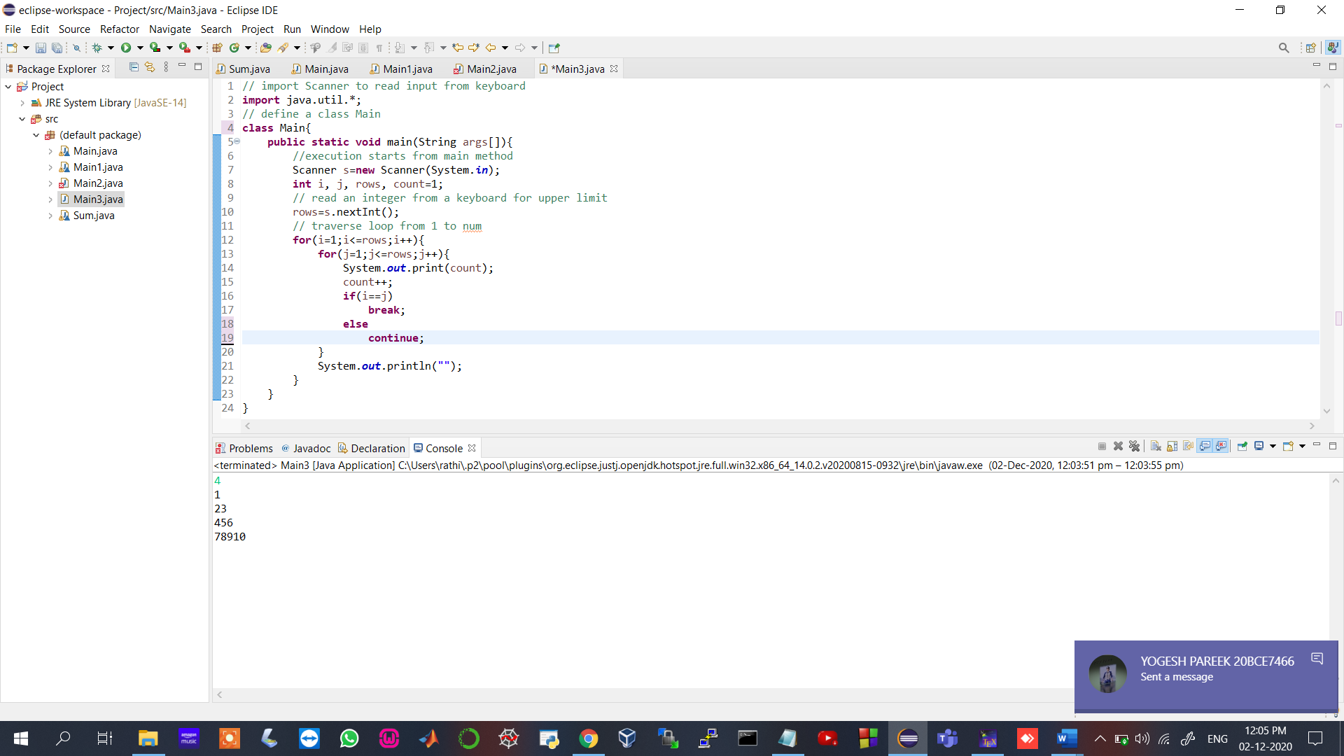

Test cases:

1. Input: 4

Expected output:

1

23

456

78910

1. Input: 5

Expected output:

1

23

456

78910

1112131415