**VIT– AP University**

Inavolu, Beside AP Secretariat Amaravati, Andhra Pradesh – 522 237, India,

Web: www.vitap.ac.in

___________________________________________________________

Date: 14.12.2020

**School of Computer Science and Engineering**

(CSE1004: Problem Solving using JAVA)

Non-Evaluative Programs- Lab 4

1. Write a Java program to print the following pattern.

* * * * *

* * * * *

* * * * *

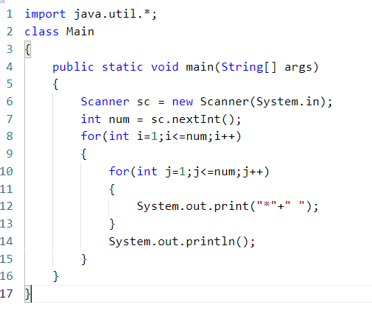

1. Write a java program to print perfect numbers within a given range.

Input:50

Output:

1

6

28

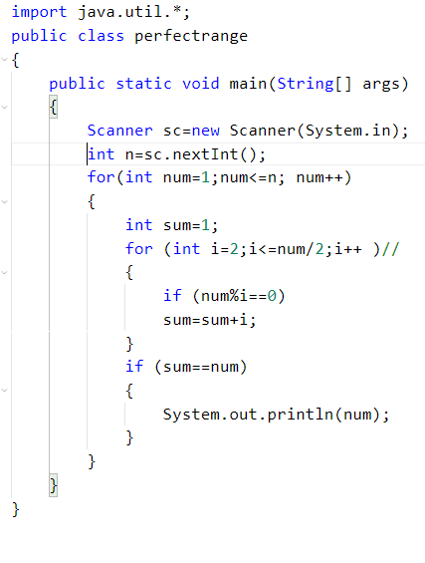

3. Write a Java program to print the following pyramid.

1

24

369

481216

51015

612

7

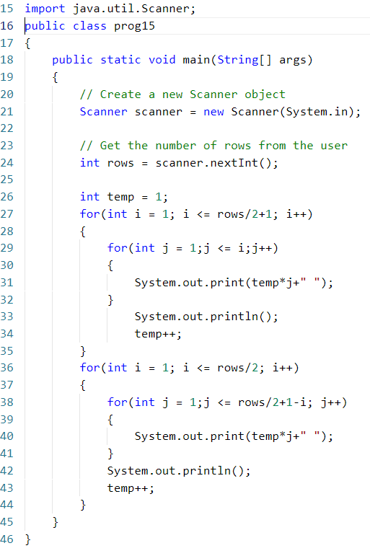

4. Write a Java program to print the following pyramid.

ABCDEF  
ABCDE  
ABCD  
ABC  
AB  
A  
A  
AB  
ABC  
ABCD  
ABCDE  
ABCDEF

