Week-08 HandsOn Solution

- Git-HOL

Question 1: Write the Git commands to create a local repo, add welcome.txt, and push it to GitLab.

- Command:

KIIT@BT-22052206 MINGW64 ~
$ git clone https://gitlab.com/Gaurav-3002-group/git01.git
cd git01
Cloning into 'git01'...
info: please complete authentication in your browser...
remote: Enumerating objects: 3, done.
remote: Counting objects: 100% (3/3), done.
remote: Compressing objects: 100% (2/2), done.
remote: Total 3 (delta 0), reused 0 (delta 0), pack-reused 0 (from 0)
Receiving objects: 100% (3/3), done.

KIIT@BT-22052206 MINGW64 ~/git01 (main)
$ echo "Welcome to Git" > welcome.txt
git add welcome.txt
git commit -m "Initial commit"
warning: in the working copy of 'welcome.txt', LF will be replaced by CRLF the next time Git touches it
[main a410227] Initial commit
1 file changed, 1 insertion(+)
create mode 100644 welcome.txt

KIIT@BT-22052206 MINGW64 ~/git01 (main)
$ echo "*.log" > .gitignore
echo "logs/" >> .gitignore
git add .gitignore
git commit -m "Added rules to ignore .log files and logs folder"
warning: in the working copy of '.gitignore', LF will be replaced by CRLF the next time Git touches it
[main 71c23e7] Added rules to ignore .log files and logs folder
1 file changed, 2 insertions(+)
create mode 100644 .gitignore

KIIT@BT-22052206 MINGW64 ~/git01 (main)
$ git push origin main:master
Enumerating objects: 7, done.
Counting objects: 100% (7/7), done.
Delta compression using up to 8 threads
Compressing objects: 100% (4/4), done.
Writing objects: 100% (6/6), 608 bytes | 152.00 KiB/s, done.
Total 6 (delta 0), reused 0 (delta 0), pack-reused 0 (from 0)
remote:
remote: To create a merge request for master, visit:
remote: https://gitlab.com/Gaurav-3002-group/git01/-/merge_requests/new?merge_request%5Bsource_branch%5D=master
remote:
To https://gitlab.com/Gaurav-3002-group/git01.git
* [new branch] main -> master

- Output:

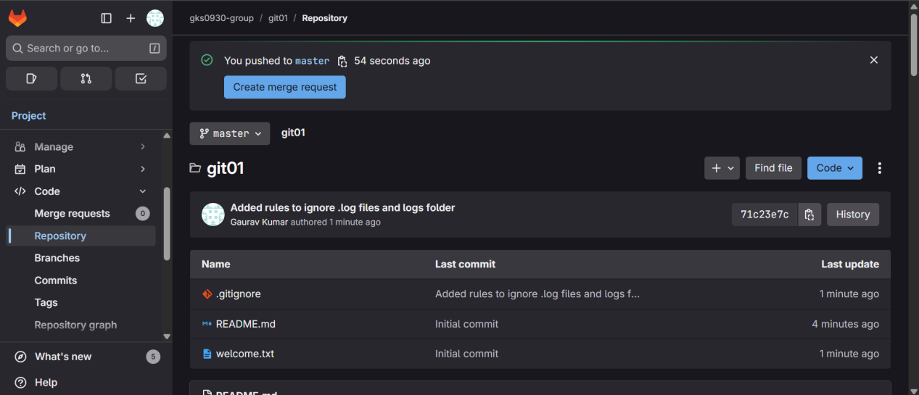

Question 2: Write the Git commands to create a .gitignore that ignores .log files and the logs/ folder, then push it to GitLab.

- Command:

KIIT@BT-22052206 MINGW64 ~/git02 (main)
$ echo "*.log" > .gitignore
echo "logs/" >> .gitignore

KIIT@BT-22052206 MINGW64 ~/git02 (main)
$ git add .gitignore
git commit -m "Added rules to ignore .log files and logs folder"
warning: in the working copy of '.gitignore', LF will be replaced by CRLF the next time Git touches it
[main 8ce7a20] Added rules to ignore .log files and logs folder
1 file changed, 2 insertions(+)
create mode 100644 .gitignore

KIIT@BT-22052206 MINGW64 ~/git02 (main)
$ git branch -M master
git push origin master
Enumerating objects: 4, done.
Counting objects: 100% (4/4), done.
Delta compression using up to 8 threads
Compressing objects: 100% (2/2), done.
Writing objects: 100% (3/3), 312 bytes | 312.00 KiB/s, done.
Total 3 (delta 0), reused 0 (delta 0), pack-reused 0 (from 0)
remote:
remote: To create a merge request for master, visit:
remote: https://gitlab.com/Gaurav-3002-group/git02/-/merge_requests/new?merge_request%5Bsource_branch%5D=master
remote:
To https://gitlab.com/Gaurav-3002-group/git02.git
* [new branch] master -> master

KIIT@BT-22052206 MINGW64 ~/git02 (master)
$ git clone https://gitlab.com/Gaurav-3002-group/git03.git
cd git03
Cloning into 'git03'...
remote: Enumerating objects: 3, done.
remote: Counting objects: 100% (3/3), done.
remote: Compressing objects: 100% (2/2), done.
remote: Total 3 (delta 0), reused 0 (delta 0), pack-reused 0 (from 0)
Receiving objects: 100% (3/3), done.

- Output:

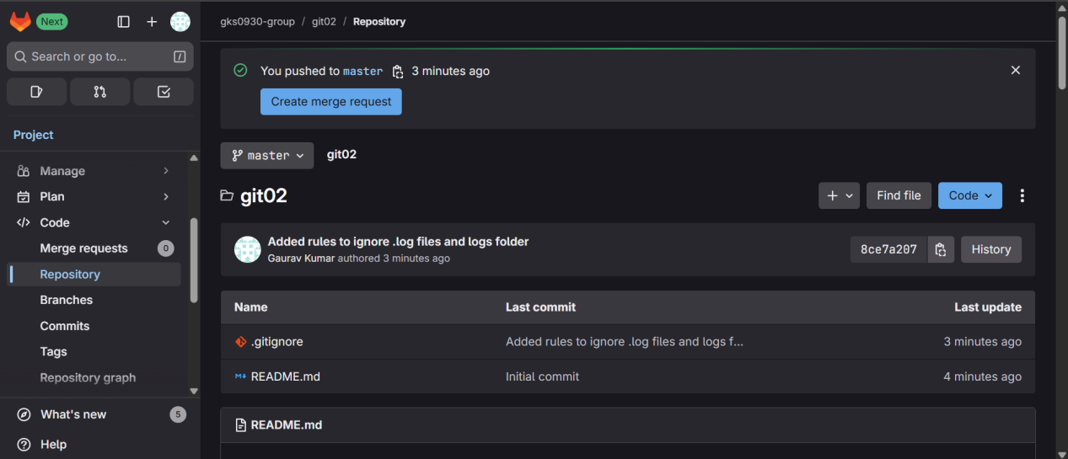

Question 3: Write the Git commands to create a branch GitNewBranch, add a file in it, push it, and merge it into master.

- Command:

KIIT@BT-22052206 MINGW64 ~/git03 (main)
$ git branch -M master

KIIT@BT-22052206 MINGW64 ~/git03 (master)
$ git checkout -b GitNewBranch
Switched to a new branch 'GitNewBranch'

KIIT@BT-22052206 MINGW64 ~/git03 (GitNewBranch)
$ echo "This is from GitNewBranch" > branchfile.txt
git add branchfile.txt
git commit -m "Added branchfile.txt in GitNewBranch"
warning: in the working copy of 'branchfile.txt', LF will be replaced by CRLF the next time Git touches it
[GitNewBranch b102e1a] Added branchfile.txt in GitNewBranch
1 file changed, 1 insertion(+)
create mode 100644 branchfile.txt

KIIT@BT-22052206 MINGW64 ~/git03 (GitNewBranch)
$ git push origin GitNewBranch
Enumerating objects: 4, done.
Counting objects: 100% (4/4), done.
Delta compression using up to 8 threads
Compressing objects: 100% (2/2), done.
Writing objects: 100% (3/3), 325 bytes | 162.00 KiB/s, done.
Total 3 (delta 0), reused 0 (delta 0), pack-reused 0 (from 0)
remote:
remote: To create a merge request for GitNewBranch, visit:
remote: https://gitlab.com/Gaurav-3002-group/git03/-/merge_requests/new?merge_request%5Bsource_branch%5D=GitNewBranch
remote:
To https://gitlab.com/Gaurav-3002-group/git03.git
* [new branch] GitNewBranch -> GitNewBranch

KIIT@BT-22052206 MINGW64 ~/git03 (GitNewBranch)
$ git checkout master
git pull origin master
git branch -d GitNewBranch
Switched to branch 'master'
Your branch is up to date with 'origin/main'.
fatal: couldn't find remote ref master
error: the branch 'GitNewBranch' is not fully merged
hint: If you are sure you want to delete it, run 'git branch -D GitNewBranch'
hint: Disable this message with "git config set advice.forceDeleteBranch false"

KIIT@BT-22052206 MINGW64 ~/git03 (master)
$ git clone https://gitlab.com/Gaurav-3002-group/git04.git
cd git04
git branch -M master
Cloning into 'git04'...
remote: Enumerating objects: 3, done.
remote: Counting objects: 100% (3/3), done.
remote: Compressing objects: 100% (2/2), done.
remote: Total 3 (delta 0), reused 0 (delta 0), pack-reused 0 (from 0)
Receiving objects: 100% (3/3), done.

- Output:

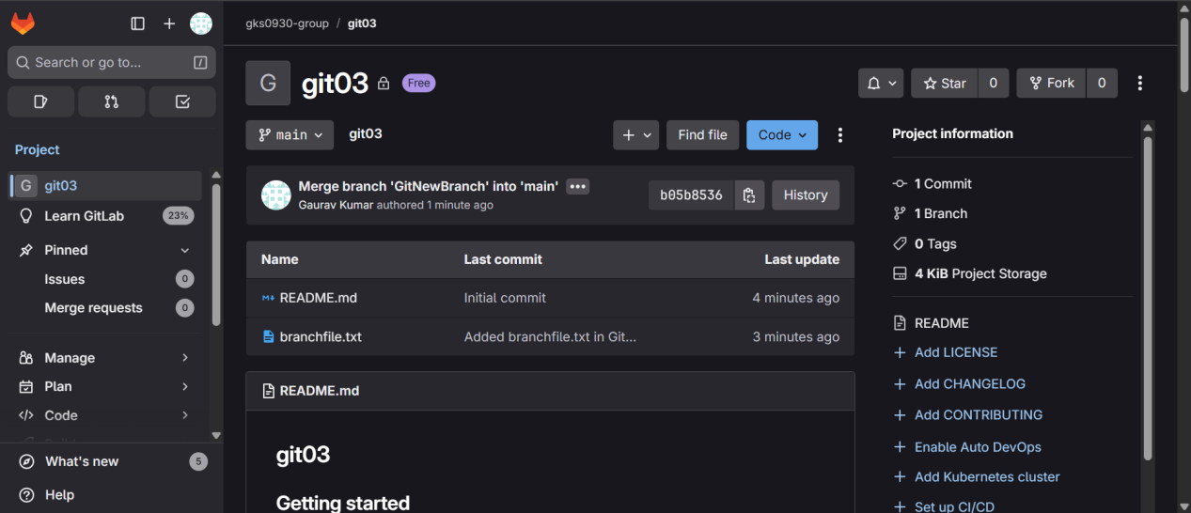

Question 4: Write the Git commands to create a merge conflict with hello.xml, resolve it, and push the changes to GitLab.

- Command:

KIIT@BT-22052206 MINGW64 ~/git04 (master)
$ git checkout -b GitWork
echo "<message>Hello from GitWork branch</message>" > hello.xml
git add hello.xml
git commit -m "Added hello.xml in GitWork branch"
Switched to a new branch 'GitWork'
warning: in the working copy of 'hello.xml', LF will be replaced by CRLF the next time Git touches it
[GitWork 94d0f60] Added hello.xml in GitWork branch
1 file changed, 1 insertion(+)
create mode 100644 hello.xml

KIIT@BT-22052206 MINGW64 ~/git04 (GitWork)
$ git push origin GitWork
Enumerating objects: 4, done.
Counting objects: 100% (4/4), done.
Delta compression using up to 8 threads
Compressing objects: 100% (2/2), done.
Writing objects: 100% (3/3), 337 bytes | 168.00 KiB/s, done.
Total 3 (delta 0), reused 0 (delta 0), pack-reused 0 (from 0)
remote:
remote: To create a merge request for GitWork, visit:
remote: https://gitlab.com/Gaurav-3002-group/git04/-/merge_requests/new?merge_request%5Bsource_branch%5D=GitWork
remote:
To https://gitlab.com/Gaurav-3002-group/git04.git
* [new branch] GitWork -> GitWork

KIIT@BT-22052206 MINGW64 ~/git04 (GitWork)
$ git checkout master
echo "<message>Hello from master branch</message>" > hello.xml
git add hello.xml
git commit -m "Added hello.xml in master branch"
git push origin master
Switched to branch 'master'
Your branch is up to date with 'origin/main'.
warning: in the working copy of 'hello.xml', LF will be replaced by CRLF the next time Git touches it
[master fb3d41f] Added hello.xml in master branch
1 file changed, 1 insertion(+)
create mode 100644 hello.xml
Enumerating objects: 4, done.
Counting objects: 100% (4/4), done.
Delta compression using up to 8 threads
Compressing objects: 100% (2/2), done.
Writing objects: 100% (3/3), 329 bytes | 109.00 KiB/s, done.
Total 3 (delta 0), reused 0 (delta 0), pack-reused 0 (from 0)
remote:
remote: To create a merge request for master, visit:
remote: https://gitlab.com/Gaurav-3002-group/git04/-/merge_requests/new?merge_request%5Bsource_branch%5D=master
remote:
To https://gitlab.com/Gaurav-3002-group/git04.git
* [new branch] master -> master

KIIT@BT-22052206 MINGW64 ~/git04 (master)
$ git merge GitWork
Auto-merging hello.xml
CONFLICT (add/add): Merge conflict in hello.xml
Automatic merge failed; fix conflicts and then commit the result.

KIIT@BT-22052206 MINGW64 ~/git04 (master|MERGING)
$ git checkout -b GitWork
echo "<message>Hello from GitWork branch</message>" > hello.xml
fatal: a branch named 'GitWork' already exists

KIIT@BT-22052206 MINGW64 ~/git04 (master|MERGING)
$ git checkout master
hello.xml: needs merge
error: you need to resolve your current index first

KIIT@BT-22052206 MINGW64 ~/git04 (master|MERGING)
$ nano hello.xml

KIIT@BT-22052206 MINGW64 ~/git04 (master|MERGING)
$ git add hello.xml
warning: in the working copy of 'hello.xml', LF will be replaced by CRLF the next time Git touches it

KIIT@BT-22052206 MINGW64 ~/git04 (master|MERGING)
$ git commit -m "Resolved merge conflict in hello.xml"
[master 7176cd8] Resolved merge conflict in hello.xml

KIIT@BT-22052206 MINGW64 ~/git04 (master)
$ git push origin master
Enumerating objects: 7, done.
Counting objects: 100% (7/7), done.
Delta compression using up to 8 threads
Compressing objects: 100% (2/2), done.
Writing objects: 100% (3/3), 363 bytes | 121.00 KiB/s, done.
Total 3 (delta 0), reused 0 (delta 0), pack-reused 0 (from 0)
remote:
remote: To create a merge request for master, visit:
remote: https://gitlab.com/Gaurav-3002-group/git04/-/merge_requests/new?merge_request%5Bsource_branch%5D=master
remote:
To https://gitlab.com/Gaurav-3002-group/git04.git
fb3d41f..7176cd8 master -> master

- Output:

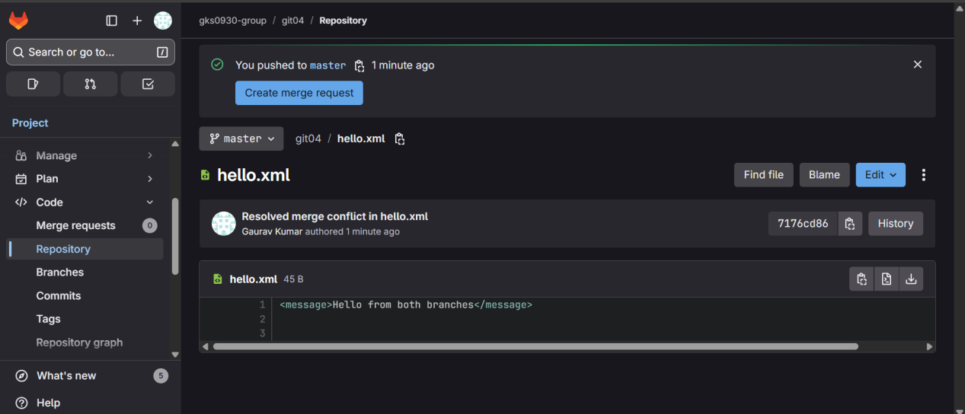

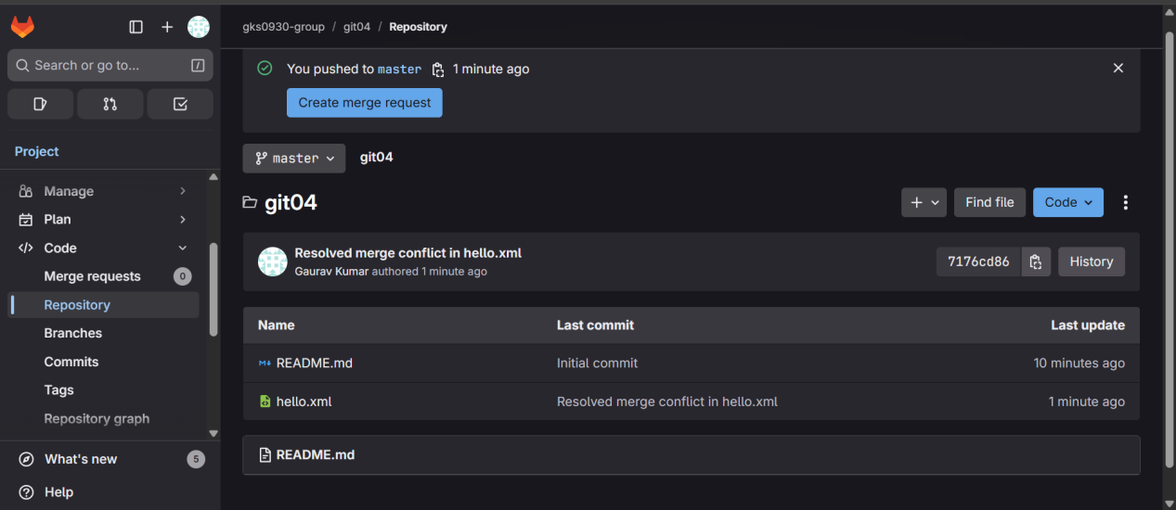

Question 5: Write the Git commands to pull the latest changes from the remote repo into master and push them back after merging.

- Command:

KIIT@BT-22052206 MINGW64 ~
$ git clone https://gitlab.com/Gaurav-3002-group/git05.git
cd git05
git branch -M master
Cloning into 'git05'...
remote: Enumerating objects: 3, done.
remote: Counting objects: 100% (3/3), done.
remote: Compressing objects: 100% (2/2), done.
remote: Total 3 (delta 0), reused 0 (delta 0), pack-reused 0 (from 0)
Receiving objects: 100% (3/3), done.

KIIT@BT-22052206 MINGW64 ~/git05 (master)
$ ^C

KIIT@BT-22052206 MINGW64 ~/git05 (master)
$ git status
On branch master
Your branch is up to date with 'origin/main'.

nothing to commit, working tree clean

KIIT@BT-22052206 MINGW64 ~/git05 (master)
$ git branch -a
* master
remotes/origin/HEAD -> origin/main
remotes/origin/main

KIIT@BT-22052206 MINGW64 ~/git05 (master)
$ git pull origin master
fatal: couldn't find remote ref master

KIIT@BT-22052206 MINGW64 ~/git05 (master)
$ ^C

KIIT@BT-22052206 MINGW64 ~/git05 (master)
$ git pull origin main
From https://gitlab.com/Gaurav-3002-group/git05
* branch main -> FETCH_HEAD
Already up to date.

KIIT@BT-22052206 MINGW64 ~/git05 (master)
$ git checkout -b GitWork
echo "<message>Hello from GitWork branch</message>" > hello.xml
git add hello.xml
git commit -m "Added hello.xml in GitWork branch"
git push origin GitWork
Switched to a new branch 'GitWork'
warning: in the working copy of 'hello.xml', LF will be replaced by CRLF the next time Git touches it
[GitWork ef732cb] Added hello.xml in GitWork branch
1 file changed, 1 insertion(+)
create mode 100644 hello.xml
Enumerating objects: 4, done.
Counting objects: 100% (4/4), done.
Delta compression using up to 8 threads
Compressing objects: 100% (2/2), done.
Writing objects: 100% (3/3), 334 bytes | 111.00 KiB/s, done.
Total 3 (delta 0), reused 0 (delta 0), pack-reused 0 (from 0)
remote:
remote: To create a merge request for GitWork, visit:
remote: https://gitlab.com/Gaurav-3002-group/git05/-/merge_requests/new?merge_request%5Bsource_branch%5D=GitWork
remote:
To https://gitlab.com/Gaurav-3002-group/git05.git
* [new branch] GitWork -> GitWork

KIIT@BT-22052206 MINGW64 ~/git05 (GitWork)
$ git checkout master
echo "<message>Hello from master branch</message>" > hello.xml
git add hello.xml
git commit -m "Added hello.xml in master branch"
git push origin master
Switched to branch 'master'
Your branch is up to date with 'origin/main'.
warning: in the working copy of 'hello.xml', LF will be replaced by CRLF the next time Git touches it
[master c27064a] Added hello.xml in master branch
1 file changed, 1 insertion(+)
create mode 100644 hello.xml
Enumerating objects: 4, done.
Counting objects: 100% (4/4), done.
Delta compression using up to 8 threads
Compressing objects: 100% (2/2), done.
Writing objects: 100% (3/3), 332 bytes | 166.00 KiB/s, done.
Total 3 (delta 0), reused 0 (delta 0), pack-reused 0 (from 0)
remote:
remote: To create a merge request for master, visit:
remote: https://gitlab.com/Gaurav-3002-group/git05/-/merge_requests/new?merge_request%5Bsource_branch%5D=master
remote:
To https://gitlab.com/Gaurav-3002-group/git05.git
b0babfa..c27064a master -> master

KIIT@BT-22052206 MINGW64 ~/git05 (master)
$ git merge GitWork
Auto-merging hello.xml
CONFLICT (add/add): Merge conflict in hello.xml
Automatic merge failed; fix conflicts and then commit the result.

KIIT@BT-22052206 MINGW64 ~/git05 (master|MERGING)
$ git add .

KIIT@BT-22052206 MINGW64 ~/git05 (master|MERGING)
$ git commit -m "Complementing Git-T03-HOL_002 lab changes"
[master 9f91759] Complementing Git-T03-HOL_002 lab changes

KIIT@BT-22052206 MINGW64 ~/git05 (master)
$ git push origin master
Enumerating objects: 7, done.
Counting objects: 100% (7/7), done.
Delta compression using up to 8 threads
Compressing objects: 100% (3/3), done.
Writing objects: 100% (3/3), 402 bytes | 201.00 KiB/s, done.
Total 3 (delta 0), reused 0 (delta 0), pack-reused 0 (from 0)
remote:
remote: To create a merge request for master, visit:
remote: https://gitlab.com/Gaurav-3002-group/git05/-/merge_requests/new?merge_request%5Bsource_branch%5D=master
remote:
To https://gitlab.com/Gaurav-3002-group/git05.git
c27064a..9f91759 master -> master

KIIT@BT-22052206 MINGW64 ~/git05 (master)
$ git log --oneline -n 3
9f91759 (HEAD -> master, origin/master) Complementing Git-T03-HOL_002 lab changes
c27064a Added hello.xml in master branch
ef732cb (origin/GitWork, GitWork) Added hello.xml in GitWork branch

- Output:

