SIMATS ENGINEERING
ASSESSMENT TOOL 2
COURSE NAME: COMPUTER ARCHITECTURE
COURSE CODE: CSA12

Student Name | P JASWANTH
Reg. No. | 192312437
Department | ECE

Course Outcome Covered
CO1: Components of a computer system, including CPU, memory, and I/O; instruction execution cycle; bus structures; performance factors such as CPU execution time, CPI and clock cycles; 8085 and 8086 architectures; modern architectures including ARM Cortex, Intel Core and AMD Ryzen; instruction sets, formats, addressing modes; and binary and hexadecimal number systems. (BL4)
Assessment Tool Weightage: 40% | Questions: 5 | Total Marks: 25

Q1. Analytical Concept Map
Construct a concept map that connects the components of a computer system (CPU, memory, and I/O) with the instruction execution cycle. Clearly show how instruction fetch, decode, and execution stages interact with memory and input/output operations during program execution.
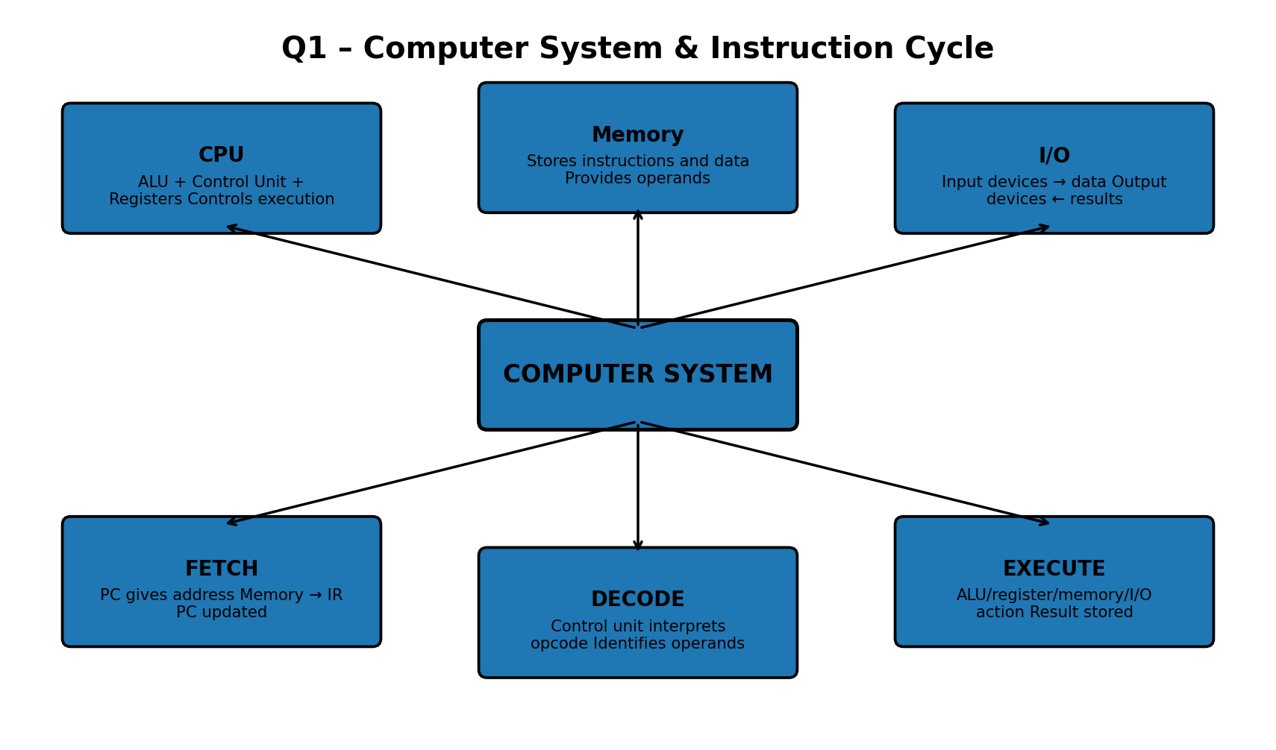

Key Interpretation
The instruction cycle is a continuous interaction among CPU, memory and I/O. The CPU fetches an instruction from memory, decodes it, executes it using registers/ALU and accesses memory or I/O when required.

Q2. Analytical Concept Map
Develop a concept map linking different bus structures (single-bus, multi-bus, hierarchical bus) with system performance factors such as CPU execution time, clock cycles, and CPI. Illustrate how bus design influences data transfer speed and overall system efficiency.
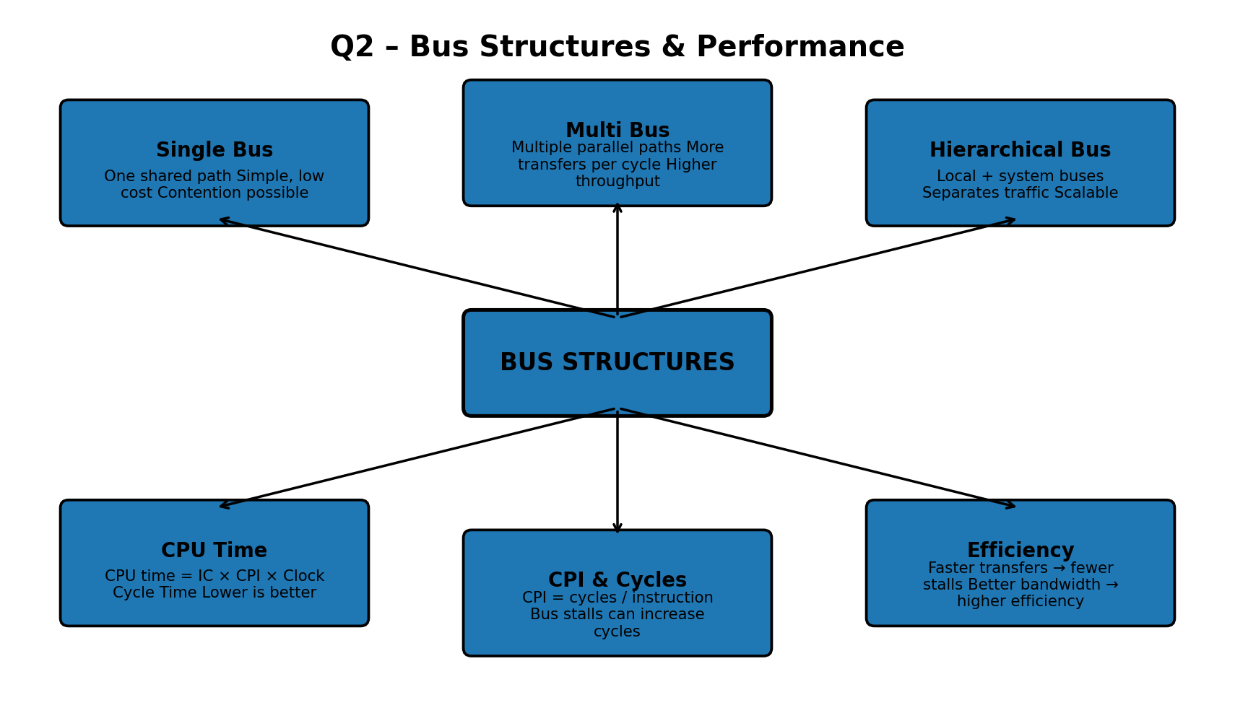

Key Interpretation
Bus architecture affects bandwidth and waiting time. A single shared bus is simple but can become a bottleneck; multi-bus designs permit more parallel transfers; hierarchical buses isolate traffic and improve scalability. These effects influence cycles, CPI and CPU execution time.

Q3. Analytical Concept Map
Create a concept map that compares 8085 and 8086 architectures with modern architectures like ARM Cortex, Intel Core, and AMD Ryzen. Show relationships in terms of instruction sets, addressing modes, processing capability, and architectural advancements.
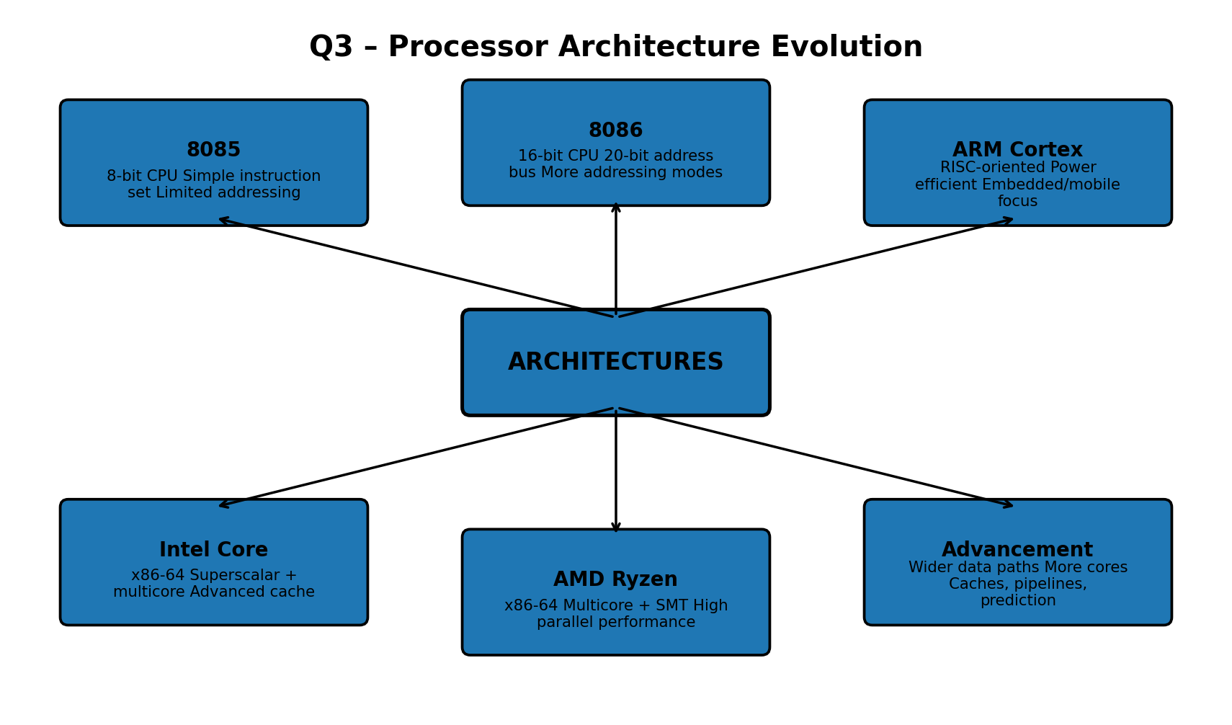

Key Interpretation
8085 and 8086 represent earlier generations with simpler, narrower processing resources. ARM Cortex emphasizes efficiency, while Intel Core and AMD Ryzen provide advanced multicore x86-64 processing. Modern designs add caches, pipelines, prediction and parallel execution.

Q4. Analytical Concept Map
Design a concept map that integrates instruction sets, instruction formats, and addressing modes with number systems (binary and hexadecimal). Explain how instructions are represented, decoded, and executed using these number systems in a computer.
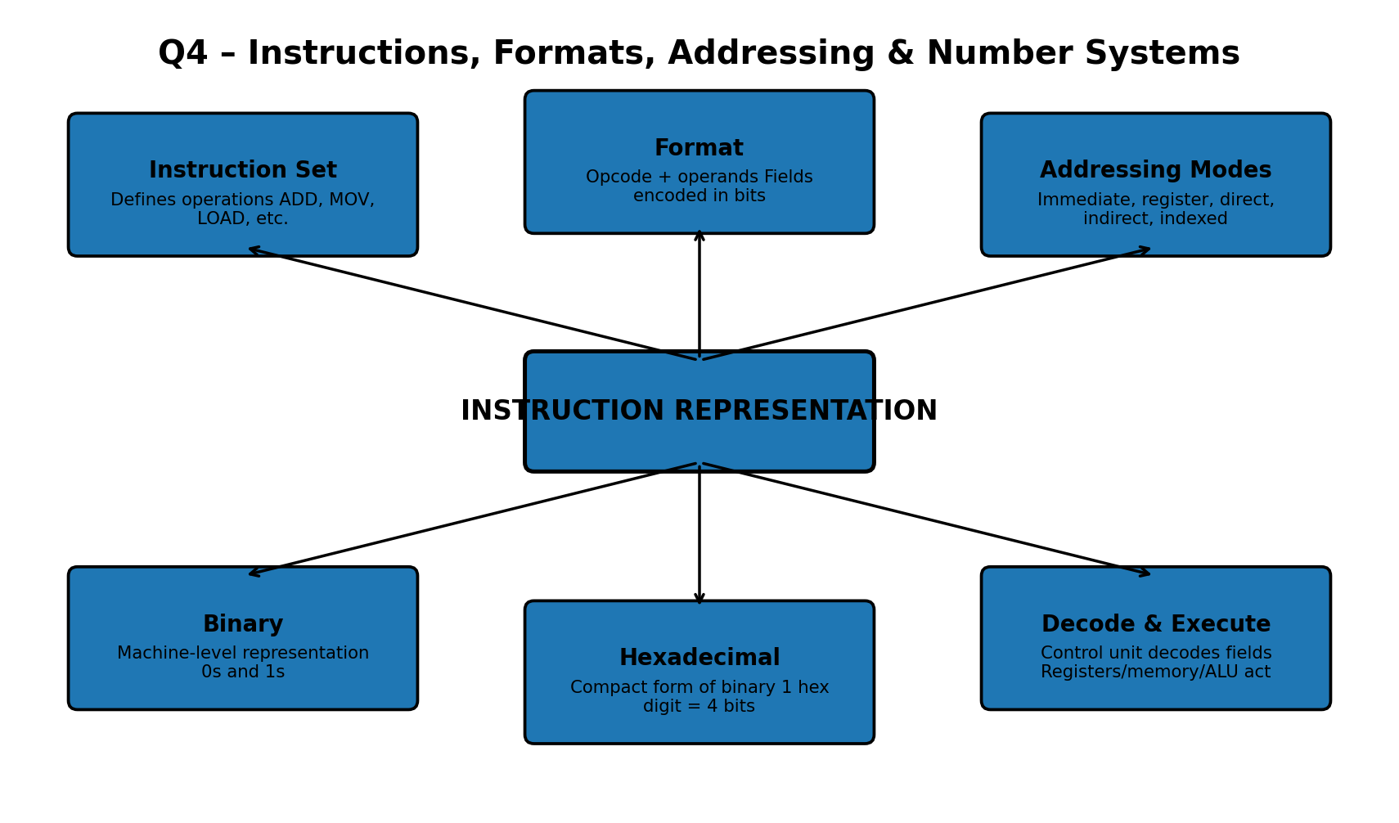

Key Interpretation
Instructions are ultimately encoded as binary fields. Hexadecimal provides a compact representation. The instruction format contains opcode and operand/address fields; addressing modes determine how operands are obtained, after which the control unit decodes and executes the instruction.

Q5. Analytical Concept Map
Prepare a concept map that connects benchmarking techniques with performance metrics such as CPU execution time, CPI, and clock cycles, and relate these to different architectures (8085, 8086, and modern processors). Demonstrate how performance evaluation varies across different system designs.
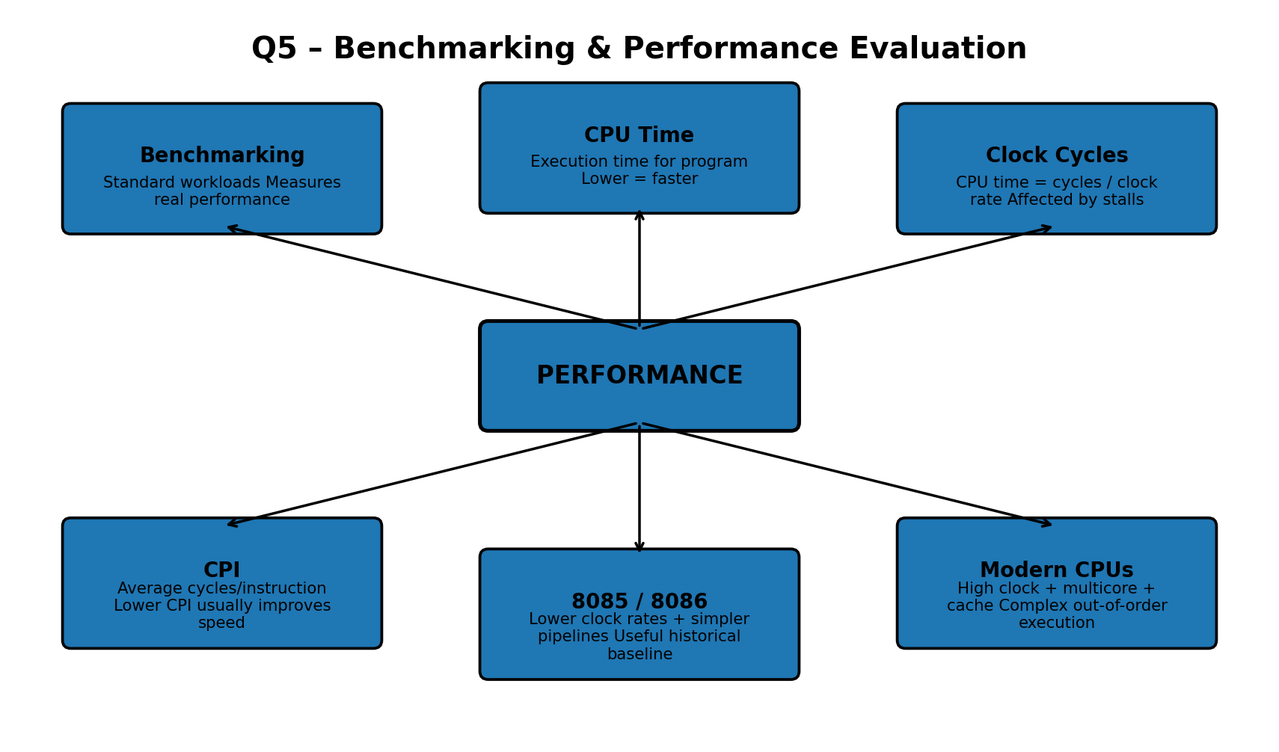

Key Interpretation
Benchmarking uses repeatable workloads to compare systems. CPU execution time, clock cycles and CPI reveal different performance characteristics. Historical processors are useful baselines, while modern processors gain performance from higher clocks, multicore execution, caches and advanced pipelines.

