**Database Management System Project**

|  |  |
| --- | --- |
| Name of student | T.V.Jaswanth Chowdary |
| E-mail | [Jaswanthchowdarytalluru25@gmail.com](mailto:Jaswanthchowdarytalluru25@gmail.com) |
| Roll number | AM.EN.U4CSE22156 |

* ER-Diagram for e-Bay:-

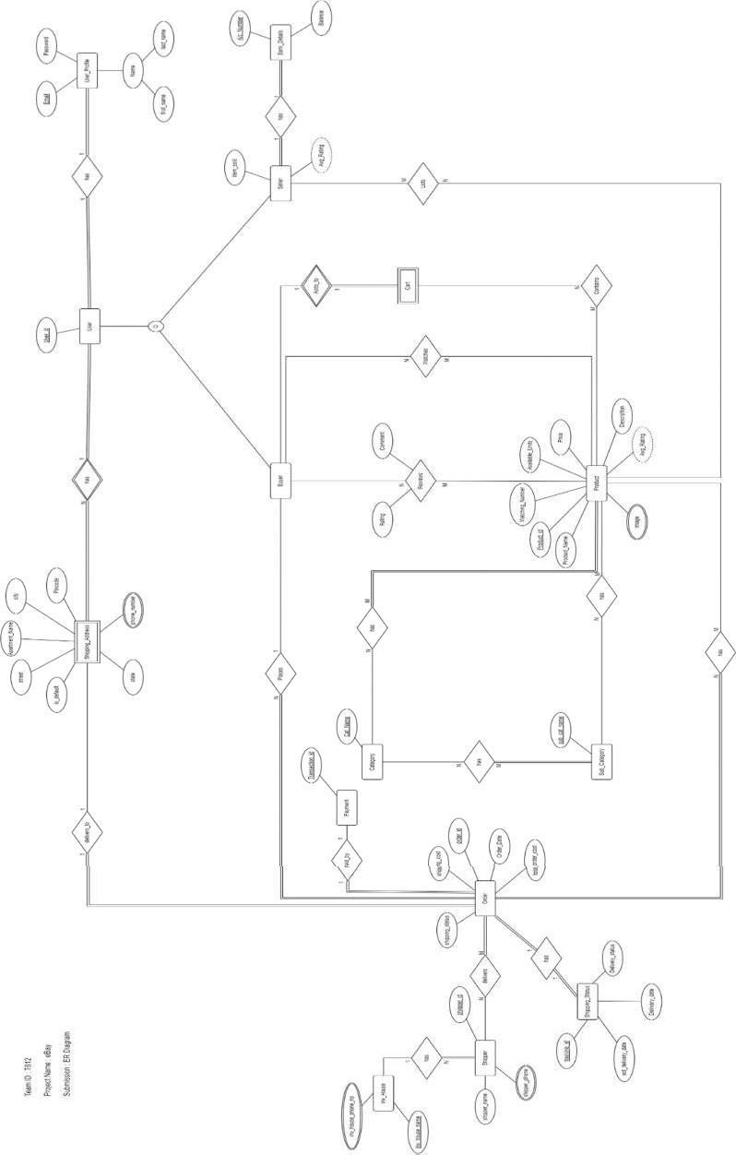

* Relational Schema for e-Bay:-

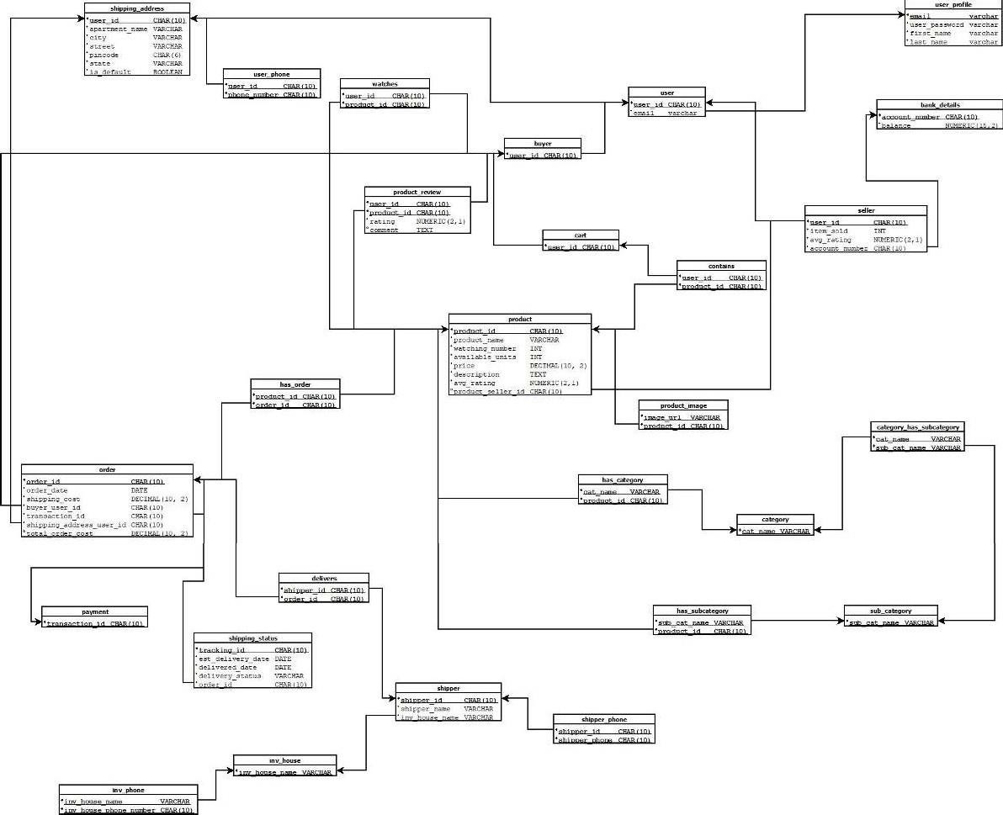

* **All Functional Dependencies :-**

Email → Password Email → first_name Email → last_name User_id → Email User_id → item_sold User_id → Avg_Rating User_id → A/C_Number A/C_Number → Balance

Product_id → Product_Name Product_id → Watching_Number Product_id → Available_Units Product_id → Price

Product_id → Description Product_id → Avg_Rating Product_id → Product_Seller_id

{Product_id , User_id } → Rating

{Product_id , User_id } → Comments Order_id → Order_Date

Order_id → Shipping_Cost Order_id → Buyer_id Order_id → Transaction_id Order_id → Shipping_User_id Order_id → Total_order_cost Transaction_id → Order_id Transaction_id → Order_Date

Transaction_id → Shipping_Cost Transaction_id → Buyer_id Transaction_id → Shipping_User_id Transaction_id → Total_order_cost tracking_id → Est_Delivery_Date tracking_id → Delivered_Date

tracking_id → Delivery_Status tracking_id → Order_id Order_id → Est_Delivery_Date Order_id → Delivered_Date Order_id → Delivery _Status Order_id → tracking_id Shipper_id → Inv_House_Name Shipper_id → Shipper_Name Phone_No → Shipper_id

Inv_Phone_No → Inv_House_Name User_id → Apartment_Name User_id → City

User_id → Street User_id → State User_id → Pincode User_id → Is_Default Phone_No → User_id