New Perspectives Excel 365/2021 | Module 3: SAM Project 1a

# Scrub Jay Peripherals

## Performing Calculations with Formulas and Functions

### GETTING STARTED

* Save the file **NP_EX365_2021_3a_*FirstLastName*_1.xlsx** as **NP_EX365_2021_3a_*FirstLastName*_2.xlsx**

Edit the file name by changing “1” to “2”.

If you do not see the **.xlsx** file extension, do not type it. The file extension will be added for you automatically.

* With the file **NP_EX365_2021_3a_*FirstLastName*_2.xlsx** open, ensure that your first and last name is displayed in cell B6 of the Documentation worksheet.

If cell B6 does not display your name, delete the file and download a new copy.

### PROJECT STEPS

1. Danilo Lewellen is an entrepreneur planning to manufacture and market an innovative handheld controller for virtual reality gaming. Danilo is building a business plan as he recruits investors and plans logistics for the launch of his new company, Scrub Jay Peripherals, and wants to use Excel to summarize data and create projections.  
     
   Switch to the *Sales Projections* worksheet. Use the values in the range B6:C6 to extend the incremented percentages to the range D6:H6.
2. Use the values in the range A7:A8 to extend the list of years to the range A9:A11.
3. Use **AutoFill** to fill the range A9:H11 with the formatting from the range A7:H8.
4. In cell B8, create a formula without using a function that multiplies the value in cell **B7** by the value in cell **B6** and then adds the value in **B7**. In this formula, use a mixed reference for cell B6 by including an absolute reference to row 6. Copy the formula from cell B8 to the range B9:B11 and then copy the formulas from the range B8:B11 to the range C8:H11.
5. Switch to the *Cost Estimates* worksheet. In cell A9, create a formula using the **AVERAGE** function that calculates the average of the values in the range **A5:A7**, then copy your formula to cell D9.
6. In cell A10, create a formula using the **MAX** function that identifies the maximum value in the range **A5:A7** and then copy your formula to cell D10.
7. In cell A11, create a formula using the **MIN** function that identifies the minimum value in the range **A5:A7** and then copy your formula to cell D11.
8. In cell B13, create a formula using the **VLOOKUP** function that looks up the value from cell **A11** in the range **A5:B7**, returns the value in column **2**, and specifies an exact match. Copy the formula to cell E13.
9. Switch to the *Profit Projections* worksheet. In cell H5, use the **TODAY** function to insert the current date.
10. In cell H7, create a formula that uses the **NETWORKDAYS** function to calculate the number of working days between the dates in cells **H5** and **H6**. Leave the Holidays argument blank.
11. Use the values in the range B12:C12 to extend the incremented percentages to the range D12:H12.
12. Use the values in the range A13:A14 to extend the list of years to the range A15:A17.
13. In cell B13, create a formula without a function using absolute references that subtracts the values of cells **B5** and **B7** from cell **B6** and then multiplies the result by cell **B8**. Copy the formula from cell B13 to the range C13:H13.
14. In cell B14, create a formula without using a function that adds **1** to the value in cell **B12** and then multiplies the result by the value in cell **B13**. In this formula, use a mixed reference for cell B12 by including an absolute reference to row 12. Copy the formula from cell B14 to the range B15:B17 and then copy the formulas from the range B14:B17 to the range C14:H17.
15. Delete row 19.

Your workbook should look like the Final Figures on the following pages. Save your changes, close the workbook, and then exit Excel. Follow the directions on the website to submit your completed project.

(Note: The value in cell H5 and H7 of the Profit Projections worksheet is intentionally blurred.)

### Final Figure 1: Sales Projections Worksheet

Microsoft product screenshot reprinted with permission from Microsoft Incorporated. Copyright © 2020 Cengage Learning. All Rights Reserved.

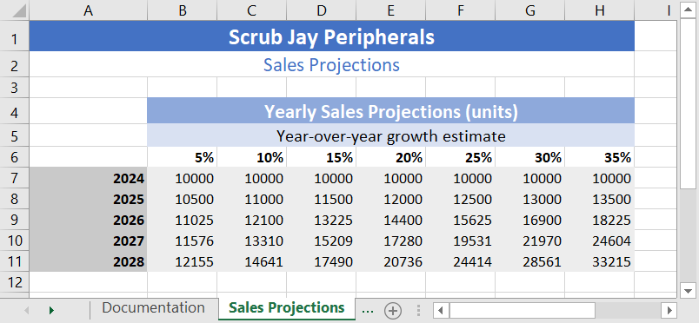

### Final Figure 2: Cost Estimates Worksheet

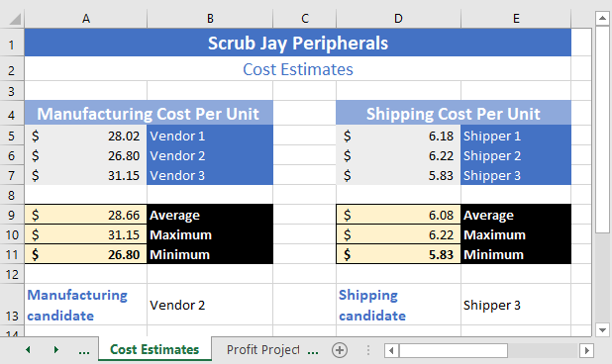

### Final Figure 3: Profit Projections Worksheet

