VIT UNIVERSITY

APPLICATIONS OF DIFFERENTIAL EQUATIONS

MAT2002

experiment-10

Faculty: Dr. Mellacheruvu Naga Srinivasu slot:L49+L50 venue:SJT319

**NAME: KARANI JASWANTH REG.NO:16BIT0058**

**DATE:22/03/2018**



CODE:

clc

clear all

syms n k1 k2 m

assume(n,'integer')

a=input('Enter the coefficient of y(n+2):');

b=input('Enter the coefficient of y(n+1):');

c=input('Enter the coefficient of y(n):');

g=input('Enter the coefficient of non-homogenous part:');

r=subs(solve(a*m^2+b*m+c,m));

if imag(r)~=0

rho=sqrt(real(r(1))^2+imag(r(1))^2);

theta=atan(abs(imag(r(1)))/real(r(1)));

y1=(rho^n)*cos(n*theta);

y2=(rho^n)*sin(n*theta);

elseif r(1)==r(2)

y1=r(1)^n;

y2=n*r(1)^n;

else

y1=r(1)^n;

y2=r(2)^n;

end

Co=det([y1,y2;subs(y1,n,n+1),subs(y2,n,n+1)]);

%Casoratian of the solutions

y_c=k1*y1+k2*y2;

disp('Complementary Solution is :');

disp(y_c);

if(g~=0)

y11=subs(y1,n,n+1);

y21=subs(y2,n,n+1);

Co1=subs(Co,n,n+1);

u1=simplify(symsum(-g*y21/C01,n))

u2=simplify(symsum(g*y11/Co1,n))

y_p=simplify(u1*y1+u2*y2);

y=y_c+y_p;

else

y=y_c;

end

check=input('If the problem has initial conditions then enter 1 else 0:');

if(check==1)

yval1=input('Enter the initial condition at n=0:');

yval2=input('Enter the initial condition at n=1:');

cond1=strcat(char(subs(y,n,0)),'=',num2str(yval1));

cond2=strcat(char(subs(y,n,1)),'=',num2str(yval2));

[k1,k2]=solve(cond1,cond2);

y=subs(y);

end

disp(collect(collect(y,y1),y2))

if(check~=0)

nrange=0:10;

Y=subs(y,n,nrange);

stem(nrange,Y);

set(gca,'XTick',linspace(0,10,11))

xlabel('n');

ylabel('y(n)');

end



INPUT:

Enter the coefficient of y(n+2):1

Enter the coefficient of y(n+1):-1

Enter the coefficient of y(n):-1

Enter the coefficient of non-homogenous part:0

If the problem has initial conditions then enter 1 else 0:1

Enter the initial condition at n=0:0

Enter the initial condition at n=1:1

OUTPUT:

Complementary Solution is :

k1*(1/2 - 5^(1/2)/2)^n + k2*(5^(1/2)/2 + 1/2)^n

Y=

(5^(1/2)/5)*(5^(1/2)/2 + 1/2)^n + (-5^(1/2)/5)*(1/2 – 5^(1/2)/2)^n

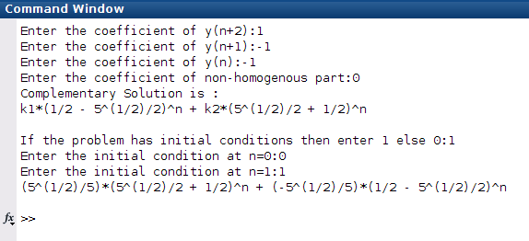

GRAPH:

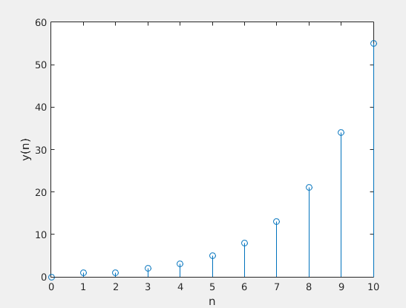



**INPUT:**

Enter the coefficient of y(n+2):1

Enter the coefficient of y(n+1):6

Enter the coefficient of y(n):8

Enter the coefficient of non-homogenous part:0

If the problem has initial conditions then enter 1 else 0:1

Enter the initial condition at n=0:0

Enter the initial condition at n=1:1

**OUTPUT:**

Complementary Solution is :

(-2)^n*k2 + (-4)^n*k1

Y=

(-2)^n/2 - (-4)^n/2

**GRAPH:**

