VIT UNIVERSITY

APPLICATIONS OF DIFFERENTIAL EQUATIONS

MAT2002

experiment-6

Faculty: Dr. Mellacheruvu Naga Srinivasu slot:L49+L50 venue:SJT319

**NAME: KARANI JASWANTH REG.NO:16BIT0058**

**DATE:08/02/2018**

**MATLAB CODE:**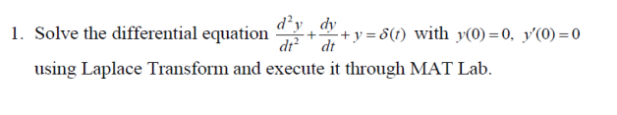

clc

clear all

syms s t Y

y2=diff(sym('y(t)'),2);

y1=diff(sym('y(t)'),1);

y0=sym('y(t)');

a=input('The coeficient of D2y= ');

b=input('The coeficient of Dy= ');

c=input('The coeeficient of y= ');

nh=input('Enter the NOn homogenous part= ');

eqn=a*y2+b*y1+c*y0-nh;

LTY=laplace(eqn,t,s)

if(a==0)

d=input('The initial value at 0 is');

LTY=subs(LTY,{'laplace(y(t),t,s)','y(0)'},{Y,d})

else

d=input('The initial value at 0 is ');

e=input('The initial value at 0 is');

LTY=subs(LTY,{'laplace(y(t),t,s)','y(0)','D(y)(0)'},{Y,d,e})

end

eq=collect(LTY,Y);

Y=simplify(solve(eq,Y));

y=simplify(ilaplace(Y,s,t))

**INPUT :**

The coeficient of D2y= 1

The coeficient of Dy= 1

The coeeficient of y= 1

Enter the NOn homogenous part= dirac(t)

The initial value at 0 is 0

The initial value at 0 is0

**OUTPUT:**

LTY = s*laplace(y(t), t, s) - D(y)(0) - y(0) - s*y(0) + s^2*laplace(y(t), t, s) + laplace(y(t), t, s) – 1

LTY =Y*s^2 + Y*s + Y – 1

y = (2*3^(1/2)*exp(-t/2)*sin((3^(1/2)*t)/2))/3

