Week6:

KARANI JASWANTH 16BIT0058

Laplace:

clear all

clc

syms t

f=input('enter the function in terms of t:');

F=laplace(f)

F=simplify(F)

**input:**

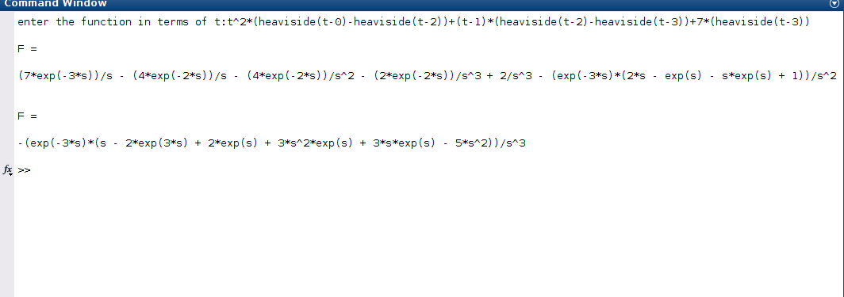

**SIMPLIFICATIION OF DE USING LAPLACE**

**CODE:**

clc

clear all

syms s t Y

y2=diff(sym('y(t)'),2);

y1=diff(sym('y(t)'),1);

y0=sym('y(t)');

a=input('The coeficient of D2y= ');

b=input('The coeficient of Dy= ');

c=input('The coeeficient of y= ');

nh=input('Enter the NOn homogenous part= ');

eqn=a*y2+b*y1+c*y0-nh;

LTY=laplace(eqn,t,s)

if(a==0)

d=input('The initial value at 0 is');

LTY=subs(LTY,{'laplace(y(t),t,s)','y(0)'},{Y,d})

else

d=input('The initial value at 0 is ');

e=input('The initial value at 0 is');

LTY=subs(LTY,{'laplace(y(t),t,s)','y(0)','D(y)(0)'},{Y,d,e})

end

eq=collect(LTY,Y);

Y=simplify(solve(eq,Y));

y=simplify(ilaplace(Y,s,t))

input and output:

