VIT UNIVERSITY

APPLICATIONS OF DIFFERENTIAL EQUATIONS

MAT2002

experiment-8

Faculty: Dr. Mellacheruvu Naga Srinivasu slot:L49+L50 venue:SJT319

**NAME: KARANI JASWANTH REG.NO:16BIT0058**

**DATE:22/03/2018**

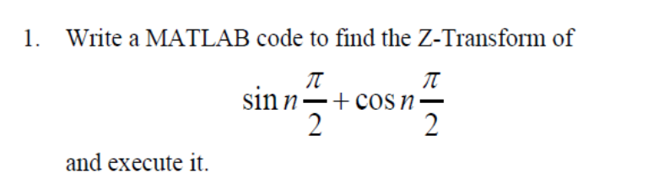

**CODE:**

**syms z n ;**

ztrans(sin(n*pi/2)+cos(n*pi/2))

**OUTPUT:**

ztrans

ans =

z/(z^2 + 1) + z^2/(z^2 + 1)

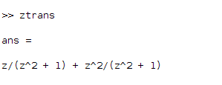

**continued...**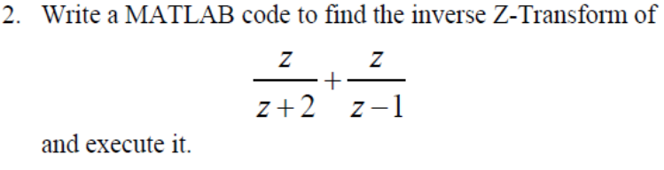

**CODE:**

clc

syms z n ;

iztrans((z/(z+2)+(z/(z-1))))

**OUTPUT:**

ans =

(-2)^n + 1

