“Farm Assist”

Project Report submitted for the partial fulfillment of grade for the course

Data Structures and Algorithms -3 (25CS2103E)

in

DEPARTMENT OF COMPUTER SCIENCE ENGINEERING

by

B JASWANTH BHASKAR : 2520030553

V DEEPAK : 2520030503

Team Number:20
Section:8

Under the Guidance of

Dr. S. Vinay Kumar
Associate Professor
Department of Computer Science and Engineering





2026-27

DEPARTMENT OF COMPUTER SCIENCE ENGINEERING

Declaration

The Project Report entitled “Farm Assist” is a record of Bonafide work of Jaswanth Bhaskar – 2520030553-B, Deepak – 2520030503-V submitted in partial fulfillment for the award of B. Tech in Computer Science and Engineering. The results embodied in this report have not been copied from any other departments/University/Institute.

B Jaswanth Bhaskar – 2520030553
V Deepak – 2520030503

DEPARTMENT OF COMPUTER SCIENCE ENGINEERING

CERTIFICATE

This is certify that the mini project based report entitled “Farm Assist” is a bonafide work done and submitted by B JASWANTH BHASKAR – 2520030553,V DEEPAK – 2520030503 in partial fulfillment of the requirements for the award of the degree of BACHELOR OF TECHNOLOGY in Department of Computer Science Engineering, during the academic year 2026-27.

Signature of the Guide Signature of the HOD
(Dr. S. Vinay Kumar)

Signature of the External Examiner
ACKNOWLEDGEMENT

We express our sincere gratitude to our project guide, Dr. S. Vinay Kumar, Associate Professor, Department of Computer Science and Engineering, for his guidance, encouragement and valuable suggestions throughout the course of this project. The faculty feedback received on the project, which led us to add a larger agricultural corpus, helped us improve the quality of the work.
We are thankful to Dr. P. Venkateshwara Rao, Associate Professor and Head of the Department of Computer Science and Engineering, for providing the academic environment and facilities required to carry out this work. We also thank all the faculty members of the department who taught us the concepts of Data Structures and Algorithms on which this project is based.
Finally, we thank our families and friends for their continuous support and encouragement during the development of Farm Assist and the preparation of this report.

B Jaswanth Bhaskar – 2520030553
V Deepak – 2520030503

Abstract

Information that farmers and students need about crops, plant diseases, symptoms, fertilizers and treatment practices is usually scattered across many sources and is difficult to search quickly, especially when the exact terminology or spelling is not known. Farm Assist is a Java-based agricultural assistance application developed as a Data Structures and Algorithms project. It combines a Java Swing graphical user interface with a set of classical algorithms and an image-based plant disease identification module, so that the algorithms are applied to a practical agricultural problem rather than presented in isolation.

Farm Assist provides crop, disease, fertilizer and symptom search, crop recommendation, fertilizer/resource allocation, photo-based disease identification and a search over a larger agricultural text corpus. Text searching uses the Knuth-Morris-Pratt (KMP), Rabin-Karp and Aho-Corasick algorithms together with Levenshtein-based fuzzy matching for approximate queries. Crop recommendation uses a dynamic-programming (knapsack) formulation, fertilizer/resource allocation is modelled as a maximum-flow problem solved with the Edmonds-Karp algorithm, and a greedy set cover heuristic selects a compact set of symptoms or terms. Disease identification from plant images uses a MobileNetV2 model in ONNX format executed through ONNX Runtime, and the predicted class is mapped to the application's disease terminology.

The application is organised into GUI, service, algorithm, input/output, model and vision layers. Structured agricultural data and a larger plain-text agricultural corpus, added in response to faculty feedback, are stored in text files and loaded by dedicated loader classes; no database is used. Translation data for English, Hindi and Telugu is included. This report describes the requirements, architecture, implementation and algorithmic justification of the system, together with its limitations and possible future work.

Table of Contents

 |  |  | Page No.
 | Acknowledgement
 | Abstract
 | Table of Contents
 | List of Figures
1 | Introduction | 1.1 Overview  1.2 Problem statement  1.3 Scope of the project  1.4 Objectives | 9-11
2 | System Requirements | 2.1 Functional Requirements  2.2 Non-Functional Requirements | 12-13
3 | System Design | 3.1 High-level Architecture Diagram  3.2 Description of each layer | 14-16
4 | Implementation | 4.1 Module-wise implementation  4.2 Front-end logic (UI rendering, state management)  4.3 API integration  4.4 Algorithm Analysis and DSA Justification | 17-22
5 | Results | Result screenshots | 23
6 | Challenges & Limitations | 6.1 Issues faced during development  6.2 Solutions applied  6.3 Limitations of the System | 24-25
7 | Conclusion & Future Work | 7.1 Conclusion  7.2 Future Work  7.3 Skills learned during development | 26
 | References | - Books, tutorials, APIs, documentation sites used | 27

List of Figures

1.1 Functional modules of Farm Assist
3.1 Layered architecture of Farm Assist
4.1 Request-processing workflow of Farm Assist

- INTRODUCTION

1.1 Overview
Farm Assist is a Java-based agricultural assistance application that helps farmers and other users obtain information about crops, plant diseases, symptoms and fertilizers, receive crop recommendations, allocate available fertilizer resources, identify plant diseases from photographs, and search a larger agricultural text corpus. The application is built with a Java Swing graphical user interface and is supported by several data structures and algorithms studied in the course Data Structures and Algorithms-3.
The project is intended as a practical agricultural assistant rather than a stand-alone demonstration of algorithms. Each algorithm is attached to a concrete task: string-matching algorithms support the text searches, dynamic programming supports crop recommendation, a maximum-flow algorithm models fertilizer/resource allocation, and a greedy set cover heuristic selects compact sets of symptoms or terms. An image-based disease identification module, which uses a MobileNetV2 model in ONNX format executed with ONNX Runtime, complements the algorithmic components. The major functional modules of the application are shown in Fig. 1.1.
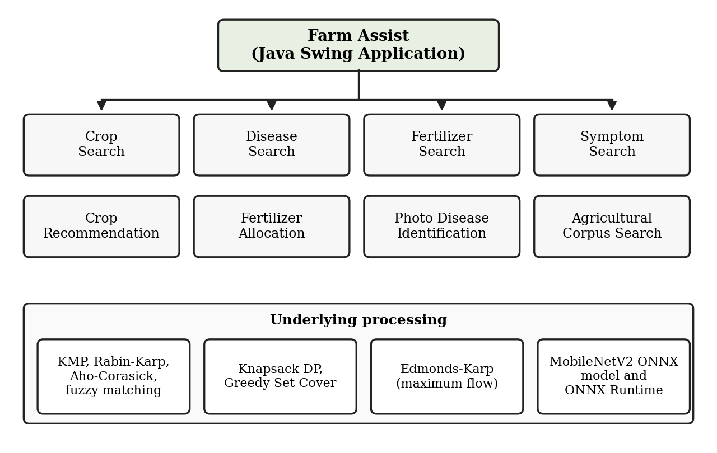
Fig. 1.1 Functional modules of Farm Assist
The agricultural data used by the application is stored in plain text files and is loaded into memory at run time. No database management system is used in this project. The technologies and tools used in the project are summarised in Table 1.1.
Table 1.1 Technologies and tools used in Farm Assist
Technology / Tool | Purpose in Farm Assist
Java | Core implementation language of the application
Java Swing | Graphical user interface
Object-oriented programming | Organisation of the code into classes and packages (models, algorithms, service, io, gui, vision)
Java Collections and standard Java APIs | In-memory data structures and general-purpose utilities
File handling (text files) | Storage and loading of the agricultural data files and the agricultural corpus
MobileNetV2 ONNX model | Image-based plant disease classification
ONNX Runtime | Running the ONNX model for inference from Java
Git and GitHub | Version control and collaboration between the team members
VS Code / Java development environment | Writing, compiling and running the application

The project was developed collaboratively by the two team members, Jaswanth Bhaskar (2520030553-B) and Deepak (2520030503-V), using Git [11] for version control and GitHub as the collaboration platform.
1.2 Problem Statement
Information about crops, diseases, symptoms and fertilizers is usually distributed across books, leaflets and websites in unstructured form. A user who wants to find a disease from its symptoms, check the fertilizer information for a crop, or decide which crops to grow within a limited land area and budget has to search and compare large amounts of text manually. Exact keyword search is also unreliable, because users may misspell terms or describe the same symptom using different words. In addition, identifying a disease from the appearance of a plant requires either expert knowledge or an automated image-based method.
The problem addressed by this project is to design and implement a Java desktop application that organises agricultural information, supports efficient exact, multi-pattern and approximate text searching, assists crop selection and fertilizer/resource allocation under limited resources, and identifies plant diseases from images, while demonstrating the practical use of data structures and algorithms.
1.3 Scope of the Project
The scope of the current version of Farm Assist covers the following:
- Searching crop, disease, fertilizer and symptom information stored in structured text files.
- Exact, multi-pattern and approximate (fuzzy) text matching using KMP, Rabin-Karp, Aho-Corasick and Levenshtein-based matching.
- Searching a larger plain-text agricultural corpus and displaying occurrence counts and context snippets.
- Crop recommendation using dynamic programming under constraints such as land area and budget.
- Fertilizer/resource allocation modelled as a maximum-flow problem and solved with the Edmonds-Karp algorithm.
- Selecting a compact set of symptoms or terms using a greedy set cover heuristic.
- Identifying a plant disease from an image using a MobileNetV2 ONNX model and mapping the predicted class to the application's disease terminology.
- A Java Swing graphical interface, with translation data for English, Hindi and Telugu.
The current version does not use a database, does not obtain real-time weather, soil or market data, and is a desktop application only. This report covers the use of the MobileNetV2 model for inference; training of the model is not described. Possible extensions are listed in Section 7.2 as future work.
1.4 Objectives
- To design and implement a Java Swing desktop application that makes agricultural information easy to search and use.
- To apply the KMP, Rabin-Karp and Aho-Corasick string-matching algorithms to agricultural data and to a larger agricultural corpus.
- To support approximate matching of terms using a Levenshtein-based fuzzy matching technique.
- To recommend crops using a dynamic-programming (knapsack) approach under resource constraints.
- To model fertilizer/resource allocation as a flow network and solve it using the Edmonds-Karp algorithm.
- To select a compact set of symptoms or terms using a greedy set cover heuristic.
- To integrate an image-based plant disease identification module using a MobileNetV2 ONNX model and ONNX Runtime.
- To organise the software into separate GUI, service, algorithm, input/output, model and vision components, and to develop it collaboratively using Git and GitHub.
- SYSTEM REQUIREMENTS
2.1 Functional Requirements
The functional requirements of Farm Assist, derived from the modules of the final application, are listed in Table 2.1.
Table 2.1 Functional requirements
ID | Requirement
FR1 | The system shall present a dashboard and an About panel giving access to the functional modules and project information.
FR2 | The system shall allow the user to search crop, disease and fertilizer information.
FR3 | The system shall allow the user to search for diseases using symptoms or terms, including several terms at the same time.
FR4 | The system shall support approximate matching when an entered term does not exactly match a stored term.
FR5 | The system shall select a compact set of symptoms or terms that covers the relevant disease information.
FR6 | The system shall recommend crops that suit constraints such as land area, budget and crop requirements.
FR7 | The system shall allocate available fertilizer/resources to crop requirements.
FR8 | The system shall accept a plant/disease image, run the ONNX model, and display the predicted disease with its confidence score after mapping the model class to the application's disease terminology.
FR9 | The system shall search the larger agricultural corpus using KMP and Rabin-Karp for single patterns and Aho-Corasick for multiple patterns, and display occurrence counts and context snippets.
FR10 | The system shall load the structured agricultural data from text files and the agricultural corpus from a plain-text file.
FR11 | The system shall include translation data for English, Hindi and Telugu.

2.2 Non-Functional Requirements
- Modularity: the code shall be separated into GUI, service, algorithm, input/output, model and vision components so that each can be understood and modified independently.
- Maintainability and extensibility: agricultural data shall be kept in text files separate from the program code, and each algorithm shall be implemented as a separate component.
- Usability: all functions shall be available through a graphical interface, so that the user does not need to use the command line.
- Portability: the application shall be written in Java and shall run on systems that support Java and the ONNX Runtime Java library.
- Local operation: data storage uses local files and the disease identification model runs locally through ONNX Runtime.
- Efficiency: algorithms with well-known polynomial or linear time complexity are used for searching, recommendation and allocation. Their complexities are discussed in Section 4.4; no benchmark figures are claimed in this report.
The software environment required to build and run the application is given in Table 2.2.
Table 2.2 Software environment
Item | Description
Programming language | Java (Java Development Kit)
GUI toolkit | Java Swing
Inference library | ONNX Runtime (Java), placed in the lib/ directory
Model | MobileNetV2 plant disease model in ONNX format, placed in the model/ directory
Data | Text files in the data/ directory
Development tools | VS Code / Java development environment, Git and GitHub
Hardware | A standard desktop or laptop computer capable of running a Java Swing application and ONNX Runtime inference

- SYSTEM DESIGN
3.1 High-level Architecture Diagram
Farm Assist follows a layered design, shown in Fig. 3.1. The Java Swing GUI is the user-facing layer. It sends requests to FarmAssistService, which acts as the integration layer between the user interface, the data and the algorithms. The service layer obtains data through the input/output components, calls the appropriate algorithm in the algorithms package or the ONNX-based disease identification in the vision package, and returns the results to the GUI. The model classes are shared by all layers, and the data files, model file and libraries are stored in separate resource directories.
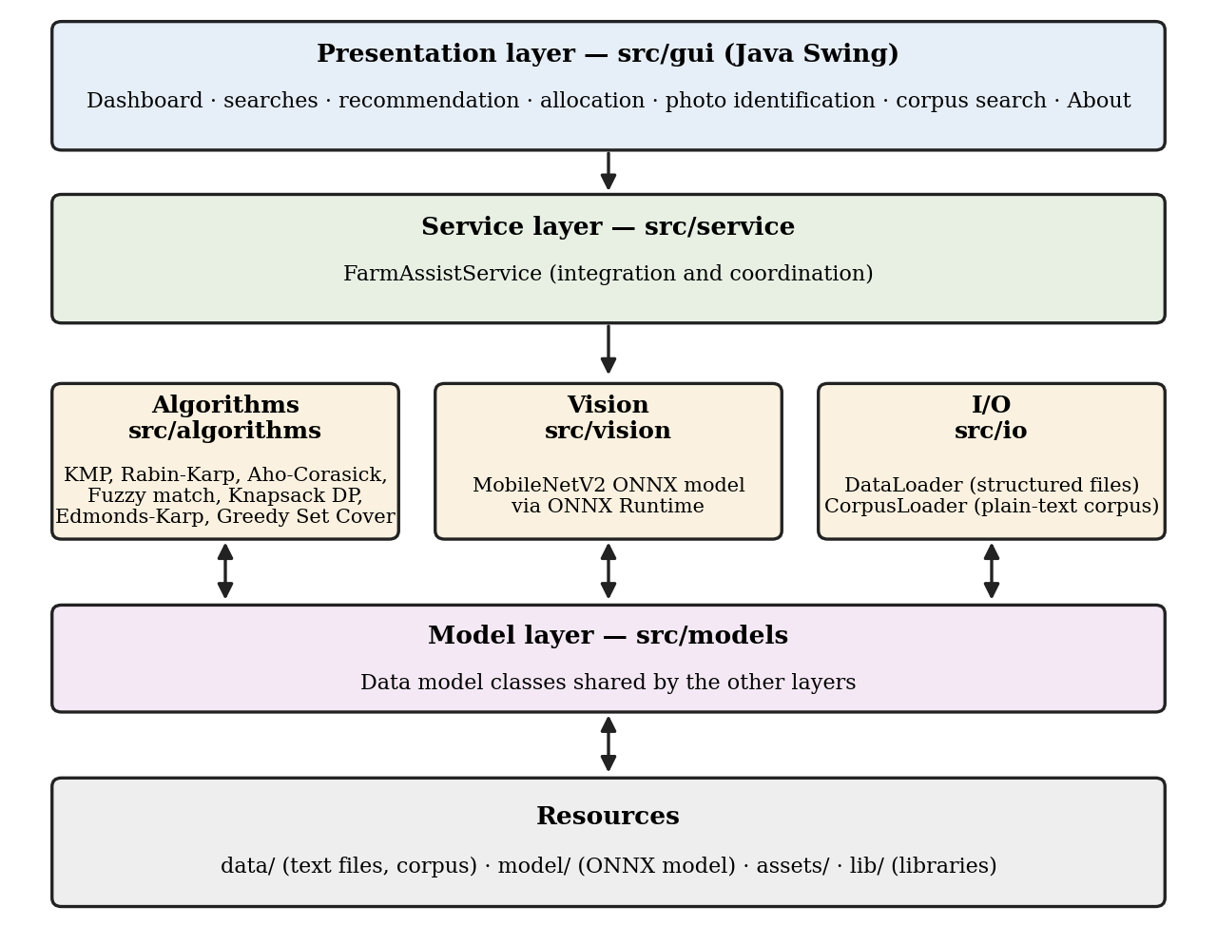
Fig. 3.1 Layered architecture of Farm Assist
3.2 Description of Each Layer
The project is organised into the directories and files listed in Table 3.1.
Table 3.1 Project structure of Farm Assist
Directory / File | Role
src/Main.java, src/GuiMain.java | Application entry points; GuiMain.java launches the Swing graphical interface.
src/gui/ | Java Swing windows and panels; the user-facing layer.
src/service/ | FarmAssistService; coordinates GUI requests, data loading and algorithm execution.
src/algorithms/ | Implementations of KMP, Rabin-Karp, Aho-Corasick, fuzzy matching, crop knapsack DP, Edmonds-Karp and greedy set cover.
src/io/ | DataLoader for the structured data files and CorpusLoader for the agricultural corpus.
src/models/ | Data model classes that represent the agricultural information handled by the application.
src/vision/ | Image-based disease identification using the ONNX model and ONNX Runtime.
data/ | Text data files (crops, diseases, fertilizers, requirements, symptoms, class mapping, translations) and the agricultural corpus.
assets/ | Non-code resources used by the application.
lib/ | External libraries required by the application, including ONNX Runtime.
model/ | MobileNetV2 ONNX model used for disease identification.
tools/ | Supporting utilities used during development.
src-optional/ | Additional optional source code kept separate from the main source tree.

3.2.1 Presentation layer (src/gui)
This layer is implemented with Java Swing. It collects input from the user, requests the required operation from the service layer, and displays the returned results. It does not implement the algorithms itself; the processing is performed in the service and algorithm layers.
3.2.2 Service layer (src/service)
FarmAssistService is the central integration layer. It receives requests from the GUI, makes use of the loaded agricultural data and corpus, invokes the appropriate algorithm or the vision module, and returns the results to the GUI. The agricultural corpus is also integrated with the search algorithms through this class.
3.2.3 Algorithm layer (src/algorithms)
This package contains the data-structure and algorithm implementations: KMP, Rabin-Karp, Aho-Corasick, fuzzy (Levenshtein-based) matching, crop knapsack dynamic programming, Edmonds-Karp maximum flow and greedy set cover. Each algorithm solves one clearly defined problem of the application and is described in Section 4.4.
3.2.4 Input/output layer (src/io)
This layer contains two loaders with different responsibilities. DataLoader handles the structured agricultural files such as crops, diseases, fertilizers, requirements, symptoms and translations. CorpusLoader handles the larger plain-text agricultural corpus (data/agricultural_corpus.txt) and loads it into memory for text searching.
3.2.5 Model layer (src/models)
The model classes represent the agricultural information that is loaded from the data files and passed between the loaders, the service layer, the algorithms and the GUI.
3.2.6 Vision layer (src/vision)
This layer performs image-based disease identification. It uses the MobileNetV2 ONNX model through ONNX Runtime to obtain a predicted class and confidence score for an input image, and maps the raw model class to the disease terminology used in the application.
3.2.7 Resource directories
The data/ directory holds the text files and the agricultural corpus, model/ holds the ONNX model, lib/ holds the external libraries, and assets/ holds non-code resources. The tools/ directory contains supporting utilities used during development, and src-optional/ contains additional optional source code that is kept apart from the main source tree.
- IMPLEMENTATION
4.1 Module-wise Implementation
The overall workflow of Farm Assist is shown in Fig. 4.1 and consists of the following steps.
- Step 1: the user launches Farm Assist.
- Step 2: the user interacts through the Java Swing GUI.
- Step 3: the GUI requests the required operation.
- Step 4: FarmAssistService coordinates the operation.
- Step 5: data is loaded from the appropriate data files or from the corpus.
- Step 6: the appropriate DSA algorithm or the ONNX model is invoked.
- Step 7: the results are returned and displayed to the user.
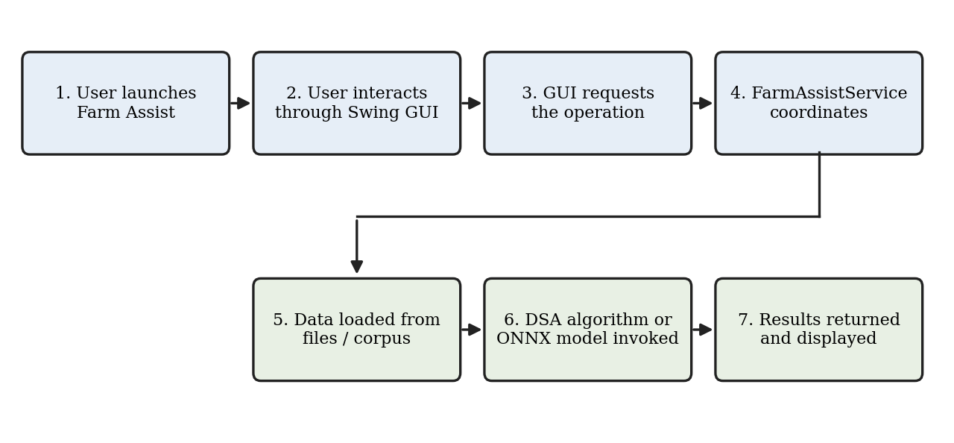
Fig. 4.1 Request-processing workflow of Farm Assist
4.1.1 Data loading and storage
The structured agricultural information is stored in plain text files in the data/ directory and is read by DataLoader. The application does not use a database; the data is file-based. The files and their roles are given in Table 4.1.
Table 4.1 Data files used by Farm Assist
File | Content
crops.txt | Crop information
diseases.txt | Disease information
fertilizers.txt | Fertilizer information
requirements.txt | Crop requirement information
symptoms.txt | Symptom information
model_class_to_disease.txt | Mapping from the raw class names produced by the ONNX model to the application's disease terminology
translations_hi.txt | Hindi translation data
translations_te.txt | Telugu translation data
agricultural_corpus.txt | Larger plain-text agricultural corpus (loaded by CorpusLoader, not by DataLoader)

4.1.2 Agricultural corpus loader and corpus search
Following faculty feedback, a larger text corpus was added so that the string-matching algorithms operate on a larger body of text than the small structured data files. The corpus is stored in data/agricultural_corpus.txt and is loaded into memory by src/io/CorpusLoader.java. It is approximately 10 KB in size and contains agricultural information on crops, soil requirements, irrigation, nutrients, fertilizers, crop-specific fertilizer information, diseases, pests, treatment, water management and harvesting.
FarmAssistService integrates the corpus with the existing search algorithms. KMP and Rabin-Karp are used for single-pattern searching, and Aho-Corasick is used for multiple-pattern searching. The GUI contains a visible Search Agricultural Corpus feature through which the user enters a search term; the application reports the number of occurrences found by each algorithm and displays context snippets from the corpus. For example, a search for the term "nitrogen" gave 9 occurrences with KMP and 9 occurrences with Rabin-Karp. Agreement between the two independent algorithms provides a useful consistency check of the implementations.
The two loaders have separate responsibilities: DataLoader handles the structured data files, whereas CorpusLoader handles only the plain-text corpus.
4.1.3 Text searching and approximate matching
The crop, disease, fertilizer and symptom searches are based on string matching. KMP and Rabin-Karp locate a single pattern in a text, and Aho-Corasick is used where several symptoms or terms must be searched simultaneously. When an entered term does not match exactly because of spelling differences, fuzzy matching based on Levenshtein edit distance is used to find approximate matches. The algorithms are discussed in detail in Section 4.4.
4.1.4 Symptom set selection
A greedy set cover heuristic is used to select a compact set of symptoms or terms that covers the relevant disease information. At each step the heuristic chooses the candidate set that contributes the best coverage of the elements not yet covered, and the process continues until the required coverage is obtained or no candidate improves it.
4.1.5 Crop recommendation
Crop recommendation is implemented as a dynamic-programming (knapsack-type) selection of crops. The candidate crops are considered one by one, and the selection takes into account constraints such as the available land area, the budget and other crop requirements, with the objective of maximising the profit or objective value of the selected crops. The result is the set of crops recommended for the given constraints.
4.1.6 Fertilizer/resource allocation
The application contains fertilizer information and a fertilizer/resource allocation mechanism. Allocation is modelled as a flow network in which the available fertilizer or resource quantities are connected to the crop requirements, and the maximum flow computed by the Edmonds-Karp algorithm gives the largest quantity that can be allocated within the given capacities. This module is a deterministic network-flow computation; it is not a machine-learning fertilizer recommendation system.
4.1.7 Disease identification from images
The vision module identifies a plant disease from an image. The user selects a plant/disease image, the image is passed to the MobileNetV2 [8] ONNX model through ONNX Runtime, and the model produces a prediction with a confidence score. The raw class label of the model, obtained using labels.txt, is then mapped to the disease terminology used in the application with model_class_to_disease.txt, and the disease name and confidence are displayed to the user. The application uses the model for inference; model training is not part of the application.
4.1.8 Localization
The project contains translation data for Hindi (translations_hi.txt) and Telugu (translations_te.txt) in addition to the English data. These files store translated terms that are loaded from the data/ directory so that agricultural terminology can be presented in the corresponding language.
4.2 Front-end Logic (UI Rendering, State Management)
The user interface is implemented with Java Swing [10] and acts as the user-facing layer of the application. The panels of the final GUI are summarised in Table 4.2.
Table 4.2 Panels of the Farm Assist GUI
Panel | Purpose
Dashboard | Entry view that gives access to the functional modules
Crop Search | Searching crop information
Disease Search | Searching disease information
Fertilizer Search | Searching fertilizer information
Symptom Search | Searching diseases using symptoms or terms
Crop Recommendation | Recommending crops for the entered constraints
Fertilizer Allocation | Allocating available fertilizer/resources to crop requirements
Photo Disease Identification | Selecting a plant image and displaying the predicted disease and confidence
Agricultural Corpus Search | Searching the agricultural corpus (Search Agricultural Corpus) and displaying occurrence counts and context snippets
About | Project information

Swing is event-driven. User actions such as entering a search term or pressing a button are handled by event listeners, which pass the request to FarmAssistService and then update the display components of the panel with the returned result. The GUI therefore holds the user's input and the displayed result, while the agricultural data, the corpus and the processing are handled by the service, input/output and algorithm layers. The loaded data is kept in memory by the application and is accessed through the service layer.
4.3 API Integration
Farm Assist does not use web services, REST interfaces or cloud services. The application programming interfaces used by the project are the standard Java APIs (file input/output, collections and the Swing/AWT user-interface classes) and the ONNX Runtime Java API [9].
The ONNX Runtime library is placed in the lib/ directory and is used by the vision module to load the MobileNetV2 ONNX model from the model/ directory. For each identification request the selected image is converted to the input format expected by the model, the model is executed through ONNX Runtime, and the output scores are interpreted to obtain the predicted class and its confidence. The predicted class is then converted to the application's disease terminology using the class mapping file, as described in Section 4.1.7.
4.4 Algorithm Analysis and DSA Justification
Table 4.3 summarizes the algorithms implemented in Farm Assist. In the table, n is the length of the text, m is the length of the pattern, and the remaining symbols are defined in the corresponding subsections. The complexities are those of the standard formulations of the algorithms; no benchmark figures are claimed in this report.
Table 4.3 Algorithms used in Farm Assist
Algorithm | Use in Farm Assist | Input / Output | Time complexity
KMP | Single-pattern search in agricultural text and corpus | Text and pattern / positions and count of occurrences | O(n + m)
Rabin-Karp | Single-pattern search using hashing, alongside KMP | Text and pattern / positions and count of occurrences | Average O(n + m); worst case O(nm)
Aho-Corasick | Searching several symptoms/terms in one pass | Text and a set of patterns / occurrences of each pattern | O(n + z) search after automaton construction (z = number of matches)
Fuzzy matching (Levenshtein) | Approximate matching of misspelt terms | Two strings / edit distance and match decision | O(mn) per string pair
Crop knapsack DP | Crop recommendation under constraints | Crops with requirements and values, resource limits / selected crops and objective value | Grows with the number of crops and the constraint sizes (O(nW) for one constraint)
Edmonds-Karp | Fertilizer/resource allocation | Flow network with capacities / maximum flow and allocation | O(VE²)
Greedy set cover | Compact set of symptoms/terms | Elements and candidate sets / chosen sets | Polynomial; approximation guarantee of about ln n

4.4.1 Knuth-Morris-Pratt (KMP)
- Suitability: KMP avoids re-comparing characters that have already matched. In a preprocessing step it builds the LPS (longest proper prefix which is also a suffix) table of the pattern; during matching, a mismatch moves the pattern using this table instead of restarting the comparison from the next text position [2].
- Problem solved: exact search of a term in crop and disease text and in the larger agricultural corpus.
- Input: a text and a pattern.
- Output: the positions and the number of occurrences of the pattern.
- Complexity: preprocessing takes O(m) and matching takes O(n), so the total time is O(n + m) with O(m) extra space.
4.4.2 Rabin-Karp
- Suitability: Rabin-Karp compares the hash value of the pattern with the hash values of the text windows, which are updated with a rolling hash in constant time per shift [3]. The full characters are compared only when the hash values are equal, to rule out collisions.
- Problem solved: single-pattern search that is used alongside KMP on the text and corpus data; the two algorithms can be compared on the same input.
- Input: a text and a pattern.
- Output: the positions and the number of occurrences.
- Complexity: the average time is O(n + m); the worst case is O(nm) when many hash collisions occur, so the efficiency depends on the hash function and collision behaviour.
4.4.3 Aho-Corasick
- Suitability: Aho-Corasick builds a trie of all patterns and adds failure links, which gives a finite automaton that finds all patterns in a single pass over the text [4]. This is more suitable than running a single-pattern algorithm once per pattern when many terms are searched together.
- Problem solved: simultaneous search for several symptoms or terms in agricultural text and in the corpus.
- Input: a text and a set of patterns.
- Output: the occurrences of every pattern.
- Complexity: the search takes O(n + z) time, where z is the number of matches, after the automaton has been built in time proportional to the total length of the patterns.
4.4.4 Fuzzy matching (Levenshtein-based)
- Suitability: exact matching fails when a term is misspelt. The Levenshtein distance is the minimum number of single-character insertions, deletions and substitutions needed to change one string into another [6], and it can be computed by dynamic programming over a table of prefix lengths. A small distance indicates that two terms are probably the same.
- Problem solved: finding the closest stored terms when the entered spelling does not match exactly.
- Input: the entered term and the stored terms.
- Output: the edit distance and the resulting approximate matches.
- Complexity: O(mn) time for two strings of lengths m and n.
4.4.5 Crop knapsack dynamic programming
- Suitability: choosing crops under limited land area and budget is a selection problem with overlapping subproblems, which suits dynamic programming. The best value obtainable with a given number of crops and remaining resources is computed from the best values of smaller subproblems, and each crop is either included or excluded [1].
- Problem solved: crop recommendation that maximises the objective value (profit) under the constraints.
- Input: candidate crops with their requirements and values, and the available resource limits.
- Output: the selected crops and the total objective value.
- Complexity: for n crops and a single capacity W the time is O(nW); with several constraints the table has one dimension per constraint, so the cost grows with the sizes of the constraint dimensions.
4.4.6 Edmonds-Karp
- Suitability: Edmonds-Karp is the Ford-Fulkerson method in which each augmenting path is found by breadth-first search, i.e. the shortest path in the number of edges [5]. Allocation of limited fertilizer/resources to crop requirements fits a flow network in which capacities limit what can be supplied and what can be used.
- Problem solved: fertilizer/resource allocation.
- Input: the flow network with edge capacities built from the available resources and the crop requirements.
- Output: the maximum flow and the flow on each edge, which gives the allocation.
- Complexity: each breadth-first search takes O(E), and the number of augmentations is O(VE), so the total time is O(VE²), where V is the number of vertices and E the number of edges.
4.4.7 Greedy set cover
- Suitability: finding the smallest collection of sets that covers all elements is NP-hard, and the greedy heuristic gives a practical solution by repeatedly choosing the set that covers the largest number of elements that are still uncovered. It is known to give a solution within a factor of about ln n of the optimum [7].
- Problem solved: selecting a compact set of symptoms or terms that covers the relevant disease information.
- Input: the elements to be covered and the candidate sets of symptoms or terms.
- Output: the selected sets.
- Complexity: the algorithm runs in polynomial time because each iteration evaluates the uncovered contribution of the candidate sets and the number of iterations is bounded by the number of candidate sets.

5.Results

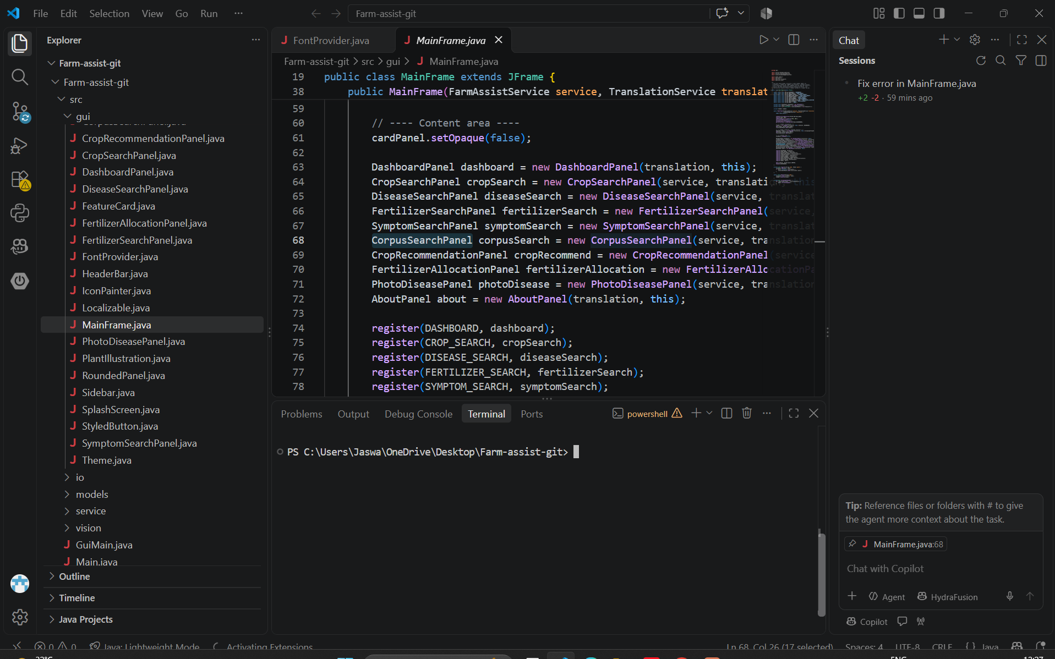
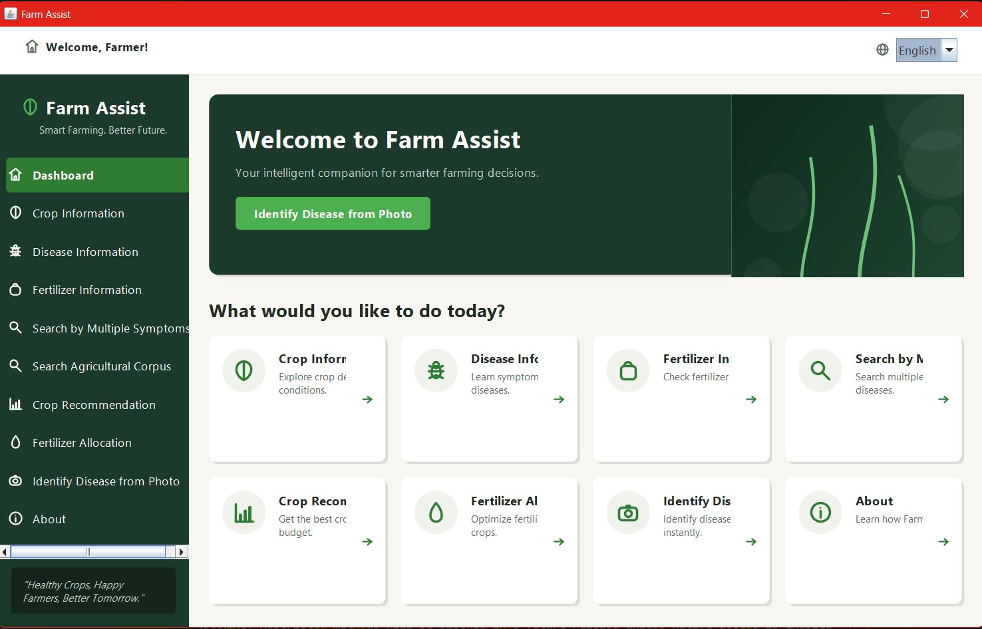
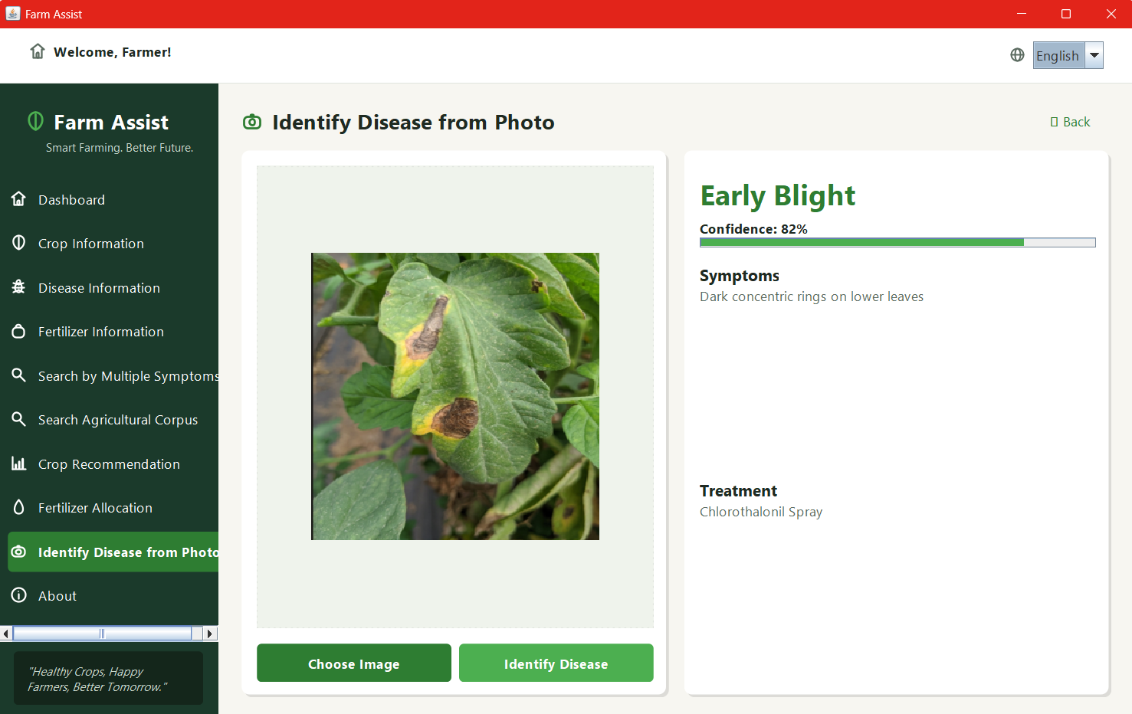
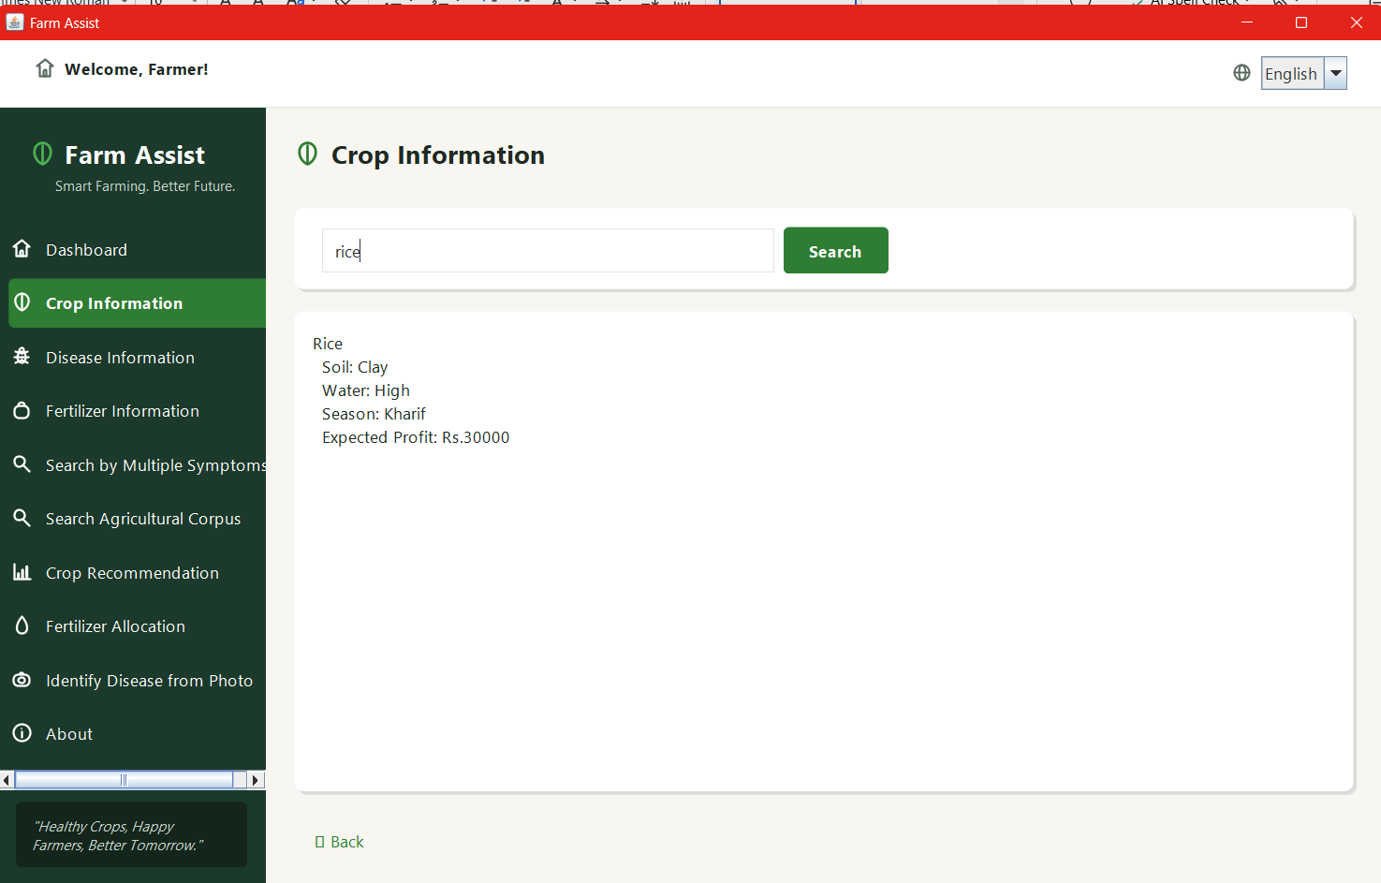
6.CHALLENGES & LIMITATIONS
6.1 Issues Faced during Development
- Small text data for the search algorithms: the structured data files are small, so the string-matching algorithms could not be demonstrated on a larger body of text. This was pointed out in the faculty feedback.
- Differences between model labels and application terminology: the class names produced by the ONNX model do not necessarily match the disease names used in the application's data files.
- Inexact user input: users may misspell crop, disease or symptom names, and exact matching alone does not return results in such cases.
- Combining many algorithms with a GUI: several independent algorithms and a vision module had to be connected to a Swing interface without mixing user-interface code and algorithm code.
- Two kinds of data: the structured agricultural files and the larger plain-text corpus have different structures and had to be handled separately.
- Integrating the ONNX model into a Java application: a model in ONNX format had to be executed from Java through ONNX Runtime.
6.2 Solutions Applied
- A larger agricultural corpus of about 10 KB was added in data/agricultural_corpus.txt, and CorpusLoader was written to load it; KMP, Rabin-Karp and Aho-Corasick were integrated with it through FarmAssistService, and a Search Agricultural Corpus feature was added to the GUI.
- The mapping file model_class_to_disease.txt was used to convert the raw model classes to the application's disease terminology.
- Levenshtein-based fuzzy matching was implemented for approximate matching of terms.
- A layered design with FarmAssistService as the integration layer keeps the GUI separate from the algorithms and the data loading.
- DataLoader was kept for the structured files and CorpusLoader for the corpus, so that each loader has one responsibility.
- The ONNX Runtime library was placed in the lib/ directory and a separate vision package was created for model execution.
6.3 Limitations of the System
- The data is file-based and limited in size; the corpus is approximately 10 KB, and the numbers of crops, diseases and fertilizers are limited to those in the data files.
- The recommendation and allocation results depend on the data in the files; the application does not use real-time weather, soil or market data.
- Disease identification depends on the pre-trained MobileNetV2 model and on the classes that it supports. The confidence score indicates the certainty of the model and does not guarantee a correct prediction.
- Fertilizer allocation is a flow-based allocation of the available resources; it is not a machine-learning fertilizer recommendation system.
- Translation data is available only for English, Hindi and Telugu.
- Farm Assist is a desktop application; there is no web or mobile version, and no database or cloud storage is used.
- CONCLUSION & FUTURE WORK
7.1 Conclusion
Farm Assist is a Java-based agricultural assistance system that combines data structures and algorithms with agricultural data processing. It integrates text searching with KMP, Rabin-Karp, Aho-Corasick and Levenshtein-based fuzzy matching, crop recommendation using dynamic programming, fertilizer/resource allocation using the Edmonds-Karp maximum-flow algorithm, symptom selection using greedy set cover, and image-based disease identification using a MobileNetV2 ONNX model executed with ONNX Runtime. A Java Swing GUI makes these functions available to the user, and a larger agricultural corpus, loaded by CorpusLoader and integrated through FarmAssistService, allows the search algorithms to be applied to a larger body of text.
The project shows that the algorithms studied in the course can be used to solve practical problems when they are connected to real data and a user interface, rather than being presented in isolation. The layered structure separates the GUI, service, algorithm, input/output, model and vision components, which makes the system easier to understand and extend.
7.2 Future Work
The following improvements are possible future work. They are not features of the current version.
- Using larger agricultural datasets and a larger text corpus.
- Improving the disease identification model and extending it to more crops and diseases.
- Adding more crops, diseases and fertilizers to the data.
- Providing richer multilingual support.
- Improving the accuracy of crop recommendation.
- Integrating a database and cloud storage.
- Providing mobile and web versions of the application.
- Integrating real-time agricultural, weather and soil data.
7.3 Skills Learned during Development
- Implementing string-matching algorithms (KMP, Rabin-Karp, Aho-Corasick) and the Levenshtein edit-distance technique.
- Applying dynamic programming, network flow (Edmonds-Karp) and greedy methods to practical problems.
- Object-oriented design and layered organisation of a Java project.
- Developing a graphical user interface with Java Swing.
- Reading and processing text-file data, including a larger text corpus.
- Running an ONNX model from Java using ONNX Runtime.
- Collaborative development using Git and GitHub.
- Preparing technical documentation of a software project.
REFERENCES
- T. H. Cormen, C. E. Leiserson, R. L. Rivest and C. Stein, Introduction to Algorithms, 4th ed., MIT Press, 2022.
- D. E. Knuth, J. H. Morris Jr. and V. R. Pratt, “Fast pattern matching in strings,” SIAM Journal on Computing, vol. 6, no. 2, pp. 323–350, 1977.
- R. M. Karp and M. O. Rabin, “Efficient randomized pattern-matching algorithms,” IBM Journal of Research and Development, vol. 31, no. 2, pp. 249–260, 1987.
- A. V. Aho and M. J. Corasick, “Efficient string matching: An aid to bibliographic search,” Communications of the ACM, vol. 18, no. 6, pp. 333–340, 1975.
- J. Edmonds and R. M. Karp, “Theoretical improvements in algorithmic efficiency for network flow problems,” Journal of the ACM, vol. 19, no. 2, pp. 248–264, 1972.
- V. I. Levenshtein, “Binary codes capable of correcting deletions, insertions, and reversals,” Soviet Physics Doklady, vol. 10, no. 8, pp. 707–710, 1966.
- V. Chvátal, “A greedy heuristic for the set-covering problem,” Mathematics of Operations Research, vol. 4, no. 3, pp. 233–235, 1979.
- M. Sandler, A. Howard, M. Zhu, A. Zhmoginov and L.-C. Chen, “MobileNetV2: Inverted residuals and linear bottlenecks,” in Proc. IEEE/CVF Conf. Computer Vision and Pattern Recognition (CVPR), 2018, pp. 4510–4520.
- ONNX Runtime documentation, https://onnxruntime.ai/docs/
- The Java Tutorials: Creating a GUI with Swing, Oracle, https://docs.oracle.com/javase/tutorial/uiswing/
- Git documentation, https://git-scm.com/doc

