# SALESFORCE DEVELOPER PROJECT

# LEASE MANAGEMENT

## ASSIGNMENT

### **Team ID :** LTVIP2025TMID30244

**Team Size :** 4

**Team Leader :** Pamarthi Devi Phanindra

**Team member :** Kandula Atchireddy

**Team member :** Jaswanth Ch

**Team member :** Kocherla Raviteja

EMAIL ID’S OF TEAM MEMBERS:  
Dphani0504@gmail.com  
Atchireddykandula576@gmail.com  
Jaswanthchilamkurthy@gmail.com  
[Kocherlaraviteja07@gmail.com](mailto:Kocherlaraviteja07@gmail.com)

## PROJECT DETAILS : LEASE MANAGEMENT

1. PROJECT OVERVIEW: The Lease Management System is an innovative solution designed to revolutionize how lease agreements are handled. It centralizes all lease-related operations, providing a streamlined approach to managing agreements, tracking payments, and ensuring compliance. This system addresses key challenges such as manual errors, inefficiencies, and lack of visibility by offering an intuitive, data driven platform. With features like automated alerts, real-time updates, and detailed reporting, it supports seamless lease lifecycle management from initiation to renewal or termination. The solution is tailored to enhance operational efficiency, reduce administrative burdens, and improve decision-making by providing stakeholders with actionable insights. It ensures transparency and consistency, helping businesses focus on strategic objectives without being bogged down by operational complexities.

ASSIGNMENTS : ALL THE PROJECT IS DONR BY JASWANTH.CH

SMART INTERNZ PROFILE

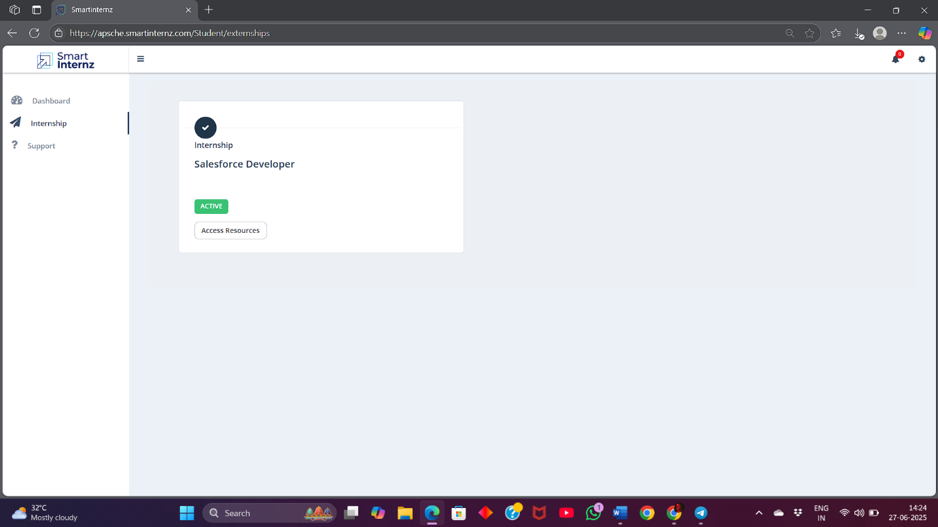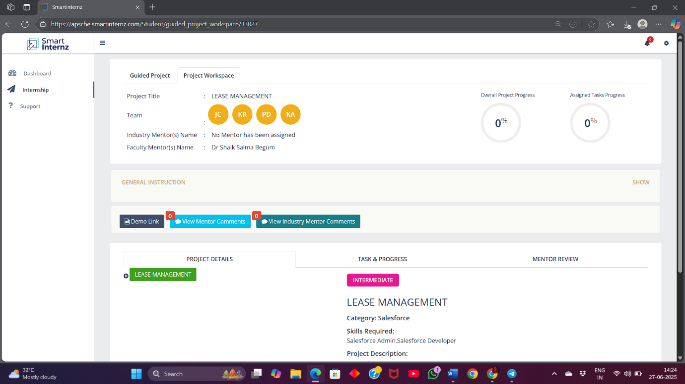 PROJECT WORKSPACE

ASSIGNED PROJECT

