PaymentService.java:
package com.example;
public class PaymentService {

public boolean processPayment(double amount, String cardNumber) {
if (amount <= 0) {
return false;
}
if (cardNumber == null || cardNumber.isEmpty()) {
return false;
}
return true;
}
}
PaymentServiceTest.java
package com.example;

import org.junit.jupiter.api.Test;
import static org.junit.jupiter.api.Assertions.*;

public class PaymentServiceTest {

PaymentService service = new PaymentService();

@Test
public void testSuccess() {
assertTrue(service.processPayment(100, "1234"));
}

@Test
public void testFailure() {
assertFalse(service.processPayment(-10, ""));
}
}
pom.xml
<project xmlns="http://maven.apache.org/POM/4.0.0"
xmlns:xsi="http://www.w3.org/2001/XMLSchema-instance"
xsi:schemaLocation="http://maven.apache.org/POM/4.0.0
http://maven.apache.org/xsd/maven-4.0.0.xsd">

<modelVersion>4.0.0</modelVersion>

<!-- Project Details -->
<groupId>com.demo</groupId>
<artifactId>agilefat</artifactId>
<version>1.0-SNAPSHOT</version>

<name>Payment Processing System</name>

<!-- Java Version -->
<properties>
<maven.compiler.source>17</maven.compiler.source>
<maven.compiler.target>17</maven.compiler.target>
<project.build.sourceEncoding>UTF-8</project.build.sourceEncoding>
</properties>

<!-- Dependencies -->
<dependencies>

<!-- JUnit 5 for Testing -->
<dependency>
<groupId>org.junit.jupiter</groupId>
<artifactId>junit-jupiter</artifactId>
<version>5.9.0</version>
<scope>test</scope>
</dependency>

</dependencies>

<!-- Build Plugins -->
<build>
<plugins>

<!-- Maven Compiler Plugin -->
<plugin>
<groupId>org.apache.maven.plugins</groupId>
<artifactId>maven-compiler-plugin</artifactId>
<version>3.11.0</version>
</plugin>

<!-- Maven Surefire Plugin (for running tests) -->
<plugin>
<groupId>org.apache.maven.plugins</groupId>
<artifactId>maven-surefire-plugin</artifactId>
<version>3.0.0-M7</version>
</plugin>

<!-- Maven Jar Plugin -->
<plugin>
<groupId>org.apache.maven.plugins</groupId>
<artifactId>maven-jar-plugin</artifactId>
<version>3.3.0</version>
<configuration>
<archive>
<manifest>
<mainClass>com.demo.App</mainClass>
</manifest>
</archive>
</configuration>
</plugin>

</plugins>
</build>

</project>
maven project structure:
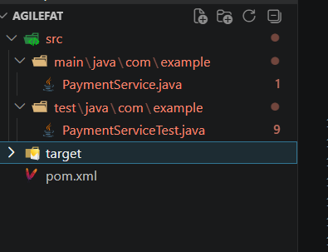
build using maven :
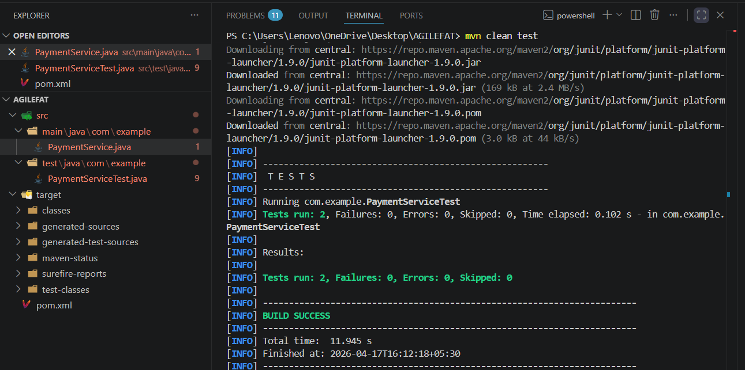
git commands for pushing into github:
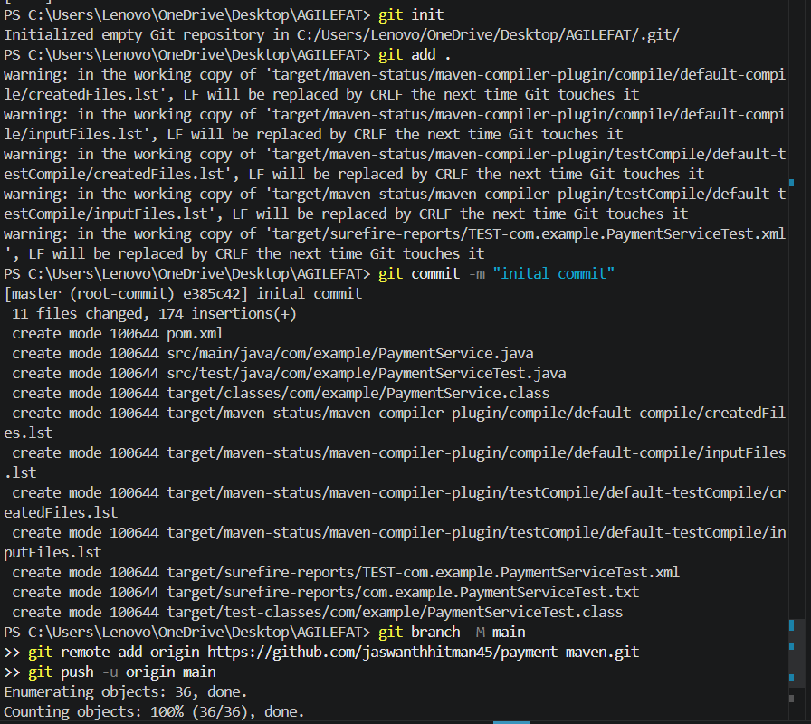
github repository:

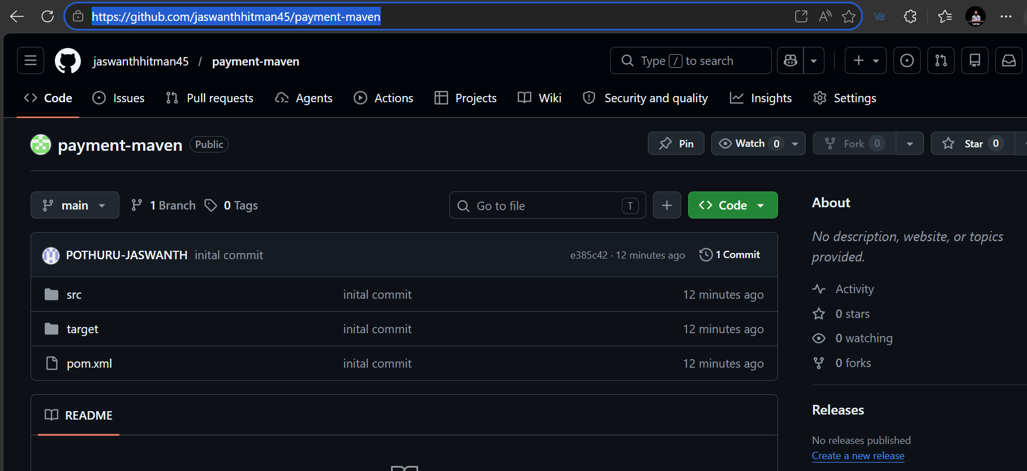
dockerfile and deployment.yaml
and service.yaml added to the project
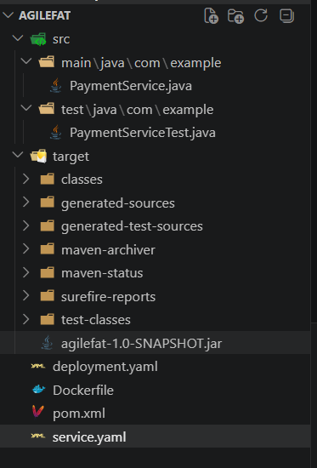
Docker file :
FROM eclipse-temurin:17
COPY target/agilefat-1.0-SNAPSHOT.jar app.jar
ENTRYPOINT ["java","-jar","/app.jar"]
deployment.yaml:
apiVersion: apps/v1
kind: Deployment
metadata:
name: payment-deployment
spec:
replicas: 2
selector:
matchLabels:
app: payment
template:
metadata:
labels:
app: payment
spec:
containers:
- name: payment
image: payment-app
ports:
- containerPort: 8080

Service.yaml:
apiVersion: v1
kind: Service
metadata:
name: payment-service
spec:
type: NodePort
selector:
app: payment
ports:
- port: 80
targetPort: 8080
nodePort: 30035
pipeline script:
pipeline {
agent any

tools {
maven 'maven'
jdk 'JAVA_HOME'
}

environment {
IMAGE_NAME = "payment-app"
DOCKERHUB_USER = "pothurujaswanth"
IMAGE_TAG = "latest"
}

stages {

stage('Checkout') {
steps {
git branch: 'main', url: 'https://github.com/jaswanthhitman45/payment-maven.git'
}
}

stage('Build') {
steps {
bat 'mvn clean compile'
}
}

stage('Test') {
steps {
bat 'mvn test'
}
}

stage('Package') {
steps {
bat 'mvn package'
}
}

stage('Docker Build') {
steps {
bat "docker build -t %DOCKERHUB_USER%/%IMAGE_NAME%:%IMAGE_TAG% ."
}
}

stage('Docker Login') {
steps {
withCredentials([usernamePassword(
credentialsId: 'dockerhub',
usernameVariable: 'USERNAME',
passwordVariable: 'PASSWORD'
)]) {
bat "docker login -u %USERNAME% -p %PASSWORD%"
}
}
}

stage('Docker Push') {
steps {
bat "docker push %DOCKERHUB_USER%/%IMAGE_NAME%:%IMAGE_TAG%"
}
}

stage('Kubernetes Deploy') {
steps {
withCredentials([file(credentialsId: 'kubeconfig', variable: 'KUBECONFIG')]) {
bat "kubectl --kubeconfig=%KUBECONFIG% apply -f deployment.yaml"
bat "kubectl --kubeconfig=%KUBECONFIG% apply -f service.yaml"
}
}
}
}
}

console output:
