MYSQL STORED PROCEDURES
2520030590
MANNEPALLI JASWANTH

1. Setup: Employees Table
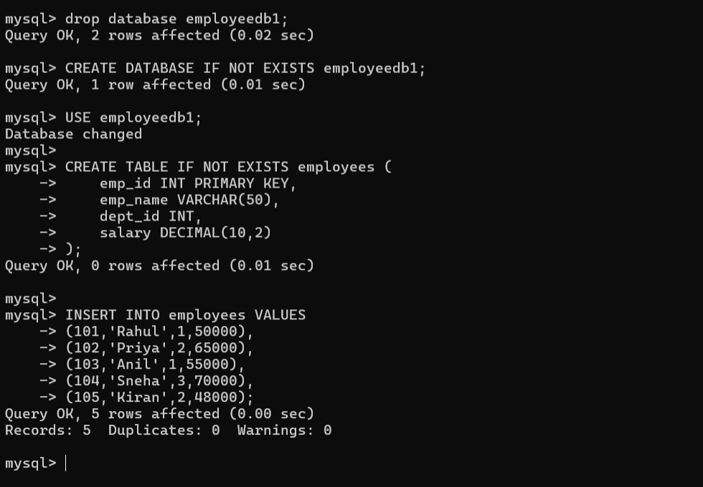

2. Verify Data
Question: Display all employee records.

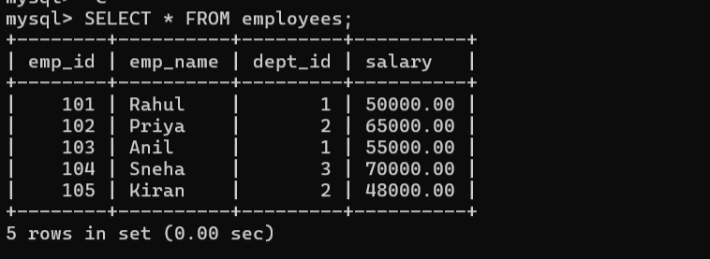Procedure 1 – Display All Employees
Question: Create a procedure that displays all employees.

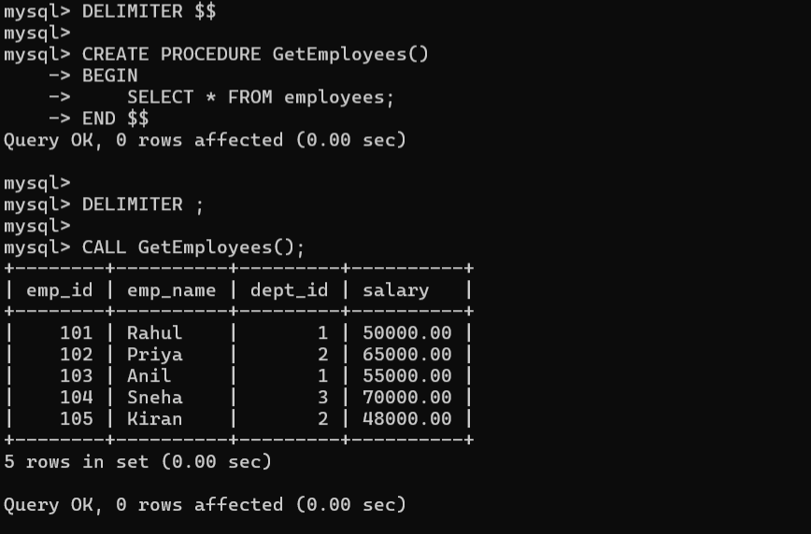Procedure 2 – IN Parameter
Question: Create a procedure that accepts an employee ID and displays that employee's details.

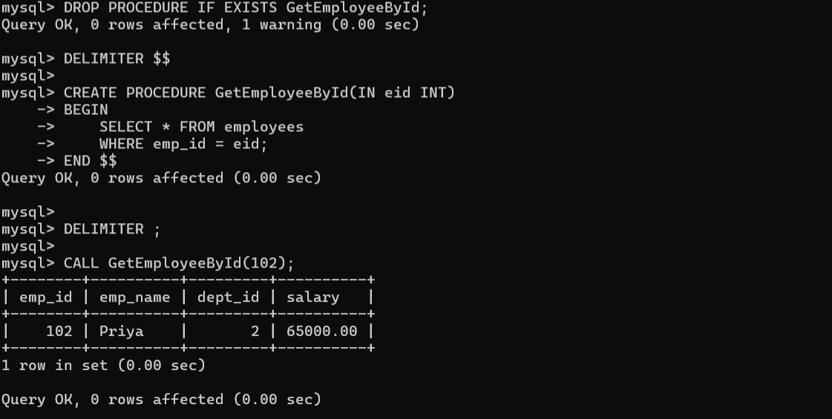Procedure 3 – Update Salary
Question: Create a procedure that accepts employee ID and amount, then increases the employee's salary.

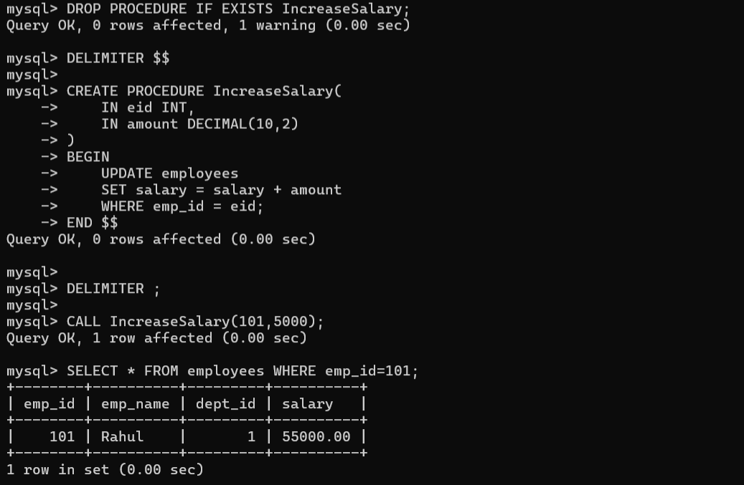Procedure 4 – Aggregate Function
Question: Create a procedure to calculate the average salary of all employees.

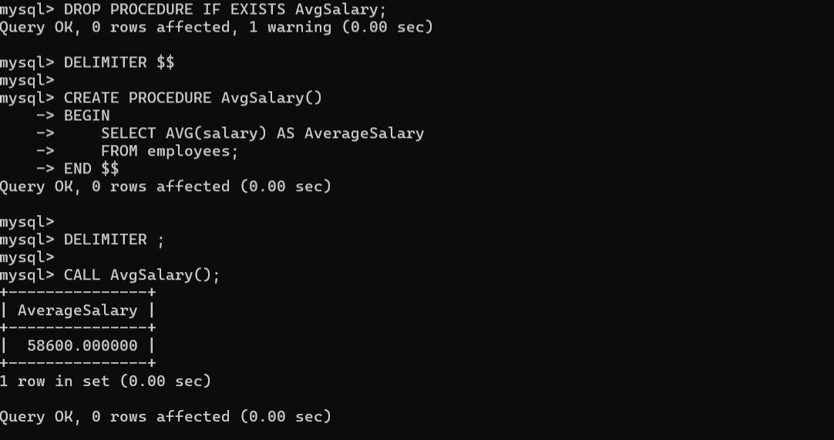Procedure 5 – JOIN
Question: Create a procedure to display employee name, department name and salary. Run the department setup first.

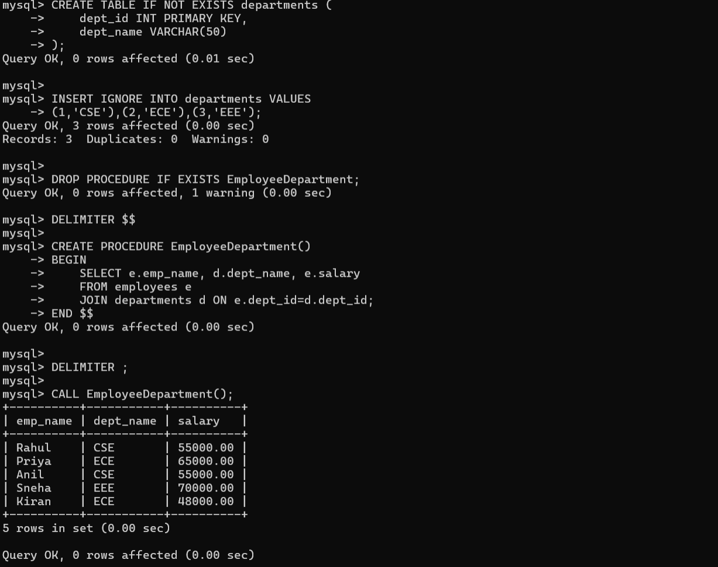Procedure 6 – GROUP BY and AVG
Question: Create a procedure to display department-wise employee count and average salary.
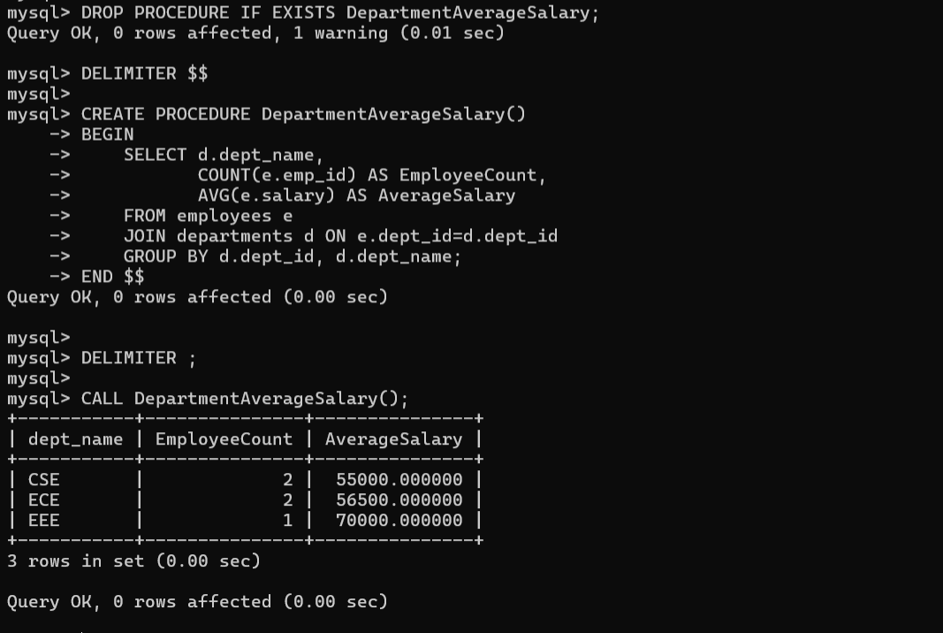

Procedure 7 – IF...ELSE
Question: Display High Salary if salary is at least 60000; otherwise display Low Salary.

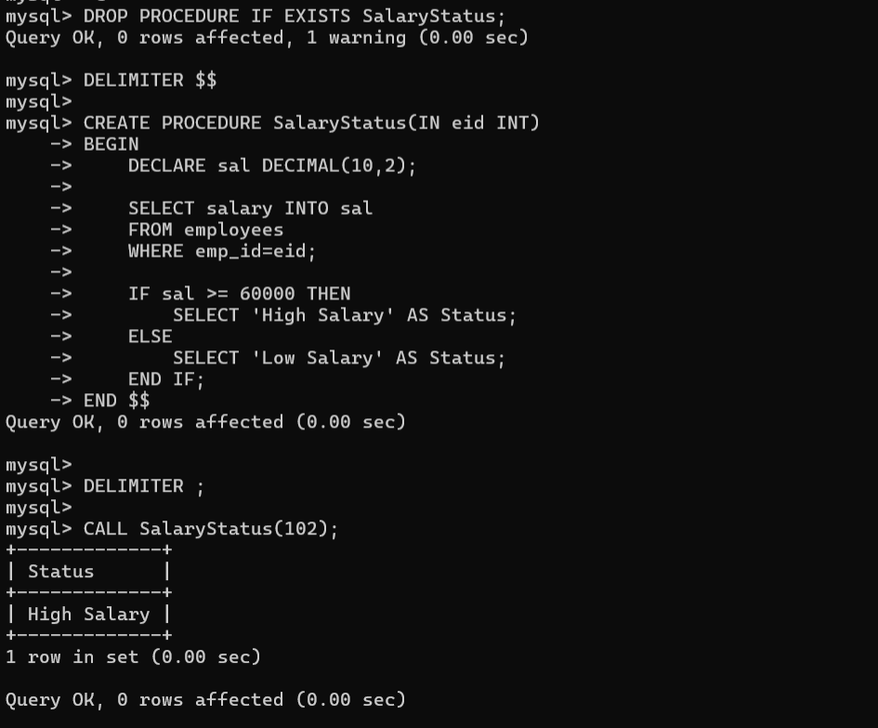Procedure 8 – OUT Parameter
Question: Return the total number of employees using an OUT parameter.

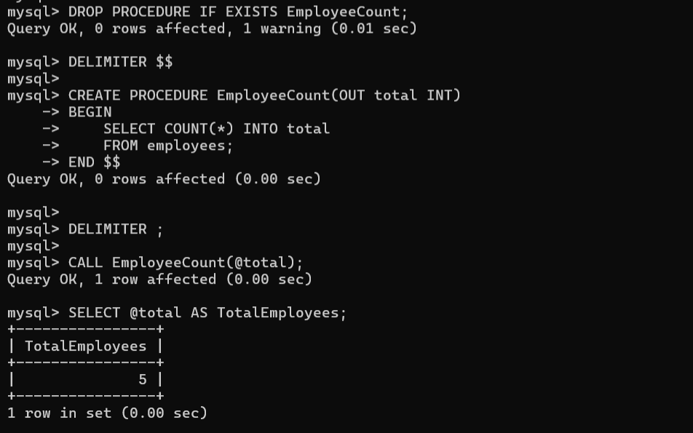Procedure 9 – INOUT Parameter
Question: Receive a bonus through an INOUT parameter and add 5000 to it.
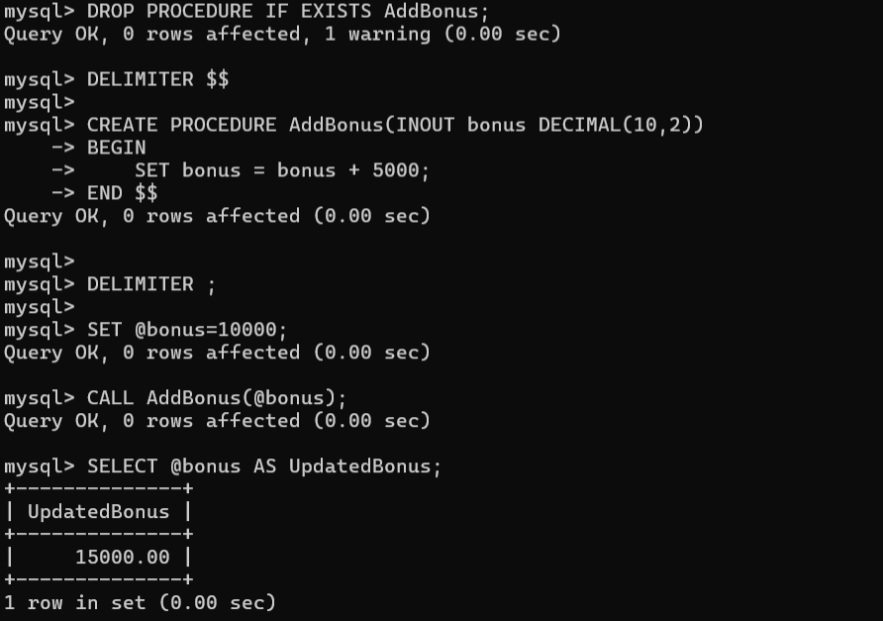

Procedure 10 – Transaction
Question: Transfer an amount from one employee salary record to another using START TRANSACTION and COMMIT.

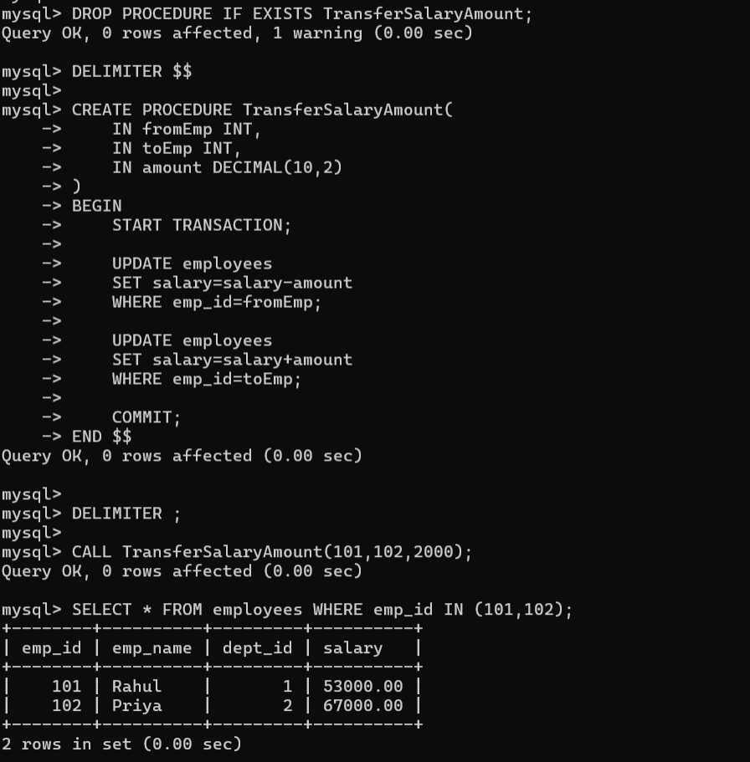4. Useful Procedure Commands

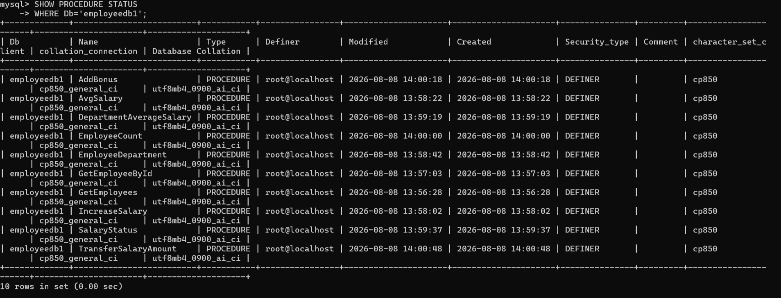

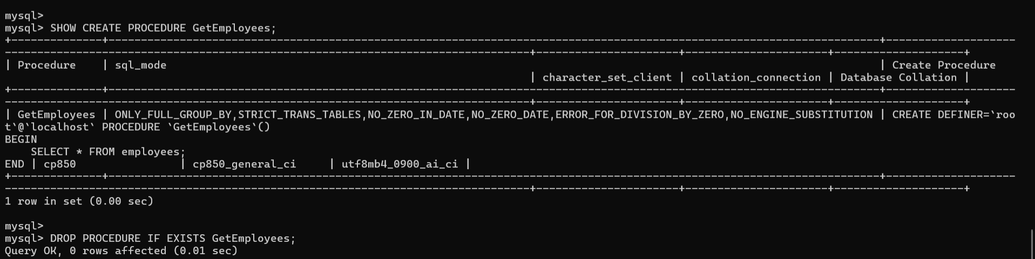5. Why DELIMITER is Used
DELIMITER temporarily changes the statement terminator in MySQL Workbench. It prevents the semicolons inside BEGIN...END from being interpreted as the end of the entire CREATE PROCEDURE statement.

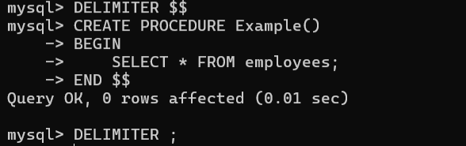

6. Student Practice Tasks
1. Create a procedure to display employees whose salary is greater than a given amount.
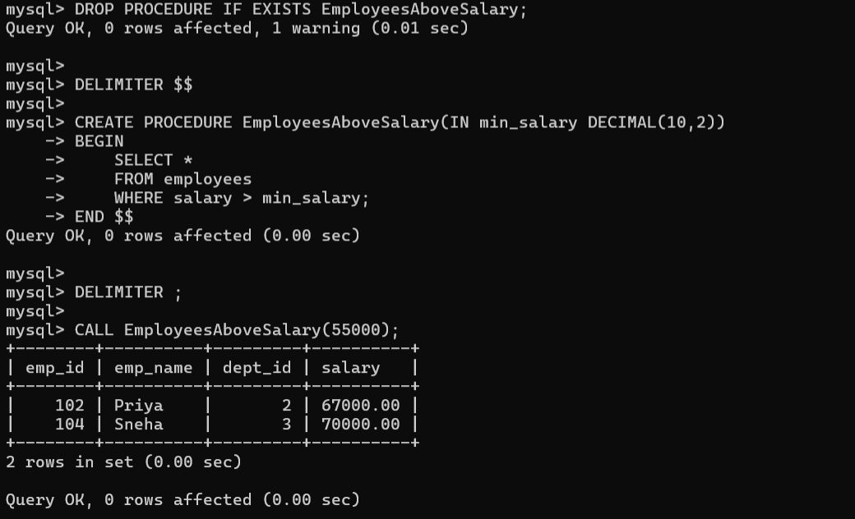
2. Create a procedure to update an employee's department using IN parameters.
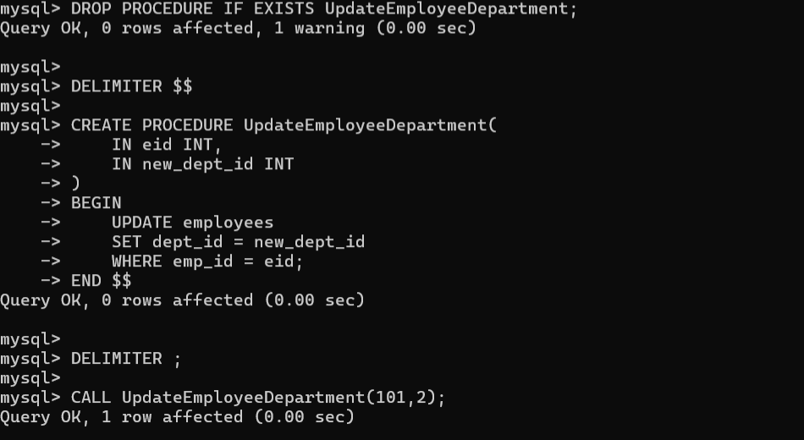
3. Create a procedure to return the maximum salary using an OUT parameter.
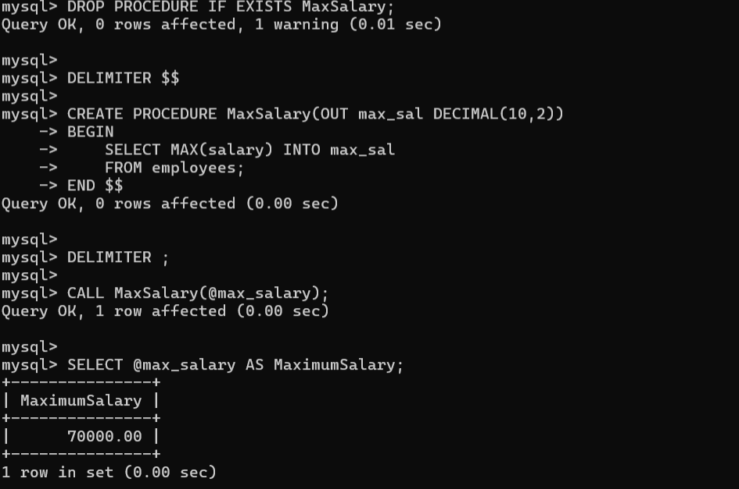
4. Create a procedure to return the employee count of a specified department.
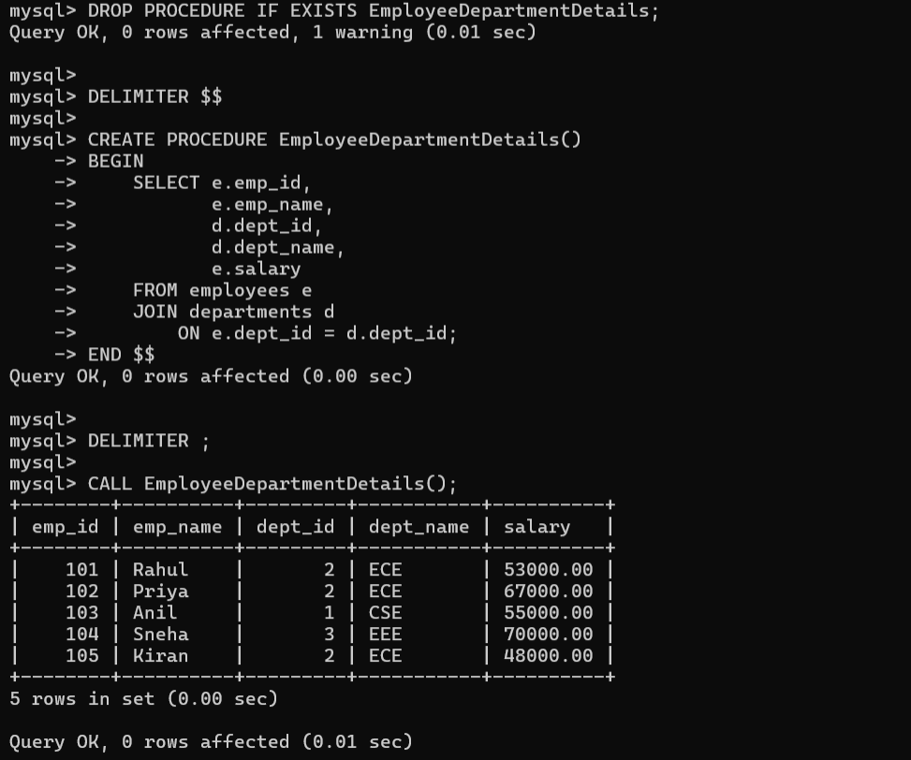
5. Create a procedure using JOIN to display employee and department details.
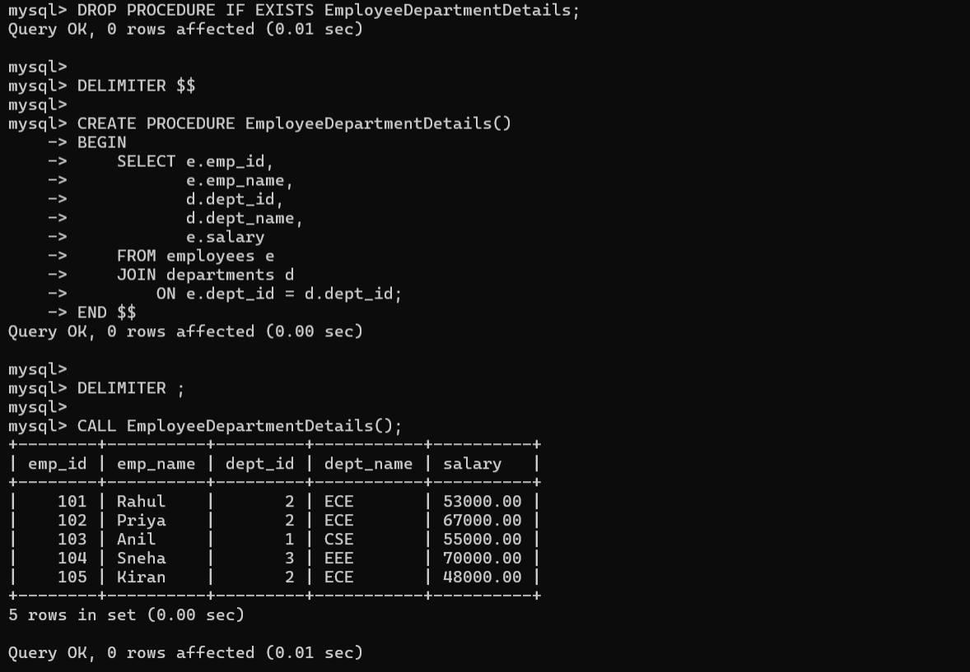
6. Create a procedure to display departments whose average salary is greater than 55000.
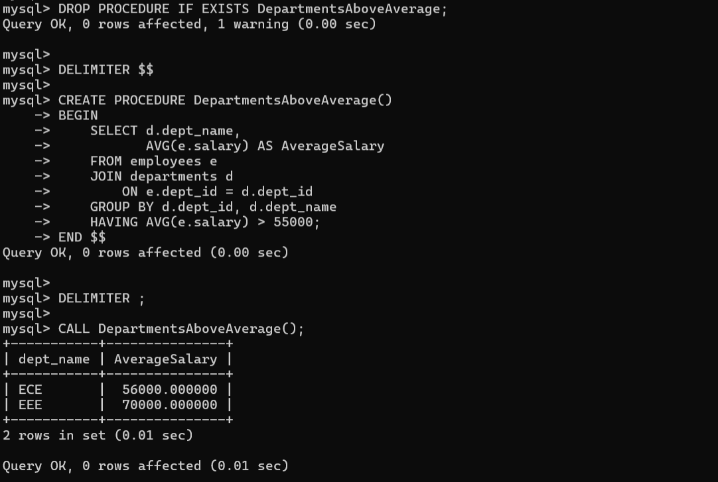
7. Create a procedure using IF...ELSE to classify salary as High, Medium or Low.
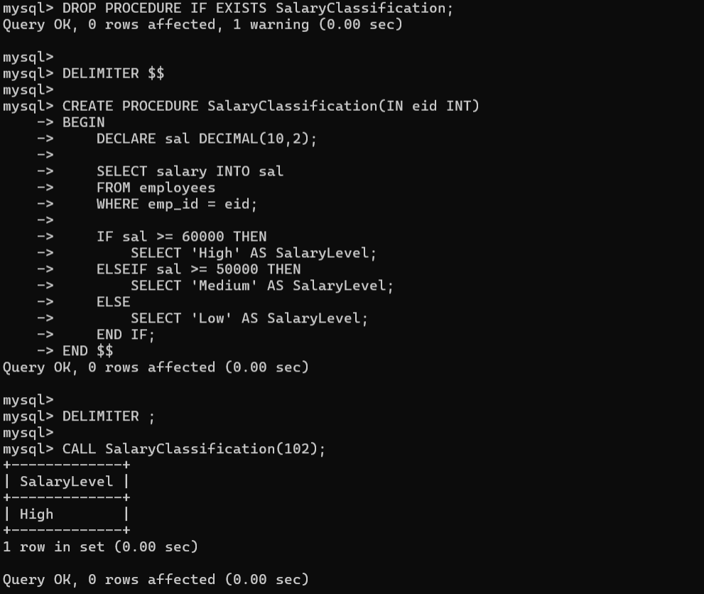
8. Create a procedure that accepts a department ID and returns its average salary.
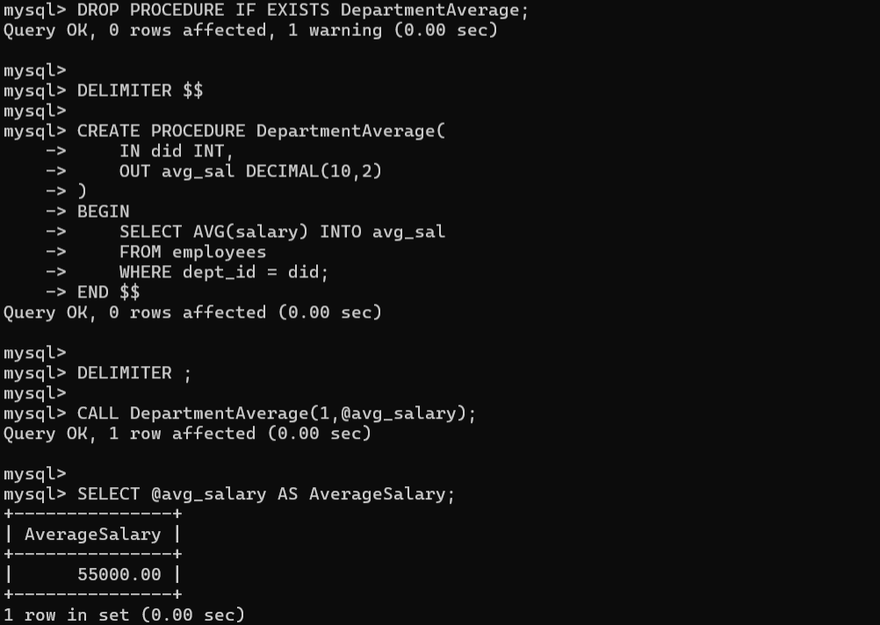
9. Create a procedure using INOUT to apply a bonus to an input salary.
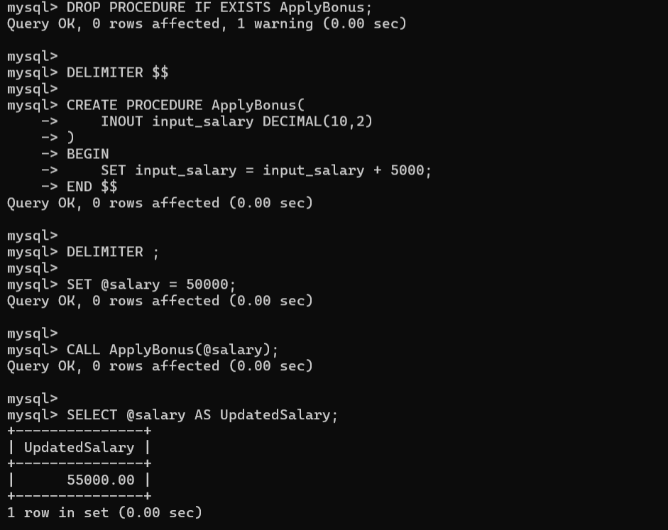
10. Create a procedure that performs two related updates inside a transaction.
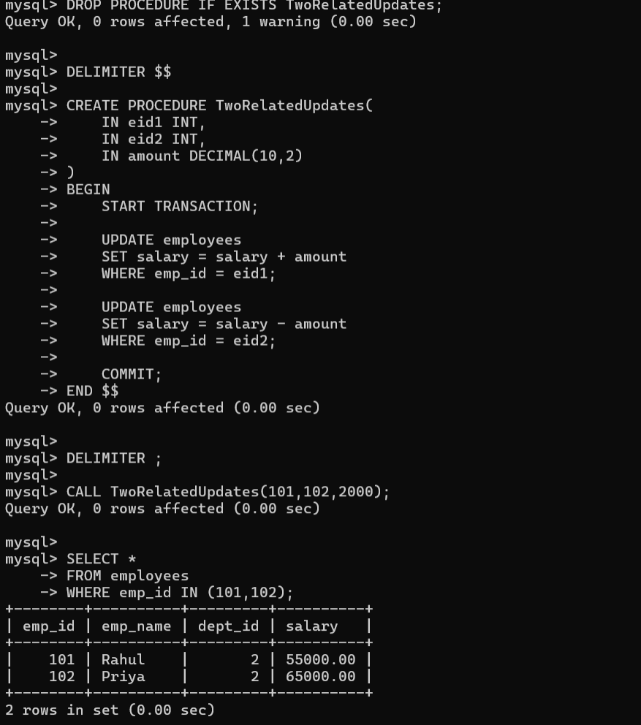

7. Common Errors
Procedure already exists: Use DROP PROCEDURE IF EXISTS before recreating it.
Syntax error near BEGIN: Check DELIMITER $$ and DELIMITER ;.
Table does not exist: Run USE employeedb1; and SHOW TABLES;.
Unknown column: Check names using DESCRIBE employees;

