**23CSE111**

OOPS

**LAB MANUAL**

**Department of CSE**

**Amrita School of Engineering**

**Amrita Vishwa Vidyapeetham, Amaravati Campus**

**Verified By : Name: Ch Jaswanth Reddy**

**Roll No: 24034**

|  |  |  |  |  |
| --- | --- | --- | --- | --- |
| S.NO | Programs | Date | Pg:No | Signature |
| WEEK-1 | a) Download and install Java software.  b) Write a java program that prints message”welcome to java  program”.  c) Write a java program that prints name,roll number,section of a  student. |  |  |  |
| WEEK-2 | a) Write a java program to calculate the area of the rectangle.  b) Write a java program to convert temperature from Celsius to  Fahrenheit and viceversa.  c) Write a java program to calculate the simple intrest.  d) Write a java program to find largest of three numbers using  ternary operator.  e) Write a java program to find factorial of number. |  |  |  |
| WEEK-3 | 1. Write a java program with the following instructions.  a) Create a class with name car.  b) Create four attributes named car_colour,car_brand,fuel  type,top_speed.  c) Create three method named  “Start_Racing”,”End_Race”.{ }  d) Create three objects named Car1,Car2,Car3.  e) Create a constructor which should print “Welcome to car  garage”.  2. Write a class by writing java program named Bank Account  with two methods “deposits and withdraw”.  a) In deposit method whenever an amount is deposited it  has to be updated with current amount (logic C.A+D.A).  b) With draw amount whenever an amount is being  withdraw it has to be less than the current amount less  than the amount else print “Insufficient funds”. |  |  |  |
|  |  |  |  |  |
|  |  |  |  |  |
|  |  |  |  |  |

Week-1

* Program : 1
* Aim : Download and Install Java Software.
* Step 1 : Visit chrome and search “ java download”.and select Oracle website.

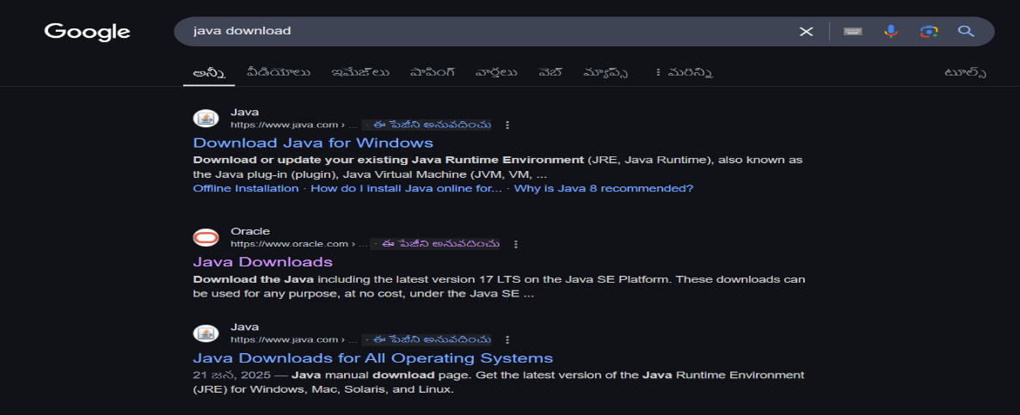

* Step 2 : Now open Oracle website scroll down and now select “JDK 21” for

Windows and select “X64 installer” and download it.

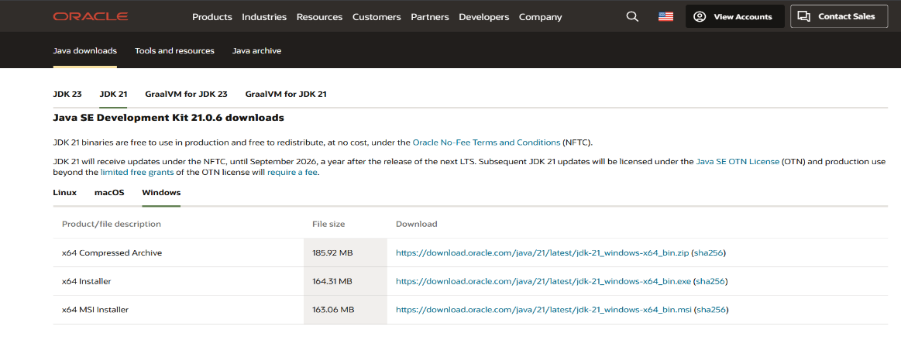

* Step 3 : After downloading open “this pc” in our laptop and open “program

files”,open “java”,open “JDK 21”

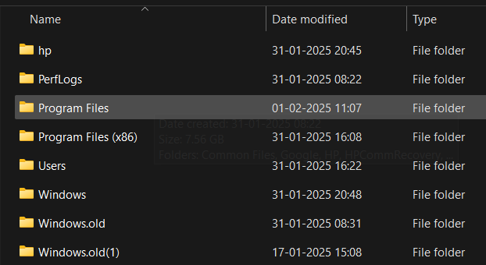

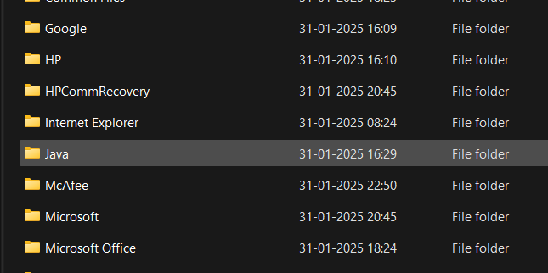

* Step 4 : In the task bar search and open “environment variables of

system”,after opening environment variables, go to the system

variables and see for java if there leave it. Or click path and add

“JAVA” in ‘variable name’ and copy link in ‘variable value’

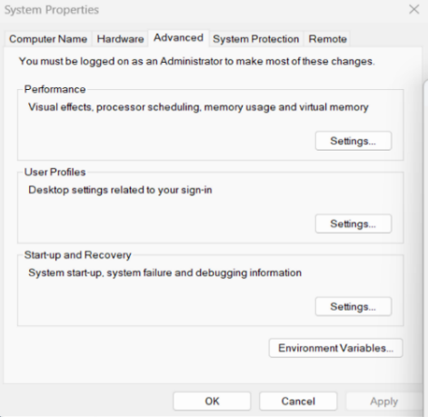

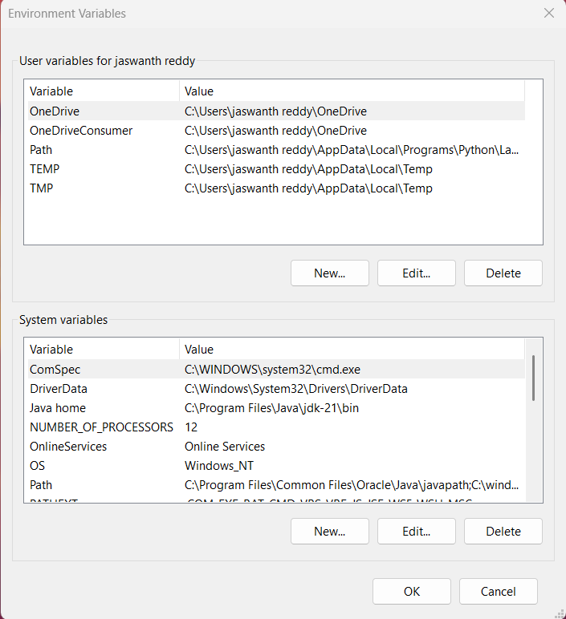

* Step 5 : Verifying Installation of Java. Again open task bar and search “cmd”,

open it ant type “java –version” and press enter. It will show the

version of installation of java.

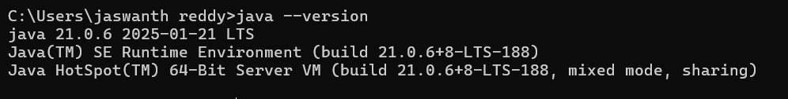

Successfully Java is installed and it will show the version otherwise it will show error and command is not recognized.

* Program : 2

**Q) Write a java program to print the message “welcome to java program**”.

class Main{

public static void main(String[] args){

System.out.println("welcome to java programming");

}

}

OUTPUT

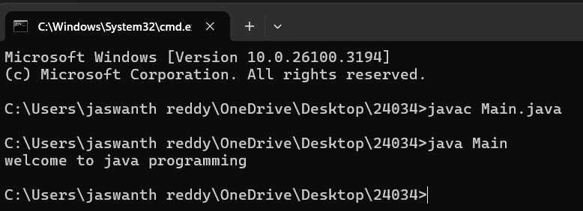

* Program : 3

**Q) Write a java program that prints name,roll number,section of a student.**

public class My_Profile

{

public static void main(String args[]) {

System.out.println("Name: Ch.Jaswanth Reddy");

System.out.println("Class: CSE 'A'");

System.out.println("Roll No: 24034");

}

}

OUTPUT

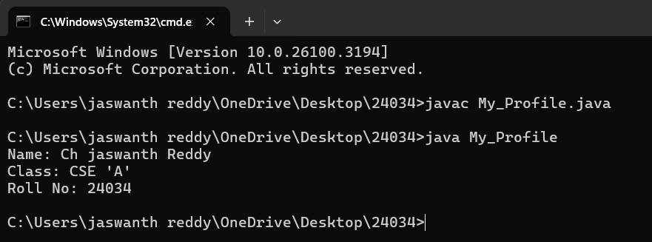

WEEK-2

* Program : 1

**Q) Write a java program to calculate the area of the rectangle.**

import java.util.Scanner;

class rectangle{

public static void main(String[]args){

Scanner input=new Scanner(System.in);

System.out.println("enter the length");

int len=input.nextInt();

System.out.println("enter the bredth");

int bred=input.nextInt();

int area=len*bred;

System.out.println(area);

}

}

OUTPUT

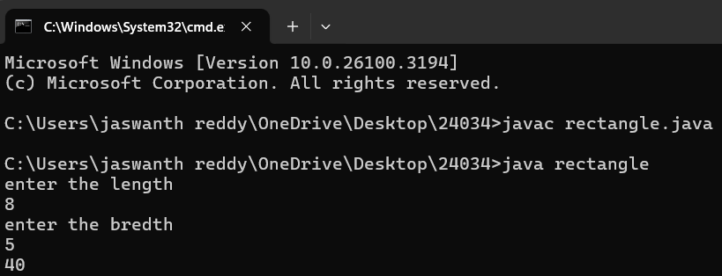

|  |  |  |
| --- | --- | --- |
| **S.NO** | **Errors** | **Rectification** |
| 1 | ; | ; is expected at end |
| 2 | area | Declaration of int type variable |

* Program : 2

**Q) Write a java program to convert temperature from Celsius to Fahrenheit and viceversa.**

import java.util.Scanner;

class temperature{

public static void main(String[]args){

Scanner input =new Scanner(System.in);

System.out.println("enter the the temperature in degrees:");

double deg=input.nextDouble();

System.out.println("the temperatuer in fahrenheit ="+((deg*9/5)+32));

}

}

OUTPUT

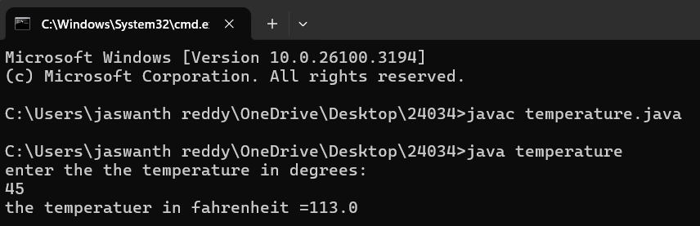

|  |  |  |
| --- | --- | --- |
| **S.NO** | **Errors** | **Rectification** |
| 1 | ; | ; is expected at end |
| 2 | Input.close(); | The input is expected to be closed. |

* Program : 3

**Q) Write a java program to calculate the simple intrest**.

import java.util.Scanner;

class simpleintrest{

public static void main(String[]args){

Scanner input=new Scanner(System.in);

System.out.println("enter the p value");

int p=input.nextInt();

System.out.println("enter the t value");

int t=input.nextInt();

System.out.println("enter the r value");

int r=input.nextInt();

float si=(p*t*r)/100;

System.out.println(“si=”+si);

}

}

OUTPUT

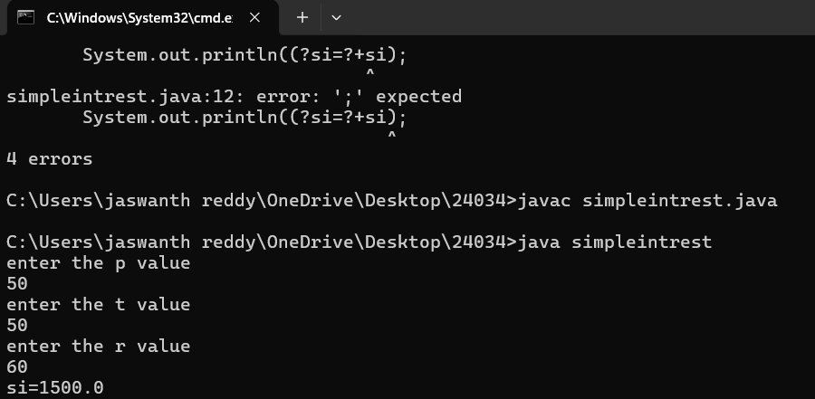

|  |  |  |
| --- | --- | --- |
| **S.NO** | **Errors** | **Rectification** |
| 1 | ; | ; is expected at end |
| 2 | Int t | Without declaring the compiler cannot execute the  program. |

* Program : 4

**Q) Write a java program to find largest of three numbers using ternary operator.**

import java.util.Scanner;

class largest{

public static void main(String[]args){

Scanner input=new Scanner(System.in);

System.out.println("enter value of A");

int a=input.nextInt();

System.out.println("enter value of B");

int b=input.nextInt();

System.out.println("enter value of C");

int c=input.nextInt();

int large=(a>b)?((a>c)?a:c):((b>c)?b:c);

System.out.println(“large=”+large);

}

}

OUTPUT

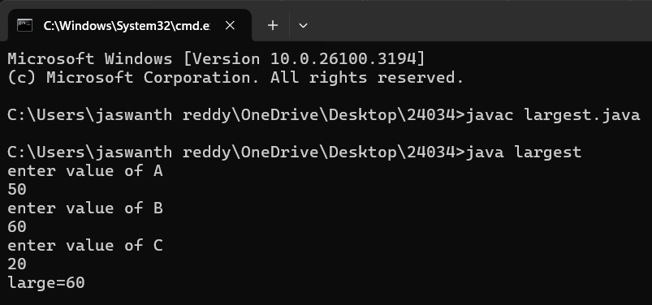

|  |  |  |
| --- | --- | --- |
| **S.NO** | **Errors** | **Rectification** |
| 1 | ? | Checks the condition |
| 2 | : | Comparing between two variables |

* Program : 5

**Q) Write a java program to find factorial of number.**

import java.util.Scanner;

class factorial{

public static void main(String[]args){

Scanner input=new Scanner(System.in);

System.out.println("enter the number to find its factorial");

int n=input.nextInt();

int sum=1;

for(int i=1;i<=n;i++){

sum=sum*i;}

System.out.println(sum);

}

}

OUTPUT

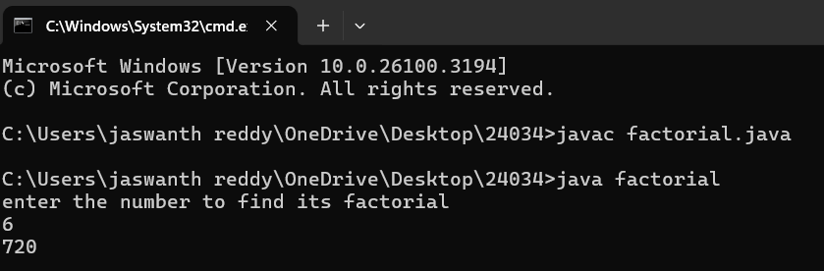

|  |  |  |
| --- | --- | --- |
| **S.NO** | **Errors** | **Rectification** |
| 1 | } | To close for loop |
| 2 | System.out.print(); | If we place the print statement inside the for loop it will print the each i value everytime but to print only the final value we must place it outside the for loop. |

WEEK-3

* Program : 1

Q) **Write a java program with the following instructions**.

1. Create a class with name car.
2. Create four attributes named car_colour,car_brand,fuel_type,top_speed.
3. Create three method named “Start_Racing”,”End_Race”.{ }
4. Create three objects named Car1,Car2,Car3.
5. Create a constructor which should print “Welcome to Garage”

Class Diagram:

|  |
| --- |
| **Car** |
| * carColor: String |
| * carBrand: String |
| * fuelType: String |
| * topSpeed: int |
| + Car(String,String,String,int) |
| + startRacing() |
| + endRace() |

// Car.java

public class Car {

// Attributes

private String carColour;

private String carBrand;

private String fuelType;

private int topSpeed;

// Constructor

public Car(String carColour, String carBrand, String fuelType, int

topSpeed) {

this.carColour = carColour;

this.carBrand = carBrand;

this.fuelType = fuelType;

this.topSpeed = topSpeed;

System.out.println("Welcome to car garage");

}//End of the constructor

// Method to start racing

public void startRacing() {

System.out.println(carBrand + " (" + carColour + ") is starting the

race with a top speed of " + topSpeed + " km/h and runs on " +

fuelType + "!");

}//End of Method

// Method to end race

public void endRace() {

System.out.println(carBrand + " (" + carColour + ") has finished

the race!");

}//End of the Method

// Main method to create objects and demonstrate functionality

public static void main(String[] args) {

// Creating three objects

Car car1 = new Car("Red", "Ferrari", "Petrol", 200);

Car car2 = new Car("Blue", "Tesla", "Electric", 250);

Car car3 = new Car("Black", "BMW", "Diesel", 220);

// Starting and ending races

car1.startRacing();

car1.endRace();

car2.startRacing();

car2.endRace();

car3.startRacing();

car3.endRace();

}

}

Output:

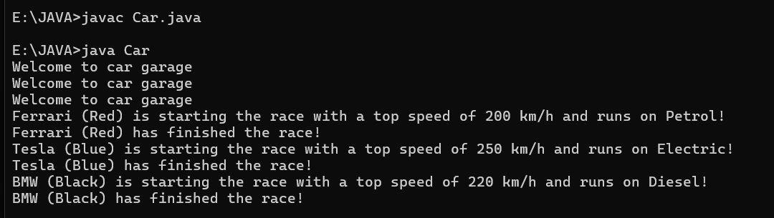

|  |  |  |
| --- | --- | --- |
| **S.NO** | **Errors** | **Rectification** |
| 1 | } | To close for loop |
| 2 | System.out.print(); | If we place the print statement inside the for loop it will print the each i value everytime but to print only the final value we must place it outside the for loop. |

* Program : 2

Q ) Write a class by writing java program named Bank Account

with two methods “deposits and withdraw”.

a) In deposit method whenever an amount is deposited it

has to be updated with current amount (logic C.A+D.A).

b) With draw amount whenever an amount is being

withdraw it has to be less than the current amount less

than the amount else print “Insufficient funds”.

Class Diagram:

|  |
| --- |
| Bank Account |
| * currentAmount: double |
| + BankAccount(initialAmount:double) |
| + deposit(amount: double):void |
| + withdraw(amount: double):void |
| + getCurrentAmount():double |

import java.util.Scanner;

class BankAccount {

String name;

int accountNumber;

int currentBalance;

// Constructor to initialize the bank account

BankAccount(String name, int accountNumber, int currentBalance) {

this.name = name;

this.accountNumber = accountNumber;

this.currentBalance = currentBalance;

System.out.println("Customer Details: " + name + ", Account Number: " + accountNumber + ", Current Balance: " + currentBalance);

}

// Method to withdraw an amount

public void withdraw(int withdrawAmount) {

if (withdrawAmount <= currentBalance) {

currentBalance -= withdrawAmount;

System.out.println("Withdrawn: " + withdrawAmount);

System.out.println("Current Balance: " + currentBalance);

} else {

System.out.println("Insufficient Funds");

}

}

// Method to deposit an amount

public int deposit(int depositAmount) {

currentBalance += depositAmount;

System.out.println("Deposited: " + depositAmount);

return currentBalance;

}

// Main method to run the program

public static void main(String[] args) {

Scanner scanner = new Scanner(System.in);

// Input for account details

System.out.print("Enter your name: ");

String name = scanner.nextLine();

System.out.print("Enter your account number: ");

int accountNumber = scanner.nextInt();

System.out.print("Enter your initial balance: ");

int initialBalance = scanner.nextInt();

// Create a new bank account

BankAccount account = new BankAccount(name, accountNumber, initialBalance);

// Input for withdrawal and deposit

System.out.print("Enter amount to withdraw: ");

int withdrawAmount = scanner.nextInt();

account.withdraw(withdrawAmount);

System.out.print("Enter amount to deposit: ");

int depositAmount = scanner.nextInt();

account.deposit(depositAmount);

// Final balance

System.out.println("Final Amount: " + account.currentBalance);

// Close the scanner

scanner.close();

}

}

Output:

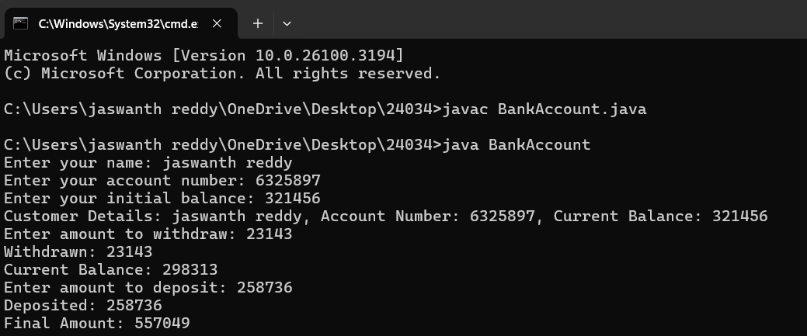

|  |  |  |
| --- | --- | --- |
| **S.NO** | **Errors** | **Rectification** |
| 1 | ; | ; is expected at end |
| 2 | Int t | Without declaring the compiler cannot execute the  program. |