### SPRINGBOOT

### **CRUD OPERATIONS**

Contents:

Work Flow-UI Project……………………………………………………………….1

Login…………………………………………………………………………………………2

Crud Operations…………………………………………………………………….…3

Health Care Task……………………………………………………………….4

1. Pharmacy
2. Pharmacy Bills

Database Table………………………………………………………….5

1.Work Flow-UI Project

* First, I cloned Work Flow-UI and n User from n Products Organization.
* Secondly, I connected Work Flow-UI to Visual Studio Code and installed node modules in it by using these commands:
* N pm Install
* N pm i -legacy-peer-deps
* N pm i –force
* N pm start
* Thirdly, I connected n User to Eclipse IDE and installed its essential dependencies.
* I imported it as Gradle Project and I runed it as Gradle project.
* Later, I installed SQL Workbench and gave the connection to the eclipse.
* I gave the connection by giving the SQL Password in Application properties.
* Also, I installed Rabbit M q server and erlang in order to make the spring boot work.

2.Login

* First, I Successfully Run the Frontend and backend
* This is the Home Page of the Login Page
* You can see the Data Here,



3.Crud Operations

CRUD stands for CREATE, READ, UPDATE and DELETE

4.Health Care Task

Pharmacy.java

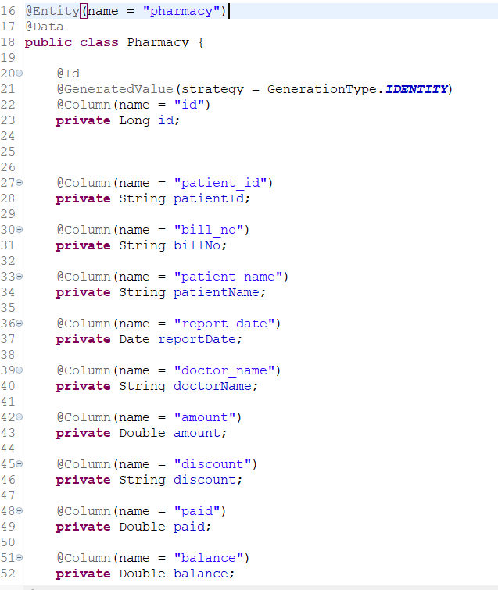

Create a Table in MySQL

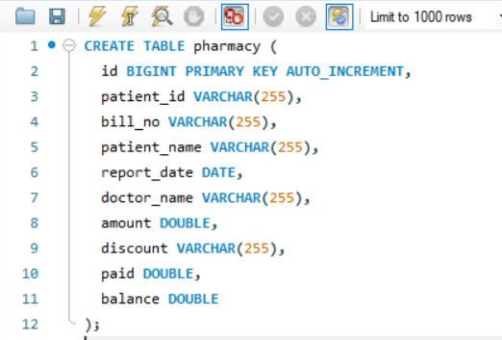

* You can see the Data Here,

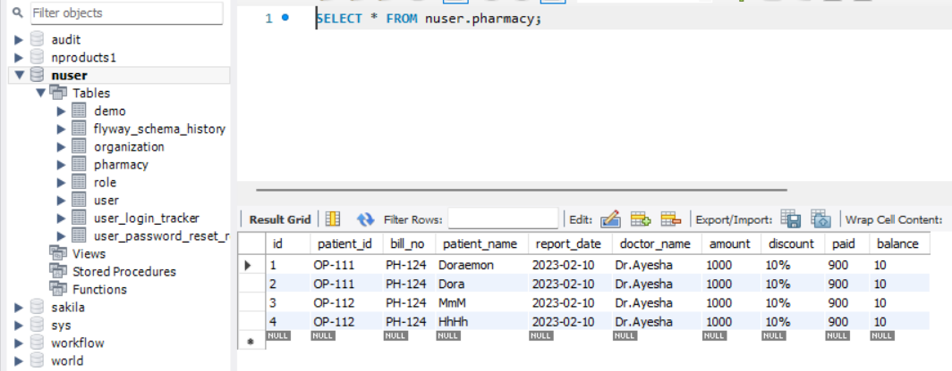

Pharmacy Controller.java

GET:

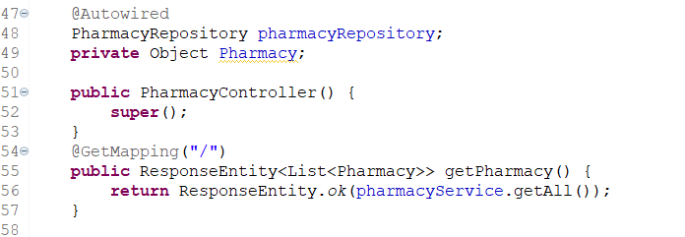

PUT:

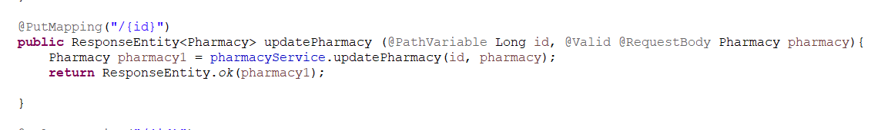

POST:

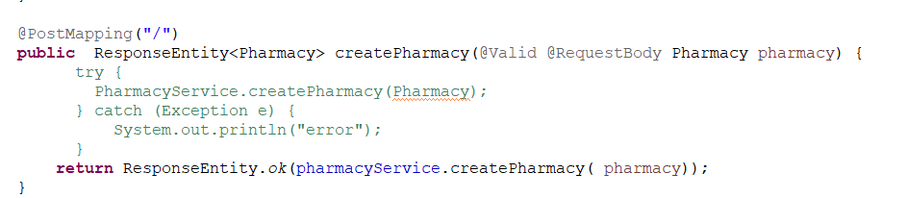

DELETE:

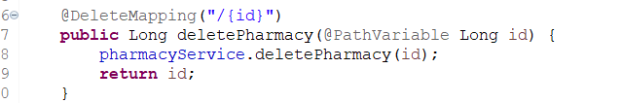

Pharmacy Service.java

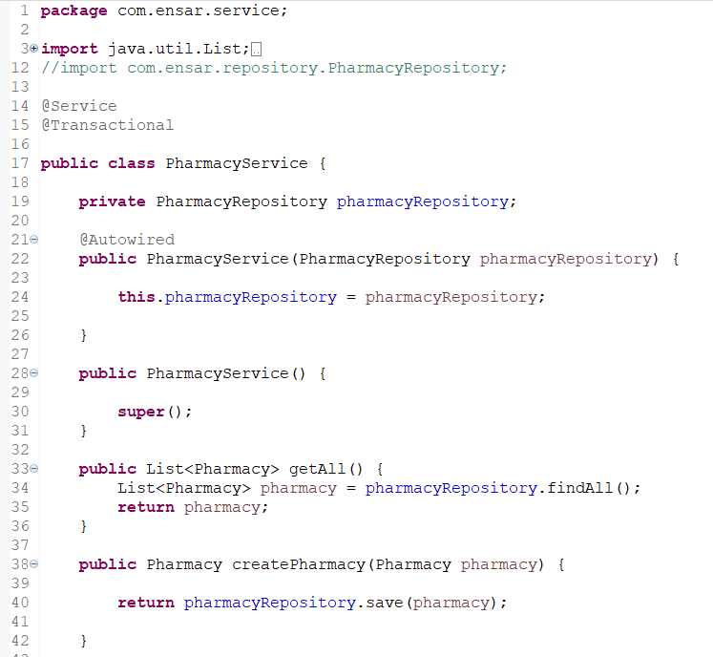

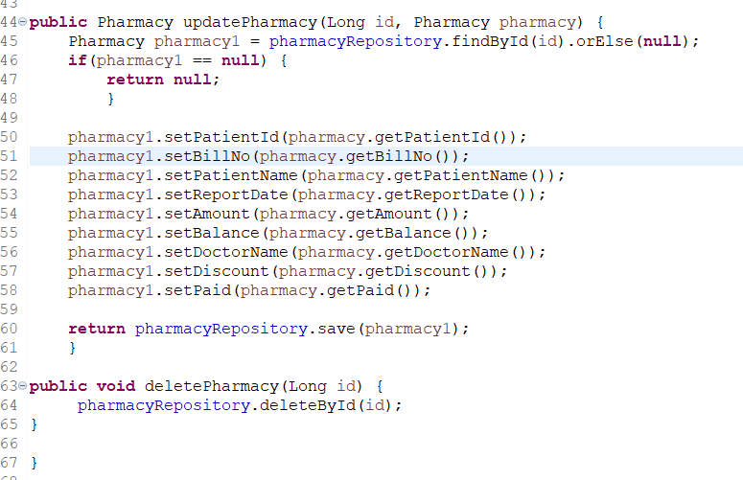

Pharmacy List Page.tsx

Pharmacy Create Page.tsx

Pharmacy Edit Page.tsx

Pharmacy New Edit Form.tsx

Pharmacy Table Row.tsx

Pharmacy Table Toolbar.tsx

* Axios.ts
* Config-navigation.tsx
* Paths.ts
* Ic_pharmacy.svg
* Elements.tsx
* Pharmacy.ts…\slices
* Pharmacy.ts…\@types

Pharmacy List

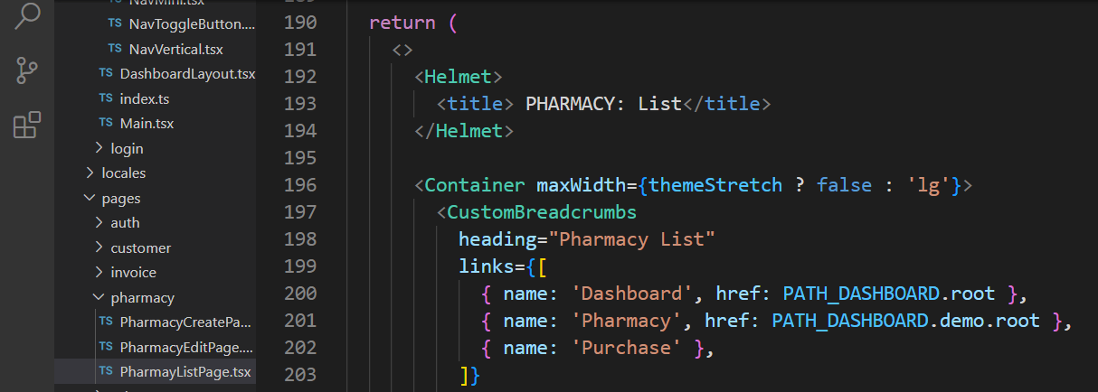

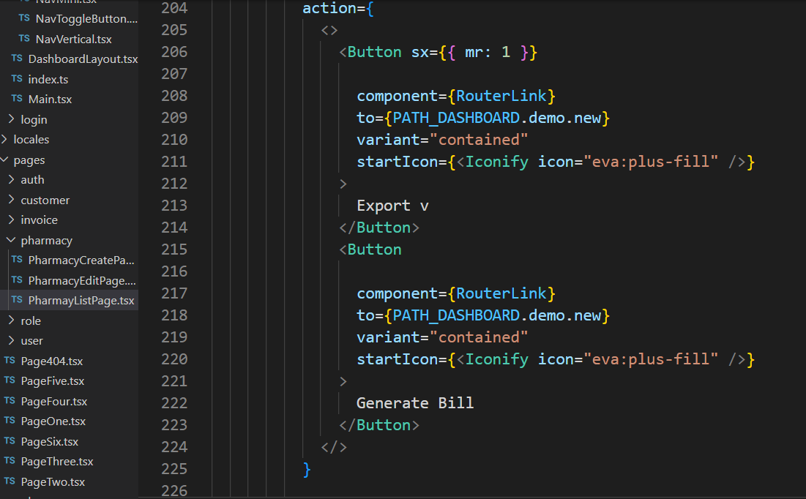

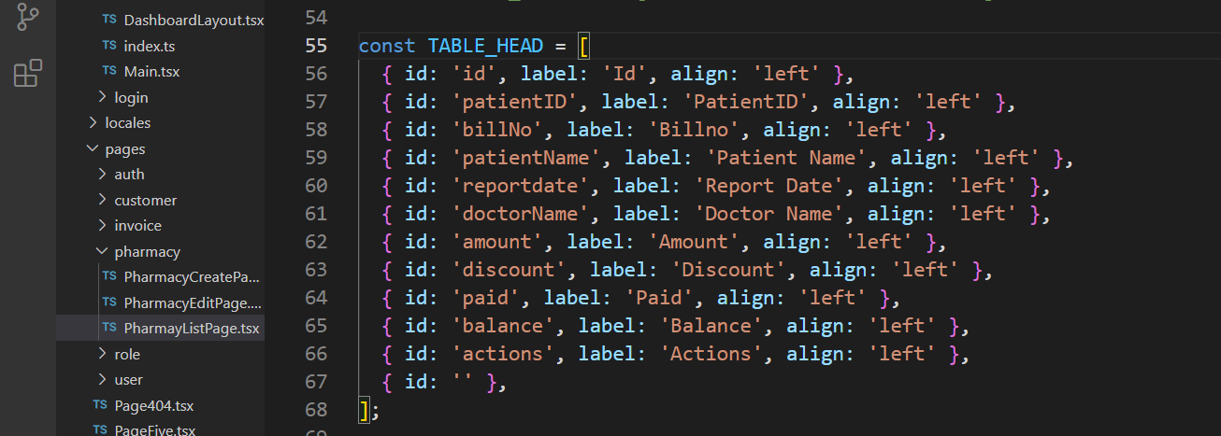

UI Page:



Pharmacy Create Page

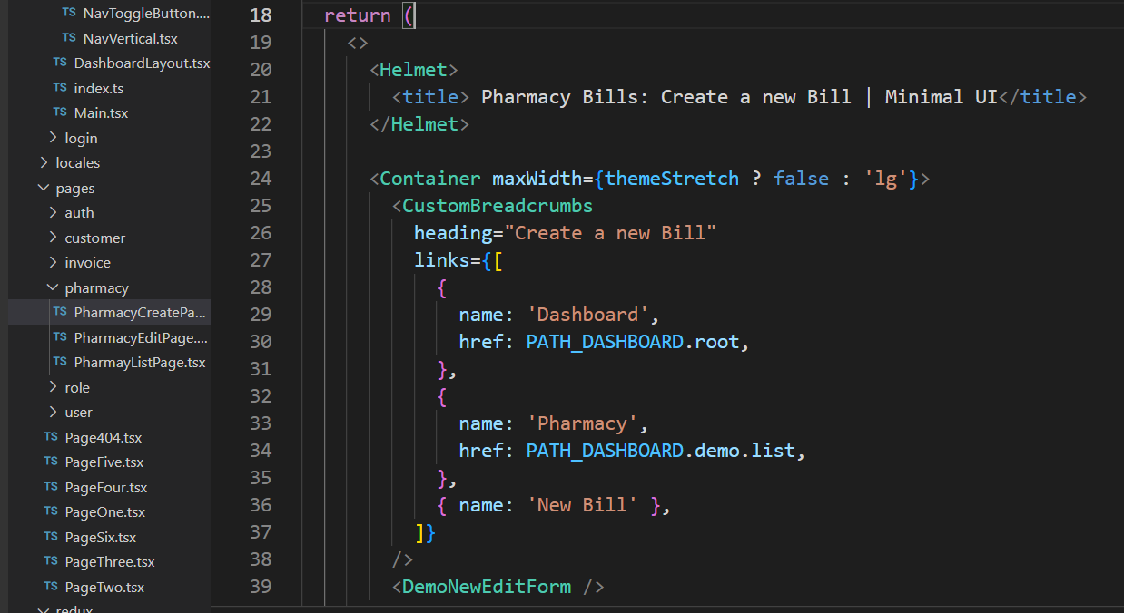

UI Page



Pharmacy Edit Page

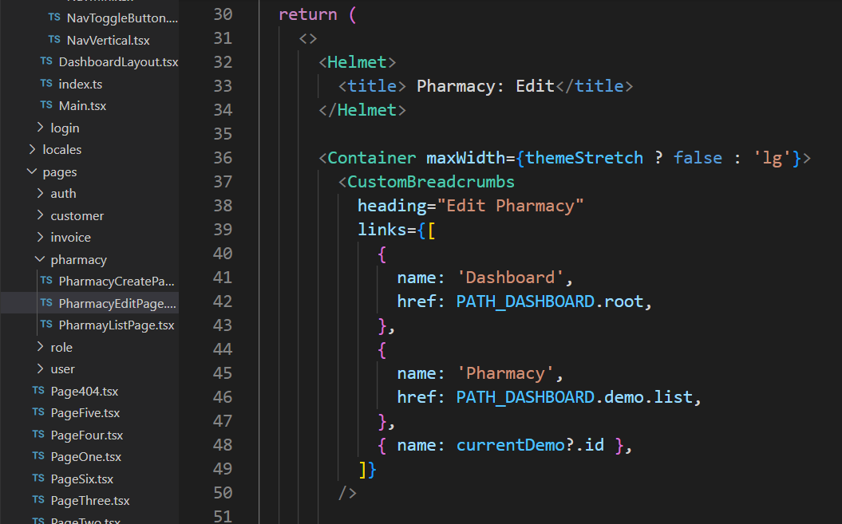

UI Page



Pharmacy New Edit Form

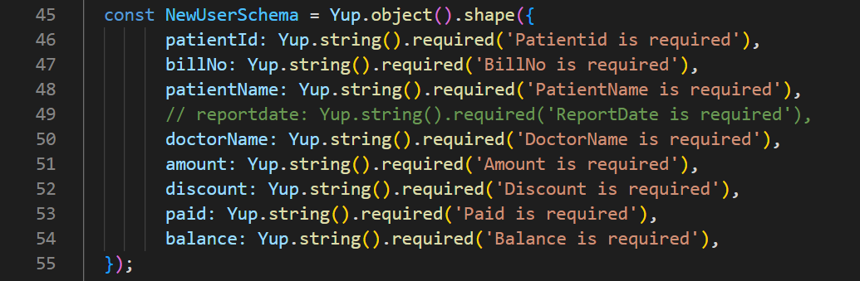

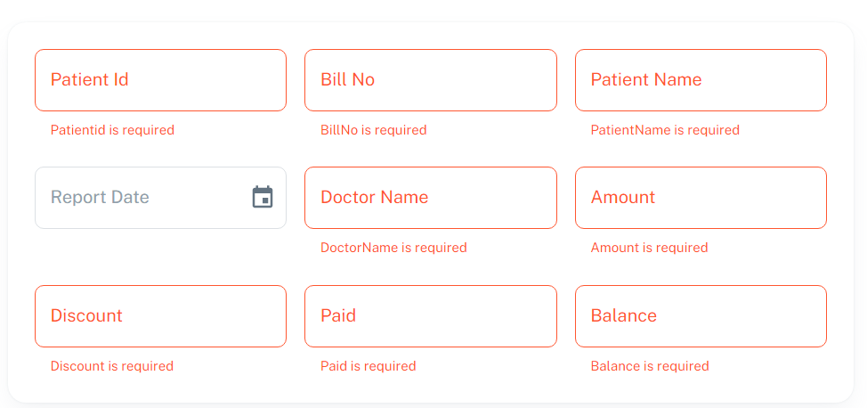

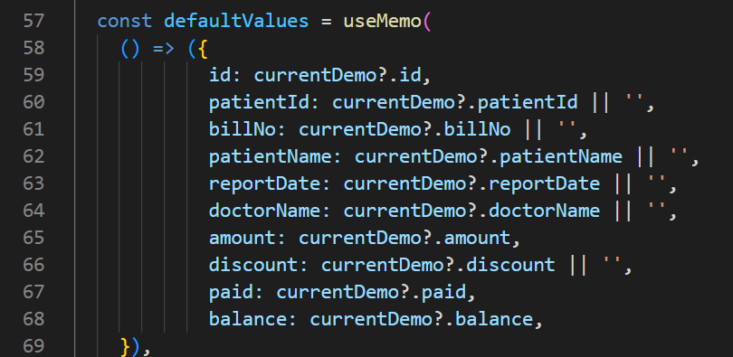

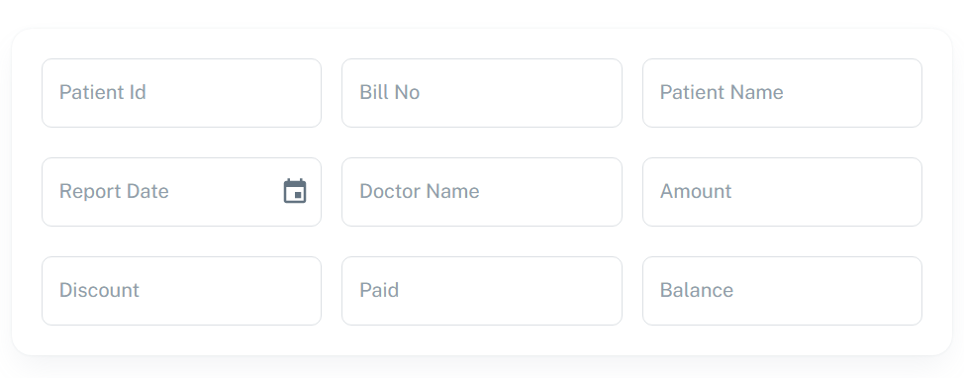

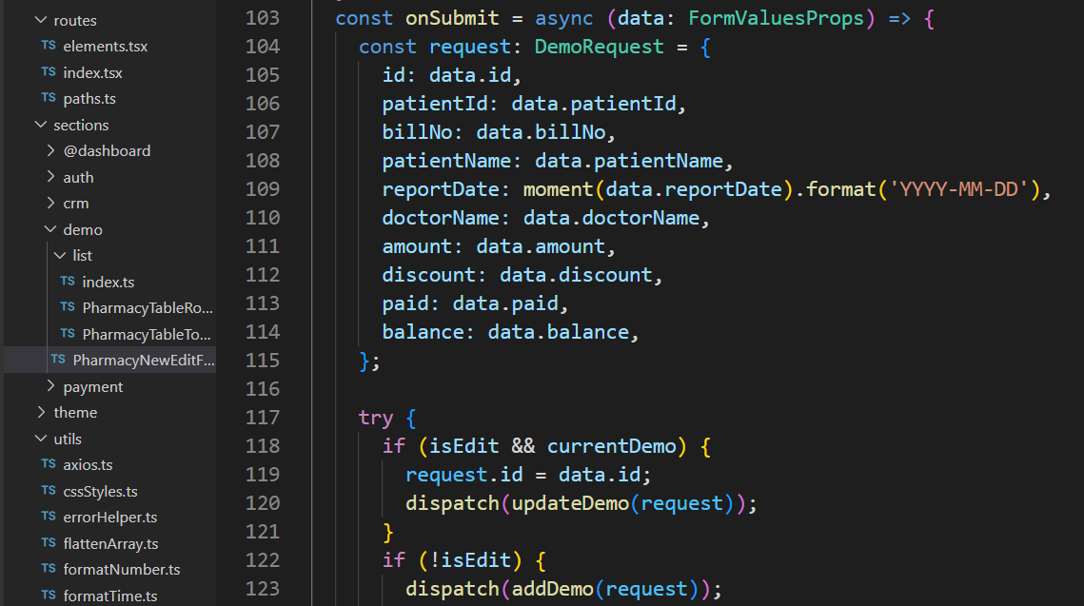

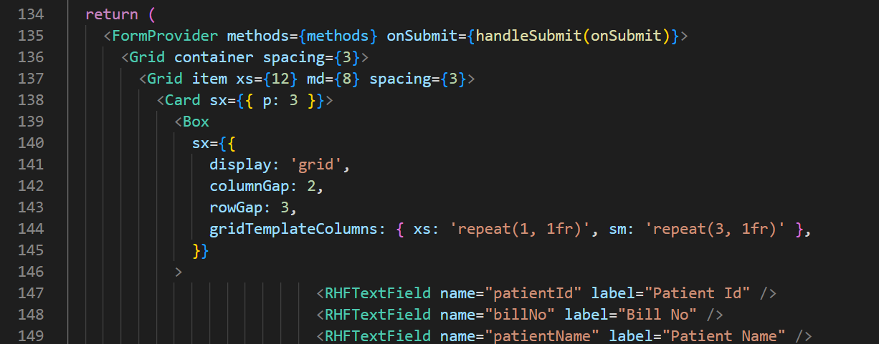

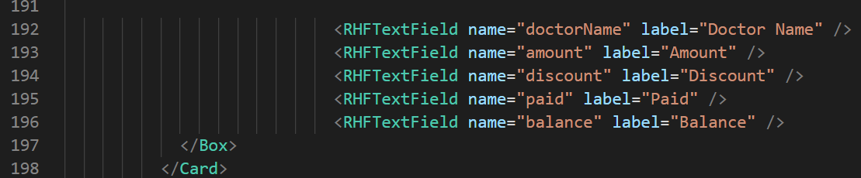

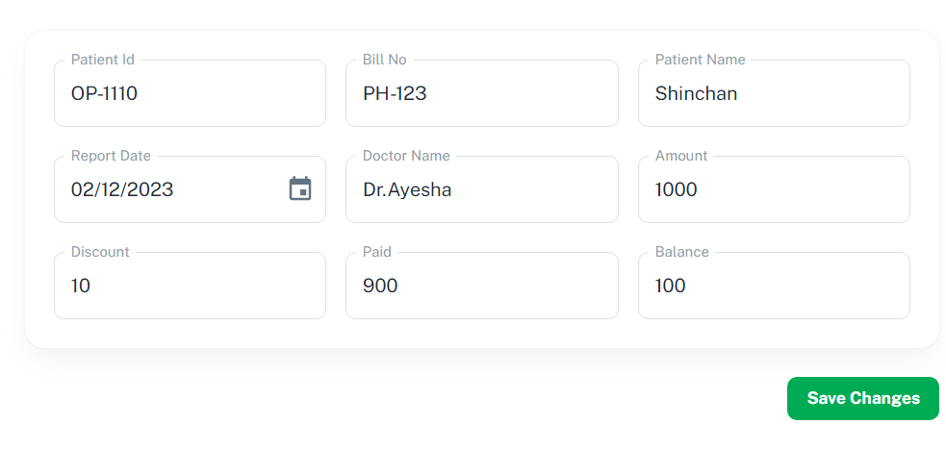

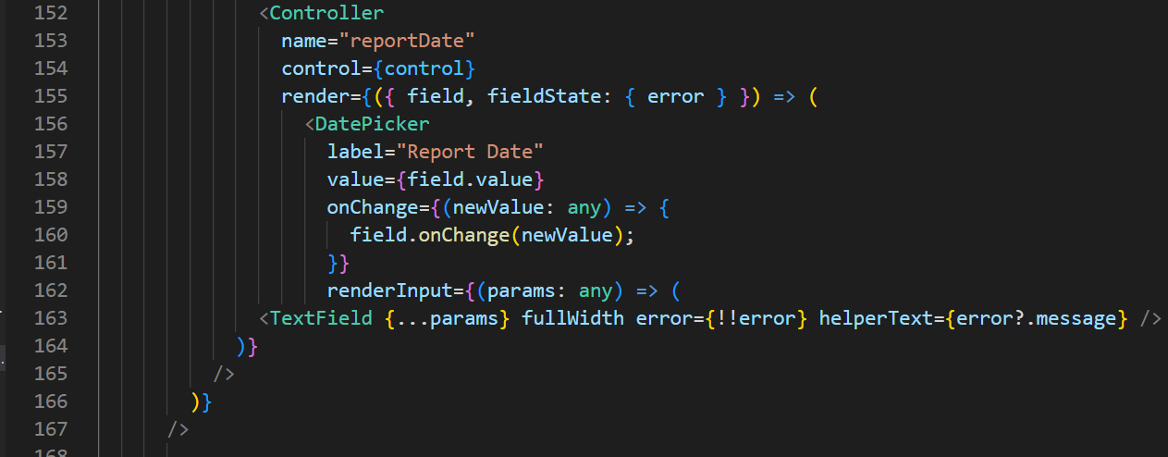

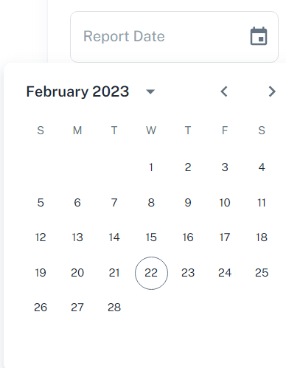

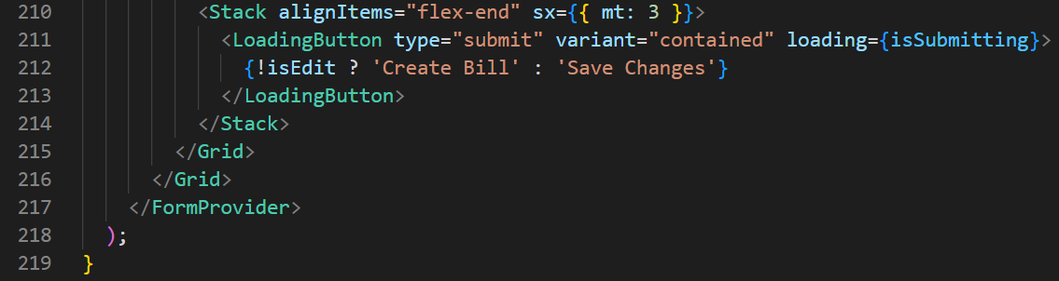

 

Pharmacy. t s\ @types

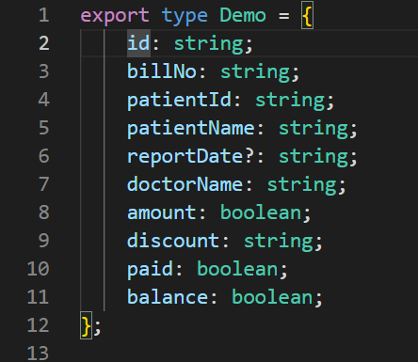

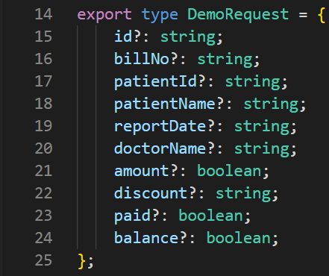

Pharmacy .t s \slices

import {Demo, Demo Request, Demo State} from '../../@types/pharmacy';

elements .t s

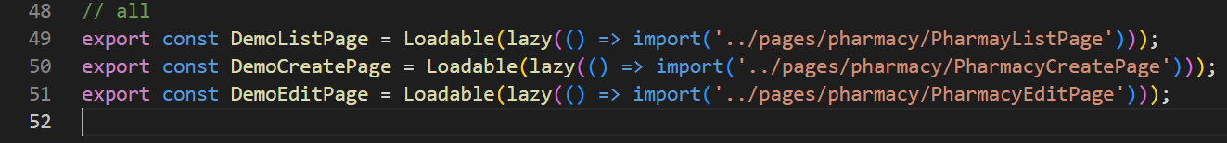

ICON

Public 🡪 assets🡪 icons🡪 navbar🡪 ic_pharmacy.svg

<svg xmlns="http://www.w3.org/2000/svg" view Box="0 0 512 512"><!--! Font Awesome Pro 6.3.0 by @fontawesome - https://fontawesome.com License - https://fontawesome.com/license (Commercial License) Copyright 2023 Fonticons, Inc. --><path d="M96 352V96c0-35.3 28.7-64 64-64H416c35.3 0 64 28.7 64 64V293.5c0 17-6.7 33.3-18.7 45.3l-58.5 58.5c-12 12-28.3 18.7-45.3 18.7H160c-35.3 0-64-28.7-64-64zM272 128c-8.8 0-16 7.2-16 16v48H208c-8.8 0-16 7.2-16 16v32c0 8.8 7.2 16 16 16h48v48c0 8.8 7.2 16 16 16h32c8.8 0 16-7.2 16-16V256h48c8.8 0 16-7.2 16-16V208c0-8.8-7.2-16-16-16H320V144c0-8.8-7.2-16-16-16H272zm24 336c13.3 0 24 10.7 24 24s-10.7 24-24 24H136C60.9 512 0 451.1 0 376V152c0-13.3 10.7-24 24-24s24 10.7 24 24l0 224c0 48.6 39.4 88 88 88H296z"/></svg>

Config-navigation

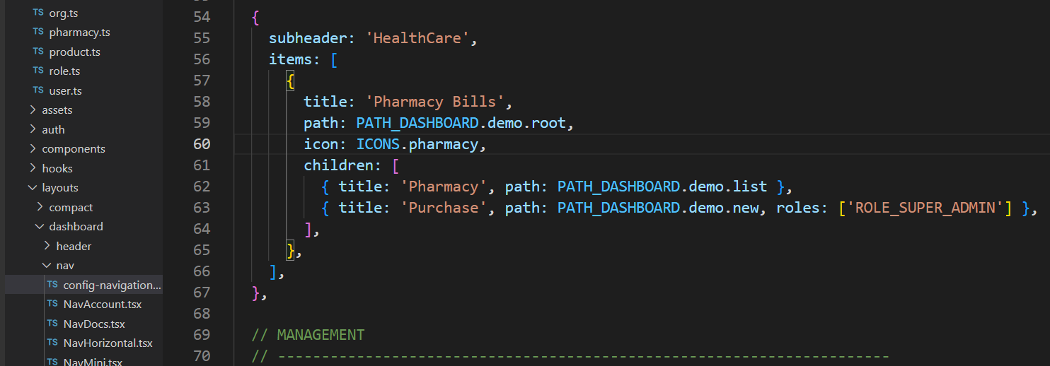

Path. t s

