RASPBERRY PI CODING

Generally using the raspberry general purpose input output pins any application can be developed the basic code involves including some packages they are

>Import RPi.GPIO as GPIO

This command imports and activates the GPIO pins and controls them

>Import time

This command imports the time package which enables us to use functions like producing delay in the output

After importing these packages we have to setup GPIO pins depending on whether they are input pins are output pins

>GPIO.setup(pinnumber,GPIO>IN)

> GPIO.setup(pinnumber,GPIO>OUT)

These two commands enable us to configure the pins as input and output pins

And next to number the pins according to their default value we have to use the command

>GPIO.setmode(GPIO.board)

>GPIO.cleanup command clears up the gpio pins after execution of program

\*\* Generally while running the python code we get a warning called you may receive an error that says the selected GPIO channels are already in use. This can be avoided by using the command GPIO.setwarnings(False)

All the GPIO pins form the rasp berry are 3.3v general purpose input output pins

Pin diagram for raspberry (pi 3) model is shown below

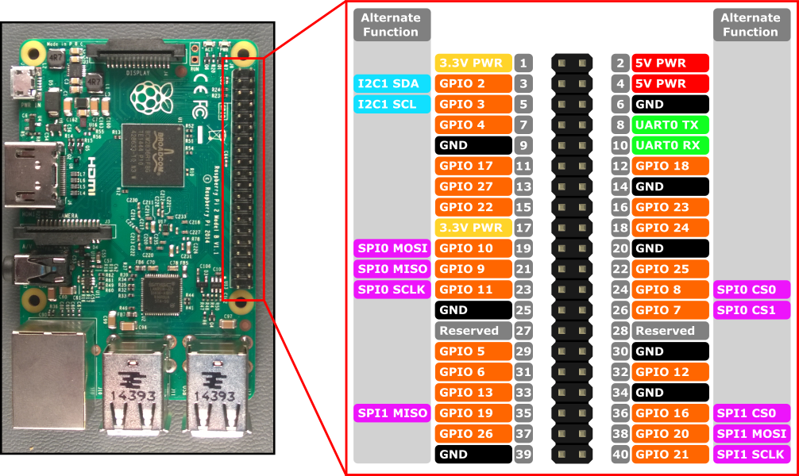

Basic code for led blink circuit

1. import time
2. import RPi.GPIO as GPIO
3. GPIO.setmode(GPIO.BCM)
4. for x in range(0,10):
5. GPIO.setup(22, GPIO.OUT)
6. GPIO.output(22, True)
7. time.sleep(0.05)
8. GPIO.output(22, False)
9. time.sleep(0.45)
11. GPIO.cleanup()

time.sleep() functions produces the delay in the output the value in the braces is in seconds.

Code to run a servo :

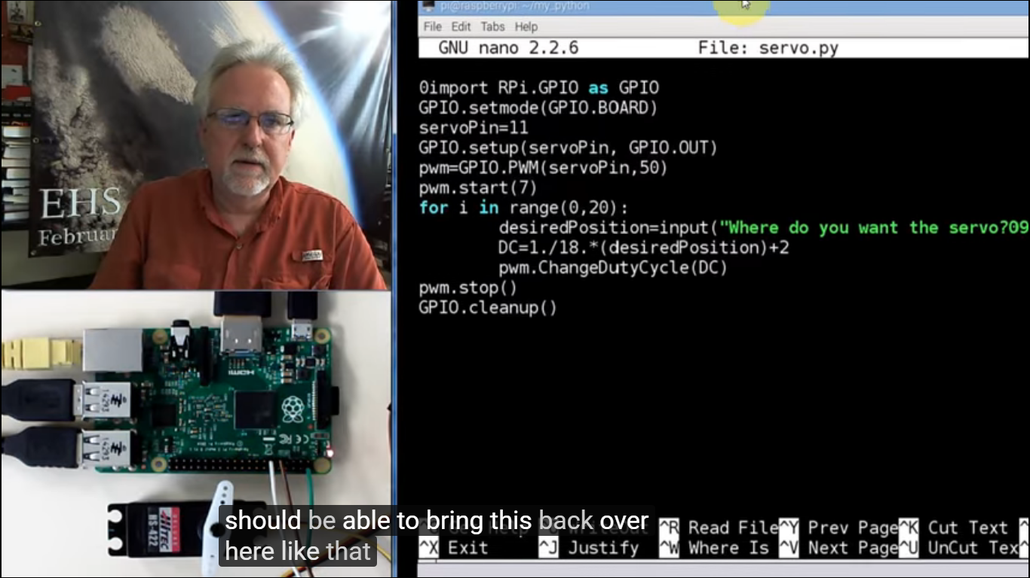

The term duty cycle here indicates the angle through which the motor should rotate it can be fed into the for loop for continuous rotation of the motor.

21-09-2017:

To create a new user in raspi we need to use the command

>sudo adduser <username>

To grant permissions to the user use the command (thi command should be used only if you are logged in as pi so that you will be able to make other users sudo)

>sudo visudo

And then add the user name along with ALL (ALL:ALL) as there in above line

This enables granting the permissions for the new user

To create a new directory use mkdir

To remove directory use rmdir

To switch user use command ( su <username>)