SOFTWARE REQUIREMENTS SPECIFICATION
CodeGuard — Mini Static Analyzer
Compact 15-Page Project SRS

Item | Specification
Project Name | CodeGuard — Mini Static Analyzer for Detecting Common Programming Errors
Domain | Compiler Design / Developer Tools / Static Program Analysis
Target Platform | Web application; desktop-browser compatible
Primary Users | Students, instructors/evaluators, developers
Target Language | C subset defined by this SRS
Recommended Stack | React + TypeScript, Python + FastAPI
Document Version | 1.0
Project Scope | Focused educational static analyzer; source code is analyzed without execution

Purpose: This SRS converts the original small-project concept into a practical, testable specification sized for a three-student Compiler Design project. The source proposal defines CodeGuard as a focused static analyzer and identifies lexical/syntax analysis, common code-error detection, optimization suggestions, and an interface as the main work areas.

Prepared as a compact academic SRS aligned with the structure of ISO/IEC/IEEE 29148 and the traditional IEEE 830 SRS organization.

1. INTRODUCTION

1.1 Purpose
CodeGuard accepts C source code and performs static analysis without executing the program. It reports lexical and syntax problems plus selected programming issues such as unused variables, duplicate declarations, undeclared variables, division by zero, unreachable code, and constant conditions.

1.2 Scope
- In scope: source editor, C-file input, lexical analysis, basic syntax analysis, AST/symbol table, selected static-analysis rules, simple optimization suggestions, results dashboard, statistics, and automated tests.
- Out of scope: full C compiler, machine-code generation, program execution, debugging, full runtime analysis, C++, Python, enterprise accounts, and advanced interprocedural/pointer analysis.

1.3 Conventions
Term | Meaning
Must | Required for Version 1 acceptance
Should | Important but may be deferred if necessary
Could | Optional enhancement
Won't | Explicitly excluded from Version 1
FR | Functional requirement
NFR | Non-functional requirement
TC | Test case

1.4 Intended Audience
- Supervisor/evaluator: overview, scope, architecture and acceptance criteria.
- Developers: functional requirements, interfaces and data structures.
- QA/tester: requirement IDs, edge cases, performance and traceability.
- Students: module ownership, examples and demonstration workflow.

1.5 Standards & References
- ISO/IEC/IEEE 29148:2018 — requirements engineering.
- IEEE 830 — historical SRS structure; superseded by ISO/IEC/IEEE 29148.
- WCAG 2.1 AA — accessibility target for the web interface.
- OWASP Top 10:2025 — web-security considerations.

2. OVERALL DESCRIPTION

2.1 Product Perspective
CodeGuard is a standalone educational developer tool. The browser provides the editor and result view; a FastAPI service runs the analyzer pipeline. The analyzer is logically independent from the UI so that lexer, parser, and analysis rules can be unit-tested without the browser.
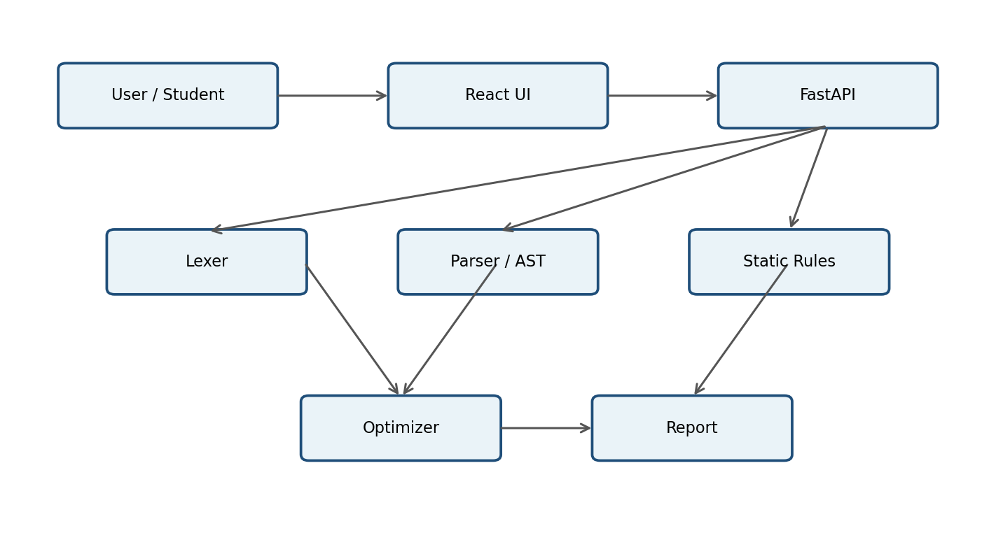

2.2 Main Data Flow
User enters/uploads source → API validates request → lexer creates tokens → parser builds structure → static rules inspect the structure → optimizer identifies simple improvements → report generator returns diagnostics and statistics.

2.3 Recommended Technology
Layer | Technology | Reason
Frontend | React + TypeScript | Simple component-based UI
Editor | Monaco Editor | Code editing and line display
Backend | Python + FastAPI | Fast development and clear API
Analysis | Custom Python modules | Suitable for compiler-design learning
Testing | Pytest + Vitest | Unit and integration coverage
Version Control | Git + GitHub | Three-member collaboration

2. OVERALL DESCRIPTION — USERS & CONSTRAINTS

2.4 User Classes
User | Knowledge | Main Activities | Privileges
Student | Basic C/programming | Enter code, analyze, inspect warnings | Analyze
Teacher/Evaluator | Intermediate/advanced | Review demonstration/results | Analyze/review
Developer | Advanced | Implement lexer, parser, rules, UI | Development
QA Tester | Intermediate | Run functional/performance tests | Testing

2.5 Operating Environment
- Client: current Chrome/Edge/Firefox; Safari where supported.
- Recommended display: 1366×768 or higher.
- Server: Linux environment, 2 CPU cores, 4 GB RAM, Python 3.12+.
- Network: HTTPS in production; approximately 1 Mbps is sufficient for normal use.
- Core analysis shall not require Internet access after deployment.

2.6 Constraints
- Only the documented C subset is required.
- Submitted code is treated as data and must never be executed.
- Source size is limited to 500 KB in Version 1.
- The architecture must remain understandable and implementable by three students.
- Analysis rules should be modular so additional checks can be added later.

2.7 Assumptions & Dependencies
- Users understand basic C syntax.
- Modern browser support is available.
- FastAPI and Python runtime are available on the backend.
- Git repository access is available to the team.
- Persistent history is optional; Version 1 can work without a database.

3. FUNCTIONAL REQUIREMENTS — INPUT & LEXICAL ANALYSIS

3.1 Source Input Module
ID | Requirement | Priority
FR-INPUT-01 | Provide a source-code editor with line numbers. | Must
FR-INPUT-02 | Accept .c file uploads. | Must
FR-INPUT-03 | Reject unsupported file types. | Must
FR-INPUT-04 | Reject source larger than 500 KB. | Must
FR-INPUT-05 | Provide Analyze and Clear actions. | Must
FR-INPUT-06 | Provide example code for demonstration. | Should

3.2 Lexical Analysis Module
The lexer converts source characters into a token stream and records source locations. It identifies keywords, identifiers, literals, operators, separators, comments, and supported punctuation.
ID | Requirement | Priority
FR-LEX-01 | Tokenize supported C source code. | Must
FR-LEX-02 | Identify keywords and identifiers. | Must
FR-LEX-03 | Identify numeric, character and string literals. | Must
FR-LEX-04 | Identify operators and delimiters. | Must
FR-LEX-05 | Record line and column for tokens. | Must
FR-LEX-06 | Report invalid characters/tokens. | Must
FR-LEX-07 | Provide token table in the UI. | Should

3.3 Acceptance Example
Input: int x = 10;
Expected tokens: KEYWORD(int), IDENTIFIER(x), ASSIGNMENT(=), INTEGER_LITERAL(10), SEMICOLON(;).

3.4 Edge Cases
- Empty input → INPUT_EMPTY.
- Unknown character → lexical error with line/column.
- Unterminated string → lexical error.
- Oversized upload → INPUT_TOO_LARGE.

3. FUNCTIONAL REQUIREMENTS — SYNTAX & AST

3.5 Syntax Analysis Module
The parser validates the token sequence against the supported C grammar and constructs an AST for statements and expressions that later analysis rules can inspect.
ID | Requirement | Priority
FR-SYN-01 | Parse supported variable declarations. | Must
FR-SYN-02 | Parse assignments. | Must
FR-SYN-03 | Parse arithmetic expressions. | Must
FR-SYN-04 | Parse comparison expressions. | Must
FR-SYN-05 | Parse if/else statements in the supported subset. | Must
FR-SYN-06 | Parse compound blocks. | Must
FR-SYN-07 | Detect missing semicolons/brackets/braces. | Must
FR-SYN-08 | Detect malformed expressions. | Must
FR-SYN-09 | Attach line/column to syntax diagnostics. | Must
FR-SYN-10 | Construct an AST for valid supported code. | Should

3.6 User Story & Acceptance Criteria
User story: As a student, I want syntax errors identified with source locations so I can correct them.
- Given valid supported C code, when parsing completes, then syntax analysis passes.
- Given a missing semicolon, when parsing runs, then an error identifies the affected line.
- Given an unmatched brace, when parsing runs, then the parser reports a structural error.

3.7 Parser Error Handling
- The parser shall stop dependent semantic stages when the AST cannot be safely constructed.
- The system shall preserve the original source for display.
- The UI shall distinguish syntax errors from later warnings.

3. FUNCTIONAL REQUIREMENTS — STATIC ANALYSIS

3.8 Semantic / Static Analysis
This module creates a symbol table and applies the project's core static-analysis rules. It does not execute the program.
ID | Rule | Expected Result | Priority
FR-SEM-01 | Build symbol table | Declaration metadata | Must
FR-SEM-02 | Duplicate declarations | Error with location | Must
FR-SEM-03 | Undeclared variables | Error with location | Must
FR-SEM-04 | Unused variables | Warning with location | Must
FR-SEM-05 | Constant division by zero | Error | Must
FR-SEM-06 | Unreachable code | Warning | Must
FR-SEM-07 | Constant conditions | Warning | Must
FR-SEM-08 | Track scope and usage | Symbol metadata | Must
FR-SEM-09 | Nested scope support | Scope hierarchy | Should
FR-SEM-10 | Shadowing detection | Warning | Could

3.9 Diagnostic Format
Each diagnostic should contain: rule ID, severity, short message, source line, optional column, and optional explanation/suggestion.
Example: WARNING — FR-SEM-04 — Variable 'unused' is declared but never used. Line 2.

3.10 Edge Cases
- A variable used before declaration shall be reported as undeclared within the supported language model.
- A declaration repeated in the same scope shall be reported as duplicate.
- A variable used in a nested valid scope shall resolve to the nearest valid declaration.
- Division by a non-constant variable shall not be falsely reported as division by zero.

3. FUNCTIONAL REQUIREMENTS — OPTIMIZATION & REPORTING

3.11 Optimization Module
ID | Requirement | Priority
FR-OPT-01 | Detect constant arithmetic expressions. | Must
FR-OPT-02 | Detect constant comparisons. | Must
FR-OPT-03 | Identify constant conditions. | Must
FR-OPT-04 | Explain why a suggestion applies. | Must
FR-OPT-05 | Show a safe replacement where equivalence is clear. | Should
FR-OPT-06 | Never automatically rewrite source in Version 1. | Must

3.12 Reporting Module
ID | Requirement | Priority
FR-REPORT-01 | Show lexical and syntax stage status. | Must
FR-REPORT-02 | Aggregate errors, warnings and suggestions. | Must
FR-REPORT-03 | Show line/column for diagnostics where available. | Must
FR-REPORT-04 | Show variable, error and warning counts. | Must
FR-REPORT-05 | Return machine-readable JSON from API. | Must
FR-REPORT-06 | Allow result reset for a new analysis. | Must

3.13 Demonstration Result
For the project's example containing 'unused = 50' and if (10 > 5), the report should show: lexical passed, syntax passed, an unused-variable warning, a constant-condition warning, and statistics for variables/warnings/errors.

3. FUNCTIONAL REQUIREMENTS — UI & API

3.14 User Interface
ID | Requirement | Priority
UI-01 | Display source editor prominently. | Must
UI-02 | Provide Analyze/Clear controls. | Must
UI-03 | Display lexical and syntax status. | Must
UI-04 | Separate errors, warnings and suggestions. | Must
UI-05 | Highlight affected source lines where practical. | Should
UI-06 | Display statistics panel. | Must
UI-07 | Provide token view. | Should
UI-08 | Support keyboard navigation. | Must

3.15 API Interface
POST /api/v1/analyze accepts JSON containing language, source and enabled rules. The service returns analysis status, diagnostics, statistics and an analysis identifier.
Field | Type | Required
language | string | Yes
source | string | Yes
rules | object | No
analysis_id | string | Response
diagnostics | array | Response
statistics | object | Response

3.16 API Error Codes
Condition | HTTP / Code
Malformed request | 400 / INVALID_REQUEST
Unsupported language | 422 / UNSUPPORTED_LANGUAGE
Oversized source | 413 / INPUT_TOO_LARGE
Analysis timeout | 408 / ANALYSIS_TIMEOUT
Unexpected backend failure | 500 / INTERNAL_ERROR

4. SYSTEM WORKFLOW & GRAPHIC REPRESENTATION

4.1 End-to-End Analysis Workflow
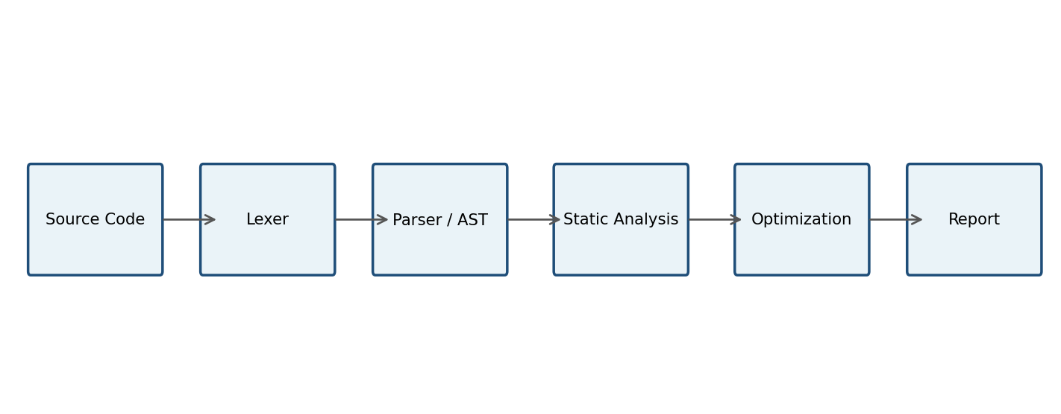

4.2 Workflow Description
- User enters or uploads C source.
- Input validation checks file type and size.
- Lexer produces tokens and source locations.
- Parser validates syntax and creates an AST.
- Symbol table records declarations and scopes.
- Static rules inspect declarations, usages and control flow.
- Optimization rules detect constant expressions and conditions.
- Report generator combines diagnostics and statistics.
- Frontend displays the final report.

4.3 Why the Graphic Matters
This pipeline diagram can be reused in the final report, presentation, viva, and project poster. It visually demonstrates that CodeGuard is based on compiler-design stages rather than being only a web form.

5. NON-FUNCTIONAL REQUIREMENTS

5.1 Performance
ID | Requirement | Target
NFR-PERF-01 | Normal analysis P95 latency | ≤ 2 sec
NFR-PERF-02 | Normal analysis P99 latency | ≤ 5 sec
NFR-PERF-03 | Maximum source size | 500 KB
NFR-PERF-04 | Concurrent analysis requests | 20
NFR-PERF-05 | Small-input throughput | ≥ 5 requests/sec
NFR-PERF-06 | Per-analysis memory target | ≤ 256 MB

5.2 Security
- Submitted C code shall never be executed.
- Production API shall use HTTPS/TLS.
- Input size and content type shall be validated.
- Diagnostics shall be safely rendered to prevent XSS.
- Rate limiting should be enabled for public deployment.
- Internal stack traces shall not be returned to users.
- Logs shall avoid unnecessary complete source-code storage.

5.3 Availability & Recovery
- Production target: 99.9% monthly availability.
- Target RPO for optional persisted history: 24 hours.
- Target RTO: 4 hours.
- One malformed request must not crash the service.

5.4 Accessibility
The UI targets WCAG 2.1 AA: keyboard navigation, visible focus, semantic labels, accessible status messages, adequate contrast, and non-color-only error indicators.

6. DATA SPECIFICATIONS

6.1 Data Model
Entity | Key Fields | Purpose
User | user_id, email, created_at | Optional if accounts are introduced
Analysis | analysis_id, user_id, language, status, duration | One analysis request
SourceCode | source_id, analysis_id, source_text, source_hash | Submitted source
Diagnostic | diagnostic_id, analysis_id, rule_id, severity, line, message | Detected issue
Statistics | analysis_id, variable_count, errors, warnings, suggestions | Summary metrics

6.2 Relationships
- One user may have many analyses.
- One analysis may have one source record.
- One analysis may have many diagnostics.
- One analysis has one statistics summary.

6.3 Persistence Strategy
A database is optional for Version 1. The simplest implementation is stateless analysis with no permanent source storage. If history is required, SQLite is suitable for local demonstration; a managed relational database can be used for later deployment.

6.4 Privacy & Retention
- Do not permanently store source code unless history is explicitly implemented.
- If history is enabled, source code may be retained for 30 days by default.
- Analysis metadata and diagnostics may be retained for 90 days.
- Application logs should be retained for 30 days and should not contain full source code.

7. ERROR HANDLING, EDGE CASES & QUALITY

7.1 Error Handling Matrix
Scenario | System Response
Empty source | Display INPUT_EMPTY; do not call analyzer.
Unsupported file | Display INPUT_UNSUPPORTED_TYPE.
Source too large | Reject with INPUT_TOO_LARGE.
Invalid token | Show lexical error and location.
Syntax error | Show syntax error; dependent stages may stop.
Unknown identifier | Show undeclared-variable error.
Duplicate declaration | Show duplicate-declaration error.
Constant division by zero | Show error.
Unreachable statement | Show warning.
Constant condition | Show warning/suggestion.
Backend unavailable | Show SERVICE_UNAVAILABLE.
Unexpected exception | Return safe error ID; log technical detail server-side.

7.2 Quality Attributes
Attribute | Requirement
Maintainability | Separate lexer, parser, semantic rules, optimizer and reporting.
Testability | Each rule must have independent unit tests.
Extensibility | New rules should not require rewriting the UI.
Reliability | Malformed input must not crash the service.
Usability | Diagnostics must be understandable to a student.
Scalability | Stateless API design should support horizontal scaling.

7.3 Definition of Done
- All Must requirements implemented.
- Core demo produces expected categories of results.
- Automated tests cover lexer, parser, semantic rules and API.
- Source code is never executed.
- UI separates errors, warnings and suggestions.
- Setup and run instructions are documented.

8. TEAM PLAN & TEST STRATEGY

8.1 Three-Member Work Allocation
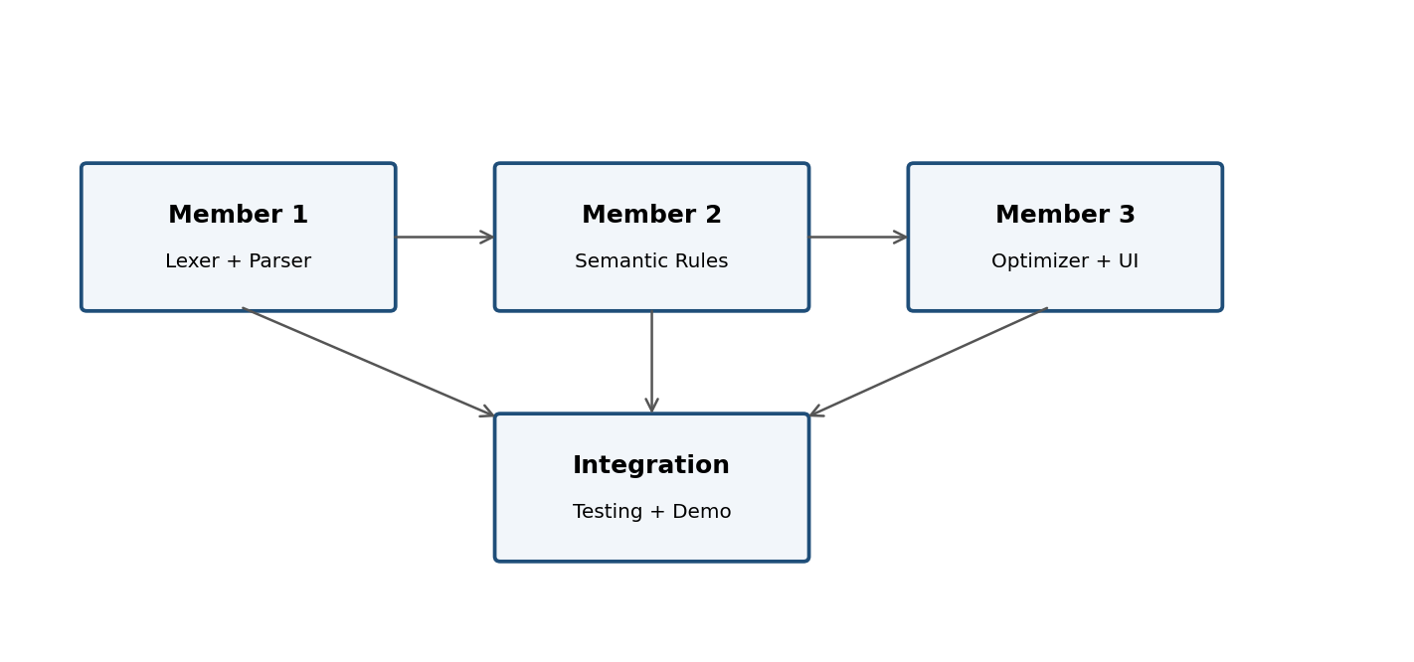
Member | Primary Ownership | Deliverables
Member 1 | Lexical + Syntax | Lexer, token model, parser, AST, lexer/parser tests
Member 2 | Semantic Analysis | Symbol table, duplicate/undeclared/unused/division/unreachable rules
Member 3 | Optimization + UI | Optimizer, report UI, API integration, statistics, end-to-end tests

8.2 Test Levels
- Unit tests: individual token, parser, symbol-table and rule behavior.
- Integration tests: lexer → parser → semantic analyzer → report.
- API tests: request validation and response schema.
- UI tests: editor, Analyze button, result rendering and accessibility.
- Performance tests: 1 KB, 10 KB, 100 KB and 500 KB inputs with concurrent requests.
- Security tests: oversized input, malformed JSON, XSS payloads and confirmation that source is never executed.

9. ACCEPTANCE & TRACEABILITY

9.1 Core Acceptance Test Matrix
Test ID | Input / Scenario | Expected Result
TC-01 | Valid C declaration | Lexical + syntax pass
TC-02 | Unused variable | Warning FR-SEM-04
TC-03 | Duplicate variable | Error FR-SEM-02
TC-04 | Undeclared variable | Error FR-SEM-03
TC-05 | 10 / 0 | Division-by-zero error
TC-06 | Statement after return | Unreachable warning
TC-07 | if (10 > 5) | Constant-condition warning
TC-08 | 10 + 20 | Constant-expression suggestion
TC-09 | 500 KB input | Accepted within configured limit
TC-10 | Input > 500 KB | Rejected safely
TC-11 | Malformed API JSON | HTTP 400
TC-12 | 20 concurrent small analyses | System remains responsive

9.2 Requirements Traceability
Requirement Group | Primary Tests
FR-INPUT | TC-01, TC-09, TC-10
FR-LEX | TC-01
FR-SYN | TC-01
FR-SEM | TC-02 through TC-07
FR-OPT | TC-07, TC-08
FR-REPORT | TC-01 through TC-08
API | TC-10 through TC-12
NFR-PERF | TC-12
SEC | TC-10, security test suite
UI | Manual/UI automation suite

9.3 Final Acceptance Statement
CodeGuard is accepted for the academic project when all Must requirements are implemented, core acceptance tests pass, the demonstration workflow produces the expected diagnostic categories, and the application can be run from documented setup instructions.

9.4 Suggested Graphics for the Final SRS
- System architecture diagram — use diagrams.net (draw.io) for a clean technical diagram.
- Compiler pipeline diagram — use diagrams.net or Figma.
- Team responsibility diagram — use Canva for a polished visual.
- UI wireframe — use Figma.
- For a distinctive academic report, combine technical diagrams from diagrams.net with a consistent Canva/Figma cover and section graphics.
Source basis: The original project proposal defines CodeGuard as a mini static analyzer and lists the same three-person division and core analysis features expanded in this compact SRS.

