**CLCP: 1100**

**Name: Jaswant Singh**

**Student ID: 100995271**

**AWS Architecture Project: Oshawa Public Library (OPL)**

Project Link: <https://github.com/jaswantsingh1000/test.git>

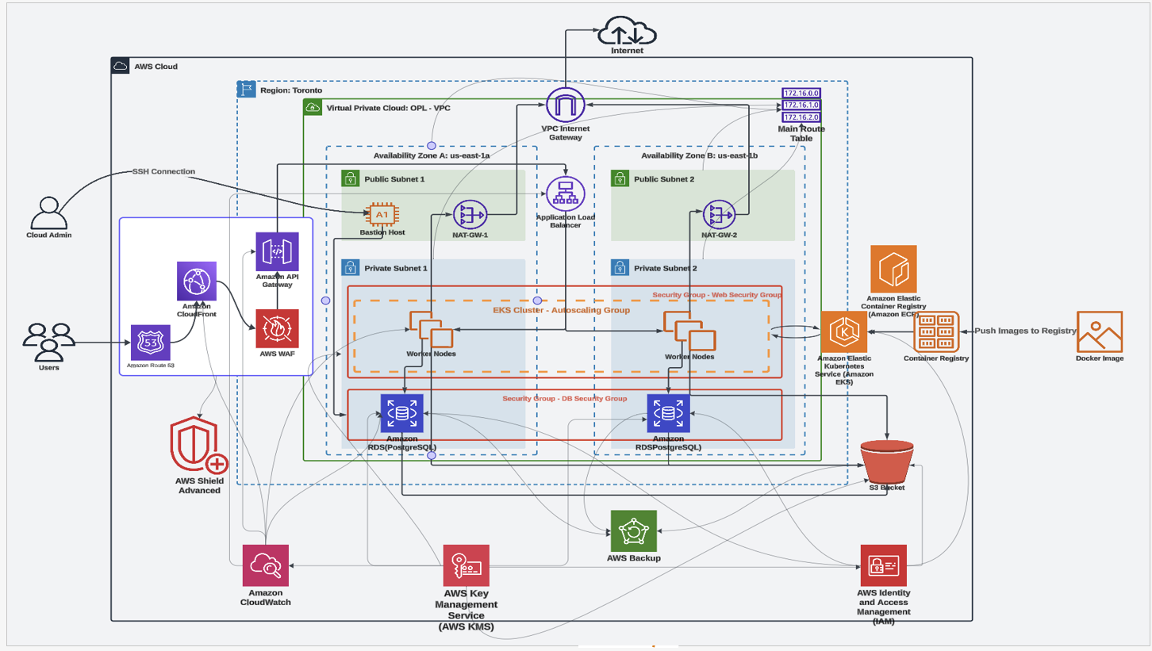

**Why You Selected This Project:**

The AWS Architecture for the Oshawa Public Library is a meaningful problem to tackle as a group, a real world problem with a local government impact that will provide valuable experience for all involved. The project sought to increase digital accessibility, scalability and efficiency with the use of cloud based solutions. Its alignment with our interest in using cloud technology for the benefit of the public made it an ideal fit for our own focus on leveraging cloud technology to improve education and digital transformation in the community libraries play a key role in.

**What Did You Learn from Creating This Project?**

This project taught us several crucial aspects of cloud computing:

1. **AWS Service Integration:** Integrating all this AWS services like EC2, S3, RDS and Lambda required us to build a robust and scalable architecture.

2. **Design Principles:** Using cloud architecture best practices such as high availability, fault tolerance, cost optimization, we learned how to apply.

3. **Collaboration and Project Management:** During the design and deployment phases the project was incredibly dependent upon the effectiveness of teamwork and clear communication.

**What Would You Do Differently If You Could Start Again?**

If we were to restart this project, we would:

1. Plan and test more time for the deployment of services implementation to catch their potential problems.

2. Use more automation like AWS CloudFormation or Terraform to provision infrastructure as so on.

3. Take actions in the early stage of the process to improve the security, for instance, via IAM policies and multi factor authentication.

**Did This Project Spur Interests in Other Domains?**

Yes, this project sparked interest in several adjacent domains:

1. **Data Analytics and AI:** When we worked with AWS, we were able to follow the trend of incorporating analytics tools such as AWS QuickSight or artificial intelligence services like SageMaker to offer insights and automation in library operations.

2. **Cybersecurity:** This motivated us to investigate advanced security tools and frameworks to help secure cloud environments.

3. **DevOps Practices:** Therefore, managing and deploying services in AWS motivated us to get deeper into CI/CD pipelines and containerization using tools like Kubernetes and Docker.

**Would You Undertake This Project Again?**

Absolutely! Apart from offering learning experiences, the project also helped the digital transformation of the library system. Going back to this project would give us the opportunity to leverage on newer tools and technologies, improve our approach over time and expand its limitations on what is possible with a cloud based library system.