**6 Week Training Report**

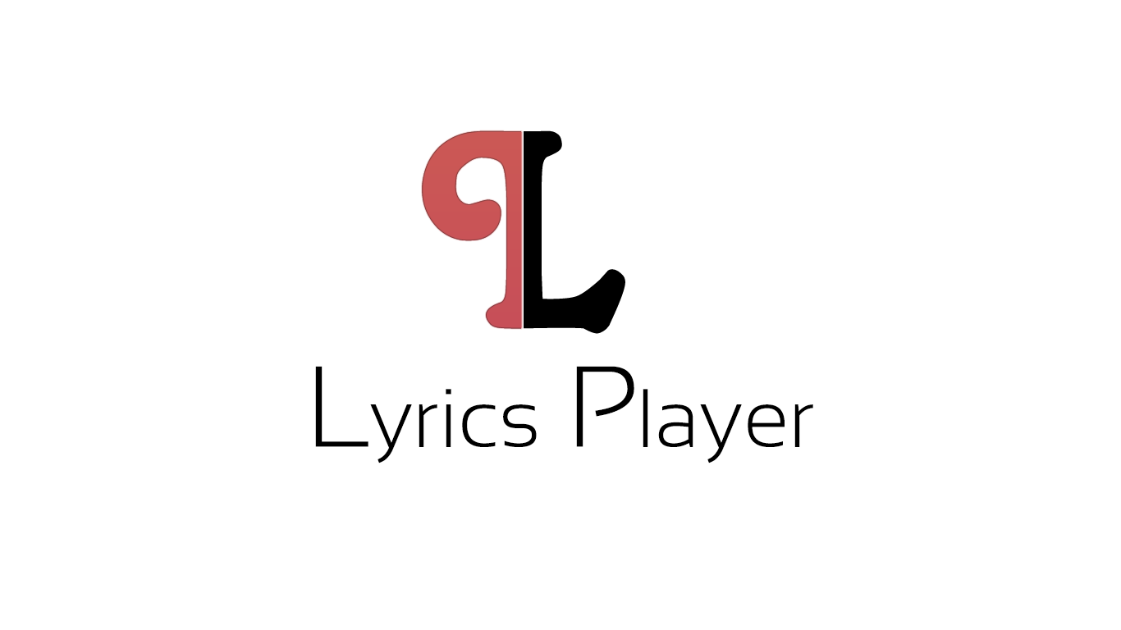

Submitted for the partial fulfilment of the Degree

of

Bachelor of Technology

(Computer Science & Engineering.)



**Submitted By: Submitted to:**

**Baljeet** Singh Sukhjit Singh

1183691 (Assistant Professor)

CSE Department Training Co-ordinator

Department of Computer Science & Engineering

Guru Nanak Dev Engineering College

Ludhiana 141006

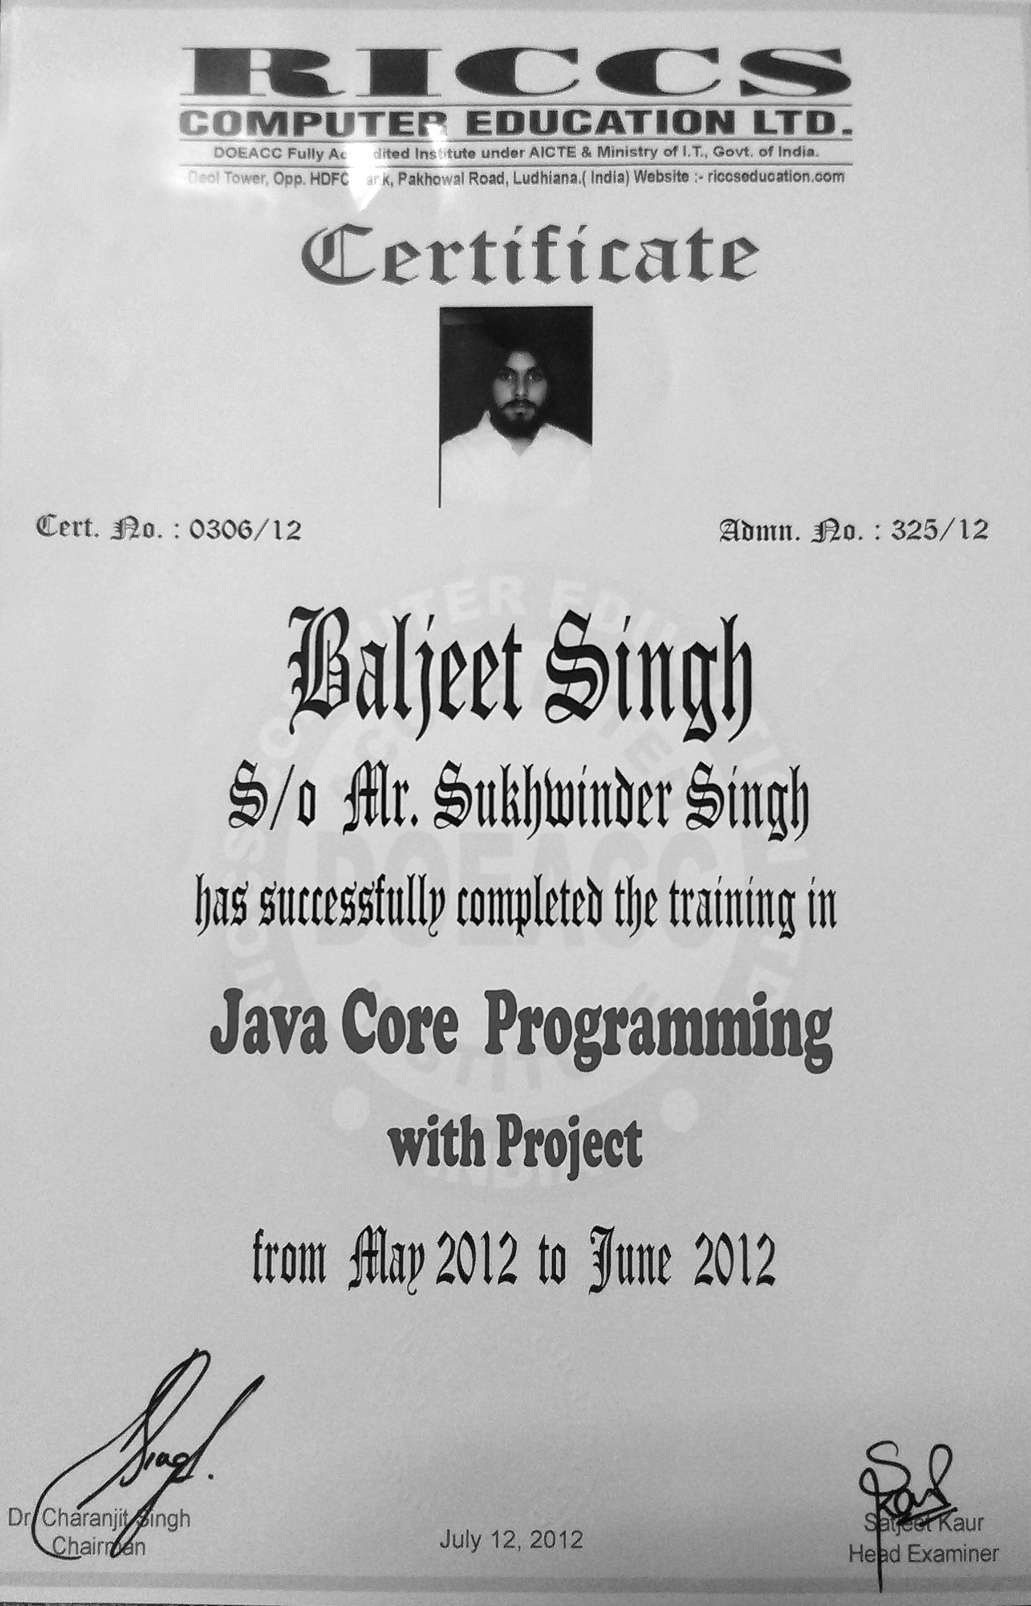

**Acknowledgement**

“Outstanding achievements are not possible in vacuums. It needs a lot of help and assistance beside a healthy environment, luckily we have.”

Nothing concrete can be achieved without an optimal combination of inspiration and perspiration. No work can be accomplished without taking the guidance of the experts. It is only the views and advice from ingenious intellectual that help in the transformation of a product into a quality product.

There are many people who helped us in this project. First of all I would like to thank God, and then I would like to thank **RICSS Computer Education** Training centre’s whole staff who taught us in a very innovative way of their teaching. We owe my sincere gratitude to **Miss Satjeet Kaur** our honourable project guide during our practical training from **RICCS Computer Education**. Her help and support made us confident about the success and worth of the project.

Last but not the least our sincere thank goes to our **Er. Kulwinder Singh Mann, Er.Sukhjit Singh** and our **H.O.D. Er. Amanpreet Singh Brar** for guided us to take training .

My thanks and appreciations also go to my colleague in developing the project and people who have willingly helped me out with their abilities.

Baljeet Singh

**CONTENTS**

|  |  |  |
| --- | --- | --- |
| **S. No.** | **Title** | **Page No.** |
|  | **Introduction**   * **Purpose** * **Scope** * **Definitions, Acronyms and Abbreviations** * **Technology to be used** * **Overview** | **5-10**  **5**  **5**  **5-6**  **6-8**  **9** |
| **2.** | **Overall Description**   * **Product Perspective** * **Product Functions** * **User Characteristics** * **Constraints** * **Use-Case Model Survey** * **Database design** * **Assumptions and Dependencies** | **10-12**  **10**  **10**  **10**  **10**  **11**  **12**  **12** |
| **3.** | **Specific Requirements**   * **External Interface required** * **Supplementary Requirements** | **13-14**  **13**  **13-14** |
| **4.** | **Supporting Information** | **15** |
| **5.** | **Appendices** | **16-33** |
| **6.** | **Introduction to Company(RICSS)** | **34** |
| **7.** | **Bibliography and References** | **35** |

**1. Introduction**

Lyrics player is a fully functional mp3 player with Unicode lyrics support built in. Here there are two windows mp3 window and lyrics window. In mp3 window you can see the song while playing. You can create playlists, open playlists, add or remove specific songs in the mp3 window. And in the lyrics window you can see the lyrics of the songs which you are playing.

**1.1) Purpose**

The purpose of this project is to provide a single fully functional GUI mp3 player & to provide a full Unicode lyrics support built in (which is not available before in any other player). Thus this a single integrated mp3 player and lyrics player that solves our purpose for which the project has made.

**1.2) Scope**

The scope of this project is widespread. It can run on any system with JDK installed. The lyrics database of this project is online, which means you can search for lyrics from any system which is connected to the internet.

**1.3) Definitions, Acronyms and Abbreviations**

* ***Java****-* Java allows you to play online games, chat with people around the world, calculate your mortgage interest, and view images in 3D, just to name a few. It's also integral to the intranet applications and other e-business solutions that are the foundation of corporate computing.
* ***J.D.K****:-* JDK stands for Java Development Toolkit. The Java Development Kit (JDK) is an Oracle Corporation product aimed at Java developers. Since the introduction of Java, it has been by far the most widely used Java Software Development Kit (SDK). On 17 November 2006, Sun announced that it would be released under the GNU General Public License (GPL), thus making it free software. This happened in large part on 8 May 2007; Sun contributed the source code to the OpenJDK.
* ***JRE****:-*JRE is an abbreviation for Java Runtime Environment. Java is a programming language and since it is a newer language, it is not natively supported by all operating systems. Therefore, a Java Runtime Environment is required for Java applets and Java applications to run. JRE is developed by Sun Microsystems Inc. and includes the Java Virtual Machine libraries and components, which are necessary to run programs that are written in Java. The JRE is available for multiple computer platforms, including Mac, Windows, and UNIX, and provides a runtime environment in which Java programs can run.
* **JVM**:- A Java virtual machine (JVM) is a virtual machine that can execute Java bytecode. It is the code execution component of the Java software platform. A JVM is distributed along with a set of standard class libraries that implement the Java application programming interface (API). These libraries, bundled together with the JVM, form the Java Runtime Environment (JRE).

**1.4 Technology to be Used**

**1.4.1) Introduction to Java**

As stated in Java language white paper by Sun Microsystems: "Java is a simple, object-oriented, distributed, interpreted, robust, secure, architecture neutral, portable, multithreaded, and dynamic."

* **Java is simple:** Partially modelled after C++, Java has replaced the complexity of multiple inheritances in C++ with a simple structure called interface, and also has eliminated the use of pointers. The reason that why Java is much simpler than C++ is because Java uses automatic memory allocation and garbage collection where else C++ requires the programmer to allocate memory and to collect garbage.
* **Java is Distributed:** Distributed computing involves several computers on a network working together. Java is designed to make distributed computing easy with the networking capability that is inherently integrated into it. Writing network programs in Java is like sending and receiving data to and from a file.
* **Portability**: Program once, Run anywhere (Platform Independence) One of the most compelling reasons to move to Java is its platform independence. Java runs on most major hardware and software platforms, including Windows 95 and NT, the Macintosh, and several varieties of UNIX. Java applets are supported by all Java-compatible browsers. JAVA programs become more portable. Any hardware and operating system dependencies are removed.
* **Java is interpreted:** An interpreter is needed in order to run Java programs. The programs are compiled into Java Virtual Machine code called bytecode. The bytecode is machine independent and is able to run on any machine that has a **Java** interpreter. Normally, a compiler will translate a high-level language program to machine code and the code is able to only run on the native machine.
* **Security:** Java is one of the first programming languages to consider security as part of its design. The Java language, compiler, interpreter, and runtime environment were each developed with security in mind. The compiler, interpreter, and Java-compatible browsers all contain several levels of security measures that are designed to reduce the risk of security compromise, loss of data and program integrity, and damage to system user.
* **Reliability:** Security and reliability go hand in hand. Security measures cannot be implemented with any degree of assurance without a reliable framework for program execution. Java provides multiple levels of reliability measures, beginning with the Java language itself The Java compiler provides several levels of additional checks to identify type mismatches and other inconsistencies.
* **Multimedia: Images, Sounds and Animation:** The sizzle of JAVA is MULTIMEDIA - Sounds, Images, Graphics and Video. In this growing age of multimedia, new computers are known as "multimedia ready" with CD-ROM drives, sound cards, 3D accelerator cards and other new special sound or graphic technology capabilities.

**1.5.2) Overview of Swings**

The Swing toolkit includes a rich set of components for building GUIs and adding interactivity to Java applications. Swing includes all the components you would expect from a modern toolkit: table controls, list controls, tree controls, buttons, and labels. Swing is far from a simple component toolkit, however. It includes rich undo support, a highly customizable text package, accessibility support and integrated internationalization. To truly leverage the cross-platform capabilities of the Java platform, Swing supports numerous look and feels, including the ability to create your own look and feel. The ability to create a custom look and feel is made easier with Synth, a look and feel specifically designed to be customized. Swing wouldn't be a component toolkit without the basic user interface primitives such as drag and drop, event handling, customizable painting, and window management.

**1.5.2.1) Features of Swing**

* **Swing GUI Components:** The Swing toolkit includes a rich array of components: from basic components, such as buttons and check boxes, to rich and complex components, such as tables and text. Even deceptively simple components, such as text fields, offer sophisticated functionality, such as formatted text input or password field behaviour. There are file browsers and dialogs to suit most needs, and if not, customization is possible. If none of Swing's provided components are exactly what you need, you can leverage the basic Swing component functionality to create your own.
* **Java 2D API:** To make your application stand out; convey information visually; or add figures, images, or animation to your GUI, you'll want to use the Java 2D API. Because Swing is built on the 2D package, it's trivial to make use of 2D within Swing components. Adding images, drop shadows, compositing — it's easy with Java 2D.
* **Pluggable Look-and-Feel Support:** Any program that uses Swing components has a choice of look and feel. The classes shipped by Oracle provide a look and feel that matches that of the platform. The Synth package allows you to create your own look and feel. The GTK+ look and feel makes hundreds of existing look and feels available to Swing programs.
* **Data Transfer:** Data transfer, via cut, copy, paste, and drag and drop, is essential to almost any application. Support for data transfer is built into Swing and works between Swing components within an application, between Java applications, and between Java and native application
* **Internationalization:** This feature allows developers to build applications that can interact with users worldwide in their own languages and cultural conventions. Applications can be created that accept input in languages that use thousands of different characters, such as Japanese, Chinese, or Korean. Swing’s layout managers make it easy to honor a particular orientation required by the UI. For example, the UI will appear right to left in a locale where the text flows right to left. This support is automatic: You need only code the UI once and then it will work for left to right and right to left, as well as honour the appropriate size of components that change as you localize the text.
* **Accessibility API:** People with disabilities use special software assistive technologies that mediate the user experience for them. Such software needs to obtain a wealth of information about the running application in order to represent it in alternate media: for a screen reader to read the screen with synthetic speech or render it via a Braille display, for a screen magnifier to track the caret and keyboard focus, for on-screen keyboards to present dynamic keyboards of the menu choices and toolbar items and dialog controls, and for voice control systems to know what the user can control with his or her voice.
* **Undo Framework API:** Swing’s undo framework allows developers to provide support for undo and redo. Undo support is built in to Swing's text component. For other components, Swing supports an *unlimited* number of actions to undo and redo, and is easily adapted to an application. For example, you could easily enable undo to add and remove elements from a table.
* **Flexible Deployment Support:** If you want your program to run within a browser window, you can create it as an applet and run it using Java Plug-in, which supports a variety of browsers, such as Internet Explorer, Firefox, and Safari. If you want to create a program that can be launched from a browser, you can do this with Java Web Start. Of course, your application can also run outside of browser as a standard desktop application.

**1.5 Overview**

As the lyrics player is able to have user interface. It has drop down boxes and if we drag mouse on any control at our welcome screen, information regarding that control displays. Help menu is there. So it is complete GUI player, so it is very user friendly and made according to the user's requirements. Which will be understandable by the user with pencil and pen.

**2. OVERALL DESCRIPTION**

**2.1) Product Perspective**

Lyrics Player has single fully functional GUI mp3 player. It has full Unicode lyrics support built in (not available before in any player). It has ability to create playlists, search songs lyrics.

Lyrics Player provides a basic and easy interface to play a song and to search lyrics of song and it is possible to upload a new lyrics form user side into our database. Lyrics Player is compatible with operating systems like Windows Xp , Windows7 , Ubuntu.

**2.2) Product Functions**

The following are the product functions of the Lyrics Player:

Lyrics Player works in two modules-

1. Lyrics Window
2. mp3 player window

* **Lyrics window**: where you will see the lyrics
* **mp3 player window**: where you can see the song playing

**2.3) User Characteristics**

* Ability to play mp3 songs.
* fully functional mp3 player with lyrics module built in .
* ability to create playlists.
* ability to search songs lyrics.
* User Friendly GUI interface

**2.4) Constraints**

Compatibility of Player is only with .mp3 files. It cannot play any other format like .aac,.mp4. We can play only .mp3 files.

**2.5) Use-Case Model Survey**

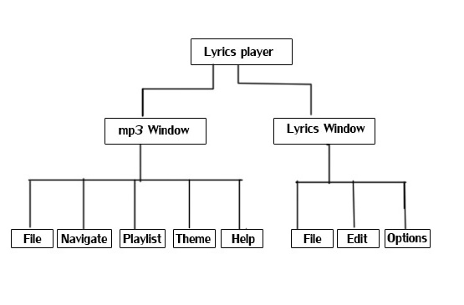

Figure no. 1 : Hierarchical Structure

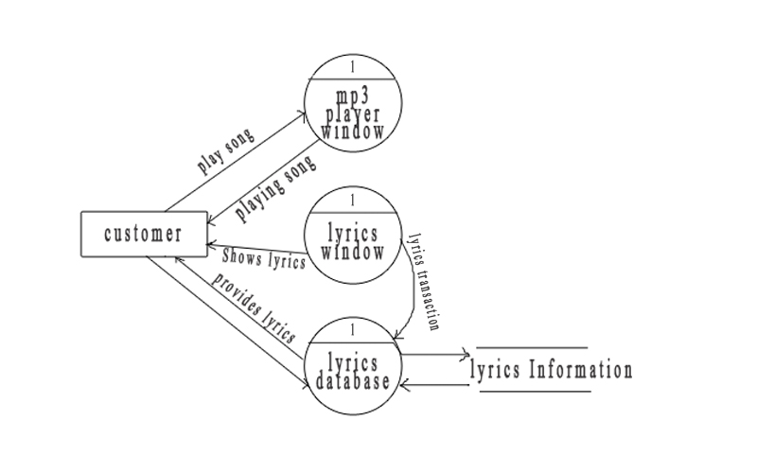

Figure no.2 : Process flow

**2.6) Database design**

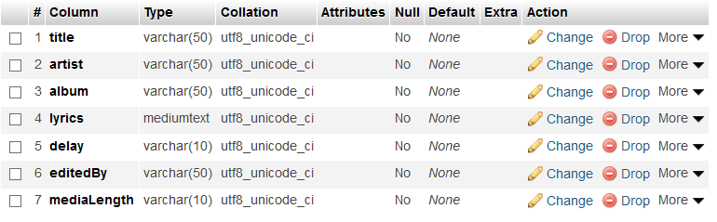

**2.7) Assumptions and Dependencies**

The nature and extent of project changes designed to resolve the program’s financing problem depend, of course, on the magnitude of the problem. Lyrics Player is CROSS PLATFORM. It can run on any system which have JRE installed.

1. **SPECIFIC REQUIREMENTS**

**3.1) External Interface Required**

**3.1.1 User Interfaces**

Lyrics Player provides Graphical User Interface. The users who can run this software are those who have access to this software and their systems meet the minimum requirements to install/run this software package.

* + 1. **Hardware Interfaces**

The external hardware interface used for accessing the Lyrics Player is the personal computers of the end users. The PCs may be laptops with wireless LAN as the internet connections provided can be wireless or wired.

* + 1. **Software Interfaces**

The Operating Systems can be any version of Windows, Linux, Unix or Mac.

**3.2 Supplementary Requirements**

**3.2.1 Software Details:-**

|  |  |
| --- | --- |
| Front End | J2SE |
| Back End | MySQL |
| Server | XAMPP |
| Operating  System | Windows XP/ Windows Vista/  Windows 7/Ubuntu/MAC |

Table:1: Software Details

**3.2.2 Hardware Details**

|  |  |
| --- | --- |
| Processor | Intel Pentium 4 or Above |
| Space | 250MB (Recommended) |
| RAM | 512 MB(min.) |

Table :2: Hardware Requirements

**4. SUPPORTING INFORMATION**

* You must install JAVA RUNTIME ENVIORNMENT.
* You must have Arial Unicode MS Font installed on your system.
* When your system met these basic requirements then start the software package(Lyrics Player).
* To play a song click on File -> Open in the mp3 window, then select song which you want to play from open dialog box and then click Open.
* Now go to Lyrics Window then click on Lyrics Search from File menu to search with suitable options like enter song title, album, artist or combination of any of three and click on Search Button. Then it will come up with suitable results based on your searched options.
* Then select suitable lyrics from the searched list then it will appear in Lyrics Window.
* There is option for edit lyrics and either user can directly edit the lyrics on his hard drive or he/she can choose other suitable options of uploading the lyrics directly to the database server.
* There are various options for customizing the software according to user needs.

**5. APPENDICES**

1. **Lyrics Editor**

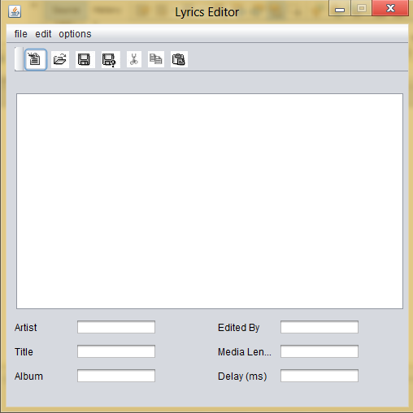

Figure no.3: Lyrics Editor

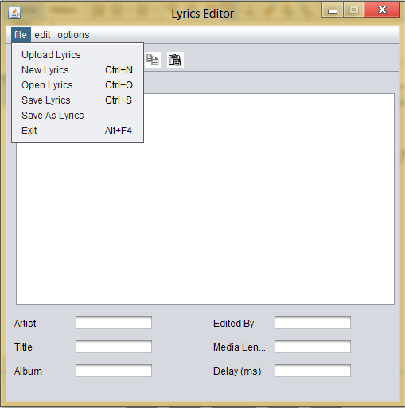

Figure no. 4: Lyrics Editor File Menu

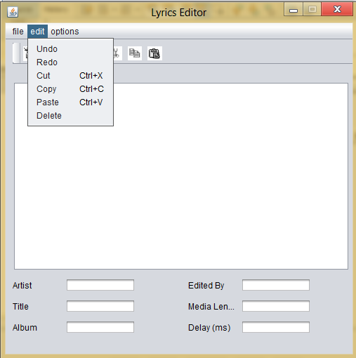

Figure no. 5: Lyrics Editor Edit Menu

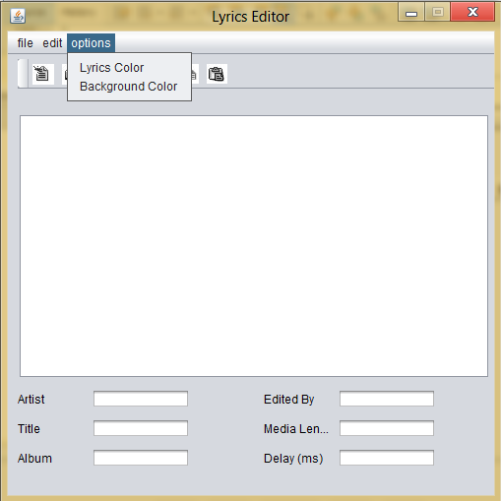

Figure no. 6: Lyrics Editor Options Menu

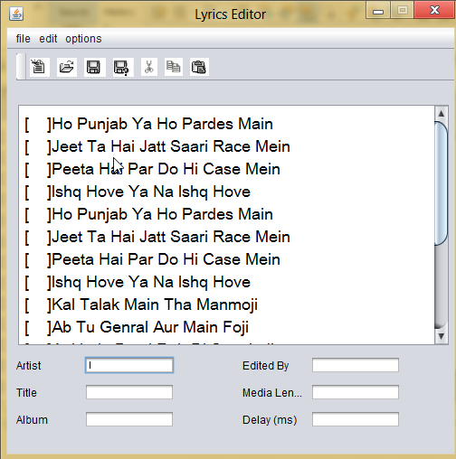

Figure no. 7: Lyrics Editor While editing Lyrics

1. **Lyrics Viewer**

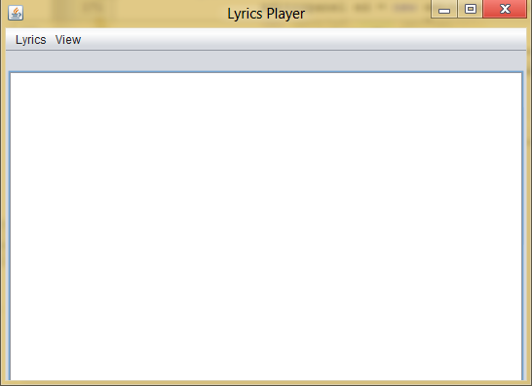

Figure no. 8: Lyrics Viewer

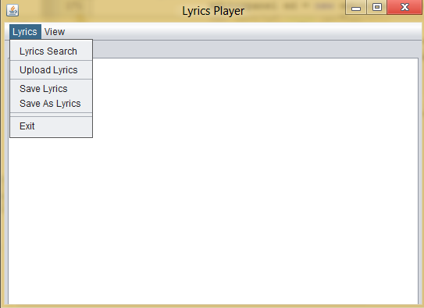

Figure no. 9: Lyrics Viewer Lyrics menu

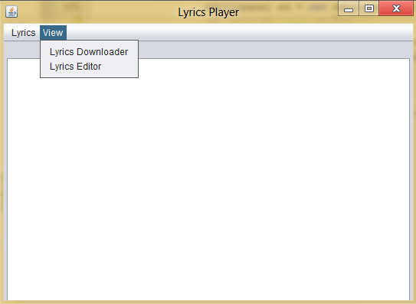

Figure no. 10: Lyrics Viewer View menu

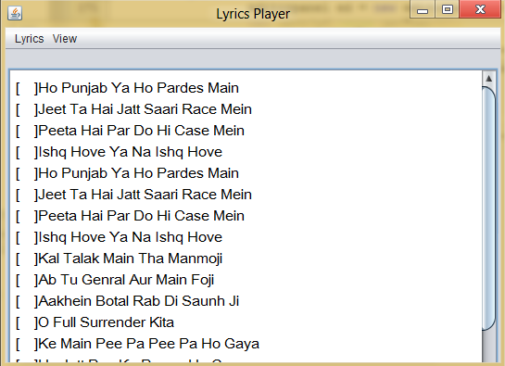

Figure no. 11: Lyrics viewer window While Opening Lyrics

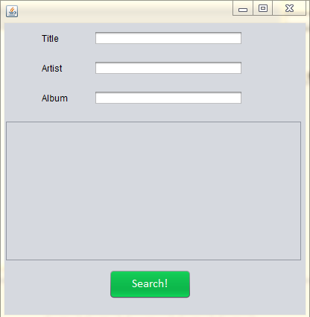

Figure no. 12: Lyrics Viewer Search Window

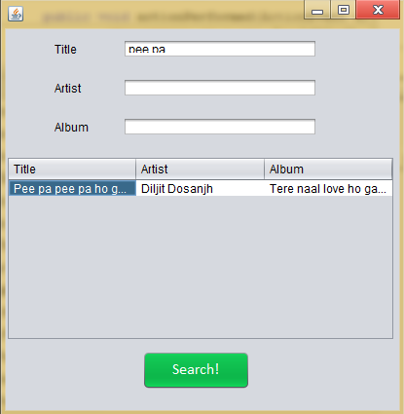

Figure no. 13: Lyrics Viewer Search Window with search query executed

**c.Mp3 window**

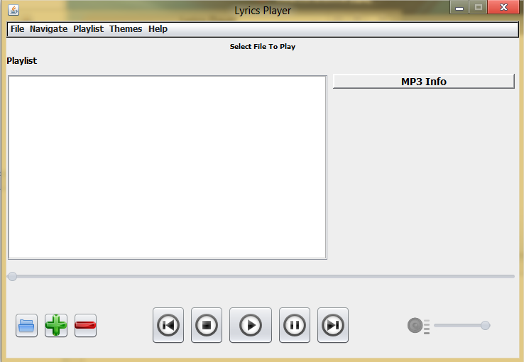

Figure no. 14: Mp3 window interface

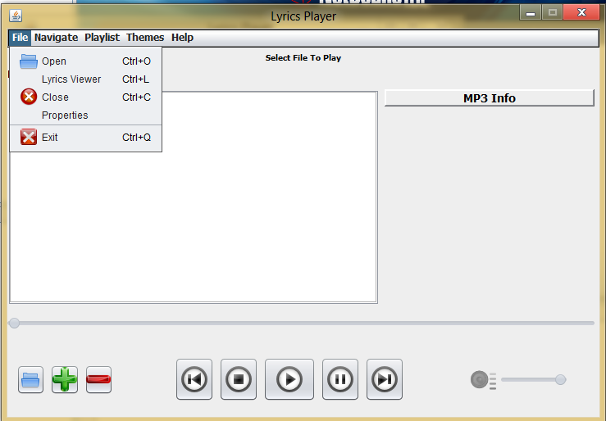

Figure no. 15: Mp3 Player File Menu

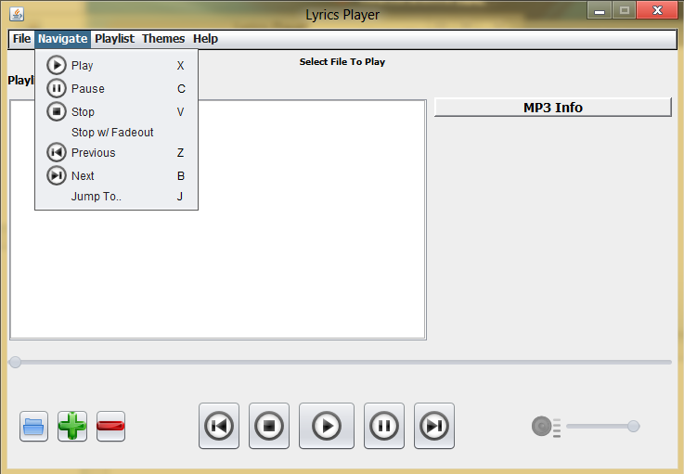

Figure no. 16: Mp3 Player Navigate Menu

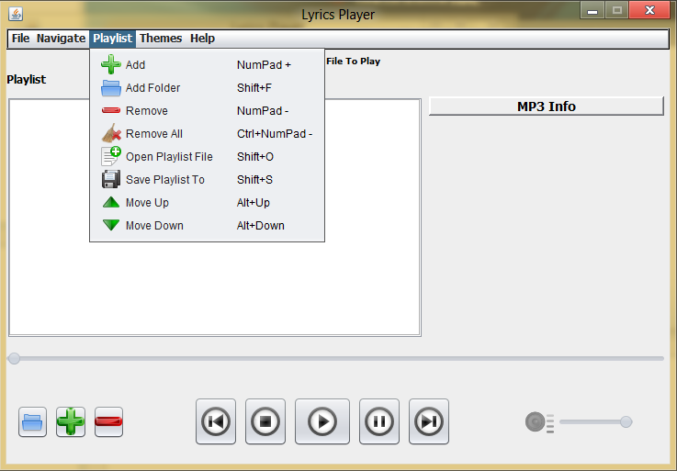

Figure no. 17: Mp3 Player Playlist Menu

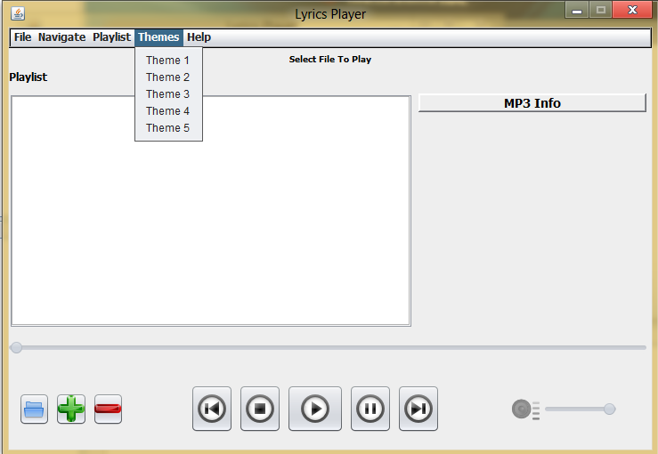

Figure no. 18: Mp3 Player Theme Menu

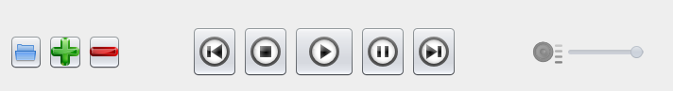

Figure no. 19:Mp3 Player Various Buttons

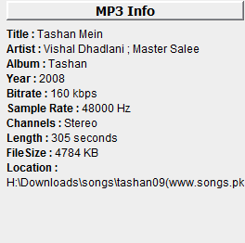

Figure no. 20: Mp3 Player Mp3 Info

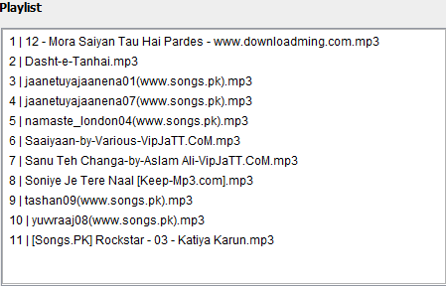

Figure no. 21: Mp3 Player Playlist view

**6. INTRODUCTION TO COMPANY: (RICCS)**

**RICCS Computer Education Ltd.** Is a public Limited Company under Companies Act 1956 and is an Accredited Computer Institute for software, Hardware & Networking Courses under **DOEACC**, Ministry of Information Technology, and Government of India. **RICCS** is the pioneer institute for preparing the professionals by imparting international standards of education in the field of the Computer applications.

**RICCS** is the only Authorized Training Centre in Punjab of ministry of Information Technology, Govt. of India having granted permission for Software as well as Hardware, Networking & Telecommunication Course.   
**RICCS** has been declared as the “Institute with best infrastructure in Punjab & Chandigarh” by Punjab Govt.

**RICCS** is Computer education Service Provider to various leading colleges & Schools.

1. Accredited institute of DOEACC, Govt of India for Software & Hardware Courses & Networking Courses.
2. Approved Study Centre of LOVELY PROFESSIONAL University, Jalandhar (Recognised by UGC) for IT and Management Courses.
3. Approved Study Centre of Karnataka State Open University (UGC recognised).
4. Approved Institute by various technical Colleges for providing Practical training to students of B. Tech / Diploma.
5. Approved Institute for importing computer training to the students of Institute of Cost & Works Accountants of India (ICWAI).
6. Approved Institute to provide computer training to Govt. & Semi-Govt. organisations.
7. Approved Practical Examination centre of O/A/B levels by DOEACC, Govt. of India
8. Approved Examination centre of Course on Computer Concepts (CCC) by DOEACC, Govt. of India.

## 

## **7. BIBLIOGRAPHY & REFERENCES**

**7.1 Bibliography**

* Java TM look and feel design Guidelines: Advanced topic by Sun Microsystems Inc.
* Advanced Java By Prentice Hall and Sun Microsystems Press.
* Patrick Naughton and Herbert Schildt **,** “The Complete Reference.
* Java 2”**,** Third edition, The Tata McGraw-Hill Edition 1999.

**7.2 References**

## [**www.w3schools.com**](http://www.w3schools.com/)

## [**www.google.com**](http://www.google.com/)

## [**www.wikipedia.com**](http://www.wikipedia.com/)

## [**www.sourcecodeonline.com**](http://www.sourcecodeonline.com/)

## [**www.onlineresources.com**](http://www.onlineresources.com/)