Ideation Phase
Brainstorm & Idea Prioritization
Date | 23 June 2026
Team ID
Project Name | RK Health – AI Smart Patient Appointment & Medication Reminder System
Maximum Marks | 4 Marks

Brainstorm & Idea Prioritization Template
Brainstorming provides a free and open environment that encourages everyone within a team to participate in the creative thinking process that leads to problem solving. Prioritizing volume over value, out-of-the-box ideas are welcome and built upon, and all participants are encouraged to collaborate, helping each other develop a rich amount of creative solutions.
This session was used to shape the RK Health concept — an AI-powered patient appointment and medication reminder system — from an open problem statement into a prioritized, buildable feature set.

Step 1: Team Gathering, Collaboration and Problem Statement
Define your problem statement
How might we help patients and caregivers stay on top of doctor appointments, medication schedules, and follow-up care — through one centralized, reminder-driven platform that also explains visit outcomes in plain language?
Traditional healthcare tracking relies on paper records, memory, and manual follow-up, which leads to missed appointments, missed doses, and fragmented health information. RK Health addresses this by combining cloud storage, automated SMS reminders, calendar integration, and AI-generated summaries into a single dashboard.

Step 2: Brainstorm, Idea Listing and Grouping
Ideas generated during the session were clustered into themes, one cluster per core module of the application:
Appointment Management
- Add/edit/delete doctor appointments with patient, doctor, date, time, notes
- Search and filter appointments by date or doctor
- Auto-generate a Google Calendar event link for each appointment
- Calendar view of upcoming visits
Medication Reminders
- Track medicine name, dosage, frequency, timing, start/end date
- SMS reminder at dose time via Twilio
- Mark reminders as taken/missed for compliance tracking
- Reminder history log per patient
AI Health Summary
- Convert doctor notes and visit details into a plain-language summary
- Use Groq (llama-3.3-70b-versatile) to generate visit overview, guidance, follow-up
- Show summary in a readable modal on the dashboard
- Store every generated summary for later reference
SMS Notifications
- Twilio-based reminders for both medications and appointments
- Delivery status tracking (sent/failed) and retry on failure
- Reminder log with timestamps
Health Reports & Records
- Consolidated patient report: appointments, medications, summaries, compliance
- Printable / PDF export
- Centralized health log searchable across all record types
Dashboard & Analytics
- Stat cards: total appointments, active reminders, compliance score
- Recent activity feed
- Auto-refresh after any add/update/delete action

Step 3: Idea Prioritization
Your team should all be on the same page about what's important moving forward. Each idea was placed on an Importance vs. Feasibility grid (0–10 scale) to decide what to build first.
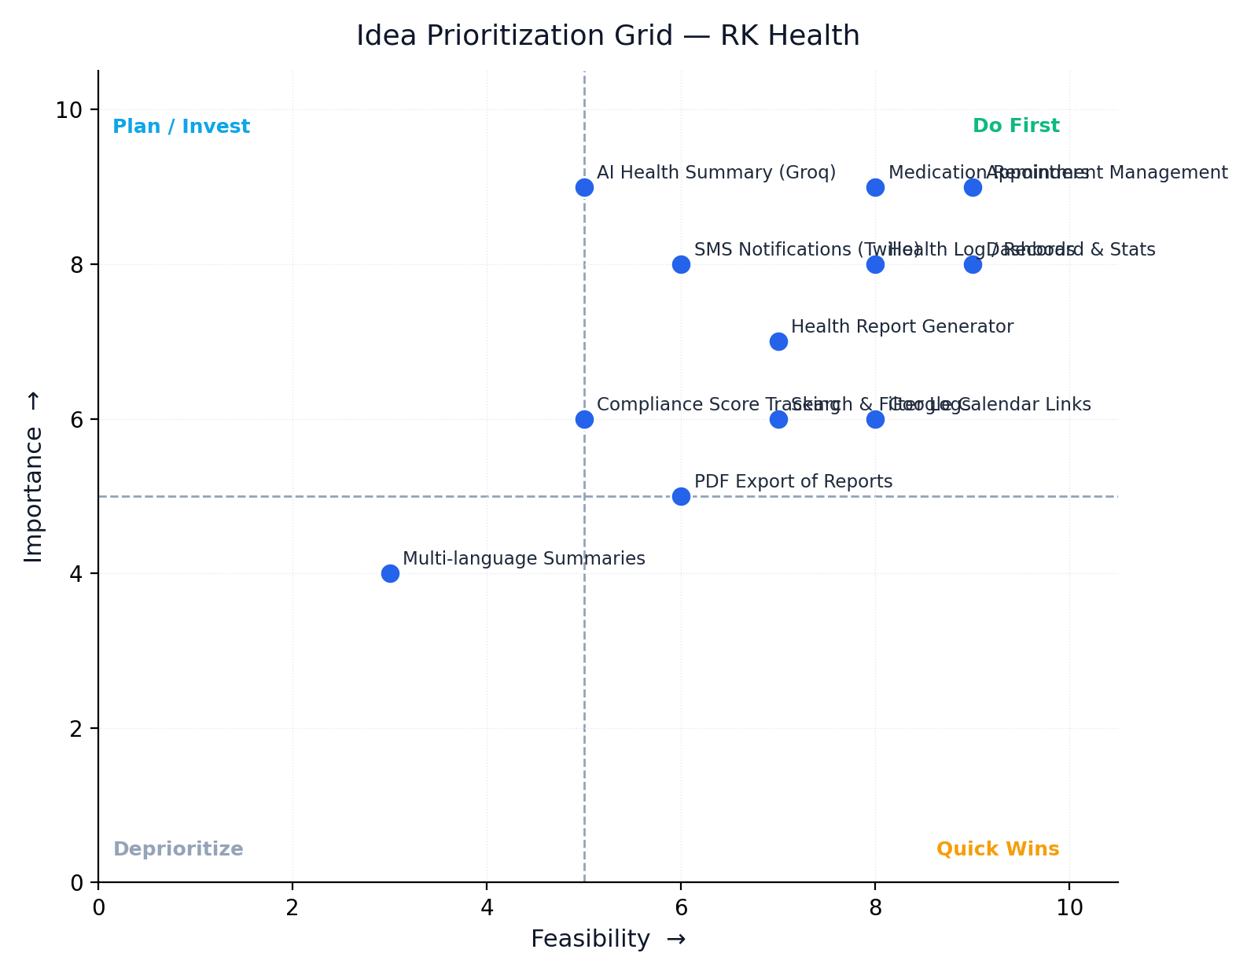
Idea | Importance | Feasibility | Quadrant
Appointment Management | 9 | 9 | Do First
Medication Reminders | 9 | 8 | Do First
Dashboard & Stats | 8 | 9 | Do First
Health Log / Records | 8 | 8 | Do First
SMS Notifications (Twilio) | 8 | 6 | Do First
AI Health Summary (Groq) | 9 | 5 | Plan / Invest
Health Report Generator | 7 | 7 | Do First
Google Calendar Links | 6 | 8 | Quick Win
Compliance Score Tracking | 6 | 5 | Quick Win
PDF Export of Reports | 5 | 6 | Quick Win
Search & Filter Logs | 6 | 7 | Quick Win
Multi-language Summaries | 4 | 3 | Deprioritize

Outcome: Appointment Management, Medication Reminders, the Dashboard, Health Logs, SMS Notifications, and the Health Report Generator are high-importance and highly feasible — these form the MVP built in the first development milestone. The AI Health Summary feature is equally important but depends on external AI service integration, so it's planned as a fast-follow. Calendar links, compliance scoring, PDF export, and search/filter are quick wins layered in once the MVP is stable. Multi-language summaries are deprioritized for a future release.

