Ideation Phase
Empathize & Discover
Date | 23 June 2026
Team ID
Project Name | RK Health – AI Smart Patient Appointment & Medication Reminder System
Maximum Marks | 4 Marks

Empathy Map Canvas:
An empathy map is a simple, easy-to-digest visual that captures knowledge about a user's behaviours and attitudes.
It is a useful tool to help teams better understand their users. Creating an effective solution requires understanding the true problem and the person who is experiencing it. The exercise of creating the map helps participants consider things from the user's perspective along with his or her goals and challenges.
RK Health — Primary Persona: Patient using the appointment & medication reminder system
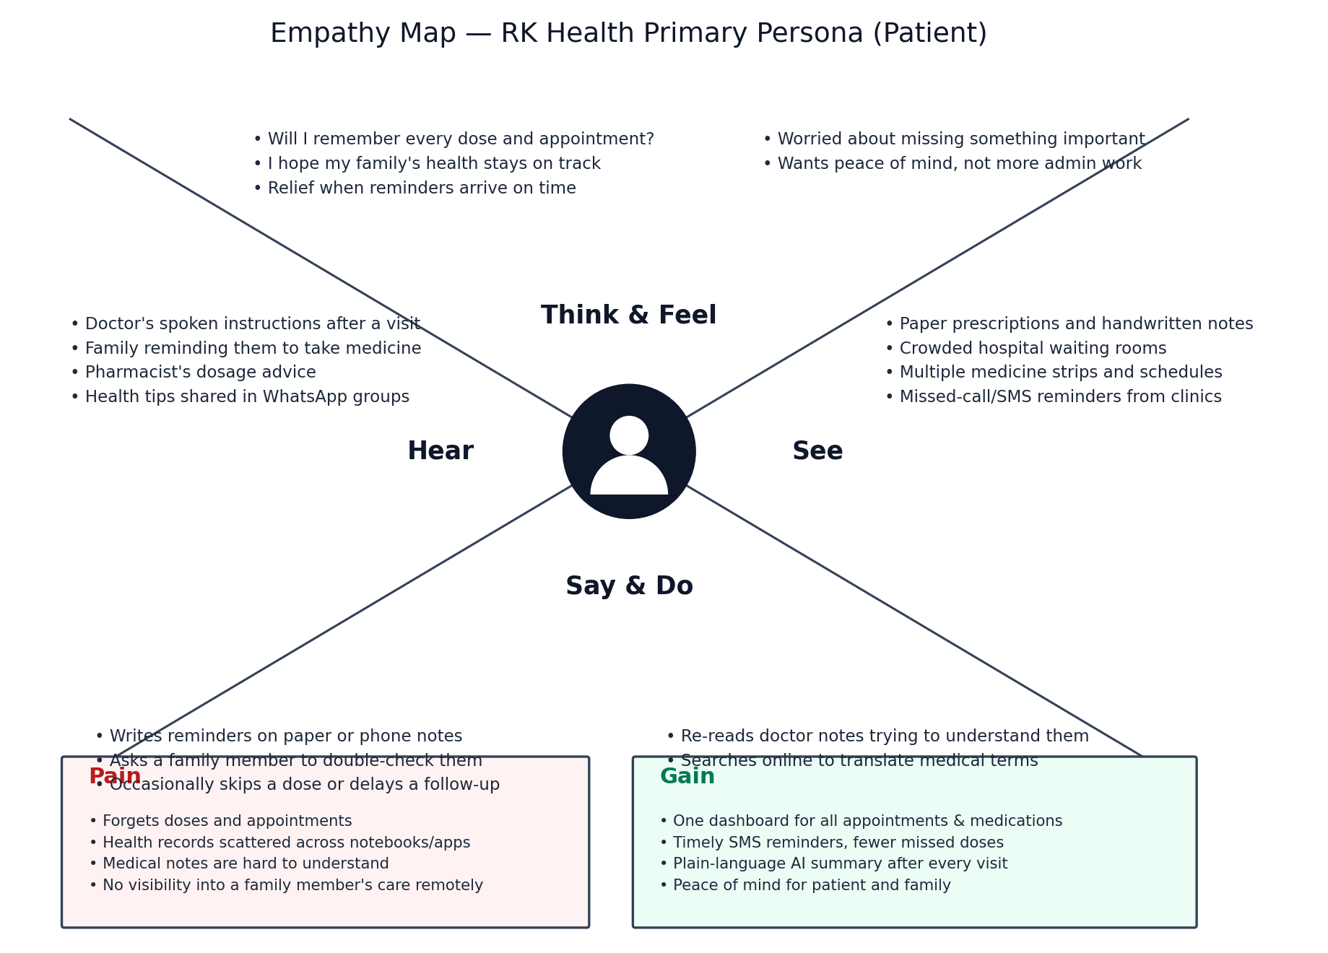
Key Insight
Patients and caregivers aren't struggling because they don't care about health — they're struggling because appointment details, medication schedules, and doctor instructions live in disconnected places (memory, paper, scattered messages) with no reminders tying them together. RK Health's core value is turning that scattered information into one dashboard with automatic reminders and a plain-language AI summary after every visit, directly addressing the Pain items above and delivering the Gains patients and caregivers want.

