Project Design Phase-II
Data Flow Diagram & User Stories
Date | 23 June 2026
Team ID
Project Name | RK Health – AI Smart Patient Appointment & Medication Reminder System
Maximum Marks | 4 Marks

Data Flow Diagrams:
A Data Flow Diagram (DFD) is a traditional visual representation of the information flows within a system. A neat and clear DFD can depict the right amount of the system requirement graphically. It shows how data enters and leaves the system, what changes the information, and where data is stored.
DFD Level 0 — Context Diagram
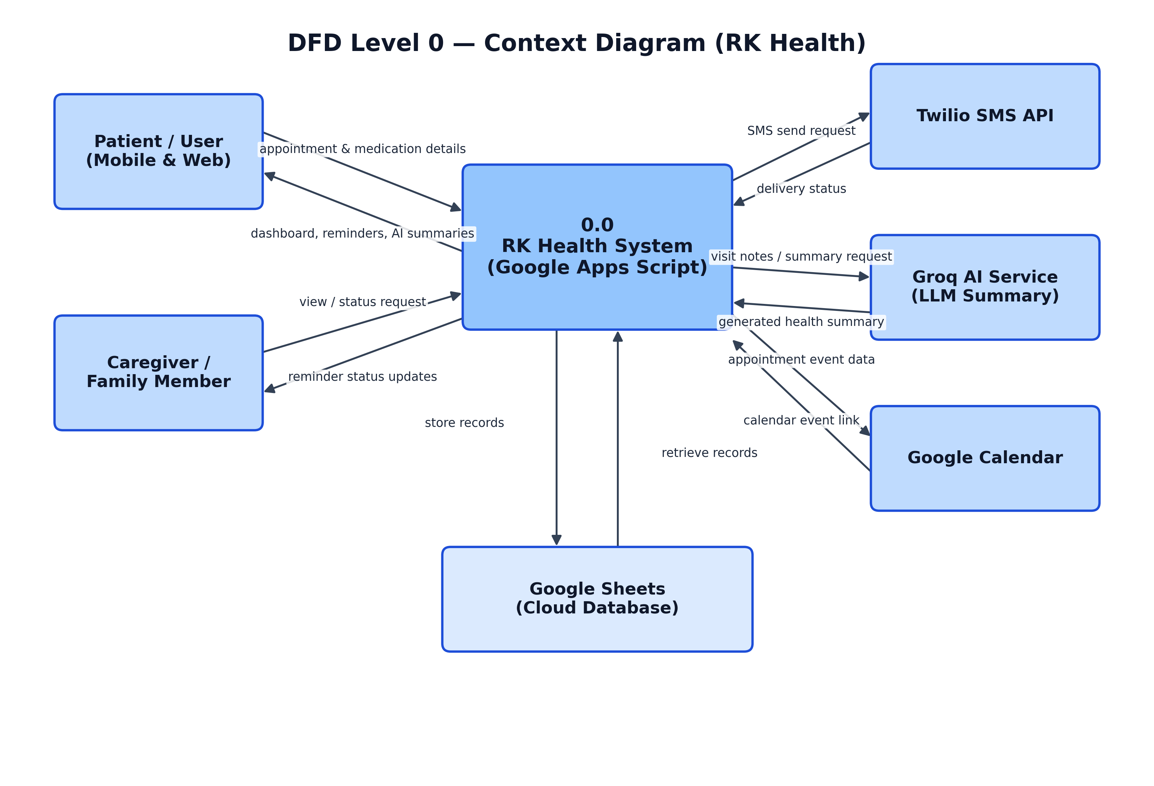
DFD Level 1 — Detailed Process Diagram
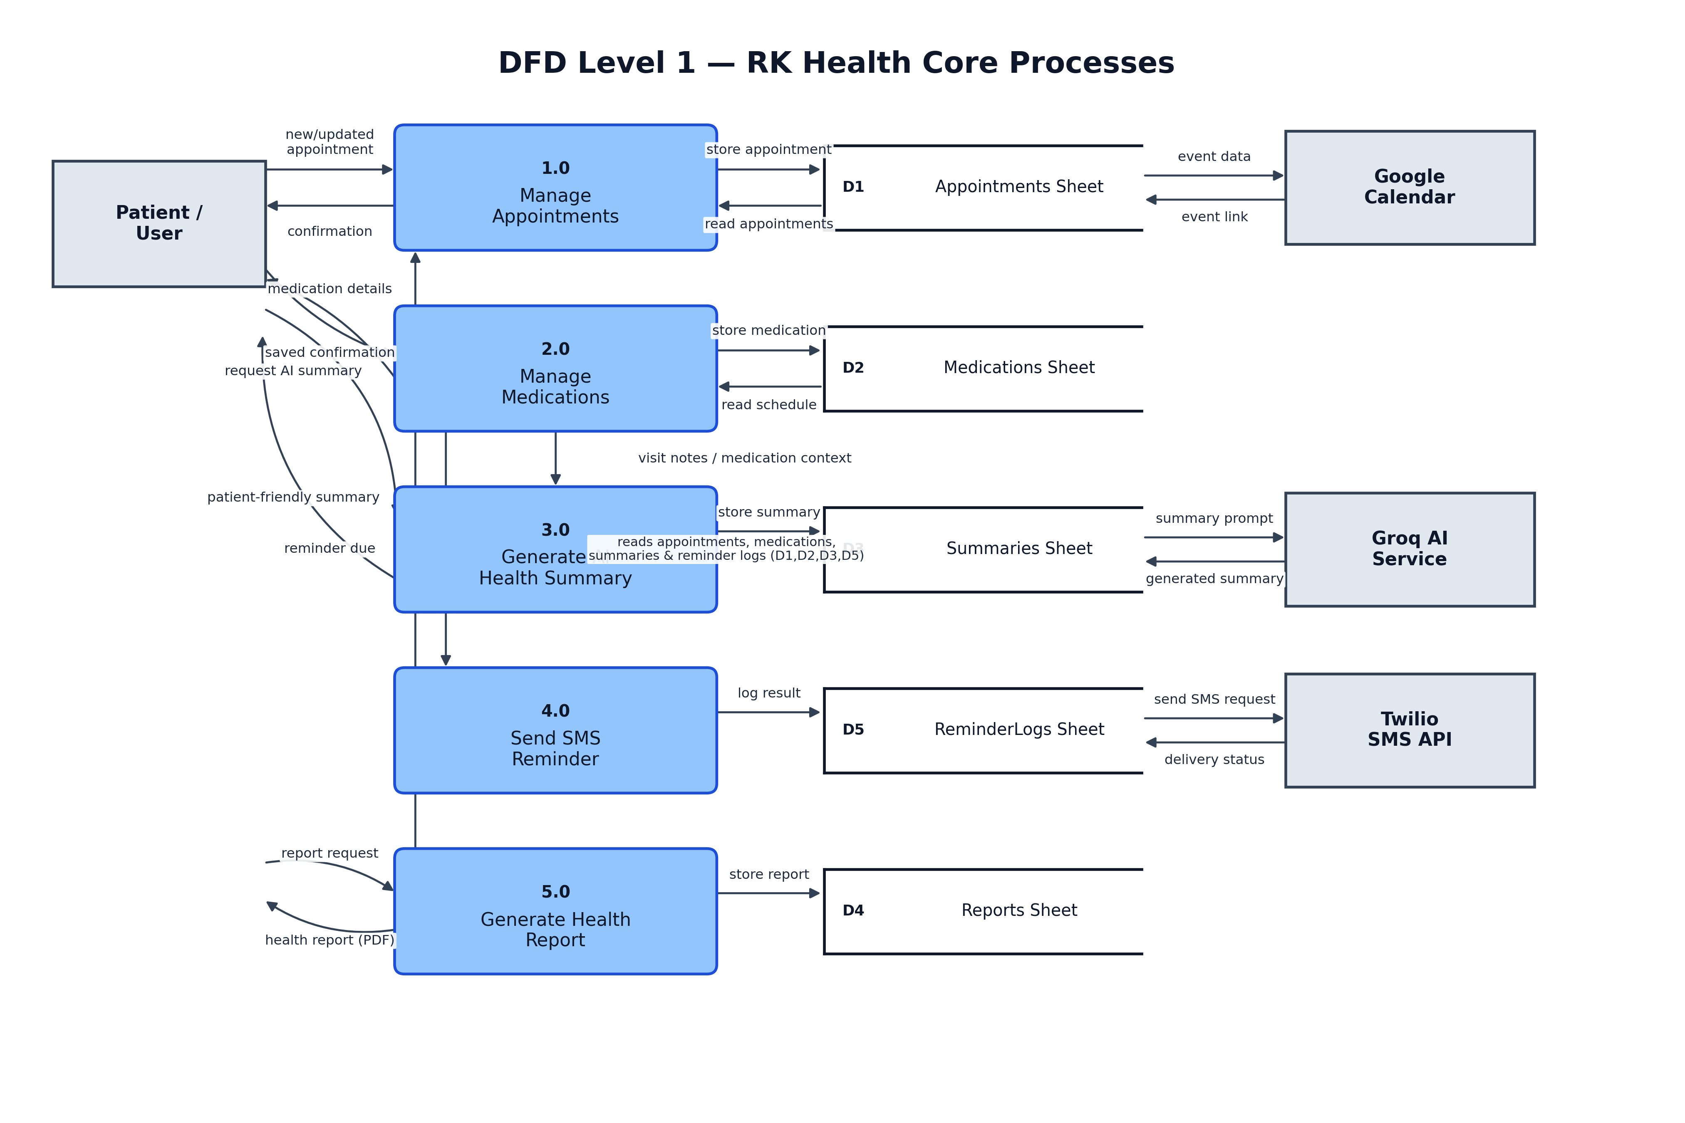
User Stories
Use the below template to list all the user stories for the product.
User Type | Functional Requirement (Epic) | User Story Number | User Story / Task | Acceptance Criteria | Priority | Release
Patient (Mobile/Web User) | Registration | USN-1 | As a patient, I can register by entering my name, email, phone number, and password. | I can create an account and access my dashboard. | High | Sprint-1
 |  | USN-2 | As a patient, I receive a confirmation email/SMS after registering. | I receive and can confirm the registration message. | High | Sprint-1
 |  | USN-3 | As a patient, I can register using my Google account. | I can register and reach the dashboard via Google login. | Low | Sprint-2
 | Login | USN-4 | As a patient, I can log in using my email and password. | I am authenticated and redirected to the dashboard. | High | Sprint-1
 |  | USN-5 | As a patient, I can reset my password if I forget it. | I receive a reset link by email and can set a new password. | Medium | Sprint-2
 | Dashboard | USN-6 | As a patient, I can view stat cards for appointments, active reminders, and compliance score. | Dashboard stats load correctly and refresh after any change. | High | Sprint-1
 | Appointment Management | USN-7 | As a patient, I can add a new appointment with doctor, date, time, and notes. | The appointment is saved and appears in the appointment list. | High | Sprint-1
 |  | USN-8 | As a patient, I can edit or delete an existing appointment. | The change is reflected instantly on the dashboard. | High | Sprint-2
 |  | USN-9 | As a patient, I can generate a Google Calendar link for an appointment. | I can add the event to my calendar in one click. | Medium | Sprint-2
 | Medication Reminders | USN-10 | As a patient, I can add a medication with dosage, frequency, and timing. | The medication is saved and a reminder is scheduled. | High | Sprint-1
 |  | USN-11 | As a patient, I receive an SMS reminder at dose time. | I receive an SMS with medicine name, dosage, and time. | High | Sprint-2
 |  | USN-12 | As a patient, I can mark a dose as taken or missed. | The compliance score updates on the dashboard. | Medium | Sprint-2
 | AI Health Summary | USN-13 | As a patient, I can generate an AI summary from my visit notes. | A patient-friendly summary is generated and displayed within seconds. | High | Sprint-3
 |  | USN-14 | As a patient, I can view past AI summaries in my health log. | Summary history is displayed in date order. | Medium | Sprint-3
 | Health Reports | USN-15 | As a patient, I can generate a consolidated health report. | The report includes appointments, medications, summaries, and compliance. | High | Sprint-3
 |  | USN-16 | As a patient, I can export or print my health report as a PDF. | A correctly formatted PDF downloads successfully. | Medium | Sprint-3
Caregiver (Family Member) | Remote Monitoring | USN-17 | As a caregiver, I can view a linked family member's upcoming appointments and medication schedule. | The caregiver dashboard reflects the patient's data in real time. | Medium | Sprint-3
 | Reminder Confirmation | USN-18 | As a caregiver, I receive a notification when the patient marks a dose taken or missed. | The caregiver is notified promptly and accurately. | Low | Sprint-4
Administrator | System Monitoring | USN-19 | As an administrator, I can view system-wide statistics such as total users and SMS delivery success rate. | Stats accurately reflect the underlying Google Sheets data. | Medium | Sprint-4
 | Data Management | USN-20 | As an administrator, I can view failed SMS deliveries and trigger a retry. | Failed logs are visible and retry updates the delivery status. | Low | Sprint-4

