Project Design Phase-II
Technology Stack (Architecture & Stack)
Date | 23 June 2026
Team ID
Project Name | RK Health – AI Smart Patient Appointment & Medication Reminder System
Maximum Marks
Technical Architecture:
The diagram below illustrates the end-to-end architecture of RK Health, including the frontend dashboard, the Google Apps Script backend, and the connected cloud storage and external services.
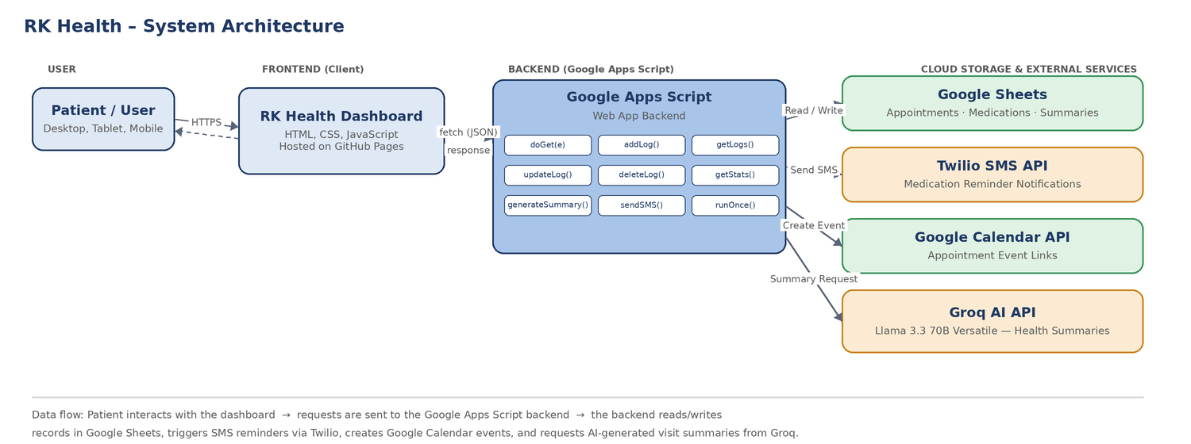
Table-1: Components & Technologies
S.No | Component | Description | Technology
1. | User Interface | Responsive web dashboard through which patients view and manage appointments, medications and reports. | HTML5, CSS3, JavaScript
2. | Application Logic-1 | Handles appointment and medication CRUD operations (add, view, update, delete records). | Google Apps Script (JavaScript)
3. | Application Logic-2 | Prepares patient visit data and generates AI-based health summaries. | Google Apps Script + Groq API
4. | Application Logic-3 | Formats phone numbers, triggers medication reminder messages and tracks delivery status. | Google Apps Script + Twilio SDK
5. | Database | Stores patient records, appointments, medication schedules and reminder status. | Google Sheets (structured rows/columns)
6. | Cloud Database | Cloud-hosted spreadsheet database accessible to the backend at all times. | Google Sheets (Cloud)
7. | File Storage | Stores static frontend assets such as icons, fonts and stylesheets. | GitHub Pages (static hosting)
8. | External API-1 | Sends SMS notifications for medication and appointment reminders. | Twilio SMS API
9. | External API-2 | Creates appointment event links for patients to add to their calendars. | Google Calendar API
10. | Machine Learning Model | Generates short, patient-friendly summaries from visit notes and health logs. | Groq — Llama 3.3 70B Versatile
11. | Infrastructure (Server / Cloud) | Frontend hosted as a static site; backend deployed as a serverless web app.  Local Server Configuration: Not applicable (serverless)  Cloud Server Configuration: Google Apps Script Web App + GitHub Pages | GitHub Pages, Google Cloud (Apps Script runtime)
Table-2: Application Characteristics
S.No | Characteristics | Description | Technology
1. | Open-Source Frameworks | Frontend built without heavy frameworks for fast load times; uses open-source icon and font libraries. | Font Awesome, Google Fonts
2. | Security Implementations | API keys (Groq, Twilio) stored as environment variables and excluded from version control; input validation on all forms before processing. | Environment variables, .gitignore, input validation
3. | Scalable Architecture | Serverless backend and cloud-based spreadsheet storage allow the system to handle growth in users and records without infrastructure changes. | Google Apps Script (serverless), Google Sheets
4. | Availability | Frontend and backend are hosted on managed cloud platforms with high uptime, removing dependency on a single local server. | GitHub Pages, Google Apps Script Web App
5. | Performance | Asynchronous fetch-based requests keep the dashboard responsive; AI summaries are generated using a fast inference model. | Fetch API, Groq low-latency inference

