Project Design Phase
Solution Architecture
Date | 23 June 2026
Team ID
Project Name | RK Health – AI Smart Patient Appointment & Medication Reminder System
Maximum Marks
Solution Architecture:
Solution architecture is a complex process — with many sub-processes — that bridges the gap between business problems and technology solutions. Its goals are to:
- Find the best tech solution to solve existing business problems.
- Describe the structure, characteristics, behavior, and other aspects of the software to project stakeholders.
- Define features, development phases, and solution requirements.
- Provide specifications according to which the solution is defined, managed, and delivered.
RK Health – Solution Architecture Diagram:
The diagram below shows how patient requests flow from the dashboard through the Google Apps Script backend to cloud storage and external services, and how responses and notifications flow back.
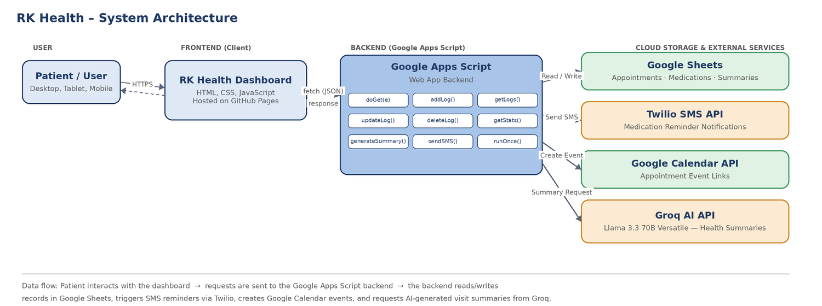
Figure 1: Architecture and data flow of the RK Health application

