**LIBRARY MANAGEMENT SYSTEM DATABASE**

**JASWITHAKOMATIGUNTA B.TECH 2ND YEAR ,ECE**

**ROLL NO :194130**

**Komati_961921@student.nitw.ac.in**

**PROBLEM STATEMENT**

The aim of the project is to make a database for library books management to maintain books by staff and maintain a track of readers with the help of records and update books time to time, through the site which is normalized to maximum extent.

**ENTITIES AND THEIR ATTRIBUTES**

**BOOK :** book name, isbn number, price, category, edition.

**READER:** readername, readerid , phone number , address.

**AUTHOR :** name , dob , age , address , phone number.

**RECORDS :** readerid , reg no, return date, issue date , status.

**STAFF :** staff name, satffid, phone ,loginid.

**PUBLISHER :** isbn number, year of publication , publisherid , name.

**ER DIAGRAM**

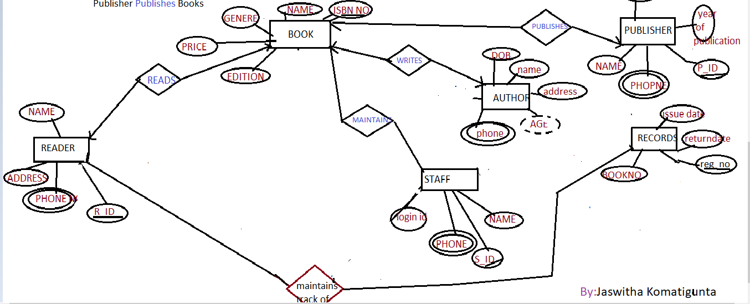

**RELATIONAL SCHEMA**

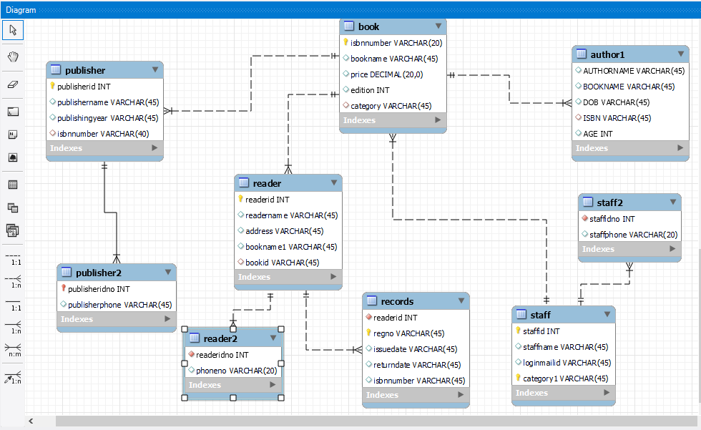

**TABLES IN DATABASE**

BOOKS

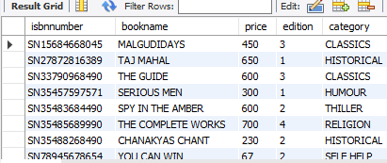

READER

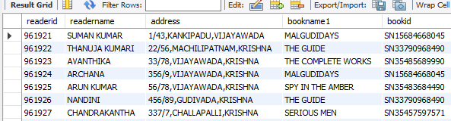

READER2

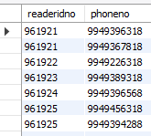

AUTHOR

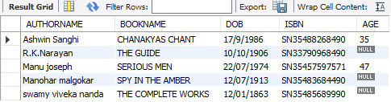

STAFF

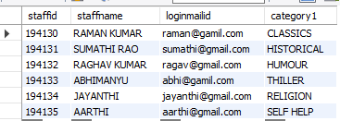

STAFF2

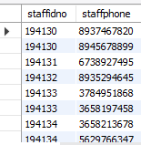

RECORDS

