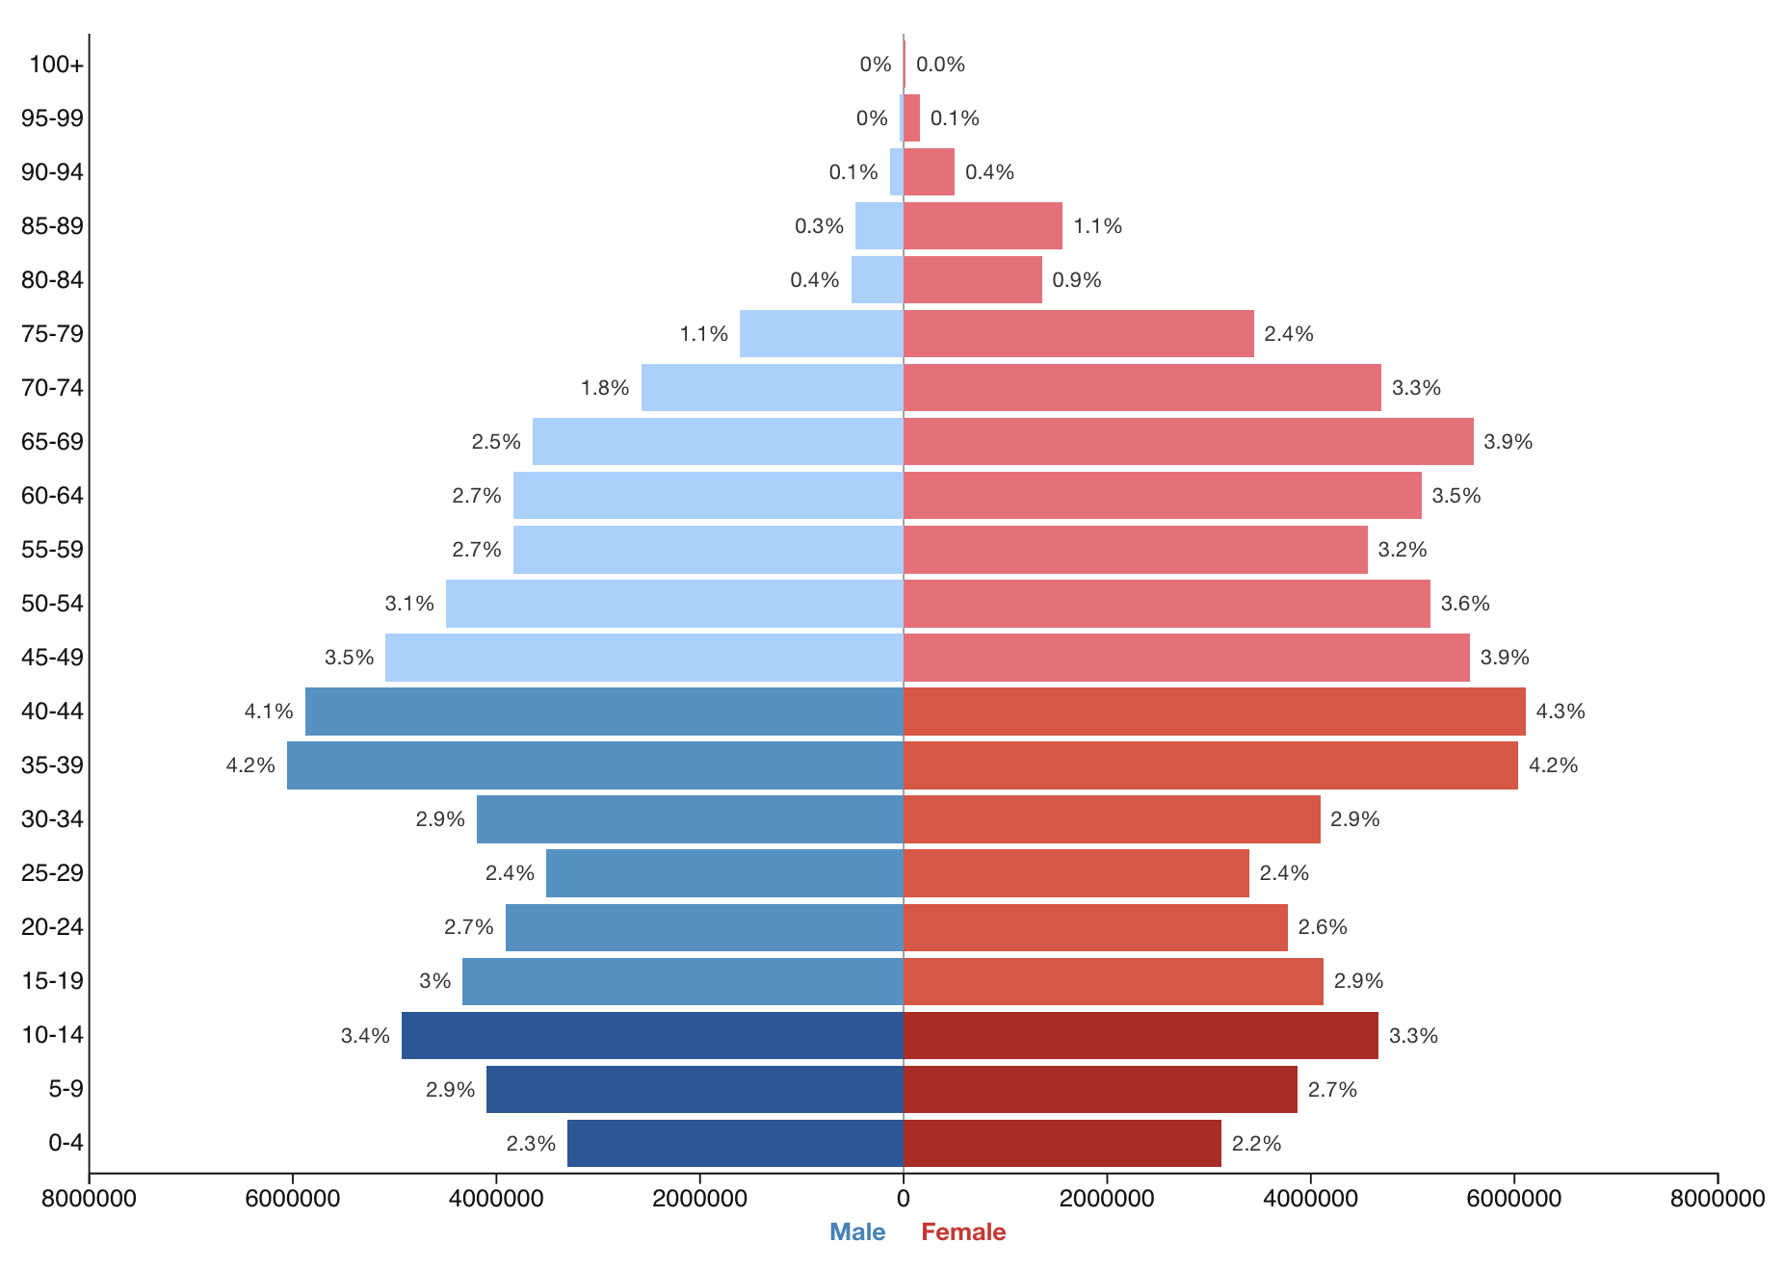
The demographic pyramid of the Russian Federation

- The demographic pyramid of the Russian federation divided by biological sex: Male and Female. Also, include the age range form 0 - 100+ and the estimated population rate.
- The main concept of making demographic pyramid is visualisation of population data. In our example, the population of Russian citizens by age and sex illustated in our chart.
- Demographic (population) pyramids are graphical representations of age and sex distribution, categorized into three main types based on growth rates:
A. Expansive (wide base, rapid growth)
B. Constrictive (narrow base, aging/declining population)
C. Stationary (rectangular, stable growth).

- The demographic pyramid of the Russian federation is analyzed through two main levels of decomposition:

- Biological Sex: The horizontal split between males (left) and females (right)

- Three Age Cohorts: The vertical axis is decomposed into functional socio-economic groups:
A. Children (0–15): The "base" of the pyramid.
B. Working Age (16–64): The "body" or bulk of the pyramid.
C. Elderly (65+): The "peak."

