Exercise 04: Types of Decomposition

Part 1: Analysis of the decomposition in Figure 3

1.1. Goal and Type of Decomposition
- Goal: To describe the process of preparing breakfast.
- Type: Functional decomposition, as it attempts to break down the process into consistent actions or functions.

1.2. Number of Decomposition Levels
There are two levels of decomposition depicted below the root "Breakfast" element.
- Cook an egg
- Make buttered toast

1.3. Decomposition Errors

1. Violation of the Singularity of Criterion Rule:
- The decomposition mixes criteria. It presents a sequence of actions (a process flow) rather than a hierarchical breakdown based on a single, consistent criterion for each level. For example, "Pour water into a kettle" and "Boil water" are sequential steps, not a logical subdivision of a parent function at that level.
2. Violation of the Integrity (Completeness) Rule:
- The breakfast menu is defined as "boiled egg, buttered toast, juice, tea". The decomposition completely omits the preparation of the boiled egg and the juice.
3. Violation of the Subordination Rule:
- Elements of different hierarchical importance are placed at the same level. For instance, "Make tea" (a high-level function) is shown at the same level as "Pour tea into a cup" (a low-level sub-task of making tea).

1.4. Corrected Functional Decomposition
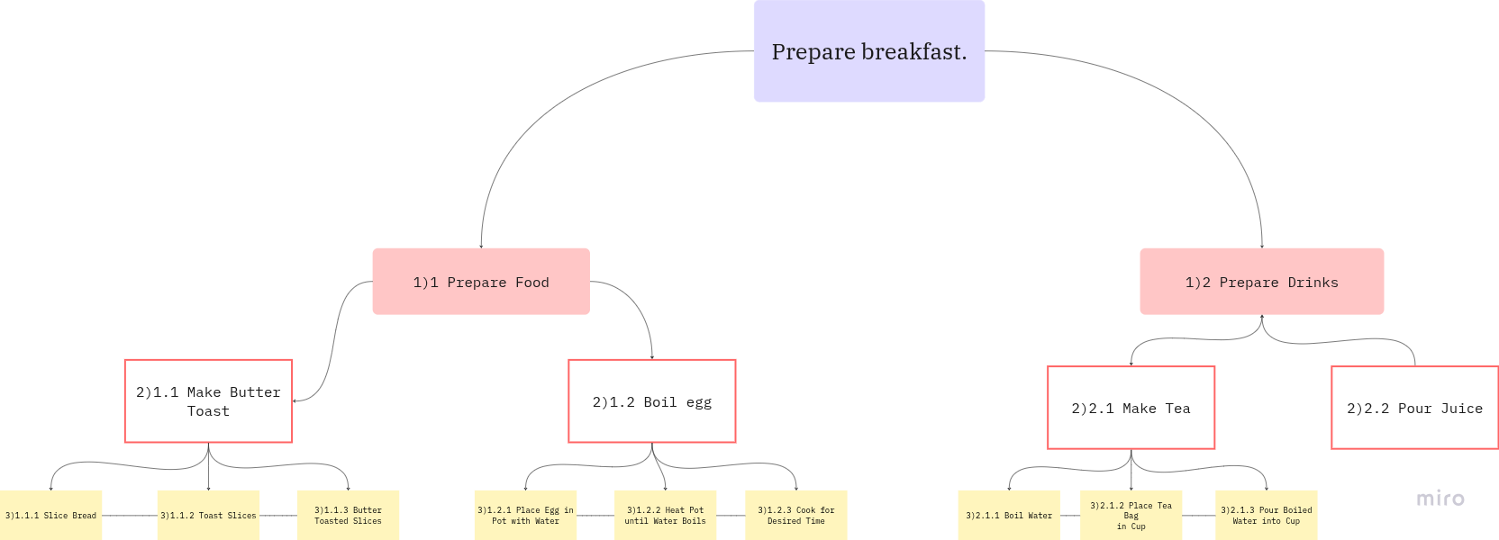
A corrected functional decomposition would look like this:

Part 2: Object Decomposition of Breakfast

2.1. Goal of the Decomposition
- Goal: To identify and structure the constituent parts (components) of the final breakfast meal.

2.2. Object Decomposition (to Level 2)
