Exercise 05 — Types of Decomposition

1. Decomposition of couriers' actions.

Goal of decomposition: Identification of functions.

Type of decomposition: Functional decomposition.

Decomposition:
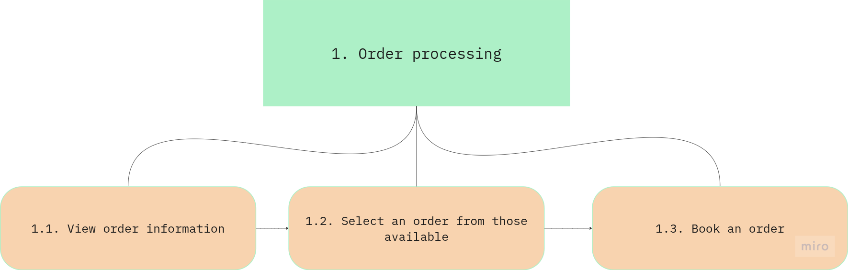
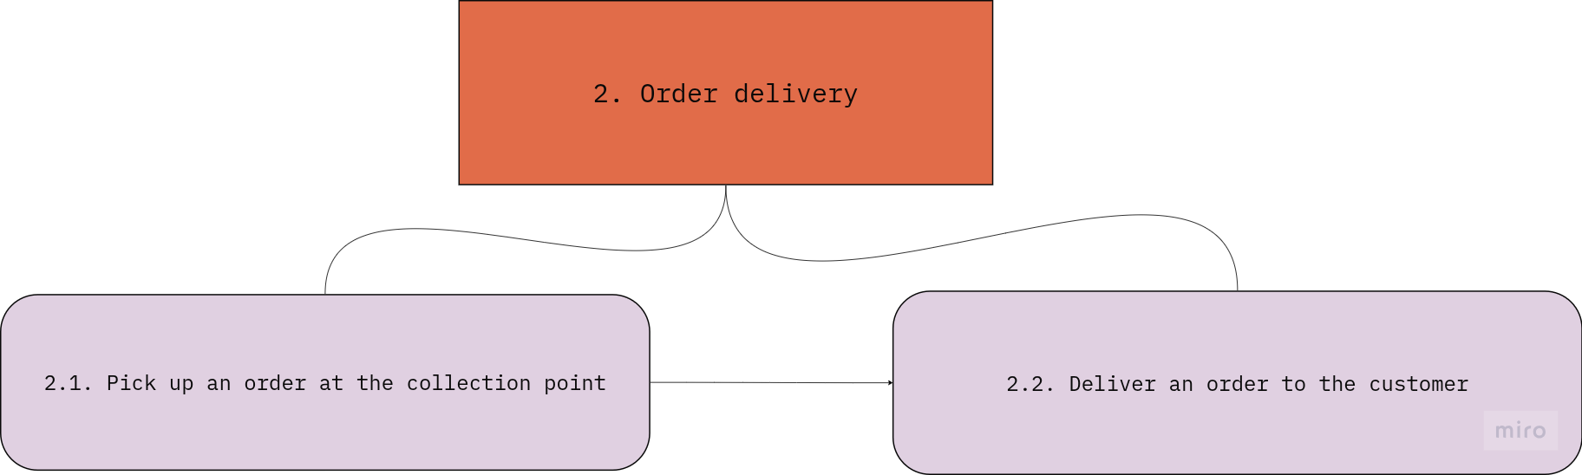

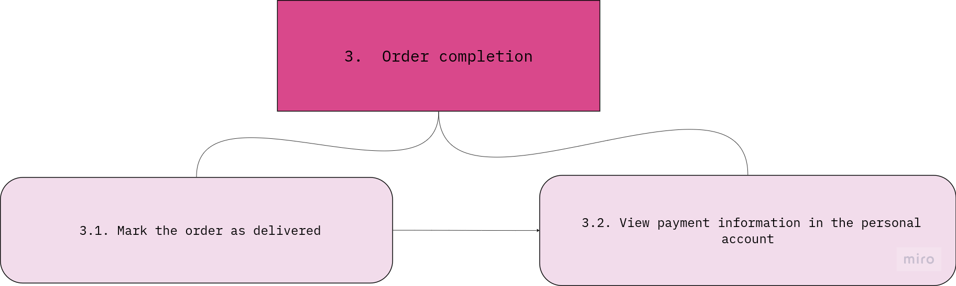

2. Object decomposition of the actors (roles) of the task.

Goal of object decomposition: Identification of constituent parts (component).

Type of decomposition: Object decomposition.

Decomposition:

