In the continuous-outcome source task, items can be similar in terms of the presentation context, either in the temporal domain (serial position in the presentation list) or in the spatial domain (angular distance between presentation angles). The items can also be similar in terms of features of the items themselves, and because we used words as stimuli, we identified the orthography and semantics of words as the most obvious relationships between words. A natural intuition is that increased similarity of any kind should result in more confusions between target and non-targets. Contrary to this, in Zhou et al. (2022), we found that neither semantic nor orthographic similarity between target and non-target words affected the probability of the non-target word intruding in the source retrieval task, although spatial and temporal similarity did.

One explanation for this null result lies particular words used as stimuli in Zhou et al. (2022). Word lists were constructed without regard to the semantics or orthography, so word pairs with high orthographic or semantic similarity were uncommon. As a result, any effect of item similarity may have been too small to exert a noticeable influence on intrusions, being dominated by the spatiotemporal similarity. If this is the case, then we should expect to see stronger evidence for item similarity when word lists are specifically constructed to maximize the orthographic or semantic similarity across the list. If, on the other hand, orthography and semantics truly don’t matter, then manipulating the similarity of items on each list should have no effect on intrusion gradient, which will continue to be determined by spatiotemporal similarity.

# Method

## Participants

Ten participants were recruited using Prolific, an online participant recruitment platform. For each session they completed, participants were paid at a rate of 6.50 GBP/hour. Nine of the ten participants completed ten sessions, while the remaining participant completed nine sessions. Participants were provided with plain language statements and consent forms and gave informed consent prior to the start of the first session of the experiment.

## Stimuli and Apparatus

The experiment was run online and presented in the browsers of participants’ computers. Software written in JavaScript using the jsPsych library (de Leeuw, 2015) controlled stimulus presentation and recorded responses. Participants were instructed to use the same display between sessions, and to keep the browser in fullscreen mode for the duration of each session, so that while hardware varied across participants, the experimental conditions for each participant was consistent across sessions. Words were displayed in 24 point Courier New white font positioned in the center of a uniform gray field. The use of a monospaced font and the restriction to six letters ensured that stimuli always occupied the same amount of space relative to the size of the screen.

Stimuli were six-letter words drawn from the SUBTLEXus database (Brysbaert & New, 2009). Word frequencies ranged from 10 and 500, which represents the number of times per million each word appears in the corpus of 51 million words. From this pool of words, study lists were constructed according to one of three experimental conditions. In the orthographic condition, lists of words were chosen that minimized the Damerau-Levenshtein distance between all the words in the list. The Damerau-Levenshtein distance is a measure of the minimum number of substitutions of single letters or transpositions of two adjacent letters needed to transform one word into another (because all words were six letters long, insertion or deletion of letters was not applicable). To compromise between the inter-list similarity, the number of items on each list, and the total number of lists, the maximum allowable Damerau-Levenshtein distance between any pair of words in each list was three edits. In total, there were 14 lists of 16 orthographically similar words.

To construct the stimuli for the semantic condition, we filtered out all words that appear on the orthographic lists from the word pool, and then followed a similar process that maximized inter-list semantic similarity from the remaining words. In contrast to free association approaches used to construct lists of words with critical lures (such as the DRM paradigm) which maximize the similarity between one unstudied word (the critical lure) and the rest of the list, we required all pairwise relationships between words on the same list to be above a threshold level of semantic similarity. To achieve this, we used vector representations of each word, with each vector representing 300 internal dimensions, obtained from a *word2vec* model that was pre-trained on multiple corpora of natural text (Mikolov et al., 2017)[1]. Semantic similarity was then defined as the cosine similarity between these vector representations. On a scale between 0, which means entirely orthogonal vectors (i.e. minimal semantic similarity) to 1, which means identical vector representations (i.e. maximal semantic similarity), all pairwise associations between words in the semantic condition were above 0.3. As with the orthographic lists, there were a total of 14 lists of 16 semantically related words that met these criteria. The code used to filter and construct the word lists are provided [REPO LINK], and the word lists themselves are provided as supplementary material.

## Procedure

Participants completed the experimental tasks over a maximum of 10 sessions. Each session consisted of 15 blocks, and each block consisted of 8 trials. There were a further 5 practice trials at the beginning of each session, the data from which was not included for analysis. We first describe the list manipulation at the level of the block, and then describe the structure of each individual trial. The composition of the word list was manipulated across blocks according to three conditions: 1) an orthographic condition where all words were drawn from the same orthographically related list, 2) a semantic condition where words were drawn from the same semantically related list, and 3) an unrelated condition where words were selected without constraint on their semantic or orthographic relationships. There were an equal number of blocks belonging to each condition, 5 each for a total of 15 blocks. At the beginning of each session, 5 orthographic and 5 semantic word lists were assigned to the orthographic and semantic blocks respectively.

In the orthographic condition blocks, all 8 trials used words drawn from the same preconstructed orthographic list. Similarly, words in blocks in the semantic condition were all drawn from the same semantic list. For the unrelated condition, words were drawn from across from the 18 word lists that were not used in the orthographic and semantic blocks, so that items on the same preconstructed list would not appear together. While incidentally similar pairs of words sometimes occurred, the average orthographic and semantic similarity of words in the unrelated condition was lower than the respective conditions. Figure 1 shows the pairwise orthographic distance and semantic similarity between words in each condition across the entire dataset.

Figure 1. Comparison of occurrences of pairwise orthographic (top) and semantic (bottom) similarity in orthographic, semantic, and unrelated lists

Each trial consisted of four phases: study, distractor, recognition, and source memory judgements. In the study phase, participants were presented with a black marker positioned on a randomly generated angle on the outline of a circle, as well as a word positioned at the same angle as the marker, offset by a longer radius. The precise location of the word relative to the marker was determined by the sector the angle was in, with the word being offset to one of eight points on the bounds of the text box, corresponding to the middle of each of the four sides, and the four corners (i.e. in the North sector, the anchor was the bottom middle of the text box, while in the Northeast sector the anchor was the bottom left of the text box). The stimulus display remained visible for 1000 ms. Once the stimulus display time had elapsed, to ensure that participants attended to the source information, they were instructed to indicate the previous location of the cross on the blank target circle using a computer mouse. Responses made within π/8 radians of the true target location were classified as attended and advanced participants to the next item. There was no time limit for this response. Responses further away were deemed unattended and the words “TOO DISTANT” was displayed for 1000 ms, then the location was then re-presented and the verification task was repeated.

After studying each of the items for that block, in the distractor phase, participants were then instructed to complete a distractor task, which involved 30 seconds of arithmetic problems. These problems were presented as three single digit integers, which summed to a fourth number which would either be the correct sum, or a number that was one higher or lower than the actual sum. Participants indicated if the sum was correct by pressing the keys 0 (false) or 1 (true).

In the recognition task, the studied words (old words) were mixed with an equal number of unstudied foils (new words). When presented with each word, participants indicated whether the item was studied or unstudied using a 6-point confidence scale using the keys from 1-3 and 8-0 on the keyboard where 1 represented certainty that the item was new, and 0 represented certainty that the item was old. The reason the confidence scale was split in this way was so that the lower half of the confidence scale associated with “new” responses would naturally be entered by the left hand, while “old” responses would be entered by the right hand.

Finally, in the source memory retrieval task, participants were cued with the words for 1500 ms, and then indicated the recalled location by a moving the mouse from the starting point in the center of the circle to a point on the circumference of the response circle. Response time was measured from the first movement of the mouse beyond a calibration marker, which was a circle with a radius of 8 pixels in the center of the screen. The cursor was required to be centered on this calibration marker to begin each trial. Participants were not explicitly instructed to prioritize speed or accuracy in their responses, nor did they have a hard time limit to give a response (i.e. the response circle would remain on screen until a response was received, no trials terminated without a response). However, responses which took longer than 7000 ms would be followed by feedback reading “TOO SLOW”. Responses with extremely fast RTs (< 300 ms) were followed by a “TOO FAST” display, coupled with a 2000 ms delay until the onset of the next trial, with the intention to discourage participants from responding without engaging with the task to terminate the experimental session as quickly as possible.

# Results

To investigate the effect of item similarity on source retrieval, we first consider differences in item recognition. After examining differences in source accuracy for cue words which were recognized or unrecognized, we then restrict our analysis to trials in which words were recognized, and look at differences between the word list conditions in source responding.

## Item Recognition

We first wished to establish if the word list manipulation affected performance in the recognition component of the task. Performance was quantified by two metrics: firstly, the proportion of studied items that were correctly identified as old (hit rate), which we defined as a rating of lower than 3 on the 6-point confidence scale. The second metric was the proportion of unstudied lures that were incorrectly identified as old (false alarms). Individual participants varied in both hit rate and false alarms, which we show in Figure 2 along with the mean proportions for each condition. Notably, the hit rate for Participant 8 was below chance accuracy in all three similarity conditions.

A within-subject ANOVA indicated that there was no significant effect of the word list manipulation on the hit rate across conditions *F*(2, 18) = 3.50, *p* = .05, but there was a significant effect of the list condition on the rate of false alarms *F*(2, 18) = 67.77, *p* < .001. Post hoc analysis with Tukey’s test showed that false alarms were significantly higher in when words were orthographically similar (M = 0.35, SD = 0.09) compared to when words were semantically related (M = 0.21, SD = 0.07) or unrelated (M = 0.18, SD = 0.07) at p < .001. The rate of false alarms did not significantly differ between the semantically related or unrelated word conditions. This suggests that word similarity did not impact participants’ overall ability to identify previously studied words. Orthographically similar lures were more likely to be confused with studied items, while there was no such effect of semantic similarity (Figure 2).

Figure 2. Hit rates and false alarms across word list conditions.

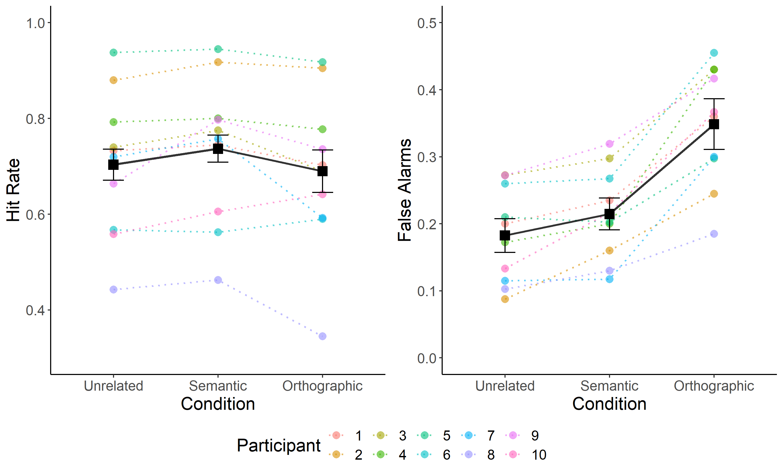

*Note.* Individual participants’ data are represented by colored circles and dotted lines. Group-level means are represented by squares and solid black lines. Error bars represent 95% within-subject confidence (Morey, 2008).

## Source Judgements

How participants respond in the recognition task may influence their response in the subsequent source retrieval task. Specifically, one potential reason people might guess randomly in the source retrieval task is that they simply do not recognize the retrieval cue. Because the focus of this study is on intrusion effects in source retrieval, we consider cases in which source retrieval fails because the retrieval cue is not recognized as a contaminant which increases the proportion of unsystematic source guessing. Figure 3 shows the distributions of source error responses at each level of confidence. That we see some evidence of central tendency even for items rated 1 or 2 out of 6 supports the idea that source memory exists even for unrecognized items (Fox & Osth, 2020).

Figure 3. Frequency distribution of source error across levels of confidence in item recognition.

*Note*. For the recognition portion of the task, items were rated on a scale ranging from 1 (sure new) to 6 (sure old). The histograms show the distribution of source errors when source judgements made after the recognition, conditioned on the rating the retrieval cue received the prior recognition judegment.

Although Figure 3 indicates that some source information was present in the lower range of confidence in the recognition task (higher concentration of responses centered on 0), the distribution of error at lower confidence ratings is qualitatively different to items recognized with high confidence, with a greater degree of uniformity and a lower central peak. To exclude these lower accuracy source responses elicited when items were not recognized, we restricted modelling of source responding to trials in which stimuli were successfully recognized (i.e. rated >3).

After conditioning the data on successful recognition of items, we considered differences in the distributions of source error across the similarity conditions, shown at a group level in Figure 4.

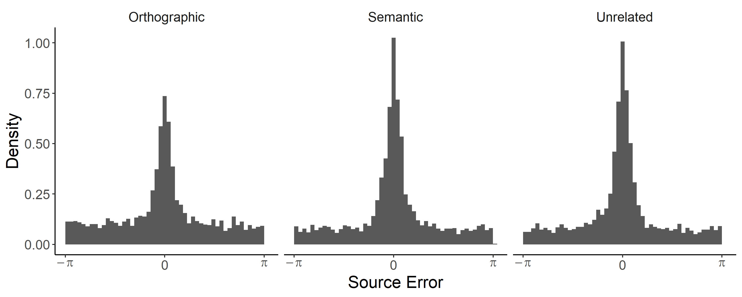

* Model using Zhang and Luck to show difference is in P(Guess) and not Precision?

## Source Intrusions

Having established that the difference between similarity conditions is in the proportion of non-target responses, rather than the precision of target responses, we now consider the distinction between responses related to non-target items (intrusions) and responses not related to any item on the list (for brevity, we refer to these as guesses but see X).

* Break down P(Guess) into guesses and intrusions
* Show recentered histograms, conditioned on levels of similarity
* Fitted models
* Fitted models with gamma and beta

## Models of Intrusion Effects in Source Retrieval

# Discussion

It is possible that the difference between the semantic and orthographic word lists is attributable the strength of the semantic manipulation simply being weaker than that of the orthographic manipulation. However, the alternative interpretation that semantics have a qualitatively different impact on memory than orthographic or contextual similarity dovetails with findings in the literature on serial-recall tasks which have found that…

1. Pretrained models were obtained from the fasttext.cc website, which were trained on the meta pages archive of English Wikipedia from June 2017, resulting in a text corpus of over 9 billion words in addition to news sources from statmt.org from 2007 - 2016, as described by Mikolov et al. (2017). Word2vec is an example of a semantic space model (see Jones et al., 2015 for a review) which differs from traditional approaches in that it relies on prediction during the course of training and negative sampling (Johns et al., 2019) and has been found to outperform models such as latent semantic analysis (LSA; Landauer & Dumais, 1997) in accounting for lexical decision latencies (Mandera et al., 2017).