When we recall a past experience, we often not only retrieve information about an item in memory, but also information about the conditions under which that memory was formed, or the *source* of that memory (Johnson et al., 1993). Episodic memory, which describes memory for events, has been studied experimentally using item recognition and source memory tasks, often in tandem. In a source memory task, subjects are shown stimuli (e.g., words, shapes, or objects) which are presented in some context (e.g., the voice of a speaker, location on a display). When later cued with the item, participants are then asked to report the source. Several models have been advanced to understand the processes governing both recognition and source judgements (Yonelinas, 1999; Slotnick & Dodson, 2005; Hautus et al., 2008).   
 A key question such models contend with is whether the retrieval of information from source memory is better characterized as a continuous or a discrete process. Models of memory retrieval as a continuous process, based upon Signal Detection Theory (SDT), assume that memory strength varies continuously, and so predict that performance in a source memory task declines gradually as memory strength decreases (Banks, 2000; Mickes et al., 2009). In contrast, threshold or discrete-state models assume that memory strength for an item must reach a certain threshold in order for that item to be retrieved, and so predict that source responses are either made with high precision when driven by memory or are guesses, made in the absence of information, when the memory is below the retrieval threshold (Batchelder & Riefer, 1990; Klauer & Kellen, 2010). Another alternative is the dual-process framework, in which different retrieval mechanisms are used in different kinds of memory tasks (Mander, 1980). Specifically, the two processes in the influential Yonelinas (1999) dual-process model are 1) familiarity, which yields a continuous measure of strength for an item in memory and 2) recollection, which yields richer contextual information about the study event through a search process which is thresholded. Successful recollection or familiarity can both contribute to recognition, because familiarity can distinguish between a studied and an unstudied item. On the other hand, familiarity does not distinguish between two items from different sources, which are both studied, and so the Yonelinas (1999) dual-process model predicts that source judgements should be thresholded as they can only be driven by recollection. This dual-process view of memory retrieval holds only if recollection, and therefore source memory performance, can be characterized as a thresholded process. Existing research which attempted to distinguish between continuous and thresholded models of source memory has been based on data from two-choice tasks, whereby confidence ratings and accuracy in two-choice tasks are used to construct Receiver Operating Characteristic (ROC) curves (Yonelinas, 1999; Slotnick & Dodson, 2005). Although the predicted shape of these curves were initially thought to distinguish between continuous and thresholded models, subsequent work found numerous conditions under which the models mimic each other (Yonelinas & Parks, 2007; Klauer & Kellen, 2010).

**Continuous-Outcome Tasks**

An alternative to using two-choice tasks is to use *continuous-outcome* tasks, in which responses are made on a continuous scale. The advantage of using such a task is that it allows direct measurement of response precision, as opposed to the proportion of responses in each of the discrete options in a traditional two-choice task. This richer, continuous measurement is more informative about the nature of mental representations, particularly in terms of the variability of decisions made about these representations (Smith et al., 2020). Continuous-outcome tasks were first used to study memory in the specific context of how visual working memory (VWM) representations change with the number of items stored in memory (Wilken & Ma, 2004). Just as the source memory literature has been concerned with the question of retrieval thresholds, the VWM literature has historically grappled with whether storage capacity is determined by a discrete number of “slots” to be filled, or a continuous resource that can be distributed across an increasing number of items that are represented with decreasing resolution in memory. In both cases, the common question about the architecture of memory is if information is stored in discrete states. Zhang and Luck (2008) modelled distributions of response outcomes in a color recall task under different set size conditions, and found the data was well described by a mixture model, specifically a mixture of a von Mises distribution[1] and a uniform distribution.

Applying a similar approach to source memory modelling, Harlow and Donaldson (2013) used a continuous-outcome task in which source was operationalized as the locations of word stimuli along the circumference of a circle. At test, participants reproduced remembered locations on a response circle when cued with each word in the study list. The authors found that a mixture model consisting of a wrapped Cauchy and a uniform component was preferred over a pure wrapped Cauchy model, which was interpreted as evidence for a thresholded retrieval process which yields uniform guesses when memory strength is subthreshold (Harlow & Donaldson, 2013). This analysis attributes variability in response precision to two sources in memory: 1) variability in memory precision and 2) the possibility that memory is absent and the response is a guess. To account for the role of decision-making processes in generating responses, Zhou et al. (2021) applied the circular diffusion model, a model of decision-making in circular domains, which decomposes variability into that arising from memory and decision-making processes.

### Decision-Making in Continuous-Outcome Tasks

Any response observed in a memory task is a product of a decision-making process in addition to the information from memory driving the decision. Accurately characterizing the effect of decision-making is critical to understanding the nature of memory retrieval (Ratcliff, 1978). Accounting for decision-making over time requires analysis of not only response outcome, but also response time (RT) data, and considering both types of data yields more diagnostic information about the underlying cognitive processes. The importance of modeling decision-making is well illustrated in the recognition memory literature, where initial conclusions founded on the shape of ROC curves were later challenged by including RT data in addition to the response proportions used to form ROCs (Ratcliff & Starns, 2009; Starns et al., 2012; Dube et al., 2013; Osth et al., 2017), and in characterizing serial position effect in free recall (Osth & Farrell, 2019).

A particularly influential account of decision-making is the diffusion decision model, which successfully explains well-documented phenomena like the speed-accuracy trade-off, and slow and fast error patterns under different decision conditions (Ratcliff et al., 2016). The diffusion model describes decision-making as a noisy evidence accumulation process, the rate of which is defined as the *drift rate*, that accumulates until a response boundary or criterion that represents the amount of evidence required for a given response to be output (Ratcliff & McKoon, 2008). Variation in decision criteria can reflect response bias, for example, decision-making under speed emphasis can be represented with a lower criterion relative to emphasizing accuracy. Drift rate reflects the quality of evidence driving the decision process, and draws an explicit link between response accuracy and RT: higher drift rates result in higher accuracy and faster RTs, while lower drift rates result in lower accuracy and slower RTs (Ratcliff et al., 2015).

The circular diffusion model inherits the desirable explanatory qualities of the standard two-choice diffusion model and extends the model to a continuous response space by representing evidence accumulation as a vector in two-dimensional space that starts at the origin of a circle and terminates at a point in its circumference, which represents the decision outcome (Smith, 2016). The introduction of the circular diffusion model addressed the lack of a formal model of RT and decision-making in continuous-outcome tasks, enabling use of the noted advantages of the paradigm over two-choice tasks in addition to RT modeling.

When the drift rate and the decision criterion are fixed across trials, the circular diffusion model predicts that the distribution of decision outcomes falls along a von Mises distribution. The variability of outcomes in the von Mises distribution depends on a precision parameter, κ, which is jointly a function of the drift norm, ||μ||, the decision criterion, *a*, and the noise in the evidence accumulation process, σ2:

|  |  |
| --- | --- |
|  | (1) |

which defines a clear relationship between the strength of evidence and decision criterion in determining the observed distribution of responses.

Through across-trial variability decision-making, specifically drift variability in the circular diffusion model, a single continuous process can produce distributions of response error with heavy-tails through the decision-making process, without invoking mixture with a uniform component in the memory process (van den Berg et al., 2012; Smith, 2016). By jointly fitting response error and response time (RT) and error data, Zhou et al. (2021) found that thresholded model with a uniform component was preferred over a continuous model with drift variability, corroborating the conclusions of Harlow and Donaldson (2013).

## Non-target Responding

In the VWM literature, the slots account of memory capacity proposed by Zhang and Luck (2008) is built upon the finding that a proportion of responses appear to be uniformly distributed and reflect random guessing. Bays et al. (2009) challenged this interpretation by arguing that confusions between target and non-target items could also account for errors that appear uniform relative to the target item. The authors demonstrated that a model incorporating probability distributions centered on the identity of each non-target item in the display accounted for the Zhang and Luck (2008) finding without a discrete limit on the number of items stored (this model is formally described below). Confusions between items, such that information about a non-target item is reported in place of the cued target, result in *swap errors*, and because the possibility of these swaps can be confounded for variability in memory precision, disentangling these sources of error has been important in accurately characterizing VWM processes (Bays, 2016). Study of memory for spatial location has found that errors were composed entirely of swap errors, with little evidence of guess responses (Rajsic & Wilson, 2012, 2014; Pertzov et al., 2012). In this study, we apply the same logic to the continuous-outcome source memory task, asking to what extent mis-bindings between item identity and source location accounts for uniformity in the distribution of errors, and by extension, challenges the theoretical justification for a thresholded model of source memory retrieval.

### Contiguity Effects

The tendency for subjects to respond to non-target features or items has been observed in a wide variety of cognitive tasks, and the related types of errors that arise are referred to by various terms including *binding, transposition, intrusion,* and *swap errors[2]*, each reflecting specific properties of the tasks used to study the phenomenon (Bays, 2016). Most explanations of non-target responding attribute the phenomenon to confusion between items that are similar (Rerko et al., 2014; Bays, 2016; Oberauer & Lin, 2017; but see Pratte, 2018 for an alternative). In the continuous-outcome source memory paradigm, items may be similar in several ways, including the position of items in the study list, the spatial distance in the location of the items, as well as features of the words used as stimuli such as their semantic and orthographic similarity, the effects of which have been studied across the broader body of episodic memory research. In the paragraphs to follow, we review the commonalities between findings across different tasks, all of which motivate the present modelling of source memory.

The principle of *temporal contiguity* is that events that occur close in time become associated with each other (for an extensive review of contiguity effects in episodic memory, see Healey et al., 2018). In free-recall tasks, where participants are asked to recall a list of items in any sequence they wish, Kahana (1996) demonstrated that after recalling a given item, the next item to be recalled tends to be a neighboring item in the study sequence. The distance between item *i* in the study list and another item in the list is known as the *lag*. Additionally, neighbors in the forwards direction (*i* + lag) were more likely to follow an item than backwards neighbors (*i* – lag), referred to as forward asymmetry in the contiguity effect (Kahana, 1996). The probability of transitioning to a given lag at recall is known as the lag-conditional response probability (lag-CRP), and the effect of increasing lag on this probability can be seen in Figure 1.

Figure

*Transition gradient seen in lag-CRP in free recall*

While associations between temporally contiguous items can facilitate free-recall, the same type of association can contribute to errors in tasks when the sequence of items is important. Specifically, in serial recall tasks, where subjects must call lists of items in the sequence in which they are given, a classic finding is that incorrect responses tend to be items studied near the target in the study sequence (Lee & Estes, 1977; Nairne, 1990). This effect can be described as a transposition of two items, so that the position of non-target items are swapped with that of the target item, and as in free-recall, the probability of a swap is inversely related to the distance of the two items (Henson et al., 1996; Page & Norris, 1998; Lewandowsky & Farrell, 2008). While early models explained this effect through a “chaining” process by which items were bound to each other in sequence, more recent explanations argue that items are instead associated with representations of their serial position, and that these representations overlap so that an item can cue not only its position but that of its neighbors (Lewandowsky & Farrell, 2008; Rerko et al., 2014). Applying the lag-CRP methodology to serial recall data forms a *transposition gradient* around the target location effect (Kahana & Caplan, 2002; Solway et al., 2012). Like the shape of the lag-CRP curve in free recall, transposition gradients tend to exhibit a forwards asymmetry both in terms of transposition probability (Klein et al., 2005; Haberlandt et al., 2005[3]) as well as latency (Farrell & Lewandowsky, 2004; Hurlstone & Hitch, 2014).

The temporal contiguity effect has also been observed in paired-associate recall. After studying pairs of words, Davis et al. (2008) found that when participants recalled non-target items, the erroneous item tended to be intrusions from temporally contiguous pairs. One again following the logic of lag-CRP analyses, the probability of an intrusion from pair *i* + lag when cued with an item from pair *i* decreases with absolute lag, and is asymmetric in the forwards direction so that intrusion probability is greatest when lag = 1.

Most recently and closely related to the present study, Popov et al. (2021) investigated errors in binding between words and the locations along a circle in which they were presented. In particular, when participants made a mis-binding error, responses were not generated from a random non-target. As with intrusions from paired words (Davis et al., 2008), Popov et al. (2021) found that mis-binding errors were most likely to come from locations in neighboring serial positions by separately estimating the probability that a response came from each of the locations in the study set. The authors demonstrated a contiguity effect by comparing the probability of mis-binding across lags (Popov et al., 2021). The present study aims build upon this body of work by systematically modelling the rate at which intrusion probability decreases with lag.

In the same way that temporal contiguity effect describes how limitations of temporal distinctiveness explains transition and transposition gradients in memory for lists of items, Rerko et al. (2014) refer to an analogous effect in the spatial domain to explain similarly graded effects of distance, in that spatial confusions between items are more common at smaller distances (Emrich & Ferber, 2012; Bays, 2016; Sahan et al., 2019). The link between swap errors in VWM and transposition errors in serial recall has been proposed to reflect a more general mechanism in memory by which items are bound to context dimensions (Oberauer & Lin, 2017; Schneegan et al., in press).

### Source Memory for Associated Items

Many source memory paradigms, including that of the present study, use word stimuli in which semantic associations are particularly salient. The Deese-Roediger-McDermott (Deese, 1959; Roediger & McDermott, 1995) paradigm is an influential demonstration of how semantic association between words can result in false memory for non-presented words, known as critical lures. When asked to make source judgements for critical lures, participants make source attributions with high confidence, corresponding to the source of the semantically related words (Lampinen et al., 1999; Gallo et al., 2001; Gallo & Roediger, 2003; Roediger et al., 2004). Furthermore, when a list of semantically associated words is split between two sources such that one source presents the strongest associations and the other presents the weakest, critical lures are consistently attributed to the source with the stronger half (Hicks & Hancock, 2002; Hicks & Starns, 2006). Similarly to how temporal and spatial similarity affect transposition and swap errors in a graded fashion, the present study investigates if the degree of semantic similarity between words used as cues in the source memory task affects the probability of intrusions between item-source pairs. While research about the effect of orthographic similarity on source attributions is scarce, orthography has established to have an effect on rates of false memory, and the processing of semantic information is simultaneously integrated with orthographic information multiplicatively in memory retrieval (Massaro et al., 1991; Nieznański et al., 2019),

## Description of Models

Table 1

*Summary of models*

|  |  |  |
| --- | --- | --- |
| Model | Guessing | Intrusion Gradient |
| 1 | Yes | None |
| 2 | No | Flat |
| 3 | Yes | Flat |
| 4 | Yes | Temporal |
| 5 | Yes | Spatiotemporal |
| 6 | Yes | Spatiotemporal, Semantic, Orthographic |

## The Present Study

In Experiment 1, we found qualitative improvements in model fit by introducing successively sophisticated models of intrusions between items, ranging from Model 1 with no intrusions to Model 5 with a spatiotemporal similarity gradient on intrusion probability. However, we did not find a corresponding quantitative improvement in terms of fit statistics, which may have been due to an insufficient number of observations reflecting intrusion responses to support the parameter penalty incurred by the more sophisticated models. In Experiment 2, we address this issue by concentrating power at the level of individuals by using a small-*N* design which found that Model 5 was quantitatively preferred, supporting the view that spatiotemporal similarity influences intrusion probability, but did not find support for further elaborations including semantics and orthography in determining similarity between items.

# Experiment 1

## Method

### Participants

In Experiment 1, 10 participants were recruited online through the University of Melbourne undergraduate research experience program and 40 participants were recruited via *Prolific*, an online participant recruitment platform. Five participants from the undergraduate pool and seven participants from the Prolific pool did not complete all sessions of the online experiment, resulting in incomplete datasets which were excluded from the final analyses. Additionally, two participants recruited via Prolific were excluded due to at-chance performance in the memory retrieval task, measured by applying the Rayleigh test which indicated no evidence for a departure from uniformity, interpretable as completely random responding. After exclusion, there were five undergraduate participants and 31 Prolific participants, for a total sample of 36 participants. For their participation in each session, undergraduate students were granted credit towards course requirements, and Prolific participants were paid 6.50 GBP/hour. Participants were provided with plain language statements and consent forms and gave informed consent prior to the start of the first session of the experiment.

### Stimuli and Apparatus

Stimuli consisted of words generated from the SUBTLEXus database, filtered for words with a length of four letters, and with frequency ratings between one and five. Words were displayed in size 24 point “Courier New” white font positioned in the center of a uniform mean luminance field. The choice of a monospaced font and the restriction of words to strictly four letters were to ensure stimuli always occupied a consistent amount of space on the screen. Software written in Javascript using jsPsych (deLeeuw, 2015) controlled stimulus presentation and recorded responses.

### Procedure

Participants completed the experimental tasks over three sessions. Each of the three sessions consisted of 120 trials, which was broken up into 12 blocks of ten items each. Blocks consisted of a study phase, a math distractor phase, a recognition phase, and finally a source recall phase. There were additionally five practice trials at the beginning of each session, the data from which was not included for analysis. There were two conditions in this experiment, a simultaneous study condition and a sequential study condition, with all other phases being identical between the conditions. Participants were randomly allocated to either the simultaneous or the sequential presentation condition when beginning session one of the experiment, which would be the same for all subsequent sessions for that participant.

In the sequential study condition, participants were presented with a black marker positioned on a randomly generated angle on the outline of a circle at the start of each trial for 600 ms. The presentation of the marker was followed by the display of a word in the center of the screen for 1500 ms. To ensure that participants attended to the source information, they were instructed to indicate the previous location of the cross on the blank target circle using a computer mouse. Responses made within π/8 radians of the true target location were classified as attended and advanced participants to the next item. Responses further away were deemed unattended and the words “TOO DISTANT” was displayed for 1000 ms, then the location was then re-presented and the verification task was repeated.

In the simultaneous study condition, participants were presented with the marker and the word simultaneously for 1000 ms. Instead of being positioning the word in the center of the screen, in the simultaneous encoding condition, the word was positioned at the same angle as the marker, offset by a longer radius. The location of the word relative to the marker was determined by the sector the angle was in, with the word being offset to one of eight points on the bounds of the text box, corresponding to the middle of each of the four sides, and the four corners (i.e. in the North sector, the anchor was the bottom middle of the text box, while in the Northeast sector the anchor was the bottom left of the text box). As with the sequential condition, a verification task followed each presentation, which was repeated until participants reproduced the location to within π/8 radians of the presented angle.

After studying each of the items for that block, participants were then instructed to complete a distractor task, which involved 30 seconds of arithmetic problems. These problems were presented as three single digit integers, which summed to a fourth number which would either be the correct sum, or a number that was one higher or lower than the actual sum. Participants would indicate if the sum was correct by pressing the keys 0 (false) or 1 (true).

In the recognition phase, participants were shown a shuffled list of 10 previously studied items and 10 foils and asked to rate each item on a six-point Old/New confidence scale. Participants responded by pressing a number from 1 to 6 on their keyboard, with 1 representing “Sure New” and 6 representing “Sure Old”.

Finally, in the source memory retrieval task, participants were cued with the words for 1500 ms, and then indicated the recalled location by a moving the mouse from the starting point in the centre of the circle to a point on the circumference of the response circle. There was no time limit on the decision task. A schematic for one trial in each of the phases is shown in Figure 2.

Figure

*Schematic of display presented to the participant in one trial in each phase of the experiment.*

## Results

To facilitate presentation of the analyses, we step through incremental elaborations of the response error model, and then repeat these steps with the circular diffusion model that models response error and response time data. First, we assess whether there is a difference between the sequential and simultaneous presentations of source and item, in terms of both recognition and source judgements. Second, we turn our attention to intrusions and compare a thresholded model without intrusions to a model with intrusions, and a model with intrusions and a threshold. Third, we introduce a more sophisticated intrusion component to the model that is sensitive to the similarity between items when determining individual pairwise intrusion probabilities. Finally, we repeat these steps with the circular diffusion model.

### Data Exclusion

In addition to the rejection of two participants previously described under methodology, individual responses from the remaining participants with a response time of faster than 300 ms or slower than 7000 ms were also excluded from subsequent analyses. This resulted in the omission of 1.72% of data.

### Simultaneous vs Sequential Presentation

With regard to performance in the source judgments, response error averaged within and compared between the simultaneous (M = .009, SD = 1.37) and sequential (M = .002, SD = 1.43) groups were not significantly different *t*(12460) = .28, *p* = .773. This can be confirmed visually by comparing the distributions of response error in the two conditions (Figure 3)

Figure   
*Normalized Histograms of Source Error in Sequential and Simultaneous Presentation Conditions*

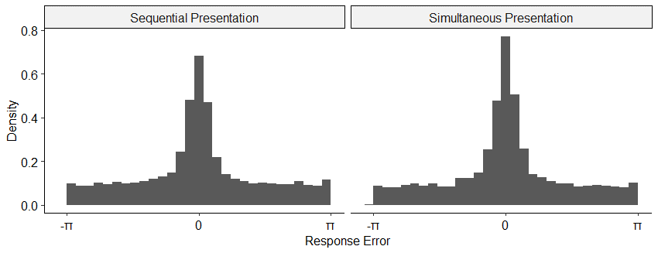

Subsequent modelling analyses were conducted on an individual level, and significance tests on resultant parameter estimates between the presentation conditions were also not significant. For brevity, these analyses are provided as supplementary material and commentary on the modelling will not make further reference to the presentation manipulation.

### Evidence of Intrusions

While guesses and intrusions will both appear uniform relative to the target on each trial, the two can be distinguished by examining the distance between responses and each of the non-target items on each trial (Bays et al., 2009). With no contribution of intrusions, the resultant distribution should appear uniform, while evidence for intrusions is reflected in the kind of central tendency present in our data as shown in Figure 4. We will subsequently refer to this analysis as it is equivalent to recentering response errors relative to the non-target items.

Figure

*Response Angles Relative to Non-targets*

Figure 5 splits the recentered data by the lag and direction of the intrusion for each trial. Central tendency, and hence evidence for intrusions, is stronger in the forwards direction and decreases with higher absolute lag.

Figure

*Response Angles Relative to Non-targets, Split across Lag and Direction*

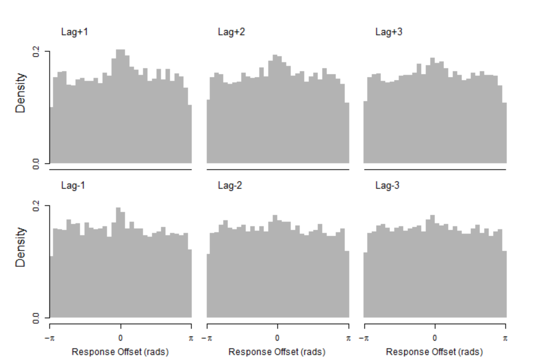

### Response Error Models

Our modelling approach was to start with a two-component mixture model equivalent to Zhang and Luck (2008), and then introduce successive elaborations on the intrusion component to make it sensitive to similarity first in terms of temporal, then spatial similarity of presentation, and finally semantic and orthographic features of the stimuli. The same stepwise process was also taken with the circular diffusion model, using the same calculations to weight intrusion probability by the various kinds of similarity, using the Zhou et al. (2021) thresholded circular diffusion model as a base in place of the Zhang and Luck (2008) model. The models are formally described in the sections to follow, and the key differences between models are summarized in Table X. In addition, we implemented variations of some models with allowances such as different parameters for primacy and recency items, and additive and multiplicative combinations of similarity when calculating intrusion probabilities. For ease of presentation, we have excluded these variants in this text, but code for all the models is available at [link here] and are provided as supplementary material.

### Model 1: Pure Guessing

As previously described, the Zhang and Luck (2008) model expresses the idea that responses are generated from a mixture of two process, one which is target-driven with Gaussian error, and another which is driven by guesses made at random:

|  |  |
| --- | --- |
|  | (2) |

where in the target-driven component, represents the target angle, is the reported angle, and represents a Von Mises distribution with a mean of 0 and a standard deviation of . The probability that a response is a guess is represented by .

### Model 2: Pure Intrusions

To test the strong prediction that all non-target responses can be accounted for with intrusions from non-target items without invoking any uniform guessing, Model 2 substitutes the guessing component in the mixture model with an intrusion component:

|  |  |
| --- | --- |
|  | (3) |

where the probability of an intrusion occurring is represented by , and the angle associated with the *i*th intruding item is represented by . Note that of the *m* non-target items, the probability of a particular non-target intruding is equal. We report fits of a model which allows different values of *δ* for target and intrusion von Mises distributions.

### Model 3: Intrusions + Guessing

Model 3 combines intrusion and guess responses in the three-component model of Bays et al. (2009):

|  |  |
| --- | --- |
|  | (4) |

Models were fit on an individual level, and the relative performance of the models for each participant is shown in Table 2. Performance is evaluated on the basis of AIC weights, which is interpretable as the probability that a given model is correct for that participant (Burnham & Anderson, 2002). For the majority of participants, Model 3 (Intrusion + Guess) is heavily preferred over simpler models with guessing or intrusion components exclusively, and more sophisticated models with contextual gradients on the probability of each intruding item. Table 1 shows AIC values summed over participants, in which Model 3 is also preferred. Models 4 and 5, which were not preferred quantitatively, are formally introduced in the following sections.

|  |  |  |
| --- | --- | --- |
| Table 1  *AIC Values Summed Over Participants* | |  |
| Model | ΣAIC | ΔΣAIC |
| 1. Pure Guess | 37338.77 | 276.86 |
| 1. Pure Intrusion | 38178.07 | 1116.16 |
| 1. Intrusion + Guess | **37061.91** | **0** |
| 1. Temporal Gradient | 37176.82 | 114.91 |
| 1. Spatiotemporal Gradient | 37237.68 | 175.77 |

### Intrusions

The reason for underperformance of the Pure Intrusion model compared to the Pure Guess and Intrusion + Guess model can be seen in Table 2, which shows the average estimated parameter for each model. The lower value of precision for the memory component *δ1* results in the Pure Guess model underestimating the peak of response error distribution around 0 seen in Figure 6. This suggests that a substantial portion of errors are not associated with intrusions, and that an additional source of error like the uniform guessing component of the other models is required to simultaneously account for these errors and the precision of target responses. However, as shown in Figure 7, the Pure Guess model does not predict the central tendency seen in the response error recentered on non-targets. The Intrusions + Guess model, with both guessing and intrusion components, is able to produce both patterns of data at the same time.

|  |  |  |  |  |  |  |  |  |  |
| --- | --- | --- | --- | --- | --- | --- | --- | --- | --- |
| Table 2  *Average Parameter Value Estimates for Each Model* | | | | | | | | | |
| Model | *δ1* | *δ2* | *β* | *γ* | *κ* | *λ1* | *λ1* | *ζ* | *ρ* |
| 1 | 19.53 |  | 0.60 |  |  |  |  |  |  |
| 2 | 5.31 | 4.28 |  | 0.46 |  |  |  |  |  |
| 3 | 19.06 | 14.64 | 0.36 | 0.24 |  |  |  |  |  |
| 4 | 16.02 | 10.10 | 0.39 | 0.58 | 0.56 | 0.89 | 1.08 |  |  |
| 5 | 18.82 | 8.86 | 0.39 | 0.22 | 0.56 | 1.69 | 1.55 | 0.52 | 0.63 |

The Pure Guess and Intrusion + Guess models agree on the proportion of non-target responses (*β* = 0.60 in Model 1, *β + γ =* 0.60 in Model 3), but contrary to our expectations, the inclusion of temporal and spatiotemporal gradients did not further decrease the proportion of guesses relative to the flat gradient in the Intrusion + Guess model.

Figure

*Comparison of Pure Guess and Pure Intrusion Models to Response Error data*

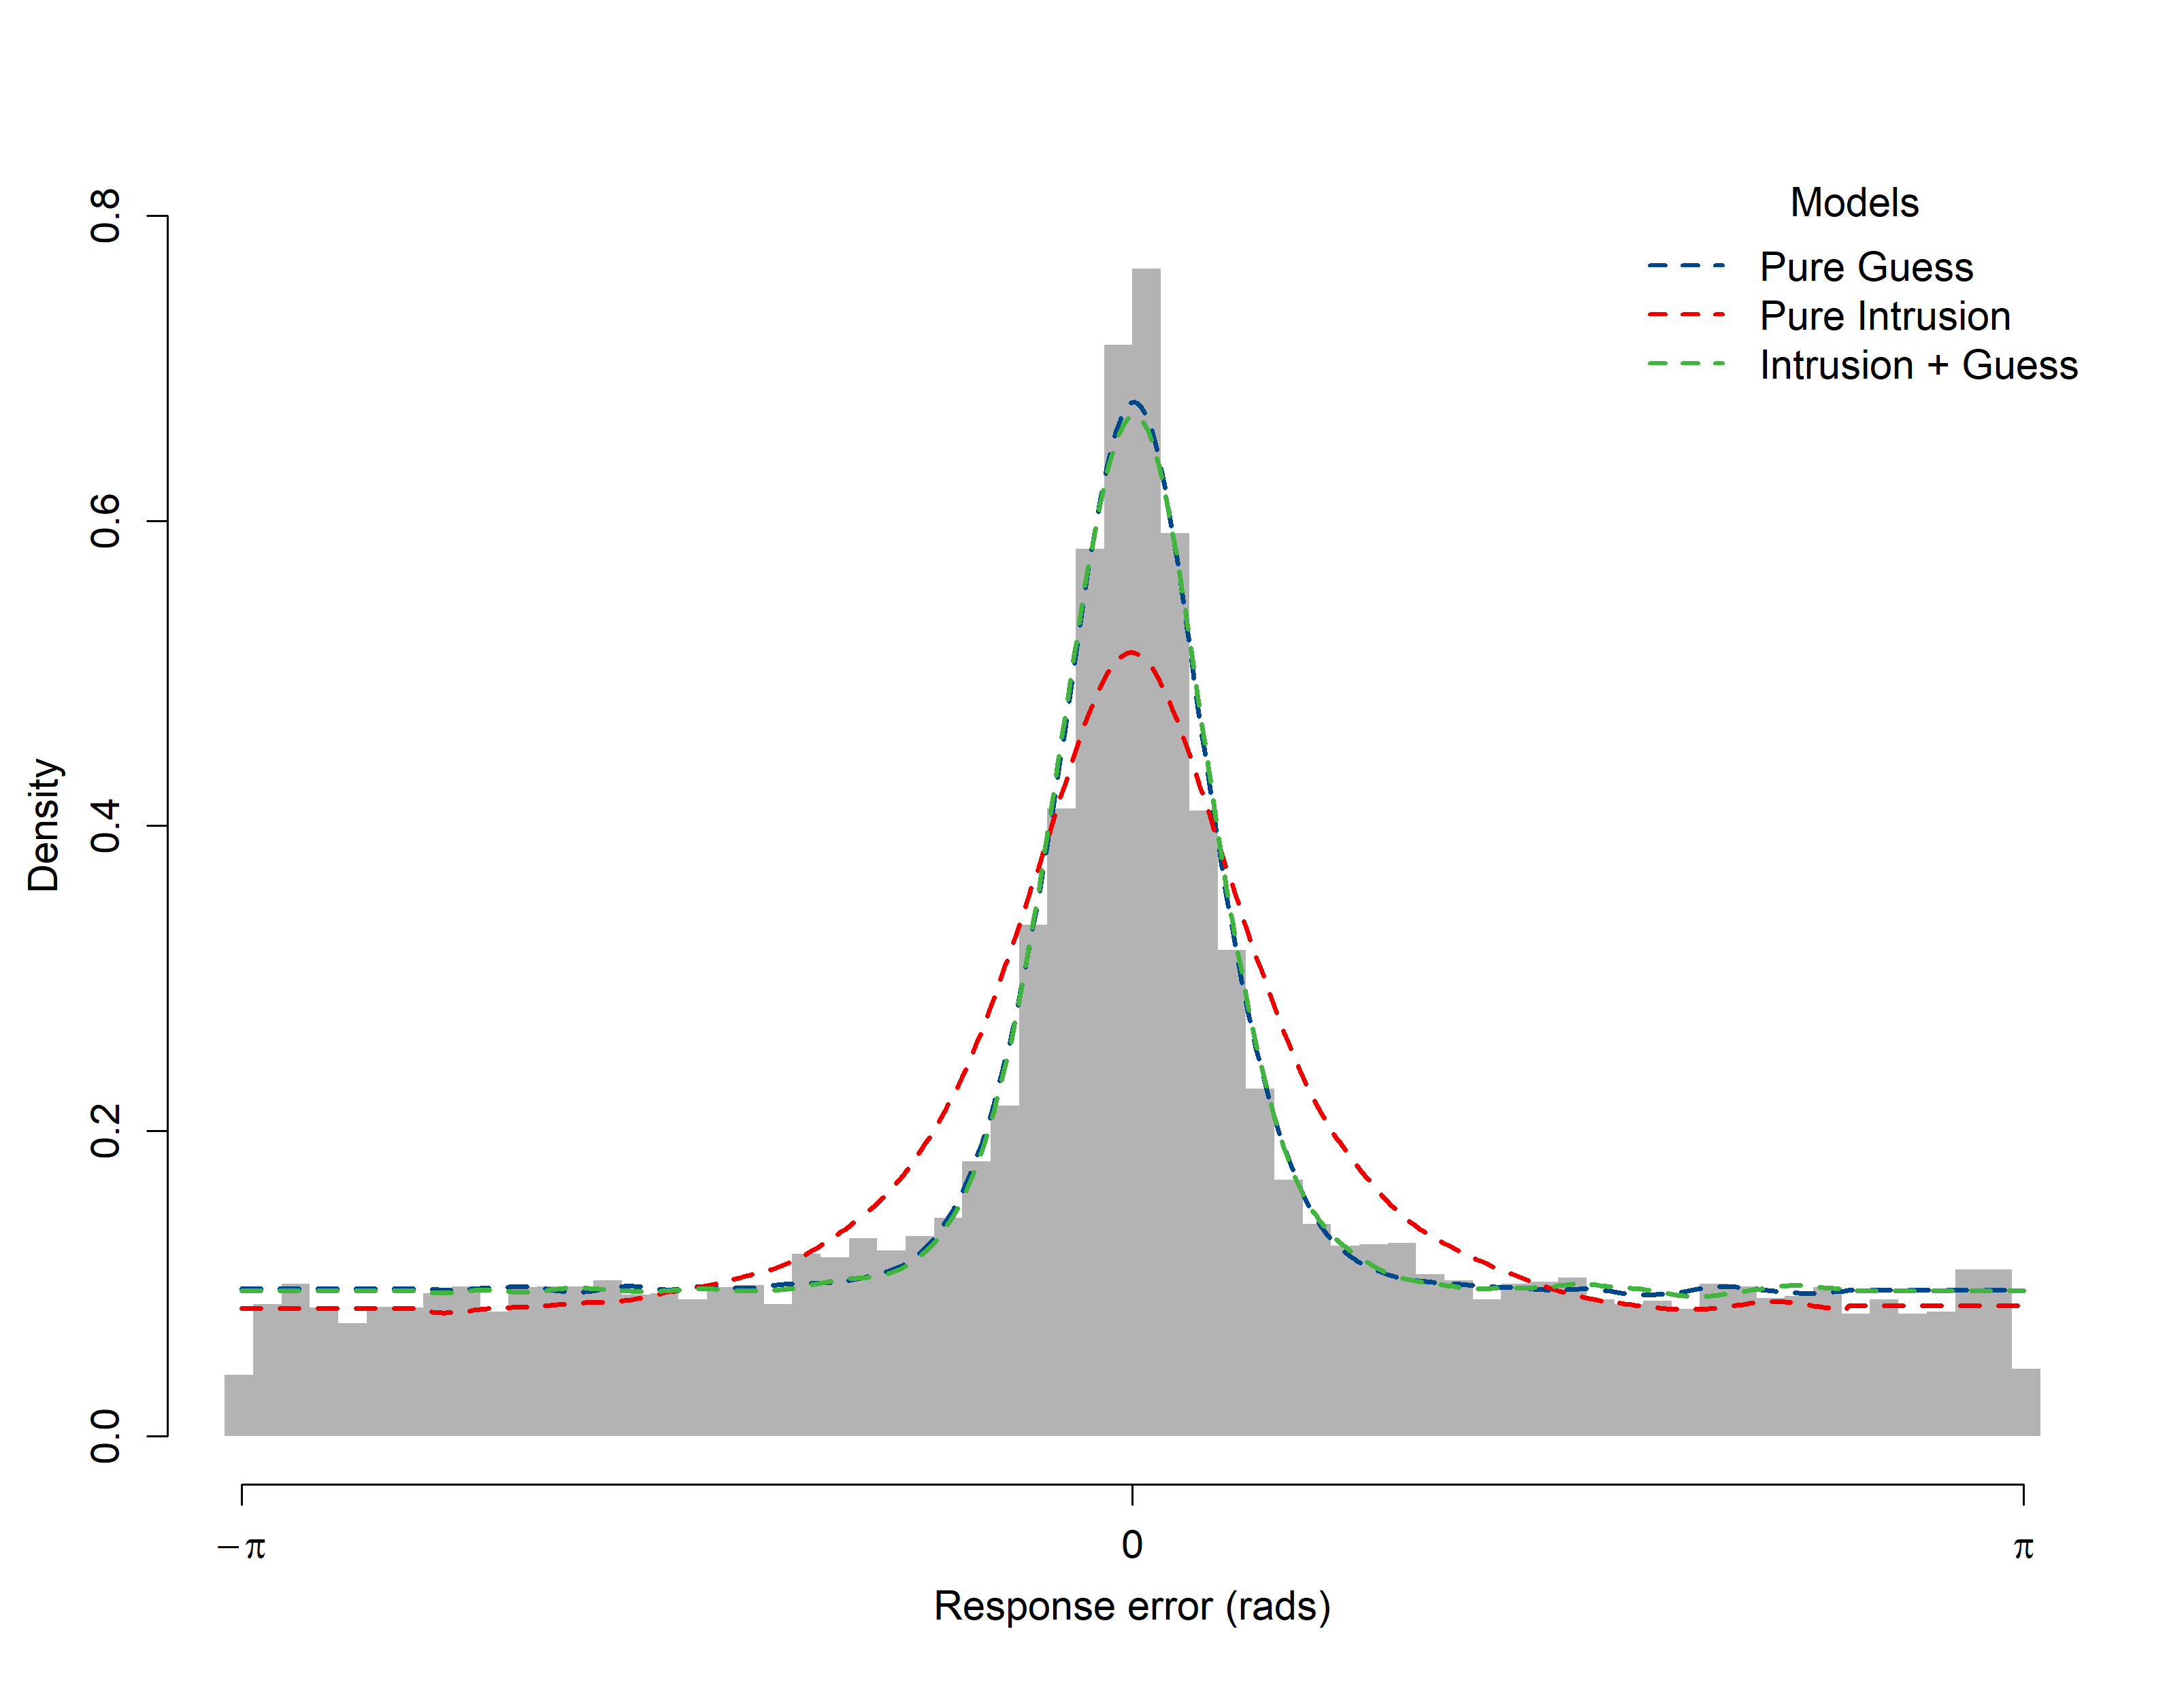

Figure

*Model Fits to Distances between Response Angles and Non-Target Angles*

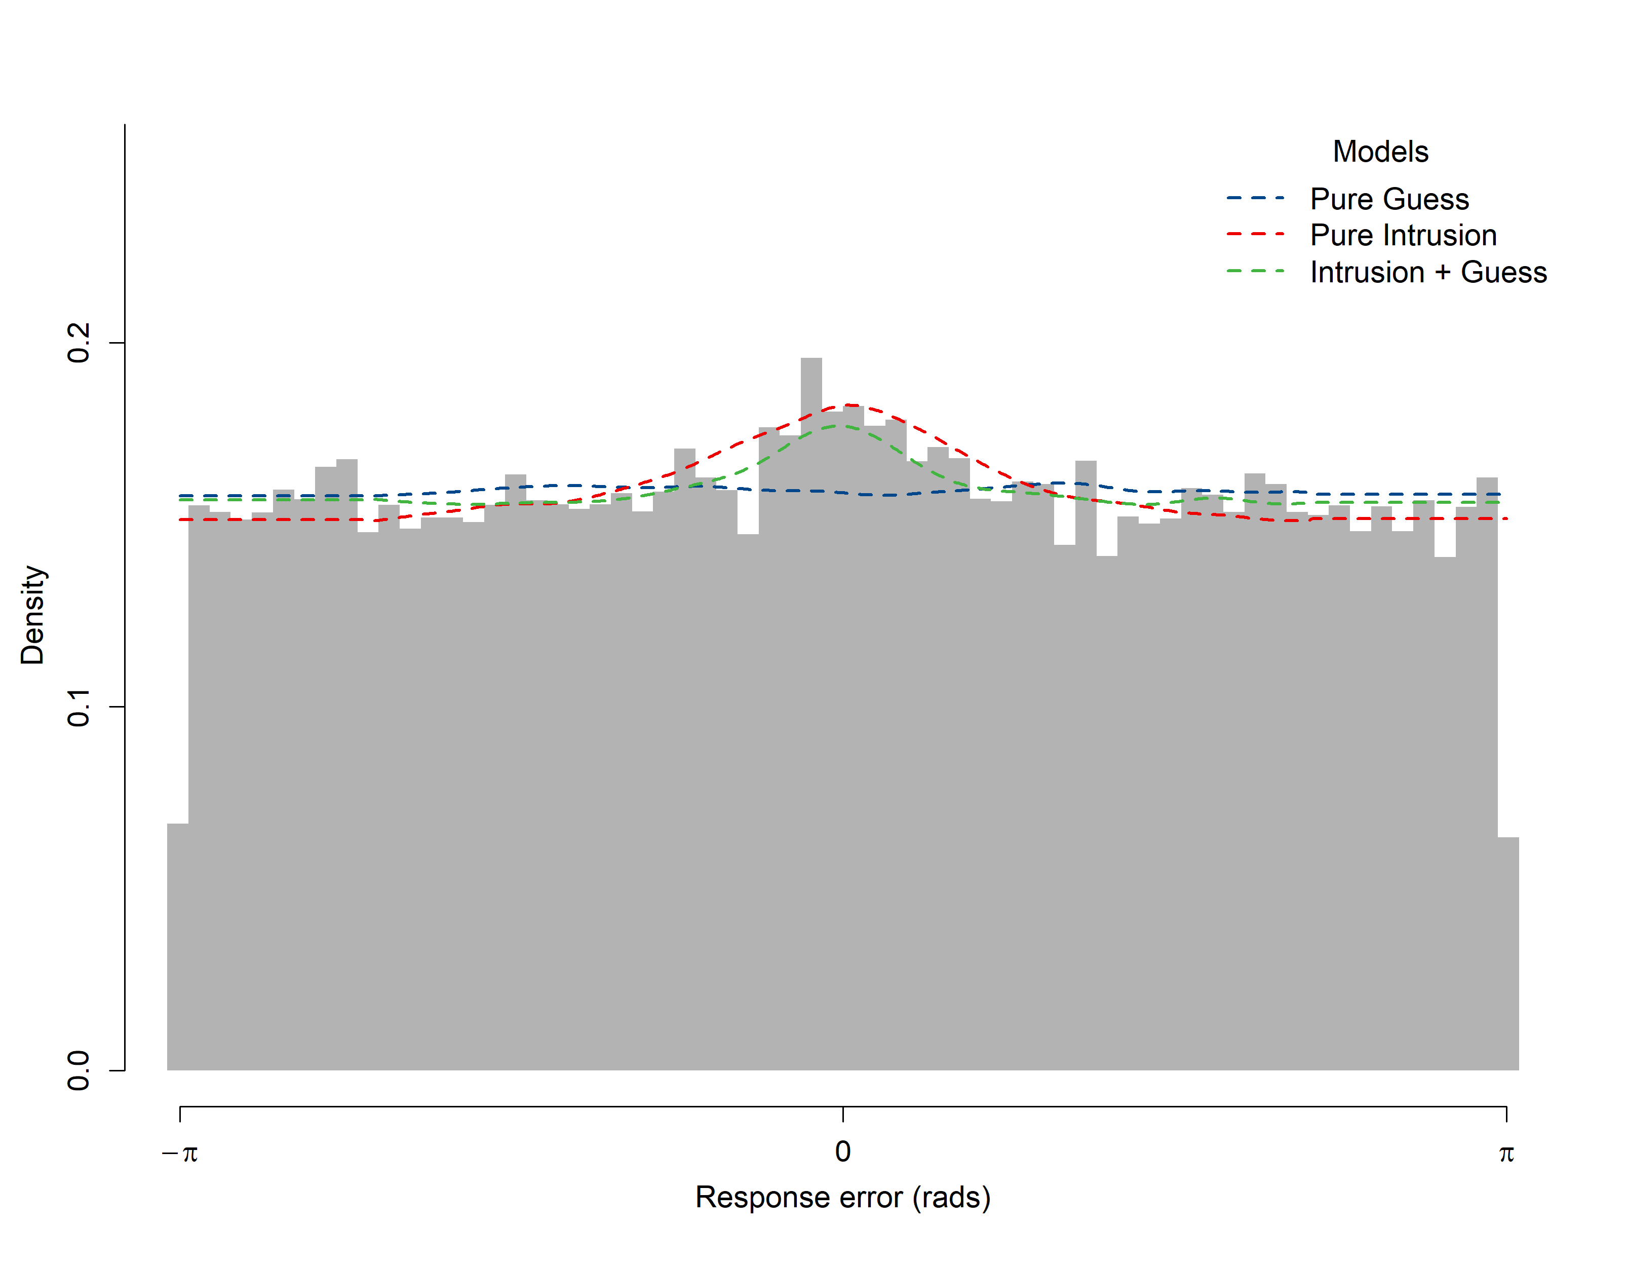

### Model 4: Temporal Similarity Gradient

In contrast to Models 2 and 3 in which each intrusion is equally weighted (that is, the likelihood of each intruding item is divided by the number of intrusions), in Model 4 the weight of each intruding item is determined by its temporal similarity to the target represented by *t:*

|  |  |
| --- | --- |
|  | (5) |

|  |  |
| --- | --- |
|  | (6) |

We incorporate the assumption that the strength of association between items is an exponentially decreasing function of distance, in this case *l*, the lag of the intruding item from the target (Shepard, 1987). To allow for asymmetry in terms of temporal similarity for backwards and forwards lags, scales the similarity slope in each direction such that when , items presented after the target have greater temporal similarity, and hence are weighted more in calculating the overall likelihood of intrusion, compared to items preceding the target. The rate of exponential decay is estimated separately for the forwards and backwards similarity slopes.

### Model 5: Spatiotemporal Similarity Gradient

Using the same basic structure as the previous models, in Model 5 intrusion likelihood is a weighted product of temporal and spatial similarity:

|  |  |
| --- | --- |
|  | (7) |
|  | (8) |

where the overall weight given to each intruding angle, *w*, is determined by both the temporal similarity between the intruding item and the target, *t* as defined in (6), and the spatial similarity between the target and intruding angles *s*:

|  |  |
| --- | --- |
|  | (9) |

as with temporal similarity, we assume that spatial similarity decreases exponentially with distance, which in this case is circular distance between the two angles. The relative contribution of temporal and spatial similarity in determining overall spatiotemporal similarity is weighted by . When the weight of spatial similarity increases in Model 5, response error measured from the target angle decreases, as a greater proportion of intrusion responses are centered on non-targets close to the target angle.

Models 3, 4, and 5 make almost indistinguishable predictions about the distribution of response errors (Figure 8). Instead, the effect of different intrusion probability gradients can be seen in the recentered data in Figure 9. Because Model 3 assumes that intrusions are equally likely from all non-target items, there is no relationship between lag magnitude or direction and how pronounced the central tendency is in the recentered data. In contrast, Models 4 and 5 predict fewer intrusions from greater lags and from backwards lags, a pattern described previously in the data (Figure 9).

Figure

*Comparison of Intrusion + Guess, Temporal, and Spatiotemporal Gradient Model Fits.*

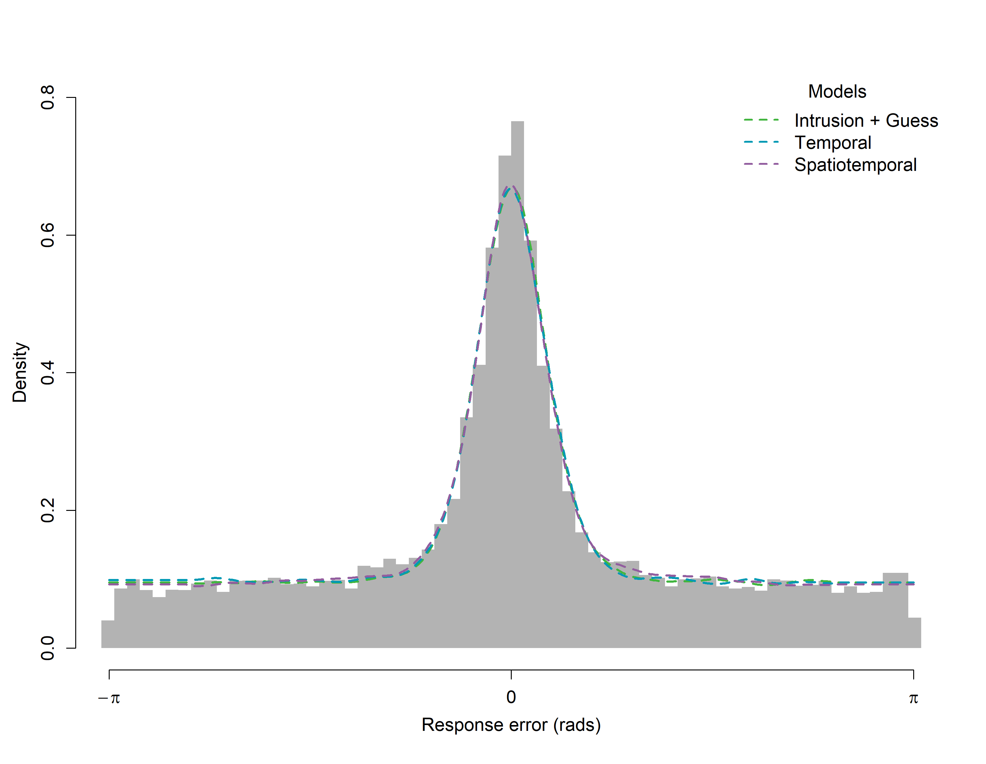

*Note*. All three models have both an intrusion and guessing component. In the Intrusion + Guess model, all non-targets are equally likely to intrude, while in the temporal and spatiotemporal models, intrusions are individually determined by the respective similarity gradients.

Figure

*Model Fits to Distances between Response Angles and Non-target Angles by Direction and Lag*

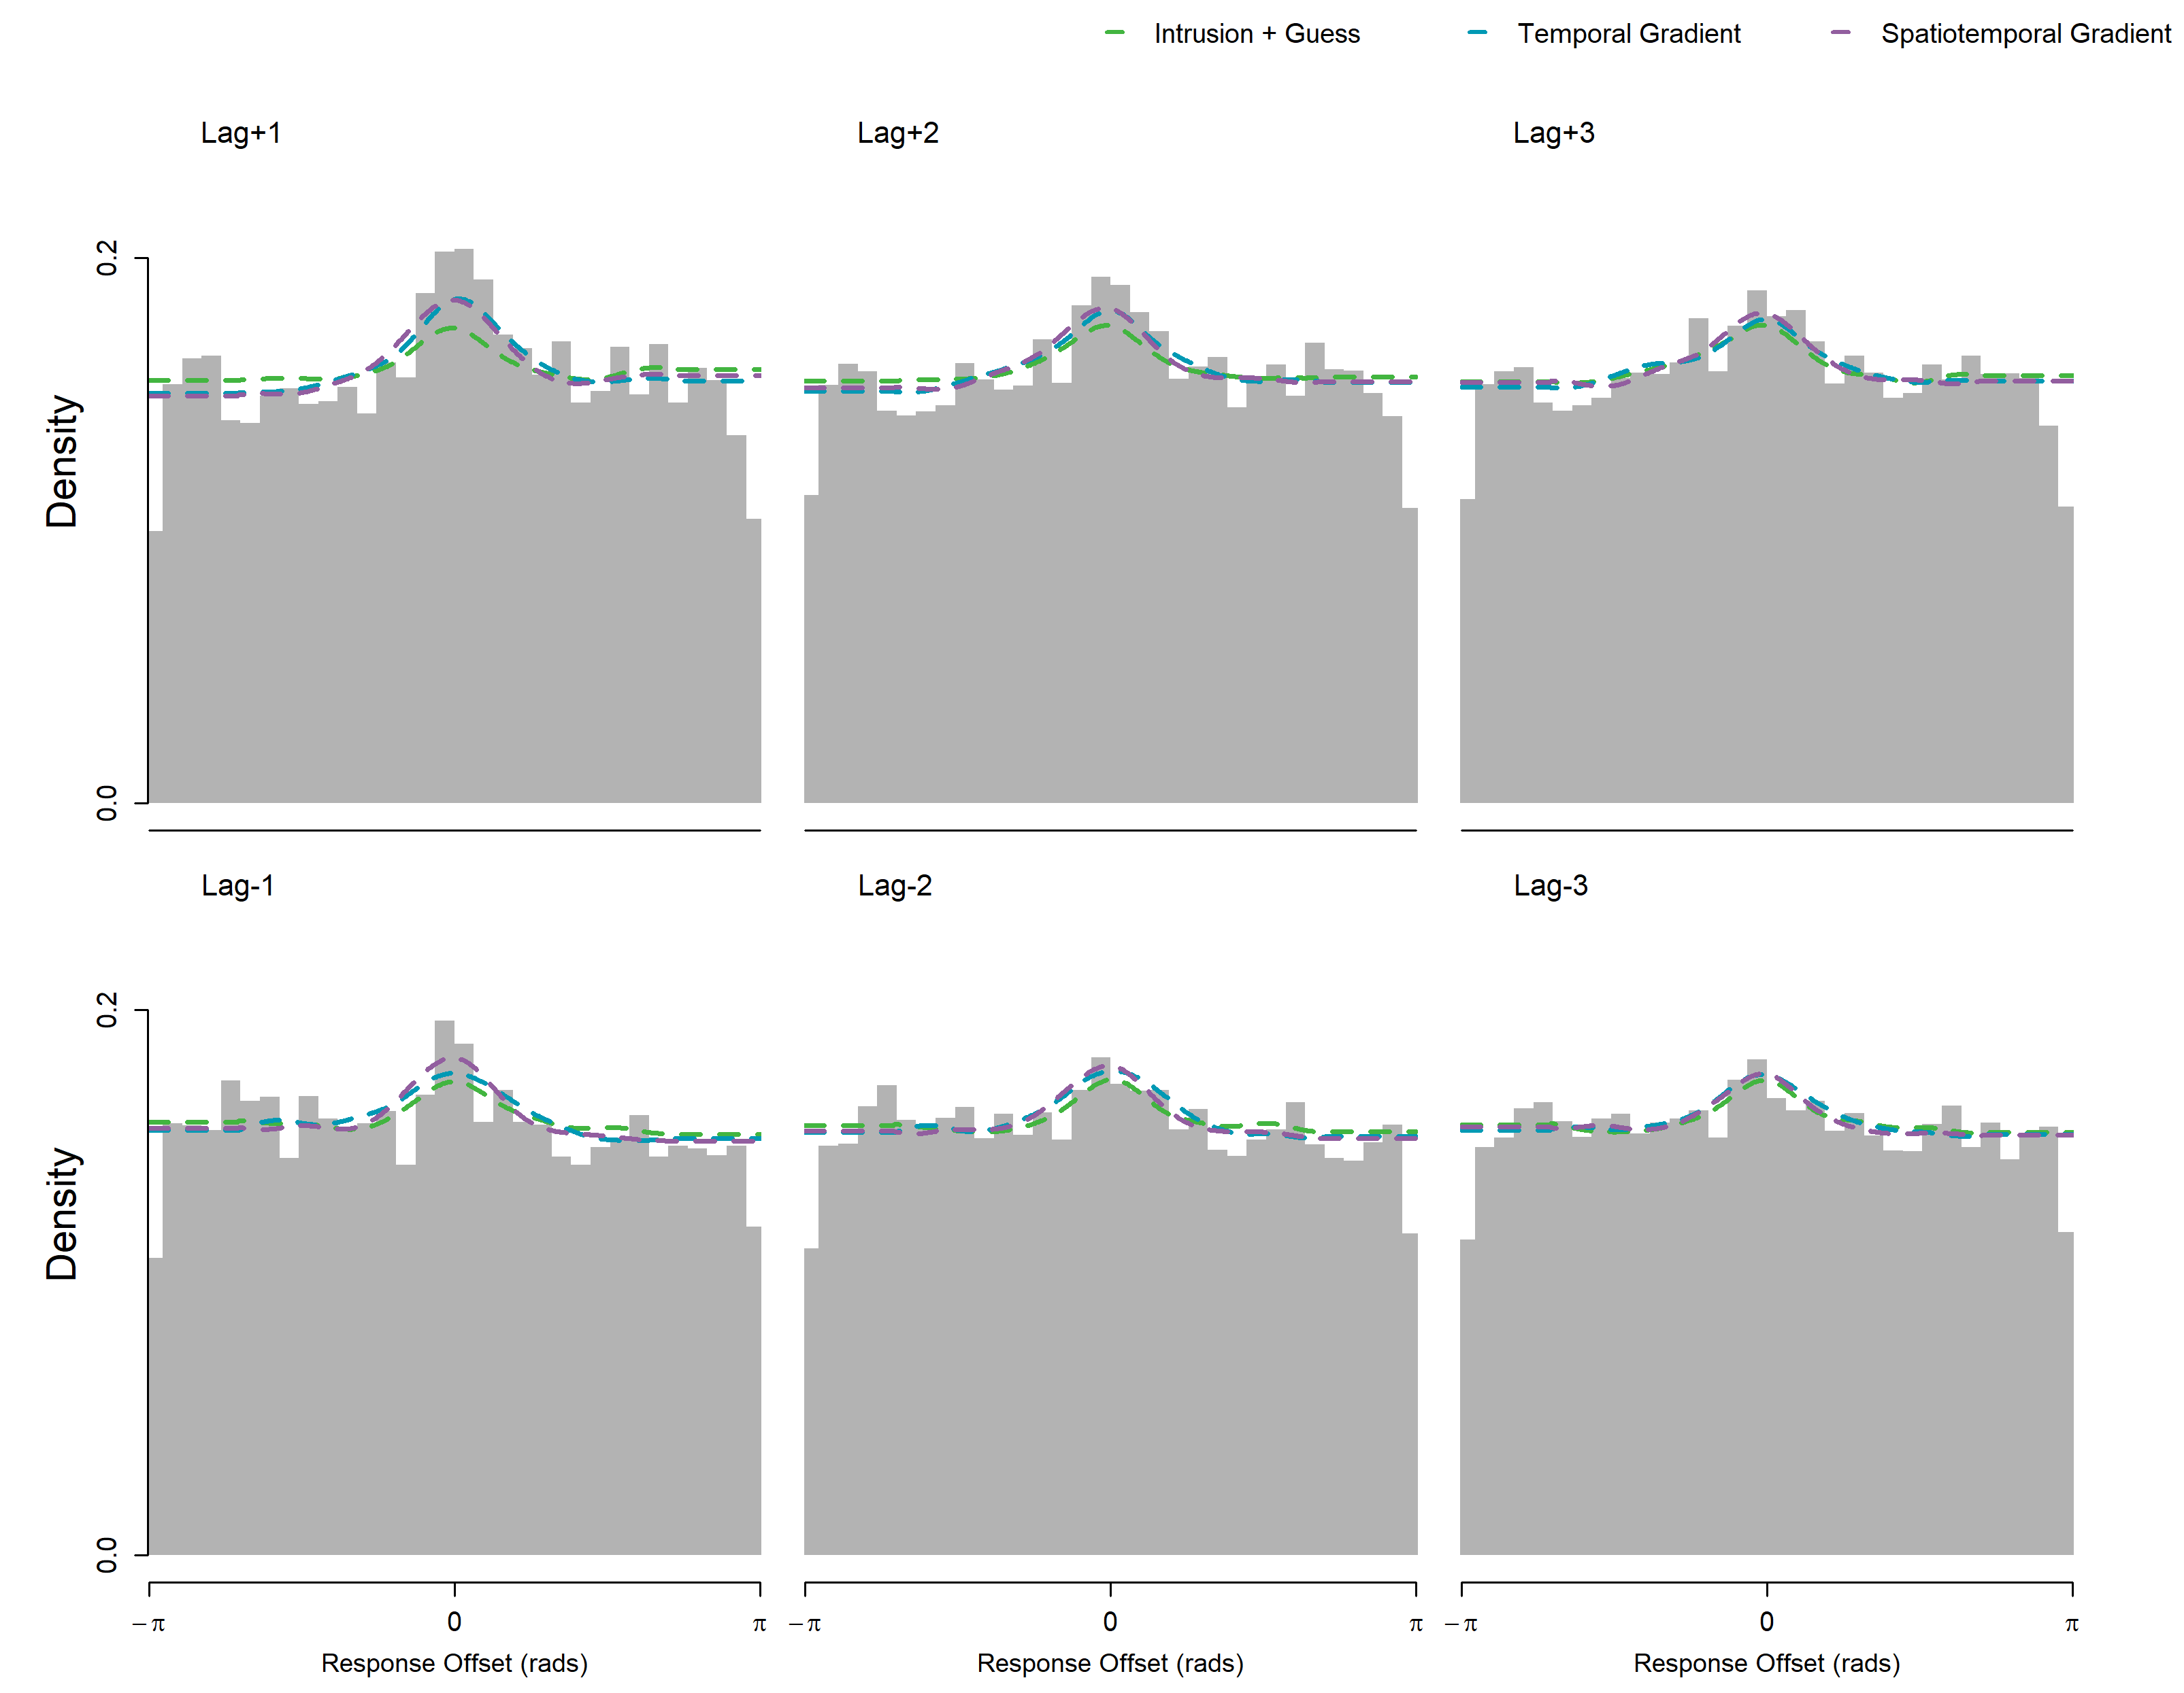

Another qualitative advantage of the gradient models (Models 4 and 5) is that they predict a parabolic relationship between the position of targets in the study list and average response error (Figure 10).

Figure

*Average Response Error Across Target Serial Positions*

### Diffusion Model Comparison

When models are hard to tell apart, look at a richer dataset.

Figure

*Diffusion Model Fits to Response Error and Latency*

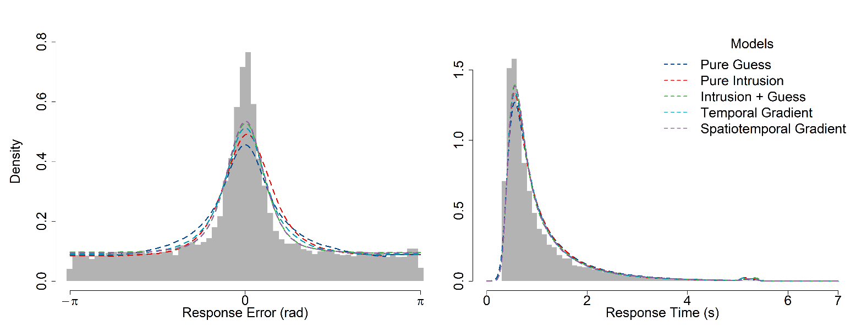

### Model Recovery

## Discussion

Successive qualitative improvement in fits when intrusion probabilities were determined by temporal and spatiotemporal gradients. However, this was not reflected in quantitative fit statistics, in which marginal improvements in model likelihood with the temporal and spatiotemporal models were outweighed by the additional parameters entailed by those models.

# Experiment 2

## Method

The method for Experiment 2 was identical to Experiment 1 with the following exceptions detailed below.

### Participants

In Experiment 2, participants were recruited solely via Prolific. Of the 10 participants recruited, four participants did not finish all sessions of the experiment, and one participant was excluded as the Rayleigh test indicated no deviance from uniform responding, leaving a final sample of five participants included for the analyses.

### Stimuli

Words were sampled anew from the entire list each time

### Procedure

Only simultaneous presentation. 10 sessions instead of three.

## Results

## Discussion

# General Discussion

## Mixture Models

Ambiguity about the relative contribution of multiple components (i.e. is the decrease in overall intrusion probability over the serial position of the target item associated with an increased probability of the memory component or the guessing component in the model?)

It does not seem reasonable to expect that the proportion of guesses remains the same across serial positions, but we do not have a formal alternative model of guessing. To take an extreme example, we can consider a potential interaction between recognition and intrusion probability where items that are not recognized do not intrude. In a list where no items are recognized, we would intuit that all responses should be guesses.

Need for a process model, like racing diffusion models, to address this ambiguity.

|  |  |  |  |  |  |
| --- | --- | --- | --- | --- | --- |
| Table X  *Individual-level Response Error Model Comparison* | | | | | |
| Participant | Model AIC Weight | | | | |
| 1  Pure Guess | 2  Pure Intrusion | 3  Intrusion + Guess | 4  Temporal | 5  Spatiotemporal |
| 1 | 0.12 | 0.00 | **0.88** | 0.00 | 0.00 |
| 2 | **0.62** | 0.08 | 0.23 | 0.05 | 0.02 |
| 3 | **0.54** | 0.00 | 0.33 | 0.12 | 0.02 |
| 4 | 0.07 | 0.00 | **0.88** | 0.03 | 0.02 |
| 5 | 0.00 | 0.00 | **0.96** | 0.03 | 0.01 |
| 6 | 0.00 | 0.00 | 0.00 | 0.38 | **0.62** |
| 7 | 0.01 | 0.00 | **0.86** | 0.12 | 0.02 |
| 8 | 0.00 | 0.00 | 0.24 | 0.09 | **0.66** |
| 9 | 0.04 | 0.00 | **0.49** | 0.29 | 0.18 |
| 10 | 0.00 | 0.00 | **0.94** | 0.03 | 0.03 |
| 11 | 0.01 | 0.00 | **0.68** | 0.15 | 0.15 |
| 12 | **0.44** | 0.00 | 0.27 | 0.27 | 0.02 |
| 13 | **0.68** | 0.00 | 0.25 | 0.06 | 0.01 |
| 14 | 0.00 | 0.01 | **0.99** | 0.00 | 0.00 |
| 15 | **0.40** | 0.00 | 0.15 | **0.40** | 0.05 |
| 16 | 0.01 | 0.00 | 0.10 | **0.73** | 0.16 |
| 17 | 0.06 | 0.00 | **0.74** | 0.16 | 0.04 |
| 18 | **0.81** | 0.00 | 0.18 | 0.01 | 0.00 |
| 19 | 0.00 | 0.00 | **0.49** | 0.02 | **0.49** |
| 20 | 0.00 | 0.00 | 0.06 | **0.47** | **0.47** |
| 21 | 0.00 | 0.00 | **0.70** | 0.26 | 0.04 |
| 22 | 0.00 | 0.00 | **0.42** | **0.42** | 0.16 |
| 23 | 0.00 | 0.00 | **0.71** | 0.26 | 0.04 |
| 24 | 0.00 | 0.00 | **0.60** | 0.37 | 0.03 |
| 25 | 0.13 | 0.00 | 0.21 | **0.58** | 0.08 |
| 26 | 0.03 | 0.00 | **0.88** | 0.07 | 0.02 |
| 27 | **0.72** | 0.00 | 0.27 | 0.01 | 0.00 |
| 28 | 0.01 | 0.00 | **0.93** | 0.05 | 0.02 |
| 29 | **0.46** | 0.01 | **0.46** | 0.06 | 0.01 |
| 30 | 0.00 | 0.01 | **0.98** | 0.00 | 0.01 |
| 31 | 0.00 | 0.00 | 0.02 | **0.49** | **0.49** |
| 32 | 0.08 | 0.00 | **0.61** | 0.22 | 0.08 |
| 33 | **0.63** | 0.00 | 0.23 | 0.09 | 0.05 |
| 34 | **0.59** | 0.00 | 0.36 | 0.05 | 0.00 |
| 35 | **0.47** | 0.00 | **0.47** | 0.04 | 0.02 |
| 36 | **0.59** | 0.00 | 0.36 | 0.05 | 0.01 |

*Note*. The AIC weight can be interpreted as

1. The von Mises distribution is a circular analogue of the Gaussian distribution.
2. We refer to erroneous responses driven by non-target items as intrusions, describing how words from non-target word-location pairs are intruding on the cued pair. These within-list intrusions are not to be confused with extra-list intrusions, or *protrusion* errors, which we do not expect to contribute to errors in our paradigm.
3. The authors note that Healey (1974) observed a symmetric transposition gradient and Madigan (1971) observed asymmetry in the opposite direction, potentially due to differences in response modality.